**Supplemental Figures**

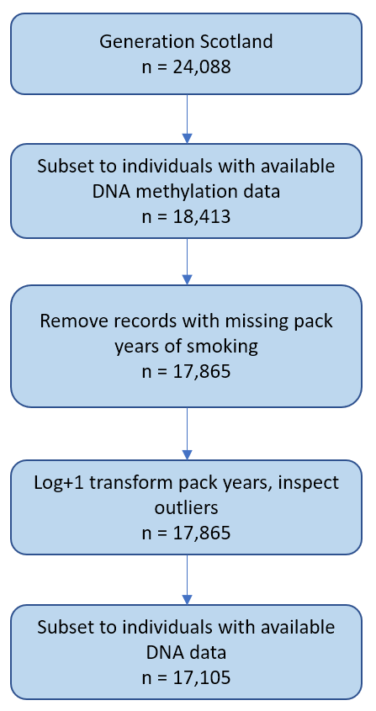

**Supplementary Figure 1. Pack years data pre-processing in Generations Scotland.** Trimming outliers consisted of removing log+1 transformed pack years values more than 4 SDs from the mean.

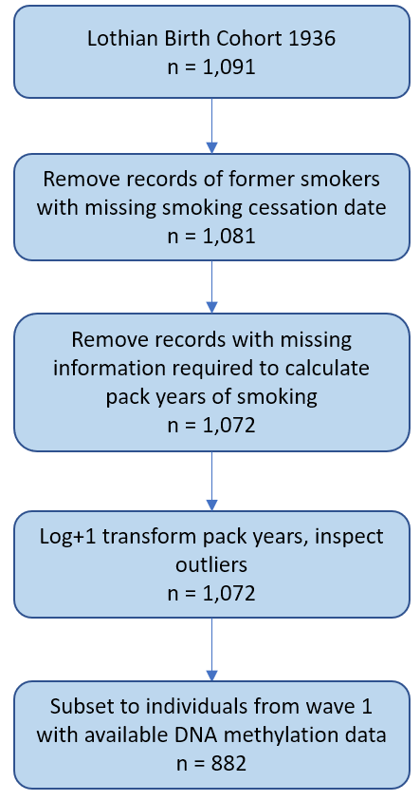

**Supplementary Figure 2. Pack years data pre-processing in Lothian Birth Cohort 1936.** Records of participants that described themselves as never- or ex-smokers, provided the date they started smoking and did not provide the date they quit smoking were likely to contain data entry errors and were therefore removed from the dataset. Trimming outliers consisted of removing log+1 transformed pack years values more than 4 SDs from the mean.

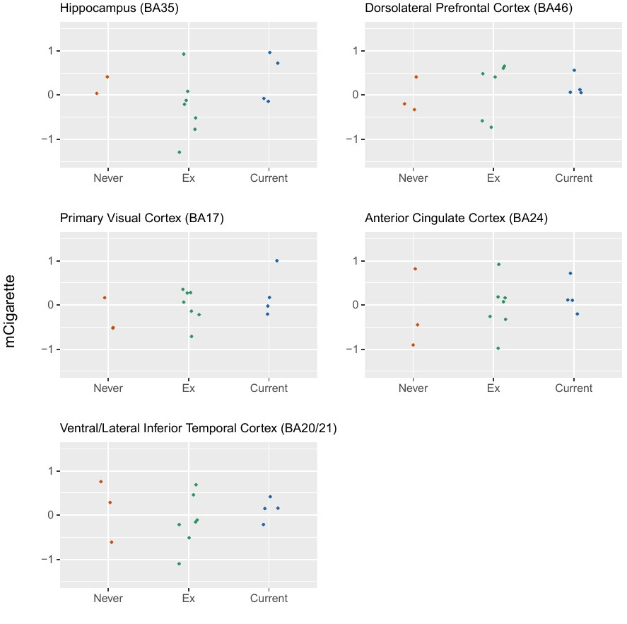

**Supplementary Figure 3. mCigarette applied to post-mortem brain samples from** **LBC1936 (n=14, nhippocampus=13).** Three smoking categories were considered (never, former and current smokers). The association was plotted across five brain regions.

|  |  |
| --- | --- |
|  |  |
|  |  |

**Figure 4. Genetic correlations between epigenetic (EpiSmokEr, Grimage pack years) and self-reported smoking.** Genome-Wide Association Studies of EpiSmokEr and Grimage pack years scores were conducted in Generation Scotland (n=17,105). The results were compared to previously published GWAS of tobacco use (nmax=2,669,029 Europeans), which considered four smoking behaviours: smoking initiation (SmkInit), smoking cessation (SmkCes), age of initiation of smoking (AgeSmk) and cigarettes per day (CigDay) (Saunders *et al.*, 2022).