Supplement 4: Leave-one out forest plot
(a) Studies sorted by proportion | (b) Studies sorted by heterogeneity
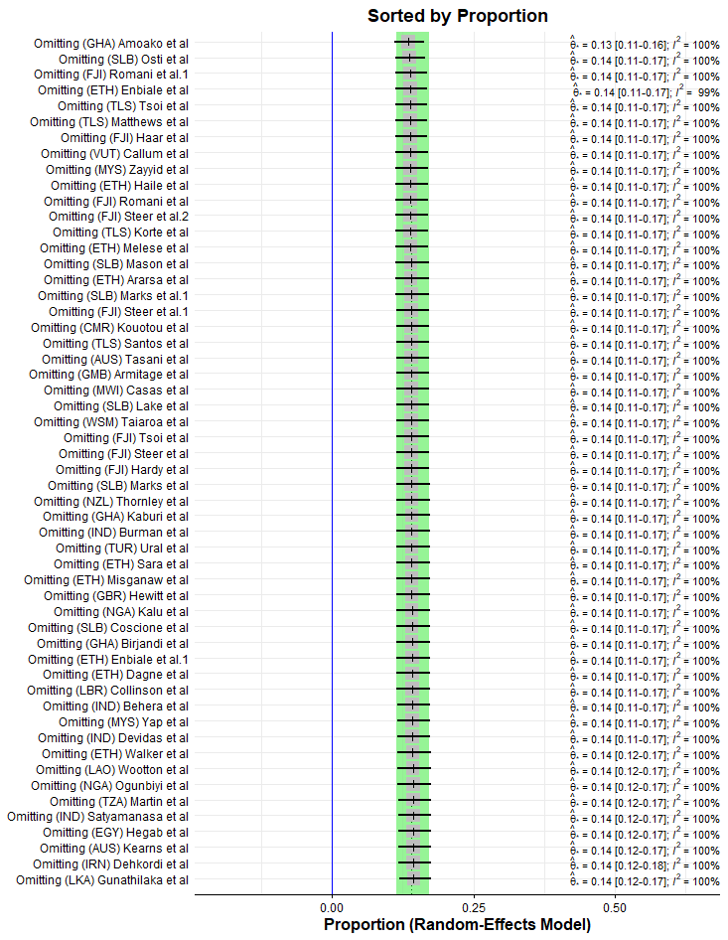 | 