Supplementary Tables
Supplementary Table 1: Association of risk indicator burden (continuous) with incident dementia
 | β | SE | Statistic | P
Risk Indicator Burden | 0.53 | 0.04 | 13.63 | 2.602E-42
Cohort
NACC | - | - | - | -
ADNI | 0.77 | 0.08 | 9.74 | 1.9534E-22
Race/Ethnicity
NLW | - | - | - | -
Asian | -0.88 | 0.71 | -1.24 | 0.21481153
Black | -0.22 | 0.13 | -1.66 | 0.09676162
Latinx | 0.38 | 0.17 | 2.24 | 0.02492268
Other | 0.2 | 0.25 | 0.79 | 0.42821037

Supplementary Table 2: Association of risk indicator burden (categorical) with incident dementia
 | β | SE | Statistic | P
Risk Indicator Burden
0 | - | - | - | -
1 | 0.54 | 0.13 | 4.21 | 2.50E-05
2 | 1.13 | 0.13 | 8.93 | 4.36E-19
3 | 1.49 | 0.15 | 10.19 | 2.15E-24
4 | 2.5 | 0.26 | 9.69 | 3.24E-22
Cohort
NACC | - | - | - | -
ADNI | 0.77 | 0.08 | 9.72 | 2.51E-22
Race/Ethnicity
NLW | - | - | - | -
Asian | -0.88 | 0.71 | -1.24 | 0.21
Black | -0.22 | 0.13 | -1.66 | 0.09
Latinx | 0.37 | 0.17 | 2.21 | 0.03
Other | 0.18 | 0.25 | 0.73 | 0.46

Supplementary Figures
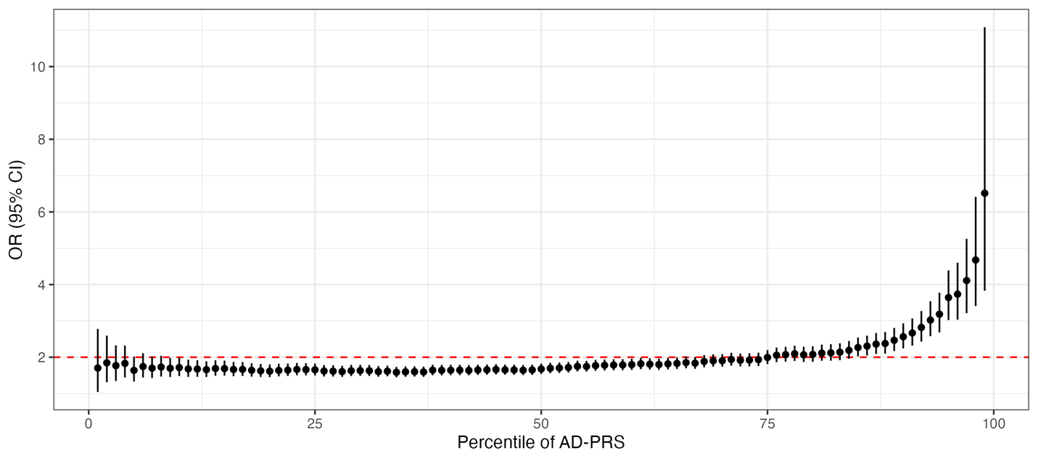
Supplementary Figure 1: Logistic regression coefficients for the AD-PRS across percentiles. At the 85th percentile, the high-risk category is associated with increased dementia of OR (95% CI) = 2.27 (2.02, 2.54), p = 1.13e-44.

