Supplemental Content

Supplemental Table 1. Imputed values for features with missingness

Feature | Feature Type | Imputed
pH at 24 hours | Categorical | Normal
Systolic blood pressure | Categorical | Normal if no Vasopressor used at 24 hours, Abnormal if Vasopressor used at 24 hours
PaO2/FiO2 | Categorical | No ARDS
Albumin | Continuous | 4
Lactate | Continuous | 0
Fluid balance | Continuous | 0
Heart rate | Continuous | 80
Temperature | Continuous | 98.6
Bicarbonate | Continuous | 24
Creatinine | Continuous | 1
Blood glucose | Continuous | 160
WBC | Continuous | 8
Potassium | Continuous | 4
Sodium | Continuous | 140
HGB | Continuous | 16 if Male, 14 if Female
HCT | Continuous | 46 if Male, 42 if Female
PLT | Continuous | 300

Supplemental Table 2. Mortality prediction variables with definitions
Feature | Feature Type | Number (%) of missingness | Definition
Baseline Patient Characteristics
Age | Continuous | 0 (0) | N/A
Sex | Categorical | 0 (0) | N/A
ICU Admission Information
Admission diagnosis | Categorical | 0 (0) | Burn, cardiovascular, dermatology, electrolyte abnormalities, endocrine, fever, gastrointestinal, hematologic, hepatic, infection, mental health, neoplasm, neurology, pneumonia, pregnancy, pulmonary, renal, respiratory, respiratory failure, sepsis, shock, syncope, toxicology/ingestion, trauma, weakness, or other
ICU Type | Categorical | 0 (0) | Burn, cardiac, cardiothoracic, medical, neurosciences, surgical, or mixed
24 Hours After ICU Admission
Severity of Illness
APACHE II at 24 hours | Continuous | 0 (0) | N/A
SOFA at 24 hours | Continuous | 0 (0) | N/A
Vital Signs
Heart rate at 24 hours | Continuous | 3 (0.3) | Highest heart rate at 24 hours
Ind_miss heart rate at 24 hours |  |  | Indicator of missingness for heart rate at 24 hours
SBP at 24 hours | Categorical | 12 (1.21) | Lowest systolic blood pressure at 24 hours. This variable is categorized into two levels by cut point 90
Ind_miss SBP at 24 hours |  |  | Indicator of missingness for SBP at 24 hours. This variable indicates missingness into two categories depending on the level of vasopressor at 24 hours
Temperature at 24 hours | Continuous | 26 (2.62) | The most extreme temperature at 24 hours comparing with the normal value, 97.97
Ind_miss temperature at 24 hours |  |  | Indicator of missingness for temperature at 24 hours
ARDS Classification
PaO₂:FiO₂ at 24 hours | Categorical | 622 (62.76) | The lowest PaO₂:FiO₂ at 24 hours. This variable is categorized into four levels by cut points 100, 200, and 300.
Ind_miss PaO₂:FiO₂ at 24 hours |  |  | Indicator of missingness for PaO₂:FiO₂ at 24 hours
Supportive Care Devices
CRRT at 24 hours | Categorical | 0 (0)
Mechanical ventilation at 24 hours | Categorical | 0 (0) | N/A
Serum Laboratory Values
Albumin at 24 hours | Continuous | 521 (52.57) | The lowest albumin at 24 hours
Ind_miss albumin at 24 hours |  |  | Indicator of missingness for albumin at 24 hours
Bicarbonate at 24 hours | Continuous | 46 (4.64) | The most extreme bicarbonate at 24 hours comparing with the normal value, 24
Ind_miss bicarbonate & creatinine & sodium at 24 hours |  |  | Indicator of missingness for bicarbonate & creatinine & sodium at 24 hours
Blood glucose at 24 hours | Continuous | 31 (3.13) | The most extreme blood glucose at 24 hours comparing with the normal value, 125
Ind_miss blood glucose at 24 hours |  |  | Indicator of missingness for blood glucose at 24 hours
Creatinine at 24 hours | Continuous | 46 (4.64) | The highest creatinine at 24 hours
HCT at 24 hours | Continuous | 80 (8.07) | The lowest HCT at 24 hours
HGB at 24 hours | Continuous | 80 (8.07) | The lowest HGB at 24 hours
Ind_miss HGB & HCT at 24 hours |  |  | Indicator of missingness for HGB & HCT at 24 hours. This variable indicates missingness into two categories depending on the level of Sex
Lactate at 24 hours | Continuous | 670 (67.61) | The highest lactate at 24 hours
Ind_miss lactate at 24 hours |  |  | Indicator of missingness for lactate at 24 hours
pH at 24 hours | Categorical | 582 (58.73) | The most extreme pH at 24 hours comparing with the normal value, 7.4. This variable is categorized into three levels by two cut points, 7.2 and 7.5
Ind_miss pH at 24 hours |  |  | Indicator of missingness for pH at 24 hours
PLT at 24 hours | Continuous | 83 (8.38) | The most extreme PLT at 24 hours comparing with the normal value, 300.
Ind_miss PLT at 24 hours |  |  | Indicator of missingness for PLT at 24 hours
Potassium at 24 hours | Continuous | 44 (4.44) | The most extreme potassium at 24 hours comparing with the normal value, 4.35
Ind_miss potassium at 24 hours |  |  | Indicator of missingness for potassium at 24 hours
Sodium at 24 hours | Continuous | 46 (4.64) | The most extreme sodium at 24 hours comparing with the normal value, 140
WBC at 24 hours | Continuous | 81 (8.17) | The most extreme WBC at 24 hours comparing with the normal value, 7.75
Ind_miss WBC at 24 hours |  |  | Indicator of missingness for WBC at 24 hours
Fluid balance at 24 hours | Continuous | 100 (10.09)
Ind_miss fluid balance at 24 hours |  |  | Indicator of missingness for fluid balance at 24 hours
Medication Data at 24 Hours
MRC-ICU at 24 hours | Continuous | 0 (0) | N/A
Vasopressor at 24 hours | Categorical | 0 (0) | N/A
APACHE: Acute Physiology and Chronic Health Evaluation; CRRT: continuous renal replacement therapy; HCT: hematocrit; HGB: hemoglobin; MRC-ICU: Medication Regimen Complexity – Intensive Care Unit; PaO₂:FiO₂: ratio of partial pressure of arterial oxygen to fraction of inspired oxygen; PLT: platelets; SBP: systolic blood pressure; SOFA: Sequential Organ Failure Assessment; WBC: white blood cells

Supplemental Table 3. Baseline study cohort demographics – validation set

 | All (n=4878) | Mortality (n=964) | No mortality (n=3914) | p-value
ICU baseline
Age, mean (SD) | 58.87 (16.47) | 62.46 (14.53) | 57.98 (16.80) | 0.00
Male sex, n (%) | 2532 (51.91) | 528 (54.77) | 2004 (51.20) | 0.05
ICU Type, n (%) |  |  |  | 0.57
Mixed ICU | 2 (0.04) | 0 (0.00) | 2 (0.05)
Burn ICU | 32 (0.66) | 4 (0.41) | 28 (0.72)
Cardiac ICU | 41 (0.84) | 12 (1.24) | 29 (0.72)
Cardiothoracic ICU | 15 (0.31) | 3 (0.31) | 12 (0.31)
Medical ICU | 4631 (94.94) | 917 (95.12) | 3714 (94.89)
Neurosciences ICU | 31 (0.64) | 5 (0.52) | 26 (0.66)
Surgical ICU | 126 (2.58) | 23 (2.39) | 103 (2.63)
Primary ICU admission diagnosis, n (%) |  |  |  | 0.00
Burn | 12 (0.25) | 1 (0.10) | 11 (0.28)
Cardiovascular | 364 (7.46) | 58 (6.02) | 306 (7.82)
Dermatology | 34 (0.70) | 5 (0.52) | 29 (0.74)
Electrolyte Abnormalities | 47 (0.96) | 5 (0.52) | 42 (1.07)
Endocrine | 200 (4.10) | 8 (0.83) | 192 (4.91)
Fever | 75 (1.54) | 11 (1.14) | 64 (1.64)
Gastrointestinal | 573 (11.75) | 76 (7.88) | 497 (12.70)
Hematologic | 347 (7.11) | 75 (7.78) | 272 (6.95)
Hepatic | 188 (3.85) | 66 (6.85) | 122 (3.12)
Infection | 399 (8.18) | 132 (13.69) | 267 (6.82)
Mental Health | 31 (0.64) | 1 (0.10) | 30 (0.77)
Neoplasm | 135 (2.77) | 29 (3.01) | 106 (2.71)
Neurology | 331 (6.79) | 57 (5.91) | 274 (7.00)
Pneumonia | 148 (3.03) | 34 (3.53) | 114 (2.91)
Pregnancy | 21 (0.43) | 1 (0.10) | 20 (0.51)
Pulmonary | 88 (1.8) | 11 (1.14) | 77 (1.97)
Renal | 180 (3.69) | 33 (3.42) | 147 (3.76)
Respiratory | 420 (8.61) | 84 (8.71) | 336 (8.58)
Respiratory failure | 396 (8.12) | 118 (12.24) | 278 (7.10)
Sepsis | 559 (11.46) | 118 (12.24) | 441 (11.27)
Shock | 49 (1.00) | 10 (1.04) | 39 (1.00)
Syncope | 18 (0.37) | 2 (0.21) | 16 (0.41)
Toxicology/Ingestion | 88 (1.80) | 4 (0.41) | 84 (2.15)
Trauma | 12 (0.25) | 2 (0.21) | 10 (0.26)
Weakness | 25 (0.51) | 4 (0.41) | 21 (0.54)
Other | 138 (2.83) | 19 (1.97) | 119 (3.04)
24 h after ICU admission
Severity of illness, mean (SD)
APACHE II Score | 15.92 (6.26) | 18.82 (6.40) | 15.20 (6.02) | 0.00
SOFA Score | 7.00 (4.48) | 10.31 (4.71) | 6.18 (4.03) | 0.00
Vital Signs
Heart rate, mean (SD) | 110.14 (21.77) | 115.92 (24.20) | 108.71 (20.89) | 0.00
Systolic blood pressure abnormal (< 90 mmHg), n (%) | 1305 (31.36) | 285 (41.73) | 1020 (29.32) | 0.00
Temperature (F), mean (SD) | 98.71 (2.69) | 98.53 (4.70) | 98.75 (1.94) | 0.17
ARDS Classification, n (%) |  |  |  | 0.00
Mild | 386 (22.13) | 104 (15.76) | 282 (26.01)
Moderate | 667 (38.25) | 265 (40.15) | 402 (37.08)
Severe | 408 (23.39) | 227 (34.39) | 181 (16.70)
Supportive devices, n (%)
CRRT at 24 h | 611 (12.53) | 316 (32.78) | 295 (7.54) | 0.00
MV at 24 h | 1415 (29.01) | 504 (52.28) | 911 (23.28) | 0.00
Serum laboratory values, mean (SD)
Albumin mg/dL | 2.61 (0.54) | 2.49 (0.54) | 2.65 (0.54) | 0.00
Bicarbonate mEq/L | 22.69 (6.53) | 20.56 (7.52) | 23.21 (6.16) | 0.00
Creatinine mg/dL | 2.03 (2.37) | 2.46 (2.11) | 1.92 (2.42) | 0.00
Glucose mg/dL | 154.35 (93.26) | 165.70 (96.27) | 151.55 (92.31) | 0.00
Lactate mmol/L | 3.33 (4.25) | 5.24 (5.84) | 2.21 (2.31) | 0.00
Potassium mEq/L | 4.12 (0.83) | 4.37 (0.95) | 4.06 (0.79) | 0.00
pH < 7.2, n (%) | 191 (9.49) | 144 (20.06) | 47 (3.63) | 0.00
pH > 7.5, n (%) | 142 (7.05) | 33 (4.60) | 109 (8.42) | 0.00
Sodium mEq/L | 137.13 (6.49) | 137.36 (6.76) | 137.07 (6.42) | 0.25
Hemoglobin g/dL | 9.69 (2.26) | 9.35 (2.32) | 9.77 (2.24) | 0.00
Hematocrit % | 30.21 (7.01) | 29.37 (7.27) | 30.42 (6.93) | 0.00
Platelets x 10³/μL | 199.57 (136.92) | 180.76 (146.07) | 204.30 (134.13) | 0.00
White blood cells x 10³/μL | 13.44 (18.64) | 17.15 (19.91) | 12.52 (18.19) | 0.00
Fluid balance at 24 h (L), mean (SD) | 1.81 (2.98) | 2.50 (3.25) | 1.64 (2.88) | 0.00
Medications
MRC-ICU, mean (SD) | 9.91 (6.64) | 13.75 (7.71) | 8.96 (5.99) | 0.00
Vasopressor at 24 h, n (%) | 2106 (43.17) | 659 (68.36) | 1447 (36.97) | 0.00
Supplemental Table 4. Data missingness in validation set

Feature | Number (%) Missingness
Age | 0 (0)
Sex | 0 (0)
MRC-ICU score at 24 hours | 0 (0)
ICU type | 0 (0)
Mechanical ventilation at 24 hours | 0 (0)
Fluid balance at 24 hours | 0 (0)
Admission diagnosis | 0 (0)
Fluid balance at 24 hours | 4 (0.08)
CRRT at 24 hours | 0 (0)
Vasopressor at 24 hours | 0 (0)
Heart rate at 24 hours | 3 (0.06)
SBP at 24 hours | 716 (14.68)
Temperature at 24 hours | 499 (10.23)
pH at 24 hours | 2865 (58.73)
Bicarbonate at 24 hours | 222 (4.55)
Creatinine at 24 hours | 192 (3.94)
Blood glucose at 24 hours | 124 (2.54)
WBC at 24 hours | 295 (6.05)
Lactate at 24 hours | 3095 (63.45)
Potassium at 24 hours | 192 (3.94)
Sodium at 24 hours | 183 (3.75)
Albumin at 24 hours | 2033 (41.68)
HGB at 24 hours | 269 (5.51)
HCT at 24 hours | 276 (5.66)
PLT at 24 hours | 293 (6.01)
PaO₂:FiO₂ at 24 hours | 3134 (64.25)

Supplemental Table 5. AUROC for mortality prediction models on validation set

 | AUROC
APACHE II | 0.66, 0.64-0.68
SOFA | 0.75, 0.73-0.77
MRC-ICU + SOFA + APACHE II | 0.72, 0.70-0.74
Linear Logistic | 0.75, 0.73-0.77
Nature Cubic Splines Logistic | 0.69, 0.67-0.71
Smoothing Splines Logistic | 0.73, 0.71-0.75
Local Linear Logistic | 0.73, 0.71-0.75
Random Forest | 0.78, 0.76-0.8
SVM | 0.74, 0.72-0.76
XGBoost | 0.73, 0.71-0.75
AUROC: area under the receiver operating characteristic

Supplemental Table 6. Accuracy, sensitivity, specificity, negative predictive value, and positive predictive value for mortality prediction on validation set

Maximizing INF | Accuracy | Sensitivity | Specificity | PPV | NPV
APACHE II | 0.67, 0.65-0.68 | 0.49, 0.45-0.52 | 0.71, 0.70-0.73 | 0.29, 0.27-0.32 | 0.85, 0.84-0.86
SOFA | 0.56, 0.55-0.58 | 0.83, 0.80-0.85 | 0.50, 0.48-0.52 | 0.29, 0.27-0.31 | 0.92, 0.91-0.93
MRC-ICU + SOFA + APACHE II | 0.67, 0.65-0.68 | 0.65, 0.62-0.68 | 0.67, 0.66-0.69 | 0.33, 0.31-0.35 | 0.89, 0.87-0.90
Linear Logistic | 0.66, 0.64-0.67 | 0.71, 0.68-0.74 | 0.64, 0.63-0.66 | 0.33, 0.31-0.35 | 0.90, 0.89-0.91
Nature Cubic Splines Logistic | 0.63, 0.61-0.64 | 0.65, 0.62-0.68 | 0.62, 0.61-0.64 | 0.30, 0.28-0.32 | 0.88, 0.87-0.89
Smoothing Splines Logistic | 0.67, 0.66-0.68 | 0.67, 0.64-0.70 | 0.67, 0.65-0.68 | 0.33, 0.31-0.35 | 0.89, 0.88-0.90
Local Linear Logistic | 0.68, 0.66-0.69 | 0.65, 0.62-0.68 | 0.68, 0.67-0.70 | 0.34, 0.31-0.36 | 0.89, 0.88-0.90
Random Forest | 0.55, 0.53-0.56 | 0.88, 0.86-0.90 | 0.46, 0.45-0.48 | 0.29, 0.27-0.30 | 0.94, 0.93-0.95
SVM | 0.66, 0.64-0.67 | 0.72, 0.69-0.75 | 0.64, 0.63-0.66 | 0.33, 0.31-0.35 | 0.90, 0.89-0.91
XGBoost | 0.74, 0.73-0.75 | 0.50, 0.47-0.53 | 0.80, 0.79-0.81 | 0.38, 0.36-0.41 | 0.87, 0.86-0.88
Maximizing MCC | Accuracy | Sensitivity | Specificity | PPV | NPV
APACHE II | 0.67, 0.65-0.68 | 0.49, 0.45-0.52 | 0.71, 0.70-0.73 | 0.29, 0.27-0.32 | 0.85, 0.84-0.86
SOFA | 0.75, 0.73-0.76 | 0.56, 0.53-0.59 | 0.79, 0.78-0.81 | 0.40, 0.37-0.43 | 0.88, 0.87-0.89
MRC-ICU + SOFA + APACHE II | 0.68, 0.66-0.69 | 0.64, 0.61-0.67 | 0.69, 0.67-0.70 | 0.33, 0.31-0.36 | 0.89, 0.87-0.90
Linear Logistic | 0.71, 0.70-0.72 | 0.64, 0.61-0.67 | 0.72, 0.71-0.74 | 0.36, 0.34-0.39 | 0.89, 0.88-0.90
Nature Cubic Splines Logistic | 0.63, 0.61-0.64 | 0.65, 0.62-0.68 | 0.62, 0.61-0.64 | 0.30, 0.28-0.32 | 0.88, 0.87-0.89
Smoothing Splines Logistic | 0.75, 0.74-0.76 | 0.49, 0.46-0.53 | 0.81, 0.80-0.83 | 0.39, 0.37-0.42 | 0.87, 0.86-0.88
Local Linear Logistic | 0.75, 0.74-0.77 | 0.47, 0.44-0.51 | 0.82, 0.81-0.83 | 0.40, 0.37-0.43 | 0.86, 0.85-0.87
Random Forest | 0.67, 0.66-0.69 | 0.75, 0.72-0.78 | 0.65, 0.64-0.67 | 0.35, 0.33-0.37 | 0.91, 0.90-0.92
SVM | 0.77, 0.75-0.78 | 0.49, 0.45-0.52 | 0.83, 0.82-0.85 | 0.42, 0.39-0.45 | 0.87, 0.86-0.88
XGBoost | 0.78, 0.76-0.79 | 0.36, 0.33-0.39 | 0.88, 0.87-0.89 | 0.42, 0.39-0.46 | 0.85, 0.84-0.86
Maximizing F1 | Accuracy | Sensitivity | Specificity | PPV | NPV
APACHE II | 0.67, 0.65-0.68 | 0.49, 0.45-0.52 | 0.71, 0.70-0.73 | 0.29, 0.27-0.32 | 0.85, 0.84-0.86
SOFA | 0.75, 0.73-0.76 | 0.56, 0.53-0.59 | 0.79, 0.78-0.81 | 0.40, 0.37-0.43 | 0.88, 0.87-0.89
MRC-ICU + SOFA + APACHE II | 0.69, 0.68-0.70 | 0.61, 0.58-0.64 | 0.71, 0.69-0.72 | 0.34, 0.32-0.36 | 0.88, 0.87-0.89
Linear Logistic | 0.71, 0.70-0.73 | 0.63, 0.60-0.66 | 0.74, 0.72-0.75 | 0.37, 0.35-0.39 | 0.89, 0.88-0.90
Nature Cubic Splines Logistic | 0.63, 0.62-0.65 | 0.64, 0.61-0.67 | 0.63, 0.62-0.65 | 0.30, 0.28-0.32 | 0.88, 0.86-0.89
Smoothing Splines Logistic | 0.75, 0.74-0.76 | 0.49, 0.46-0.53 | 0.81, 0.80-0.83 | 0.39, 0.37-0.42 | 0.87, 0.86-0.88
Local Linear Logistic | 0.75, 0.74-0.77 | 0.47, 0.44-0.51 | 0.82, 0.81-0.83 | 0.40, 0.37-0.43 | 0.86, 0.85-0.87
Random Forest | 0.77, 0.76-0.78 | 0.59, 0.55-0.62 | 0.81, 0.80-0.82 | 0.44, 0.41-0.46 | 0.89, 0.88-0.90
SVM | 0.77, 0.75-0.78 | 0.49, 0.45-0.52 | 0.83, 0.82-0.85 | 0.42, 0.39-0.45 | 0.87, 0.86-0.88
XGBoost | 0.78, 0.76-0.79 | 0.36, 0.33-0.39 | 0.88, 0.87-0.89 | 0.42, 0.39-0.46 | 0.85, 0.84-0.86
PPV: positive predictive value; NPV: negative predictive value

Supplemental Figure 1. Consort diagram

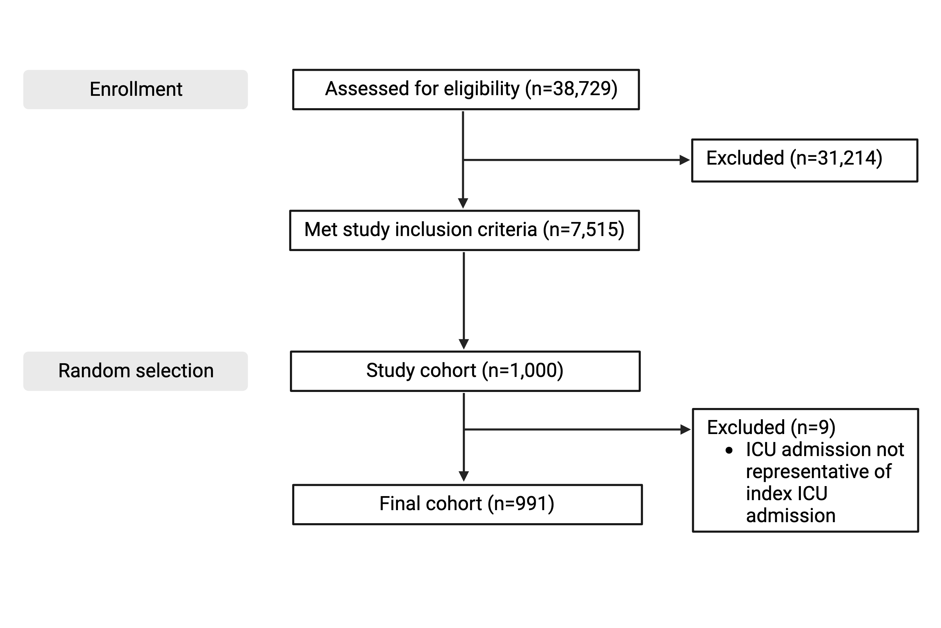

Supplemental Figure 2. Feature importance graph for Random Forest

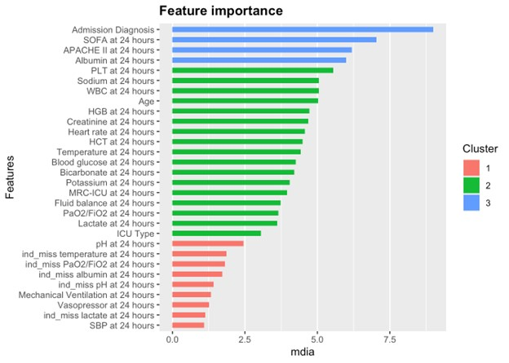

Supplemental Figure 3. Feature importance graph for SVM

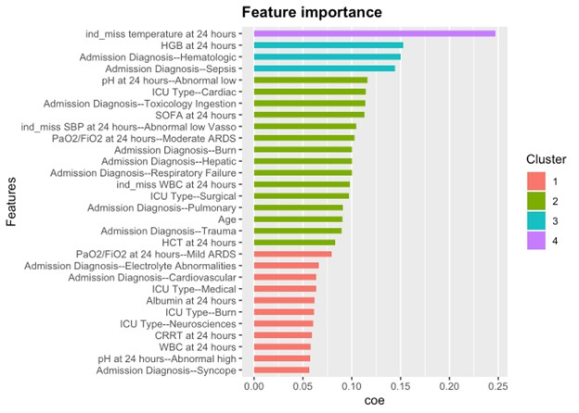

Supplemental Figure 4. AUROCs for hospital mortality prediction on validation set

