**Supplementary Figure 1. The UCSF Treat Acute HIV cohort study participants**. A total of 67 participants met inclusion criteria for acute HIV, defined as <100 days since the estimated date of detected HIV infection (EDDI) using the Infection Dating Tool (<https://tools.incidence-estimation.org/idt/>). The numbers of study participants by Fiebig stages (I-V) of HIV recency are also shown (https://doi.org:10.1097/01.aids.0000076308.76477.b8). PrEP = Pre-exposure prophylaxis with tenofovir disoproxil fumarate/emtricitabine (TDF/FTC).

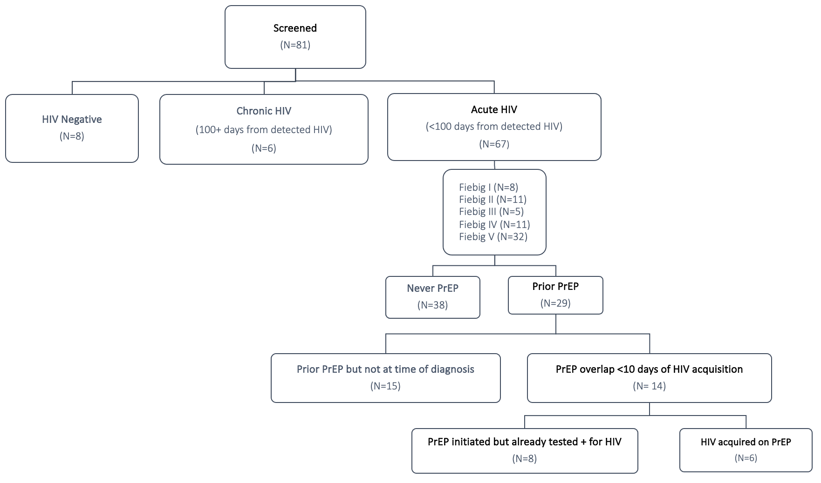

**Supplementary Figure 2. Calculation of estimated dates of detected HIV infection**.The estimated dates of detected HIV infection (EDDI), along with a “confidence interval” for early probable (EP-EDDI) and late probable (LP-EDDI) dates, were calculated using participants’ clinical test results as well as baseline study visit confirmatory assay results.

**Supplementary Figure 3. Fiebig and race/ethnicity distribution within the UCSF Treat Acute HIV cohort.** The distribution of study participants in the UCSF Treat Acute HIV cohort, by timing of ART initiation (a) and self-reported race/ethnicity (b). A total of 67 participants met inclusion criteria for acute HIV, defined as <100 days since the estimated date of detected HIV infection (EDDI) using the Infection Dating Tool (https://tools.incidence-estimation.org/idt/). The proportions of study participants by Fiebig stages (I-V) are also shown in (a).

**a. b.**

**Supplementary Figure 4. HIV-1/2 test results for study participants.** The proportion of study participants with either negative and/or indeterminate test results for HIV-1/2 p24 antigen/antibody assay (Architect) (a) and HIV-1/2 differentiation (Geenius) antibody assay (b) at baseline study visit were consistent with rates with our San Francisco Department of Public Health rates (27% and 28%, respectively).

**a. b.**

**Supplementary Figure 5.** **Observed HIV intact and defective reservoir decays highlighting participants reporting a history of PrEP use**. Most participants did not report PrEP overlap near the time of HIV diagnosis (grey lines). A subset of participants reported PrEP overlap within 10 days of HIV diagnosis; N=6 participants acquired HIV while already taking PrEP (yellow lines) and N=8 participants were prescribed PrEP but were found to already have acquired HIV (blue lines).

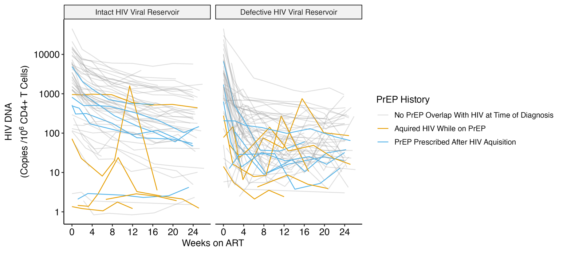

**Supplementary Figure 6. Semiparametric monophasic, biphasic, and triphasic generalized additive model fit comparison suggest biphasic model has the most parsimonious fit**. Infection points were selected by minimizing the leave-one-out prediction mean absolute error (MAE) for each model and both HIV DNA assays. Tuning results for the triphasic model show that the best model (emphasized in red) either has two knots near each other or one knot near zero (a) suggesting that it is similar in shape to a biphasic model; leave-one-out prediction mean squared error (MSE) is proved for extra support. The Akaike information criteria (AIC) value and 95% confidence interval was then used to compare monophasic, biphasic, and triphasic models for both assays (b). AIC estimates and confidence intervals were found by fitting models on 500 bootstrap resampled data sets. For both HIV intact and defective DNA, the biphasic and triphasic models had relatively equivalent performance.

**a.**

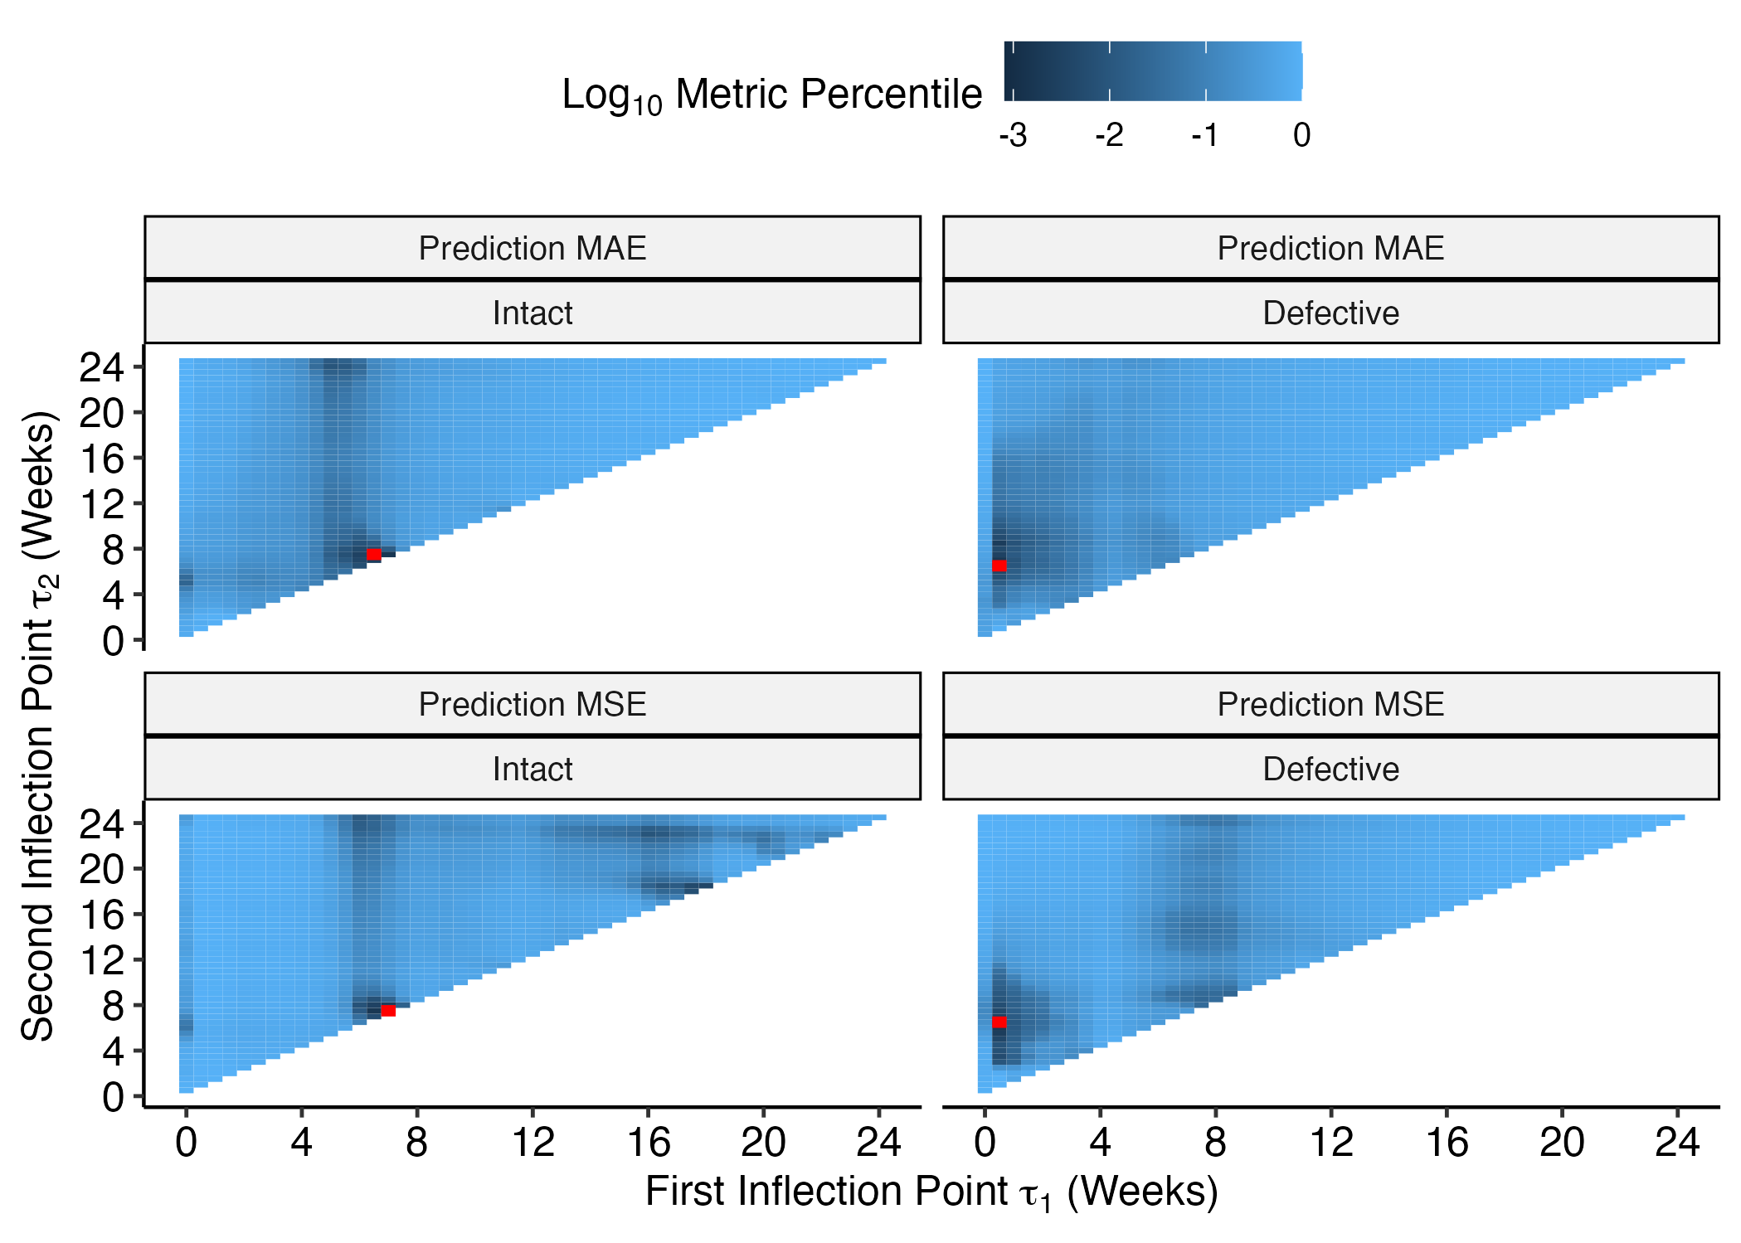

**b.**

|  |  |  |  |
| --- | --- | --- | --- |
| **HIV Reservoir** | **Monophasic (95% CI)** | **Biphasic (95% CI)** | **Triphasic (95% CI)** |
| **Intact DNA** | 886 (722, 1023) | 797 (595, 968) | 796 (597, 965) |
| **Defective DNA** | 1426 (1344, 1504) | 1268 (1183, 1343) | 1272 (1188, 1348) |

**Supplementary Figure 7.** **Modeling using the full first year of data suggests reservoir decay trends continue past the first 24 weeks on ART.** 65.7% of the total study participants continued in the study beyond 24 weeks**.** Observed HIV reservoir patterns are shown as thin grey lines, while the decay pattern for the model-predicted average participant is shown as the thick black lines (a). Average predicted participant predictions were made by taking the mean of (estimated time between HIV infection and ART initiation), (initial CD4+ T cell count), and (log10 pre-ART plasma viral load) across participants. Model inflection point tuning is shown for both intact (left panels) and defective (right panels) HIV DNA decay models, respectively (b). The biphasic decay model’s inflection point was tuned by estimating the t that minimized prediction error measured by leave-one-out mean absolute deviation (MAE, upper panels) and leave-one-out mean squared error (MSE, lower panels). A grid of t values from weeks 0 to 52, by half-weeks, was considered as potential inflection points. The best t for each loss (red point) is shown in relation to the final model’s selected inflection point of t = 5 weeks as reference (vertical dashed line).

**a.**

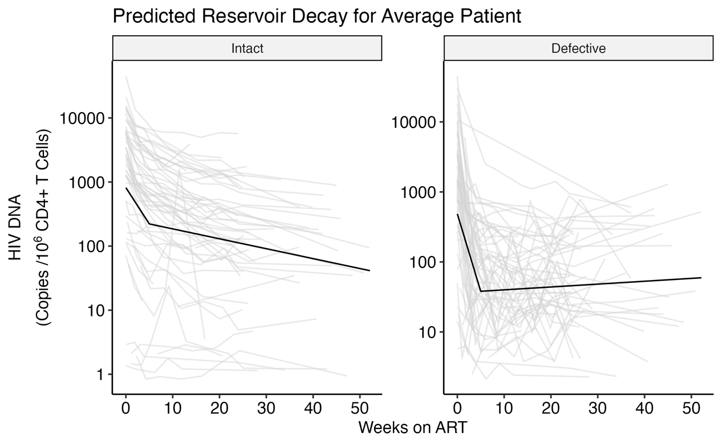

**b.**

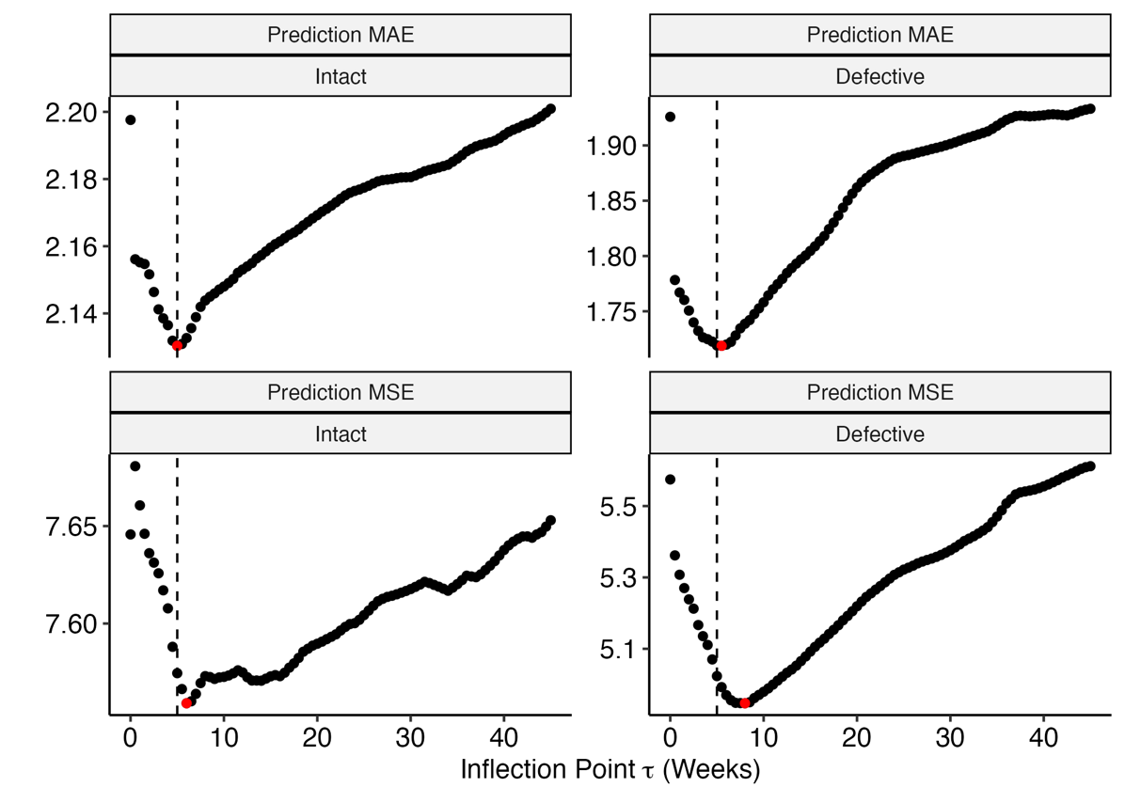

**Supplementary Figure 8. Inflection point sensitivity analyses demonstrate some variability when excluding populations of potential outliers.** To test whether the final model inflection point selection of t = 5 weeks was influenced by potential outlier data we performed t estimation on three clinically interesting sub-populations. Separate models were fit that excluded (a) participants reporting prior PrEP use (<10 days overlap between last PrEP use and estimated date of detected HIV infection), (b) participants with plasma viral load “blips” (defined as a one-time viral load >1000 copies/mL or two consecutive viral loads >100 copies/mL between weeks 0-24), and (c) participants with sudden increases in HIV intact DNA (defined as >50% increase between two consecutive measurements of HIV intact DNA during weeks 0-24). A regular grid of possible was used (0-26 weeks by half-week) and the leave-one-out cross-validation (LOOCV) mean absolute prediction error (MAE) was computed for each candidate t. The model attaining the best prediction error is denoted with a red point and our selected inflection point (t = 5) is shown with a dashed vertical line. Refer to **Supplementary Table 2** to get the sample size for each sensitivity analysis and to **Supplementary Figure 9** to see which patients are excluded from each sensitivity analysis.

**a.**

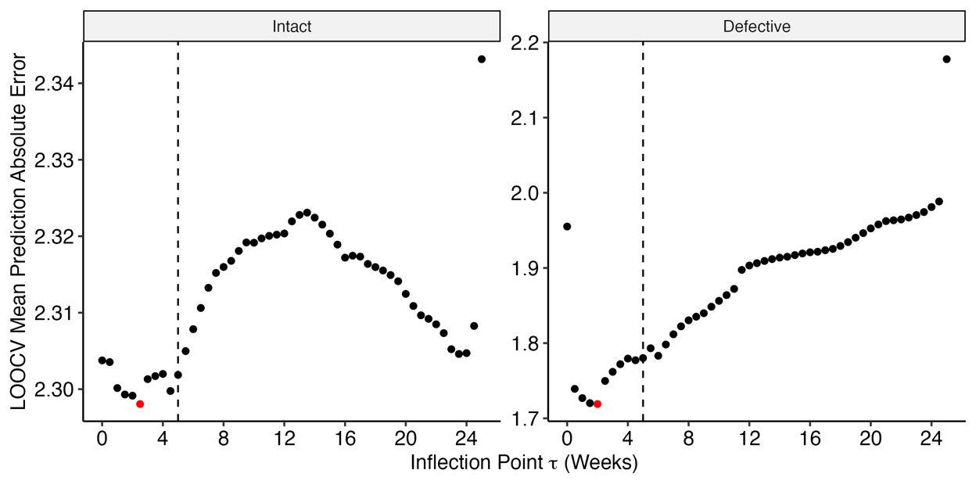

**b.**

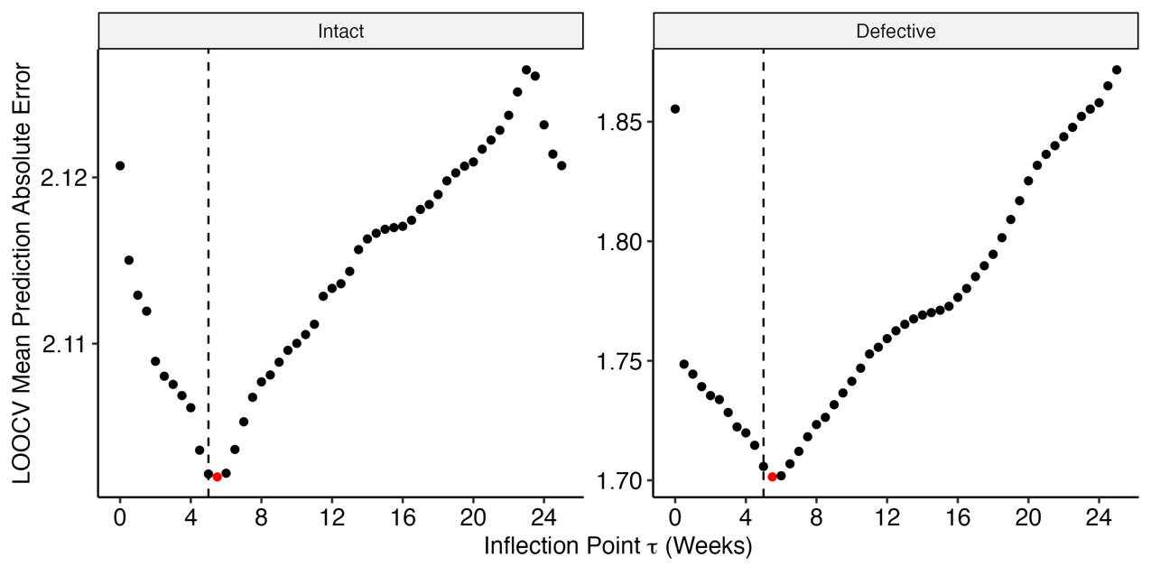

**c.**

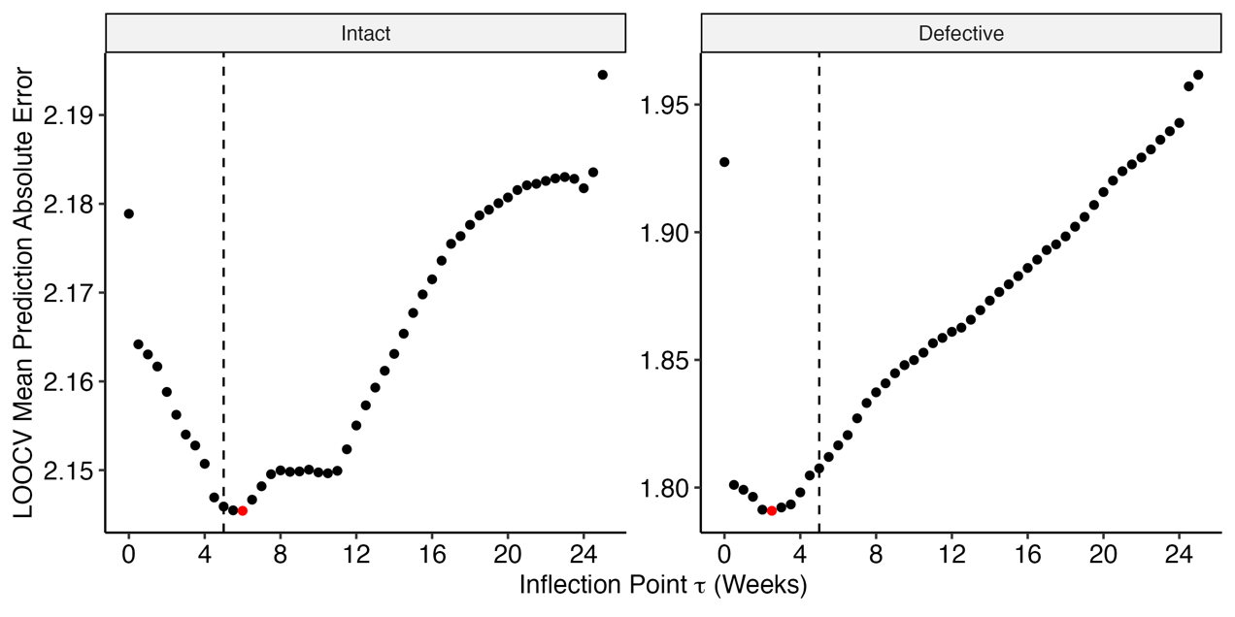

**Supplementary Figure 9. Model estimate sensitivity analyses demonstrated that results were overall unchanged after excluding populations of potential outliers**. The final model (t = 5 weeks) was fit on three clinically interesting sub-populations to assess if the influence of potential outlier data. Separate models were fit that excluded (a) participants reporting prior PrEP use (<10 days overlap between last PrEP use and estimated date of detected HIV infection), (b) participants with plasma viral load “blips” (defined as a one-time viral load >1000 copies/mL or two consecutive viral loads >100 copies/mL between weeks 0-24), and (c) participants with sudden increases in HIV intact DNA (defined as >50% increase between two consecutive measurements of HIV intact DNA during weeks 0-24). Models were fit using the cohort data (grey lines), but not the potential outlier data (red lines). The resulting predict average participant HIV reservoir decay patterns are shown as thick black lines. Refer to **Supplementary Table 2** to get the sample sizes and half-life estimates for each sensitivity analysis.

**a.**

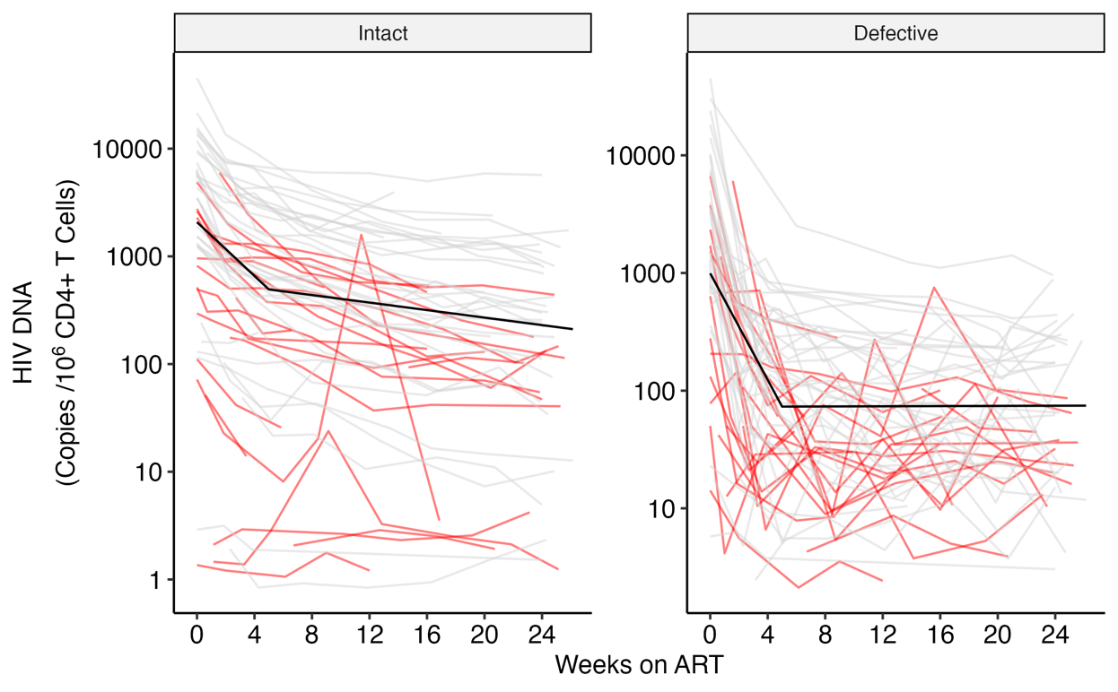

**b.**

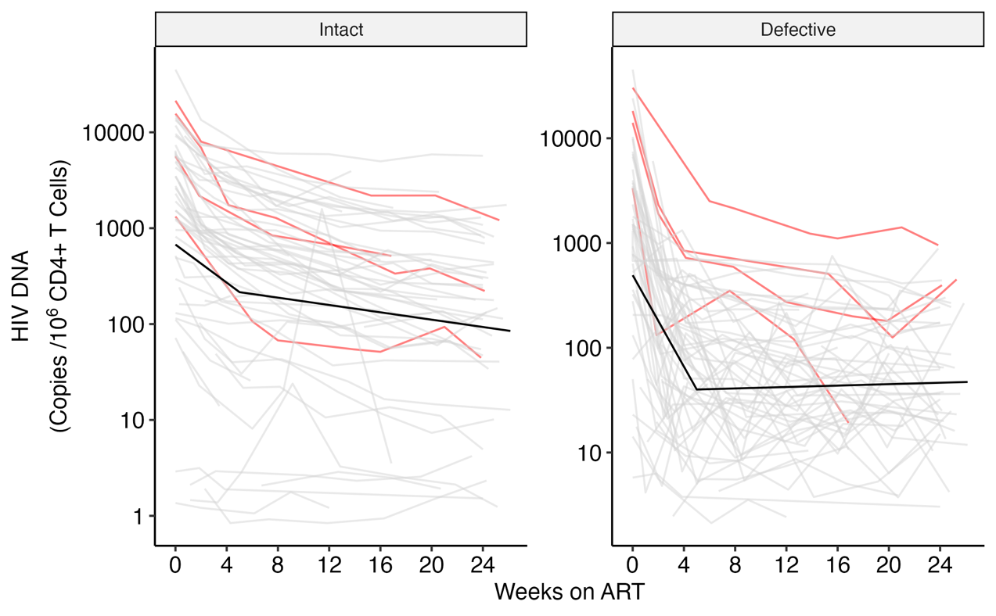

**c.**

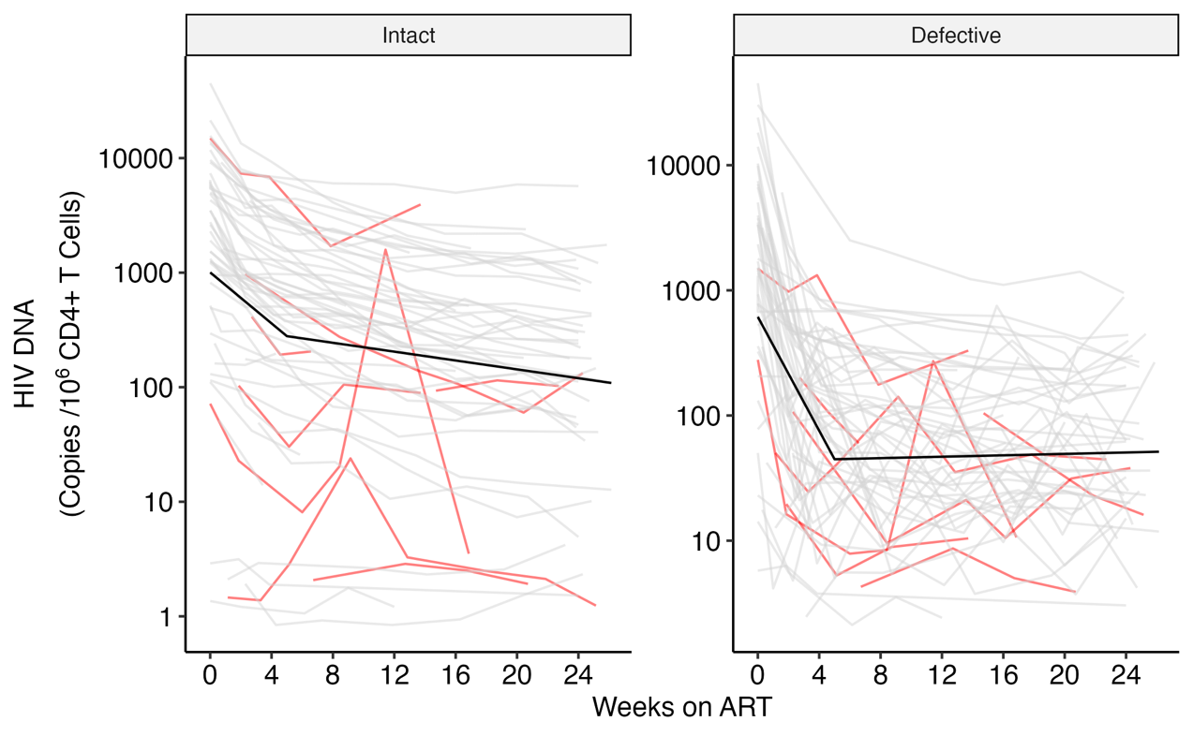

**Supplementary Figure 10.** **Predicted versus observed plots show good model performance for both HIV intact and defective DNA**. Validation for the final models for intact and defective HIV DNA decay was initially performed by looking at the plots of predicted vs observed HIV DNA counts. These plots show that both models produce relatively unbiased estimates across the observed range of HIV DNA counts and that the residual variance in the defective reservoir is much higher than the intact reservoir. A dashed, red line at y=x is added to help interpret the model fits.

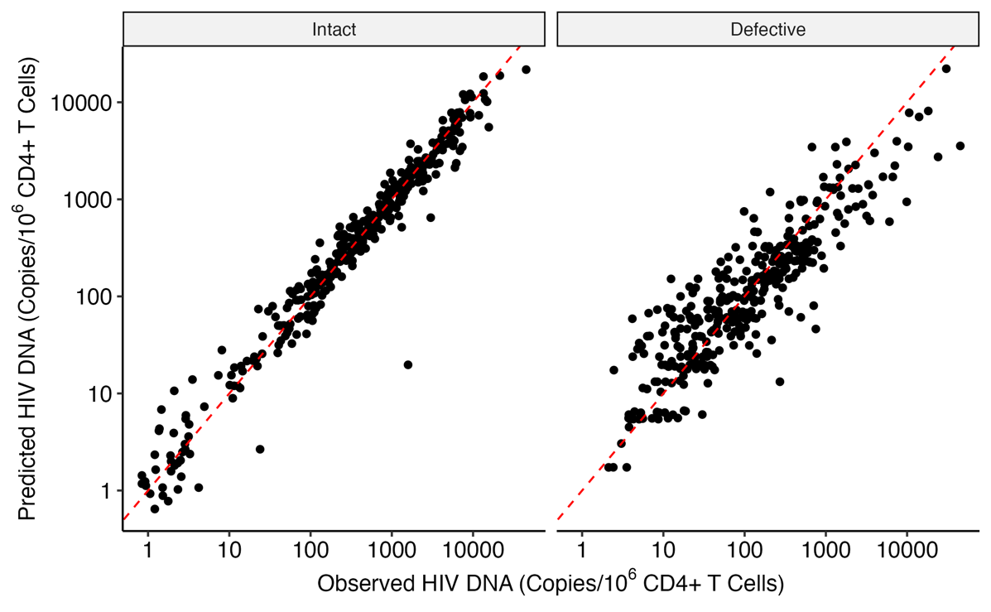

**Supplementary Table 1.** **Model estimates of HIV intact and defective DNA decay rates from baseline models**. Baseline models include random intercepts for each participant but are otherwise unadjusted for clinical covariates. Model estimates are provided for discrete periods of ART suppression after initial treatment initiation: weeks 0 up to t = 5 and for weeks after t.

|  |  |  |  |  |  |  |  |  |
| --- | --- | --- | --- | --- | --- | --- | --- | --- |
| **Time on ART** | **N** | **Estimate** | **SE** | **P** | **Decay Rate per Week (%)** | **Half Life (months)** | **Half Life (lower CI)** | **Half Life**  **(upper CI)** |
| **WEEK 0-24** | 61 |  |  |  |  |  |  |  |
| **Phase 1: 0 to 5 weeks** |  |  |  |  |  |  |  |  |
| **Intact HIV DNA** |  | -0.35659 | 0.02972 | 2.03e-27 | 21.899 | 0.701 | 0.587 | 0.816 |
| **Defective HIV DNA** |  | -0.74453 | 0.05489 | 3.28e-33 | 40.314 | 0.336 | 0.287 | 0.384 |
| **Phase 2: 5 to 24 weeks** |  |  |  |  |  |  |  |  |
| **Intact HIV DNA** |  | -0.06919 | 0.00784 | 8.87e-17 | 4.682 | 3.613 | 2.811 | 4.416 |
| **Defective HIV DNA** |  | 0.00184 | 0.01451 | 8.99e-01 | -0.127 | -136.021 | -2240.950 | 1968.909 |
| **WEEK 0-52** | 61 |  |  |  |  |  |  |  |
| **Phase 1: 0 to 5 weeks** |  |  |  |  |  |  |  |  |
| **Intact HIV DNA** |  | -0.3838 | 0.02803 | 3.22e-34 | 23.357 | 0.651 | 0.558 | 0.745 |
| **Defective HIV DNA** |  | -0.7510 | 0.05122 | 4.55e-38 | 40.582 | 0.333 | 0.288 | 0.377 |
| **Phase 2: 5 to 52 weeks** |  |  |  |  |  |  |  |  |
| **Intact HIV DNA** |  | -0.0539 | 0.00498 | 1.30e-23 | 3.665 | 4.641 | 3.800 | 5.481 |
| **Defective HIV DNA** |  | 0.0102 | 0.00910 | 2.62e-01 | -0.711 | -24.463 | -67.174 | 18.248 |

**Supplementary Table 2.** **Model estimates of HIV intact and defective DNA decay rates from models adjusted for initial CD4+ T cell count, pre-ART HIV RNA, and timing of ART initiation**. Models also include a random intercept for each participant. Model estimates are provided for discrete periods of ART suppression after initial treatment initiation: weeks 0 up to t = 5 and for weeks after t.

|  |  |  |  |  |  |  |  |  |
| --- | --- | --- | --- | --- | --- | --- | --- | --- |
| **Time on ART** | **N** | **Estimate** | **SE** | **P** | **Decay Rate per Week (%)** | **Half Life (months)** | **Half Life (lower CI)** | **Half Life**  **(upper CI)** |
| **WEEK 0-24** | 61 |  |  |  |  |  |  |  |
| **Phase 1: 0 to 5 weeks** |  |  |  |  |  |  |  |  |
| **Intact HIV DNA** |  | -0.3536 | 0.02798 | 1.08E-29 | 21.738 | 0.707 | 0.597 | 0.817 |
| **Defective HIV DNA** |  | -0.7352 | 0.05157 | 8.26E-36 | 39.925 | 0.34 | 0.293 | 0.387 |
| **Phase 2: 5 to 24 weeks** |  |  |  |  |  |  |  |  |
| **Intact HIV DNA** |  | -0.0648 | 0.00742 | 1.63E-16 | 4.394 | 3.857 | 2.992 | 4.722 |
| **Defective HIV DNA** |  | 0.0066 | 0.01370 | 6.32E-01 | -0.456 | -38.102 | -194.078 | 117.874 |
| **WEEK 0-52** | 61 |  |  |  |  |  |  |  |
| **Phase 1: 0 to 5 weeks** |  |  |  |  |  |  |  |  |
| **Intact HIV DNA** |  | -0.3768 | 0.02639 | 2.00E-36 | 23.00 | 0.663 | 0.572 | 0.755 |
| **Defective HIV DNA** |  | -0.7373 | 0.04810 | 1.05E-40 | 40.00 | 0.339 | 0.296 | 0.382 |
| **Phase 2: 5 to 52 weeks** |  |  |  |  |  |  |  |  |
| **Intact HIV DNA** |  | -0.0517 | 0.00470 | 3.06E-24 | 3.52 | 4.837 | 3.975 | 5.698 |
| **Defective HIV DNA** |  | 0.0135 | 0.00856 | 1.17E-01 | -0.94 | -18.582 | -41.768 | 4.604 |
| **Drop PrEP Participants** | 37 |  |  |  |  |  |  |  |
| **Phase 1: 0 to 5 weeks** |  |  |  |  |  |  |  |  |
| **Intact HIV DNA** |  | -0.4269 | 0.02469 | 1.37E-41 | 25.6 | 0.586 | 0.519 | 0.652 |
| **Defective HIV DNA** |  | -0.7816 | 0.06100 | 6.02E-28 | 41.8 | 0.320 | 0.271 | 0.369 |
| **Phase 2: 5 to 24 weeks** |  |  |  |  |  |  |  |  |
| **Intact HIV DNA** |  | -0.0618 | 0.00639 | 1.99E-18 | 4.20 | 4.04 | 3.22 | 4.86 |
| **Defective HIV DNA** |  | 0.000852 | 0.01582 | 9.57E-01 | -0.0591 | -293 | -11000 | 10400 |
| **Drop Plasma VL Blip People** | 57 |  |  |  |  |  |  |  |
| **Phase 1: 0 to 5 weeks** |  |  |  |  |  |  |  |  |
| **Intact HIV DNA** |  | -0.3330 | 0.02934 | 7.78E-25 | 20.61 | 0.751 | 0.621 | 0.880 |
| **Defective HIV DNA** |  | -0.7367 | 0.05473 | 2.26E-32 | 39.99 | 0.339 | 0.290 | 0.389 |
| **Phase 2: 5 to 24 weeks** |  |  |  |  |  |  |  |  |
| **Intact HIV DNA** |  | -0.0652 | 0.00773 | 1.68E-15 | 4.42 | 3.832 | 2.942 | 4.722 |
| **Defective HIV DNA** |  | 0.0111 | 0.01447 | 4.45E-01 | -0.77 | -22.604 | -80.56 | 35.36 |
| **Drop Increasing in Intact DNA after 4 weeks** | 54 |  |  |  |  |  |  |  |
| **Phase 1: 0 to 5 weeks** |  |  |  |  |  |  |  |  |
| **Intact HIV DNA** |  | -0.37096 | 0.02249 | 8.85E-43 | 22.67 | 0.674 | 0.594 | 0.754 |
| **Defective HIV DNA** |  | -0.75976 | 0.05451 | 8.25E-34 | 40.94 | 0.329 | 0.283 | 0.375 |
| **Phase 2: 5 to 24 weeks** |  |  |  |  |  |  |  |  |
| **Intact HIV DNA** |  | -0.06483 | 0.00603 | 1.05E-22 | 4.39 | 3.856 | 3.153 | 4.559 |
| **Defective HIV DNA** |  | 0.00915 | 0.01464 | 5.33E-01 | -0.636 | -27.321 | -113.012 | 58.370 |

**Supplementary Table 3.** **Changes in HIV decay rates of intact and defective DNA associated with timing of ART initiation**. Faster decay rates in both intact and defective HIV DNA during phase 1 are associated with lower delay in ART initiation. Intact, but not defective, HIV DNA have faster predicted decay rates associated with lower delay in ART initiation.

|  |  |  |  |  |  |
| --- | --- | --- | --- | --- | --- |
|  | **N** | **Change in Half-Life (Months) for each Week Delay in ART Initiation** | **Change in Half-Life (lower CI)** | **Change in Half-Life (upper CI)** | **p** |
| **Timing of ART** | 61 |  |  |  |  |
| **Phase 1: 0 to 5 weeks** |  |  |  |  |  |
| **Intact HIV DNA** |  | 0.0207 | 0.00507 | 0.0363 | 9.40E-3 |
| **Defective HIV DNA** |  | 0.0145 | 0.00781 | 0.0212 | 2.12E-5 |
| **Phase 2: 5 to 24 weeks** |  |  |  |  |  |
| **Intact HIV DNA** |  | 0.269 | 0.0790 | 0.460 | 5.55E-3 |
| **Defective HIV DNA** |  | 6.42 | -5.01 | 62.9 | 8.24E-1 |

**Supplementary Table 4.** **Changes in the intact and defective HIV DNA reservoir size associated with initial CD4+ T cell count and pre-ART viral load**. Table values are log10 adjustments to the viral reservoir size at each clinical parameter. Higher initial CD4+ T cell count and lower pre-ART viral load are associated with smaller viral reservoirs. Additional estimates can be taken from **Figure 3**.

|  |  |  |  |  |  |  |
| --- | --- | --- | --- | --- | --- | --- |
|  | **N** | **Clinical Value** | **Estimated Reservoir Adjustment** | **SE** | **Estimate (lower CI)** | **Estimate (upper CI)** |
| **Initial CD4+ Count** | 61 |  |  |  |  |  |
| **Intact Provirus Model** |  |  |  |  |  |  |
| **25th percentile** |  | 350 | 1.897 | 0.803 | 0.324 | 3.471 |
| **50th percentile** |  | 505 | -0.050 | 0.025 | -0.099 | -0.001 |
| **75th percentile** |  | 664 | -2.044 | 0.865 | -3.739 | -0.349 |
| **Defective Provirus Model** |  |  |  |  |  |  |
| **25th percentile** |  | 350 | 1.263 | 0.543 | 0.199 | 2.327 |
| **50th percentile** |  | 505 | -0.144 | 0.258 | -0.649 | 0.362 |
| **75th percentile** |  | 664 | -1.445 | 0.625 | -2.670 | -0.220 |
| **Log10 Pre-ART Viral Load** | 61 |  |  |  |  |  |
| **Intact Provirus Model** |  |  |  |  |  |  |
| **25th percentile** |  | 3.78 | -4.116 | 0.748 | -5.582 | -2.650 |
| **50th percentile** |  | 4.86 | 0.099 | 0.025 | 0.050 | 0.148 |
| **75th percentile** |  | 5.67 | 3.266 | 0.594 | 2.103 | 4.430 |
| **Defective Provirus Model** |  |  |  |  |  |  |
| **25th percentile** |  | 3.78 | -3.711 | 0.878 | -5.432 | -1.991 |
| **50th percentile** |  | 4.86 | -0.762 | 0.571 | -1.880 | 0.356 |
| **75th percentile** |  | 5.67 | 2.150 | 0.572 | 1.029 | 3.270 |