Supplementary Information for Machine Learning Models for the Prediction of Early-Onset Bipolar Using Electronic Health Records

Bo Wang, PhD^{a,b,c,d}, Yi-Han Sheu, MD, ScD^{a,b,c,d}, Hyunjoon Lee, MS^{e}, Robert G. Mealer, MD, PhD^{f}, Victor M. Castro, MS^{g}, Jordan W. Smoller, MD, ScD^{a,b,c,d*}

Appendix A1: ICCBD Coded-Broad definition for early onset bipolar disorder.

Appendix A2: Definition of mental health visit.

Appendix A3: Definition of mood disorder and ADHD.

Appendix B: NLP feature extraction.

Appendix C: Model implementation details.

Supplementary Table 1: Full model performance comparison among 7 models, for the general patient cohort.

Supplementary Table 2: Full model performance comparison among 7 models, for the mental healthcare cohort.

Supplementary Table 3: Full model performance comparison among 7 models, for the mood disorder/ADHD cohort.

Supplementary Figure 1: Full data processing and cohort building chart flow.

Supplementary Figure 2: Cumulative gain charts.

Supplementary Figure 3: Model metrics of Random Forest-full (RF-full) using 2-year prediction window, stratified by patients’ age at the landmark visit.

Supplementary Figure 4: Model metrics of RF-full using 2-year prediction window, stratified by number of visits each patient had before their “landmark visits”.

Supplementary Figure 5: Model metrics of RF-full using 2-year prediction window, stratified by gender (i.e., male vs. female).

Supplementary Figure 6: Model metrics of RF-full using 2-year prediction window, stratified by race (i.e., white vs. non-white).

Supplementary Figure 7: SHAP summary plots of the top-10 features with 6 months prediction window, for (a) the general patient cohorts, (b) the mental healthcare cohort, and (c) the mood disorder/ADHD cohort.

Supplementary Figure 8: SHAP summary plots of the top-10 features with 1-year prediction window, for (a) the general patient cohorts, (b) the mental healthcare cohort, and (c) the mood disorder/ADHD cohort.

Supplementary Figure 9: SHAP summary plots of the top-10 features with 3-year prediction window, for (a) the general patient cohorts, (b) the mental healthcare cohort, and (c) the mood disorder/ADHD cohort.

Supplementary Figure 10: Model performance comparison between the original RF model and the light-weight models, with 6 months prediction window.

Supplementary Figure 11: Model performance comparison between the original RF model and the light-weight models, with 1-year prediction window.

Supplementary Figure 12: Model performance comparison between the original RF model and the light-weight models, with 3-year prediction window.

Appendix A: Various definitions

A.1 ICCBD Coded-Broad definition for early onset BD
ICCBD Coded-Broad definition for early onset BD has a data floor – each patient must have at least 3 inpatient, outpatient, or emergency visits over a minimum 180-day window from the first to the last visit.
- For those who later developed early-onset BD (cases): the “last visit” is their first BD diagnosis (i.e., index visit) before age 25.
- For the others: the “last visit” is their last diagnosis date in the EHR before age 25.

The original ICCBD Coded-Broad case/control definitions are:
- Case definition:
  - History of:
    - >=2 BD diagnoses (at separate visits >1 month apart).
    - No major depressive disorder (MDD), schizophrenia (SCZ), schizoaffective disorder (SZA), or organic affective syndrome (OAS) diagnoses unless 2 most recent diagnoses are BD; or number of MDD, SCZ, SZA, or OAS diagnoses is greater (>50%) than number of BD diagnoses.
    - >=2 BD medication instances (lithium, valproic acid, risperidone, olanzapine, quetiapine, ziprasidone, aripiprazole, carbamazepine, or lamotrigine) within 1 year of a BD diagnosis.
- Control definition:
  - Absence of case status.
  - Meets the minimum data floor as above.

A.2 Definition of mental health visit
Mental health visits are defined using the ICD codes below:
- ICD-9 290-316 codes
- ICD-10 F codes

A.3 Definition of mood disorder and ADHD
Mood disorder excluding bipolar disorder is defined using the ICD codes below:
- ICD-9 262.2
- ICD-9 262.20
- ICD-9 262.21
- ICD-9 262.22
- ICD-9 262.23
- ICD-9 262.24
- ICD-9 262.25
- ICD-9 262.26
- ICD-9 262.3
- ICD-9 262.30
- ICD-9 262.31
- ICD-9 262.32
- ICD-9 262.33
- ICD-9 262.34
- ICD-9 262.35
- ICD-9 262.36
- ICD-9 311
- ICD-9 300.4
- ICD-9 296.9
- ICD-9 296.90
- ICD-9 296.99
- ICD-10 F32.0
- ICD-10 F32.1
- ICD-10 F32.2
- ICD-10 F32.3
- ICD-10 F32.4
- ICD-10 F32.5
- ICD-10 F32.8
- ICD-10 F32.81
- ICD-10 F32.9
- ICD-10 F32.A
- ICD-10 F33.0
- ICD-10 F33.1
- ICD-10 F33.2
- ICD-10 F33.3
- ICD-10 F33.4
- ICD-10 F33.40
- ICD-10 F33.41
- ICD-10 F33.42
- ICD-10 F33.8
- ICD-10 F33.9
- ICD-10 F34.1
- ICD-10 F34.8
- ICD-10 F34.81
- ICD-10 F34.89
- ICD-10 F34.9

ADHD is defined using the ICD codes below:
- ICD-9 314
- ICD-9 314.0
- ICD-9 314.00
- ICD-9 314.01
- ICD-9 314.1
- ICD-9 314.2
- ICD-9 314.8
- ICD-9 314.9
- ICD-10 F90.0
- ICD-10 F90.1
- ICD-10 F90.2
- ICD-10 F90.8
- ICD-10 F90.9

Appendix B: NLP feature extraction
The rule-based system is based on a custom lexicon of mental health related concepts using a variety of approaches: (1) selecting relevant semantic types from the Unified Medical Language System (UMLS)¹¹; (2) mapping of Diagnostic and Statistical Manual of Mental Disorders (DSM) symptoms and concepts from structured instruments³⁹; (3) applying automated feature extraction from public sources including Wikipedia and MedScape; (4) incorporating Research Domain Criteria (RDoC) domain matrix terms⁴⁰; (5) selecting predictive features from coded suicide attempt prediction models¹⁵; (6) manual annotation terms by clinical reviewers. Using this lexicon, we ran the HiTex⁴¹ NLP named entity extraction (NER) pipeline to identify concepts in over 120 million clinical notes and applied the ConText algorithm⁴² for negation and family history recognition.

Appendix C: Model implementation details
We used the scikit-learn⁴³ implementation of LR and NBC, the Python library imblearn⁴⁴ for a balanced random forest classifier, and the original Python implementation lightgbm for LGBM. We implemented MLP and W&D using the Python deep learning library, keras, and adopted a PyTorch implementation of TabNet (https://github.com/dreamquark-ai/tabnet). Hyperparameter tuning was performed using Optuna⁴⁵ with 100 trials for each model.

All models were trained and tested on a dedicated Windows 10 server running with 8-core Intel Xeon W-2145 CPU @ 3.70GHz and 16 logical processors, 512 GB of memory (RAM) and a RTX 2080 Ti.

Supplementary Materials

Supplementary Table 1. Full model performance comparison among 7 models, for the general patient cohort.

6 months prediction window (prevalence = 0.11%)
Model | 80% spec. |  | 90% spec. |  | 95% spec. |  | AUROC
LogReg | PPV | 0.003 | PPV | 0.005 | PPV | 0.006 | 0.768
 | Sen. | 0.597 | Sen. | 0.494 | Sen. | 0.299
NBC | PPV | 0.003 | PPV | 0.005 | PPV | 0.009 | 0.812
 | Sen. | 0.714 | Sen. | 0.519 | Sen. | 0.429
RF | PPV | 0.004 | PPV | 0.007 | PPV | 0.010 | 0.873
 | Sen. | 0.805 | Sen. | 0.688 | Sen. | 0.532
LGBM | PPV | 0.004 | PPV | 0.006 | PPV | 0.010 | 0.845
 | Sen. | 0.779 | Sen. | 0.597 | Sen. | 0.506
MLP | PPV | 0.003 | PPV | 0.005 | PPV | 0.008 | 0.775
 | Sen. | 0.610 | Sen. | 0.506 | Sen. | 0.364
W&D | PPV | 0.003 | PPV | 0.005 | PPV | 0.006 | 0.753
 | Sen. | 0.571 | Sen. | 0.468 | Sen. | 0.286
TabNet | PPV | 0.004 | PPV | 0.006 | PPV | 0.009 | 0.806
 | Sen. | 0.753 | Sen. | 0.571 | Sen. | 0.442
1 year prediction window (prevalence = 0.16%)
Model | 80% spec. |  | 90% spec. |  | 95% spec. |  | AUROC
LogReg | PPV | 0.004 | PPV | 0.006 | PPV | 0.010 | 0.767
 | Sen. | 0.556 | Sen. | 0.435 | Sen. | 0.398
NBC | PPV | 0.005 | PPV | 0.008 | PPV | 0.010 | 0.799
 | Sen. | 0.630 | Sen. | 0.519 | Sen. | 0.343
RF | PPV | 0.006 | PPV | 0.010 | PPV | 0.015 | 0.880
 | Sen. | 0.833 | Sen. | 0.676 | Sen. | 0.481
LGBM | PPV | 0.006 | PPV | 0.010 | PPV | 0.014 | 0.886
 | Sen. | 0.852 | Sen. | 0.694 | Sen. | 0.509
MLP | PPV | 0.005 | PPV | 0.006 | PPV | 0.009 | 0.762
 | Sen. | 0.593 | Sen. | 0.417 | Sen. | 0.287
W&D | PPV | 0.004 | PPV | 0.006 | PPV | 0.009 | 0.723
 | Sen. | 0.556 | Sen. | 0.398 | Sen. | 0.306
TabNet | PPV | 0.006 | PPV | 0.007 | PPV | 0.013 | 0.807
 | Sen. | 0.713 | Sen. | 0.500 | Sen. | 0.435
2 years prediction window (prevalence = 0.23%)
Model | 80% spec. |  | 90% spec. |  | 95% spec. |  | AUROC
LogReg | PPV | 0.006 | PPV | 0.010 | PPV | 0.014 | 0.738
 | Sen. | 0.569 | Sen. | 0.451 | Sen. | 0.257
NBC | PPV | 0.006 | PPV | 0.010 | PPV | 0.011 | 0.717
 | Sen. | 0.549 | Sen. | 0.451 | Sen. | 0.257
RF | PPV | 0.008 | PPV | 0.014 | PPV | 0.021 | 0.833
 | Sen. | 0.771 | Sen. | 0.653 | Sen. | 0.472
LGBM | PPV | 0.008 | PPV | 0.014 | PPV | 0.018 | 0.802
 | Sen. | 0.694 | Sen. | 0.618 | Sen. | 0.417
MLP | PPV | 0.007 | PPV | 0.009 | PPV | 0.012 | 0.751
 | Sen. | 0.583 | Sen. | 0.444 | Sen. | 0.278
W&D | PPV | 0.006 | PPV | 0.009 | PPV | 0.012 | 0.730
 | Sen. | 0.549 | Sen. | 0.403 | Sen. | 0.278
TabNet | PPV | 0.007 | PPV | 0.011 | PPV | 0.014 | 0.765
 | Sen. | 0.667 | Sen. | 0.500 | Sen. | 0.333
3 years prediction window (prevalence = 0.28%)
Model | 80% spec. |  | 90% spec. |  | 95% spec. |  | AUROC
LogReg | PPV | 0.008 | PPV | 0.011 | PPV | 0.017 | 0.741
 | Sen. | 0.564 | Sen. | 0.411 | Sen. | 0.307
NBC | PPV | 0.008 | PPV | 0.010 | PPV | 0.013 | 0.704
 | Sen. | 0.540 | Sen. | 0.380 | Sen. | 0.233
RF | PPV | 0.009 | PPV | 0.015 | PPV | 0.022 | 0.801
 | Sen. | 0.663 | Sen. | 0.546 | Sen. | 0.411
LGBM | PPV | 0.009 | PPV | 0.015 | PPV | 0.022 | 0.793
 | Sen. | 0.650 | Sen. | 0.534 | Sen. | 0.411
MLP | PPV | 0.008 | PPV | 0.011 | PPV | 0.014 | 0.711
 | Sen. | 0.540 | Sen. | 0.387 | Sen. | 0.252
W&D | PPV | 0.007 | PPV | 0.009 | PPV | 0.013 | 0.701
 | Sen. | 0.521 | Sen. | 0.344 | Sen. | 0.245
TabNet | PPV | 0.008 | PPV | 0.012 | PPV | 0.019 | 0.738
 | Sen. | 0.601 | Sen. | 0.454 | Sen. | 0.374

Supplementary Table 2. Full model performance comparison among 7 models, for the mental healthcare cohort.

6 months prediction window (prevalence = 0.40%)
Model | 80% spec. |  | 90% spec. |  | 95% spec. |  | AUROC
LogReg | PPV | 0.005 | PPV | 0.006 | PPV | 0.007 | 0.652
 | Sen. | 0.377 | Sen. | 0.195 | Sen. | 0.143
NBC | PPV | 0.006 | PPV | 0.006 | PPV | 0.007 | 0.659
 | Sen. | 0.377 | Sen. | 0.221 | Sen. | 0.117
RF | PPV | 0.009 | PPV | 0.012 | PPV | 0.014 | 0.777
 | Sen. | 0.610 | Sen. | 0.429 | Sen. | 0.247
LGBM | PPV | 0.008 | PPV | 0.011 | PPV | 0.016 | 0.758
 | Sen. | 0.571 | Sen. | 0.377 | Sen. | 0.273
MLP | PPV | 0.005 | PPV | 0.006 | PPV | 0.006 | 0.624
 | Sen. | 0.364 | Sen. | 0.208 | Sen. | 0.091
W&D | PPV | 0.005 | PPV | 0.005 | PPV | 0.005 | 0.637
 | Sen. | 0.364 | Sen. | 0.156 | Sen. | 0.078
TabNet | PPV | 0.007 | PPV | 0.007 | PPV | 0.007 | 0.720
 | Sen. | 0.468 | Sen. | 0.247 | Sen. | 0.117
1 year prediction window (prevalence = 0.58%)
Model | 80% spec. |  | 90% spec. |  | 95% spec. |  | AUROC
LogReg | PPV | 0.011 | PPV | 0.015 | PPV | 0.021 | 0.716
 | Sen. | 0.500 | Sen. | 0.364 | Sen. | 0.245
NBC | PPV | 0.011 | PPV | 0.015 | PPV | 0.018 | 0.726
 | Sen. | 0.509 | Sen. | 0.345 | Sen. | 0.209
RF | PPV | 0.015 | PPV | 0.019 | PPV | 0.022 | 0.796
 | Sen. | 0.709 | Sen. | 0.445 | Sen. | 0.255
LGBM | PPV | 0.014 | PPV | 0.021 | PPV | 0.027 | 0.785
 | Sen. | 0.645 | Sen. | 0.482 | Sen. | 0.309
MLP | PPV | 0.010 | PPV | 0.012 | PPV | 0.018 | 0.692
 | Sen. | 0.473 | Sen. | 0.300 | Sen. | 0.209
W&D | PPV | 0.011 | PPV | 0.012 | PPV | 0.015 | 0.692
 | Sen. | 0.473 | Sen. | 0.282 | Sen. | 0.164
TabNet | PPV | 0.011 | PPV | 0.014 | PPV | 0.019 | 0.710
 | Sen. | 0.500 | Sen. | 0.327 | Sen. | 0.218
2 years prediction window (prevalence = 0.73%)
Model | 80% spec. |  | 90% spec. |  | 95% spec. |  | AUROC
LogReg | PPV | 0.011 | PPV | 0.015 | PPV | 0.016 | 0.660
 | Sen. | 0.400 | Sen. | 0.254 | Sen. | 0.138
NBC | PPV | 0.010 | PPV | 0.012 | PPV | 0.009 | 0.647
 | Sen. | 0.354 | Sen. | 0.231 | Sen. | 0.077
RF | PPV | 0.016 | PPV | 0.018 | PPV | 0.026 | 0.761
 | Sen. | 0.546 | Sen. | 0.308 | Sen. | 0.231
LGBM | PPV | 0.016 | PPV | 0.021 | PPV | 0.025 | 0.750
 | Sen. | 0.546 | Sen. | 0.377 | Sen. | 0.231
MLP | PPV | 0.009 | PPV | 0.011 | PPV | 0.016 | 0.648
 | Sen. | 0.331 | Sen. | 0.200 | Sen. | 0.146
W&D | PPV | 0.010 | PPV | 0.010 | PPV | 0.012 | 0.626
 | Sen. | 0.338 | Sen. | 0.177 | Sen. | 0.100
TabNet | PPV | 0.013 | PPV | 0.017 | PPV | 0.021 | 0.670
 | Sen. | 0.446 | Sen. | 0.292 | Sen. | 0.192
3 years prediction window (prevalence = 0.89%)
Model | 80% spec. |  | 90% spec. |  | 95% spec. |  | AUROC
LogReg | PPV | 0.019 | PPV | 0.024 | PPV | 0.030 | 0.723
 | Sen. | 0.528 | Sen. | 0.347 | Sen. | 0.222
NBC | PPV | 0.016 | PPV | 0.018 | PPV | 0.024 | 0.687
 | Sen. | 0.458 | Sen. | 0.257 | Sen. | 0.174
RF | PPV | 0.021 | PPV | 0.032 | PPV | 0.045 | 0.808
 | Sen. | 0.597 | Sen. | 0.458 | Sen. | 0.333
LGBM | PPV | 0.022 | PPV | 0.030 | PPV | 0.043 | 0.790
 | Sen. | 0.611 | Sen. | 0.438 | Sen. | 0.319
MLP | PPV | 0.016 | PPV | 0.020 | PPV | 0.023 | 0.696
 | Sen. | 0.458 | Sen. | 0.319 | Sen. | 0.167
W&D | PPV | 0.017 | PPV | 0.018 | PPV | 0.021 | 0.700
 | Sen. | 0.472 | Sen. | 0.264 | Sen. | 0.153
TabNet | PPV | 0.019 | PPV | 0.025 | PPV | 0.031 | 0.758
 | Sen. | 0.549 | Sen. | 0.347 | Sen. | 0.222

Supplementary Table 3. Full model performance comparison among 7 models, for the mood disorder/ADHD cohort.

6 months prediction window (prevalence = 0.40%)
Model | 80% spec. |  | 90% spec. |  | 95% spec. |  | AUROC
LogReg | PPV | 0.007 | PPV | 0.009 | PPV | 0.009 | 0.635
 | Sen. | 0.412 | Sen. | 0.235 | Sen. | 0.118
NBC | PPV | 0.007 | PPV | 0.010 | PPV | 0.008 | 0.654
 | Sen. | 0.353 | Sen. | 0.265 | Sen. | 0.118
RF | PPV | 0.012 | PPV | 0.013 | PPV | 0.021 | 0.791
 | Sen. | 0.676 | Sen. | 0.382 | Sen. | 0.324
LGBM | PPV | 0.014 | PPV | 0.016 | PPV | 0.023 | 0.774
 | Sen. | 0.706 | Sen. | 0.412 | Sen. | 0.294
MLP | PPV | 0.005 | PPV | 0.007 | PPV | 0.010 | 0.605
 | Sen. | 0.294 | Sen. | 0.235 | Sen. | 0.176
W&D | PPV | 0.005 | PPV | 0.005 | PPV | 0.007 | 0.603
 | Sen. | 0.265 | Sen. | 0.118 | Sen. | 0.088
TabNet | PPV | 0.010 | PPV | 0.010 | PPV | 0.014 | 0.675
 | Sen. | 0.529 | Sen. | 0.353 | Sen. | 0.206
1 year prediction window (prevalence = 0.58%)
Model | 80% spec. |  | 90% spec. |  | 95% spec. |  | AUROC
LogReg | PPV | 0.012 | PPV | 0.016 | PPV | 0.018 | 0.667
 | Sen. | 0.458 | Sen. | 0.292 | Sen. | 0.188
NBC | PPV | 0.013 | PPV | 0.016 | PPV | 0.012 | 0.650
 | Sen. | 0.458 | Sen. | 0.292 | Sen. | 0.188
RF | PPV | 0.018 | PPV | 0.025 | PPV | 0.038 | 0.827
 | Sen. | 0.667 | Sen. | 0.542 | Sen. | 0.354
LGBM | PPV | 0.015 | PPV | 0.021 | PPV | 0.034 | 0.763
 | Sen. | 0.563 | Sen. | 0.417 | Sen. | 0.333
MLP | PPV | 0.011 | PPV | 0.014 | PPV | 0.034 | 0.655
 | Sen. | 0.417 | Sen. | 0.292 | Sen. | 0.146
W&D | PPV | 0.013 | PPV | 0.017 | PPV | 0.022 | 0.668
 | Sen. | 0.458 | Sen. | 0.333 | Sen. | 0.208
TabNet | PPV | 0.015 | PPV | 0.016 | PPV | 0.017 | 0.727
 | Sen. | 0.542 | Sen. | 0.292 | Sen. | 0.146
2 years prediction window (prevalence = 0.73%)
Model | 80% spec. |  | 90% spec. |  | 95% spec. |  | AUROC
LogReg | PPV | 0.016 | PPV | 0.020 | PPV | 0.025 | 0.681
 | Sen. | 0.482 | Sen. | 0.304 | Sen. | 0.196
NBC | PPV | 0.018 | PPV | 0.023 | PPV | 0.017 | 0.686
 | Sen. | 0.500 | Sen. | 0.321 | Sen. | 0.179
RF | PPV | 0.022 | PPV | 0.033 | PPV | 0.043 | 0.800
 | Sen. | 0.643 | Sen. | 0.518 | Sen. | 0.321
LGBM | PPV | 0.018 | PPV | 0.028 | PPV | 0.037 | 0.741
 | Sen. | 0.518 | Sen. | 0.429 | Sen. | 0.286
MLP | PPV | 0.013 | PPV | 0.019 | PPV | 0.020 | 0.638
 | Sen. | 0.411 | Sen. | 0.286 | Sen. | 0.161
W&D | PPV | 0.014 | PPV | 0.021 | PPV | 0.021 | 0.667
 | Sen. | 0.464 | Sen. | 0.357 | Sen. | 0.214
TabNet | PPV | 0.017 | PPV | 0.025 | PPV | 0.025 | 0.691
 | Sen. | 0.500 | Sen. | 0.357 | Sen. | 0.179
3 years prediction window (prevalence = 0.89%)
Model | 80% spec. |  | 90% spec. |  | 95% spec. |  | AUROC
LogReg | PPV | 0.020 | PPV | 0.020 | PPV | 0.027 | 0.693
 | Sen. | 0.446 | Sen. | 0.246 | Sen. | 0.154
NBC | PPV | 0.020 | PPV | 0.021 | PPV | 0.020 | 0.673
 | Sen. | 0.477 | Sen. | 0.246 | Sen. | 0.108
RF | PPV | 0.024 | PPV | 0.028 | PPV | 0.036 | 0.757
 | Sen. | 0.538 | Sen. | 0.323 | Sen. | 0.215
LGBM | PPV | 0.020 | PPV | 0.025 | PPV | 0.026 | 0.747
 | Sen. | 0.462 | Sen. | 0.292 | Sen. | 0.154
MLP | PPV | 0.014 | PPV | 0.019 | PPV | 0.020 | 0.644
 | Sen. | 0.323 | Sen. | 0.215 | Sen. | 0.123
W&D | PPV | 0.018 | PPV | 0.020 | PPV | 0.022 | 0.679
 | Sen. | 0.415 | Sen. | 0.277 | Sen. | 0.169
TabNet | PPV | 0.022 | PPV | 0.024 | PPV | 0.028 | 0.704
 | Sen. | 0.492 | Sen. | 0.292 | Sen. | 0.169

Supplementary Figure 1. Full data processing and cohort building chart flow, showing the steps were taken to go from the original RPDR database to the landmark-sampled data sets. NP: number of patients. NTV: number of total visits. NSV: number of sampled visits. NBD: number of patients who later developed early-onset BD. Note that since we defined the onset of BD between age 10 (inclusive) and 25 (non-inclusive) as the early onset, we required each patient to have at least 1 visit with the addition of the prediction window does not reach the 25th birthday mark.

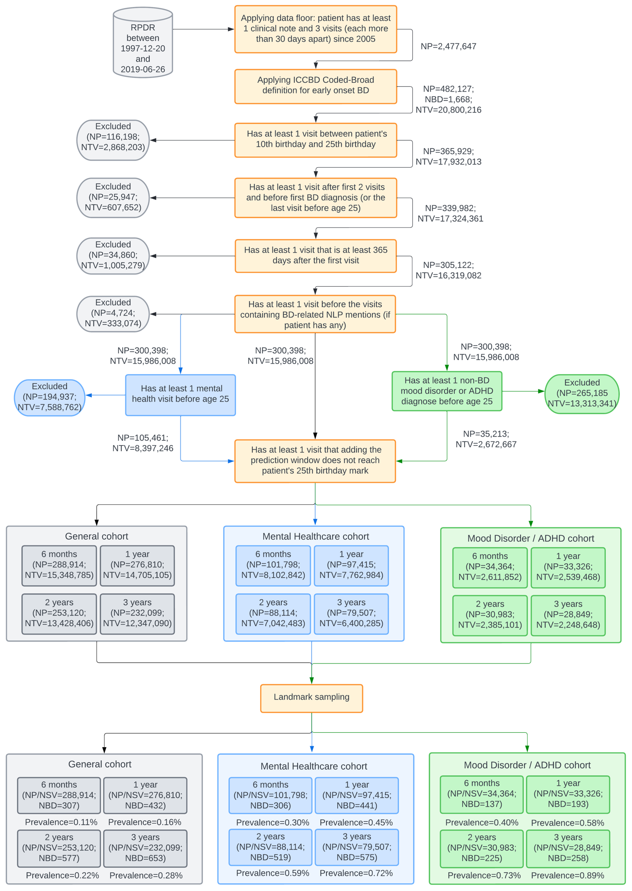

Supplementary Figure 2. Cumulative gain charts for all three cohort groups and four prediction windows. The results are from our Random Forest models. For each sub-plot, the percentage of patients in the test set (x-axis) ranked by the prediction probabilities (from left to right, i.e., from highest-risk quintile to lowest-risk quintile) is plotted against the percentage of early onset of bipolar disorder cases identified in the test set (y-axis). The color of each curve denotes the cohort group (blue: general cohort; green: mental healthcare cohort; orange: mood disorder/ADHD cohort).
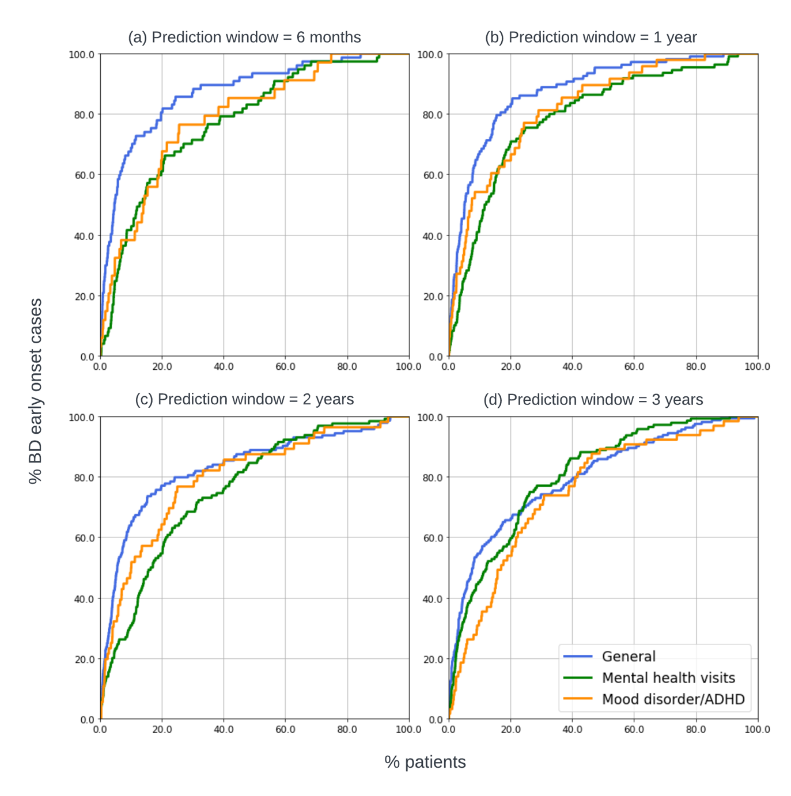

Supplementary Figure 3. Model metrics of RF-full using 2-year prediction window, stratified by patients’ age at the landmark visit.

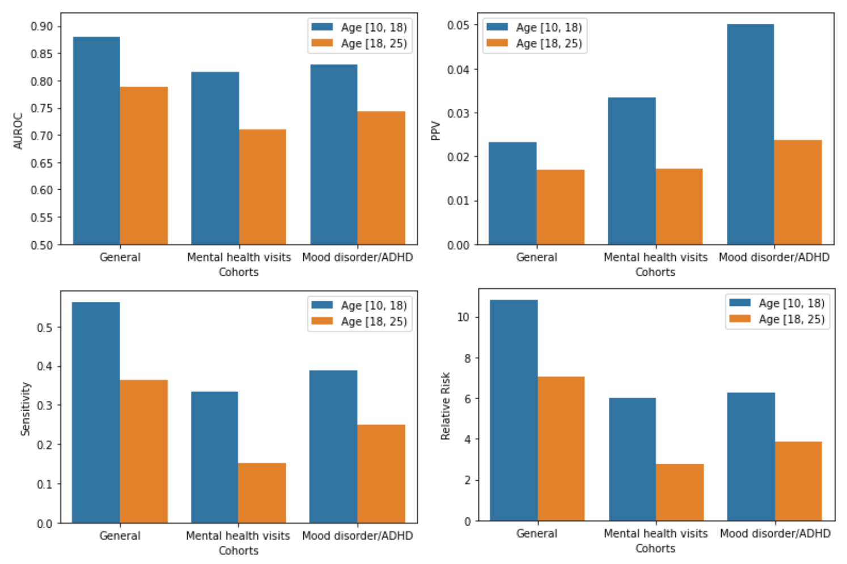

Supplementary Figure 4. Results using 2-year prediction window, stratified by number of visits each patient had before their “landmark visits”.

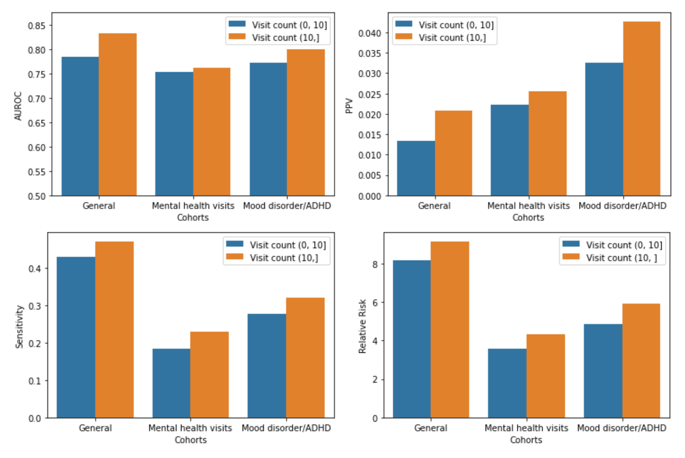

Supplementary Figure 5. Results using 2-year prediction window, stratified by gender (i.e., male vs. female).

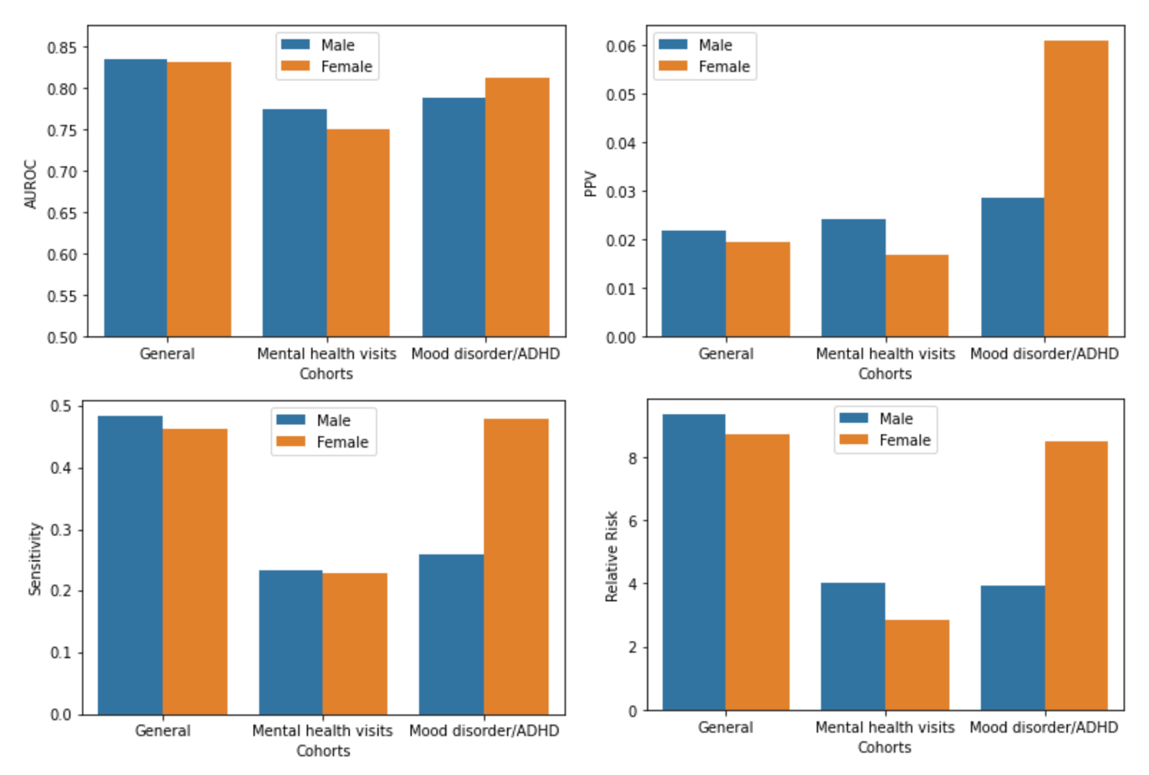

Supplementary Figure 6. Results using 2-year prediction window, stratified by race (i.e., white vs. non-white).

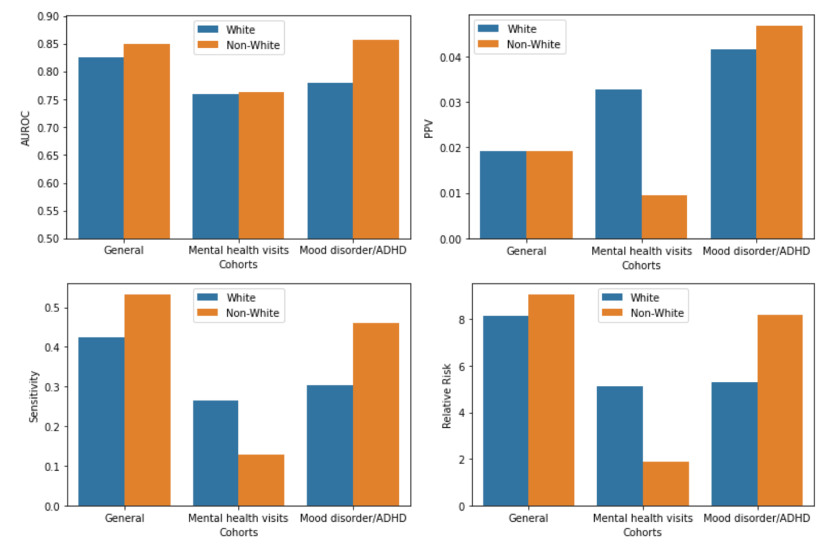

Supplementary Figure 7 (a). SHAP summary plots of the top-10 features for the General patients cohort with 6 months prediction window.

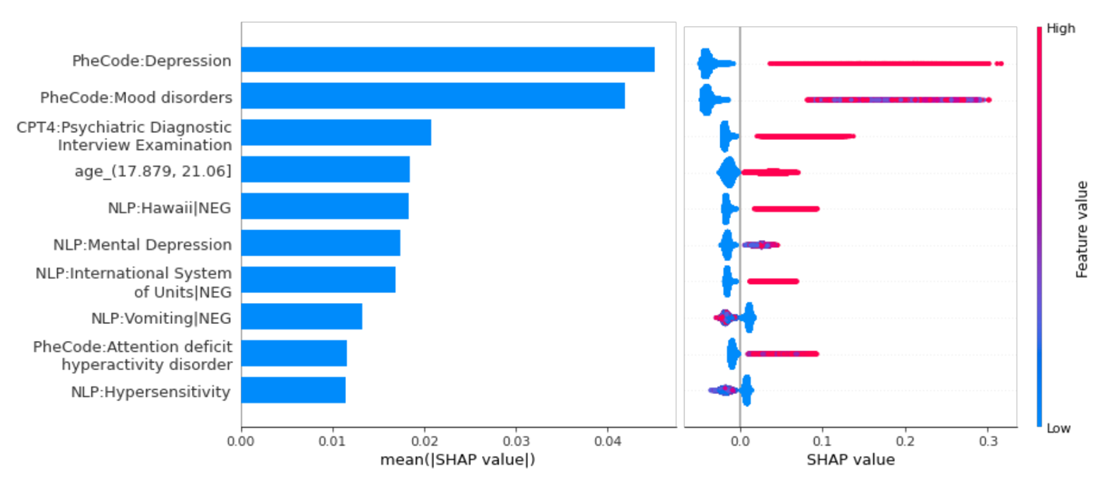

Supplementary Figure 7 (b). SHAP summary plots of the top-10 features for the Mental healthcare cohort with 6 months prediction window.

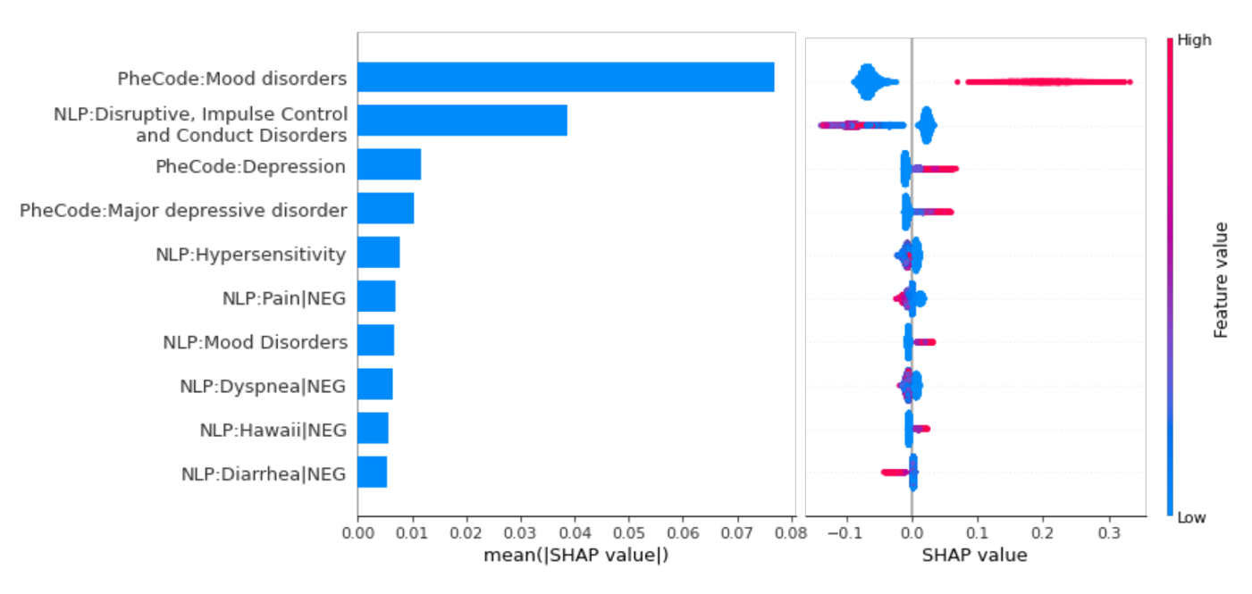

Supplementary Figure 7 (c). SHAP summary plots of the top-10 features for the Mood disorder/ADHD cohort with 6 months prediction window.

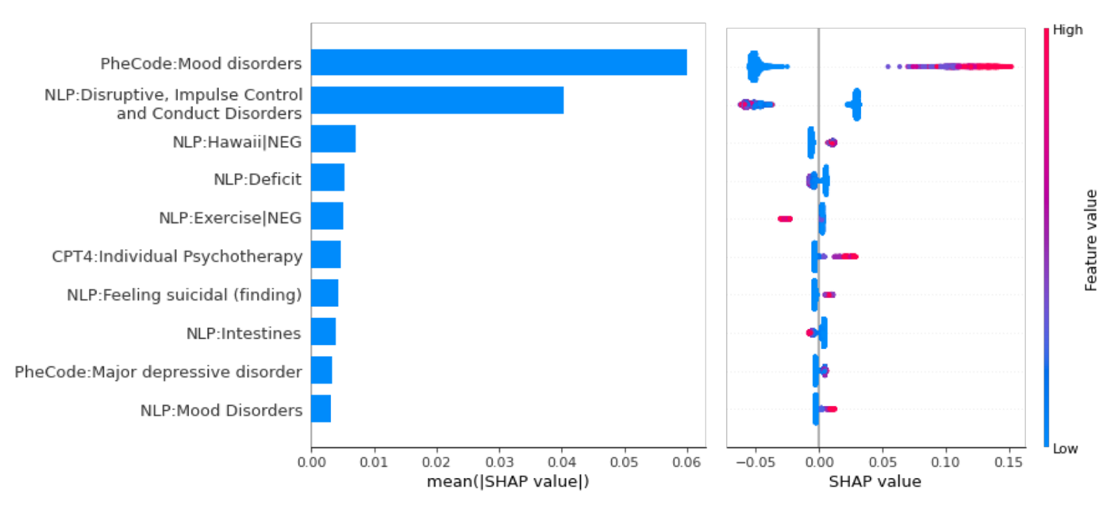

Supplementary Figure 8 (a). SHAP summary plots of the top-10 features for the General patients cohort with 1-year prediction window.

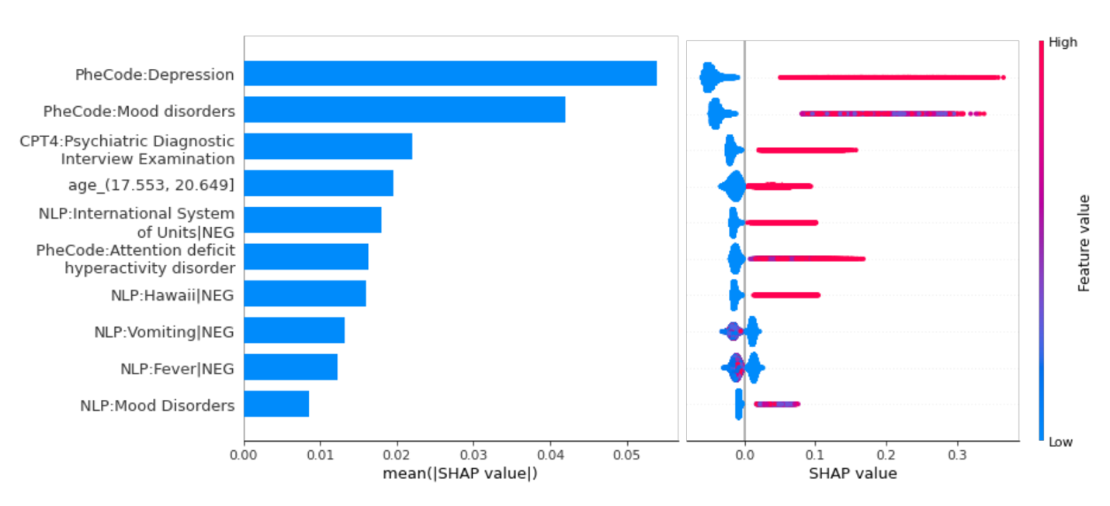

Supplementary Figure 8 (b). SHAP summary plots of the top-10 features for the Mental healthcare cohort with 1-year prediction window.

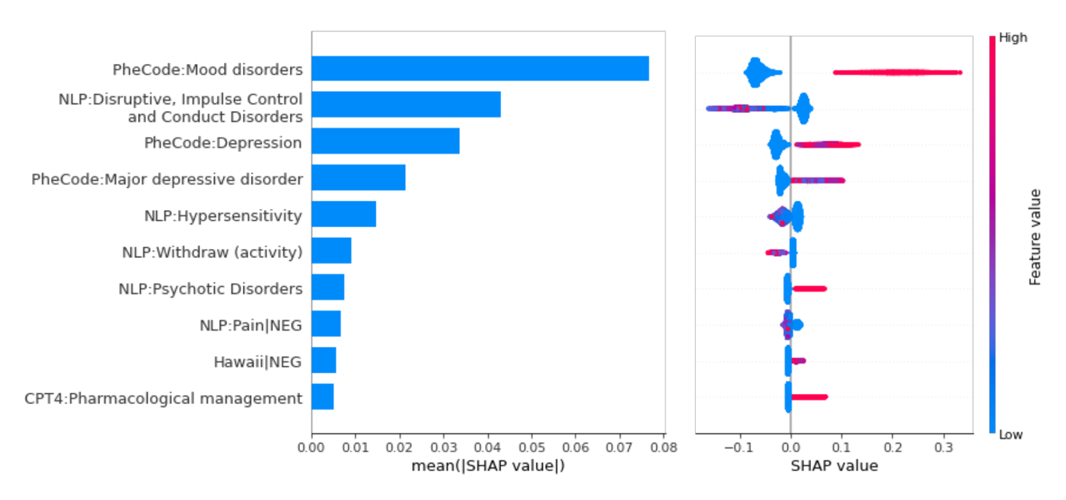

Supplementary Figure 8 (c). SHAP summary plots of the top-10 features for the Mood disorder/ADHD cohort with 1-year prediction window.

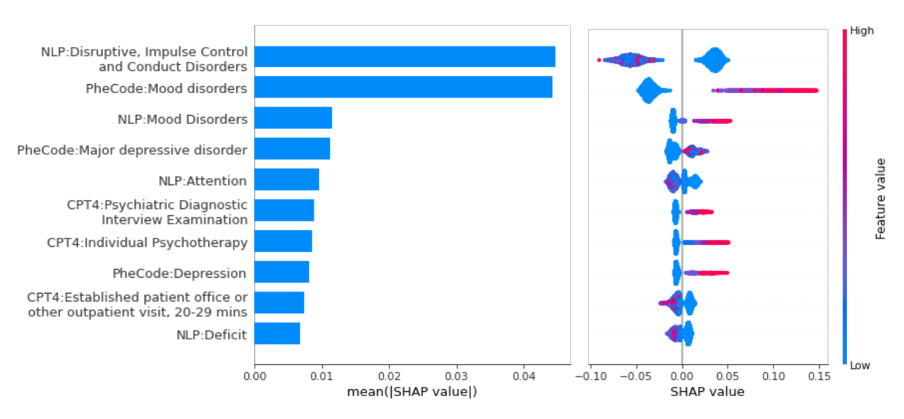

Supplementary Figure 9 (a). SHAP summary plots of the top-10 features for the General patients cohort with 3-year prediction window.

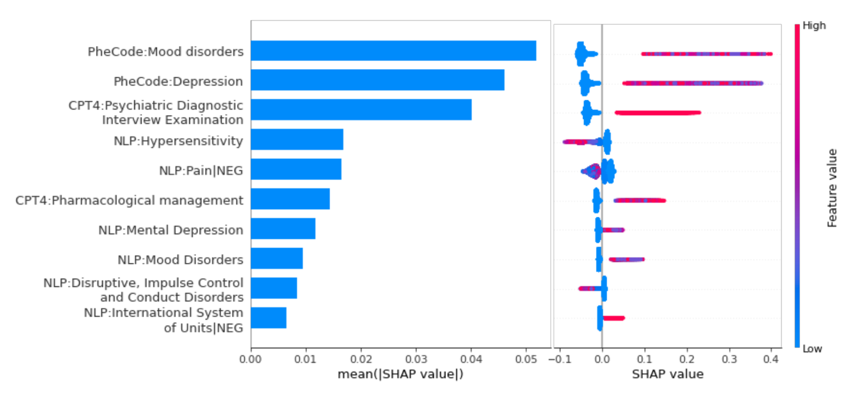

Supplementary Figure 9 (b). SHAP summary plots of the top-10 features for the Mental healthcare cohort with 3-year prediction window.

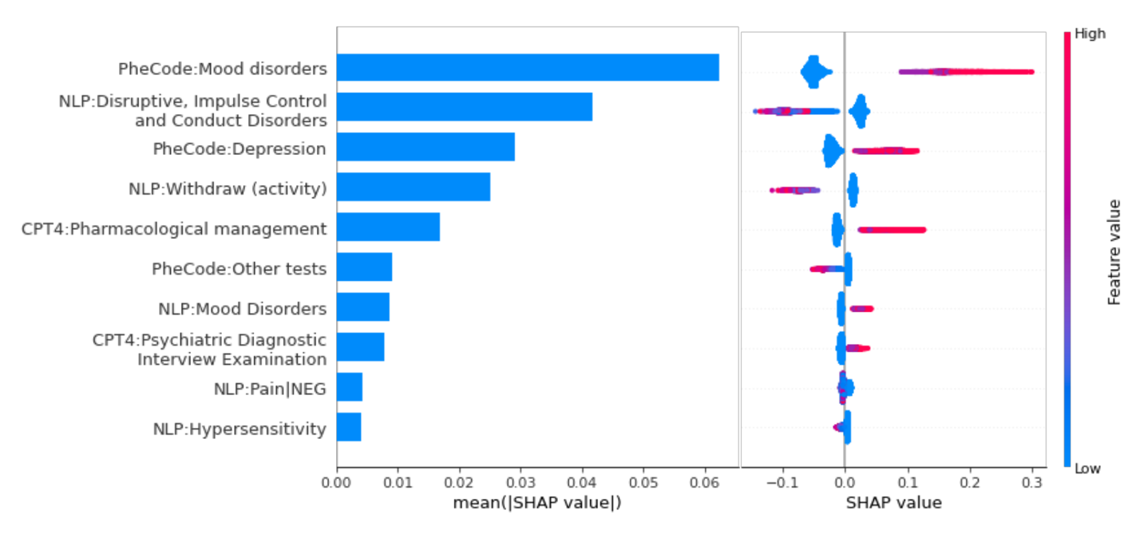

Supplementary Figure 9 (c). SHAP summary plots of the top-10 features for the Mood disorder/ADHD cohort with 3-year prediction window.

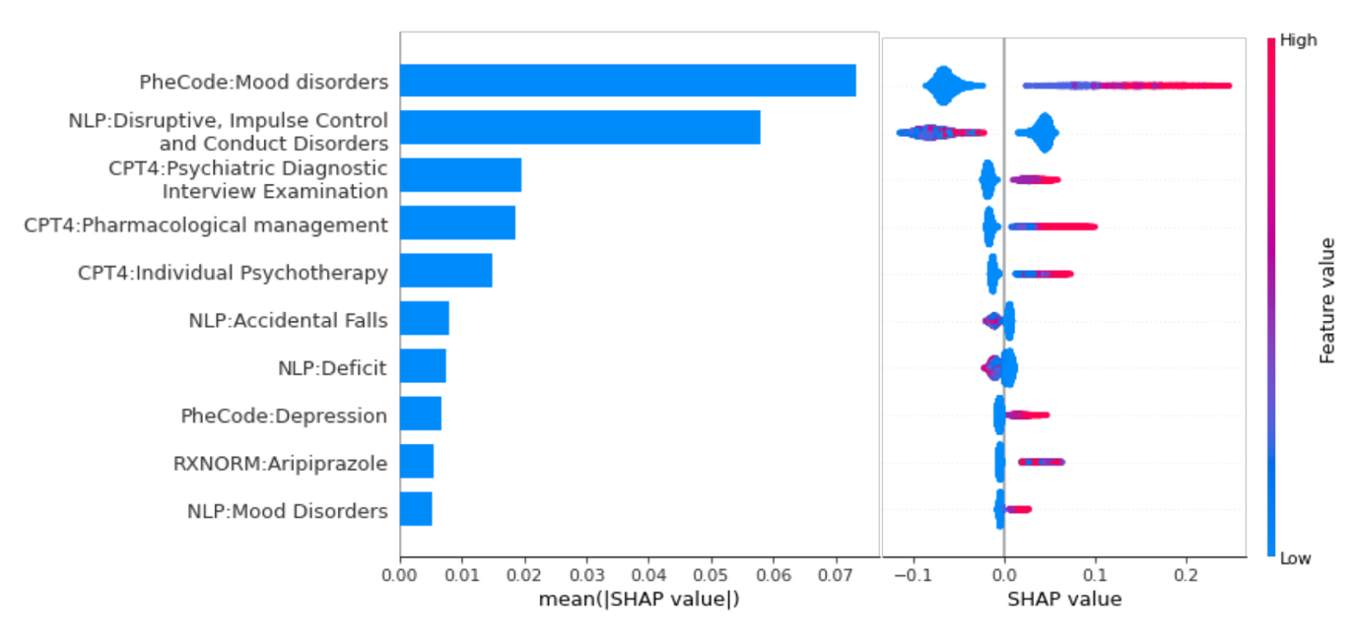

Supplementary Figure 10. Model performance comparison between the original RF model and the light-weight models, with 6 months prediction window.

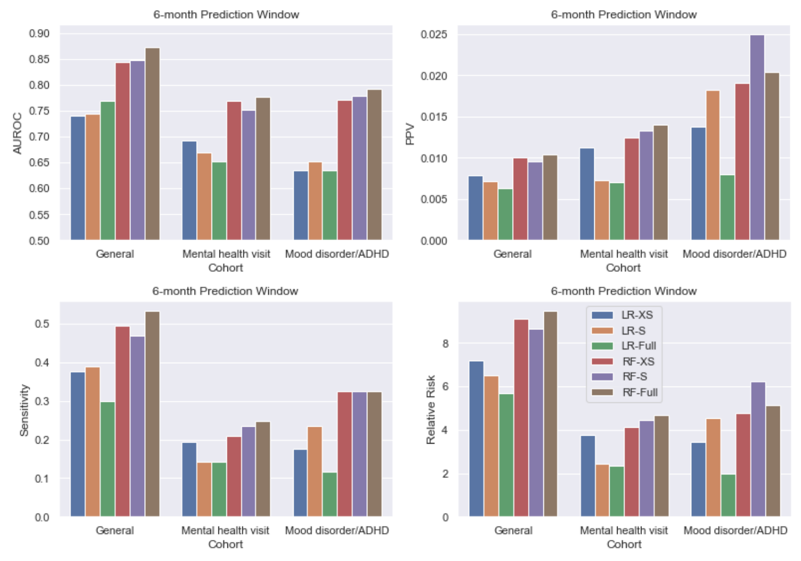

Supplementary Figure 11. Model performance comparison between the original RF model and the light-weight models, with 1-year prediction window.

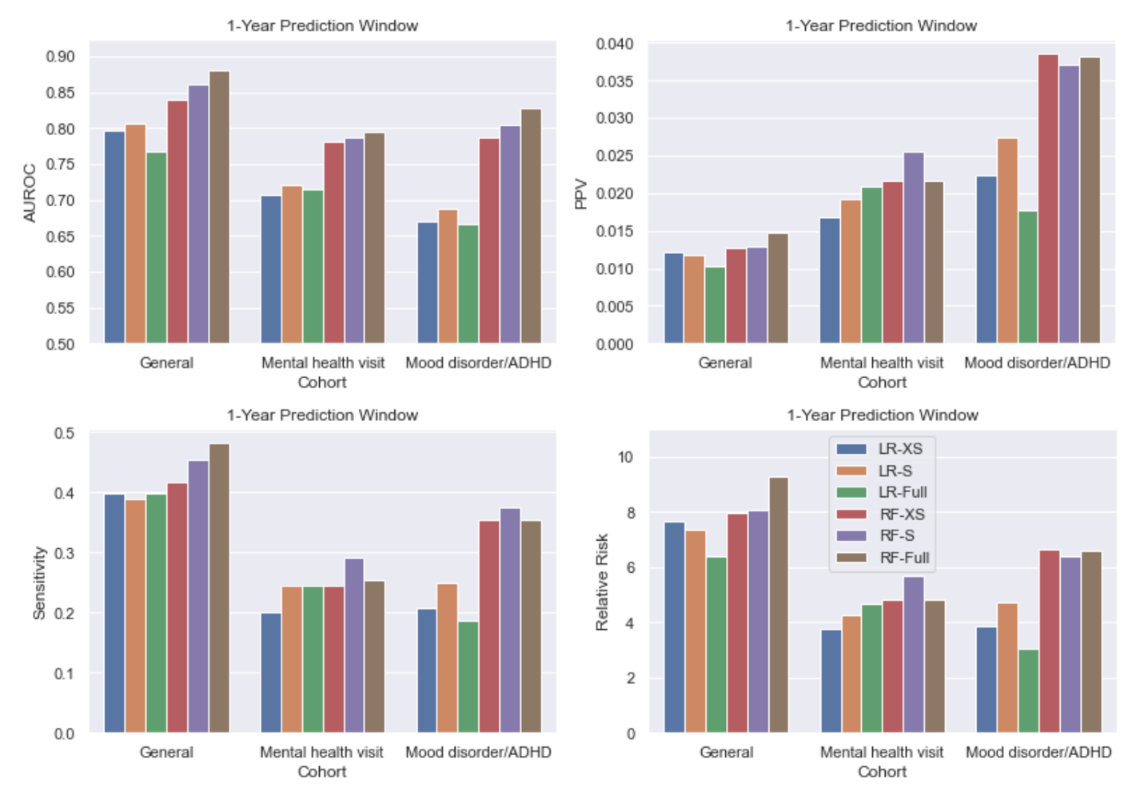

Supplementary Figure 12. Model performance comparison between the original RF model and the light-weight models, with 3-year prediction window.

