**Supplemental Materials**

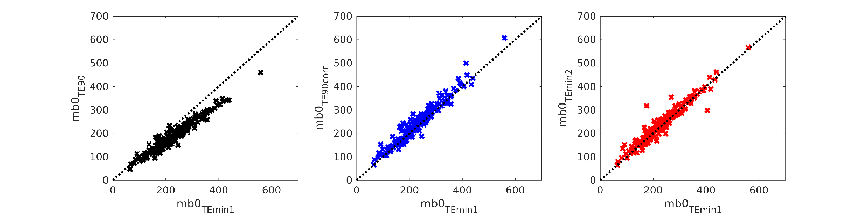**Supplementary Figure 1:** Comparison of mb0 TEmin1 for all cases to mb0 TE90 , mb0 TE90corr and mb0 TEmin2 . Black dashed lines indicate hypothetical perfect relation.

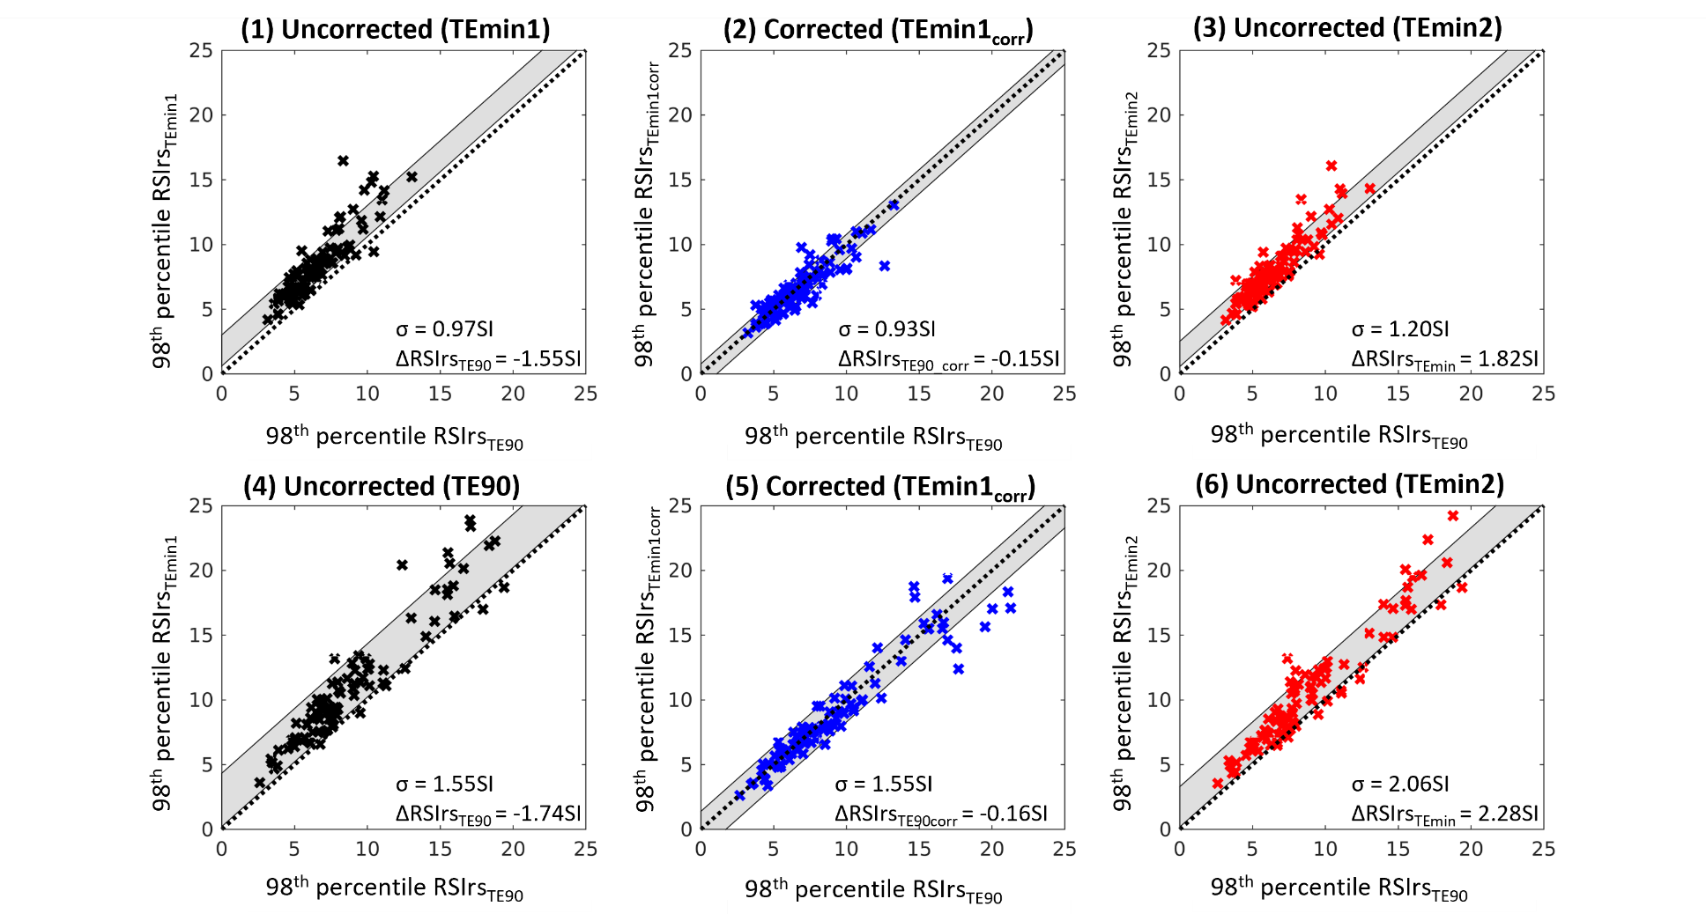

**Supplementary Figure 2:** Comparison of the 98th percentile of RSIrsTE90 for benign cases (1-3) and csPCa (4-6) cases within the prostate to the 98th percentile of RSIrsTEmin1 (1,4), RSIrsTE90corr (2,5) and RSIrsTEmin2 (3,6). Standard deviation (indicated by σ as well as gray color wash) and mean difference of the reference, 98th percentile of RSIrsTE90, to the 98th percentile of RSIrsTEmin1, RSIrsTEmin2 and RSIrsTE90corr (ΔRSIrs) indicating model bias. Black dashed lines indicate hypothetical perfect relation.

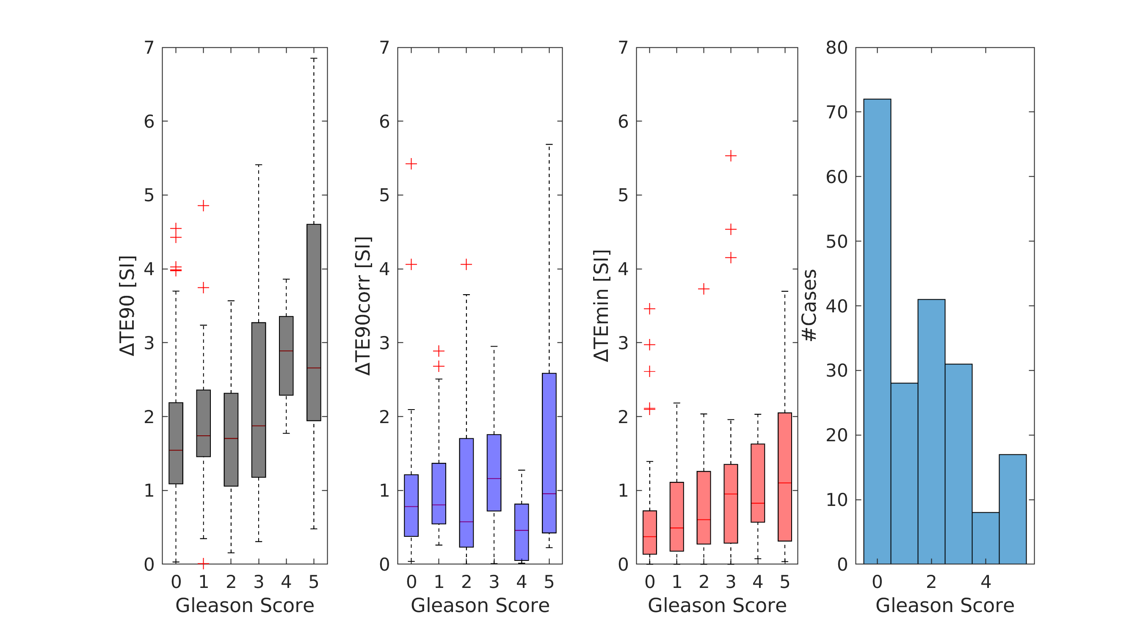

**Supplementary Figure 3:** Absolute differences between TE90, TE90corr, and TEmin2 and the reference acquisition TEmin1 for each Gleason grade group. Gleason Score =0 indicates benign cases. The histogram illustrates the frequency distributions of Gleason scores in the patient cohort.

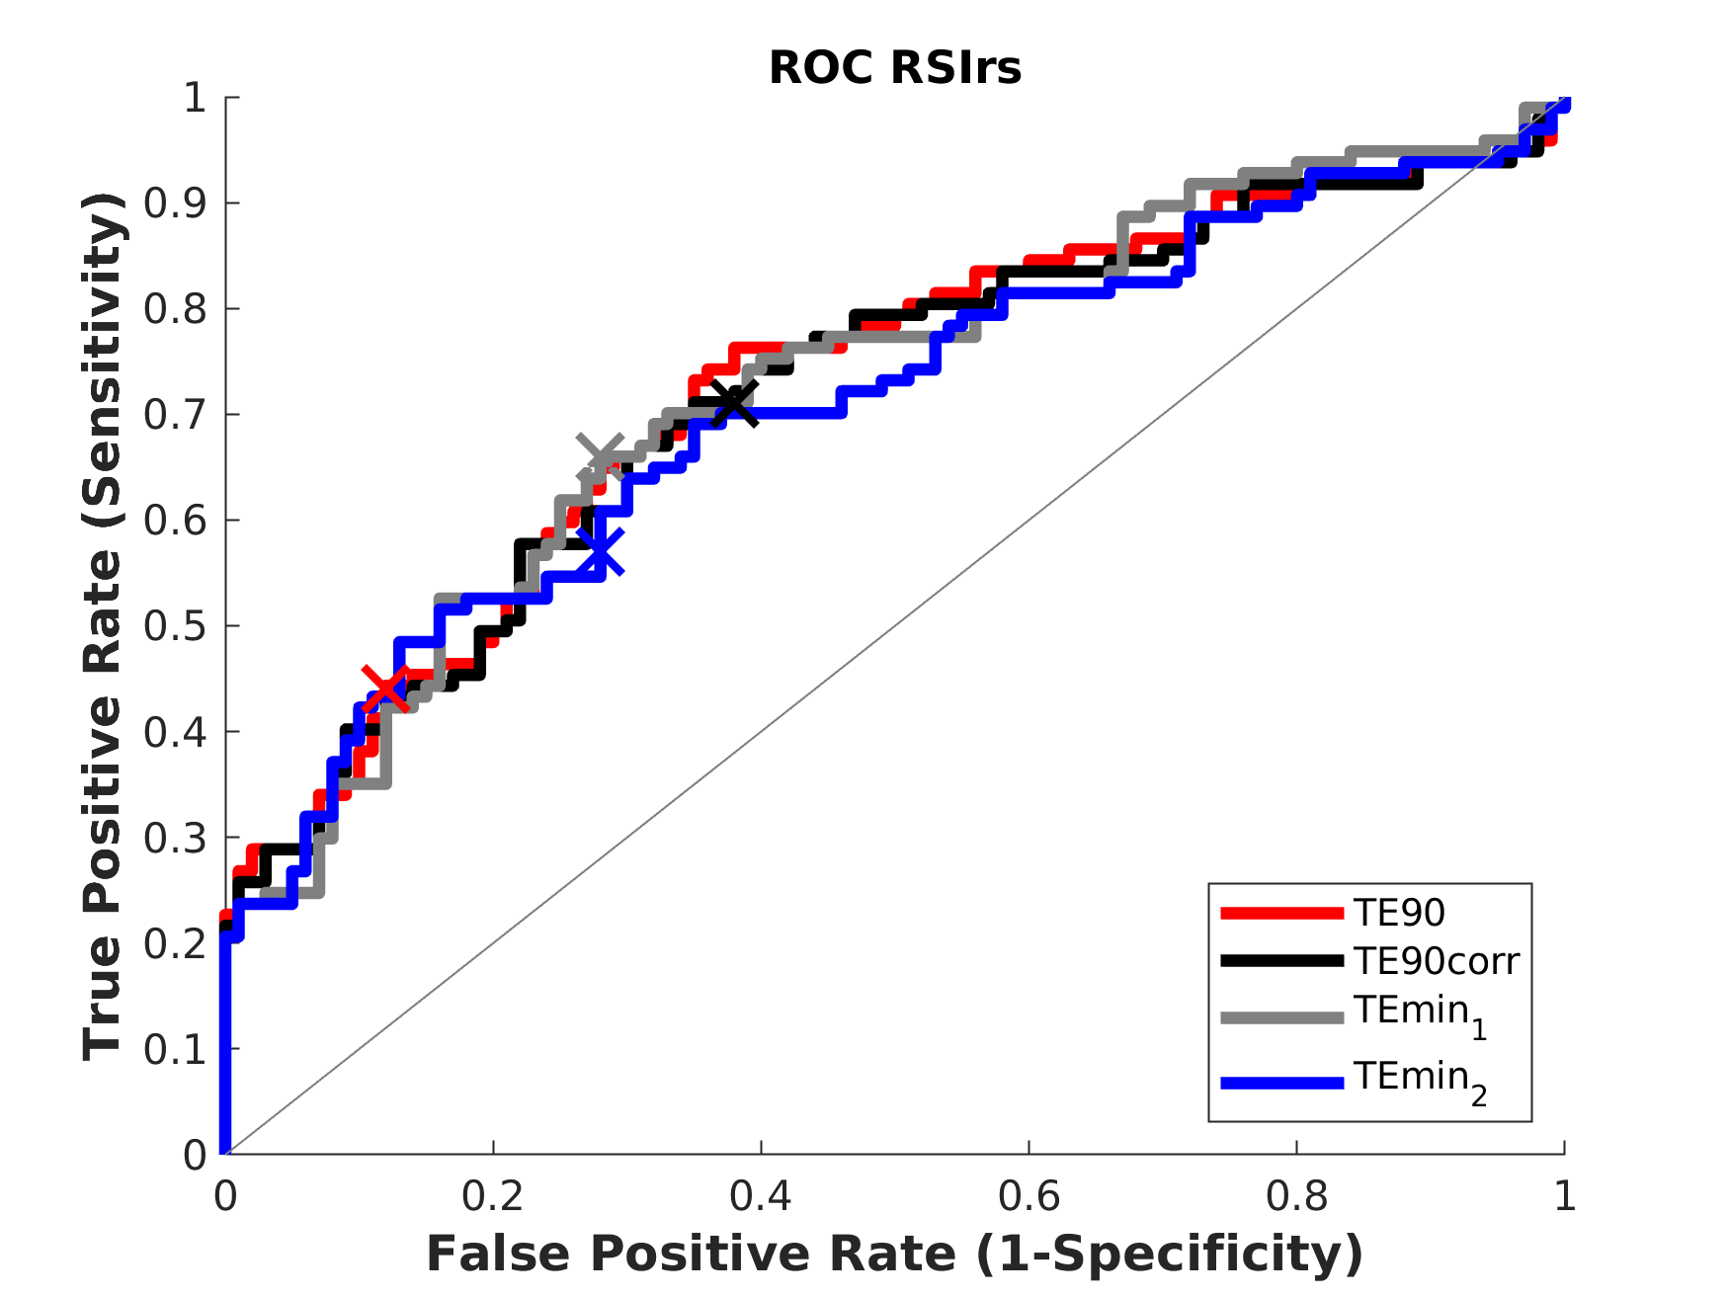

**Supplementary Figure 4:** ROC curve for classification of csPCa using the 98th percentile of RSIrs within the prostate as the biomarker. The grey line indicates a model performance better than randomness. Crosses indicate the classification performance at the threshold defined by Youden index.