Supplementary material

Table of Content

Figure S1: physical activity level according to body mass index, sex, level of education, age, and country 1

Figure S2: Self-efficacy to do physical activity when encountering barrier according to age 2

Figure S3: Self-efficacy to do physical activity when encountering barrier according to education level 3

Figure S4: Self-efficacy to do physical activity when encountering barrier according to sex 4

Figure S5: Self-efficacy to do physical activity when encountering barrier according to body mass index 5

Figure S6: Self-efficacy to do physical activity when encountering barrier according to country 6

Figure S7: Physical activity preferences according to body mass index 7

Figure S8: Physical activity preferences according to sex 8

Figure S9: Physical activity preferences according to country 9

Figure S10: Physical activity preferences according to education level 10

Figure S11: Physical activity preferences according to age 11

# Figure S1: physical activity level according to body mass index, sex, level of education, age, and country



Note : PA = Physical activity.

# Figure S2: Self-efficacy to do physical activity when encountering barrier according to age

Note: The higher the mean indicator (vertical black line), the greater the barrier. The barriers in order from the top are: “*Being tired*”, “*Feeling pressure at work*”, “*Recovering from an injury*”, “*Being in a bad mood*”, “*Having personal problems*”, “*Having more interesting things to do*”, “*Without the support of friends or family*”, “*Having other engagement*”, “*Feeling unwell*”, “*Having friends at home*”, “*Feeling anxious*”, “*Not reaching previously fixed training goals*”, “*Having family problems*”, “*During vacations*”.

# Figure S3: Self-efficacy to do physical activity when encountering barrier according to education level

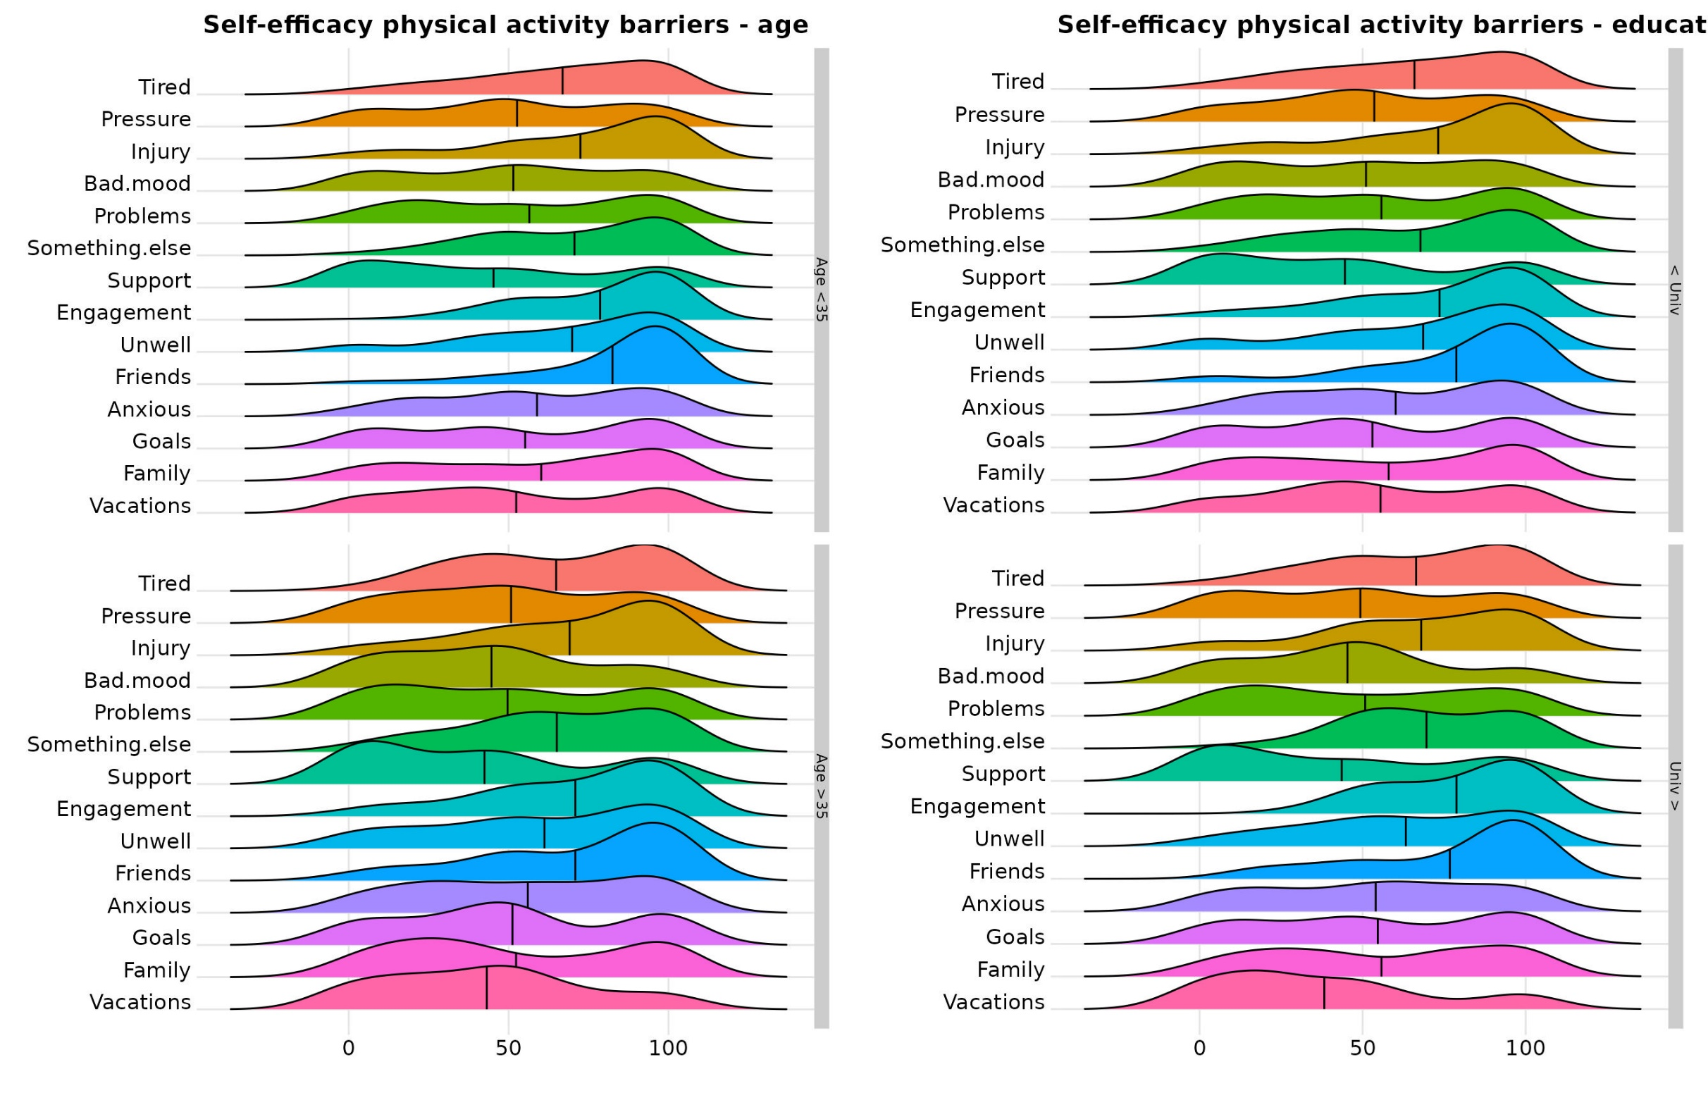

Note: The higher the mean indicator (vertical black line), the greater the barrier. The barriers in order from the top are: “*Being tired*”, “*Feeling pressure at work*”, “*Recovering from an injury*”, “*Being in a bad mood*”, “*Having personal problems*”, “*Having more interesting things to do*”, “*Without the support of friends or family*”, “*Having other engagement*”, “*Feeling unwell*”, “*Having friends at home*”, “*Feeling anxious*”, “*Not reaching previously fixed training goals*”, “*Having family problems*”, “*During vacations*”.

# Figure S4: Self-efficacy to do physical activity when encountering barrier according to sex

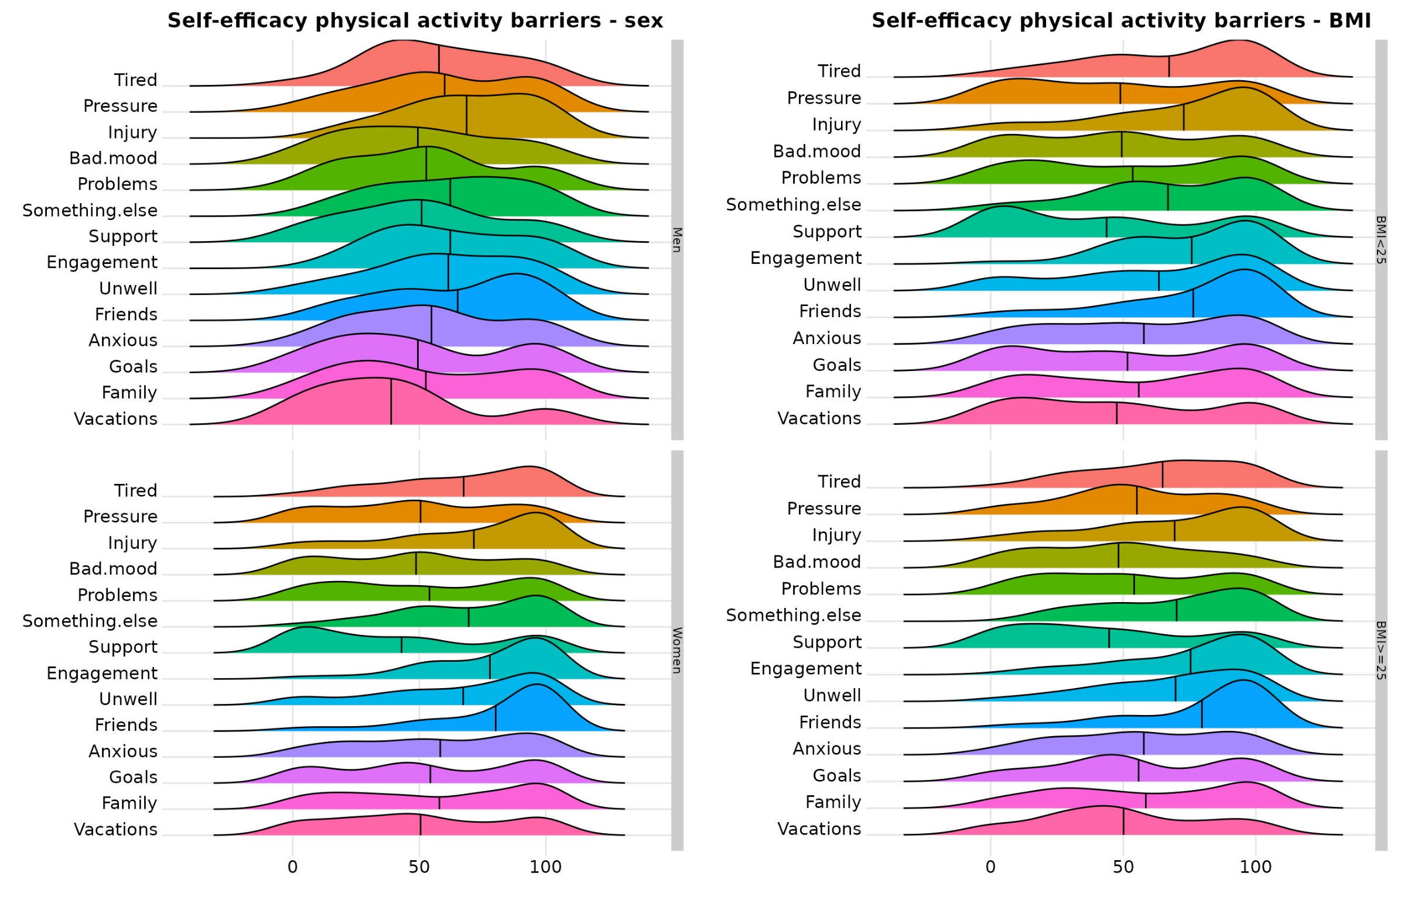

Note: The higher the mean indicator (vertical black line), the greater the barrier. The barriers in order from the top are: “*Being tired*”, “*Feeling pressure at work*”, “*Recovering from an injury*”, “*Being in a bad mood*”, “*Having personal problems*”, “*Having more interesting things to do*”, “*Without the support of friends or family*”, “*Having other engagement*”, “*Feeling unwell*”, “*Having friends at home*”, “*Feeling anxious*”, “*Not reaching previously fixed training goals*”, “*Having family problems*”, “*During vacations*”.

# Figure S5: Self-efficacy to do physical activity when encountering barrier according to body mass index

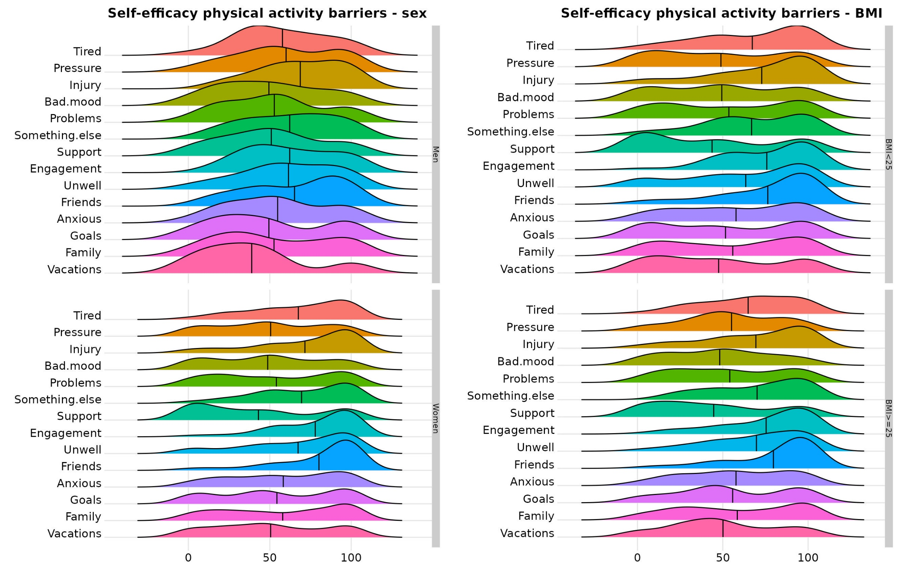

Note: BMI = Body mass index. The higher the mean indicator (vertical black line), the greater the barrier. The barriers in order from the top are: “*Being tired*”, “*Feeling pressure at work*”, “*Recovering from an injury*”, “*Being in a bad mood*”, “*Having personal problems*”, “*Having more interesting things to do*”, “*Without the support of friends or family*”, “*Having other engagement*”, “*Feeling unwell*”, “*Having friends at home*”, “*Feeling anxious*”, “*Not reaching previously fixed training goals*”, “*Having family problems*”, “*During vacations*”.

# Figure S6: Self-efficacy to do physical activity when encountering barrier according to country

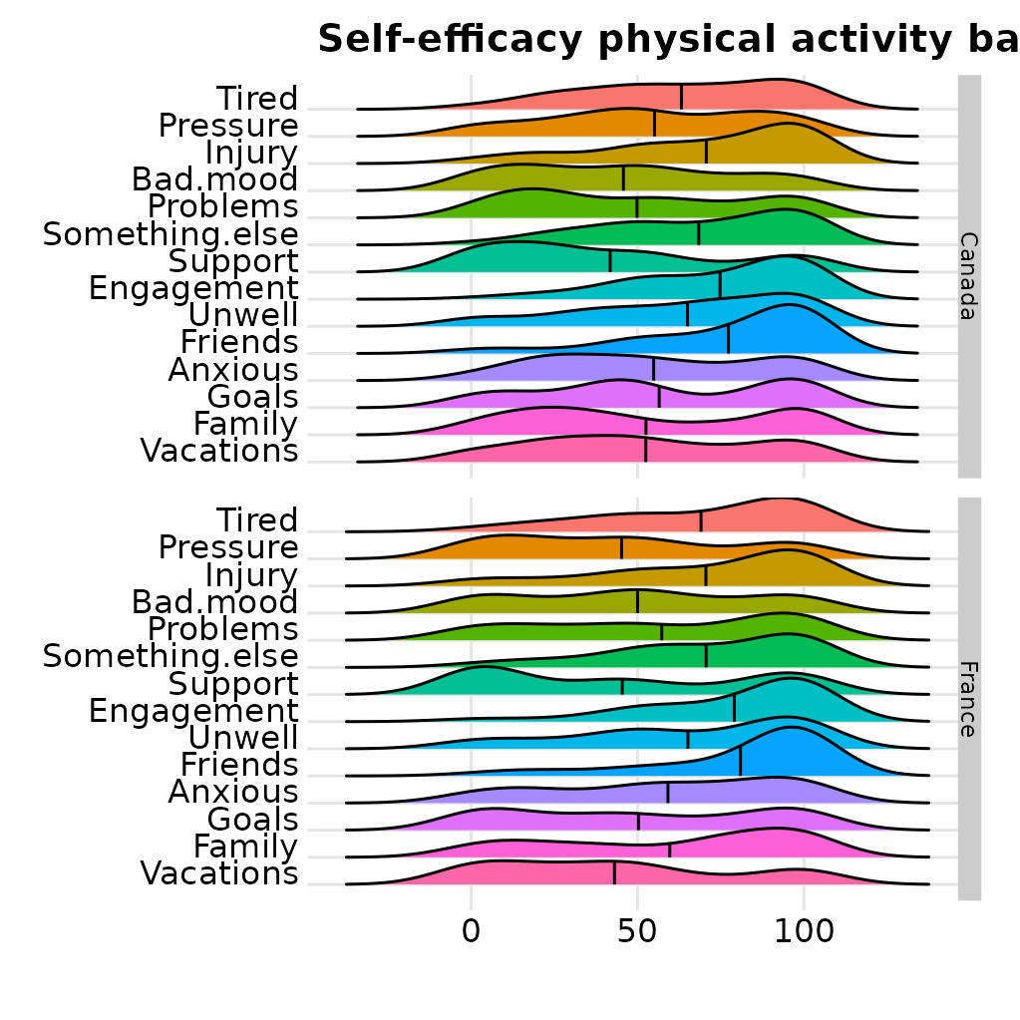

Note: The higher the mean indicator (vertical black line), the greater the barrier. The barriers in order from the top are: “*Being tired*”, “*Feeling pressure at work*”, “*Recovering from an injury*”, “*Being in a bad mood*”, “*Having personal problems*”, “*Having more interesting things to do*”, “*Without the support of friends or family*”, “*Having other engagement*”, “*Feeling unwell*”, “*Having friends at home*”, “*Feeling anxious*”, “*Not reaching previously fixed training goals*”, “*Having family problems*”, “*During vacations*”.

# Figure S7: Physical activity preferences according to body mass index

# Figure S8: Physical activity preferences according to sex

# Figure S9: Physical activity preferences according to country

# Figure S10: Physical activity preferences according to education level

# Figure S11: Physical activity preferences according to age

