Supplementary Data

FIGURES

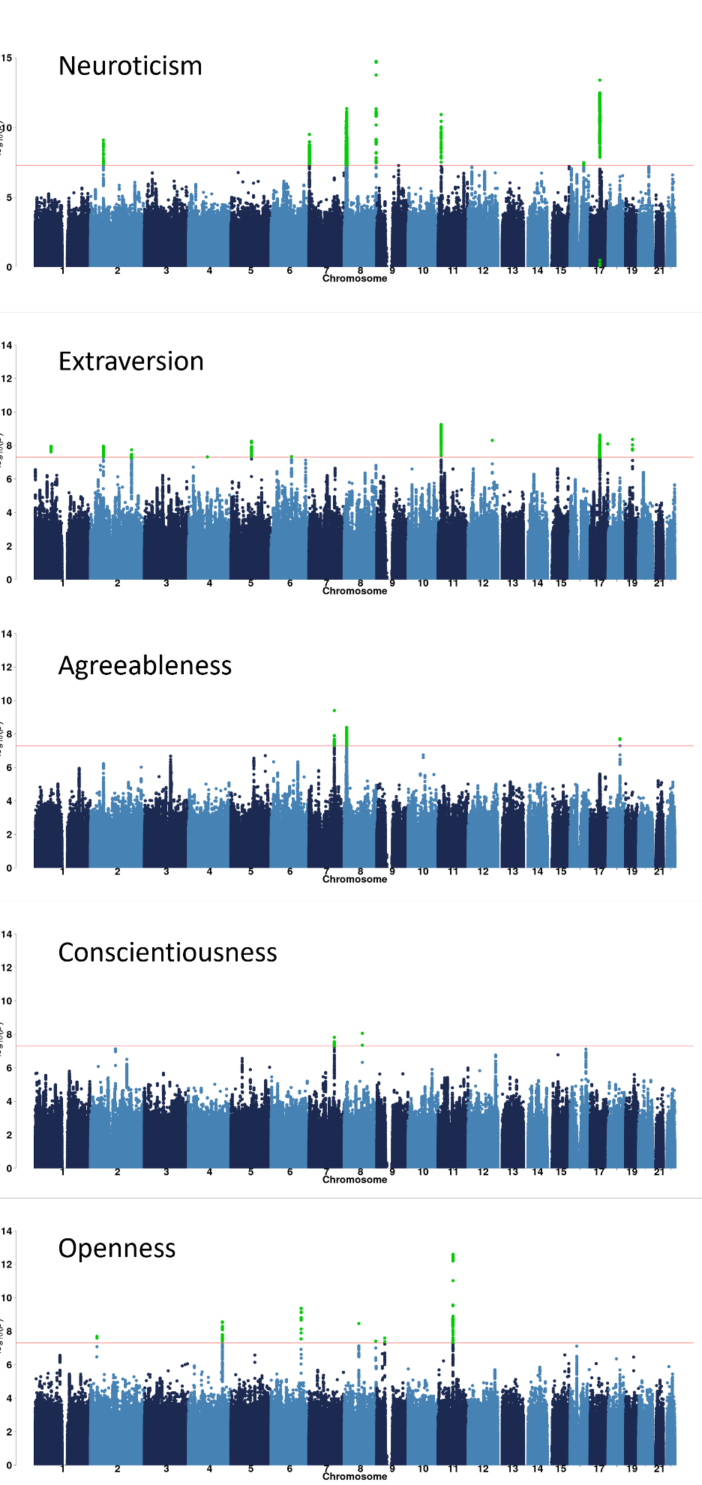

Figure S1: Manhattan plots of all 5 personalities GWAS performed in the MVP cohort.
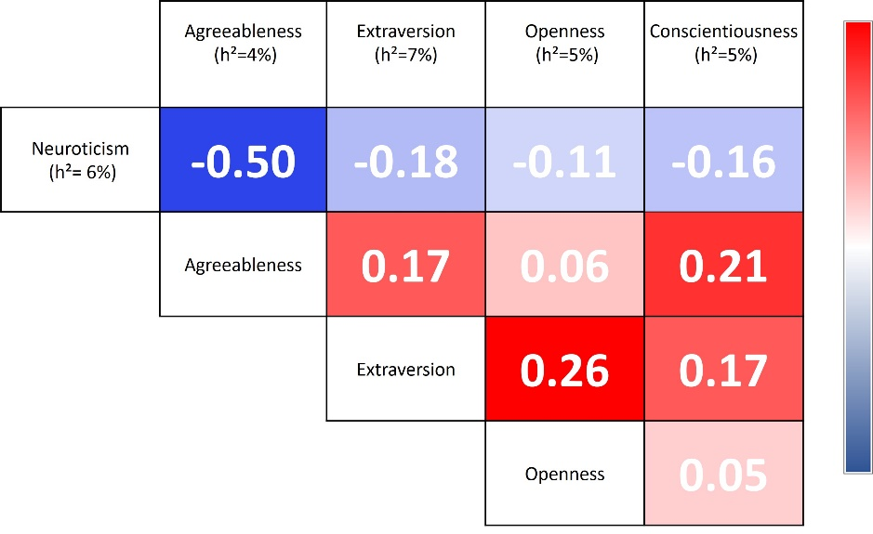
Figure S2: Genetic correlation matrix among the 5 personality traits calculated from the MVP cohort only. The heritability value of the respective trait is written in parenthesis.

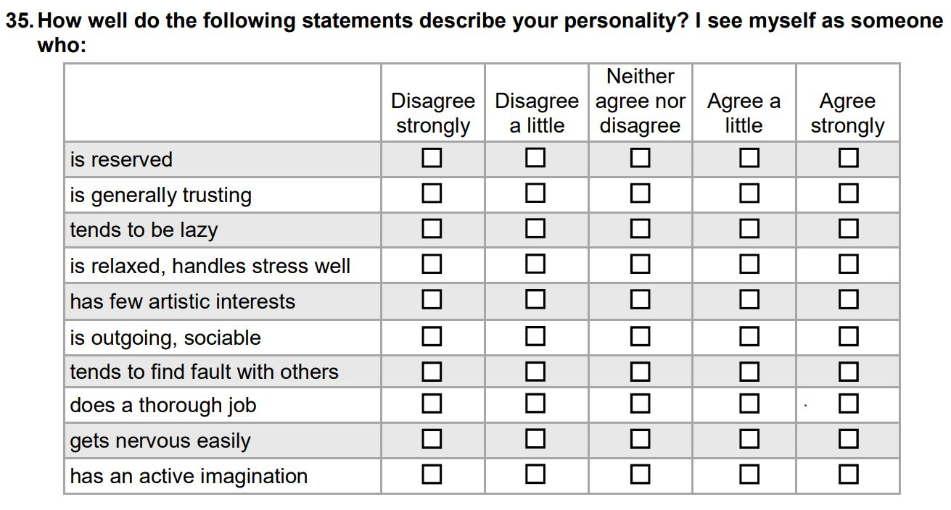
Figure S3: The figure shows the 10-item questionnaire of Big five Inventory used to assign personality type to MVP cohort participants, as part of question 35 of MVP personality survey (Department of Veterans Affairs).

TABLES
Table S1: Genetic correlations between different data cohorts/studies
Trait | Source 1 | h2 (se) | Source 2 | h2 (se) | rG (sd)
Neuroticism | MVP | 0.07 (0.004) | Nagel et al. | 0.07 (0.003) | 0.80 (0.02)
Extraversion | MVP | 0.05 (0.004) | GPC-II | 0.07 (0.003) | 0.89 (0.09)
Agreeableness | MVP | 0.04 (0.004) | GPC-I | 0.01 (.03) | 0.72 (0.99)
Conscientiousness | MVP | 0.04 (0.008) | GPC-I | 0.08 (0.03) | 0.59 (0.17)
Openness | MVP | .05 (.01) | GPC-I | 0.13 (.03) | 0.63 (0.12)

Table S2:
Gene | Direction of effect in neuroticism | Direction of effect in extraversion | eQTL associated with mood instability
CRHR1 | - | + | Yes
MAPT | - | + | yes
MAPT-AS1 | + | - | Yes
PLEKHM1 | - | + | Yes
KANSL1 | + | - | Yes
LIN02210 | + | - | No
SPPL2C | + | - | No
ARHGAP27 | + | - | No
ARL17A | + | - | No

VA Million Veteran Program:
Core Acknowledgement for Publications
February 2023

MVP Program Office

- Sumitra Muralidhar, Ph.D., Program Director
US Department of Veterans Affairs, 810 Vermont Avenue NW, Washington, DC 20420
- Jennifer Moser, Ph.D., Associate Director, Scientific Programs
US Department of Veterans Affairs, 810 Vermont Avenue NW, Washington, DC 20420
- Jennifer E. Deen, B.S., Associate Director, Cohort & Public Relations
US Department of Veterans Affairs, 810 Vermont Avenue NW, Washington, DC 20420

MVP Executive Committee

- Co-Chair: Philip S. Tsao, Ph.D.
VA Palo Alto Health Care System, 3801 Miranda Avenue, Palo Alto, CA 94304
- Co-Chair: Sumitra Muralidhar, Ph.D.
US Department of Veterans Affairs, 810 Vermont Avenue NW, Washington, DC 20420
- J. Michael Gaziano, M.D., M.P.H.
VA Boston Healthcare System, 150 S. Huntington Avenue, Boston, MA 02130
- Elizabeth Hauser, Ph.D.
Durham VA Medical Center, 508 Fulton Street, Durham, NC 27705
- Amy Kilbourne, Ph.D., M.P.H.
VA HSR&D, 2215 Fuller Road, Ann Arbor, MI 48105
- Shiuh-Wen Luoh, M.D., Ph.D.
VA Portland Health Care System, 3710 SW US Veterans Hospital Rd, Portland, OR 97239
- Michael Matheny, M.D., M.S., M.P.H.
VA Tennessee Valley Healthcare System, 1310 24th Ave. South, Nashville, TN 37212
- Dave Oslin, M.D.
Philadelphia VA Medical Center, 3900 Woodland Avenue, Philadelphia, PA 19104

MVP Co-Principal Investigators

- J. Michael Gaziano, M.D., M.P.H.
VA Boston Healthcare System, 150 S. Huntington Avenue, Boston, MA 02130
- Philip S. Tsao, Ph.D.
VA Palo Alto Health Care System, 3801 Miranda Avenue, Palo Alto, CA 94304

MVP Core Operations

- Lori Churby, B.S., Director, MVP Regulatory Affairs
VA Palo Alto Health Care System, 3801 Miranda Avenue, Palo Alto, CA 94304
- Stacey B. Whitbourne, Ph.D., Director, MVP Cohort Management
VA Boston Healthcare System, 150 S. Huntington Avenue, Boston, MA 02130
- Jessica V. Brewer, M.P.H., Director, MVP Recruitment & Enrollment
VA Boston Healthcare System, 150 S. Huntington Avenue, Boston, MA 02130
- Shahpoor (Alex) Shayan, M.S., Director, MVP Recruitment and Enrollment Informatics
VA Boston Healthcare System, 150 S. Huntington Avenue, Boston, MA 02130
- Luis E. Selva, Ph.D., Executive Director, MVP Biorepositories
VA Boston Healthcare System, 150 S. Huntington Avenue, Boston, MA 02130
- Saiju Pyarajan Ph.D., Director, Data and Computational Sciences
VA Boston Healthcare System, 150 S. Huntington Avenue, Boston, MA 02130
- Kelly Cho, M.P.H, Ph.D., Director, MVP Phenomics Data Core
VA Boston Healthcare System, 150 S. Huntington Avenue, Boston, MA 02130
- Scott L. DuVall, Ph.D., Director, VA Informatics and Computing Infrastructure (VINCI)
VA Salt Lake City Health Care System, 500 Foothill Drive, Salt Lake City, UT 84148
- Mary T. Brophy M.D., M.P.H., Director, VA Central Biorepository
VA Boston Healthcare System, 150 S. Huntington Avenue, Boston, MA 02130
- MVP Coordinating Centers
  - MVP Coordinating Center, Boston - J. Michael Gaziano, M.D., M.P.H.
VA Boston Healthcare System, 150 S. Huntington Avenue, Boston, MA 02130
  - MVP Coordinating Center, Palo Alto – Philip S. Tsao, Ph.D.
VA Palo Alto Health Care System, 3801 Miranda Avenue, Palo Alto, CA 94304
  - MVP Information Center, Canandaigua – Brady Stephens, M.S.
Canandaigua VA Medical Center, 400 Fort Hill Avenue, Canandaigua, NY 14424
  - Cooperative Studies Program Clinical Research Pharmacy Coordinating Center, Albuquerque – Todd Connor, Pharm.D.; Dean P. Argyres, B.S., M.S.
New Mexico VA Health Care System, 1501 San Pedro Drive SE, Albuquerque, NM 87108

MVP Publications and Presentations Committee

- Co-Chair: Themistocles L. Assimes, M.D., Ph. D
VA Palo Alto Health Care System, 3801 Miranda Avenue, Palo Alto, CA 94304
- Co-Chair: Adriana Hung, M.D.; M.P.H
VA Tennessee Valley Healthcare System, 1310 24th Ave. South, Nashville, TN 37212
- Co-Chair: Henry Kranzler, M.D.
Philadelphia VA Medical Center, 3900 Woodland Avenue, Philadelphia, PA 19104

MVP Local Site Investigators

- Samuel Aguayo, M.D., Phoenix VA Health Care System
650 E. Indian School Road, Phoenix, AZ 85012
- Sunil Ahuja, M.D., South Texas Veterans Health Care System
7400 Merton Minter Boulevard, San Antonio, TX 78229
- Kathrina Alexander, M.D., Veterans Health Care System of the Ozarks
1100 North College Avenue, Fayetteville, AR 72703
- Xiao M. Androulakis, M.D., Columbia VA Health Care System
6439 Garners Ferry Road, Columbia, SC 29209
- Prakash Balasubramanian, M.D., William S. Middleton Memorial Veterans Hospital
2500 Overlook Terrace, Madison, WI 53705
- Zuhair Ballas, M.D., Iowa City VA Health Care System
601 Highway 6 West, Iowa City, IA 52246-2208
- Jean Beckham, Ph.D., Durham VA Medical Center
508 Fulton Street, Durham, NC 27705
- Sujata Bhushan, M.D., VA North Texas Health Care System
4500 S. Lancaster Road, Dallas, TX 75216
- Edward Boyko, M.D., VA Puget Sound Health Care System
1660 S. Columbian Way, Seattle, WA 98108-1597
- David Cohen, M.D., Portland VA Medical Center
3710 SW U.S. Veterans Hospital Road, Portland, OR 97239
- Louis Dellitalia, M.D., Birmingham VA Medical Center
700 S. 19th Street, Birmingham AL 35233
- L. Christine Faulk, M.D., Robert J. Dole VA Medical Center
5500 East Kellogg Drive, Wichita, KS 67218-1607
- Joseph Fayad, M.D., VA Southern Nevada Healthcare System
6900 North Pecos Road, North Las Vegas, NV 89086
- Daryl Fujii, Ph.D., VA Pacific Islands Health Care System
459 Patterson Rd, Honolulu, HI 96819
- Saib Gappy, M.D., John D. Dingell VA Medical Center
4646 John R Street, Detroit, MI 48201
- Frank Gesek, Ph.D., White River Junction VA Medical Center
163 Veterans Drive, White River Junction, VT 05009
- Jennifer Greco, M.D., Sioux Falls VA Health Care System
2501 W 22nd Street, Sioux Falls, SD 57105
- Michael Godschalk, M.D., Richmond VA Medical Center
1201 Broad Rock Blvd., Richmond, VA 23249
- Todd W. Gress, M.D., Ph.D., Hershel “Woody” Williams VA Medical Center
1540 Spring Valley Drive, Huntington, WV 25704
- Samir Gupta, M.D., M.S.C.S., VA San Diego Healthcare System
3350 La Jolla Village Drive, San Diego, CA 92161
- Salvador Gutierrez, M.D., Edward Hines, Jr. VA Medical Center
5000 South 5th Avenue, Hines, IL 60141
- John Harley, M.D., Ph.D., Cincinnati VA Medical Center
3200 Vine Street, Cincinnati, OH 45220
- Kimberly Hammer, Ph.D., Fargo VA Health Care System
2101 N. Elm, Fargo, ND 58102
- Mark Hamner, M.D., Ralph H. Johnson VA Medical Center
109 Bee Street, Mental Health Research, Charleston, SC 29401
- Adriana Hung, M.D., M.P.H., VA Tennessee Valley Healthcare System
1310 24th Avenue, South Nashville, TN 37212
- Robin Hurley, M.D., W.G. (Bill) Hefner VA Medical Center
1601 Brenner Ave, Salisbury, NC 28144
- Pran Iruvanti, D.O., Ph.D., Hampton VA Medical Center
100 Emancipation Drive, Hampton, VA 23667
- Frank Jacono, M.D., VA Northeast Ohio Healthcare System
10701 East Boulevard, Cleveland, OH 44106
- Darshana Jhala, M.D., Philadelphia VA Medical Center
3900 Woodland Avenue, Philadelphia, PA 19104
- Scott Kinlay, M.B.B.S., Ph.D., VA Boston Healthcare System
150 S. Huntington Avenue, Boston, MA 02130
- Jon Klein, M.D., Ph.D., Louisville VA Medical Center
800 Zorn Avenue, Louisville, KY 40206
- Michael Landry, Ph.D., Southeast Louisiana Veterans Health Care System
2400 Canal Street, New Orleans, LA 70119
- Peter Liang, M.D., M.P.H., VA New York Harbor Healthcare System
423 East 23rd Street, New York, NY 10010
- Suthat Liangpunsakul, M.D., M.P.H., Richard Roudebush VA Medical Center
1481 West 10th Street, Indianapolis, IN 46202
- Jack Lichy, M.D., Ph.D., Washington DC VA Medical Center
50 Irving St, Washington, D. C. 20422
- C. Scott Mahan, M.D., Charles George VA Medical Center
1100 Tunnel Road, Asheville, NC 28805
- Ronnie Marrache, M.D., VA Maine Healthcare System
1 VA Center, Augusta, ME 04330
- Stephen Mastorides, M.D., James A. Haley Veterans’ Hospital
13000 Bruce B. Downs Blvd, Tampa, FL 33612
- Elisabeth Mates M.D., Ph.D., VA Sierra Nevada Health Care System
975 Kirman Avenue, Reno, NV 89502
- Kristin Mattocks, Ph.D., M.P.H., Central Western Massachusetts Healthcare System
421 North Main Street, Leeds, MA 01053
- Paul Meyer, M.D., Ph.D., Southern Arizona VA Health Care System
3601 S 6th Avenue, Tucson, AZ 85723
- Jonathan Moorman, M.D., Ph.D., James H. Quillen VA Medical Center
Corner of Lamont & Veterans Way, Mountain Home, TN 37684
- Timothy Morgan, M.D., VA Long Beach Healthcare System
5901 East 7th Street Long Beach, CA 90822
- Maureen Murdoch, M.D., M.P.H., Minneapolis VA Health Care System
One Veterans Drive, Minneapolis, MN 55417
- James Norton, Ph.D., VA Health Care Upstate New York
113 Holland Avenue, Albany, NY 12208
- Olaoluwa Okusaga, M.D., Michael E. DeBakey VA Medical Center
2002 Holcombe Blvd, Houston, TX 77030
- Kris Ann Oursler, M.D., Salem VA Medical Center
1970 Roanoke Blvd, Salem, VA 24153
- Ana Palacio, M.D., M.P.H., Miami VA Health Care System
1201 NW 16th Street, 11 GRC, Miami FL 33125
- Samuel Poon, M.D., Manchester VA Medical Center
718 Smyth Road, Manchester, NH 03104
- Emily Potter, Pharm.D., VA Eastern Kansas Health Care System
4101 S 4th Street Trafficway, Leavenworth, KS 66048
- Michael Rauchman, M.D., St. Louis VA Health Care System
915 North Grand Blvd, St. Louis, MO 63106
- Richard Servatius, Ph.D., Syracuse VA Medical Center
800 Irving Avenue, Syracuse, NY 13210
- Satish Sharma, M.D., Providence VA Medical Center
830 Chalkstone Avenue, Providence, RI 02908
- River Smith, Ph.D., Eastern Oklahoma VA Health Care System
1011 Honor Heights Drive, Muskogee, OK 74401
- Peruvemba Sriram, M.D., N. FL/S. GA Veterans Health System
1601 SW Archer Road, Gainesville, FL 32608
- Patrick Strollo, Jr., M.D., VA Pittsburgh Health Care System
University Drive, Pittsburgh, PA 15240
- Neeraj Tandon, M.D., Overton Brooks VA Medical Center
510 East Stoner Ave, Shreveport, LA 71101
- Philip Tsao, Ph.D., VA Palo Alto Health Care System
3801 Miranda Avenue, Palo Alto, CA 94304-1290
- Gerardo Villareal, M.D., New Mexico VA Health Care System
1501 San Pedro Drive, S.E. Albuquerque, NM 87108
- Agnes Wallbom, M.D., M.S., VA Greater Los Angeles Health Care System
11301 Wilshire Blvd, Los Angeles, CA 90073
- Jessica Walsh, M.D., VA Salt Lake City Health Care System
500 Foothill Drive, Salt Lake City, UT 84148
- John Wells, Ph.D., Edith Nourse Rogers Memorial Veterans Hospital
200 Springs Road, Bedford, MA 01730
- Jeffrey Whittle, M.D., M.P.H., Clement J. Zablocki VA Medical Center
5000 West National Avenue, Milwaukee, WI 53295
- Mary Whooley, M.D., San Francisco VA Health Care System
4150 Clement Street, San Francisco, CA 94121
- Allison E. Williams, N.D., Ph.D., R.N, Bay Pines VA Healthcare System
10,000 Bay Pines Blvd Bay Pines, FL 33744
- Peter Wilson, M.D., Atlanta VA Medical Center
1670 Clairmont Road, Decatur, GA 30033
- Junzhe Xu, M.D., VA Western New York Healthcare System
3495 Bailey Avenue, Buffalo, NY 14215-1199
- Shing Shing Yeh, Ph.D., M.D., Northport VA Medical Center
79 Middleville Road, Northport, NY 11768

REFERENCES

Department of Veterans Affairs, U. S. Million Veteran Program Lifestyle Survey.

