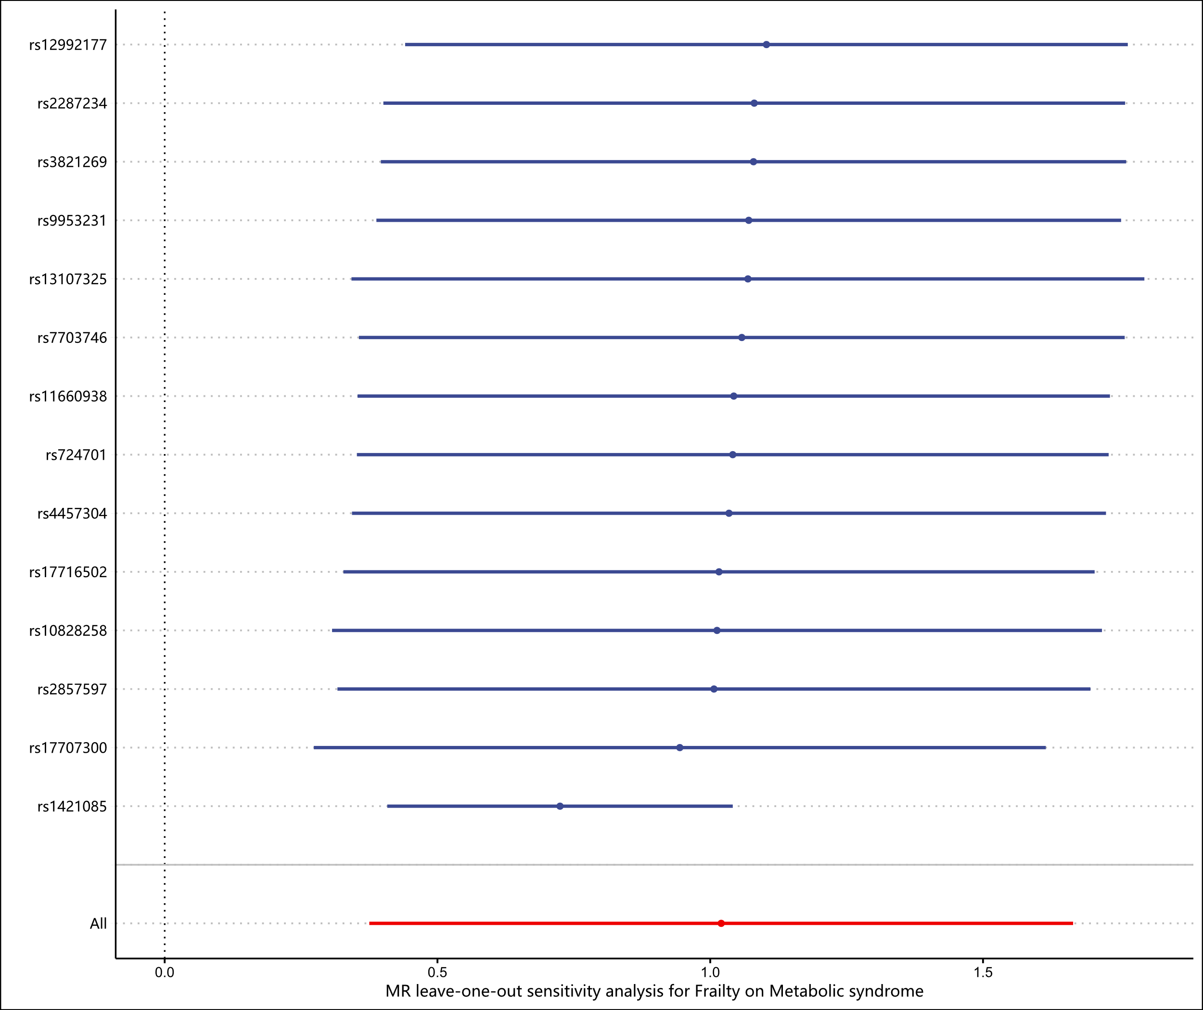

Supplementary Fig S1. Leave-one-out analysis for the causal effect of frailty on metabolic syndrome.