Supplementary Material
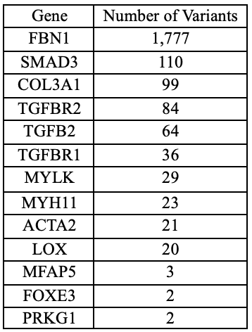
Table 1. Curated variants in the GMG app

