Supplementary Note

Integrative proteomic analyses across common cardiac diseases yield
new mechanistic insights and enhanced prediction

Art Schuermans, Ashley B. Pournamdari, Jiwoo Lee, Aeron M. Small, Rohan Bhukar, Shriienidhie Ganesh, Nicholas Darosa, Aeron Small, Zhi Yu, Whitney Hornsby,
Satoshi Koyama, James L. Januzzi, Jr., Michael C. Honigberg, Pradeep Natarajan.
TABLE OF CONTENTS

Supplementary Methods 5
Protein measurements, quality control, and data normalization 5
Covariate ascertainment 5
Cis-Mendelian randomization analyses 6
Main analyses 6
Sensitivity analyses 7
Colocalization analyses 8
Sex-stratified association analyses 9
Construction of protein-based prediction models 9
Evaluation of protein-based prediction models 10
Supplementary Figures 11
Supplementary Fig. 1. Cumulative incidence of coronary artery disease, heart failure, atrial fibrillation, and aotic stenosis during follow-up. 11
Supplementary Fig. 2. Venn diagram showing the number of distinct and shared protein associations across outcomes. 12
Supplementary Fig. 3. Top biological processes, molecular functions, and cellular components enriched among proteins associated with coronary artery disease, heart failure, atrial fibrillation, and aortic stenosis. 13
Supplementary Fig. 4. Correlation between the effect sizes of protein-disease associations in male vs. female participants. 15
Supplementary Fig. 5. Protein weights for the protein-based prediction models of coronary artery disease, heart failure, atrial fibrillation, and aortic stenosis. 17
Supplementary Fig. 6. Risk prediction of incident atrial fibrillation by risk scores incorporating NT-proBNP and all proteins except NT-proBNP and NPPB. 19
Supplementary Fig. 7. Risk prediction of incident heart failure by risk scores incorporating NT-proBNP and all proteins except NT-proBNP and NPPB. 21
Supplementary Tables (legends) 23
Supplementary Table 1. Description of the Olink Explore 1536 proteins included in the present study. 23
Supplementary Table 2. Missing protein measurements among the included participants. Missing protein measurements were quantified in UKB-PPP participants who were included in the final study cohort (N=44,313). 23
Supplementary Table 3. Associations of circulating protein levels with coronary artery disease, heart failure, atrial fibrillation, and aortic stenosis. 23
Supplementary Table 4. Top biological processes, molecular functions, and cellular components enriched among proteins associated with coronary artery disease, heart failure, atrial fibrillation, and aortic stenosis. 23
Supplementary Table 5. Genetic variants included in the genetic instruments for all proteins with valid cis-protein quantitative trait loci (cis-pQTLs). 23
Supplementary Table 6. F-statistics and R² estimates for the genetic instruments tested in cis-Mendelian randomization (MR) analyes. 24
Supplementary Table 7. Steiger filtering results for protein-disease pairs tested in sensitivity cis-Mendelian randomization (MR) analyses. 24
Supplementary Table 8. Associations of genetically predicted protein levels with coronary artery disease, heart failure, atrial fibrillation, and aortic stenosis in primary cis-Mendelian randomization (MR) analyses. 24
Supplementary Table 9. Associations of genetically predicted protein levels with coronary artery disease, heart failure, atrial fibrillation, and aortic stenosis in sensitivity Mendelian randomization (MR) analyses using different instrument construction parameters and MR-Egger. 24
Supplementary Table 10. Associations of genetically predicted protein levels with coronary artery disease, heart failure, atrial fibrillation, and aortic stenosis in one-sample cis-Mendelian randomization (MR) analyses. 25
Supplementary Table 11. Evaluation of shared protein quantitative trait loci (pQTLs) between proteins for biomarkers that were robust to sensitivity cis-Mendelian randomization (MR) analyses. 25
Supplementary Table 12. Multivariable-adjusted cis-Mendelian randomization (MR) analyses testing the genetic associations of proteins robust to sensitivity analyses with coronary artery disease, heart failure, atrial fibrillation, and aortic stenosis, adjusting for proteins with shared protein quantitative trait loci (pQTLs). 25
Supplementary Table 13. Colocalization of cis-protein quantitative trait loci (pQTLs) with cardiac diseases for protein-diseases associations that were robust to sensitivity Mendelian randomization (MR) analyses. 26
Supplementary Table 14. Sex-stratified associations of circulating protein levels with coronary artery disease, heart failure, atrial fibrillation, and aortic stenosis. 26
Supplementary Table 15. Coefficients for the covariates included in the protein-based, clinical, and combined prediction models for coronary artery disease, heart failure, atrial fibrillation, and aortic stenosis. 27
Supplementary Table 16. Diagnostic and procedural codes used to define disease-related covariates and outcomes. 27
References 28

Supplementary Methods

Protein measurements, quality control, and data normalization
Blood samples donated by UKB-PPP study participants underwent proteomic profiling using the Olink Explore 1536 platform (Olink Proteomics, Inc; Waltham, MA), which measures 1,472 protein analytes across four different panels (the Cardiometabolic, Inflammation, Neurology, and Oncology panels) representing 1,463 unique proteins (Supplementary Table 1). Details on this platform have been described previously.¹ In brief, Olink uses proximity extension assay technology, whereby antibody pairs with conjugated oligonucleotides bind their target proteins in a pairwise manner. When an antibody pair has bound its target, complementary oligonucleotides undergo hybridization and, subsequently, extension by DNA polymerase. These DNA sequences—or tags—are then amplified through polymerase chain reaction amplification, which can be quantified using next-generation sequencing. For each assay and each sample, normalized protein expression values are calculated as the log₂-transformed ratio of sequence read counts to the counts of the extension control, corrected for plate and batch effects. Additional details on data normalization and quality control have been described previously.^{2,3}
For proteins that were measured by multiple panels (TNF, IL6, and CXCL8), we only evaluated data from the panel with the highest detectability per protein and, if necessary, the largest number of protein measurements exceeding the respective limit of detection (the Cardiometabolic panel for TNF and Oncology panel for IL6 and CXCL8). We further excluded proteins with >10% missingness in the final study cohort (CTSS and NPM1 from the Neurology panel, PCOLCE from the Cardiometabolic panel, and TACSTD2 from the Oncology panel; Supplementary Table 2) and imputed the remaining 1.1% of missing protein values using K-nearest neighbors (K=10) via the impute.knn() function (impute package⁴ in R) as done previously.² The remaining 1,459 protein markers underwent Z-score transformation prior to analysis.

Covariate ascertainment
Demographic characteristics, medical history, medication use, and health behaviors were systematically assessed upon enrolment in the UK Biobank. Self-reported-race/ethnicity was collected at baseline and used as a binary variable (White vs. non-White) in analysis. Smoking was dichotomized as ever (i.e., current or past) smoking vs. no history of smoking. Type 2 diabetes was defined by self-report or qualifying International Classification of Diseases (ICD) codes (Supplementary Table 3). The Townsend deprivation index—an area-level score that incorporates data on home ownership, automobile ownership, employment, and household overcrowding—was used as a composite measure of material deprivation.⁵ Townsend deprivation index scores were inverse-rank normalized and Z-score transformed before analysis.
Anthropometric data, physical measurements, and blood samples were obtained by trained study staff.⁶ Body mass index (BMI) was calculated from standing height and weight measured at baseline. After a five-minute period of seated rest, blood pressure was measured using an electronic monitor (Omron 705 IT, OMRON Healthcare) on two separate occasions with a one-minute interval in between; the mean was calculated and used for analysis when both measurements were available. Total cholesterol, high-density lipoprotein (HDL) cholesterol, and creatinine concentrations were quantified in baseline blood samples (AU5800, Beckman Coulter).
Missing values for BMI (missing for n=717; 1.6%), systolic blood pressure (n=2,210; 5.0%), total cholesterol (n=1,995; 4.5%), HDL cholesterol (n=5,591; 12.6%), serum creatinine (n=2,010; 4.5%), and normalized Townsend deprivation index (n=53; 0.1%) were imputed using linear regression models incorporating sex, age, race/ethnicity, and the first ten principal components of genetic ancestry as predictors.

Cis-Mendelian randomization analyses

Main analyses
Because the use of cis-pQTLs (i.e., pQTLs that map near the protein-encoding gene) facilitates adherence to the assumptions of MR,^{7,8} we only used variants within a 200-kilobase range of the protein-encoding gene to construct our genetic instruments. We used a relaxed P-value threshold for instrument selection (P<5×10⁻⁶) relative to the conventional genome-wide threshold (P<5×10⁻⁸) to increase the number of genetic instruments since the cis-regions for the assayed proteins represent only a small fraction of the genome, are expected to be enriched for associations, and to optimize power. All cis-pQTLs with P<5×10⁻⁶ were clumped into largely independent loci (linkage disequilibrium R²<0.1) using PLINK.⁹ Linkage disequilibrium information was obtained from the European panel of phase 3 of the 1000 Genomes Project.¹⁰
To minimize the risk of weak instrument bias, we only performed cis-MR analyses for genetic instruments with F-statistics >10. F-statistics were obtained by performing linear regression analyses of a protein’s genetic risk score (as the independent variable) against the measured levels of that protein (as the dependent variable) in the UKB-PPP. Genetic risk scores were calculated as weighted allele scores using the “clumping and thresholding” method, applying the same P-value and linkage disequilibrium R² thresholds as those used in our primary cis-MR analyses (P<5×10⁻⁶ and R²<0.1). All scores were calculated using genotype array data; for proteins where genetic risk score calculation failed, F-statistics were estimated using summary statistics as
$$\text{F }\text{= }\frac{\text{(}\text{n} \text{- }\text{k} \text{- 1)}}{\text{k}}\text{ × }\frac{({\text{R}}^{\text{2}})}{\text{(1 - }{\text{R}}^{\text{2}})}$$where n indicates the sample size of the original genome-wide association study, k the number of variants included in the genetic instrument, and R² the variance in the exposure explained by the genetic variants, as done previously.¹¹
Depending on the number of cis-pQTLs included in a protein's genetic instrument, we used different MR methods to infer causal effects.¹² The inverse-variance-weighted (IVW) method was used with fixed effects for genetic instruments with two to three cis-pQTLs and with multiplicative random effects for those with more than three cis-pQTLs. The Wald ratio estimator was used for genetic instruments with only one cis-pQTL. We adjusted for between-variant correlation structure in all IVW models to avoid inflated estimates caused by residual correlation, as described previously.^{13,14}

Sensitivity analyses
Because it is routinely recommended to evaluate the robustness of cis-MR estimates using multiple sensitivity analyses,¹⁵ we performed additional analyses using different MR approaches and instrument selection parameters. First, we evaluated the possibility of reverse causation affecting our analyses by performing Steiger filtering to exclude variants explaining more variance in the outcome (i.e., cardiac diseases) than the exposure (i.e., circulating protein levels). Second, as cis-MR analyses often rely on pQTLs that may be residually correlated with each other, we carried out sensitivity analyses testing genetic instruments that were constructed using a range of linkage disequilibrium R² thresholds (R²<0.001, R²<0.01, R²<0.1, and R²<0.2). Third, because the primary genetic instruments were constructed using sub-genome-wide significant cis-pQTLs, we verified the robustness of our genetic associations against different P-value thresholds (P<5×10⁻⁴, P<5×10⁻⁶, and P<5×10⁻⁸). Fourth, we calculated effect estimates using the MR-Egger method to account for horizontal pleiotropy (i.e., effects of the genetic instruments on the outcome through pathways other than the exposure of interest). Fifth, we performed one-sample cis-MR analyses to test the associations of the prioritized proteins’ genetic risk scores with cardiac diseases in an external UKB sample (cfr. below). Sixth, to account for the possibility that a certain protein’s genetic instrument could affect the outcomes through one or more other proteins, we calculated multivariable-adjusted cis-MR estimates that were adjusted for the genetic instruments of all prioritized proteins significantly associated with the tested protein’s genetic risk score (cfr. below).
Genetic risk scores were calculated from genetic association data from the UKB-PPP as weighted allele scores using the “clumping and thresholding” method, applying the same P-value and linkage disequilibrium R² thresholds as those used in the primary cis-MR analyses (P<5×10⁻⁶ and R²<0.1). One-sample cis-MR was performed in UKB participants who were not included in the UKB-PPP, were free of cardiac diseases at baseline, and had no missing covariates (N=407,230). Associations of the circulating proteins’ genetic risk scores with cardiac outcomes were tested using Cox regression models adjusted for age, age², sex, race/ethnicity, and the first ten principal components of genetic ancestry. In addition, we interrogated the possibility that a certain protein’s genetic instrument was also associated with other proteins’ circulating levels (i.e., proteins with shared pQTLs). To investigate this, we tested the associations of genetic risk scores for all proteins surviving upstream sensitivity analyses with all proteins with putative causal associations in the primary cis-MR analyses. Linear regression models adjusted for age, age², sex, race/ethnicity, and the first ten principal components of genetic ancestry were employed for these analyses. For proteins with genetic instruments that were significantly associated with one or more other proteins (i.e., “correlated proteins”), we then calculated multivariable-adjusted cis-MR estimates in the independent UKB sample (N=407,230) using Cox regression models adjusted for age, age², sex, race/ethnicity, the first ten principal components of genetic ancestry, and the genetic risk scores of all “correlated” proteins.
Sensitivity analyses were performed for all genetic protein-disease associations with at least nominal significance (unadjusted P<0.05) in primary cis-MR analysis. Genetic associations were considered robust if (1) the effect estimates were directionally consistent across all primary and sensitivity analyses and (2) MR-Egger suggested no horizontal pleiotropy (i.e., P≥0.05 for the intercept test or P<0.05 for the intercept test with P<0.05 for the causal test). MR analyses were performed using the TwoSampleMR and MendelianRandomization packages in R.^{16,17}

Colocalization analyses
We performed colocalization analyses to test for shared causal variants between the prioritized proteins' cis loci (from the UKB-PPP) and corresponding cardiac outcomes (from FinnGen). Analyses considered all variants that were present in the protein and outcome summary statistics within ±200 kilobases of each biomarker’s protein-encoding region. Colocalization analyses were performed using the coloc.abf() function (coloc package¹⁸ in R). All colocalization analysis results were expressed as test statistics representing the posterior probabilities of five hypotheses: H₀, neither trait has an association with a genetic variant in the region; H₁, only the indicated protein has an association with a genetic variant in the region; H₂, only the indicated cardiac disease has an association with a genetic variant in the region; H₃, both traits are associated but with different causal variants; and H₄, both traits are associated and share a single causal variant. A posterior probability for H₄ >0.80 indicated strong colocalization evidence.

Sex-stratified association analyses
Sex-stratified analyses tested the associations of circulating protein levels with incident coronary artery disease, heart failure, atrial fibrillation, and aortic stenosis in self-reported female and male participants separately. These analyses were performed using Cox proportional hazards models adjusted for age, age², self-reported race/ethnicity, the first ten principal components of genetic ancestry, smoking, normalized Townsend deprivation index, BMI, systolic blood pressure, antihypertensive medication use, total cholesterol, HDL cholesterol, cholesterol-lowering medication use, serum creatinine, and prevalent type 2 diabetes. Coronary artery disease, heart failure, atrial fibrillation, and aortic stenosis were included as time-varying covariates. The difference in effect size for the protein-disease associations was quantified by substracting the natural logarithm of the hazard ratio (HR) in females from the natural logarithm of the HR in males (log[HR]_{males}-log[HR]_{females}).
We tested all protein-disease association reaching significance (P<0.05/5,836) in at least one sex for protein-by-sex interactions. These analyses were performed by fitting an interaction term (sex × circulating protein levels) in Cox proportional hazards models adjusted for sex, age, age², self-reported race/ethnicity, the first ten principal components of genetic ancestry, smoking, normalized Townsend deprivation index, BMI, systolic blood pressure, antihypertensive medication use, total cholesterol, HDL cholesterol, cholesterol-lowering medication use, serum creatinine, prevalent type 2 diabetes, and circulating levels of the tested protein.

Construction of protein-based prediction models
All clinical, proteomic, and combined prediction scores were constructed using the least absolute shrinkage and selection operator (LASSO) model for variable selection and regularization. In brief, LASSO is a regularized regression method that selects informative variables (e.g., proteins or clinical risk factors) from high-dimensional and correlated datasets while shrinking the regression coefficients of less informative variables to zero. We used 10-fold cross-validation to tune the regularization parameter (λ; the parameter that controls the strength of shrinkage and variable selection) for each LASSO model. During the cross-validation procedure, multiple LASSO models are iteratively constructed for each set of predictors (i.e., clinical risk factors, proteins, or both) using different values for λ, with each λ corresponding to a certain number of variables included in the prediction model. A higher λ value corresponds to fewer predictive variables in the regression model. The accuracy of each LASSO model (with its respective λ value) was quantified using the area under the receiver-operating characteristic curve (AUC).
We used the “one standard error rule” to determine the optimal λ for all proteomic and combined prediction models. This approach reduces the complexity of prediction models that are derived from high-dimensional datasets by selecting the largest λ (which corresponds to the smallest number of predictive covariates) for which the AUC is within one standard error of the highest AUC value during the cross-validation process. For models based solely on clinical risk factors, the λ corresponding to the highest AUC was used, considering that these risk scores were derived from a specific set of risk factors rather than a high-dimensional dataset.

Evaluation of protein-based prediction models
The performance of each prediction model was evaluated in the testing set by receiver-operating characteristic (ROC) curve analysis, and the DeLong test was used to evaluate differences between AUCs. In addition, we constructed Kaplan-Meier plots to visualize the cumulative incidence of each outcome during follow-up according to proteomic risk score quintiles. We also tested the multivariable-adjusted association of each risk score (as a continuous variable) with their corresponding outcome using multivariable-adjusted Cox regression models adjusted for age, age², self-reported race/ethnicity, the first ten principal components of genetic ancestry, smoking, normalized Townsend deprivation index, BMI, systolic blood pressure, antihypertensive medication use, total cholesterol, HDL cholesterol, cholesterol-lowering medication use, serum creatinine, and prevalent type 2 diabetes. Coronary artery disease, heart failure, atrial fibrillation, and aortic stenosis were included as time-varying covariates. We used the glmnet¹⁹ and pROC²⁰ packages in R to construct and test all risk scores.

Statistical analyses
All tests were two-sided. Data analysis was performed using R (version 4.1.0; R Project for Statistical Computing) unless otherwise specified.

Supplementary Figures

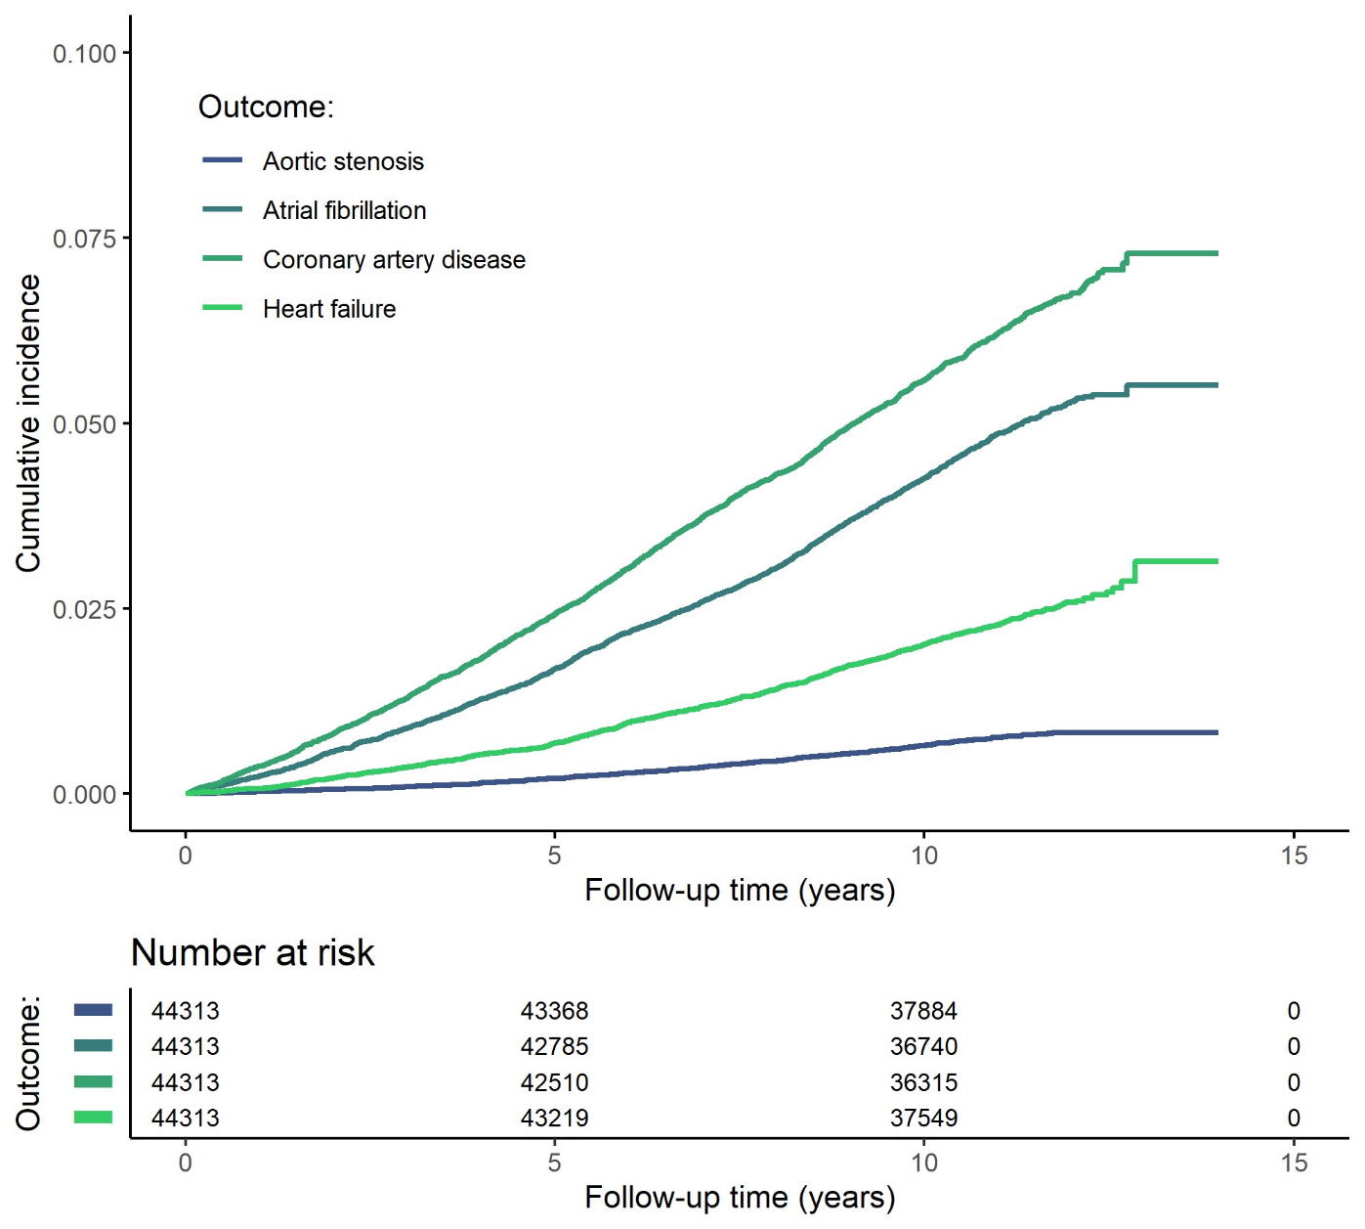
Supplementary Fig. 1. Cumulative incidence of coronary artery disease, heart failure, atrial fibrillation, and aotic stenosis during follow-up.
Cumulative incidence plots were constructed using the Kaplan-Meier method. Participants were followed for a median (interquartile range) follow-up of 11.1 (10.4-11.8) years

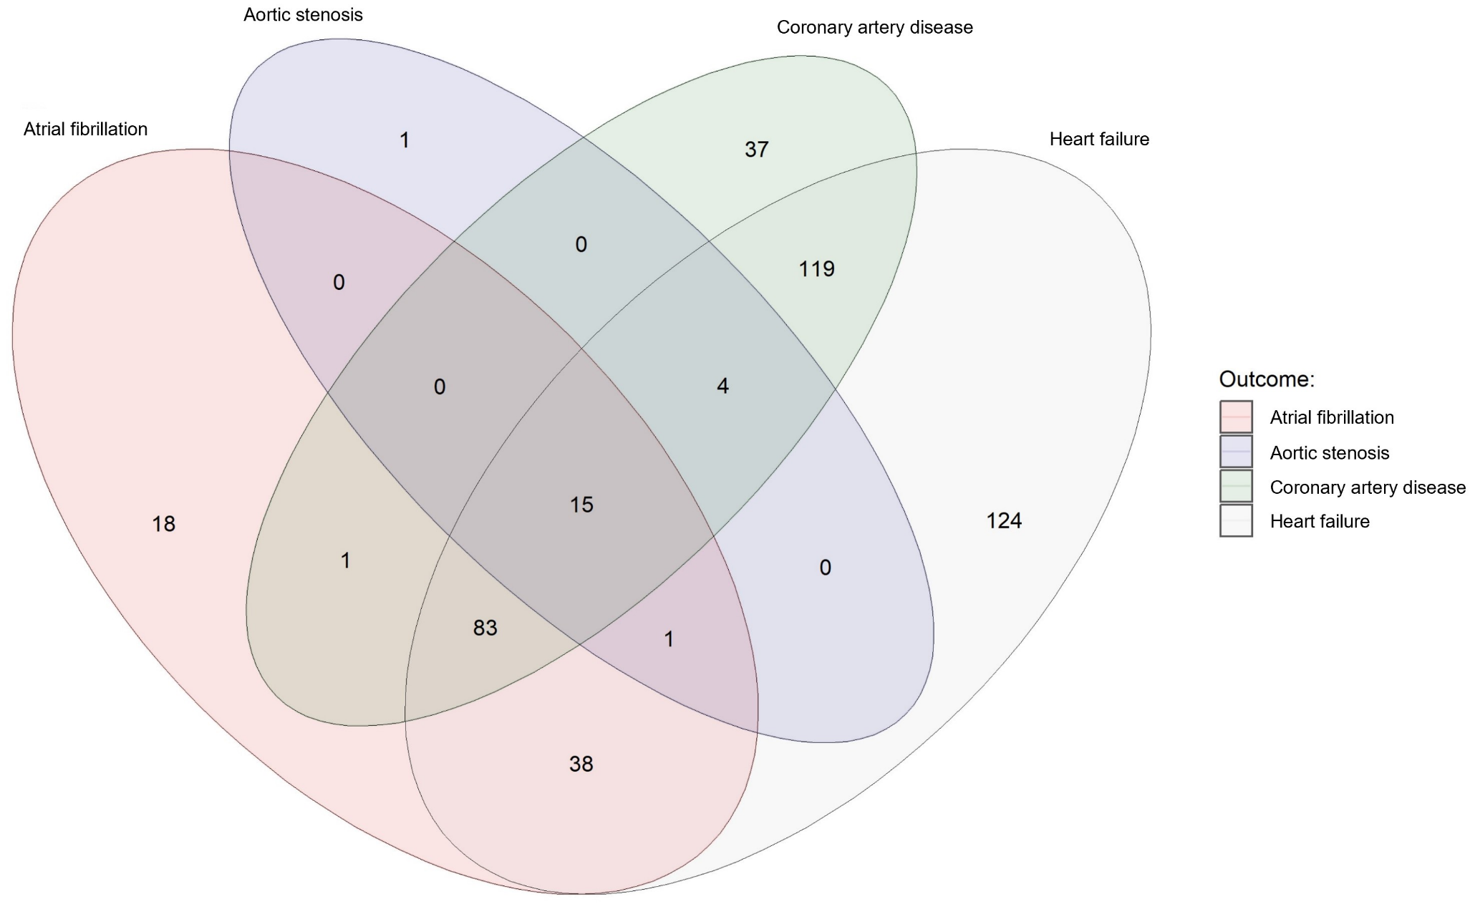
Supplementary Fig. 2. Venn diagram showing the number of distinct and shared protein associations across outcomes.
All 441 proteins that were associated with one or more outcomes at Bonferroni-corrected P<0.05 are represented in this graph.

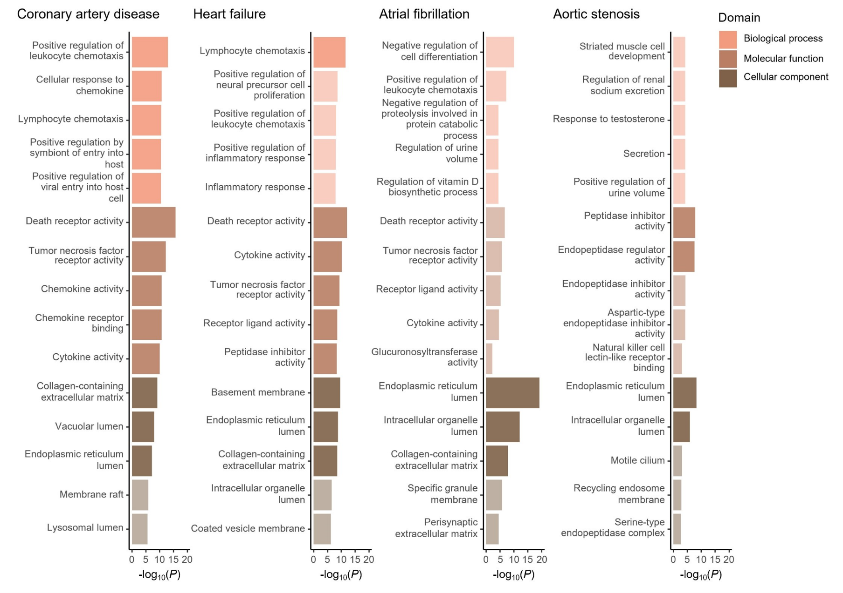
Supplementary Fig. 3. Top biological processes, molecular functions, and cellular components enriched among proteins associated with coronary artery disease, heart failure, atrial fibrillation, and aortic stenosis.
Top biological functions, molecular pathways, and cellular components were queried using the Gene Ontology resource^{21,22} via Enrichr.²³ Enrichment tests were performed against a background gene set that included the genes corresponding to all 1,459 proteins tested in primary analyses. Gene sets with a false discovery rate-adjusted P<0.05 were considered statistically significant. Bright colors indicate statistical significance, whereas dull colors indicate no statistical significance.

Supplementary Fig. 4. Correlation between the effect sizes of protein-disease associations in male vs. female participants.
The scatter plots depict the correlation between the protein-disease associations’ effect sizes (i.e., log[HR]) in female vs. male participants. HR indicates hazard ratio. All estimates were calculated using multivariable-adjusted Cox proportional hazards models, adjusted for age, age², self-reported race/ethnicity, the first ten principal components of genetic ancestry, smoking, normalized Townsend deprivation index, body mass index, systolic blood pressure, antihypertensive medication use, total cholesterol, high-density lipoprotein cholesterol, cholesterol-lowering medication use, serum creatinine, and prevalent type 2 diabetes. In addition, we included the cardiac outcomes that were not tested (e.g., heart failure, atrial fibrillation, and aortic stenosis for incident coronary artery disease models) as time-varying covariates. The labeled protein-disease represent proteins that were associated with the indicated outcome at P<0.05/5,836 in one sex without nominal significance (P>0.05) in the other sex. In addition, all proteins indicated in color had suggestive evidence for interaction by sex (P_{interaction}<0.05). HR indicates hazard ratio.

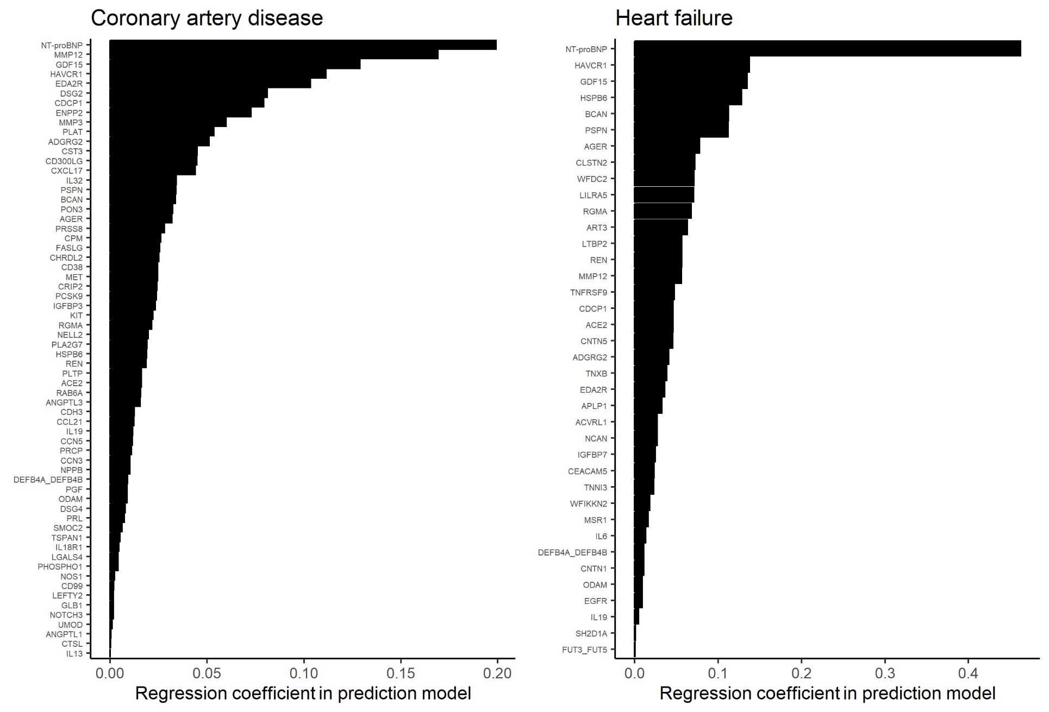
Supplementary Fig. 5. Protein weights for the protein-based prediction models of coronary artery disease, heart failure, atrial fibrillation, and aortic stenosis.

Supplementary Fig. 6. Risk prediction of incident atrial fibrillation by risk scores incorporating NT-proBNP and all proteins except NT-proBNP and NPPB.
The receiver-operating characteristics curves depict the accuracy of the clinical, proteomic, and combined risk scores in predicting atrial fibrillation events in the UKB-PPP testing set (n=8,863). Areas under the curve (AUCs) and corresponding 95% confidence intervals (95% CIs) quantify the performance of each model. Models with multiple candidate features were constructed using logistic least absolute shrinkage and selection operator (LASSO) models; the combined models included all clinical predictors (see Methods) as well as the indicated biomarkers (i.e., NT-proBNP or all proteins except NT-proBNP and NPPB) as potential covariates in the final model. Participants were followed for a median (interquartile range) follow-up of 11.1 (10.4-11.8) years.

Supplementary Fig. 7. Risk prediction of incident heart failure by risk scores incorporating NT-proBNP and all proteins except NT-proBNP and NPPB.
The receiver-operating characteristics curves depict the accuracy of the clinical, proteomic, and combined risk scores in predicting heart failure events in the UKB-PPP testing set (n=8,863). Areas under the curve (AUCs) and corresponding 95% confidence intervals (95% CIs) quantify the performance of each model. Models with multiple candidate features were constructed were constructed using logistic least absolute shrinkage and selection operator (LASSO) models; the combined models included all clinical predictors (see Methods) as well as the indicated biomarkers (i.e., NT-proBNP or all proteins except NT-proBNP and NPPB) as potential covariates in the final model. Participants were followed for a median (interquartile range) follow-up of 11.1 (10.4-11.8) years.

Supplementary Tables (legends)
All Supplementary Tables can be found in the supplementary Excel file.

Supplementary Table 1. Description of the Olink Explore 1536 proteins included in the present study.
When a single Olink analyte was encoded by two different genes, information for both genes were listed.

Supplementary Table 2. Missing protein measurements among the included participants. Missing protein measurements were quantified in UKB-PPP participants who were included in the final study cohort (N=44,313).

Supplementary Table 3. Associations of circulating protein levels with coronary artery disease, heart failure, atrial fibrillation, and aortic stenosis.
All estimates were calculated using multivariable-adjusted Cox proportional hazards models, adjusted for age, age², sex, self-reported race/ethnicity, the first ten principal components of genetic ancestry, smoking, normalized Townsend deprivation index, body mass index, systolic blood pressure, antihypertensive medication use, total cholesterol, high-density lipoprotein cholesterol, cholesterol-lowering medication use, serum creatinine, and prevalent type 2 diabetes. In addition, we included the cardiac outcomes that were not tested (e.g., heart failure, atrial fibrillation, and aortic stenosis for incident coronary artery disease models) as time-varying covariates. Protein-disease associations with Bonferroni-corrected P<0.05 (i.e., P<0.05/5,836 or ~8.6×10-6) were considered statistically significant. CI indicates confidence interval; HR, hazard ratio.

Supplementary Table 4. Top biological processes, molecular functions, and cellular components enriched among proteins associated with coronary artery disease, heart failure, atrial fibrillation, and aortic stenosis.
Top biological functions, molecular pathways, and cellular components were queried using the Gene Ontology resource via Enrichr. Enrichment tests were performed against a background gene set that included the genes corresponding to all 1,459 proteins tested in primary analyses. Gene sets with a false discovery rate-adjusted P<0.05 were considered statistically significant. The five most strongly enriched pathways per Gene Ontology domain are listed for each outcome.

Supplementary Table 5. Genetic variants included in the genetic instruments for all proteins with valid cis-protein quantitative trait loci (cis-pQTLs).
There were a total of 408 proteins with valid cis-pQTLs. All positions are expressed using Genome Reference Consortium Human Build 37 (GRCh37; hg19). pQTL indicates protein quantitative trait locus; SE, standard error.

Supplementary Table 6. F-statistics and R² estimates for the genetic instruments tested in cis-Mendelian randomization (MR) analyes.
F-statistics were obtained by performing linear regression analyses of a protein’s genetic risk score (as the independent variable) against the measured levels of that protein (as the dependent variable) in the UKB-PPP. Genetic risk scores were calculated as weighted allele scores using the “clumping and thresholding” method, applying the same P-value and linkage disequilibrium R² thresholds as those used in our primary cis-MR analyses (P<5×10⁻⁶ and R²<0.1). All scores were calculated using genotype array data; for proteins where genetic risk score calculation failed, F-statistics were estimated using summary statistics as F=((n-k-1)/k)×((R²)/(1-R²)) where n indicates the sample size of the original genome-wide association study, k the number of variants included in the genetic instrument, and R² the variance in the exposure explained by the genetic variants.

Supplementary Table 7. Steiger filtering results for protein-disease pairs tested in sensitivity cis-Mendelian randomization (MR) analyses.
Steiger filtering was performed and R² values were estimated using the steiger_filtering() function from the TwoSampleMR package in R.

Supplementary Table 8. Associations of genetically predicted protein levels with coronary artery disease, heart failure, atrial fibrillation, and aortic stenosis in primary cis-Mendelian randomization (MR) analyses.
All analyses represent cis-MR analyses performed using the inverse-variance-weighted (IVW) method (for instruments with two or more variants) or the Wald ratio method (for instruments with a single variant). Genetic instruments were constructed using cis-variants associated with circulating protein levels at P<1×10⁻⁴ clumped at R²<0.1. All associations are expressed per standard deviation increase in genetically predicted protein levels. CI indicates confidence interval; OR, odds ratio.

Supplementary Table 9. Associations of genetically predicted protein levels with coronary artery disease, heart failure, atrial fibrillation, and aortic stenosis in sensitivity Mendelian randomization (MR) analyses using different instrument construction parameters and MR-Egger.
All analyses represent cis-MR analyses performed using the indicated methods. Genetic instruments were constructed using cis-variants associated with circulating protein levels that were clumped at the indicated P-value and R² thresholds. Analyses using the inverse-variance-weighted (IVW) method incorporating principal components used genetic instruments that were not clumped against a correlation threshold. Associations were considered robust if the primary analysis was statistically significant (false discovery rate [FDR]-adjusted P<0.05) and all sensitivity analyses were directionally consistent. N/A indicates that we were unable to calculate MR estimates (if no variants met the genetic instrument selection criteria). CI indicates confidence interval; LD, linkage disequilibrium; OR, odds ratio.

Supplementary Table 10. Associations of genetically predicted protein levels with coronary artery disease, heart failure, atrial fibrillation, and aortic stenosis in one-sample cis-Mendelian randomization (MR) analyses.
All proteins with putative causal associations that were robust to the sensitivity analyses presented in Supplementary Table 9 were tested in one-sample MR analyses. One-sample MR was performed in UKB participants who were not included in the UKB-PPP, were free of cardiac diseases at baseline, and had no missing covariates (N=407,230). Associations of the circulating proteins’ genetic scores with cardiac outcomes were tested using Cox regression models adjusted for age, age², sex, race/ethnicity, and the first ten principal components of genetic ancestry. N/A indicates proteins for which genetic score calculation failed. CI indicates confidence interval; HR, hazard ratio; IVW, inverse-variance weighted; LD, linkage disequilibrium; OR, odds ratio.

Supplementary Table 11. Evaluation of shared protein quantitative trait loci (pQTLs) between proteins for biomarkers that were robust to sensitivity cis-Mendelian randomization (MR) analyses.
Linear regression analyses tested the associations of genetic scores for all proteins surviving upstream sensitivity analyses (Supplementary Tables 9-10) with all proteins with putative causal associations in the primary cis-MR analyses. Linear regression models were adjusted for age, age², sex, race/ethnicity, and the first ten principal components of genetic ancestry. Associations with Bonferroni-corrected P<0.05/13,680 (~3.7×10⁻⁶) were considered statistically significant. CI indicates confidence interval.

Supplementary Table 12. Multivariable-adjusted cis-Mendelian randomization (MR) analyses testing the genetic associations of proteins robust to sensitivity analyses with coronary artery disease, heart failure, atrial fibrillation, and aortic stenosis, adjusting for proteins with shared protein quantitative trait loci (pQTLs).
For proteins with genetic instruments that were robust to upstream sensitivity analyses (Supplementary Tables 9-10) and significantly associated with one or more other proteins (i.e., “correlated proteins”; Supplementary Table 11), we calculated multivariable-adjusted cis-MR estimates in a UKB sample excluding UKB-PPP participants, those with cardiac diseases at baseline, and those with missing covariates (N=407,230) using Cox regression models. ªCox regression models were adjusted for age, age², sex, race/ethnicity, the first ten principal components of genetic ancestry, and the genetic risk scores of all “correlated” proteins (i.e., the listed proteins). CI indicates confidence interval; HR, hazard ratio.

Supplementary Table 13. Colocalization of cis-protein quantitative trait loci (pQTLs) with cardiac diseases for protein-diseases associations that were robust to sensitivity Mendelian randomization (MR) analyses.
Colocalization analyses were performed for all protein-disease associations that were robust to sensitivity MR analyses, using cis-variants (using a window size of ±200 kilobases) associated with circulating protein levels. The current table shows posterior probabilities for H₀ (neither trait has a genetic association in the region), H₁ (only trait 1 [i.e., the indicated protein's circulating levels] has a genetic association in the region), H₂ (only trait 2 [i.e., the indicated disease] has a genetic association in the region), H₃ (both traits are associated but with different causal variants), and H₄ (both traits are associated and share a single causal variant).

Supplementary Table 14. Sex-stratified associations of circulating protein levels with coronary artery disease, heart failure, atrial fibrillation, and aortic stenosis.
P_{interaction} indicates the P-value for the interaction term between “sex” and the indicated protein on the corresponding outcome. All associations were tested using multivariable-adjusted Cox proportional hazards models, adjusted for age, age², self-reported race/ethnicity, the first ten principal components of genetic ancestry, smoking, normalized Townsend deprivation index, body mass index, systolic blood pressure, antihypertensive medication use, total cholesterol, high-density lipoprotein cholesterol, cholesterol-lowering medication use, serum creatinine, and prevalent type 2 diabetes. In addition, we included the cardiac outcomes that were not tested (e.g., heart failure, atrial fibrillation, and aortic stenosis for incident coronary artery disease models) as time-varying covariates. Interaction models were additionally adjusted for sex and circulating levels of the indicated protein.

Supplementary Table 15. Coefficients for the covariates included in the protein-based, clinical, and combined prediction models for coronary artery disease, heart failure, atrial fibrillation, and aortic stenosis.
All risk scores were constructed in the training set using logistic least absolute shrinkage and selection operator (LASSO) regression analyses with 10-fold cross-validation in the UKB-PPP training set (80%: n=35,450). N/A indicates not applicable; SD, standard deviation.

Supplementary Table 16. Diagnostic and procedural codes used to define disease-related covariates and outcomes.
Prevalent disease status was ascertained by self-report at enrolment or qualifying diagnostic or procedural codes. Incident disease status was ascertained by qualifying diagnostic or procedural codes. ICD indicates International Classification of Diseases; OPCS indicates Office of Population Censuses and Surveys Classification of Surgical Operations and Procedures.

References
1. Zhong W, Edfors F, Gummesson A, Bergström G, Fagerberg L, Uhlén M. Next generation plasma proteome profiling to monitor health and disease. Nat Commun. 2021;12:1-12. doi:10.1038/s41467-021-22767-z
2. Gadd DA, Hillary RF, Kuncheva Z, Mangelis T, Cheng Y, Dissanayake M, Admanit R, Gagnon J, Lin T, Ferber K, et al. Blood protein levels predict leading incident diseases and mortality in UK Biobank. medRxiv. Published August 4, 2023. Accessed September 6, 2023. https://www.medrxiv.org/content/10.1101/2023.05.01.23288879v2
3. Sun BB, Chiou J, Traylor M, Benner C, Hsu YH, Richardson TG, Surendran P, Mahajan A, Robins C, Vasquez-Grinnell SG, et al. Genetic regulation of the human plasma proteome in 54,306 UK Biobank participants. bioRxiv. Published June 18, 2022. Accessed September 6, 2023. https://www.biorxiv.org/content/10.1101/2022.06.17.496443v1
4. Hastie T, Tibshirani R, Narasimhan B, Chu G. impute: Imputation for microarray data. Published September 8, 2023. Accessed September 9, 2023. https://www.bioconductor.org/packages/devel/bioc/manuals/impute/man/impute.pdf
5. Jordan H, Roderick P, Martin D. The Index of Multiple Deprivation 2000 and accessibility effects on health. J Epidemiol Community Health (1978). 2004;58:250-257. doi:10.1136/JECH.2003.013011
6. Bycroft C, Freeman C, Petkova D, Band G, Elliott LT, Sharp K, Motyer A, Vukcevic D, Delaneau O, O’Connell J, et al. The UK Biobank resource with deep phenotyping and genomic data. Nature. 2018;562:203-209. doi:10.1038/s41586-018-0579-z
7. Schmidt AF, Finan C, Gordillo-Marañón M, Asselbergs FW, Freitag DF, Patel RS, Tyl B, Chopade S, Faraway R, Zwierzyna M, et al. Genetic drug target validation using Mendelian randomisation. Nat Commun. 2020;11:1-12. doi:10.1038/s41467-020-16969-0
8. Swerdlow DI, Kuchenbaecker KB, Shah S, Sofat R, Holmes M V., White J, Mindell JS, Kivimaki M, Brunner EJ, Whittaker JC, et al. Selecting instruments for Mendelian randomization in the wake of genome-wide association studies. Int J Epidemiol. 2016;45:1600-1616. doi:10.1093/IJE/DYW088
9. Purcell S, Neale B, Todd-Brown K, Thomas L, Ferreira MAR, Bender D, Maller J, Sklar P, De Bakker PIW, Daly MJ, et al. PLINK: A tool set for whole-genome association and population-based linkage analyses. Am J Hum Genet. 2007;81:559-575. doi:10.1086/519795
10. The 1000 Genomes Project Consortium. A global reference for human genetic variation. Nature. 2015;526:68-74. doi:10.1038/nature15393
11. Ardissino M, Morley AP, Slob EAW, Schuermans A, Rayes B, Raisi-Estabragh Z, de Marvao A, Burgess S, Rogne T, Honigberg MC, et al. Birth weight influences cardiac structure, function, and disease risk: evidence of a causal association. Eur Heart J. Published online September 20, 2023. doi:10.1093/EURHEARTJ/EHAD631
12. Henry A, Gordillo-Marañón M, Finan C, Schmidt AF, Ferreira JP, Karra R, Sundström J, Lind L, Arnlöv J, Zannad F, et al. Therapeutic Targets for Heart Failure Identified Using Proteomics and Mendelian Randomization. Circulation. 2022;145:1205-1217. doi:10.1161/CIRCULATIONAHA.121.056663
13. Burgess S, Dudbridge F, Thompson SG. Combining information on multiple instrumental variables in Mendelian randomization: comparison of allele score and summarized data methods. Stat Med. 2016;35:1880-1906. doi:10.1002/SIM.6835
14. Burgess S, Zuber V, Valdes-Marquez E, Sun BB, Hopewell JC. Mendelian randomization with fine‐mapped genetic data: Choosing from large numbers of correlated instrumental variables. Genet Epidemiol. 2017;41:714. doi:10.1002/GEPI.22077
15. Gkatzionis A, Burgess S, Newcombe PJ. Statistical methods for cis-Mendelian randomization with two-sample summary-level data. Genet Epidemiol. 2023;47:3-25. doi:10.1002/GEPI.22506
16. Hemani G, Zheng J, Elsworth B, Wade KH, Haberland V, Baird D, Laurin C, Burgess S, Bowden J, Langdon R, et al. The MR-base platform supports systematic causal inference across the human phenome. Elife. 2018;7. doi:10.7554/ELIFE.34408
17. Yavorska OO, Burgess S. MendelianRandomization: an R package for performing Mendelian randomization analyses using summarized data. Int J Epidemiol. 2017;46:1734-1739. doi:10.1093/IJE/DYX034
18. Giambartolomei C, Vukcevic D, Schadt EE, Franke L, Hingorani AD, Wallace C, Plagnol V. Bayesian Test for Colocalisation between Pairs of Genetic Association Studies Using Summary Statistics. PLoS Genet. 2014;10:e1004383. doi:10.1371/JOURNAL.PGEN.1004383
19. Friedman J, Hastie T, Tibshirani R. Regularization Paths for Generalized Linear Models via Coordinate Descent. J Stat Softw. 2010;33:1-22. doi:10.18637/JSS.V033.I01
20. Robin X, Turck N, Hainard A, Tiberti N, Lisacek F, Sanchez JC, Müller M. pROC: An open-source package for R and S+ to analyze and compare ROC curves. BMC Bioinformatics. 2011;12:1-8. doi:10.1186/1471-2105-12-77/TABLES/3
21. Ashburner M, Ball CA, Blake JA, Botstein D, Butler H, Cherry JM, Davis AP, Dolinski K, Dwight SS, Eppig JT, et al. Gene Ontology: tool for the unification of biology. Nat Genet. 2000;25:25-29. doi:10.1038/75556
22. Carbon S, Douglass E, Good BM, Unni DR, Harris NL, Mungall CJ, Basu S, Chisholm RL, Dodson RJ, Hartline E, et al. The Gene Ontology resource: enriching a GOld mine. Nucleic Acids Res. 2021;49:D325-D334. doi:10.1093/NAR/GKAA1113
23. Kuleshov M V., Jones MR, Rouillard AD, Fernandez NF, Duan Q, Wang Z, Koplev S, Jenkins SL, Jagodnik KM, Lachmann A, et al. Enrichr: a comprehensive gene set enrichment analysis web server 2016 update. Nucleic Acids Res. 2016;44:W90-W97. doi:10.1093/NAR/GKW377

