Supplementary materials
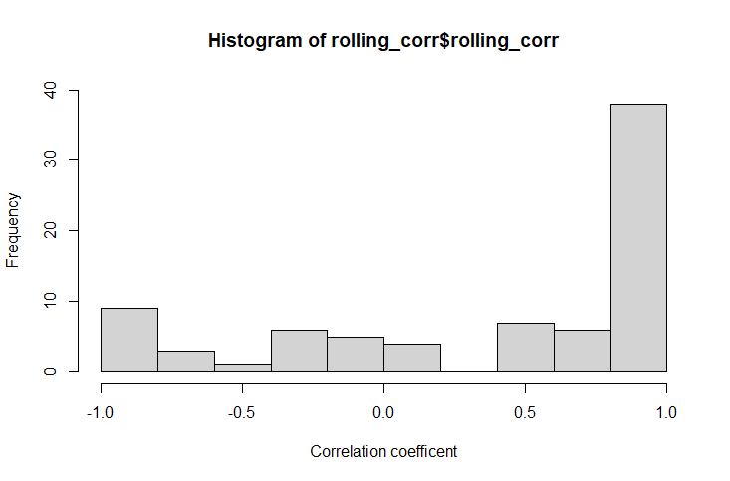

Figure 1. Histogram of the frequency distribution of 3-day rolling Pearson correlation coefficients estimated using ONS and Virus Watch (including SGSS and Pillar 2 linked data) estimated COVID-19 incidence rates in England from 22 June 2020 to 13 June 2022.

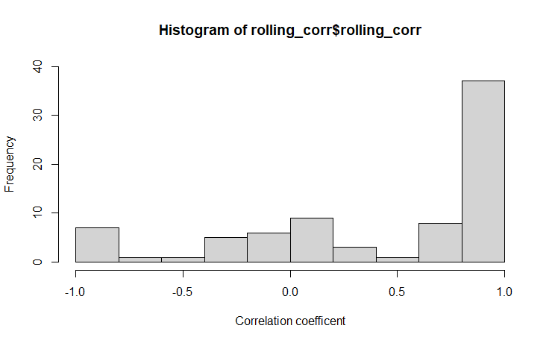
Figure 2. Histogram of the frequency distribution of 3-day rolling Pearson correlation coefficients estimated using ONS and Virus Watch (excluding SGSS and Pillar 2 linked data) estimated COVID-19 incidence rates in England from 22 June 2020 to 13 June 2022.

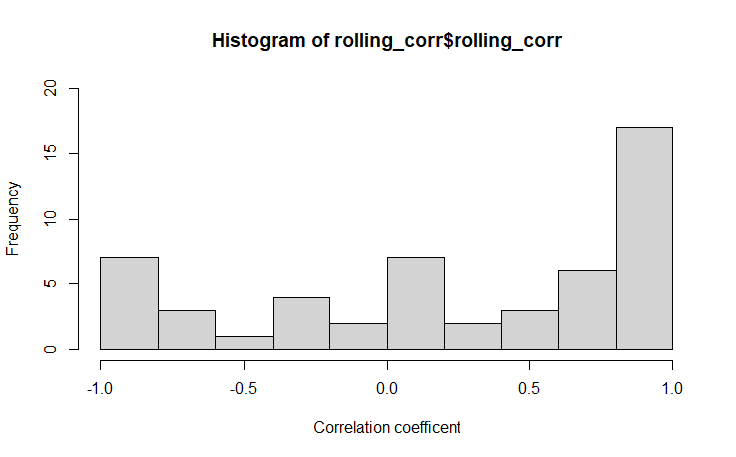
Figure 3. Histogram of the frequency distribution of 3-day rolling Pearson correlation coefficients estimated using ONS and Virus Watch estimated COVID-19 incidence rates in Wales from 22 June 2020 to 13 June 2022.

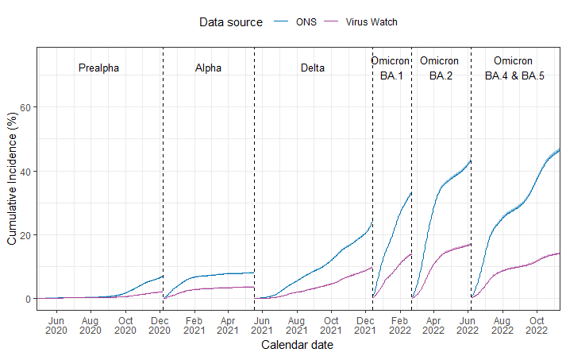
Figure 4. Virus Watch and ONS estimated cumulative incidence by period (dominant variant of concern) in England from 26 April 2020 to 11 November 2022.

Table 1. Virus Watch and ONS estimated cumulative incidence by period (variant) for all ages in England from 26 April 2020 to 11 November 2022.
 | Virus Watch  Cumulative Incidence  (95% Confidence Interval) | ONS  Cumulative Incidence  (95% Credible Interval)
pre-Alpha | 2.1% (2.0% - 2.3%) | 7.0% (6.9% - 7.2%)
Alpha | 3.6% (3.5% - 3.8%) | 8.1% (7.9% - 8.2%)
Delta | 9.8% (9.5% - 10.0%) | 24.2% (23.9% - 24.5%)
Omicron BA.1 | 14.0% (13.7% - 14.3%) | 33.6% (33.1% - 34.0%)
Omicron BA.2 | 17.0% (16.7% - 17.4%) | 43.6% (43.1% - 44.1%)
Omicron BA.4 & 5 | 14.1% (13.8% -14.5 %) | 46.5% (45.9% - 47.1%)

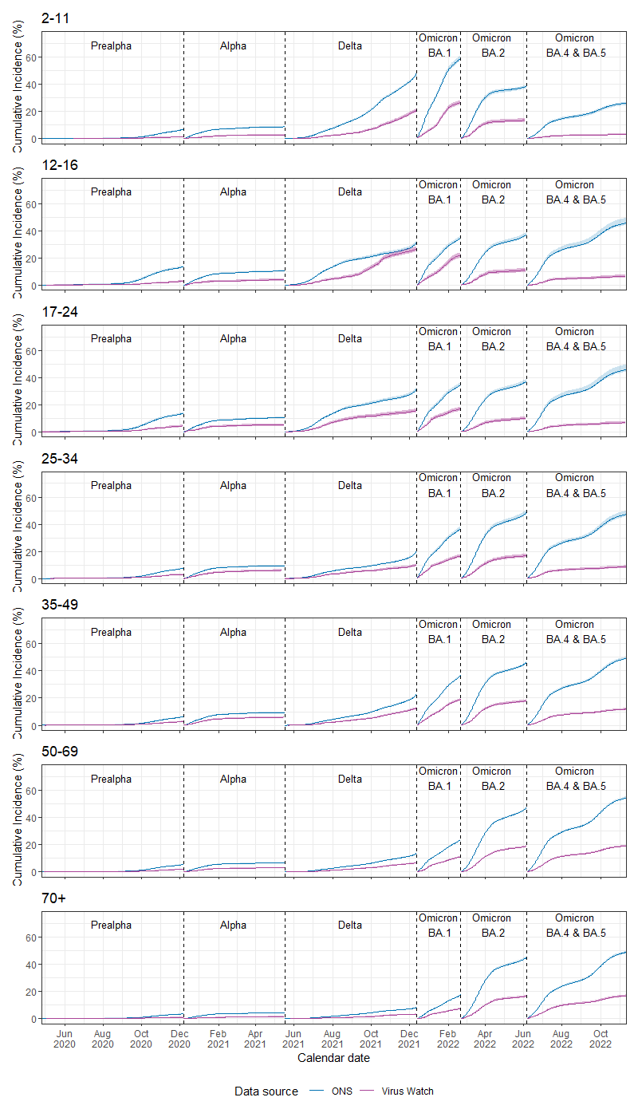
Figure 5. Virus Watch and ONS-estimated cumulative incidence by period (dominant variant of concern) and age group in England from 26 April 2020 to 11 November 2022.

