Molecular and micro-architectural mapping of abnormal gray matter developmental trajectories in psychosis

SUPPLEMENTARY INFORMATION

Datasets description 2
ABCD – Adolescent Brain and Cognitive Development 2
ALSPAC – Avon Longitudinal Study of Parents and Children 2
ASRB – Australian Schizophrenia Research Bank 3
B-SNIP – Bipolar & Schizophrenia Consortium for Parsing Intermediate Phenotypes 3
LA5c – UCLA Consortium for Neuropsychiatric Phenomics LA5c Study 4
MCIC – Mental Illness and Neuroscience Discovery (MIND) Institute Clinical Imaging Consortium 4
PAFIP – Programa de Atención a las Fases Iniciales de Psicosis 5
UKB - UK Biobank 6
Sample demographics 6
Neurobiological features 7
Extended data figures 8
REFERENCES 15

Datasets description

ABCD – Adolescent Brain and Cognitive Development
The ABCD study (NDA ID:2668) is a landmark, longitudinal study of brain development and child health¹. A baseline cohort of 11,500 nine- and ten-year-old children (and their parents/guardians) are being recruited and will be followed for ten years with annual lab-based assessments including biennial MRI². The study evaluates brain maturation within the context of social, emotional, and cognitive development, as well as a variety of health and environmental outcomes. ABCD Study employed probability sampling of U.S. schools within the 21 catchment areas as the primary method for contacting and recruiting eligible children and their parents. Sampling of schools and consenting students/parents has also been used to recruit cohorts for a number of major national studies. Individuals were included in the reference model as healthy controls based on the parental response to the ABCD screening and risk questionnaire (https://nda.nih.gov/data_structure.html?short_name=abcd_screen01) indicating the individual had never been diagnosed with a mental health disorder.
The ABCD Study builds upon existing state-of-the-art imaging protocols from the Pediatric Imaging, Neurocognition, and Genetics (PING) study³, and the Human Connectome Project (HCP; ref. ⁴) for the collection of multimodal data: T₁-weighted and T₂-weighted structural MRI (sMRI), diffusion MRI (dMRI), and functional MRI (fMRI), including both resting-state fMRI (rs-fMRI) and task-fMRI⁵.
MRI data were acquired using 3T MRI scanners (Siemens Prisma and Prisma Fit, GE MR 750, and Philips Achieva dStream and Ingenia; ref. ⁵). The ABCD imaging protocol was harmonized across data collection sites for three 3T scanning systems, all of which used standard adult-size multi-channel head coils and multiband echo planar imaging acquisitions⁶. High-resolution structural imaging sequences, such as T₁-weighted (1.0 mm isotropic voxels) and T₂-weighted axial fast-spoiled gradient echo sequence (repetition time [TR] = 2400-2500 ms, echo time [TE] = 2-2.9 ms, matrix size = 256×256, field-of-view [FOV] = 256×240-256 mm², flip angle = 8°, inversion delay = 1060 ms, and 176-225 sections), were employed to capture detailed information of the brain anatomy. Images were corrected for distortions and head motion. FreeSurfer version 6.0.1 software (http://surfer.nmr.mgh.harvard.edu; ref. ⁷) was used to perform the cortical reconstruction and volumetric segmentation, and cortical or subcortical regions were parcellated and labeled with atlas classification.

ALSPAC – Avon Longitudinal Study of Parents and Children
ALSPAC (https://www.bristol.ac.uk/alspac/researchers/access/) is a pregnancy and birth cohort established to identify the factors influencing child health and developmental outcomes⁸. The study is composed by pregnant women from Avon, South West of England, with an expected date of delivery between 1 April 1991 and 31 December 1992, who had completed the questionnaire scheduled for the third trimester of pregnancy^{9–11} . Between the ages of 18 to 24 years, a subset of ALSPAC offspring were invited to participate in three different neuroimaging studies, including the ALSPAC Psychotic Experiences (PE) study, where participants were assessed for PE using the psychotic-like symptoms semi-structured interview (PLIKS; refs. ^{12,13}), administered by trained psychologists. Those who were found to have one or more PE were invited to undergo scanning. The presence of PE was confirmed using the clinical criteria of the Schedule for Clinical Assessment in Neuropsychiatry (SCAN; ref. ¹⁴) and excluded experiences occurring due to waking, falling asleep, fever or drug consumption¹⁵. Participants who did not exhibit any symptoms of PE were randomly selected to form the control group and undergo scanning. All data were acquired at Cardiff University Brain Research Imaging Centre (CUBRIC) on a 3 Tesla General Electric HDx (GE Medical Systems, Milwaukee, WI) using an eight-channel receive only head RF head coil T₁-weighted structural images were acquired with a 3D fast spoiled gradient echo (FSPGR) sequence (TR = 7.8 ms, TE = 3.0 ms, TI = 450 ms, flip angle = 20°, voxel size = 1 mm³ isomorphic). T₂-weighted whole brain scans were acquired using a coronal TSE sequence (for 3T: TR = 10,000 ms, TE = 14 ms, FA = 149, Bandwidth = 193 and NEX = 1; for 1.5T: TR = 9000 ms, TE = 64 ms, FA = 180, Bandwidth = 149 and NEX = 2; voxel size same as for T₁ scans). sMRI images were processed using the automated FreeSurfer 6.0.0 software package for brain imaging⁸. Ethical approval for this study was given by both the Cardiff University School of Psychology Ethics Committee and the ALSPAC Ethics and Law Committee, and informed consent was obtained from all participants (ALSPAC project ID B709).

ASRB – Australian Schizophrenia Research Bank
The ASRB is a comprehensive biobank of clinical, neuroimaging and genetic data acquired in individuals with schizophrenia and healthy comparison individuals¹⁶. Assessments consist of the Diagnostic Interview for Psychosis (DIP), which is used to establish a lifetime diagnosis of a psychotic disorder, as well as present and lifetime substance use disorder diagnoses, according to DSM-IV and ICD-10 criteria¹⁷. Participants are English speaking (required for neuropsychological assessments) and aged 18-65 years. Exclusion criteria included any neurological disorder, history of brain trauma followed by a long period of amnesia (> 24 h), intellectual disability (full-scale IQ < 70), movement disorders, current substance dependence, as well as electroconvulsive therapy in the past 6 months. Controls were participants who had not personal or family history of psychosis or bipolar 1 disorder.
Participants were recruited from five sites in Australia, with all sites implementing the same recruitment procedures and MRI acquisition protocols. An individual travelled to all five sites and was scanned at each site to quantify gross inter-site differences. Structural and diffusion-weighted MRI scans of brain anatomy were acquired using Siemens Avanto 1.5T MRI scanners located in Melbourne, Sydney, Brisbane, Perth and Newcastle. A Siemens MRI phantom was scanned at each site to enable inter-site calibration and minimize potential inter-site variability. The same acquisition sequence was used at all sites. Structural T₁-weighted images were acquired using an optimized MPRAGE sequence (TR = 1980 ms, TE = 4.3 ms, flip angle = 15, FOV = 256x256x176 mm, voxel resolution = 1 mm³ isotropic; ref. ¹⁸). Participants showing gross artefacts, cerebellar cropping and/or significant head motion were excluded, following protocols established as part of a prior study in this cohort. Calculation was undertaken using FreeSurfer 6.0.1. Approval to contribute ASRB data to this study was granted by the ASRB Access Committee on December 17, 2020.

B-SNIP – Bipolar & Schizophrenia Consortium for Parsing Intermediate Phenotypes
B-SNIP is a multicenter dataset available through NDAR (ID: 2274) that includes individuals diagnosed with psychosis, including schizophrenia (SCZ), schizoaffective disorder (SAD) and psychotic bipolar disorder (BDP); as well as their first-degree relatives and healthy volunteers without psychotic illness in their immediate family^{19,20}. Each proband was rated on a Schizo-Bipolar Scale, developed by the B-SNIP collaboration, which graded their component of the DSM’s criteria for each of the three psychosis disorders. The Schizo-Bipolar scale is graded from 1 (bipolar-like) to 10 (schizophrenia-like) with SAD in the middle. Volunteers participated in a SCID interview and relatives participated in additional interviews. Diagnosis was made in a consensus conference with multiple study-trained clinicians. Family history data were collected at a minimum from the most informed family member; more detailed information was gathered whenever possible.
Whole-brain structural MRI three-dimensional acquisitions were performed on 3T scanners (GE Signa, Philips Achieva, Siemens Allegra, and Siemens Trio; ref. ²¹). All participants at each site were scanned on the same magnet. High resolution isotropic T₁-weighted MP-RAGE sequences were obtained following the Alzheimer’s Disease Neuroimaging Initiative (ADNI) protocol (https://adni.loni.usc.edu/methods/mri-tool/mri-analysis/). For the present study raw structural T₁-weighted scans were processed with FreeSurfer 6.0.1.

LA5c – UCLA Consortium for Neuropsychiatric Phenomics LA5c Study
The LA5c dataset comprises data on OpenNeuro from the UCLA Consortium for Neuropsychiatric Phenomics LA5c Study (https://openfmri.org/dataset/ds000030/) which includes imaging of a large group of healthy individuals from the community as well as samples of individuals diagnosed with schizophrenia, bipolar disorder, and ADHD. To be included individuals had to be either “White, Not of Hispanic or Latino Origin” or “Hispanic or Latino, of Any Race” following NIH designations of racial and ethnic minority groups and have completed at least 8 years of education (other racial and ethnic minority groups were excluded because this was thought to increase risk of confounding planned genetic studies). The participants, ages 21-50, were recruited by community advertisements from the Los Angeles area and completed extensive neuropsychological testing, in addition to fMRI and T₁-weighted Anatomical MPRAGE scanning. All participants were scanned on a 3T Siemens Trio at a single-center²². T₁-weighted MP-RAGE images were acquired with FOV = 250, 256x256 matrix, 176 1.0 mm sagittal partitions, TI = 1.1 s, TE = 3.5-3.3 ms, TR = 2.53 s and flip angle = 7. For the present study T₁-weighted scans were processed with FreeSurfer 6.0.1.

MCIC – Mental Illness and Neuroscience Discovery (MIND) Institute Clinical Imaging Consortium
The Mental Illness and Neuroscience Discovery Institute (MIND) Institute, now the Mind Research Network (MRN; https://www.mrn.org/) formed the MIND Clinical Imaging Consortium (MCIC) in 2003 to conduct a multi-institutional, cross-sectional study of patients with schizophrenia and demographically matched, by sex and age, healthy controls to identify quantitative neuroimaging biomarkers for this devastating disease²³. All subjects were between the ages of 18 and 60 and spoke English as their native language. To be included in the schizophrenia cohort, patients had to meet DSM-IV diagnostic criteria for schizophrenia, schizoaffective or schizophreniform disorder. Concerted effort was made to recruit patients early in the course of their illness and especially those who were antipsychotic drug naïve. Patients were not excluded from the study because of substance abuse or dependence withing the past month, except for 6 patients who were found to meet criteria for current abuse after the study data was collected. The healthy control subjects without any current or previous psychiatric illness, including substance abuse or dependence, were matched within site to the patient cohort for age, sex, and parental education. Control subjects who had not been diagnosed with any psychiatric disorders, but had been medicated with antidepressants, anti-anxiety medication or medication for sleep disturbance were included in the study provided that the duration of their medication did not exceed 2 months of lifetime use and no medication was used within the 6 months preceding the baseline MRI scan. Both patients and controls were excluded if they had (1) an IQ < 70 based on a standardized IQ test, (2) history of a head injury resulting in prolonged loss of consciousness, neurosurgical procedure, neurological disease, history of skull fracture, severe or disabling medical conditions, or (3) a contraindication for MRI scanning such as pregnancy, metal in body or head including implanted pacemaker, medication pump, vagal stimulator, deep brain stimulator, implanted TENS unit, or ventriculoperitoneal shunt.
For each subject (patients and healthy controls), structural, DWI, and functional MR data were collected (Siemens Sonata, Siemens Trio, and GE Signa). Standardization of acquisition across sites was previously evaluated in a separate calibration and validation study²⁴. All imaging data were collected using scanners with field strengths of 1.5T or 3.0T and using closely matched acquisition sequences²³. Coronal T₁ and T₂ scans were collected during each structural imaging session. Imaging parameters for the T₁ scans were, for 3T: TR = 2530 ms, TE = 3.79 ms, FA = 7, TI = 1100 and Bandwidth = 181; for 1.5T: TR = 12 ms, TE = 4.76 ms, FA = 20 and Bandwidth = 110; 0.625×0.625 mm voxel size; slice thickness 1.5 mm; FOV 256×256×128 cm matrix; FOV = 16 cm (could be increased to 18 cm when needed for full brain coverage). T₁- weighted scans took approximately 13 minutes each and 2-3 volumes were acquired. T₂-weighted whole brain scans were acquired using a coronal TSE sequence with the following parameters for 3T: TR = 10,000 ms, TE = 14 ms, FA = 149, Bandwidth = 193 and NEX = 1; for 1.5T: TR = 9000 ms, TE = 64 ms, FA = 180, Bandwidth = 149 and NEX = 2; voxel size same as for T₁ scans. Acquisition of each volume took approximately 14.5 minutes, with 2 volumes acquired. Structural MRI data from the T₁-weighted volumes were also co-registered, motion corrected, averaged, and analyzed in an automated manner with atlas-based FreeSurfer 6.0.1 software. The MCIC imaging and clinical data are available through the COINS (COllaborative Informatics Neuroimaging Suite) database²⁵ and may be freely used with no restrictions.

PAFIP – Programa de Atención a las Fases Iniciales de Psicosis
PAFIP subjects were screened for the following criteria^{26,27}: (1) age 15 to 60 years; (2) DSM-IV criteria for a principal diagnosis of schizophreniform disorder, schizophrenia, schizoaffective disorder, brief reactive psychosis, schizotypal personality disorder, or psychosis not otherwise specified; (3) habitually living in the catchment area; (4) no prior treatment with antipsychotic medication or, if previously treated, a total lifetime of adequate antipsychotic symptoms of moderate severity or greater assessed by 1 of the 5 items of the Scale for the Assessment of Positive Symptoms (SAPS; https://www.ncbi.nlm.nih.gov/projects/gap/cgi-bin/GetPdf.cgi?id=phd000837.1). Patients were excluded for any of the following reasons: 1) met the DSM-IV criteria for drug dependence (except nicotine dependence), 2) met the DSM-IV criteria for mental retardation, or 3) had a history of neurological disease or head injury. There were no additional exclusion criteria for MRI except those specific to scanning logistics (e.g., claustrophobia, braces). The healthy volunteer group was recruited from the community through advertisements. They were required to have no current or previous psychiatric, mental retardation, neurological or general medical illnesses, including substance dependence and significant loss of consciousness, as determined by using an abbreviated version of the Comprehensive Assessment of Symptoms and History (CASH; ref. ²⁸). They were selected to have a similar distribution in age, gender, and drug use history to the patients. Clinical records and family interviews also confirmed the absence of psychosis in first-degree relatives. After a detailed description of the study, each subject gave written informed consent to participate.
Structural brain MRI scans were obtained at the Hospital Universitario Marqués de Valdecilla (HUMV) with the same 3T Philips Medical Systems MRI scanner (Achieva, Best, The Netherlands) using an 8-channel head coil²⁹. A 3D T₁-weighted sequence was acquired with the following parameters: TE = 3.7 ms, TR = 8.2 ms, flip angle = 8°, acquisition matrix = 256×256, voxel size = 0.94x0.94x1 mm and 160 contiguous slices. Images were first visually inspected for artefacts and gross anatomical abnormalities. Scan images were processed using the FreeSurfer 6.0.0 longitudinal stream.

UKB - UK Biobank
The UK Biobank (https://www.ukbiobank.ac.uk/) is a prospective cohort of 500,000 individuals from across the UK, aged between 40 and 69 at recruitment^{30–32}. Of these individuals, 100,000 will undergo brain scanning³³. Participants were excluded from the MRI study on the basis of standard MRI safety criteria such as metal implants, recent surgery, or conditions problematic for scanning such as hearing problems, breathing problems, or claustrophobia³⁴. Brain imaging is being conducted on the 3T Siemens Skyra (software platform VD13) system using a 32-channel receive head coil. The T₁ structural protocol is acquired at 1mm isotropic resolution (208x256x256) using a three-dimensional (3D) MPRAGE acquisition (R = 2, TI/TR = 800/2000 ms). Images were segmented into tissue types (gray matter, white matter, and cerebrospinal fluid; ref. ³⁵). Cortical gray matter volume was estimated, comparing the segmented gray matter to an atlas reference (where the external skull surface is used to normalize for head size³⁶). The T₂ protocol used a fluid-attenuated inversion recovery (FLAIR) contrast with the 3D SPACE optimized readout (R =2, PF 7/8, fat sat, TI/TR = 1800/5000 ms, elliptical). All T₁-weighted images were processed using FreeSurfer 6.0.1. Further protocol details are available at https://biobank.ctsu.ox.ac.uk/crystal/refer.cgi?id=2367. Ethical procedures for the UK Biobank are controlled by the Ethics and Guidance council (http://www.ukbiobank.ac.uk/ethics), and the study was conducted in accordance with the UK Biobank an Ethics and Governance Framework document (https://www.ukbiobank.ac.uk/media/0xsbmfmw/egf.pdf), with institutional review board approval by the North West Multi-center Research Ethics Committee.

Sample demographics
Diagnosis | n (females) | Age | Cohort (n; females)
FEP | 352 (138) | 31.43 ± 8.78 | PAFIP
HC | 195 (75) | 30.64 ± 7.66 | PAFIP
PE-suspected | 48 (33) | 21.55 ± 1.06 | ALSPAC
PE-definite | 73 (42) | 21.75 ± 1.59 | ALSPAC
PE-clinical | 36 (28) | 20.89 ± 0.92 | ALSPAC
HC | 269 (154) | 22.30 ± 1.46 | ALSPAC
SAD | 62 (37) | 33.77 ± 10.78 | B-SNIP
SAD-relatives | 64 (43) | 40.00 ± 16.20 | B-SNIP
SCZ | 525 (148) | 37.63 ± 12.06 | ABCD (2; 1), ASRB (257; 76), BSNIP (100; 30), LA5c (48; 11), MCIC (104; 25), UKB (14; 5)
SCZ-relatives | 96 (68) | 43.75 ± 15.25 | B-SNIP
HC | 38,232 (19,139) | 51.91 ± 23.68 | ABCD (8,762; 4,500), ASRB (177; 92), BSNIP (93; 59), LA5c (121; 57), MCIC (90; 28), UKB (28,989; 14,403)

Table S1 | Sample description for each diagnosis and its respective healthy control. Values in parentheses under ‘n’ indicate the number of females. Values in parentheses under ‘cohort’ indicate the number of individuals and females, respectively.

Neurobiological features
Abbreviation | Neurobiological feature | Type
5-HT_{1A} | Serotonin receptor | Neurotransmitter
5-HT1_{B} | Serotonin receptor | Neurotransmitter
5-HT_{2A} | Serotonin receptor | Neurotransmitter
5-HT₄ | Serotonin receptor | Neurotransmitter
5-HT₆ | Serotonin receptor | Neurotransmitter
5-HTT | Serotonin transporter | Neurotransmitter
H₃ | Histamine receptor | Neurotransmitter
D₁ | Dopamine receptor | Neurotransmitter
D₂ | Dopamine receptor | Neurotransmitter
DAT | Dopamine transporter | Neurotransmitter
NET | Norepinephrine transporter | Neurotransmitter
α₄β₂ | Acetylcholine receptor | Neurotransmitter
M₁ | Acetylcholine receptor | Neurotransmitter
VAChT | Acetylcholine transporter | Neurotransmitter
CB₁ | Cannabinoid receptor | Neurotransmitter
MOR | Opioid receptor | Neurotransmitter
mGluR₅ | Glutamate receptor | Neurotransmitter
NMDA | Glutamate receptor | Neurotransmitter
GABA | GABA receptor | Neurotransmitter
Astro | Astrocytes | Cell type
Endo | Endothelial cells | Cell type
Micro | Microglia | Cell type
Oligo | Oligodendrocytes | Cell type
OPC | Oligodendrocytes precursors | Cell type
Neuro-Ex | Excitatory neurons | Cell type
Neuro-In | Inhibitory neurons | Cell type
Layer I | Layer I | Layer thickness
Layer II | Layer II | Layer thickness
Layer III | Layer III | Layer thickness
Layer IV | Layer IV | Layer thickness
Layer V | Layer V | Layer thickness
Layer VI | Layer VI | Layer thickness
Myelin | Myelin | Microstructure
Thickness | Cortical thickness | Microstructure
Gene PC1 | Gene expression PC1 | Microstructure
Neurotransmitter PC1 | Neurotransmitter PC1 | Microstructure
Synapse density | Synapse density | Microstructure
Evolutionary exp. | Evolutionary expansion | Cortical expansion
Developmental exp. | Developmental expansion | Cortical expansion
Scaling PNC | Allometric scaling from Philadelphia Neurodevelopmental Cohort | Cortical expansion
Scaling NIH | Allometric scaling from National Institutes of Health | Cortical expansion
CBF | Cerebral blood flow | Metabolism
CBV | Cerebral blood volume | Metabolism
CMRO₂ | Cerebral metabolic rate of oxygen | Metabolism
CMRGlu | Cerebral metabolic rate of glucose | Metabolism
Glycolytic index | Glycolytic index | Metabolism

Table S2 | Neurobiological features included in PCA-CCA analyses and the neurobiological similarity matrix.

Extended data figures
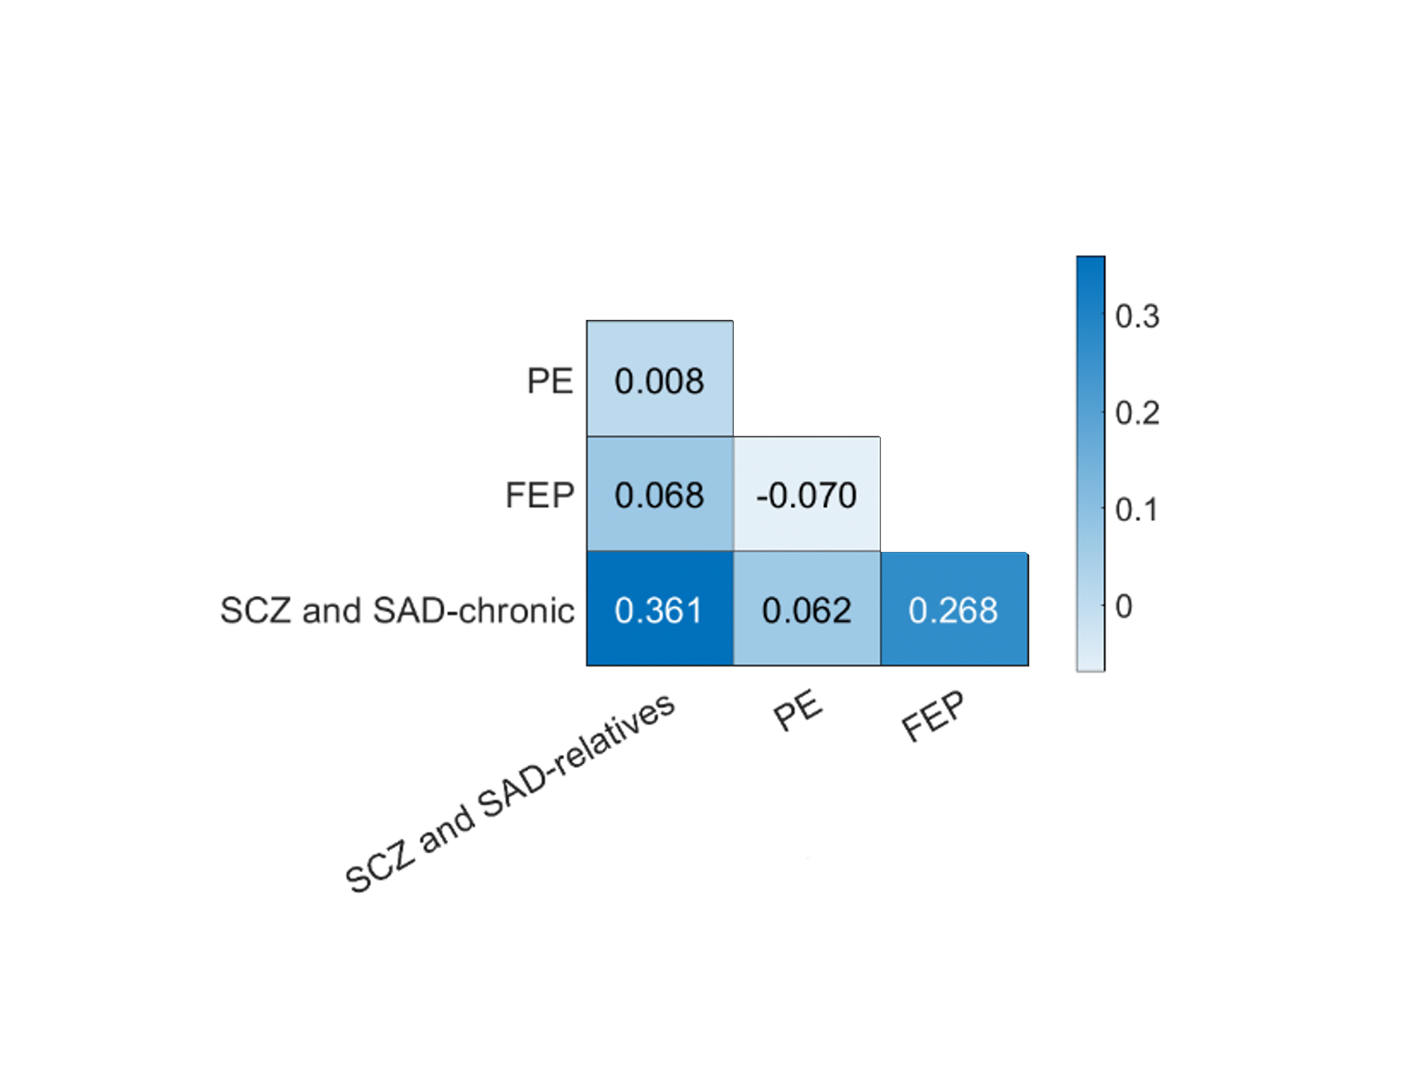
Figure S1 | Pearson correlation of centiles across regions between each pair of groups. Significance was tested by using a permutation test in which group membership was randomly reassigned across the compared groups. No significant differences were observed in correlation among any pair of groups (all P_{perm} > 0.05).

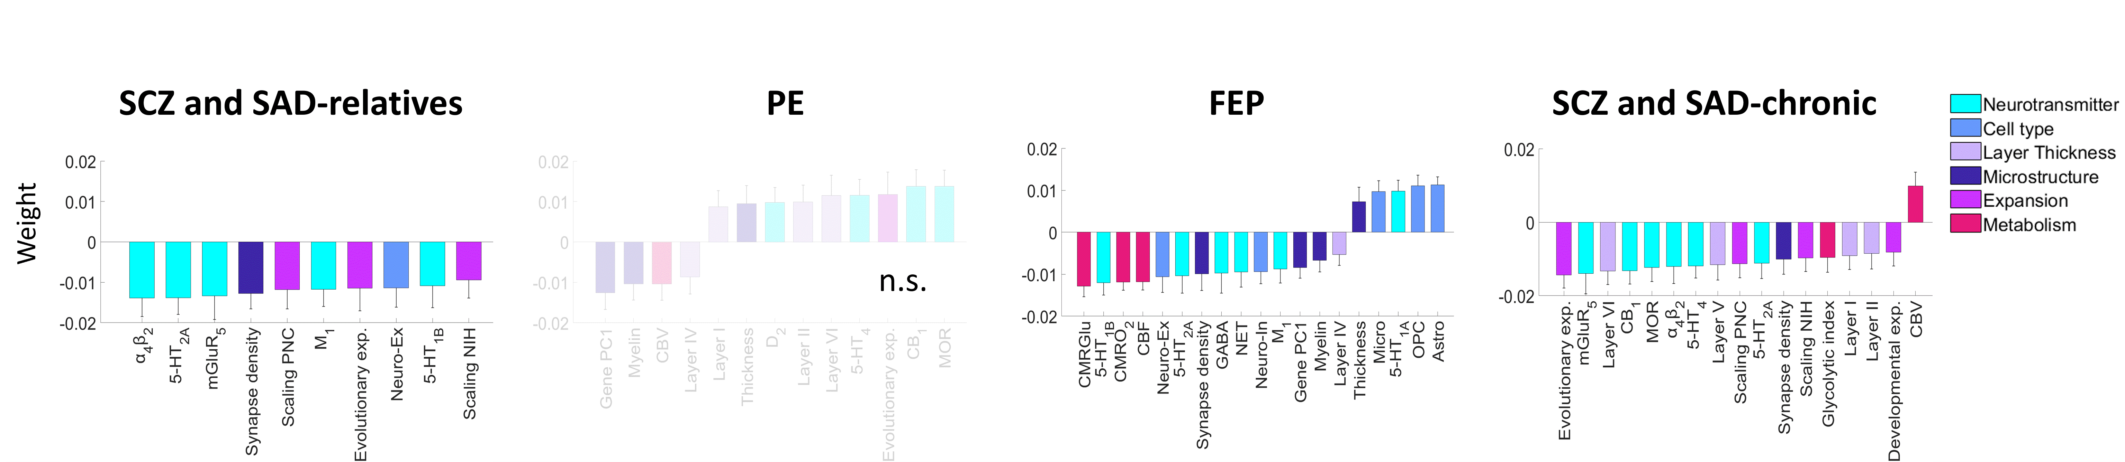
Figure S2 | PCA-CCA significant weights representing the contribution of each neurobiological feature to predicted centiles for each group. Significant weights (P_{spin} < 0.05) were derived from neurobiological features using a PCA-CCA model for each group. Non-significant models are denoted as n.s (FDR-corrected P_{spin} > 0.05). Error bars represent the standard deviation.
Figure S3 | Empirical and predicted centiles, and associated loadings from PCA-CCA models of SCZ and SAD-chronic after leave-one-study-out cross-validation. a, Maps of empirical MRI-derived centiles (top), significant MRI-derived centiles (middle; Wilcoxon rank sum test FDR-corrected, P < 0.05), and predicted PCA-CCA-derived centiles from neurobiological features (bottom; FDR-corrected P_{spin} < 0.05). b, Correlation between empirical and predicted regional centiles. c, PCA-CCA significant loadings associated to each neurobiological map (P_{spin} < 0.05). Error bars represent the standard deviation. d, Correlation between empirical centiles. Asterisks (*) indicate significant correlation of centiles between SCZ and SAD-chronic studies (FDR-corrected all P_{spin} < 10⁻³). e, Correlation between loadings. Asterisks (*) indicate significant differences in correlation of loadings between SCZ and SAD-chronic studies (FDR-corrected P_{Pearson} < 10⁻¹⁴).
Figure S4 | Empirical and predicted centiles, and associated loadings from PCA-CCA models of SCZ after leave-one-study-out cross-validation. a, Maps of empirical MRI-derived centiles (top), significant MRI-derived centiles (middle; Wilcoxon rank sum test FDR-corrected, P < 0.05), and predicted PCA-CCA-derived centiles from neurobiological features (bottom; FDR-corrected P_{spin} < 0.05). b, Correlation between empirical and predicted regional centiles. c, PCA-CCA significant loadings associated to each neurobiological map (P_{spin} < 0.05). Error bars represent the standard deviation. d, Correlation between empirical centiles. Asterisks (*) indicate significant correlation of centiles between SCZ studies (FDR-corrected P_{spin} < 10⁻³). e, Correlation between loadings. Asterisks (*) indicate significant differences in correlation of loadings between SCZ studies (FDR-corrected P_{Pearson} < 10⁻¹¹).

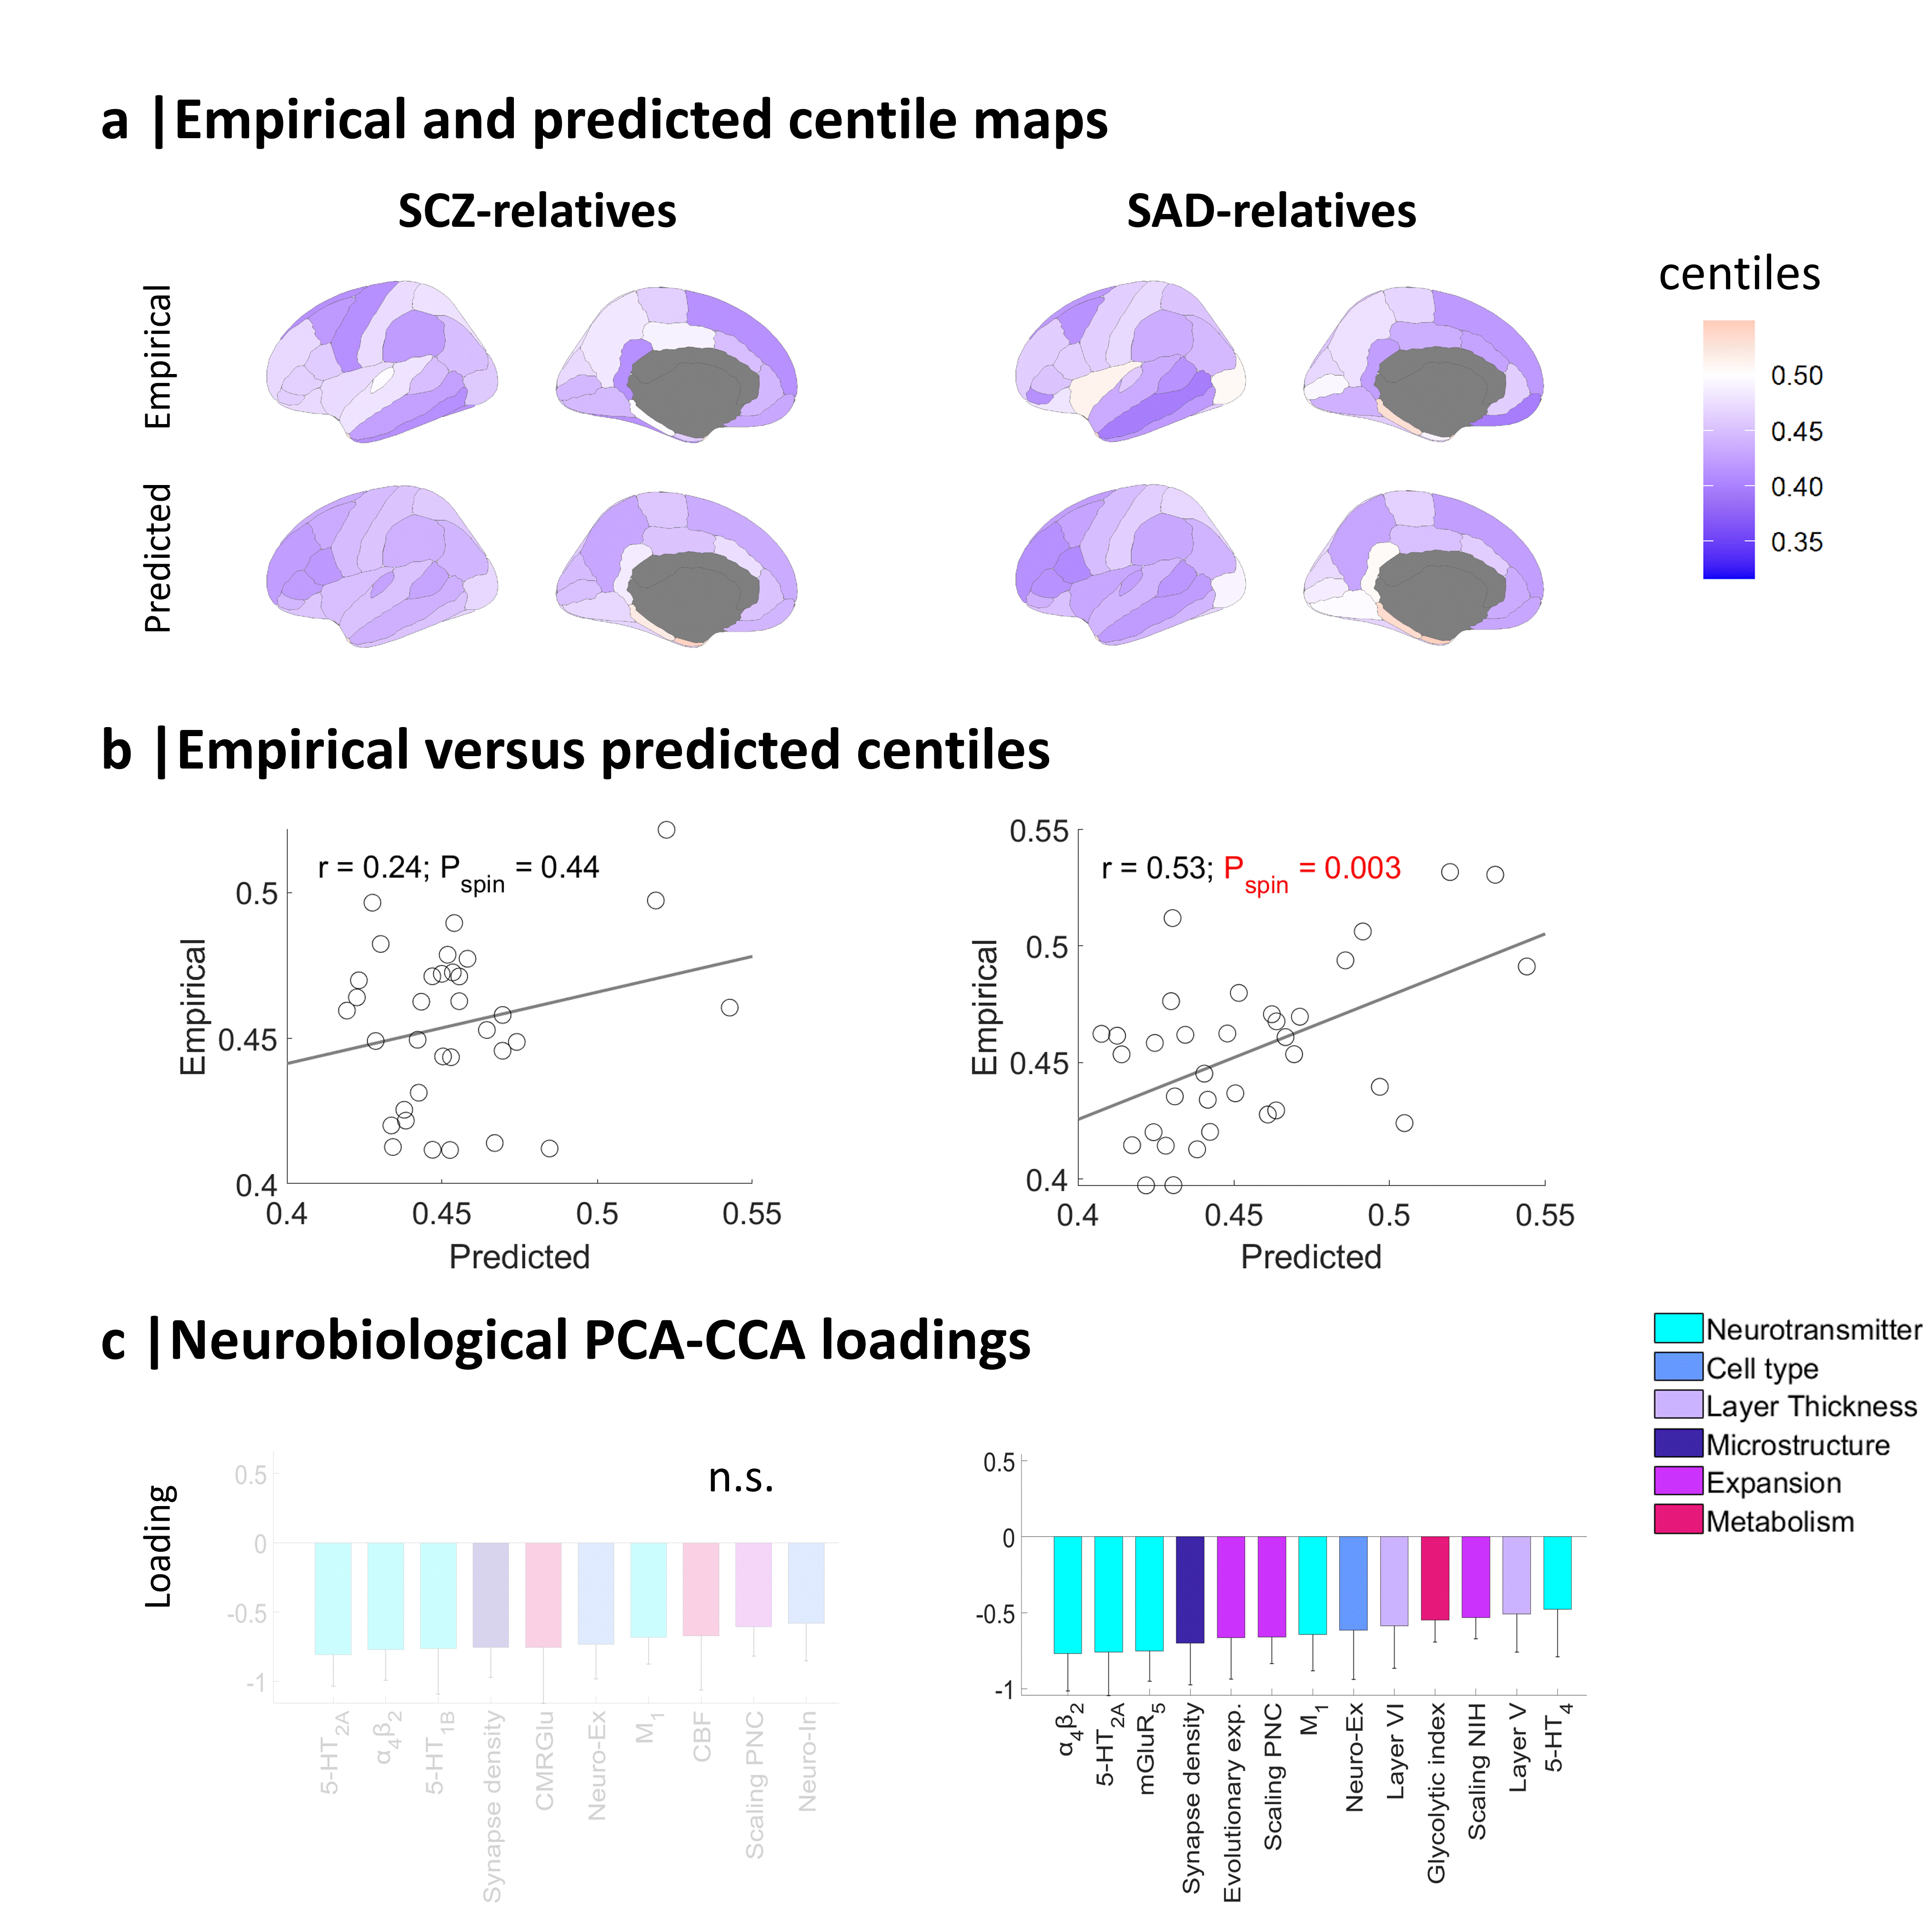
Figure S5 | Empirical and predicted centiles, and associated loadings from PCA-CCA models of SCZ and SAD relatives. a, Maps of empirical MRI-derived centiles (top) and predicted PCA-CCA-derived centiles from neurobiological features (bottom). b, Correlation between empirical and predicted regional centiles. c, PCA-CCA significant loadings associated to each neurobiological map (P_{spin} < 0.05). Non-significant models are denoted as n.s (FDR-corrected P_{spin} > 0.05). Error bars represent the standard deviation.

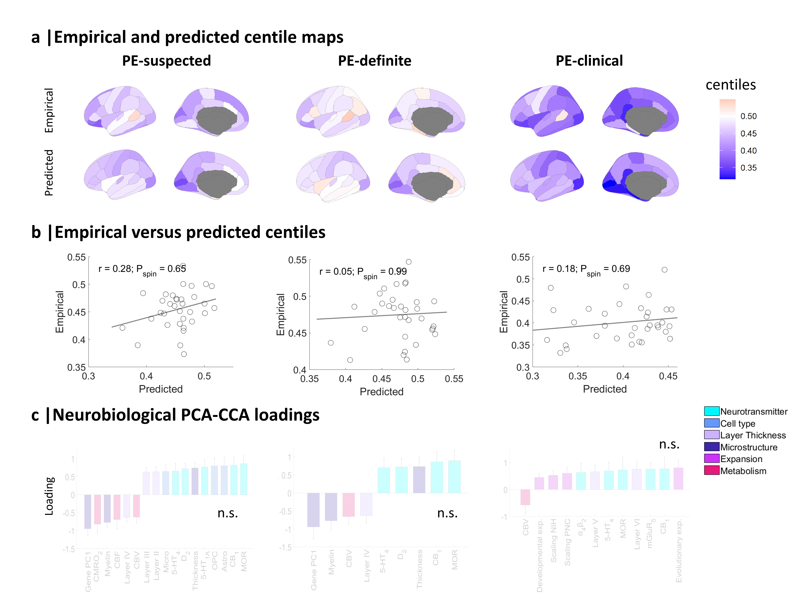
Figure S6 | Empirical and predicted centiles, and associated loadings from PCA-CCA models of individuals who reported operationally-defined psychotic experiences, rated as ‘suspected’, ‘definite’, or ‘clinical’. a, Maps of empirical MRI-derived centiles (top) and predicted PCA-CCA-derived centiles from neurobiological features (bottom). b, Correlation between empirical and predicted regional centiles. c, PCA-CCA significant loadings associated to each neurobiological map (P_{spin} < 0.05). Non-significant models are denoted as n.s (FDR-corrected P_{spin} > 0.05). Error bars represent the standard deviation.

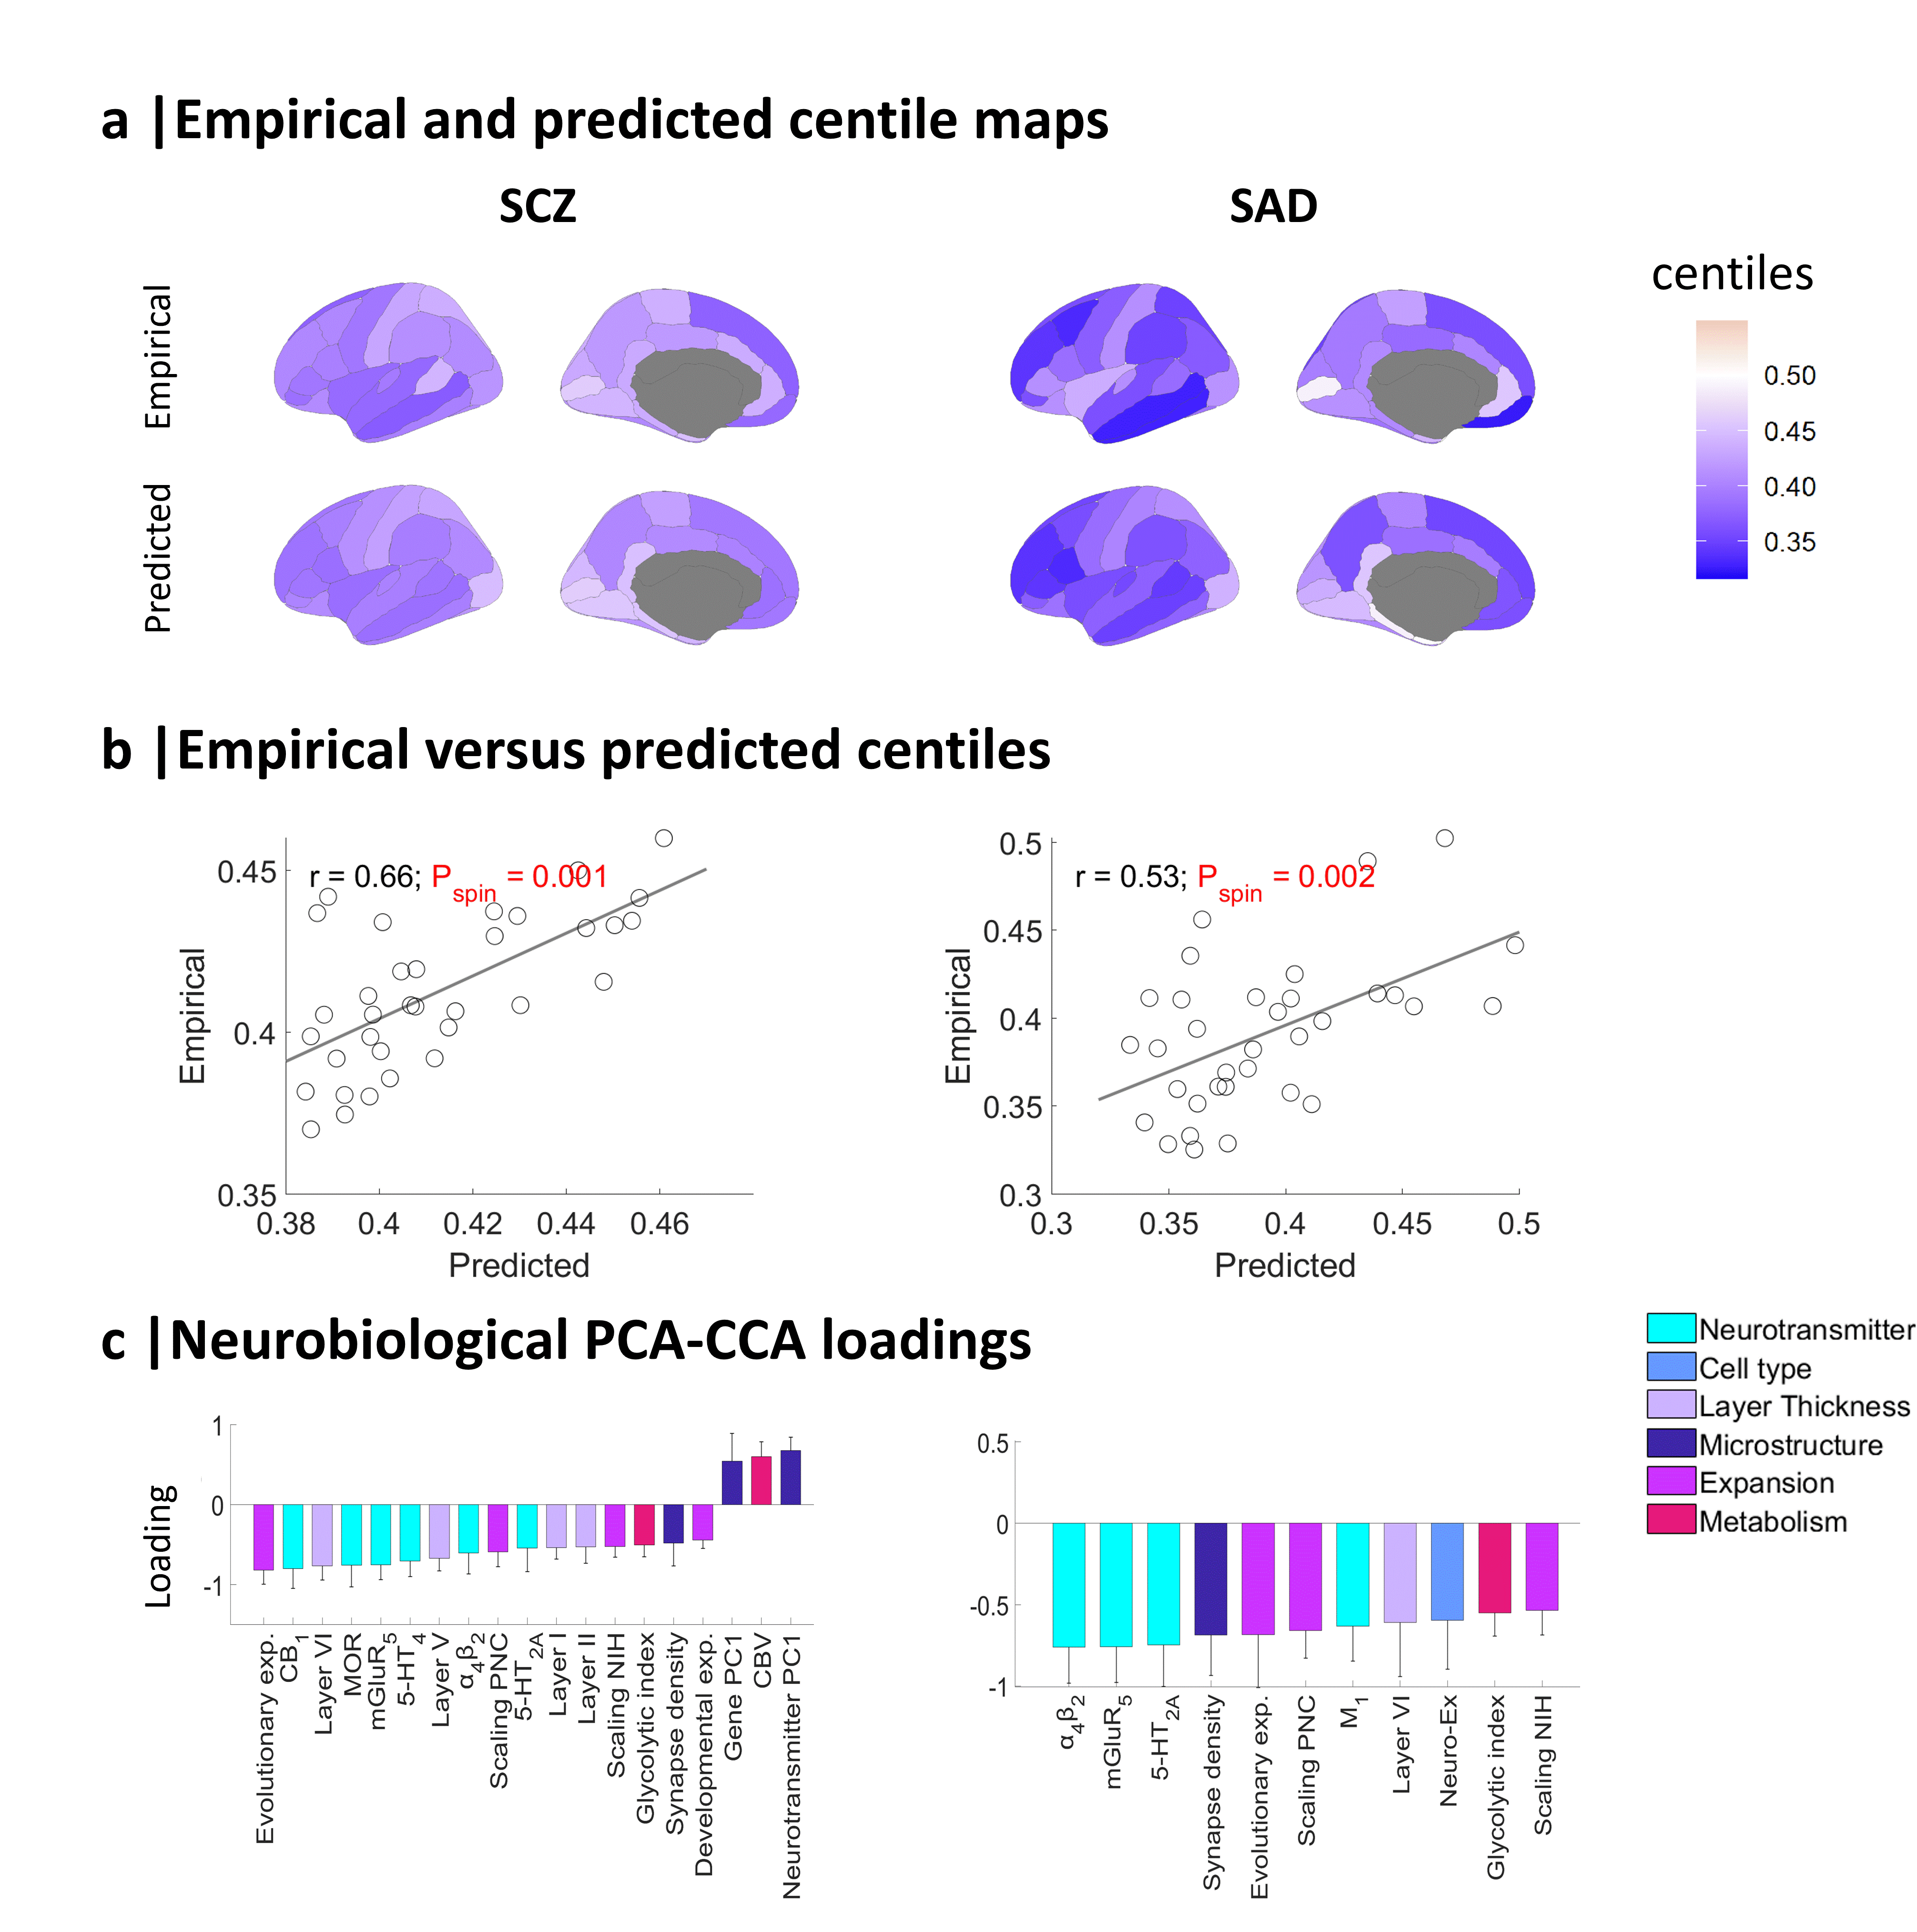
Figure S7 | Empirical and predicted centiles, and associated loadings from PCA-CCA models of SCZ and SAD. a, Maps of empirical MRI-derived centiles (top) and predicted PCA-CCA-derived centiles from neurobiological features (bottom; FDR-corrected P_{spin} < 0.05). b, Correlation between empirical and predicted regional centiles. c, PCA-CCA significant loadings associated to each neurobiological map (P_{spin} < 0.05). Error bars represent the standard deviation.

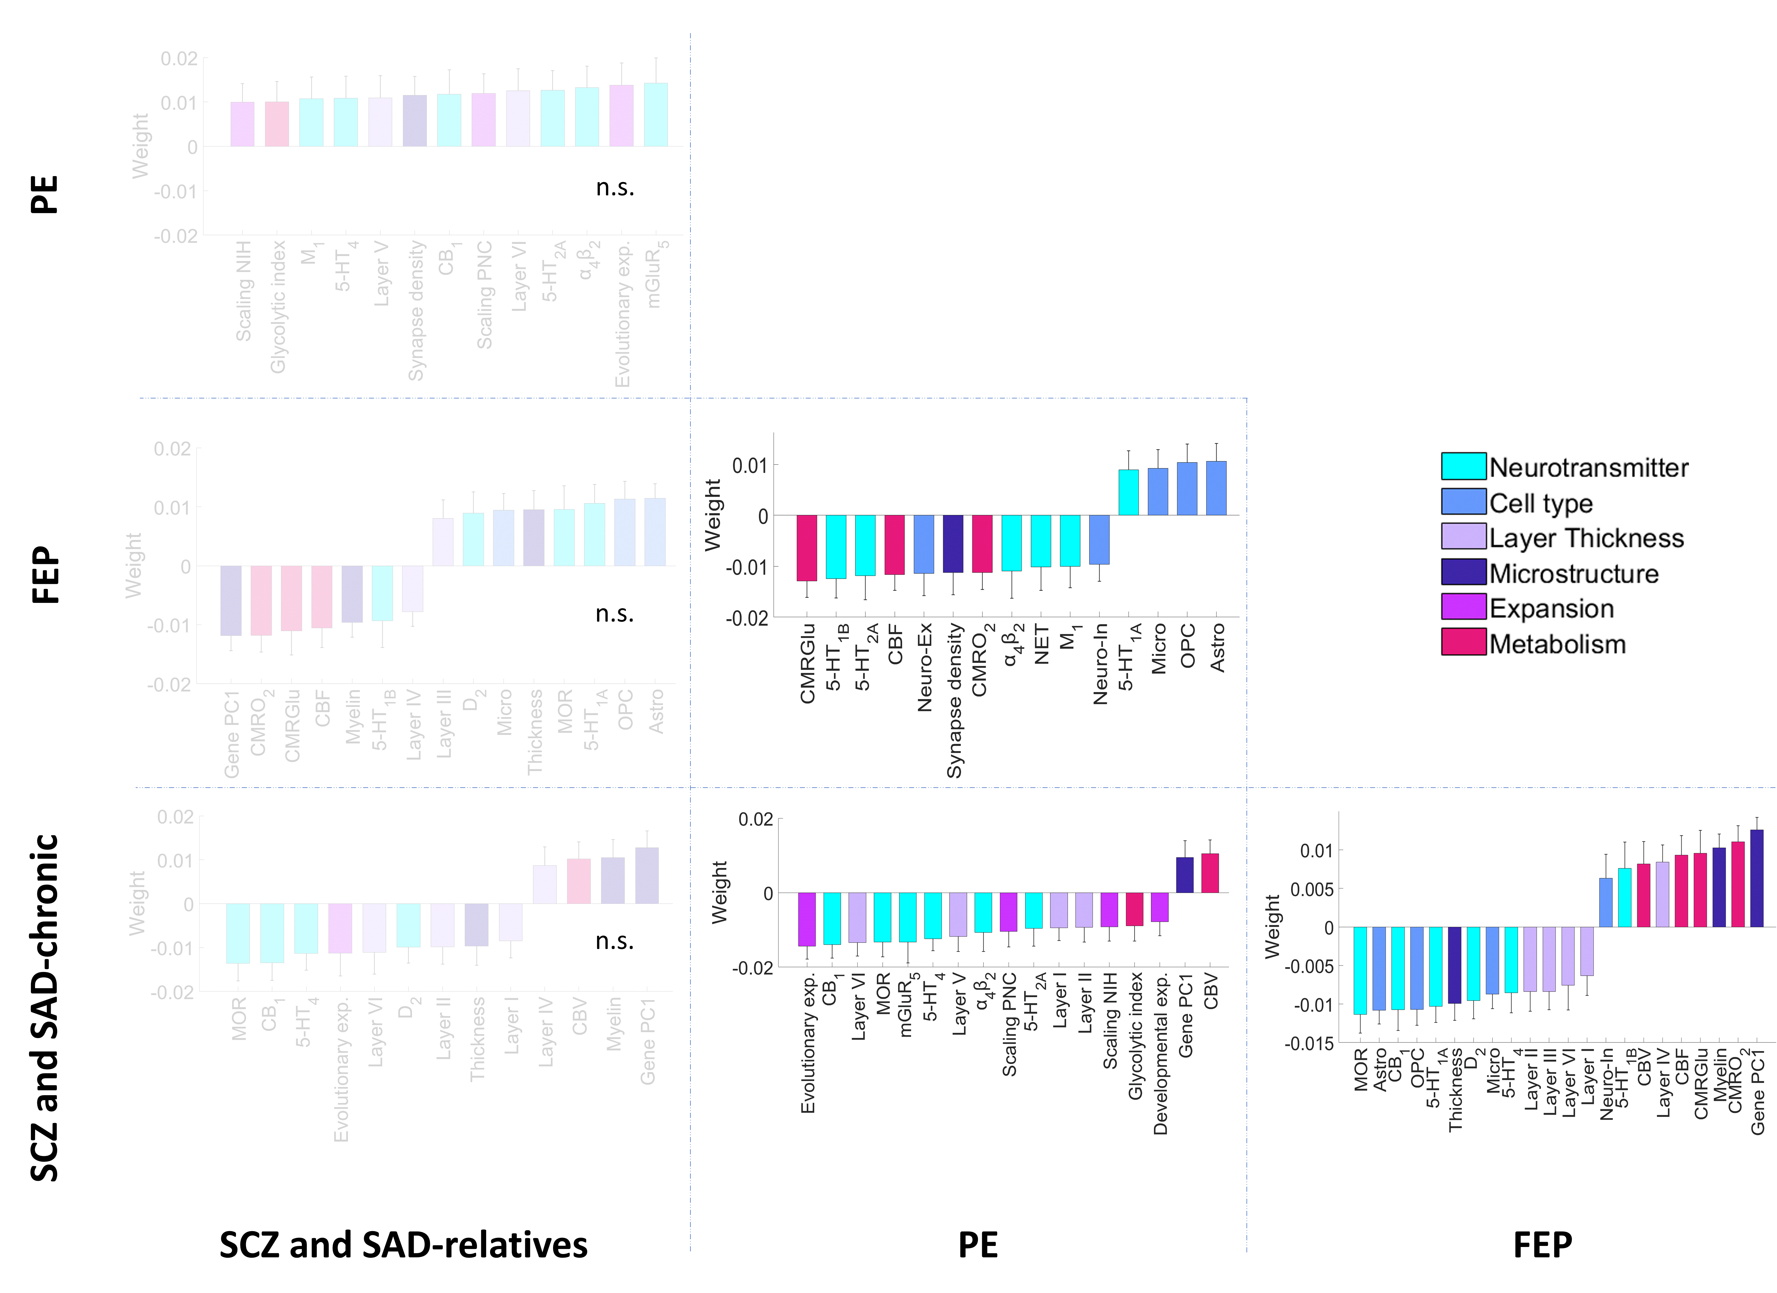
Figure S8 | PCA-CCA weights of each neurobiological feature contribution to the predicted effect sizes of centiles between groups. Significant weights (P_{spin} < 0.05) were derived from neurobiological features using a PCA-CCA model for each pair of groups. Non-significant models are denoted as n.s (FDR-corrected P_{spin} > 0.05). Error bars represent the standard deviation.

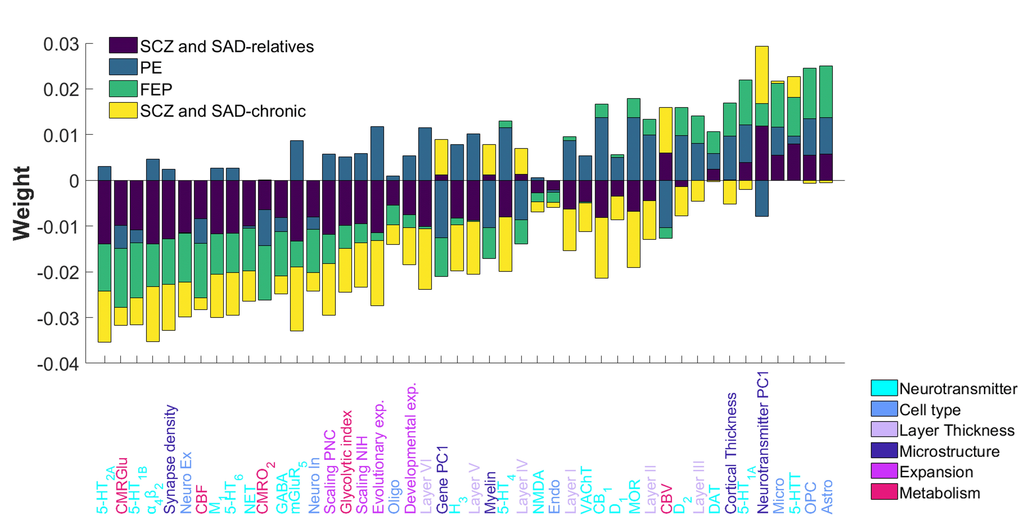
Figure S9 | Neurobiological PCA-CCA weights compared across psychosis-related groups. Stacked neurobiological weights of each group, regardless of their significance, were ranked from the most negative to the most positive average contribution. Non-significant models are denoted as n.s (FDR-corrected P_{spin} > 0.05).

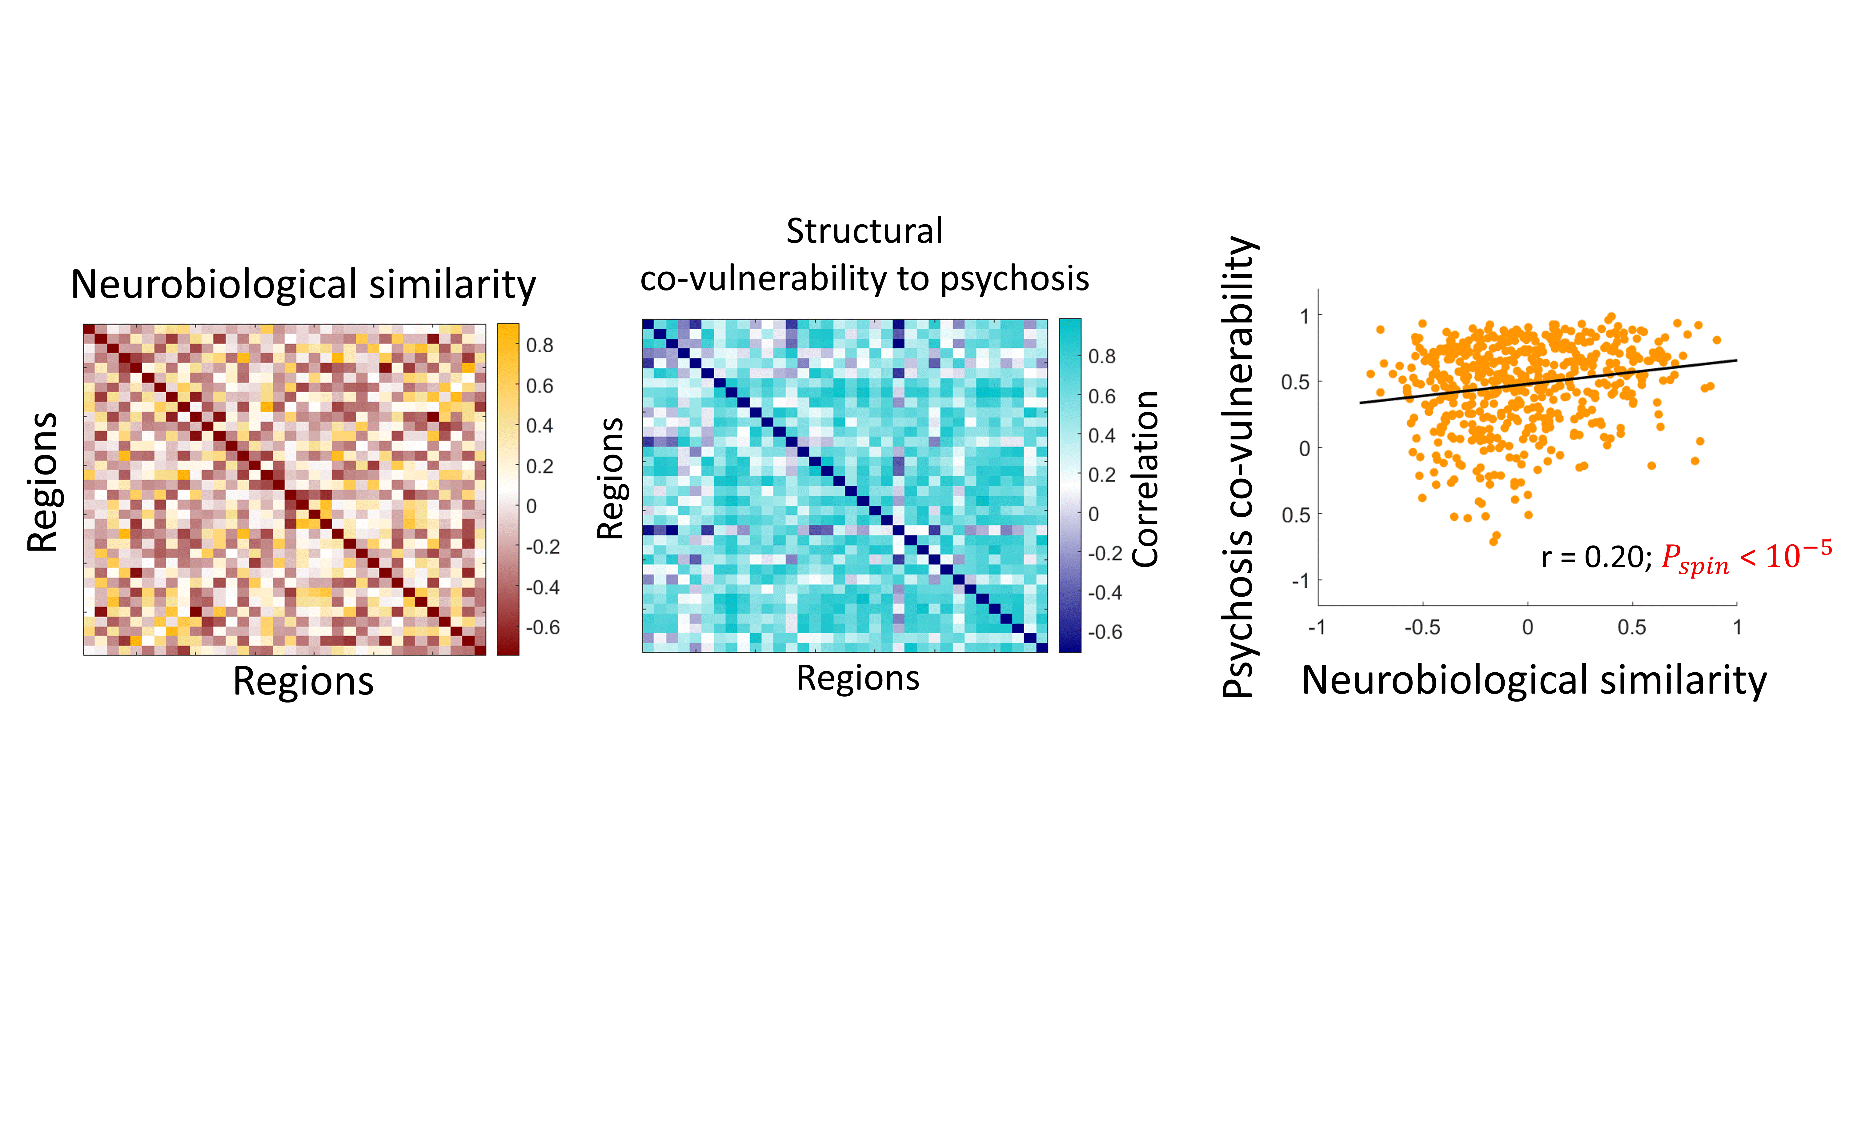
Figure S10 | Association between neurobiological similarity and structural co-vulnerability to diagnosis of psychosis. Neurobiological similarity matrix obtained by correlating the regional patterns of neurobiological features in HC (left). Structural co-vulnerability to psychosis matrix constructed by correlating the regional patterns of the effect sizes of centiles across psychosis-related diagnoses (middle). Correlation between both matrices (right; Pearson’s correlation r = 0.20, P_{spin} < 10⁻⁵).

REFERENCES
1. Casey, B. J. et al. The Adolescent Brain Cognitive Development (ABCD) study: Imaging acquisition across 21 sites. Developmental Cognitive Neuroscience vol. 32 43–54 Preprint at https://doi.org/10.1016/j.dcn.2018.03.001 (2018).
2. Garavan, H. et al. Recruiting the ABCD sample: Design considerations and procedures. Dev Cogn Neurosci 32, 16–22 (2018).
3. Jernigan, T. L. & Brown, S. A. Introduction. Dev Cogn Neurosci 32, 1–3 (2018).
4. Van Essen, D. C. et al. The Human Connectome Project: A data acquisition perspective. NeuroImage vol. 62 2222–2231 Preprint at https://doi.org/10.1016/j.neuroimage.2012.02.018 (2012).
5. Hagler, D. J. et al. Image processing and analysis methods for the Adolescent Brain Cognitive Development Study. Neuroimage 202, (2019).
6. Ji, W. et al. Preterm birth associated alterations in brain structure, cognitive functioning and behavior in children from the ABCD dataset. Psychol Med 1–10 (2023) doi:10.1017/s0033291723001757.
7. Fischl, B. et al. Whole Brain Segmentation. Neuron 33, 341–355 (2002).
8. Sharp, T. H. et al. Population neuroimaging: Generation of a comprehensive data resource within the ALSPAC pregnancy and birth cohort. Wellcome Open Res 5, (2020).
9. Fraser, A. et al. Cohort profile: The avon longitudinal study of parents and children: ALSPAC mothers cohort. Int J Epidemiol 42, 97–110 (2013).
10. Golding, G., Pembrey, P. & Jones, J. ALSPAC - The Avon Longitudinal Study of Parents and Children I. Study methodology. Paediatr Perinat Epidemiol 15, 74–87 (2001).
11. Boyd, A. et al. Cohort profile: The ’Children of the 90s’-The index offspring of the avon longitudinal study of parents and children. Int J Epidemiol 42, 111–127 (2013).
12. Horwood, J. et al. IQ and non-clinical psychotic symptoms in 12-year-olds: Results from the ALSPAC birth cohort. British Journal of Psychiatry 193, 185–191 (2008).
13. Zammit, S. et al. Investigating if psychosis-like symptoms (PLIKS) are associated with family history of schizophrenia or paternal age in the ALSPAC birth cohort. Schizophr Res 104, 279–286 (2008).
14. Wing, J. K., Babor, T., Brugha, T., Burke, J. & Sartorius, N. SCAN. Schedules for Clinical Assessment in Neuropsychiatry. Arch Gen Psychiatry 47, 589 (1990).
15. Drakesmith, M. et al. Volumetric, relaxometric and diffusometric correlates of psychotic experiences in a non-clinical sample of young adults. Neuroimage Clin 12, 550–558 (2016).
16. Bethlehem, R. A. I. et al. Brain charts for the human lifespan. Nature 604, 525–533 (2022).
17. Loughland, C. et al. Australian Schizophrenia Research Bank: a database of comprehensive clinical, endophenotypic and genetic data for aetiological studies of schizophrenia. Australian and New Zealand Journal of Psychiatry (2010) doi:10.3109/00048674.2010.501758.
18. Garrison, J. R. et al. Paracingulate sulcus morphology is associated with hallucinations in the human brain. Nat Commun 6, (2015).
19. Tamminga, C. A. et al. Bipolar and schizophrenia network for intermediate phenotypes: Outcomes across the psychosis continuum. Schizophr Bull 40, (2014).
20. Kristian Hill, S. et al. Neuropsychological impairments in schizophrenia and psychotic Bipolar disorder: Findings from the Bipolar-Schizophrenia Network on Intermediate Phenotypes (B-SNIP) study. American Journal of Psychiatry 170, 1275–1284 (2013).
21. Ivleva, E. I. et al. Gray matter volume as an intermediate phenotype for psychosis: Bipolar-Schizophrenia Network on Intermediate Phenotypes (B-SNIP). American Journal of Psychiatry 170, 1285–1296 (2013).
22. Henschel, L., Kügler, D. & Reuter, M. FastSurferVINN: Building resolution-independence into deep learning segmentation methods—A solution for HighRes brain MRI. Neuroimage 251, (2022).
23. Gollub, R. L. et al. The MCIC collection: A shared repository of multi-modal, multi-site brain image data from a clinical investigation of schizophrenia. Neuroinformatics 11, 367–388 (2013).
24. Yendiki, A. et al. Multi-site characterization of an fMRI working memory paradigm: Reliability of activation indices. Neuroimage 53, 119–131 (2010).
25. Scott, A. et al. Coins: An innovative informatics and neuroimaging tool suite built for large heterogeneous datasets. Front Neuroinform 5, (2011).
26. Crespo-Facorro, B. et al. A Practical Clinical Trial Comparing Haloperidol, Risperidone, and Olanzapine for the Acute Treatment of First-Episode Nonaffective Psychosis. J Clin Psychiatry vol. 67 (2006).
27. Rodriguez-Perez, N. et al. Long term cortical thickness changes after a first episode of non- affective psychosis: The 10 year follow-up of the PAFIP cohort. Prog Neuropsychopharmacol Biol Psychiatry 108, (2021).
28. Andreasen, N. C., Flaum, M. & Arndt, S. The Comprehensive Assessment of Symptoms and History (CASH). An instrument for assessing diagnosis and psychopathology. Arch Gen Psychiatry 49, 615–23 (1992).
29. Canal-Rivero, M. et al. Longitudinal trajectories in negative symptoms and changes in brain cortical thickness: 10-year follow-up study. The British Journal of Psychiatry 1–10 (2023) doi:10.1192/bjp.2022.192.
30. Bycroft, C. et al. The UK Biobank resource with deep phenotyping and genomic data. Nature 562, 203–209 (2018).
31. Ollier, W., Sprosen, T. & Peakman, T. UK Biobank: From concept to reality. Pharmacogenomics 6, 639–646 (2005).
32. Elliott, P. & Peakman, T. C. The UK Biobank sample handling and storage protocol for the collection, processing and archiving of human blood and urine. Int J Epidemiol 37, 234–244 (2008).
33. Sudlow, C. et al. UK Biobank: An Open Access Resource for Identifying the Causes of a Wide Range of Complex Diseases of Middle and Old Age. PLoS Med 12, (2015).
34. Miller, K. L. et al. Multimodal population brain imaging in the UK Biobank prospective epidemiological study. Nat Neurosci 19, 1523–1536 (2016).
35. Zhang, Y., Brady, M. & Smith, S. Segmentation of Brain MR Images Through a Hidden Markov Random Field Model and the Expectation-Maximization Algorithm. IEEE TRANSACTIONS ON MEDICAL IMAGING vol. 20 (2001).
36. Smith, S. M. et al. Longitudinal and cross-sectional analysis of atrophy in Alzheimer’s disease: Cross-validation of BSI, SIENA and SIENAX. Neuroimage 36, 1200–1206 (2007).

