Table S1. Definitions of hypertension, stroke, coronary heart disease, and diabetes
Diseases | Self-reported Information | ICD-9 information | ICD-10 information | OPCS-4 information
Hypertension | 2966, 6150 (4), 6153 (2), 6177 (2), 20002 (1065, 1072), 20008, 20009, 20010, 20011 | 41271 (401-405) 41281 | 41270 (I10-I13, I15, O10), 41280, 131292, 131290, 131288, 131286, 131294, 132180, 131295, 131293, 131291, 131289, 131287, 132181
Stroke | 6150 (3), 4056, 20002 (1081, 1491, 1583, 1086), 20008, 20009, 20010, 20011 | 41271 (3361, 3623, 430, 431, 4329, 4330, 4331, 4332,4333, 4338, 4339, 434, 436), 41281 | 41270 (I60, I61, I629, I63, I64, I678, I690, I693, G951, H341, H342, S066), 41280, 131378, 131376, 131374, 131372, 131370, 131368, 131366, 131364, 131362, 131360, 131180, 131379, 131377, 131375, 131373, 131371, 131369, 131367, 131365, 131363, 131361, 131181 | 41272 (A052- A054, L351, L353, L343), 41282
Diabetes | 2443 (1), 2976, 6153 (3), 6177(3), 20002 (1220, 1222, 1223), 20008, 20009 | 41271 (250, 3572, 3620), 41281 | 41270 (E10-E14, G590, G632, H280, H360, M142, N083) 41280, 130714, 130712, 130710, 130708, 130706, 130715, 130713, 130711, 130709, 130707
ICD: International Classification of Diseases
the Office of Population Censuses and Surveys Classification of Interventions and Procedures, version 4

Table S2. Cognitive domain, definition, and Field ID details for cognitive function tests
Cognitive function tests | Cognitive domain | definition | Field ID
Prospective memory test | prospective memory | the initial chose was correct | 20118
Pairs matching test | visual declarative memory | number of incorrect matches in round | 399
Numeric memory test | working memory | maximum digits remembered correctly | 4282
Fluid Intelligence test | verbal and numerical reasoning | fluid intelligence score | 20016
Reaction time test | processing speed | mean time to correctly identify matches | 20023
Trail making test 1 | executive function | duration to complete numeric path | 6348
Trail making test 2 | executive function | duration to complete alphanumeric path | 6350
Symbol digit substitution test | processing speed | number of symbol digit matches made correctly | 23324
Picture vocabulary test | vocabulary | vocabulary level | 6364
Paired associate learning test | visual declarative memory | number of word pairs correctly associated | 20197
Matrix pattern completion test | non-verbal reasoning | number of puzzles correctly solved | 6373
Tower rearranging test | executive function | number of puzzles correct | 21004

Table S3. Table Association between sunlight exposure time and brain structural markers stratified by sex (compare to Tertile 1).
 |  | Tertile 2 |  |  | Tertile 3
 | β | SE | P | β | SE | P
Global measures
Total brain volume
Male | -0.037 | 0.019 | 0.056 | -0.064 | 0.022 | 0.004
Female | -0.022 | 0.018 | 0.231 | -0.058 | 0.023 | 0.011
Volume of white matter
Male | -0.021 | 0.020 | 0.299 | -0.040 | 0.023 | 0.082
Female | -0.013 | 0.019 | 0.502 | -0.041 | 0.024 | 0.082
Volume of gray matter
Male | -0.048 | 0.018 | 0.009 | -0.079 | 0.021 | <0.001
Female | -0.028 | 0.017 | 0.106 | -0.067 | 0.022 | 0.002
Volume of white matter hyperintensities
Male | 0.012 | 0.019 | 0.536 | 0.065 | 0.022 | 0.003
Female | 0.016 | 0.018 | 0.376 | 0.043 | 0.023 | 0.056
Subcortical regions
Volume of thalamus
Male | -0.032 | 0.018 | 0.083 | -0.057 | 0.021 | 0.006
Female | -0.033 | 0.018 | 0.072 | -0.065 | 0.023 | 0.004
Volume of caudate
Male | -0.062 | 0.020 | 0.002 | -0.059 | 0.023 | 0.011
Female | 0.001 | 0.020 | 0.950 | -0.022 | 0.024 | 0.357
Volume of putamen
Male | -0.031 | 0.019 | 0.103 | -0.031 | 0.022 | 0.156
Female | -0.018 | 0.019 | 0.336 | -0.033 | 0.023 | 0.154
Volume of pallidum
Male | -0.048 | 0.020 | 0.016 | -0.031 | 0.023 | 0.178
Female | -0.009 | 0.020 | 0.652 | -0.012 | 0.024 | 0.616
Volume of hippocampus
Male | -0.021 | 0.019 | 0.282 | -0.030 | 0.022 | 0.170
Female | 0.001 | 0.019 | 0.975 | -0.055 | 0.024 | 0.020
Volume of amygdala
Male | <0.001 | 0.021 | 0.982 | -0.038 | 0.024 | 0.109
Female | -0.008 | 0.020 | 0.668 | -0.019 | 0.025 | 0.432
Volume of accumbens
Male | -0.022 | 0.018 | 0.230 | -0.034 | 0.021 | 0.097
Female | 0.014 | 0.018 | 0.422 | -0.040 | 0.022 | 0.076
Regional gray matter volumes
Volume of thalamus
Male | 0.013 | 0.021 | 0.531 | -0.030 | 0.024 | 0.196
Female | -0.027 | 0.020 | 0.169 | -0.018 | 0.025 | 0.458
Volume of caudate
Male | -0.024 | 0.020 | 0.238 | -0.006 | 0.023 | 0.797
Female | 0.006 | 0.019 | 0.753 | 0.026 | 0.024 | 0.284
Volume of putamen
Male | -0.068 | 0.020 | 0.001 | -0.074 | 0.023 | 0.002
Female | -0.038 | 0.020 | 0.057 | -0.032 | 0.024 | 0.187
Volume of pallidum
Male | 0.015 | 0.020 | 0.466 | 0.029 | 0.023 | 0.209
Female | -0.013 | 0.019 | 0.511 | 0.001 | 0.024 | 0.968
Volume of hippocampus
Male | -0.035 | 0.019 | 0.073 | -0.050 | 0.022 | 0.025
Female | -0.004 | 0.019 | 0.839 | -0.037 | 0.024 | 0.113
Volume of amygdala
Male | -0.052 | 0.019 | 0.005 | -0.090 | 0.021 | <0.001
Female | -0.029 | 0.018 | 0.111 | -0.043 | 0.022 | 0.057

Table S4. Table Association between sunlight exposure time and brain structural markers stratified by age (compare to Tertile 1).
 |  | Tertile 2 |  |  | Tertile 3
 | β | SE | P | β | SE | P
Global measures
Total brain volume | -0.032 | 0.014 | 0.018 | -0.058 | 0.017 | 0.001
<60 | -0.002 | 0.022 | 0.919 | -0.028 | 0.024 | 0.237
>=60
Volume of white matter
<60 | -0.024 | 0.014 | 0.080 | -0.044 | 0.017 | 0.011
>=60 | 0.019 | 0.022 | 0.390 | 0.001 | 0.024 | 0.972
Volume of gray matter
<60 | -0.039 | 0.014 | 0.006 | -0.069 | 0.018 | <0.001
>=60 | -0.026 | 0.023 | 0.248 | -0.058 | 0.025 | 0.020
Volume of white matter hyperintensities
<60 | 0.011 | 0.016 | 0.483 | 0.062 | 0.020 | 0.002
>=60 | 0.020 | 0.026 | 0.437 | 0.053 | 0.028 | 0.063
Subcortical regions
Volume of thalamus
<60 | -0.045 | 0.015 | 0.002 | -0.065 | 0.018 | <0.001
>=60 | 0.015 | 0.024 | 0.532 | -0.028 | 0.026 | 0.282
Volume of caudate
<60 | -0.035 | 0.016 | 0.027 | -0.041 | 0.020 | 0.037
>=60 | -0.022 | 0.026 | 0.387 | -0.032 | 0.028 | 0.243
Volume of putamen
<60 | -0.034 | 0.015 | 0.020 | -0.052 | 0.018 | 0.004
>=60 | 0.010 | 0.024 | 0.681 | 0.026 | 0.026 | 0.327
Volume of pallidum
<60 | -0.047 | 0.016 | 0.003 | -0.044 | 0.020 | 0.026
>=60 | 0.024 | 0.026 | 0.358 | 0.037 | 0.028 | 0.182
Volume of hippocampus
<60 | -0.034 | 0.016 | 0.034 | -0.046 | 0.020 | 0.023
>=60 | 0.052 | 0.026 | 0.045 | <0.001 | 0.028 | 0.986
Volume of amygdala
<60 | -0.013 | 0.016 | 0.431 | -0.012 | 0.020 | 0.534
>=60 | 0.013 | 0.026 | 0.601 | -0.052 | 0.028 | 0.063
Volume of accumbens
<60 | -0.014 | 0.016 | 0.391 | -0.057 | 0.020 | 0.004
>=60 | 0.033 | 0.026 | 0.202 | 0.014 | 0.028 | 0.620
Regional gray matter volumes
Volume of thalamus
<60 | -0.021 | 0.016 | 0.188 | -0.029 | 0.020 | 0.156
>=60 | 0.036 | 0.025 | 0.159 | 0.010 | 0.027 | 0.724
Volume of caudate
<60 | -0.024 | 0.016 | 0.138 | -0.003 | 0.021 | 0.870
>=60 | 0.007 | 0.027 | 0.785 | 0.017 | 0.029 | 0.558
Volume of putamen
<60 | -0.063 | 0.016 | <0.001 | -0.055 | 0.021 | 0.007
>=60 | -0.037 | 0.027 | 0.166 | -0.042 | 0.029 | 0.139
Volume of pallidum
<60 | -0.007 | 0.017 | 0.685 | 0.017 | 0.021 | 0.416
>=60 | 0.010 | 0.027 | 0.696 | 0.015 | 0.029 | 0.600
Volume of hippocampus
<60 | -0.042 | 0.015 | 0.006 | -0.043 | 0.019 | 0.026
>=60 | 0.045 | 0.025 | 0.072 | -0.001 | 0.027 | 0.974
Volume of amygdala
<60 | -0.045 | 0.015 | 0.003 | -0.065 | 0.019 | 0.001
>=60 | -0.024 | 0.025 | 0.329 | -0.059 | 0.027 | 0.027

Table S5. Table Association between sunlight exposure time and brain structural markers stratified by diseases (compare to Tertile 1).
 |  | Tertile 2 |  |  | Tertile 3
 | β | SE | P | β | SE | P
Global measures
Total brain volume
Hypertension | -0.053 | 0.024 | 0.028 | -0.081 | 0.028 | 0.003
Diabetes | 0.016 | 0.068 | 0.808 | 0.017 | 0.075 | 0.817
Stroke | 0.040 | 0.106 | 0.708 | 0.152 | 0.116 | 0.190
Volume of white matter
Hypertension | -0.030 | 0.024 | 0.223 | -0.056 | 0.028 | 0.045
Diabetes | 0.050 | 0.069 | 0.465 | 0.097 | 0.077 | 0.208
Stroke | 0.012 | 0.108 | 0.910 | 0.181 | 0.119 | 0.128
Volume of gray matter
Hypertension | -0.072 | 0.024 | 0.003 | -0.099 | 0.028 | <0.001
Diabetes | -0.023 | 0.068 | 0.732 | -0.072 | 0.075 | 0.338
Stroke | 0.063 | 0.107 | 0.559 | 0.099 | 0.118 | 0.403
Volume of white matter hyperintensities
Hypertension | -0.009 | 0.028 | 0.753 | 0.029 | 0.032 | 0.365
Diabetes | -0.046 | 0.077 | 0.547 | 0.018 | 0.086 | 0.830
Stroke | -0.129 | 0.128 | 0.314 | -0.085 | 0.140 | 0.545
Subcortical regions
Volume of thalamus
Hypertension | -0.047 | 0.025 | 0.066 | -0.099 | 0.029 | 0.001
Diabetes | 0.151 | 0.071 | 0.033 | 0.084 | 0.079 | 0.288
Stroke | 0.122 | 0.119 | 0.308 | 0.095 | 0.131 | 0.465
Volume of caudate
Hypertension | -0.016 | 0.028 | 0.575 | -0.024 | 0.032 | 0.456
Diabetes | 0.001 | 0.078 | 0.990 | 0.027 | 0.087 | 0.758
Stroke | 0.129 | 0.125 | 0.303 | 0.097 | 0.137 | 0.479
Volume of putamen
Hypertension | -0.004 | 0.026 | 0.884 | -0.016 | 0.029 | 0.581
Diabetes | -0.024 | 0.071 | 0.734 | -0.049 | 0.080 | 0.540
Stroke | 0.066 | 0.121 | 0.585 | 0.177 | 0.132 | 0.183
Volume of pallidum
Hypertension | 0.005 | 0.028 | 0.864 | -0.012 | 0.032 | 0.713
Diabetes | 0.003 | 0.077 | 0.969 | 0.041 | 0.086 | 0.635
Stroke | 0.099 | 0.126 | 0.434 | 0.034 | 0.138 | 0.804
Volume of hippocampus
Hypertension | 0.001 | 0.027 | 0.971 | -0.071 | 0.031 | 0.023
Diabetes | 0.046 | 0.076 | 0.546 | 0.035 | 0.085 | 0.678
Stroke | 0.013 | 0.126 | 0.916 | -0.064 | 0.138 | 0.642
Volume of amygdala
Hypertension | -0.012 | 0.028 | 0.660 | -0.050 | 0.032 | 0.127
Diabetes | -0.009 | 0.080 | 0.907 | 0.037 | 0.090 | 0.682
Stroke | 0.075 | 0.128 | 0.558 | 0.070 | 0.140 | 0.618
Volume of accumbens
Hypertension | 0.002 | 0.027 | 0.955 | -0.030 | 0.031 | 0.332
Diabetes | 0.038 | 0.074 | 0.606 | 0.052 | 0.082 | 0.525
Stroke | 0.157 | 0.121 | 0.193 | 0.093 | 0.132 | 0.482
Regional gray matter volumes
Volume of thalamus
Hypertension | -0.006 | 0.028 | 0.823 | -0.038 | 0.032 | 0.240
Diabetes | 0.075 | 0.078 | 0.336 | 0.120 | 0.087 | 0.169
Stroke | 0.021 | 0.124 | 0.866 | 0.006 | 0.136 | 0.967
Volume of caudate
Hypertension | -0.025 | 0.029 | 0.378 | -0.005 | 0.033 | 0.868
Diabetes | 0.002 | 0.080 | 0.983 | 0.022 | 0.089 | 0.803
Stroke | -0.059 | 0.127 | 0.640 | 0.140 | 0.139 | 0.315
Volume of putamen
Hypertension | -0.027 | 0.029 | 0.343 | -0.080 | 0.033 | 0.016
Diabetes | -0.078 | 0.080 | 0.333 | -0.079 | 0.089 | 0.378
Stroke | 0.012 | 0.132 | 0.926 | -0.069 | 0.145 | 0.635
Volume of pallidum
Hypertension | 0.030 | 0.029 | 0.307 | 0.029 | 0.033 | 0.380
Diabetes | -0.011 | 0.082 | 0.895 | -0.023 | 0.091 | 0.799
Stroke | 0.119 | 0.126 | 0.347 | 0.050 | 0.138 | 0.717
Volume of hippocampus
Hypertension | -0.014 | 0.027 | 0.597 | -0.084 | 0.031 | 0.006
Diabetes | 0.085 | 0.075 | 0.252 | -0.016 | 0.083 | 0.844
Stroke | 0.010 | 0.123 | 0.932 | -0.012 | 0.135 | 0.928
Volume of amygdala
Hypertension | -0.057 | 0.026 | 0.029 | -0.112 | 0.030 | <0.001
Diabetes | -0.049 | 0.071 | 0.491 | -0.073 | 0.079 | 0.356
Stroke | 0.068 | 0.119 | 0.570 | 0.132 | 0.131 | 0.315

Table S6. Association between sunlight exposure time and brain structural markers after exclude dementia incidents at first five years of follow-up. (N = 27,471) (compare to Tertile 1)
 |  | Tertile 2 |  |  | Tertile 3
 | β | SE | P | β | SE | P
Global measures
Total brain volume | -0.025 | 0.011 | 0.026 | -0.051 | 0.013 | <0.001
Volume of white matter | -0.014 | 0.012 | 0.219 | -0.031 | 0.014 | 0.022
Volume of gray matter | -0.035 | 0.011 | 0.002 | -0.067 | 0.014 | <0.001
Volume of white matter hyperintensities | 0.013 | 0.013 | 0.317 | 0.059 | 0.016 | <0.001
Subcortical regions
Volume of thalamus | -0.029 | 0.012 | 0.014 | -0.060 | 0.014 | <0.001
Volume of caudate | -0.030 | 0.013 | 0.025 | -0.040 | 0.016 | 0.012
Volume of putamen | -0.022 | 0.012 | 0.066 | -0.031 | 0.014 | 0.033
Volume of pallidum | -0.027 | 0.013 | 0.044 | -0.026 | 0.016 | 0.106
Volume of hippocampus | -0.010 | 0.013 | 0.451 | -0.046 | 0.016 | 0.003
Volume of amygdala | -0.003 | 0.014 | 0.814 | -0.031 | 0.016 | 0.054
Volume of accumbens | -0.004 | 0.013 | 0.754 | -0.041 | 0.015 | 0.007
Regional gray matter volumes
Volume of thalamus | -0.007 | 0.014 | 0.616 | -0.021 | 0.016 | 0.182
Volume of caudate | -0.010 | 0.014 | 0.457 | 0.009 | 0.016 | 0.568
Volume of putamen | -0.052 | 0.014 | <0.001 | -0.059 | 0.017 | <0.001
Volume of pallidum | 0.001 | 0.014 | 0.968 | 0.018 | 0.017 | 0.279
Volume of hippocampus | -0.018 | 0.013 | 0.150 | -0.044 | 0.015 | 0.004
Volume of amygdala | -0.038 | 0.012 | 0.002 | -0.070 | 0.015 | <0.001

Table S8. Association between sunlight exposure time and brain structural markers after exclude dementia incidents at first ten years of follow-up. (N = 27,447) (compare to Tertile 1)
 |  | Tertile 2 |  |  | Tertile 3
 | β | SE | P | β | SE | P
Global measures
Total brain volume | -0.025 | 0.011 | 0.026 | -0.051 | 0.013 | <0.001
Volume of white matter | -0.014 | 0.012 | 0.213 | -0.032 | 0.014 | 0.021
Volume of gray matter | -0.034 | 0.011 | 0.003 | -0.067 | 0.014 | <0.001
Volume of white matter hyperintensities | 0.014 | 0.013 | 0.301 | 0.062 | 0.016 | <0.001
Subcortical regions
Volume of thalamus | -0.029 | 0.012 | 0.015 | -0.060 | 0.014 | <0.001
Volume of caudate | -0.030 | 0.013 | 0.026 | -0.040 | 0.016 | 0.012
Volume of putamen | -0.022 | 0.012 | 0.065 | -0.031 | 0.014 | 0.029
Volume of pallidum | -0.026 | 0.013 | 0.048 | -0.026 | 0.016 | 0.100
Volume of hippocampus | -0.010 | 0.013 | 0.470 | -0.046 | 0.016 | 0.003
Volume of amygdala | -0.003 | 0.014 | 0.797 | -0.031 | 0.016 | 0.052
Volume of accumbens | -0.004 | 0.013 | 0.748 | -0.041 | 0.015 | 0.006
Regional gray matter volumes
Volume of thalamus | -0.007 | 0.014 | 0.604 | -0.021 | 0.016 | 0.187
Volume of caudate | -0.010 | 0.014 | 0.471 | 0.010 | 0.016 | 0.527
Volume of putamen | -0.052 | 0.014 | <0.001 | -0.059 | 0.017 | <0.001
Volume of pallidum | 0.001 | 0.014 | 0.971 | 0.019 | 0.017 | 0.261
Volume of hippocampus | -0.018 | 0.013 | 0.160 | -0.044 | 0.015 | 0.004
Volume of amygdala | -0.038 | 0.012 | 0.002 | -0.071 | 0.015 | <0.001

Table S8. Association between sunlight exposure time and brain structural markers after excluding participants with a history of hypertension, diabetes, or stroke at baseline. (N = 20,384) (compare to Tertile 1)
 |  | Tertile 2 |  |  | Tertile 3
 | β | SE | P | β | SE | P
Global measures
Total brain volume | -0.017 | 0.013 | 0.201 | -0.043 | 0.016 | 0.005
Volume of white matter | -0.010 | 0.013 | 0.461 | -0.027 | 0.016 | 0.089
Volume of gray matter | -0.023 | 0.013 | 0.087 | -0.057 | 0.016 | <0.001
Volume of white matter hyperintensities | 0.025 | 0.015 | 0.105 | 0.070 | 0.018 | <0.001
Subcortical regions
Volume of thalamus | -0.028 | 0.014 | 0.040 | -0.050 | 0.017 | 0.003
Volume of caudate | -0.036 | 0.015 | 0.021 | -0.042 | 0.019 | 0.023
Volume of putamen | -0.026 | 0.014 | 0.063 | -0.032 | 0.017 | 0.056
Volume of pallidum | -0.036 | 0.015 | 0.020 | -0.029 | 0.018 | 0.110
Volume of hippocampus | -0.013 | 0.015 | 0.390 | -0.035 | 0.018 | 0.054
Volume of amygdala | -0.002 | 0.016 | 0.916 | -0.030 | 0.019 | 0.113
Volume of accumbens | -0.007 | 0.015 | 0.630 | -0.046 | 0.018 | 0.008
Regional gray matter volumes
Volume of thalamus | -0.010 | 0.016 | 0.516 | -0.021 | 0.019 | 0.266
Volume of caudate | -0.005 | 0.016 | 0.774 | 0.012 | 0.019 | 0.546
Volume of putamen | -0.061 | 0.016 | <0.001 | -0.050 | 0.019 | 0.010
Volume of pallidum | -0.013 | 0.016 | 0.427 | 0.009 | 0.019 | 0.654
Volume of hippocampus | -0.022 | 0.015 | 0.146 | -0.030 | 0.018 | 0.086
Volume of amygdala | -0.031 | 0.014 | 0.029 | -0.056 | 0.017 | 0.001

Table S9. Association between sunlight exposure time and cognitive tests. (N = 20,859) (compare to Tertile 1)
 |  | Tertile 2 |  |  | Tertile 3
 | β | SE | P | β | SE | P
Numeric memory | -0.065 | 0.029 | 0.028 | -0.209 | 0.029 | 0.000
Pairs matching | 0.012 | 0.013 | 0.343 | 0.011 | 0.013 | 0.385
Prospective memory | 0.075 | 0.121 | 0.536 | -0.192 | 0.114 | 0.094
Reaction time | 0.001 | 0.004 | 0.757 | 0.006 | 0.004 | 0.121
Fluid intelligence / reasoning | -0.022 | 0.009 | 0.013 | -0.088 | 0.009 | <0.001
Matrix pattern completion | -0.015 | 0.008 | 0.072 | -0.052 | 0.008 | 0.000
Symbol digit substitution | -0.006 | 0.005 | 0.261 | -0.031 | 0.005 | 0.000
Tower rearranging | -0.008 | 0.007 | 0.281 | -0.034 | 0.007 | 0.000
Trail making 1 | 0.008 | 0.006 | 0.189 | 0.020 | 0.006 | 0.001
Trail making 2 | 0.016 | 0.008 | 0.037 | 0.054 | 0.007 | 0.000
Picture vocabulary | -0.163 | 0.046 | 0.000 | -0.574 | 0.045 | <0.001
Paired associate learning | -0.010 | 0.009 | 0.275 | -0.052 | 0.009 | 0.000

Figure S1. The restricted cubic spline of natural sunlight exposure with the volumes of subcortical regions and gray matter regions
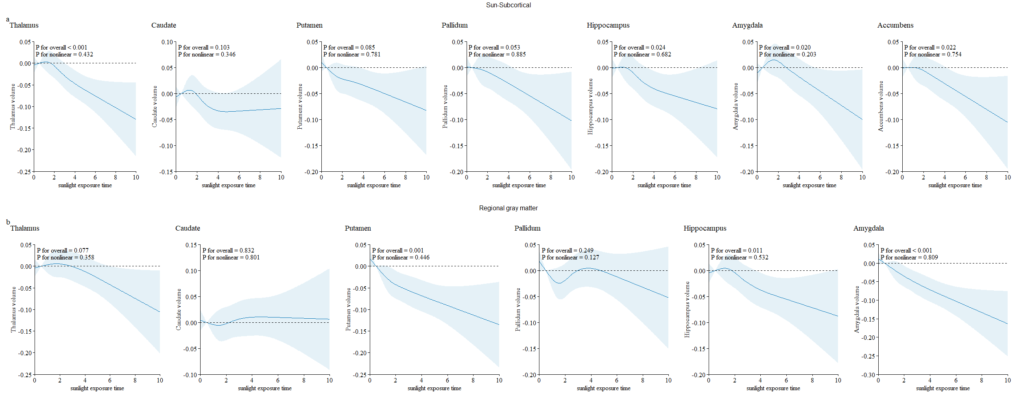
a: the volumes of subcortical regions
b: the volumes of gray matter regions

Figure S2. The restricted cubic spline of natural sunlight exposure with the volumes of subcortical regions and gray matter regions stratified by season.
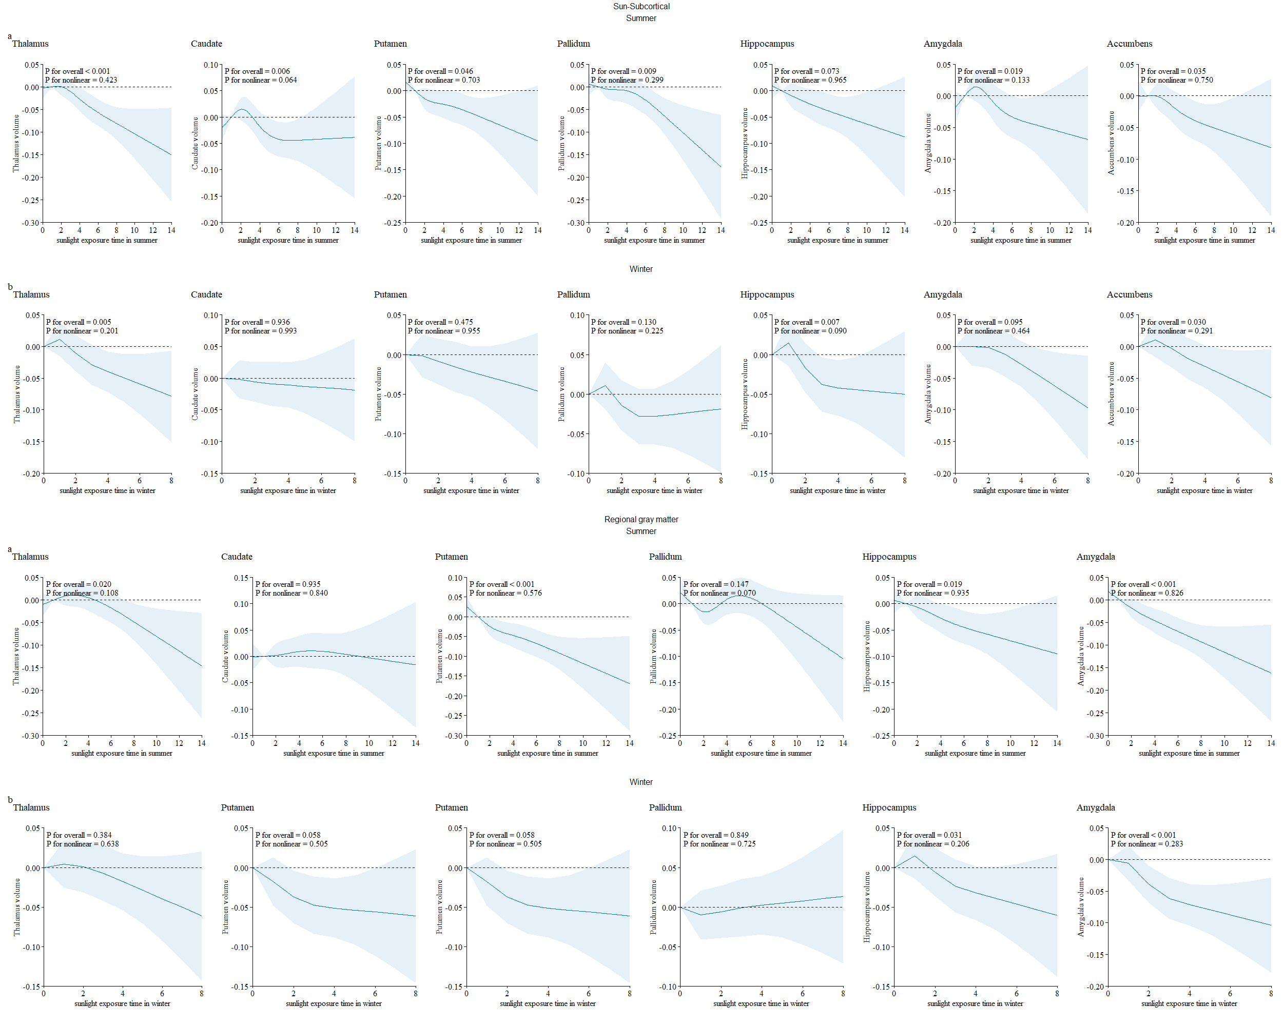
a: natural sunlight exposure in summer.
b: natural sunlight exposure in winter.

