SUPPLEMMENTARY DATA

Figure S1. Principal component (PC) analysis illustrating PC1 and PC2 in each individual population: Italian (a), Northern European and European-American (b), European (c), European-American (d) and Spanish (e). Cases and controls are shown as yellow and blue circles, respectively.
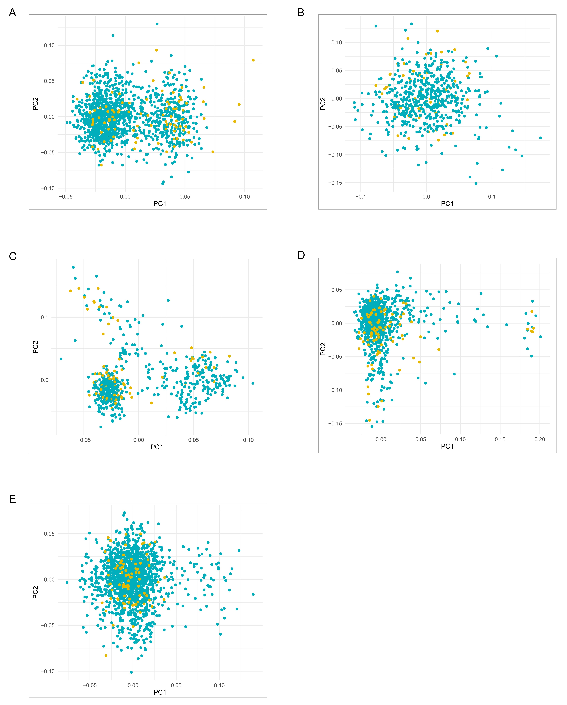
Figure S2. Manhattan plots depicting the GWAS results of each individual population: Italian (a), Northern European and European-American (b), European (c), European-American (d) and Spanish (e). The -log₁₀ p-values for genetic variants analyzed are plotted against their physical chromosomal positions. The red and blue lines represent the genome-wide level of significance (p value<5x10⁻⁸) and the suggestive level of significance (p-value<5x10⁻⁵), respectively.
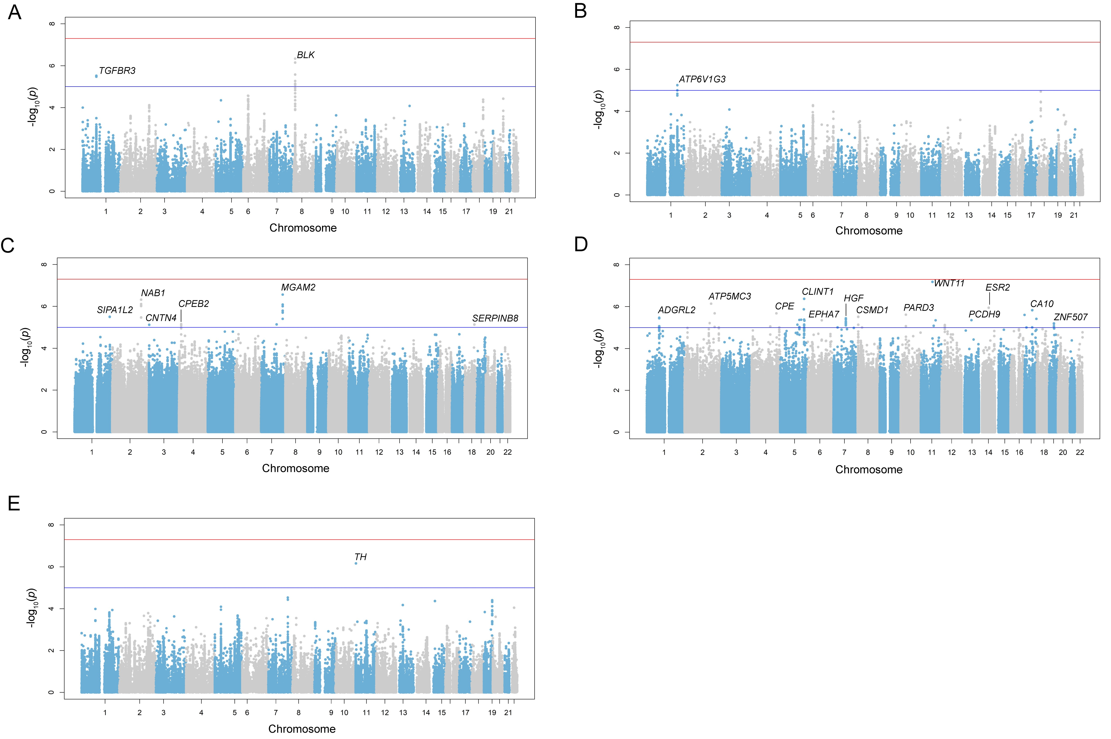

Figure S3. Quantile–quantile plots for the p-values of each individual population: Italian (a), Northern European and European-American (b), European (c), European-American (d) and Spanish (e). The x-axis indicates the expected distribution of -log₁₀ (p-values) and the y-axis indicates the observed distribution of -log₁₀ (p-values). Genomic inflation of the observed distribution is indicated by λ.
Figure S4. Regional Manhattan plots showing the results of stepwise conditional analyses in the STAT4 and HLA regions from the genome-wide meta-analysis. (A) Unconditioned in STAT4 region; (B) conditioning on rs11889341 in STAT4 region; (C) unconditioned in HLA region; (D) conditioning on rs9269041 in HLA region. The -log₁₀ p-values for each genetic variant analyzed are plotted against their physical chromosomal positions. The red and blue lines represent the genome-wide level of significance (p-value<5x10⁻⁸) and the suggestive level of significance (p-value<5x10⁻⁵), respectively.
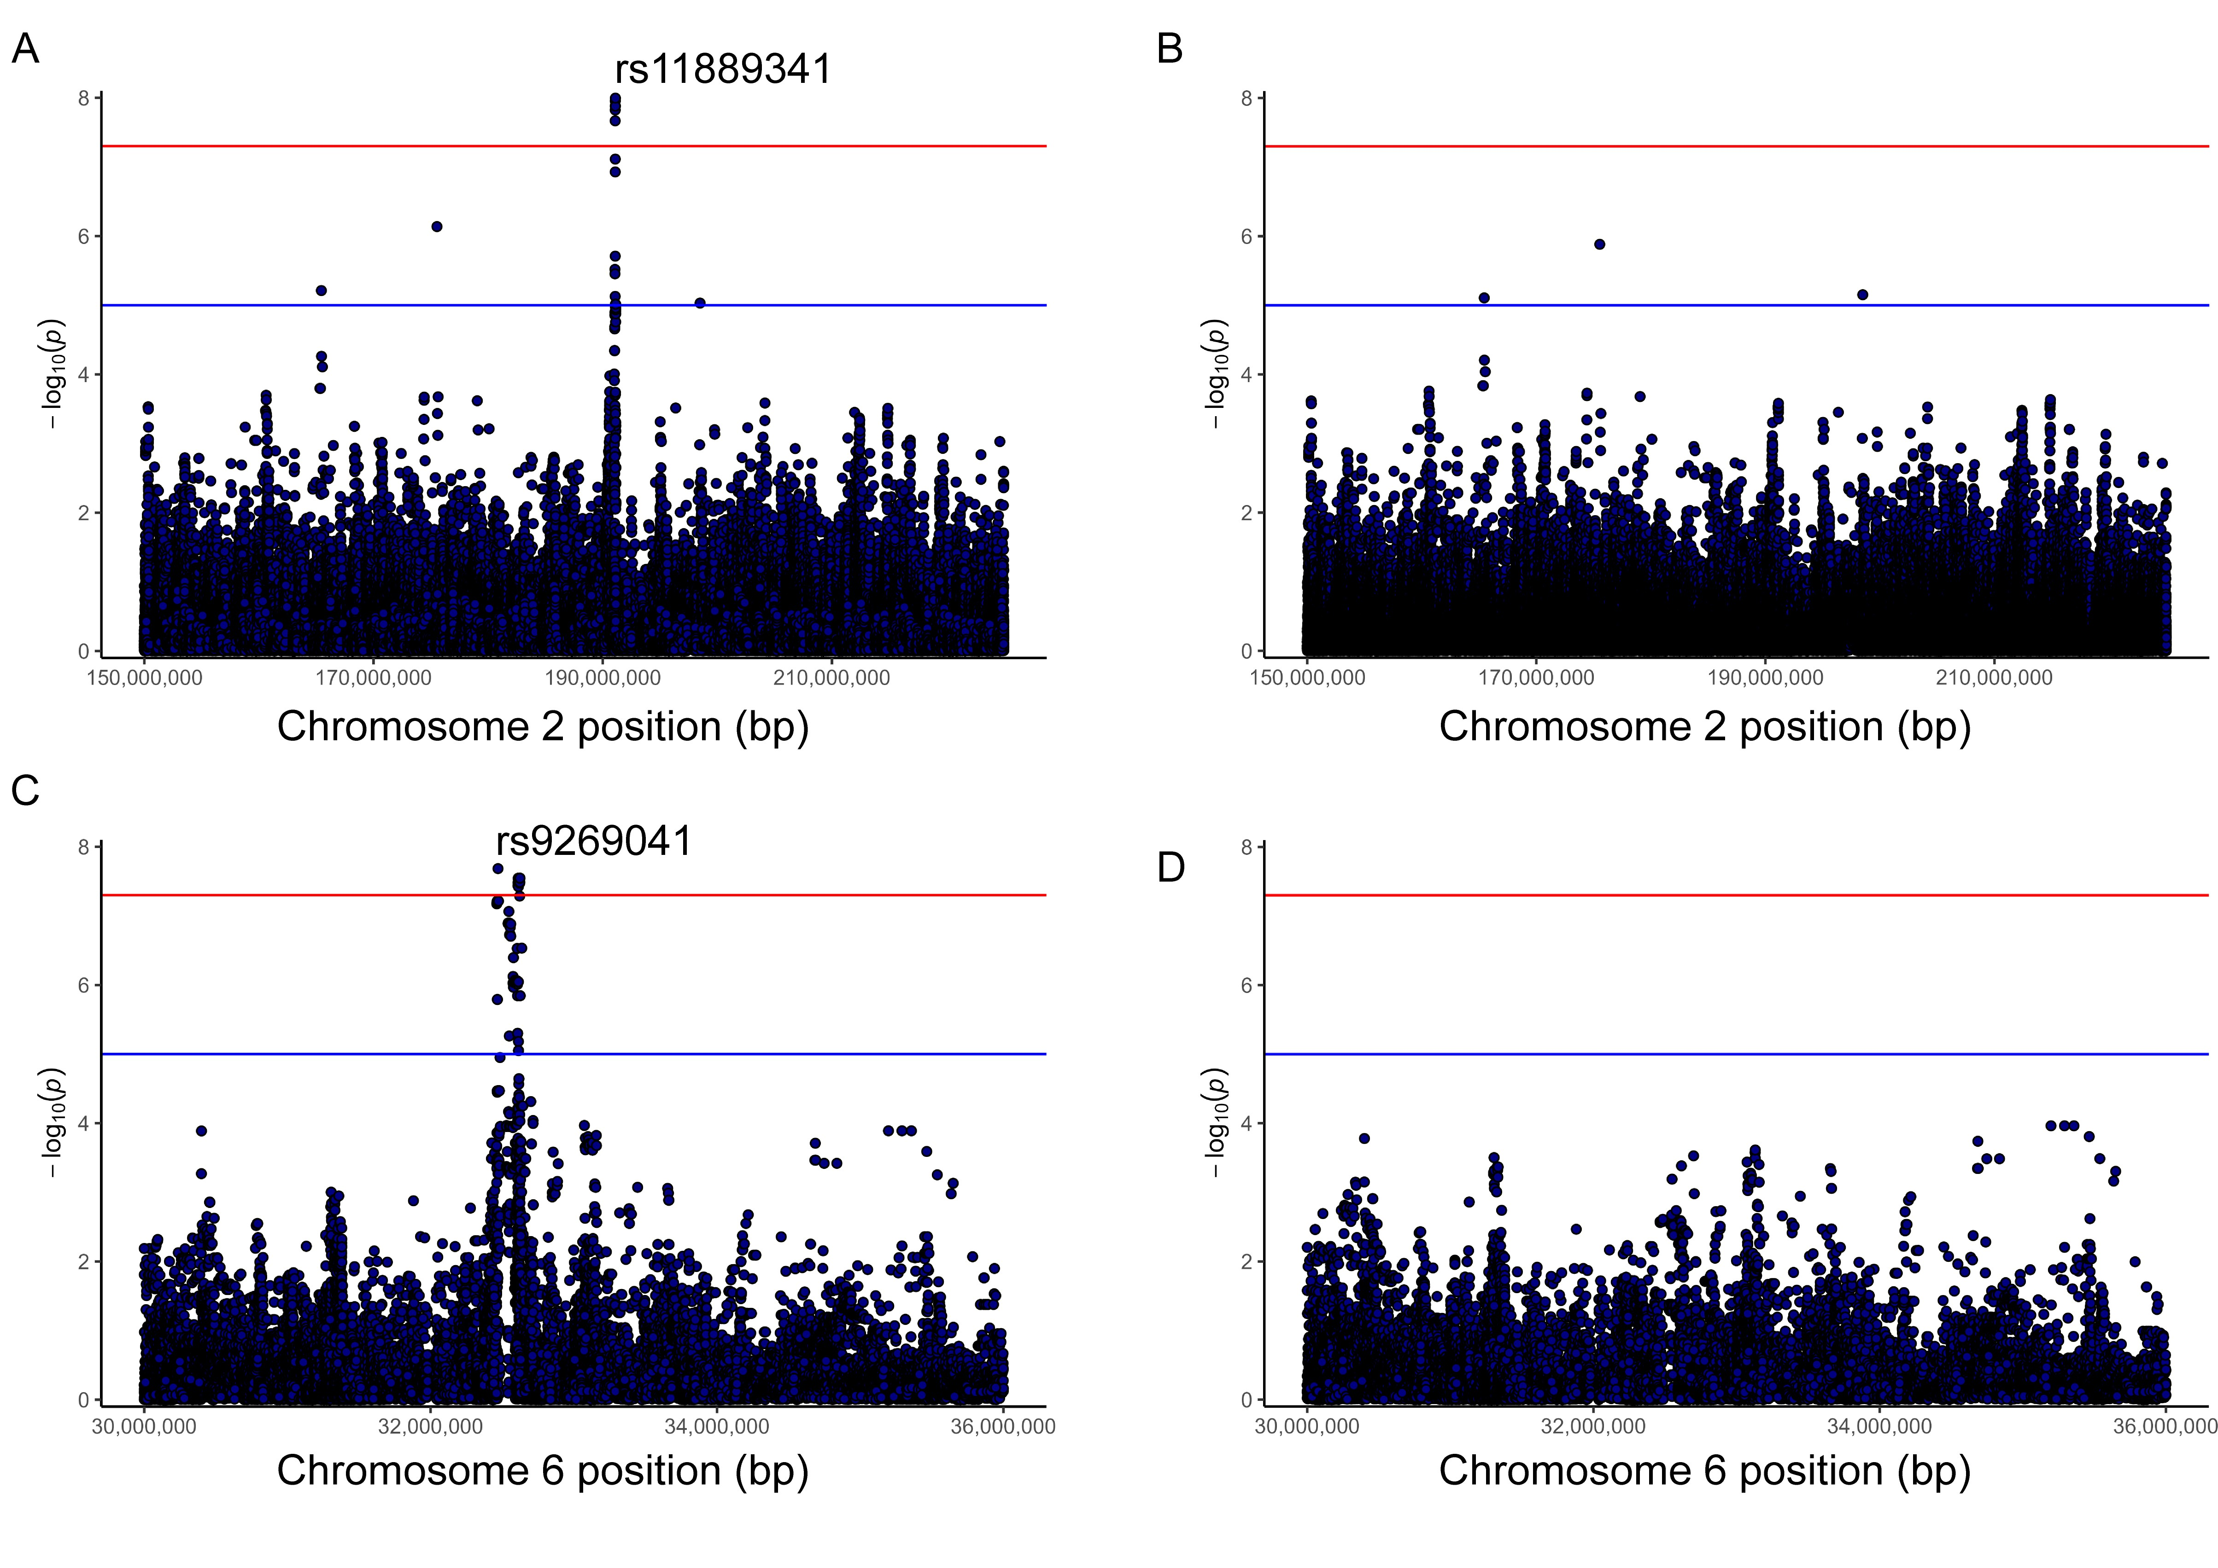

Figure S5. Violin plots representing the differences in expression levels (y-axis) of the HLA genes HLA-DRB6, HLA-DRB9, HLA-DPB2, and HLA-DQB2 depending on the genotypes of the PAPS-associated variant rs9269041 within the HLA region (x-axis). When the PAPS-risk allele is present (rs9269041-A), higher gene expression levels are observed in coronary artery and tibial nerve tissues.
Figure S6. Genome browser view of H3K27ac ChIP-seq tracks in the surrounding region of rs9269041 (hg38, chr6: 32470466, red line) in CD14+ monocytes. Rows correspond to different ChIP-seq experiments from the ENCODE/Roadmap Epigenomics project databases. The upper panel displays a large region of chromosome 6 containing the HLA-DRA gene and the PAPS-associated SNP, while the lower panel represents a zoomed in region.

