S2 Fig. InnovaPrep Concentrating Pipette Pellet TAC Results
Boxplot for InnovaPrep Concentrating Pipette Pellet – DNeasy PowerSoil Pro Manual extractions (n= 28 [N=30, 2 duplicates included in plots below]). The dashed line represents the log₁₀-transformed theoretical limit of detection (1 gene copy per reaction).
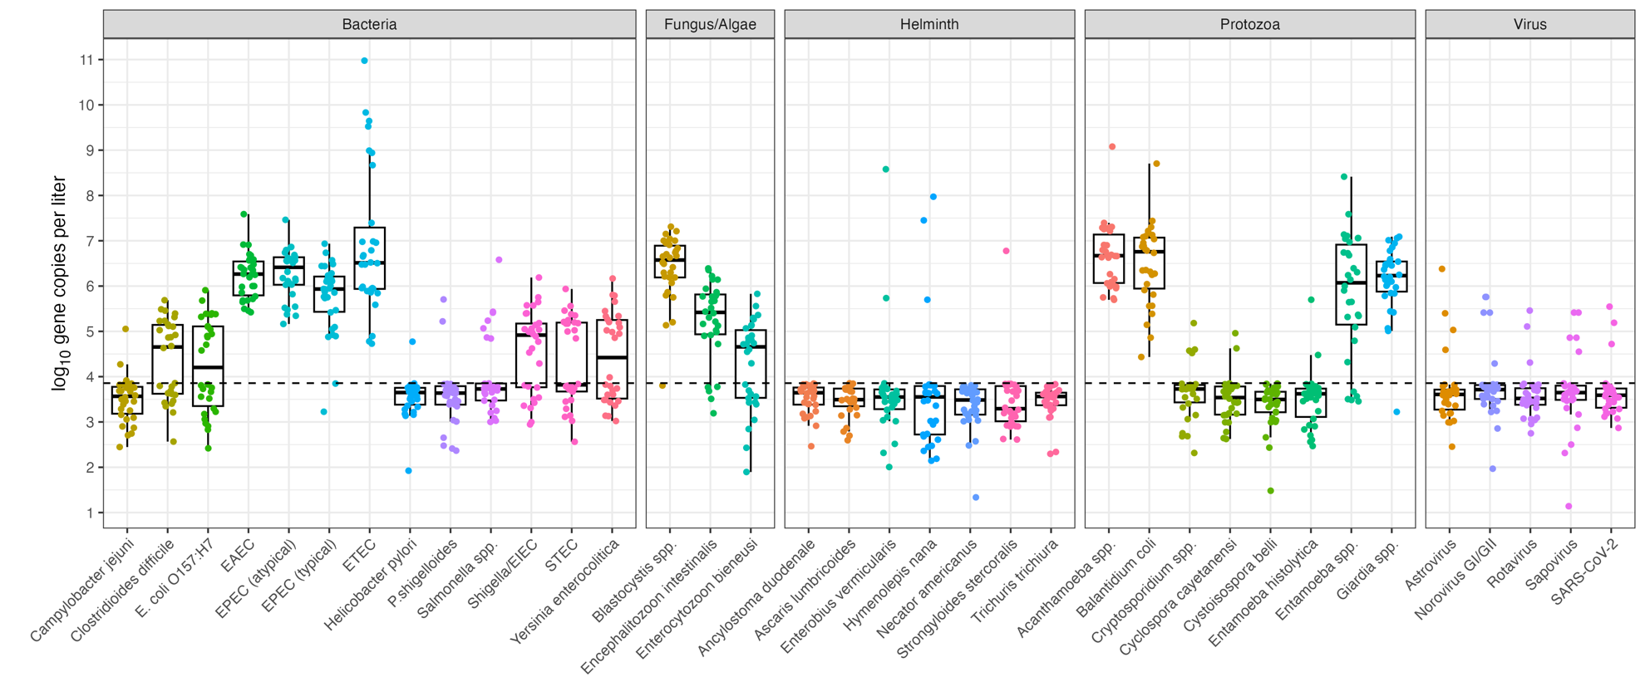

We processed an average of 139 mL through the InnovaPrep CP and the average CP pellet was 1.2 mL.

