Table S1: Study eligibility criteria
Criteria | Description
Population | - Adult advanced (stage III/IV) NCSLC Cancer Patients of any/all race/ethnicity with any/all of the following genomic alterations:  - EGFR  - ALK  - ROS1  - BRAF  - NTRK1/2/3  - RET  - MET  - PD-L1  - KRAS  - Wildtype  - Unknown driver mutation
Interventions | Any of the following technologies for detection of targetable genomic alterations:  - ctDNA-based genomic profiling  - Tissue-based genomic profiling  AND, when outcome of interest is clinical utility:  - At least 80% of population receiving Standard of Care by driver mutation (according to current NCCN Guidelines, table on page 92 of version 3.2022) defined as:  - EGFR Exon 19 deletion or L858R: afatinib or erlotinib or dacomitinib or gefitinib or osimertinib or ramucirumab or bevacizumab;  - EGFR S768I or L861Q, and/or G719X: afatinib, or erlotinib, or dacomitinib, or gefitinib, or osimertinib;  - EGFR Exon 20 insertion mutation positive: amivantamab-vmjw or mobocertinib;  - ALK rearrangement positive: alectinib or brigatinib or certinib or crizotinib or lorlatinib  - ROS1 rearrangement positive: certinib or crizotinib or entrectinib  - BRAF V600E mutation positive: dabrafenib/trametinib or vemurafenib  - NTRK1/2/3: Larotrectinib or entrectinib  - RET: selpercatinib or pralsetinib or cabozantinib  - MET: capmatinib or crizotinib or tepotinib  - KRAS: sotorasib  - PD-L1: pembrolizumab or carboplatin or cisplatin or pemetrexed or paclitaxel or bevacizumab or atezolizumab or albumin-bound paclitaxel or nivolumab or ipilimumab  - Wildtype:  [NOTE: Studies must contain two or more driver genes (e.g., EGFR and ALK) in order to be included]
Outcomes | - Clinical validity  - Sensitivity;  - Specificity; or  - Positive/negative predictive value  OR  - Clinical utility  - Progression free survival; or  - Overall survival, reported as KM or survival curve
Study design | - Prospective or retrospective cohort studies  - Randomized controlled trials
Language | - English
Time | - Only studies published from year 2012 onward

Table S2: Search strategy with Medline, Embase - searched within Embase platform (on 7/5/2023)
No. | Criteria | Strings | Hits
1 | Population | 'non small cell lung cancer'/exp OR 'non small cell lung cancer' OR nsclc | 226949
2 | Population | egfr OR 'epidermal growth factor receptor' | 275762
3 | Population | alk OR 'anaplastic lymphoma receptor tyrosine kinase' | 27898
4 | Population | ros1 OR 'ros proto-oncogene 1 receptor tyrosine kinase' | 5689
5 | Population | braf OR 'b-raf proto-oncogene, serine/threonine kinase' | 43312
6 | Population | ntrk1 OR 'neurotrophic receptor tyrosine kinase 1' | 2063
7 | Population | ntrk2 OR 'neurotrophic receptor tyrosine kinase 2' | 1162
8 | Population | ntrk3 OR 'neurotrophic receptor tyrosine kinase 3' | 1762
9 | Population | ret OR 'ret proto-oncogene' | 18947
10 | Population | met OR 'met proto-oncogene, receptor tyrosine kinase' | 420609
11 | Population | kras OR 'kras proto-oncogene' | 49111
12 | Population | 'pd-l1' OR 'programmed death-ligand 1' | 51488
13 | Population | 'genomic alterat*' | 12040
14 | Population | wildtype | 355241
15 | Population | #2 OR #3 OR #4 OR #5 OR #6 OR #7 OR #8 OR #9 OR #10 OR #11 OR #12 OR #13 OR #14 | 1162656
16 | Population | #1 AND #15 | 71563
17 | Intervention | 'genomic profiling' OR 'genetic profiling' OR 'molecular profil*' OR 'tumor profil*' OR 'mutation profil*' OR 'molecular test' OR 'biomarker test*' OR 'tumor sequenc*' | 38880
18 | Intervention | 'liquid biopsy' OR 'fluid biopsy' OR 'cell free dna' OR cfdna OR 'circulating tumor dna' OR 'ctdna' | 34466
19 | Intervention | 'tissue biopsy' OR 'needle biopsy' | 67521
20 | Intervention | #17 OR #18 OR #19 | 136618
21 | Outcomes | 'clinical validity' | 3332
22 | Outcomes | sensitivity' | 1800575
23 | Outcomes | 'specificity' | 1078876
24 | Outcomes | 'positive predictive value' | 77283
25 | Outcomes | 'negative predictive value' | 68402
26 | Outcomes | #21 OR #22 OR #23 OR #24 OR #25 | 2264504
27 | Outcomes | 'clinical utility' | 50221
28 | Outcomes | 'progression free survival' OR 'pfs' | 206013
29 | Outcomes | 'overall survival' OR 'os' | 627143
30 | Outcomes | #27 OR #28 OR #29 | 733394
31 | Outcomes | #26 OR #30 | 2945799
32 | Study design | 'retrospective study' OR 'prospective study' OR 'observational study' OR 'cohort analysis' OR 'real world evidence' OR 'register' OR 'electronic health record' OR 'electronic medical record' | 3307459
33 | Study design | 'clinical trial' OR 'randomized controlled trial' OR 'controlled clinical trial' | 2259219
34 | Study design | 'single arm trial' | 1825
35 | Study design | #32 OR #33 OR #34 | 5169692
36 |  | #16 AND #20 AND #31 AND #35 | 1920
37 | Limits | #36 AND [english]/lim | 1916
38 | Limits | #37 AND (2012:py OR 2013:py OR 2014:py OR 2015:py OR 2016:py OR 2017:py OR 2018:py OR 2019:py OR 2020:py OR 2021:py OR 2022:py) | 1749

Table S3. Patient characteristics in included clinical validity (CV) studies (n=18)
 | No. of Patients | Tumor stage III/IV (advanced) | Age (years) | Male | Former/Current Smokers | Caucasian | Asian | African American | Hispanic
Author_Year | n | % | Median (range) | n (%) | n (%) | n (%) | n (%) | n (%) | n (%)
Bustamante Alvarez_2021 | 94 | 100 | NA | NA | NA | NA | NA | NA | NA
Fernandes_2021 | 115 | 100 | 66 (38-92) | 71 (61.7%) | 73 (63.5%) | NA | NA | NA | NA
Leighl_2019 | 282 | 100 | 69 (26-100) | 129 (45.7%) | 214 (76.1%) | 231 (81.9%) | 17 (6%) | 18 (6.4%) | 23 (8.2%)
Li_2019 | 127 | 100 | NA | 47 (37%) | NA | NA | NA | NA | NA
Lin_2021 | 100 | 98 | 67.5 (35-92) | 44 (44%) | NA | NA | NA | NA | NA
Müller_2017 | 98 | 54.1 | mean=66 | 43 (44%) | NA | NA | NA | NA | NA
Palmero_2021 | 186 | 100 | 63.4 (39-86) | 121 (65%) | 132 (71%) | 180 (97%) | 0 (0%) | 0 (0%) | 0 (0%)
Park_2021 | 262 | 100 | 62 (30-89) | 175 (66.8%) | 155 (59.2%) | NA | NA | NA | NA
Pritchett_2019 | 264 | 100 | mean=67.1 (SD=11) | 128 (48.5%) | 225 (85.2%) | 226 (85.6%) | 6 (2.3%) | 26 (9.8%) | 0 (0%)
Schwaederlé_2017 | 88 | 100 | 66.2 (36.3-89.5) | 30 (34%) | 50 (56.8%) | 58 (66%) | 18 (20.5%) | 1 (1.1%) | 2 (2.3%)
Yao_2017 | 39 | 100 | 62 (28-78) | 19 (48.7%) | 10 (25.6%) | NA | NA | NA | NA
Xu_2016 | 42 | 100 | 62 (37-75) | 21 (50%) | NA | NA | NA | NA | NA
Liu_2018 | 72 | 100 | 59 (40-83) | 44 (61.1%) | 29 (40.3%) | NA | NA | NA | NA
Couraud_2014 | 106 | 87.5 | Mean=68.7 (SD=13.7) | 13 (12.3%) | 0 | NA | NA | NA | NA
Chen_2019 | 50 | 40 | NA | 35 (70%) | 21 (42%) | NA | NA | NA | NA
Remon_2019 | 214 | 100 | Mean=63.7 (SD=10.53) | 126 (58.9%) | 175 (83.3%) | NA | NA | NA | NA
Guo_2016 | 41 | 26.8 (IV) | 52 (38-73) | 22 (53.7%) | NA | NA | NA | NA | NA
Sabari_2019 | 210 | 100 | 65 (28-91) | 86 (41%) | NA | NA | NA | NA | NA
Table S4. Data included in meta-analysis on the clinical validity (CV) of ctDNA testing for multi-gene detection (n=13)
Author_Year | No. of Patients | Test driver genes | TP | FP | FN | TN | Total No. of Samples
Bustamante Alvarez_2021 | 94 | Overall (EGFR, ALK fusions, BRAF, MET exon 14 skipping mutation, ROS1 mutations and RET fusions) | 22 | 7 | 11 | 54 | 94
Fernandes_2021 | 127 | Overall (Oncomine – EGFR, KRAS, ALK, BRAF, MET, ROS1, ERBB2, MAP2K1, NRAS, PIK3CA, and TP53) | 51 | 3 | 12 | 61 | 127
Leighl_2019 | 282 | Overall (EGFR, ALK fusion, BRAF V600E, MET amplification, MET exon 14 skipping, ROS1 fusion, RET fusion, ERBB2 mutation) | 35 | 0 | 9 | 862 | 906
Li_2019 | 91 for sensitivity analysis; 19 for specificity analysis | Overall (EGFR, KRAS, ALK, BRAF, MET, ROS1, RET, ERBB2) | 68 | 0 | 23 | 789 | 880
Müller_2017 | 29 | Key 6 genes (EGFR, KRAS, ALK, BRAF, ROS1, TP53) | 16 | 1 | 12 | 145 | 174
Park_2021 | 262 | Key genes (EGFR Del 9, EGFR L858R, KRAS, ALK, BRAF V600E, MET exon 14, MET amplification, ROS1, RET, ERBB2 exon 20) | 95 | 19 | 69 | 2437 | 2620
Pritchett_2019 | 95 | Key 8 genes (EGFR (exons 18-21), KRAS, ALK/ROS1, BRAF V600E, MET exon 14, ERBB2 exon 20, STK11) | 88 | 2 | 31 | 1027 | 1148
Yao_2017 | 39 | Overall (EGFR, KRAS, PIK3CA, ALK and gene fusions (EML4-ALK and KIF5B-RET)) | 19 | 0 | 9 | 128 | 156
Xu_2015 | 42 | Key genes (EGFR, KRAS, BRAF, ERBB2, PIK3CA, TP53) | 23 | 25 | 7 | 197 | 252
Liu_2017 | 72 | Overall (EGFR L858R, EGFR exon 19 del, KRAS G12X, ALK rearrangement) | 34 | 1 | 16 | 222 | 273
Couraud_2014 | 50 | All 12 amplicons together (EGFR (exons 18-21), KRAS (exons 2 & 3), BRAF (exons 11 & 15), ERBB2 (exons 19 & 20), PI3KCA (exons 9 & 20)) | 24 | 1 | 22 | 489 | 536
Remon_2019 | 94 | Core gene variants (EGFR (exons 18-21), KRAS, BRAF V600E, MET exon 14, ERBB2 exon 20, STK11) | 35 | 10 | 8 | 320 | 373
Sabari_2019 | 106 | Key genes (EGFR, KRAS, ALK, BRAF, MET, ROS1, RET) | 44 | 7 | 35 | 656 | 742
TP: true positive; FP: false positive; FN: false negative; TN: true negative

Figure S1. Bayesian Posterior Predictive Contours (50%, 75%, 95%) of ctDNA testing for multi-gene detection (n=13)

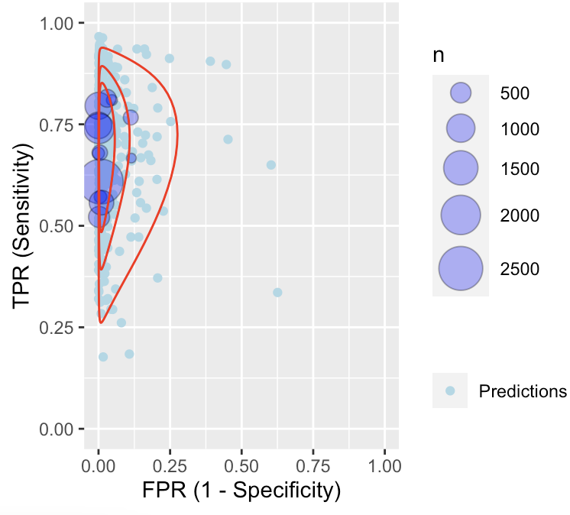

Each purple circle identifies the true positive rate (TPR) vs. the false positive rate (FPR) of each study (observed data). Light blue circles are predictions based on Bayesian meta-analysis of data by fitting a bivariate random effects model, with red lines indicating parametric predictive contours.
Table S5. Results from frequentist and Bayesian bivariate random effects meta-analyses

 |  | Frequentist Approach |  | Bayesian Approach
 | No. of studies | Sensitivity (95% CI) | Specificity (95% CI) | Sensitivity (95% CI) | Specificity (95% CI) | BAUC
Overall | 13 | 0.69(0.63, 0.74) | 0.99 (0.97, 1.00) | 0.70 (0.60, 0.79) | 0.99 (0.97, 1.00) | 0.71 (0.68, 0.73)
EGFR | 14 | 0.68 (0.62, 0.74) | 0.98 (0.95, 0.99) | 0.70 (0.60, 0.78) | 0.98 (0.95, 0.99) | 0.71 (0.68, 0.73)
KRAS | 11 | 0.77 (0.63, 0.86) | 0.96 (0.90, 0.98) | 0.82 (0.70, 0.90) | 0.97 (0.93, 0.99) | 0.72 (0.69, 0.73)
BRAF | 8 | 0.60 (0.39, 0.77) | 0.99 (0.99, 1.00) | 0.64 (0.37, 0.86) | 1.00 (0.99, 1.00) | 0.53 (0.51, 0.54)
ALK | 6 | 0.59 (0.45, 0.73) | 0.99 (0.98, 1.00) | 0.60 (0.38, 0.79) | 0.99 (0.98, 1.00) | 0.62 (0.58, 0.64)
ROS1 | 4 | 0.29 (0.13, 0.53) | 0.99 (0.97, 1.00) | 0.26 (0.06, 0.58) | 0.99 (0.97, 1.00) | 0.67 (0.52, 0.73)
MET | 5 | 0.47 (0.33, 0.62) | 0.98 (0.97, 0.99) | 0.48 (0.26, 0.71) | 0.99 (0.97, 1.00) | 0.70 (0.63, 0.73)
RET | 3 | 0.38 (0.21, 0.58) | 0.99 (0.97, 1.00) | 0.37 (0.11, 0.71) | 0.98 (0.95, 1.00) | 0.66 (0.50, 0.73)

Table S6. Data included in meta-analysis on the clinical validity (CV) of ctDNA detection of EGFR (n=14)

Author_Year | No. of patients | TP | FP | FN | TN
Leighl_2019 | 223 | 27 | 0 | 5 | 414
Li_2019 | 91 for sensitivity analysis, 19 for specificity analysis | 29 | 0 | 8 | 73
Müller_2017 | 29 | 6 | 0 | 1 | 22
Palmero_2021 | 148 | 24 | 0 | 12 | 112
Park_2021 | 262 | 35 | 4 | 14 | 471
Pritchett_2019 | 164 | 13 | 0 | 5 | 146
Schwaederlé_2017 | 26 | 7 | 2 | 3 | 14
Yao_2017 | 39 | 12 | 0 | 5 | 22
Xu_2015 | 42 | 4 | 11 | 3 | 24
Liu_2017 | 72 | 26 | 0 | 12 | 106
Couraud_2014 | 45 | 19 | 1 | 8 | 147
Chen_2019 | 7 | 2 | 0 | 1 | 4
Remon_2019 | 94 | 7 | 1 | 1 | 78
Sabari_2019 | 106 | 24 | 1 | 20 | 61
TP: true positive; FP: false positive; FN: false negative; TN: true negative

Figure S2. Forest plot of sensitivity and specificity on ctDNA detection of EGFR from bivariate random effects meta-analyses (n=14)

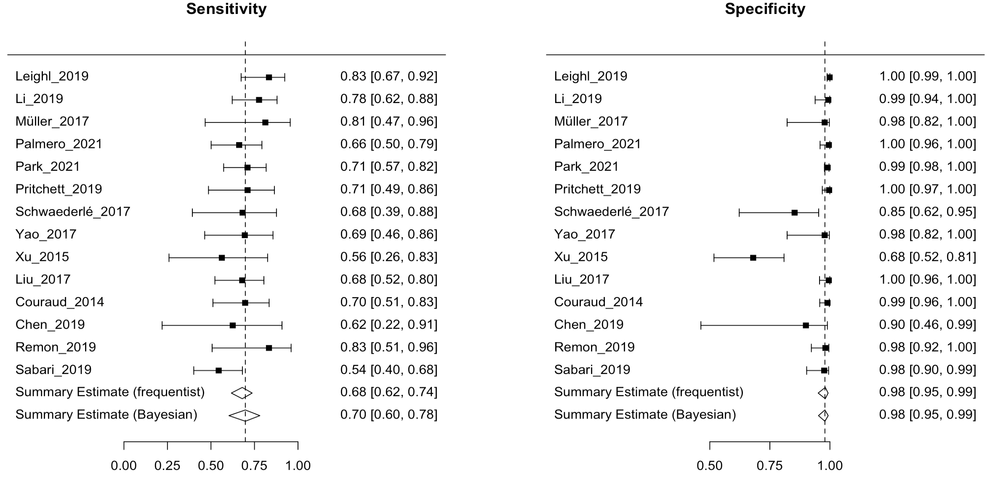

Sensitivity and specificity of single studies were based on frequentist estimations; I² = 0% based on the frequentist approach

Figure S3. Summary receiver operating characteristics (SROC) plots based on bivariate random-effects meta-analyses of ctDNA detection of EGFR (n=14)

- SROC (frequentist approach):
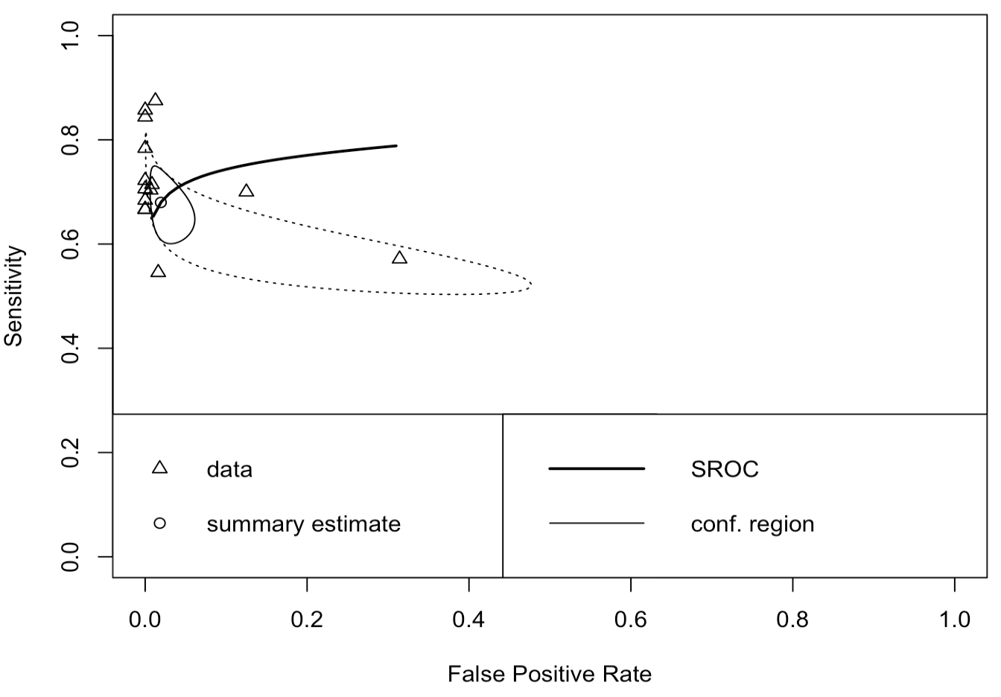

- SROC (Bayesian approach):
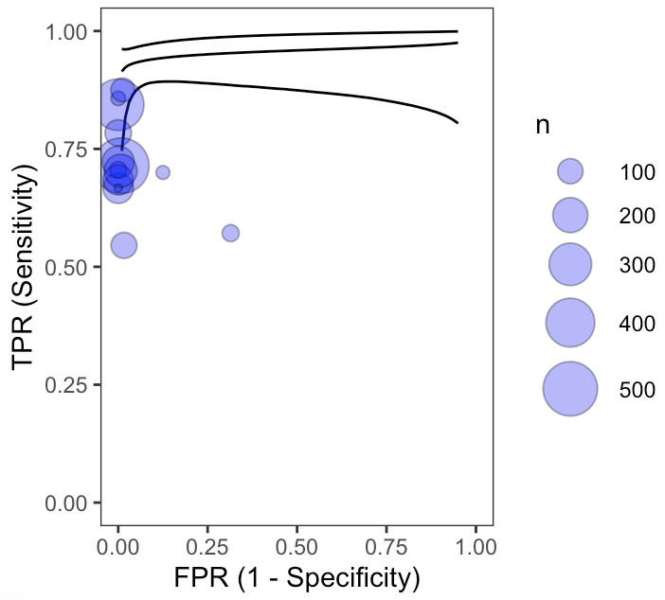

Figure S4. Bayesian Posterior Predictive Contours (50%, 75%, 95%) for ctDNA detection of EGFR (n=14)

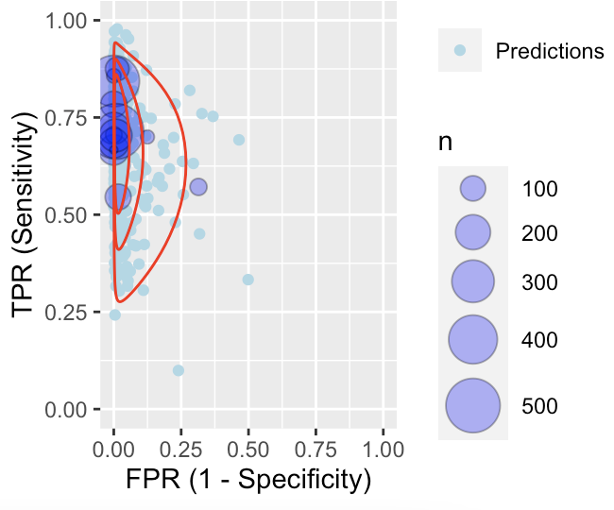

Each purple circle identifies the true positive rate (TPR) vs. the false positive rate (FPR) of each study (observed data). Light blue circles are predictions based on Bayesian meta-analysis of data by fitting a bivariate random effects model, with red lines indicating parametric predictive contours.

Table S7. Data included in meta-analysis on the CV of ctDNA detection of KRAS (n=11)

Author_Year | No. of patients | TP | FP | FN | TN
Bustamante Alvarez_2021 | 94 | 69 | 9 | 2 | 14
Li_2019 | 91 for sensitivity analysis, 19 for specificity analysis | 23 | 0 | 6 | 81
Müller_2017 | 29 | 4 | 0 | 5 | 20
Park_2021 | 262 | 23 | 3 | 11 | 225
Pritchett_2019 | 146 | 48 | 1 | 12 | 86
Yao_2017 | 39 | 3 | 0 | 1 | 35
Xu_2015 | 42 | 6 | 6 | 0 | 30
Liu_2017 | 65 | 6 | 0 | 2 | 57
Couraud_2014 | 45 | 2 | 0 | 1 | 82
Remon_2019 | 94 | 22 | 7 | 3 | 56
Sabari_2019 | 106 | 8 | 2 | 10 | 86
TP: true positive; FP: false positive; FN: false negative; TN: true negative

Figure S5. Forest plot of sensitivity and specificity on ctDNA detection of KRAS from bivariate random effects meta-analyses (n=11)

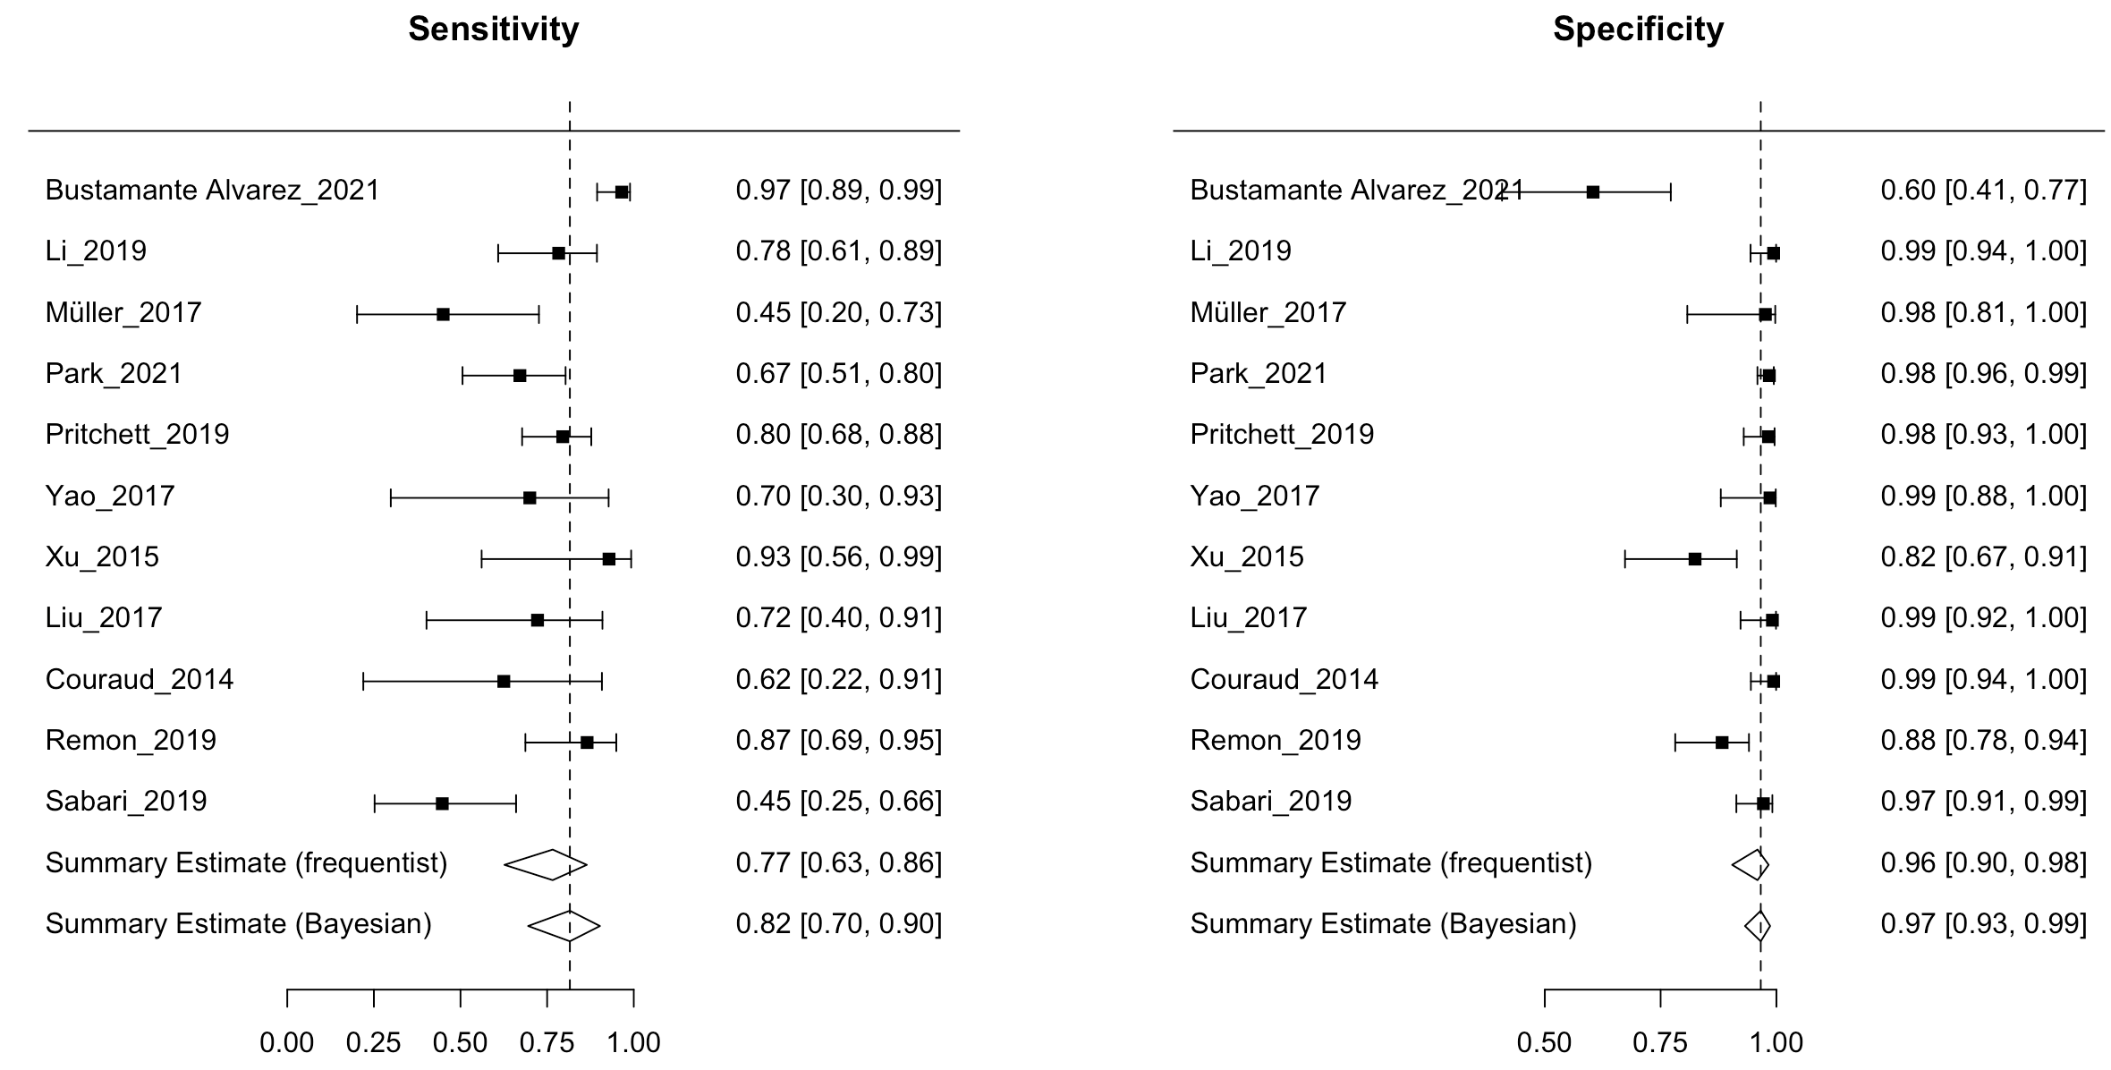

Sensitivity and specificity of single studies were based on frequentist estimations; I² = 0% based on the frequentist approach
Figure S6. Summary receiver operating characteristics (SROC) plots based on bivariate random-effects meta-analyses of ctDNA detection of KRAS (n=11)

- SROC (frequentist approach)

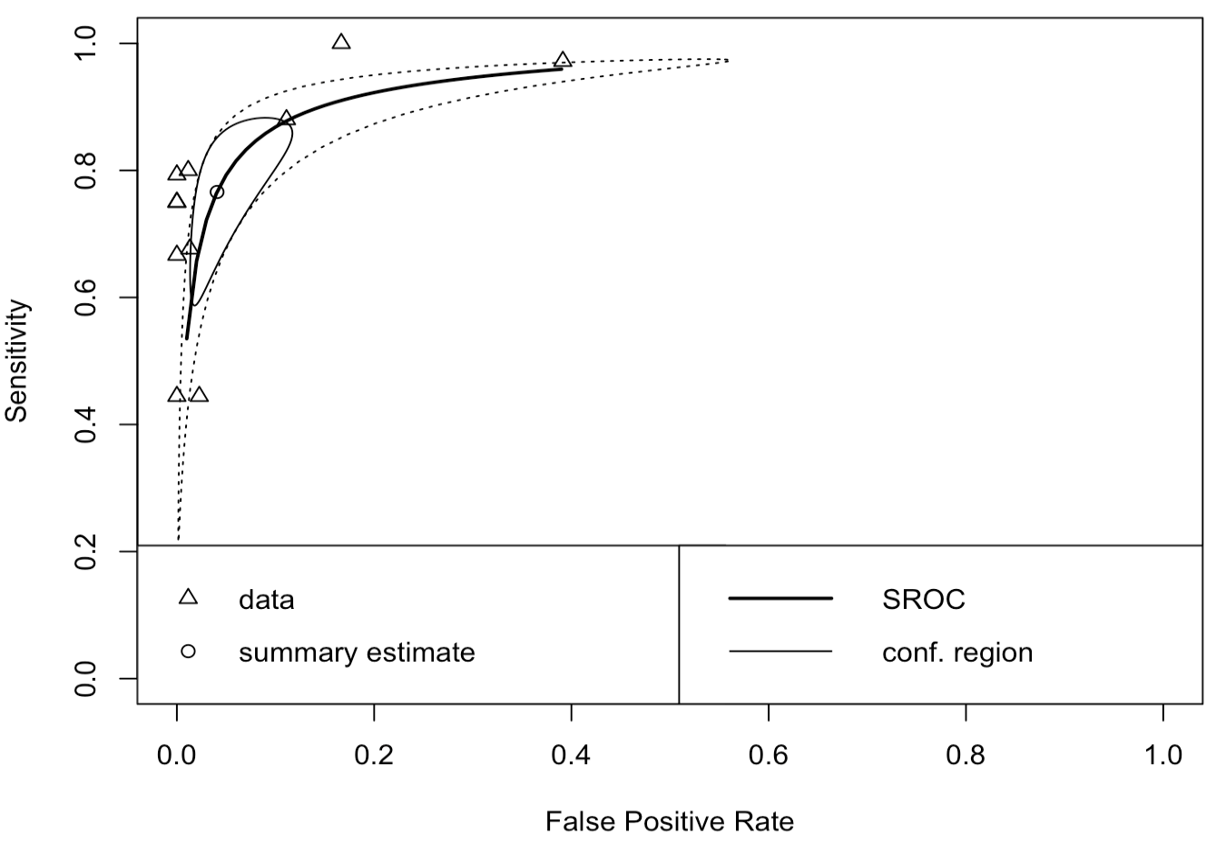

- SROC (Bayesian approach)

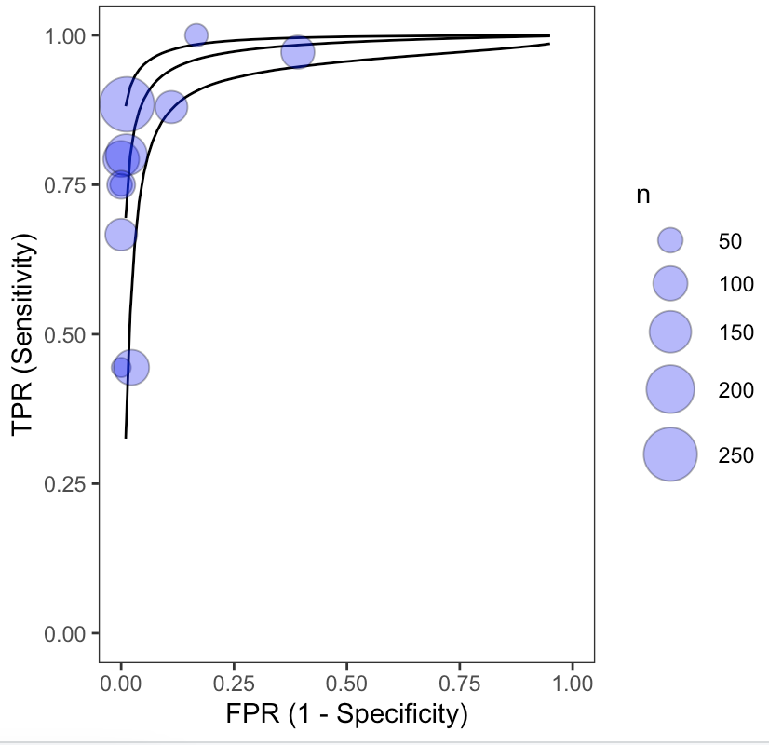

Figure S7. Bayesian Posterior Predictive Contours (50%, 75%, 95%) for ctDNA detection of KRAS (n=11)

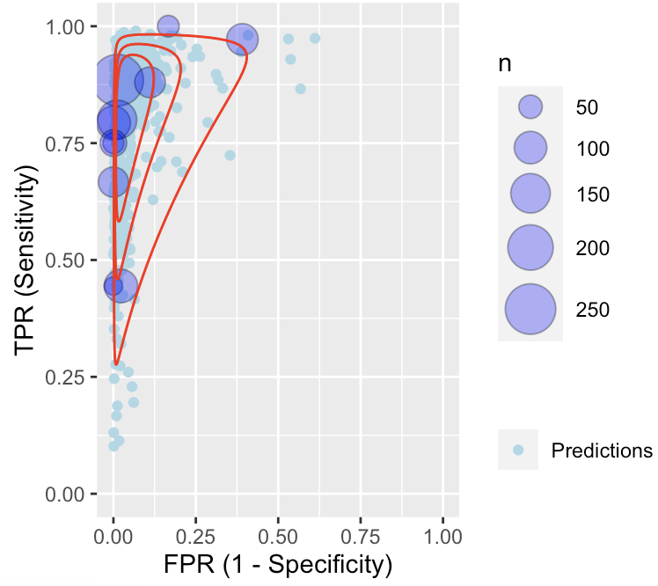

Each purple circle identifies the true positive rate (TPR) vs. the false positive rate (FPR) of each study (observed data). Light blue circles are predictions based on Bayesian meta-analysis of data by fitting a bivariate random effects model, with red lines indicating parametric predictive contours.

Table S8. Data included in meta-analysis on the CV of ctDNA detection of BRAF (n=8)

Author_Year | No. of patients | TP | FP | FN | TN
Leighl_2019 | 92 | 2 | 0 | 0 | 90
Li_2019 | 91 for sensitivity analysis, 19 for specificity analysis | 3 | 0 | 0 | 107
Müller_2017 | 29 | 0 | 0 | 1 | 28
Park_2021 | 262 | 1 | 1 | 2 | 258
Pritchett_2019 | 151 | 5 | 2 | 0 | 140
Couraud_2014 | 44 | 0 | 0 | 2 | 86
Remon_2019 | 94 | 1 | 0 | 1 | 75
Sabari_2019 | 106 | 3 | 0 | 0 | 103
TP: true positive; FP: false positive; FN: false negative; TN: true negative

Figure S8. Forest plot of sensitivity and specificity on ctDNA detection of BRAF from bivariate random effects meta-analyses (n=8)

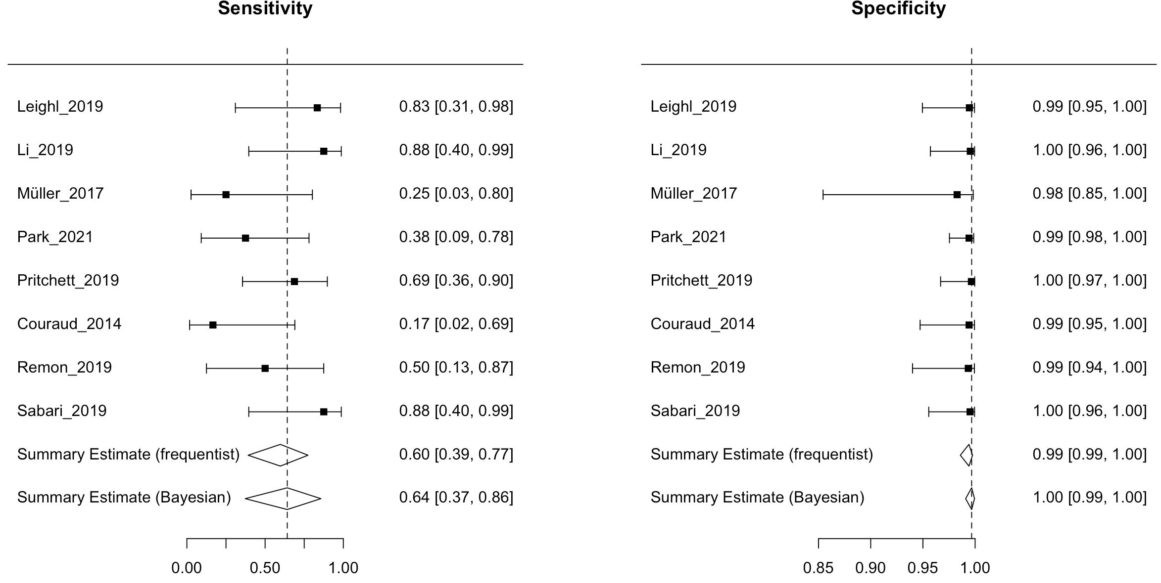

Sensitivity and specificity of single studies were based on frequentist estimations; I² = 0% based on the frequentist approach

Figure S9. Summary receiver operating characteristics (SROC) plots based on bivariate random-effects meta-analyses of ctDNA detection of BRAF (n=8)

- SROC (frequentist approach):

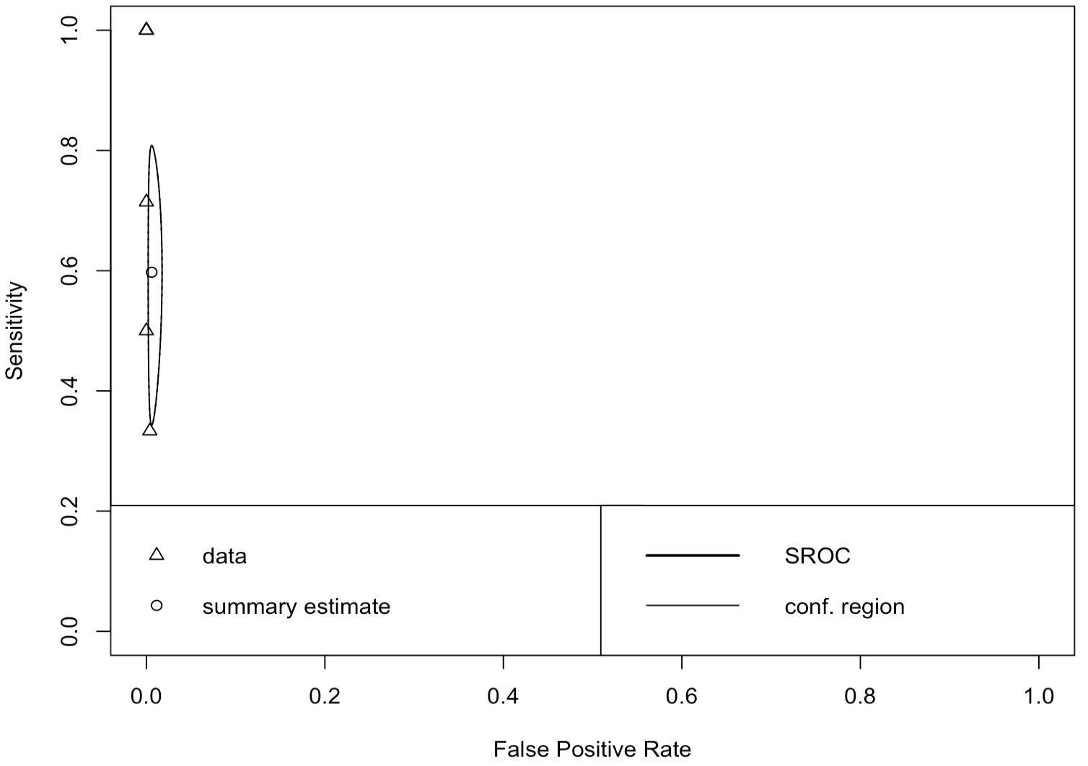

- SROC (Bayesian approach):

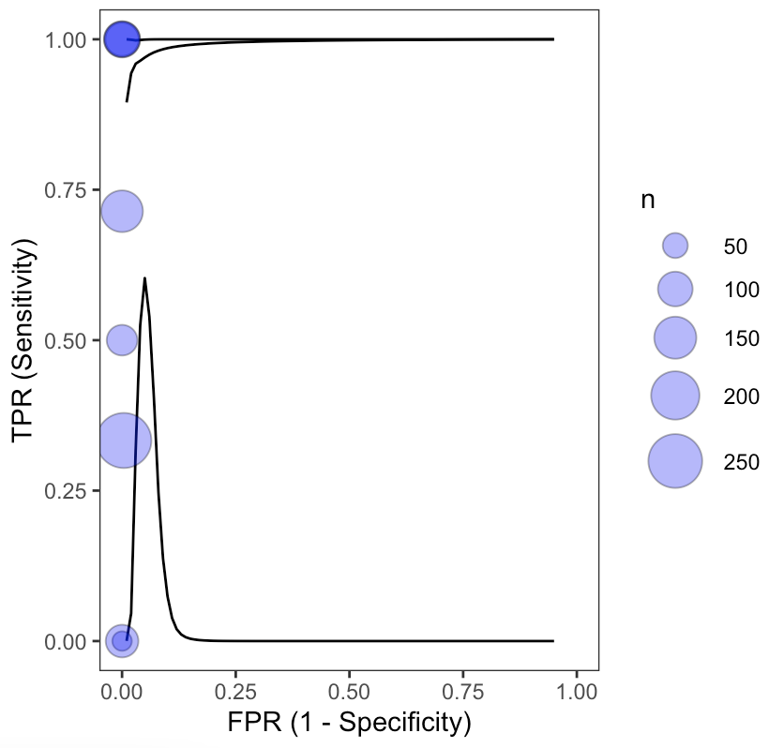

Figure S10. Bayesian Posterior Predictive Contours (50%, 75%, 95%) for ctDNA detection of BRAF (n=8)

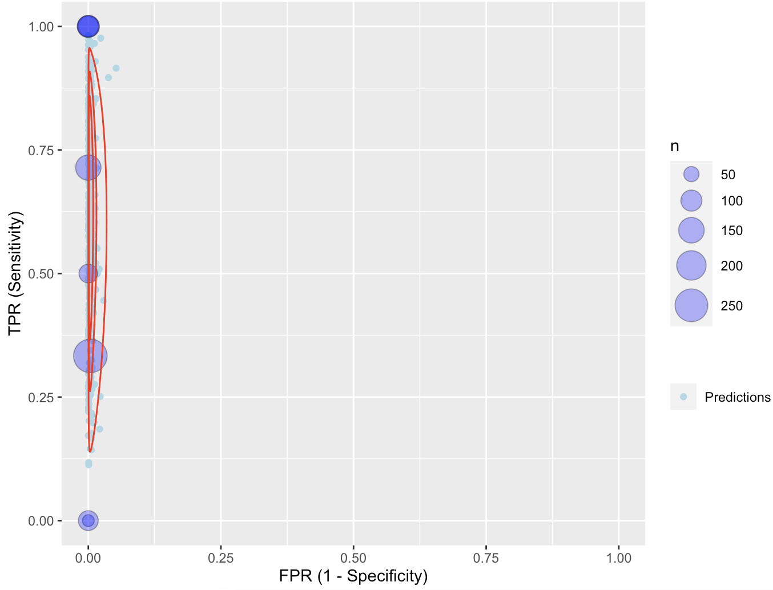

Each purple circle identifies the true positive rate (TPR) vs. the false positive rate (FPR) of each study (observed data). Light blue circles are predictions based on Bayesian meta-analysis of data by fitting a bivariate random effects model, with red lines indicating parametric predictive contours.

Table S9. Data included in meta-analysis on the CV of ctDNA detection of ALK (n=6)

Author_Year | No. of patients | TP | FP | FN | TN
Leighl_2019 | 215 | 6 | 0 | 2 | 207
Li_2019 | 91 for sensitivity analysis, 19 for specificity analysis | 5 | 0 | 3 | 102
Palmero_2021 | 132 | 2 | 1 | 3 | 126
Park_2021 | 262 | 6 | 0 | 4 | 252
Liu_2017 | 64 | 2 | 1 | 2 | 59
Sabari_2019 | 106 | 4 | 1 | 2 | 99
TP: true positive; FP: false positive; FN: false negative; TN: true negative

Figure S11. Forest plot of sensitivity and specificity on ctDNA detection of ALK from bivariate random effects meta-analyses (n=6)

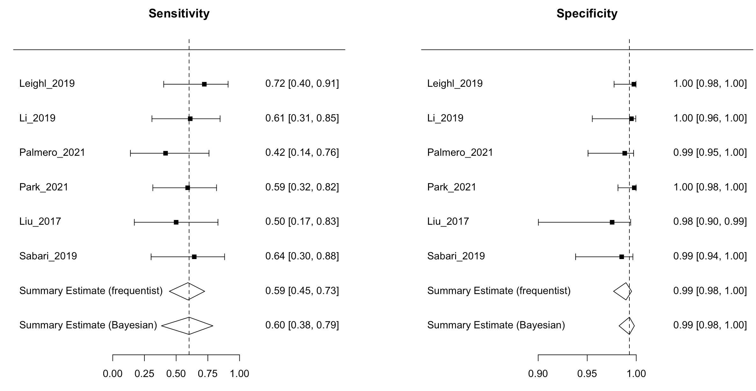

Sensitivity and specificity of single studies were based on frequentist estimations; I² = 10.9% based on the frequentist approach

Figure S12. Summary receiver operating characteristics (SROC) plots based on bivariate random-effects meta-analyses of ctDNA detection of ALK (n=6)

- SROC (frequentist approach):
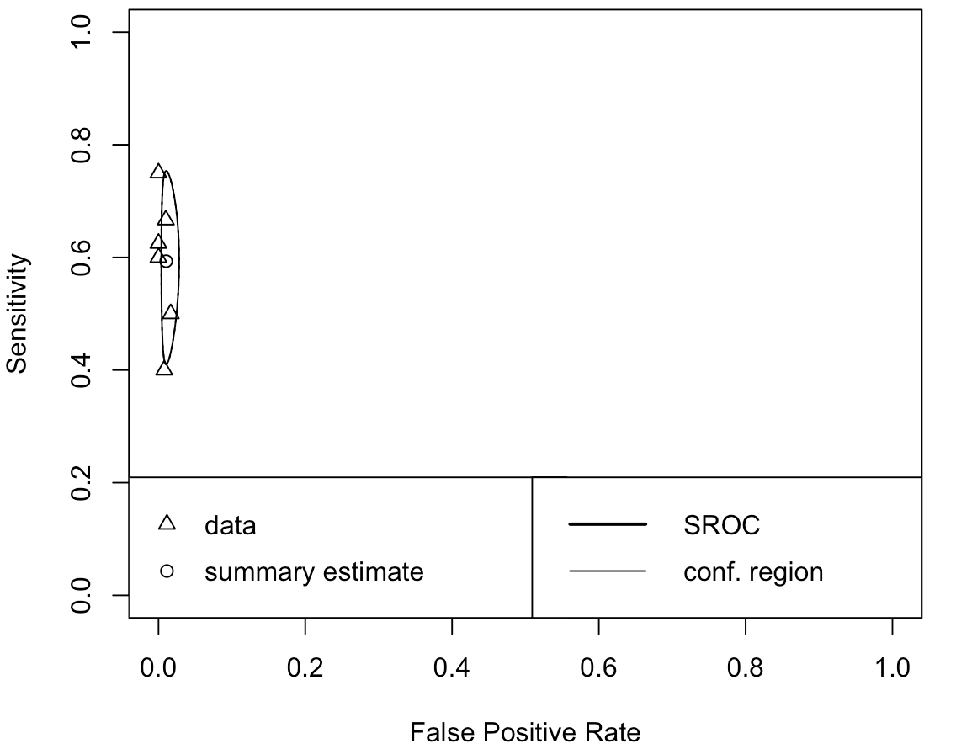

- SROC (Bayesian approach):
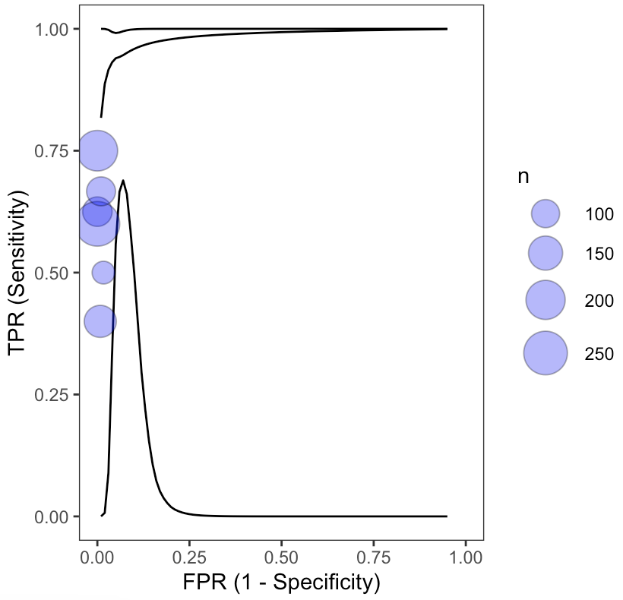

Figure S13. Bayesian Posterior Predictive Contours (50%, 75%, 95%) for ctDNA detection of ALK (n=6)

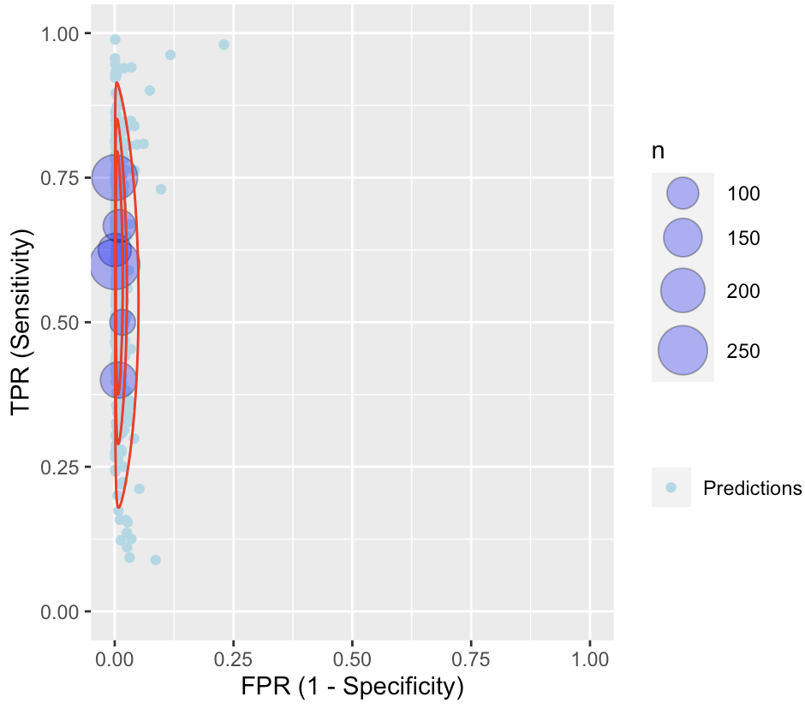

Each purple circle identifies the true positive rate (TPR) vs. the false positive rate (FPR) of each study (observed data). Light blue circles are predictions based on Bayesian meta-analysis of data by fitting a bivariate random effects model, with red lines indicating parametric predictive contours.

Table S10. Data included in meta-analysis on the CV of ctDNA detection of ROS1 (n=4)

Author_Year | No. of patients | TP | FP | FN | TN
Leighl_2019 | 153 | 0 | 0 | 2 | 151
Li_2019 | 91 for sensitivity analysis, 19 for specificity analysis | 1 | 0 | 2 | 107
Park_2021 | 262 | 3 | 0 | 12 | 247
Sabari_2019 | 106 | 1 | 2 | 1 | 102
TP: true positive; FP: false positive; FN: false negative; TN: true negative

Figure S14. Forest plot of sensitivity and specificity on ctDNA detection of ROS1 from bivariate random effects meta-analyses (n=4)

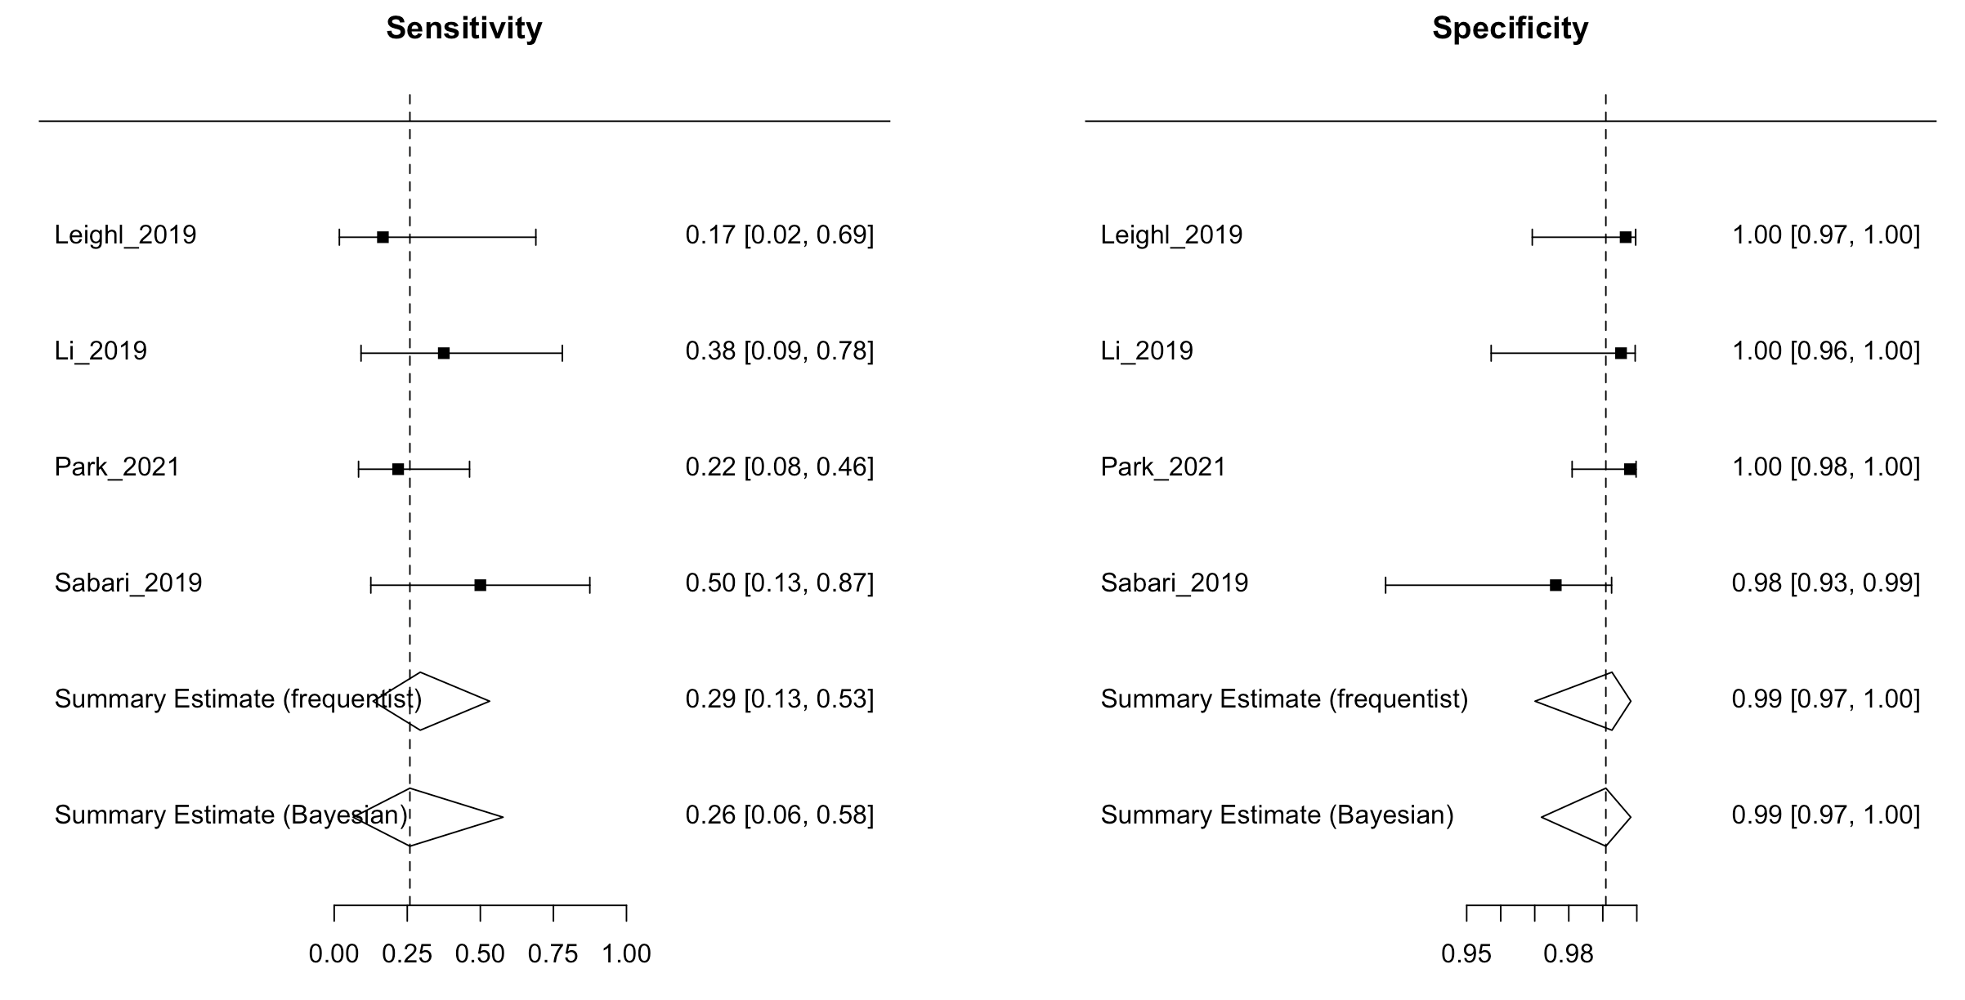

Sensitivity and specificity of single studies were based on frequentist estimations; I² = 0% based on the frequentist approach

Figure S15. Summary receiver operating characteristics (SROC) plots based on bivariate random-effects meta-analyses of ctDNA detection of ROS1 (n=4)

- SROC (frequentist approach)

- SROC (Bayesian approach):

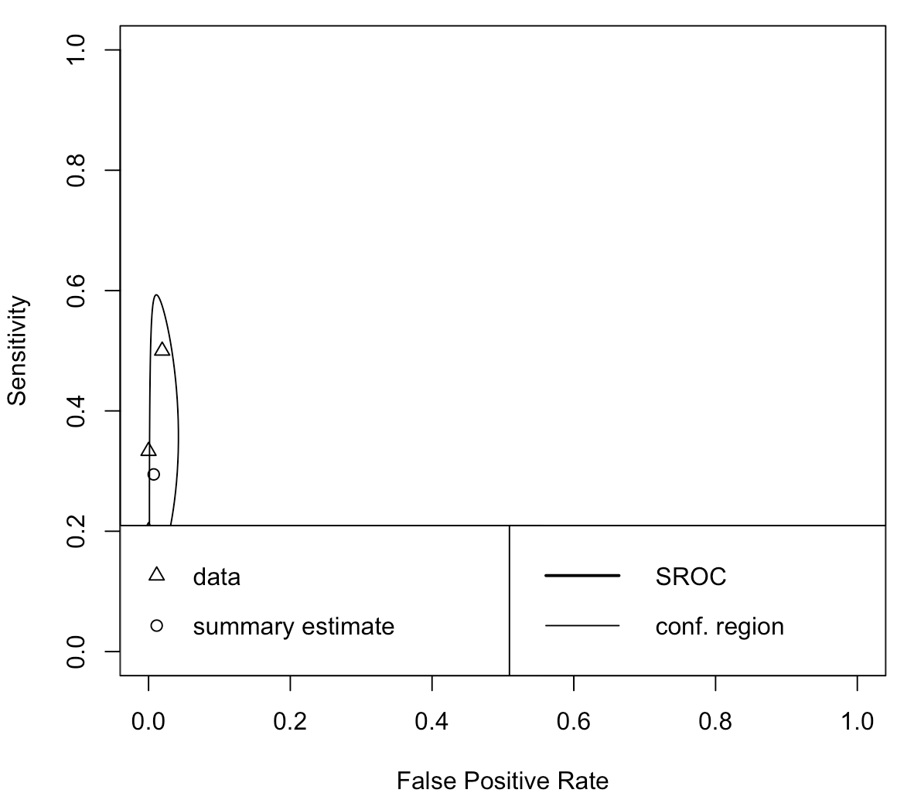

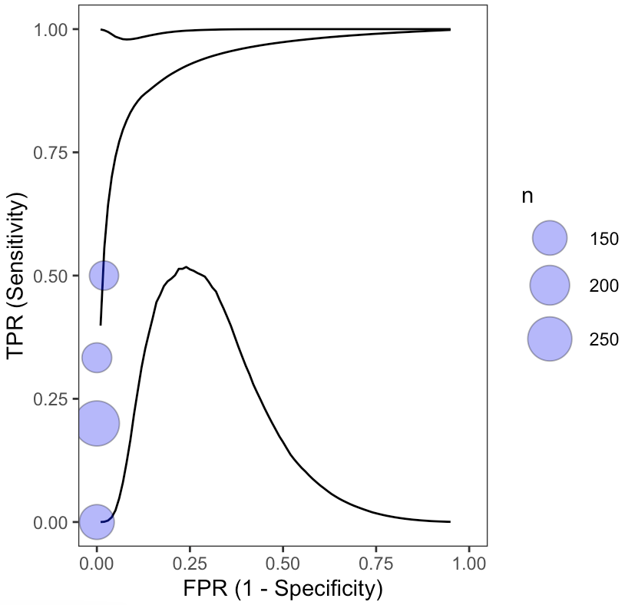

Figure S16. Bayesian Posterior Predictive Contours (50%, 75%, 95%) for ctDNA detection of ROS1 (n=4)

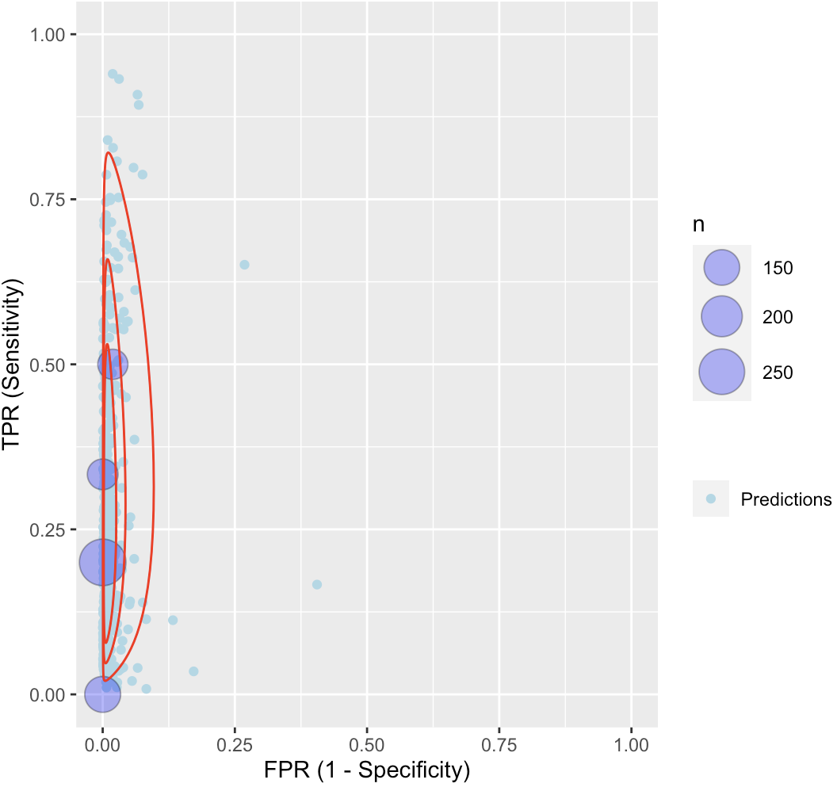

Each purple circle identifies the true positive rate (TPR) vs. the false positive rate (FPR) of each study (observed data). Light blue circles are predictions based on Bayesian meta-analysis of data by fitting a bivariate random effects model, with red lines indicating parametric predictive contours.

Table S11. Data included in meta-analysis on the CV of ctDNA detection of MET (n=5)

Author_Year | No. of patients | TP | FP | FN | TN
Li_2019 | 91 for sensitivity analysis, 19 for specificity analysis | 3 | 0 | 3 | 104
Park_2021 | 262 | 8 | 9 | 11 | 496
Pritchett_2019 | 140 | 3 | 0 | 3 | 133
Remon_2019 | 94 | 1 | 0 | 2 | 45
Sabari_2019 | 106 | 3 | 0 | 1 | 102
TP: true positive; FP: false positive; FN: false negative; TN: true negative

Figure S17. Forest plot of sensitivity and specificity on ctDNA detection of MET from bivariate random effects meta-analyses (n=5)

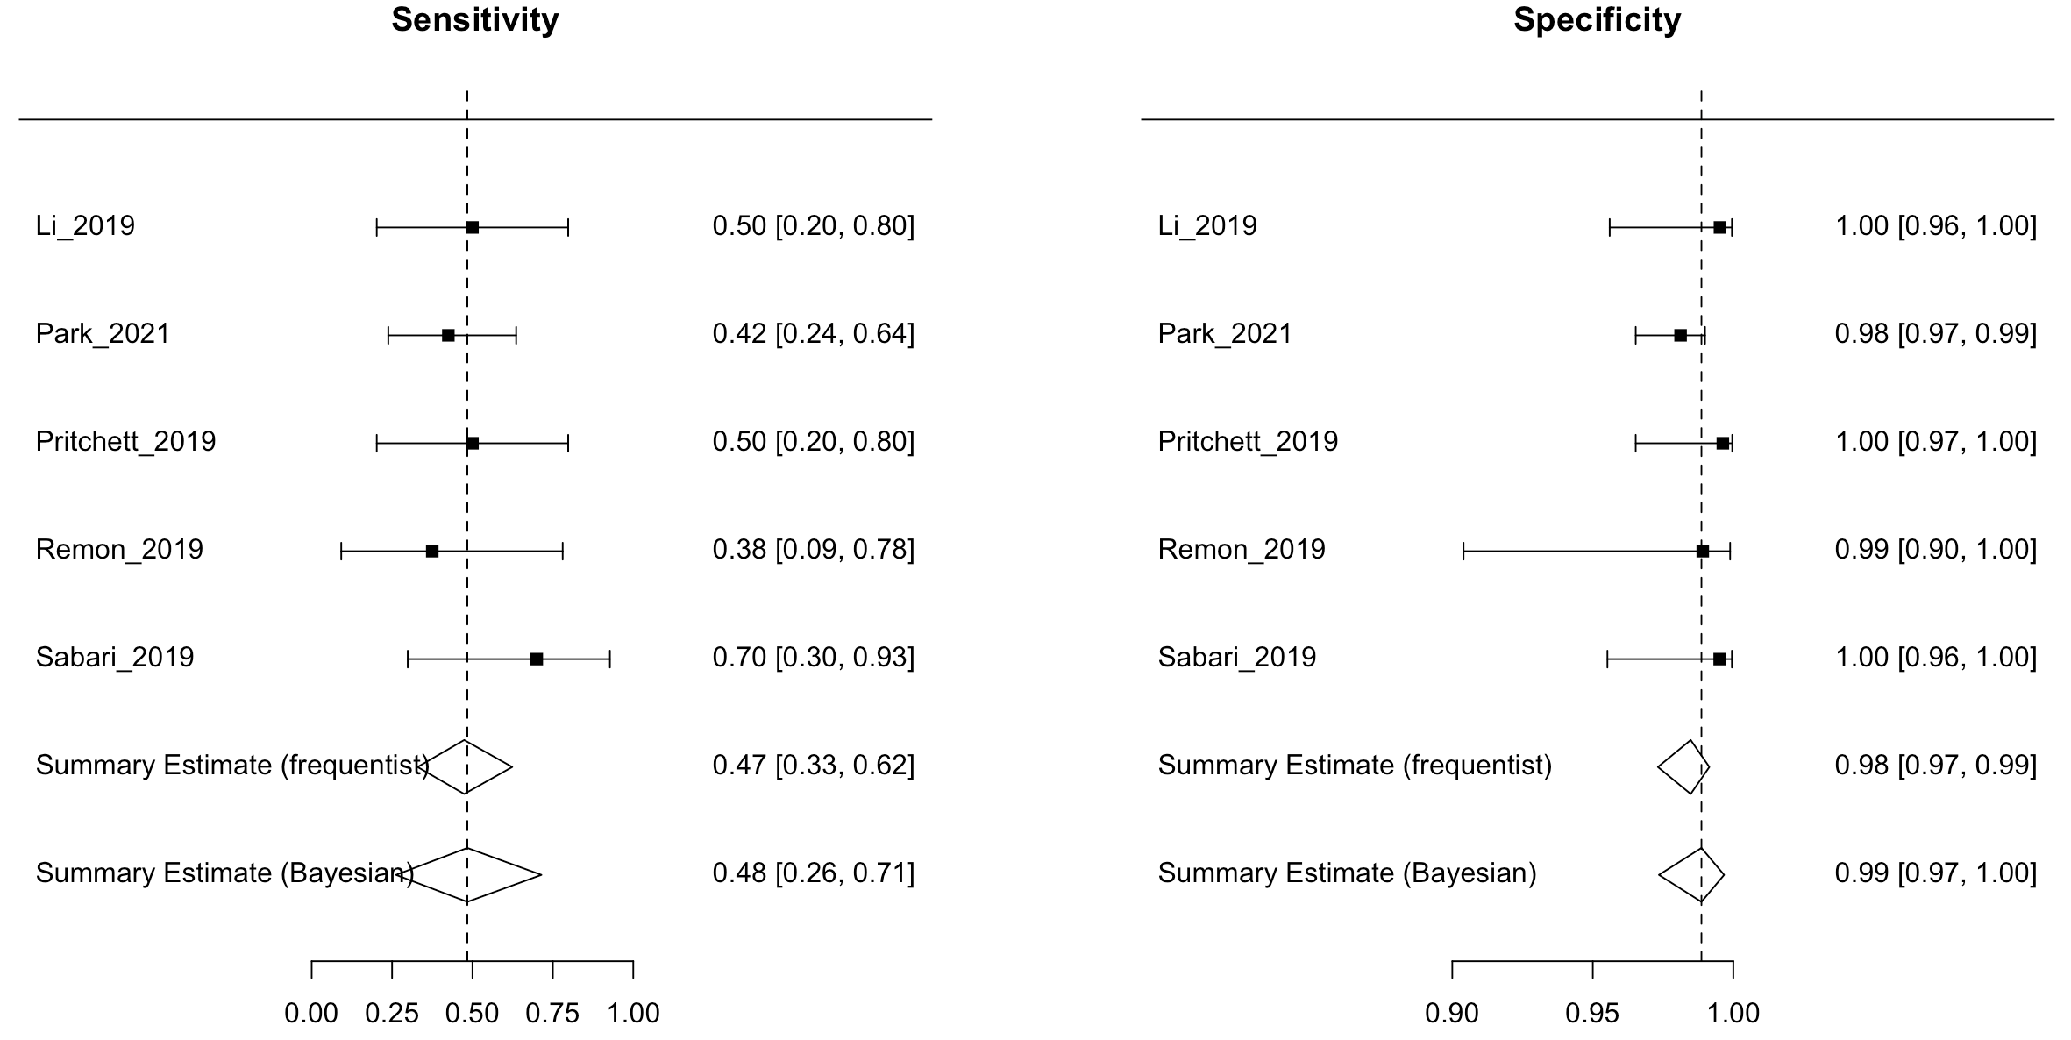

Sensitivity and specificity of single studies were based on frequentist estimations; I² = 7.3% based on the frequentist approach

Figure S18. Summary receiver operating characteristics (SROC) plots based on bivariate random-effects meta-analyses of ctDNA detection of MET (n=5)

- SROC (frequentist approach):

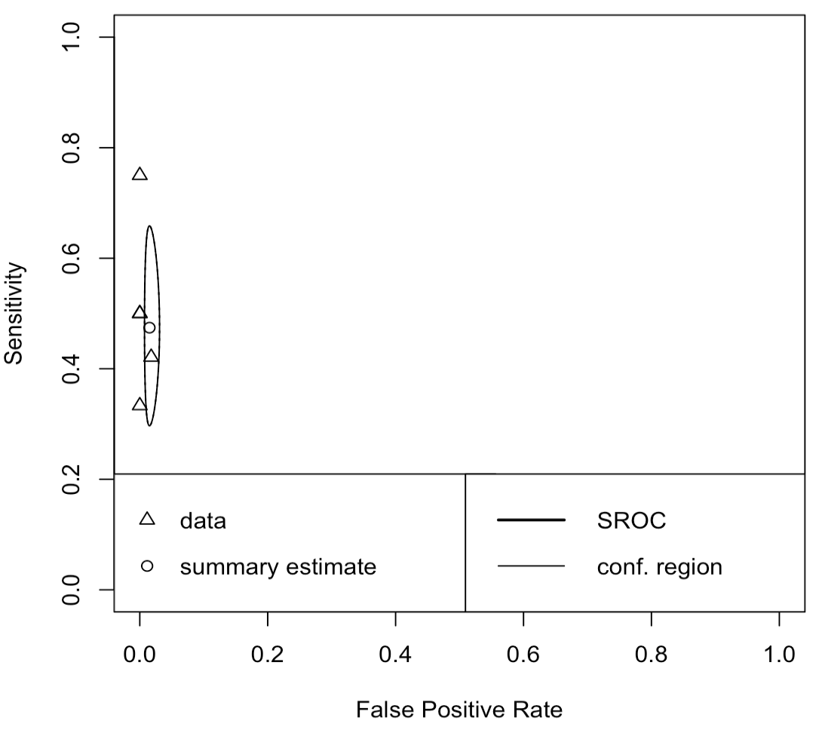

- SROC (Bayesian approach):
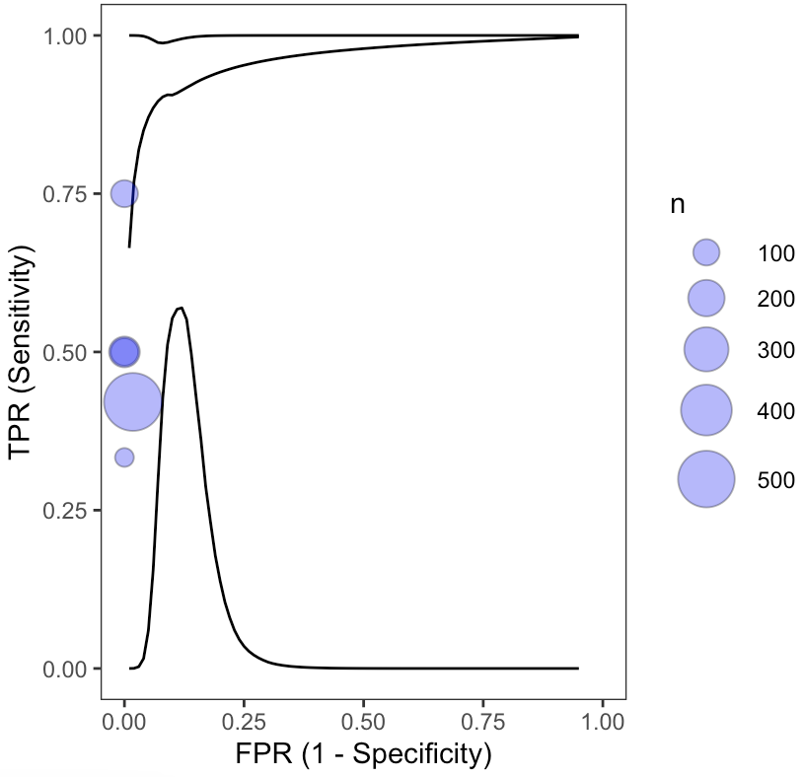

Figure S19. Bayesian Posterior Predictive Contours (50%, 75%, 95%) for ctDNA detection of MET (n=5)

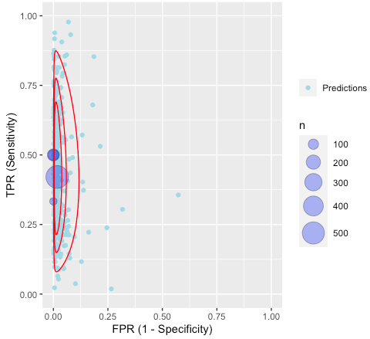

Each purple circle identifies the true positive rate (TPR) vs. the false positive rate (FPR) of each study (observed data). Light blue circles are predictions based on Bayesian meta-analysis of data by fitting a bivariate random effects model, with red lines indicating parametric predictive contours.

Table S12. Data included in meta-analysis on the CV of ctDNA detection of RET (n=3)

Author_Year | No. of patients | TP | FP | FN | TN
Li_2019 | 91 for sensitivity analysis, 19 for specificity analysis | 0 | 0 | 1 | 109
Park_2021 | 262 | 7 | 2 | 12 | 241
Sabari_2019 | 106 | 1 | 1 | 1 | 103
TP: true positive; FP: false positive; FN: false negative; TN: true negative

Figure S20. Forest plot of sensitivity and specificity on ctDNA detection of RET from bivariate random effects meta-analyses (n=3)

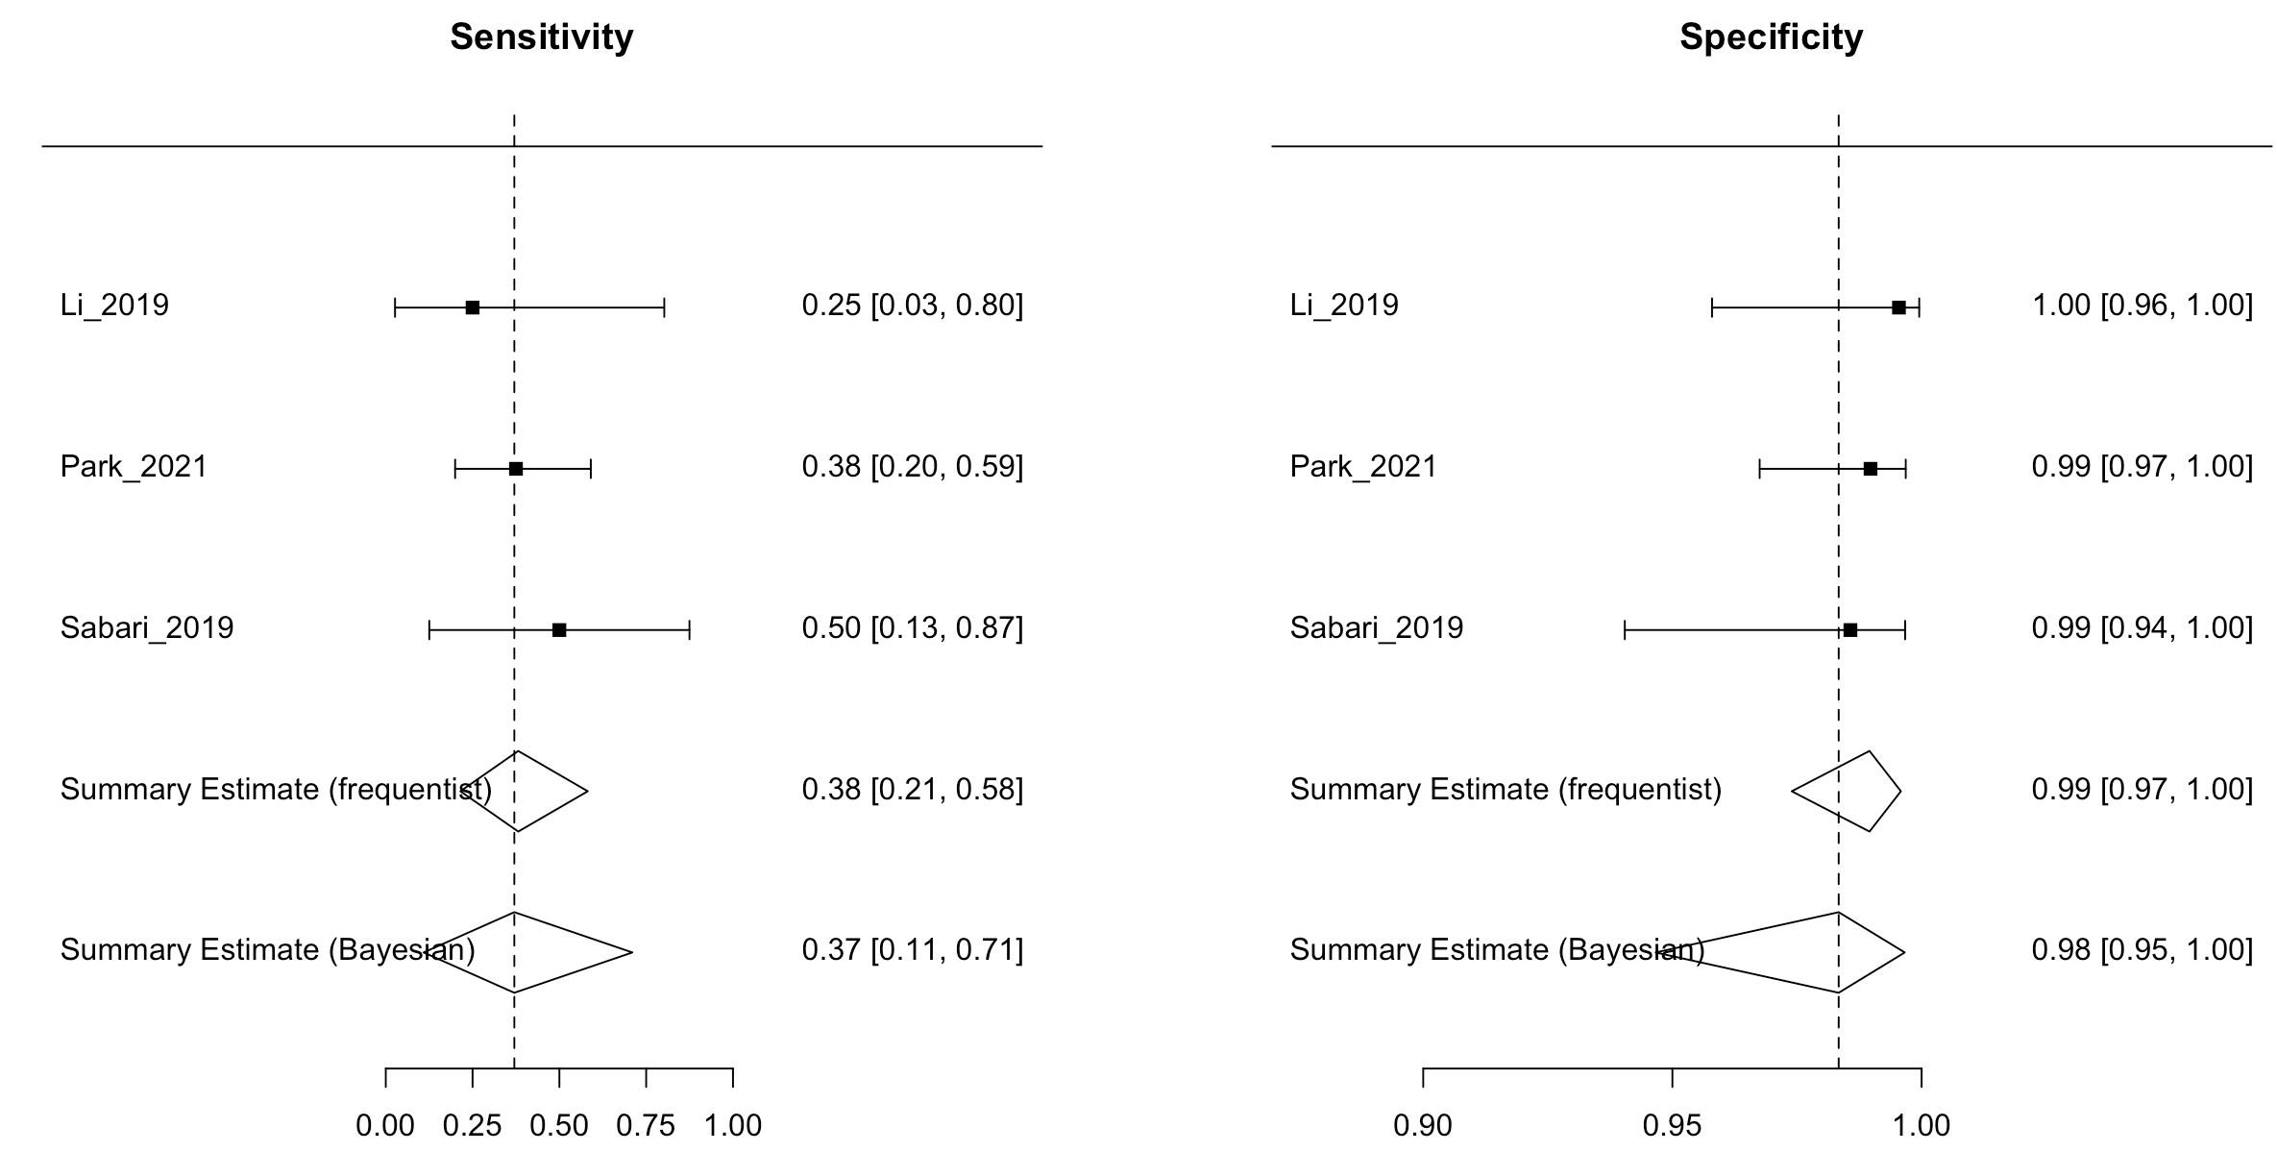

Sensitivity and specificity of single studies were based on frequentist estimations; I² = 0% based on the frequentist approach

Figure S21. Summary receiver operating characteristics (SROC) plots based on bivariate random-effects meta-analyses of ctDNA detection of RET (n=3)

- SROC (frequentist approach):

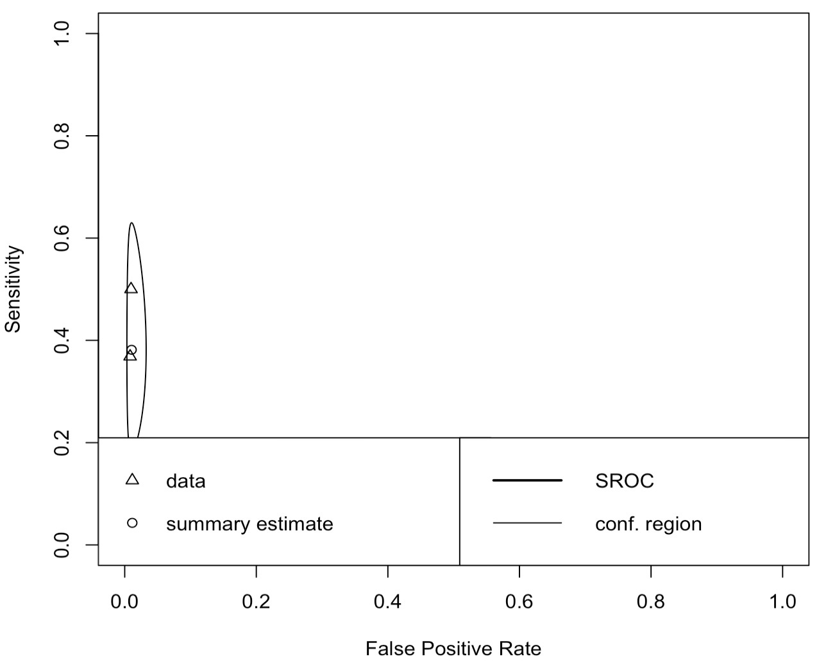

- SROC (Bayesian approach):

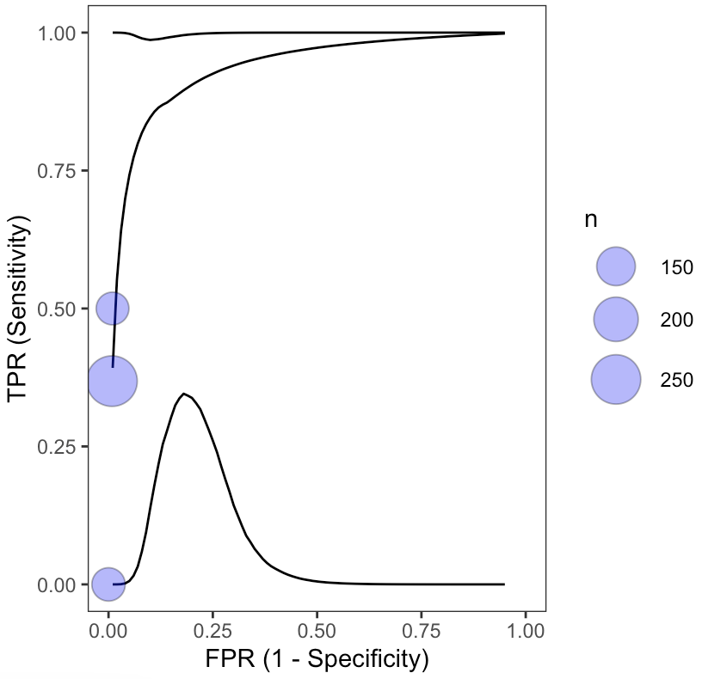

Figure S22. Bayesian posterior predictive contours (50%, 75%, 95%) for ctDNA detection of RET (n=3)

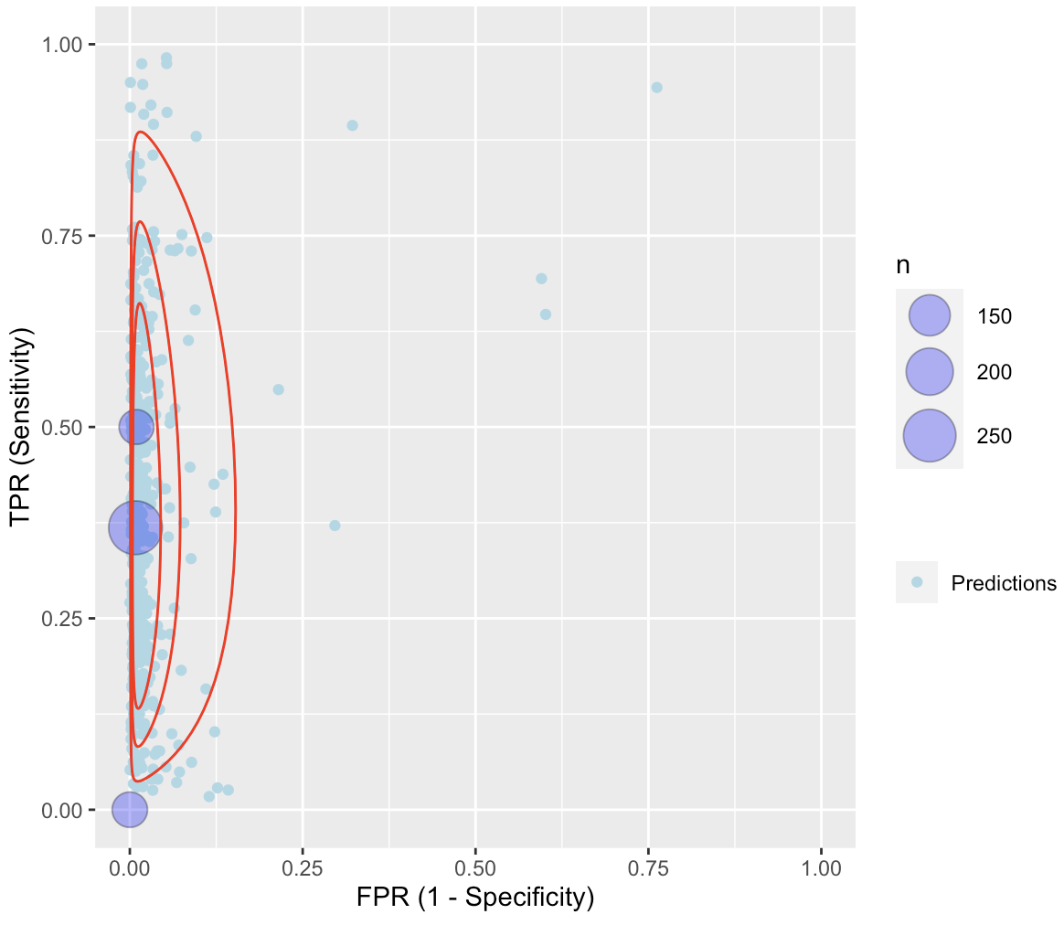

Each purple circle identifies the true positive rate (TPR) vs. the false positive rate (FPR) of each study (observed data). Light blue circles are predictions based on Bayesian meta-analysis of data by fitting a bivariate random effects model, with red lines indicating parametric predictive contours.

Table S13. Data included in meta-analysis on the CV of ctDNA detection of SNV mutation class (n=11)

Author_Year | No. of patients | TP | FP | FN | TN
Leighl_2019 | 223 | 11 | 0 | 1 | 303
Li_2019 | 91 for sensitivity analysis, 19 for specificity analysis | 26 | 0 | 6 | 188
Müller_2017 | 29 | 4 | 0 | 6 | 48
Park_2021 | 262 | 44 | 5 | 21 | 716
Pritchett_2019 | 164 | 55 | 1 | 14 | 226
Yao_2017 | 39 | 12 | 0 | 4 | 179
Xu_2015 | 42 | 9 | 19 | 2 | 96
Liu_2017 | 72 | 22 | 0 | 7 | 108
Couraud_2014 | 45 | 2 | 0 | 3 | 168
Chen_2019 | 7 | 1 | 0 | 0 | 4
Remon_2019 | 94 | 23 | 7 | 4 | 131
TP: true positive; FP: false positive; FN: false negative; TN: true negative; SNV: single nucleotide variant or polymorphism, including 1) EGFR L858R, T790M, L861Q, G719S, and other unspecified EGFR SNVs, 2) KRAS G12X and other unspecified KRAS SNVs, 3) BRAF V600E and other unspecified BRAF SNVs

Figure S23. Forest plot of sensitivity and specificity on ctDNA detection of SNVs from bivariate random effects meta-analyses (n=11)

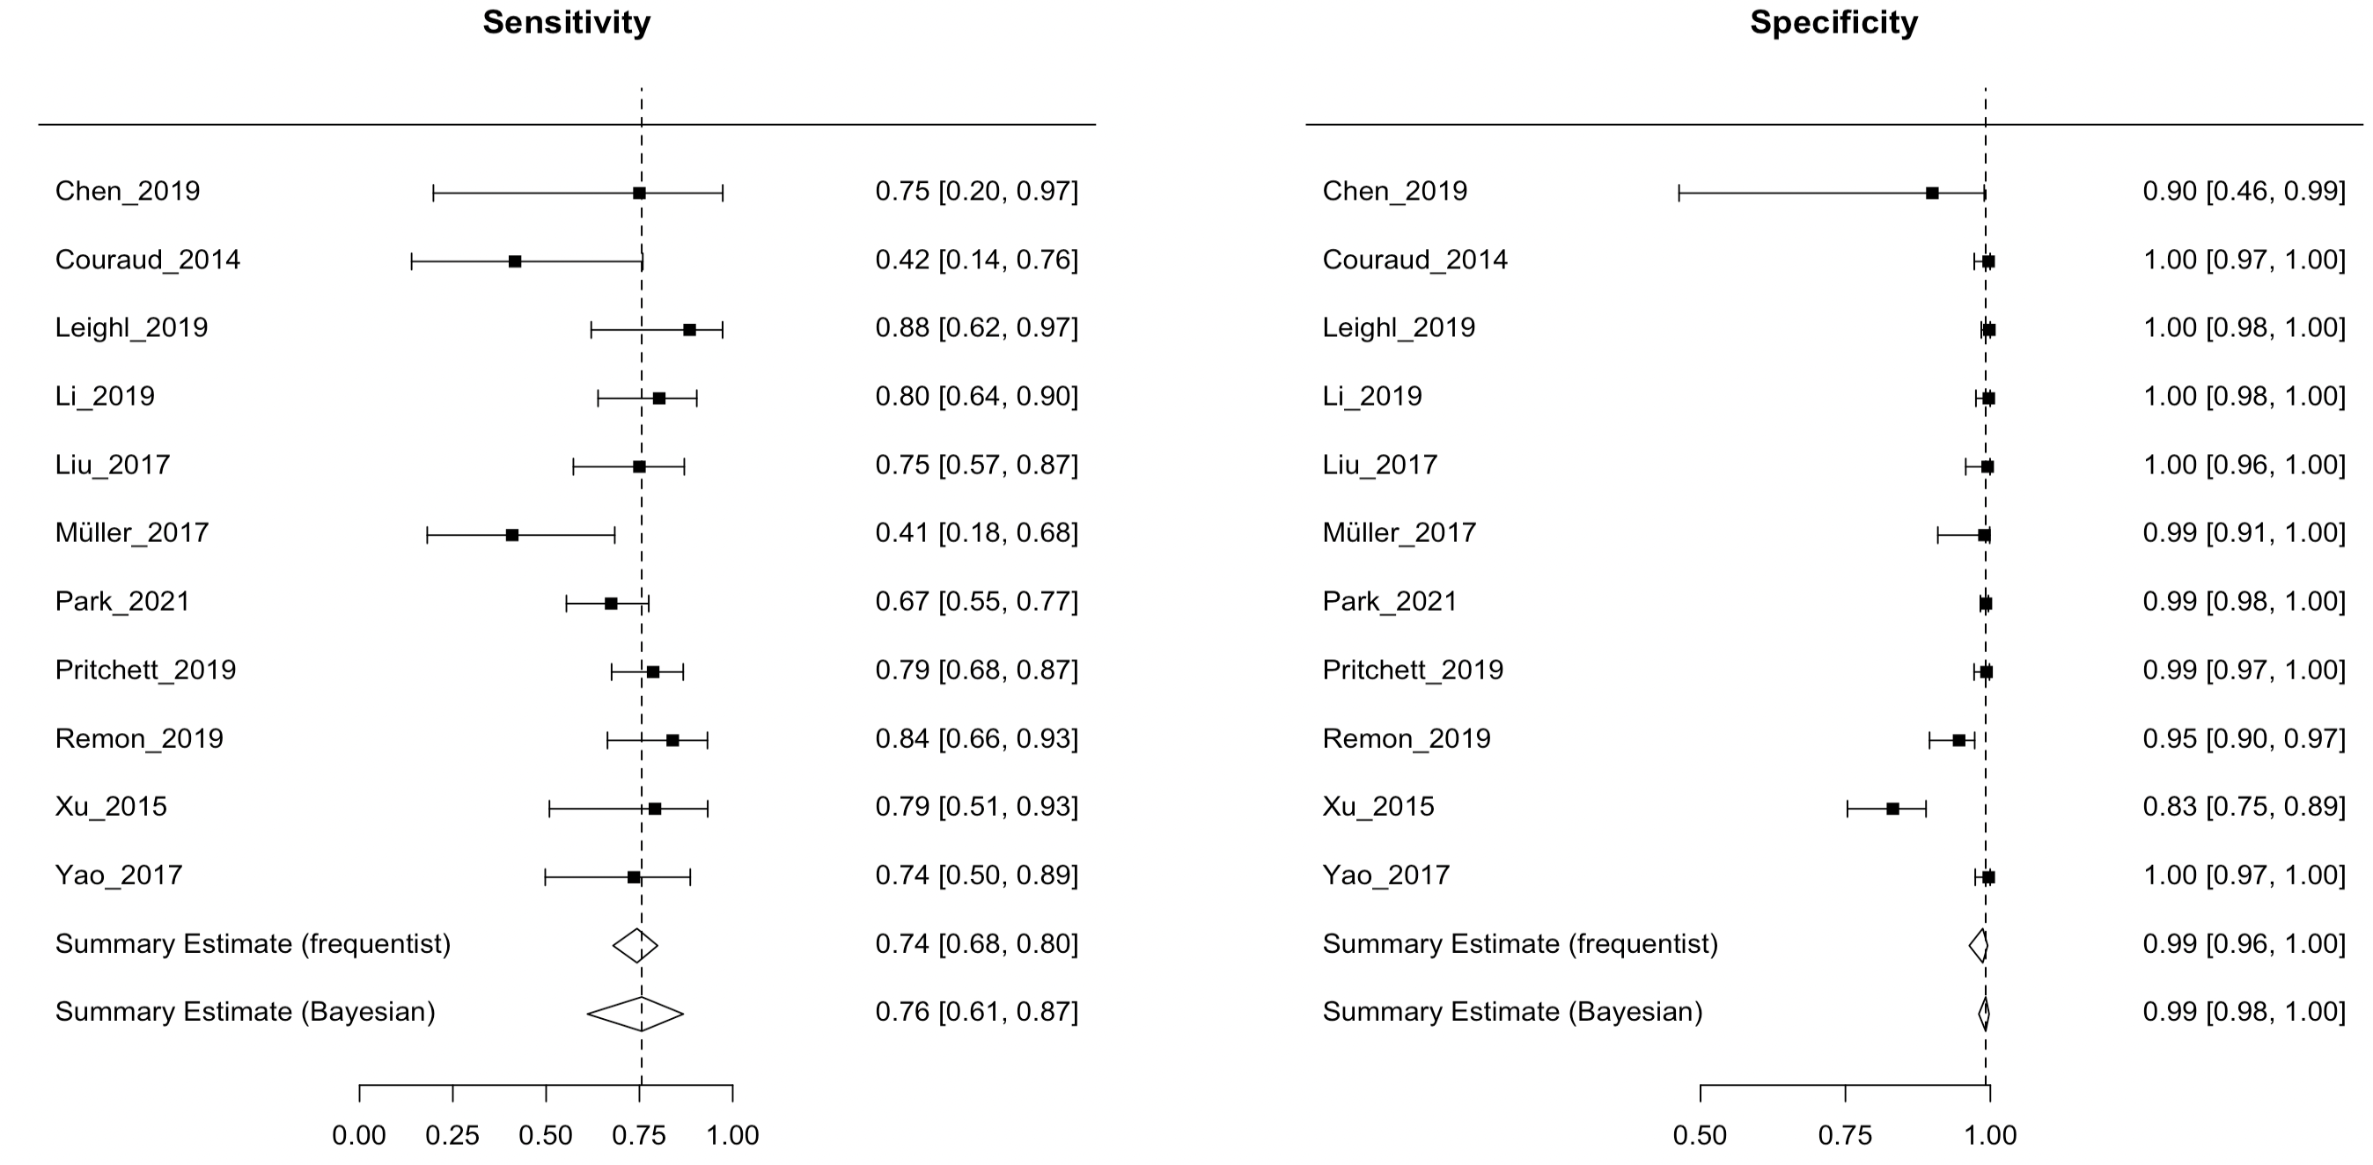

Sensitivity and specificity of single studies were based on frequentist estimations.
I² = 0% based on the frequentist approach; BAUC = 0.72 (95%CI: 0.70-0.74)

Figure S24. Summary receiver operating characteristics (SROC) plots based on bivariate random-effects meta-analyses of ctDNA detection of SNV mutation class (n=11)

- SROC (frequentist approach):

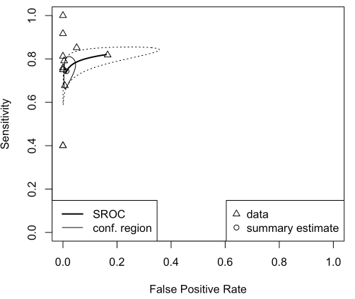

- SROC (Bayesian approach):

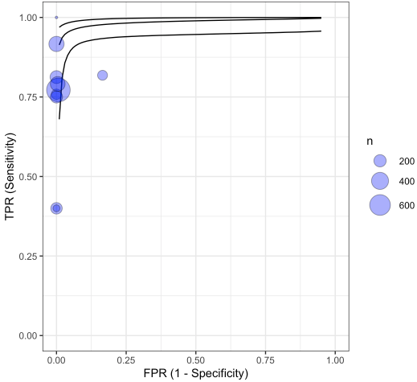

Figure S25. Bayesian posterior predictive contours (50%, 75%, 95%) for ctDNA detection of SNV mutation class (n=11)

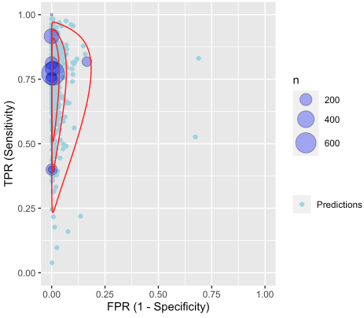

Each purple circle identifies the true positive rate (TPR) vs. the false positive rate (FPR) of each study (observed data). Light blue circles are predictions based on Bayesian meta-analysis of data by fitting a bivariate random effects model, with red lines indicating parametric predictive contours.

Table S14. Data included in meta-analysis on the CV of ctDNA detection of indel mutation class (n=6)

Author_Year | No. of patients | TP | FP | FN | TN
Leighl_2019 | 223 | 18 | 0 | 4 | 201
Park_2021 | 262 | 15 | 3 | 6 | 238
Yao_2017 | 39 | 4 | 0 | 2 | 33
Xu_2015 | 42 | 1 | 1 | 1 | 39
Liu_2017 | 72 | 10 | 0 | 7 | 55
Chen_2019 | 7 | 1 | 0 | 1 | 4
TP: true positive; FP: false positive; FN: false negative; TN: true negative; indels include EGFR exon 19 del or other unspecified EGFR indels

Figure S26. Forest plot of sensitivity and specificity on ctDNA detection of indels from bivariate random effects meta-analyses (n=6)

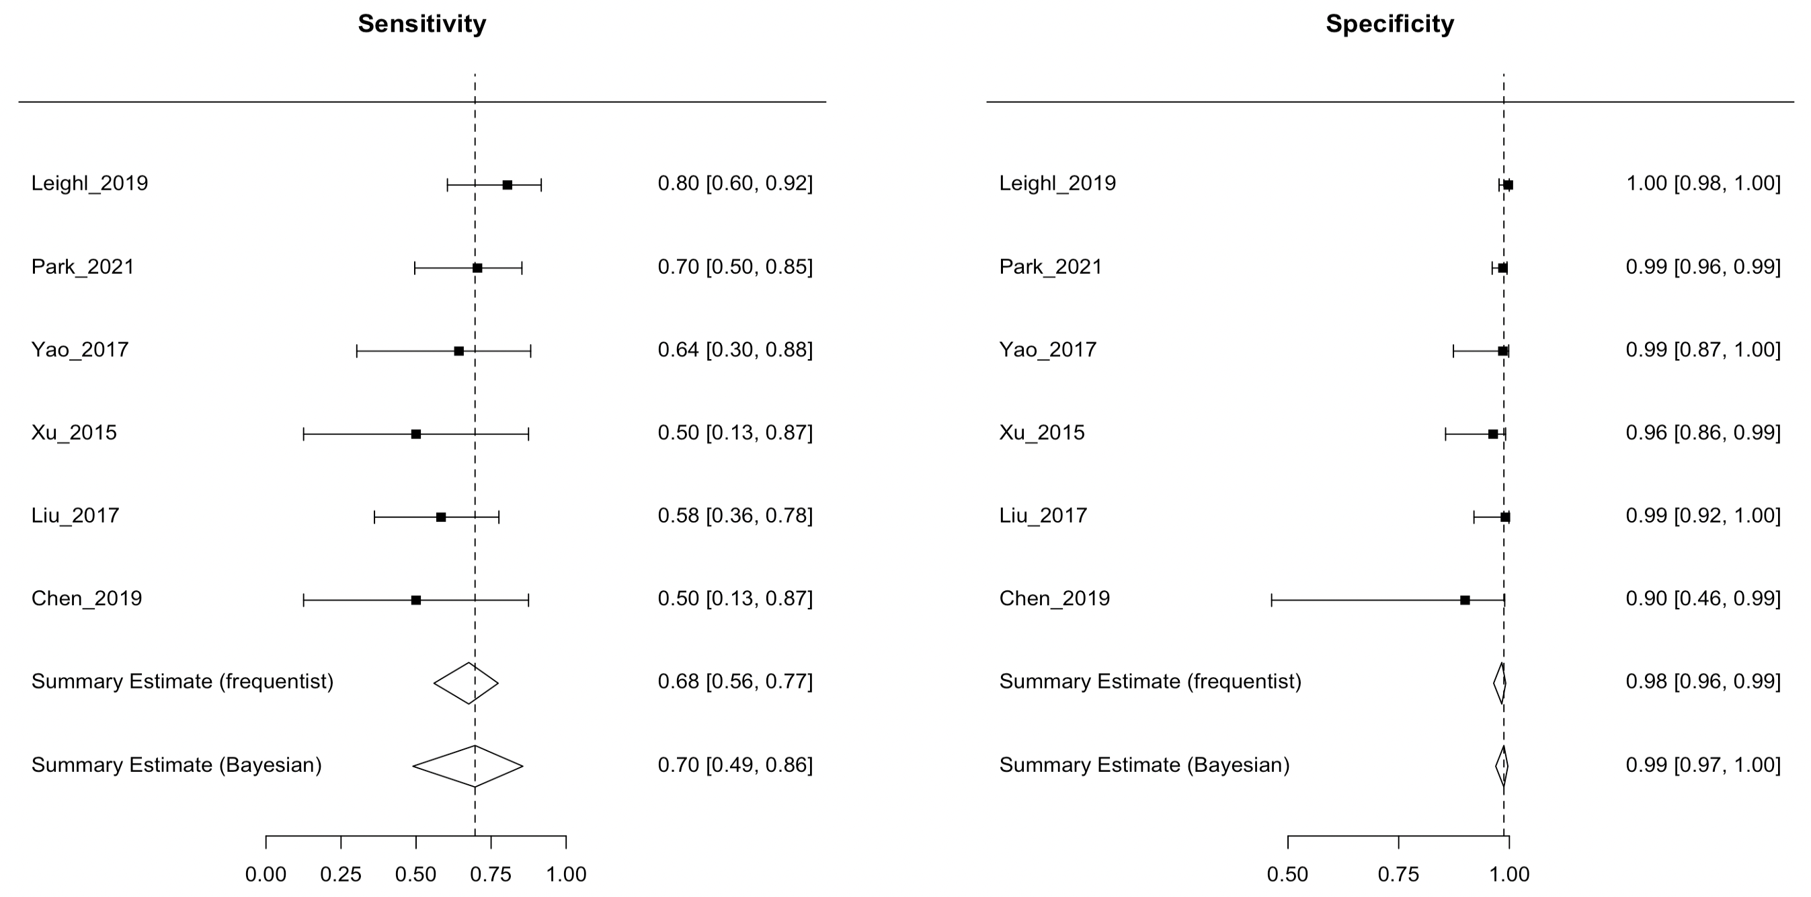

Sensitivity and specificity of single studies were based on frequentist estimations.
I² = 3.3% based on the frequentist approach; BAUC = 0.52 (95%CI: 0.48-0.54)

Figure S27. Summary receiver operating characteristics (SROC) plots based on bivariate random-effects meta-analyses of ctDNA detection of indel mutation class (n=6)

- SROC (frequentist approach):

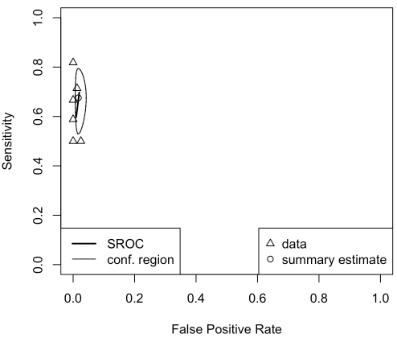

- SROC (Bayesian approach):

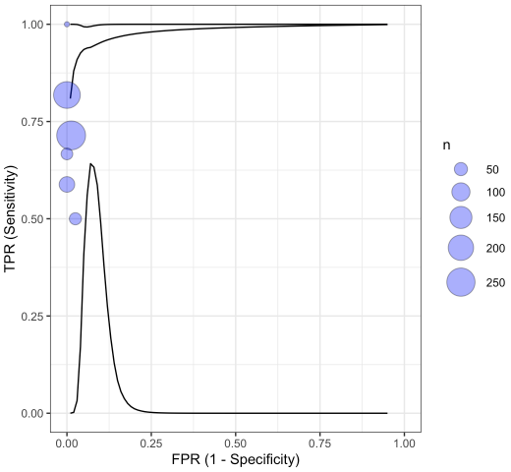

Figure S28. Bayesian posterior predictive contours (50%, 75%, 95%) for ctDNA detection of indel mutation class (n=6)

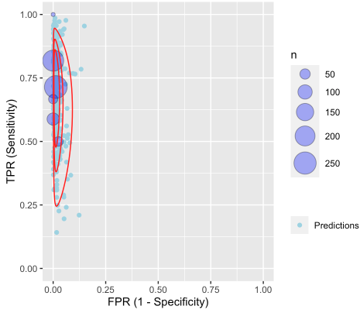

Each purple circle identifies the true positive rate (TPR) vs. the false positive rate (FPR) of each study (observed data). Light blue circles are predictions based on Bayesian meta-analysis of data by fitting a bivariate random effects model, with red lines indicating parametric predictive contours.

Table S15. Data included in meta-analysis on the CV of ctDNA detection of fusion mutation class (n=5)

Author_Year | No. of patients | TP | FP | FN | TN
Leighl_2019 | 223 | 6 | 0 | 4 | 358
Li_2019 | 91 for sensitivity analysis, 19 for specificity analysis | 6 | 0 | 6 | 318
Liu_2017 | 72 | 2 | 1 | 2 | 59
Palmero_2021 | 132 | 2 | 1 | 3 | 126
Park_2021 | 262 | 16 | 2 | 28 | 740
TP: true positive; FP: false positive; FN: false negative; TN: true negative; fusions include ALK, ROS1 and RET

Figure S29. Forest plot of sensitivity and specificity on ctDNA detection of fusions from bivariate random effects meta-analyses (n=5)

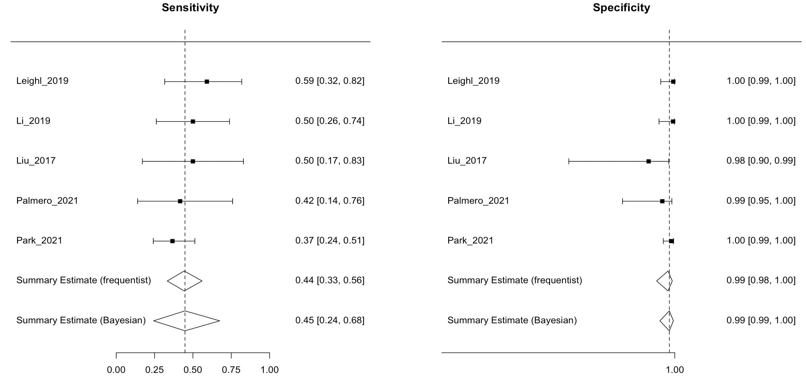

Sensitivity and specificity of single studies were based on frequentist estimations.
I² = 0% based on the frequentist approach; BAUC = 0.52 (95%CI: 0.47-0.54)

Figure S30. Summary receiver operating characteristics (SROC) plots based on bivariate random-effects meta-analyses of ctDNA detection of fusion mutation class (n=5)

- SROC (frequentist approach):

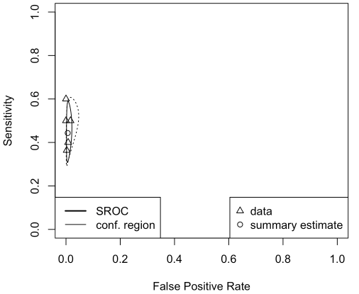

- SROC (Bayesian approach):

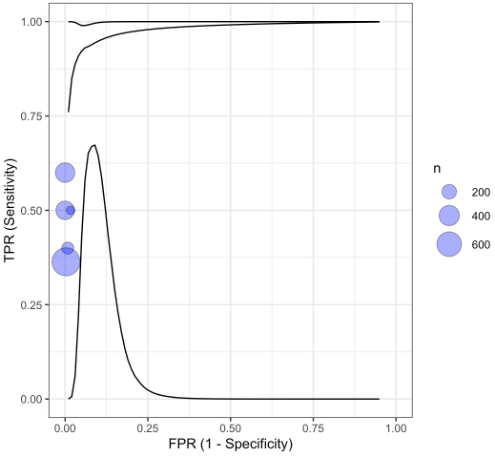

Figure S31. Bayesian posterior predictive contours (50%, 75%, 95%) for ctDNA detection of fusion mutation class (n=5)

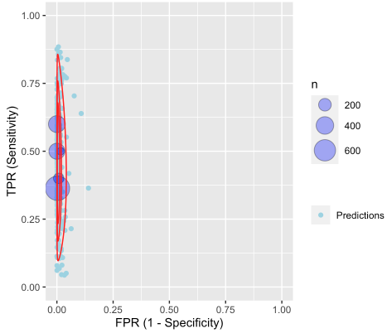

Each purple circle identifies the true positive rate (TPR) vs. the false positive rate (FPR) of each study (observed data). Light blue circles are predictions based on Bayesian meta-analysis of data by fitting a bivariate random effects model, with red lines indicating parametric predictive contours.

Table S16. Quality assessment of studies by QUADAS-2
Study ID | Risk of Bias |  |  |  | Applicability Concerns
 | Patient selection | Index Test(s) | Reference Standard | Flow and Timing | Patient selection | Index Test(s) | Reference Standard
Bustamante Alvarez_2021
Fernandes_2021
Leighl_2019
Li_2019
Lin_2021
Müller_2017 |  | ?
Palmero_2021
Park_2021
Pritchett_2019 |  |  |  |  |  | ?
Schwaederlé_2017 | ? |  |  |  |  | ?
Yao_2017
Xu_2016 | ? | ? |  |  | ? | ?
Liu_2018 |  |  |  |  |  | ?
Couraud_2014
Chen_2019 | ? | ? |  |  |  | ?
Remon_2019
Guo_2016 | ? | ? |  |  |  | ?
Sabari_2019 |  |  |  |  | ?
Low Risk High Risk ? Unclear Risk

