**Supplementary Materials**

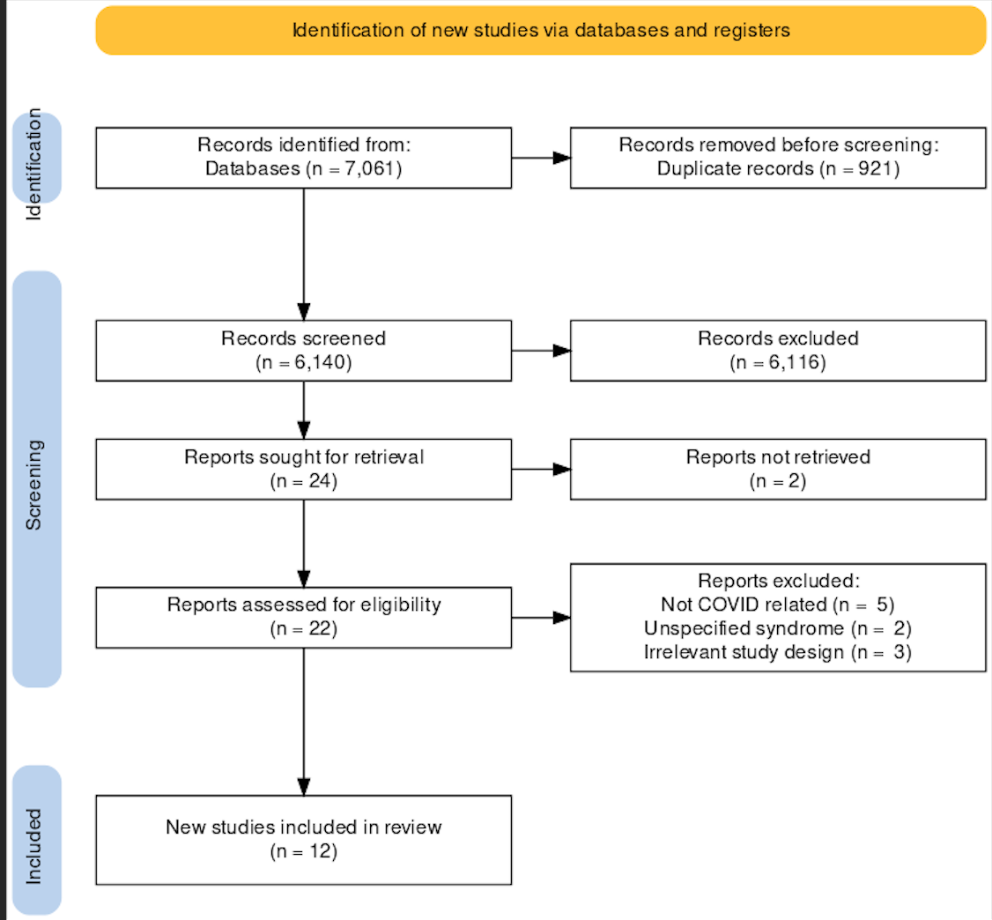

**Figure S1.** PRISMA flowchartoutlining the paper screening process.

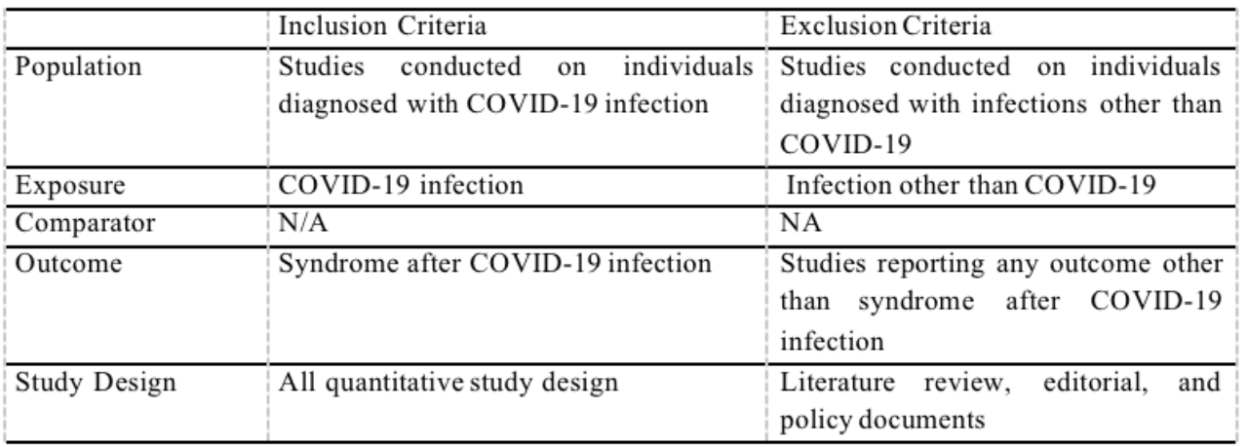**Table S1.** Inclusion and Exclusion Criteria based on Population, Exposure, Comparator, and Outcome of Review Question.

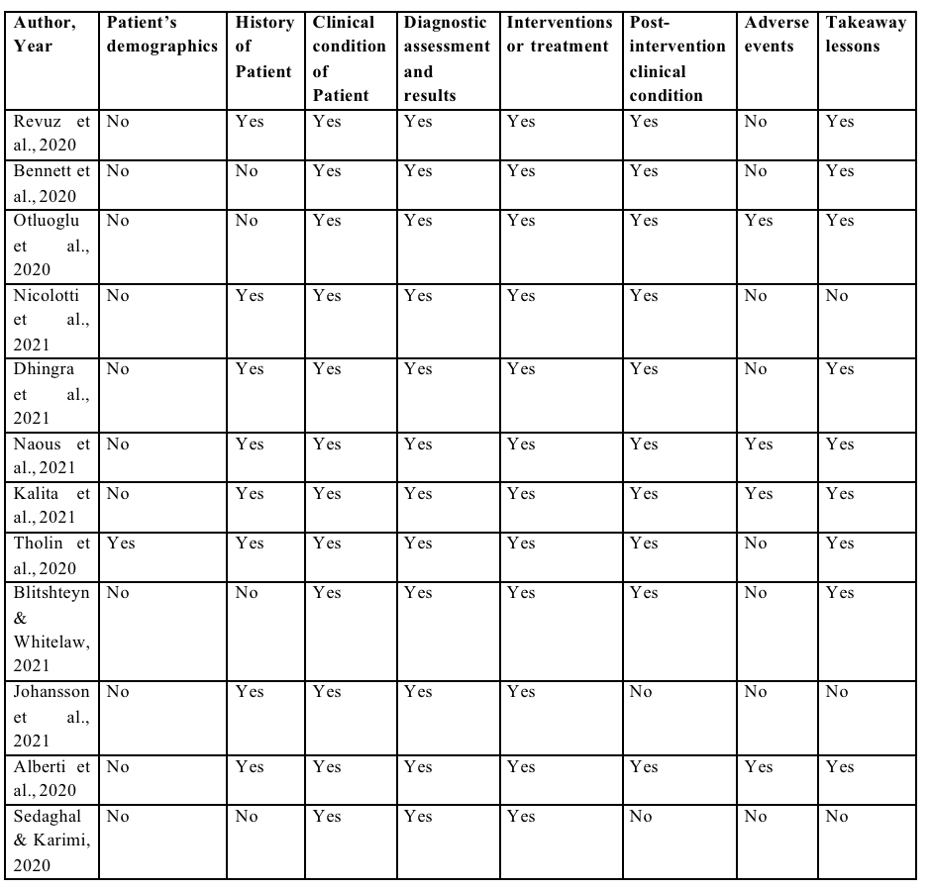**Table S2.** Risk of Bias Assessment of included studies.