Table 1: Population parameters of viral dynamics model. Using the viral dynamic model with density and time-dependent clearance of infected cells, we estimated model parameters for 589 infections in the NBA cohort with known symptom onset. For the mixed-effect model, the magnitude of measurement error was fixed at a = 0.25 log10 copies viral RNA/ml. The population parameters are recorded here and estimated individual parameters are available at https://github.com/sEsmaeili/Covid_Rebound.

Parameter (unit) | Symbol | Population Mean | Standard deviation | Distribution | Source
viral infectivity  (log₁₀ (RNAcopies/mL)⁻¹ day⁻¹) | log₁₀$β$ | -7.18 | 0.31 | normal | estimated
viral production rate  (log₁₀ day⁻¹ ) | log₁₀$π$ | 2.72 | 0.52 | normal | estimated
rate at which refractory cells revert to susceptible state  (log₁₀ day⁻¹ ) | log₁₀$ρ$ | -2.38 | 1.04 | normal | estimated
rate constant for conversion of target cells to a refractory state (log₁₀ cell⁻¹day⁻¹ ) | log₁₀$ϕ$ | -5.31 | 1.15 | normal | estimated
infected cell clearance rate when I = 1 (day⁻¹ cells^{-h}) | $$δ$$ | 1.18 | 0.90 | lognormal | estimated
exponent for density-dependent clearance of infected cells | $$h$$ | 0.007 | 0.0026 | lognormal | estimated
onset of acquired immunity relative to detection (days) | $$τ$$ | 8.82 | 0.38 | lognormal | estimated
Increase in clearance rate of infected cells due to acquired immunity (day⁻¹) | $$m$$ | 19.62 | 2.06 | lognormal | estimated
delay between infection in nasal tissue and detection (days) | $$t_{0}$$ | 2.18 | 1.02 | logit[0,20] | estimated
initial viral inoculum (RNAcopies/mL) | $$V_{0}$$ | 187 | 0.32 | logit[0,250] | estimated
viral clearance rate (day⁻¹) | $$γ$$ | 15 | -- | -- | Goyal et al.
mean eclipse phase duration (days⁻¹) | $$1/k$$ | 1/4 | -- | -- | Ke et al.
Initial number of susceptible cells | $$S_{0}$$ | $$1 ×{10}^{7}$$ | -- | -- | Ortiz et al.
Initial number of refractory cells | $$R_{0}$$ | 0 | -- | -- | --
Initial number of productively infected cells | $$I_{P,0}$$ | 0 | -- | -- | --
Initial number of infected cells in eclipse phase | $$I_{E,0}$$ | 0 | -- | -- | --

Table 2: Population parameters of pharmacokinetic model. Using the two-compartmental PK model with oral administration of the drug, we estimated model parameters for 8 healthy individuals in the phase I randomized clinical trial by Singh et al. . The population parameters are recorded here and estimated individual parameters are available at https://github.com/sEsmaeili/Covid_Rebound.

Parameter (unit) | Symbol | Population Mean | Standard deviation | Distribution
Absorption rate  (day⁻¹) | $$κ_{a}$$ | 9.98 | 0.37 | lognormal
Rate of transfer from plasma to lung  (day⁻¹ ) | $$κ_{PL}$$ | 1.58 | 0.1 | lognormal
Rate of transfer from lung to plasma  (day⁻¹ ) | $$κ_{LP}$$ | 1.22 | 0.1 | lognormal
Clearance rate (day⁻¹) | $$κ_{CL}$$ | 4.96 | 0.03 | lognormal
Plasma Volume (ml) | $$Vol$$ | 41743 | 0.12 | lognormal

Table 3: Pharmacodynamic parameters. Using the least square method, we estimated the PD parameters by fitting the Hill equation to the in vitro data.

Parameter (unit) | Symbol | Mean | Standard Error
Maximum efficacy (%) | $$E_{max}$$ | 99.9 | 0.026
Drug concentration to provide 50% efficacy ($nMol$ ) | IC₅₀ | 43.6 | 3.2
Hill coefficient | $$n$$ | 3.16 | 0.42

Fig S1. Mathematical model recapitulation of untreated SARS-CoV-2 kinetics. Model fit to individual data. Included panels are 130 sample individuals from the NBA cohort with a known time of symptom onset.
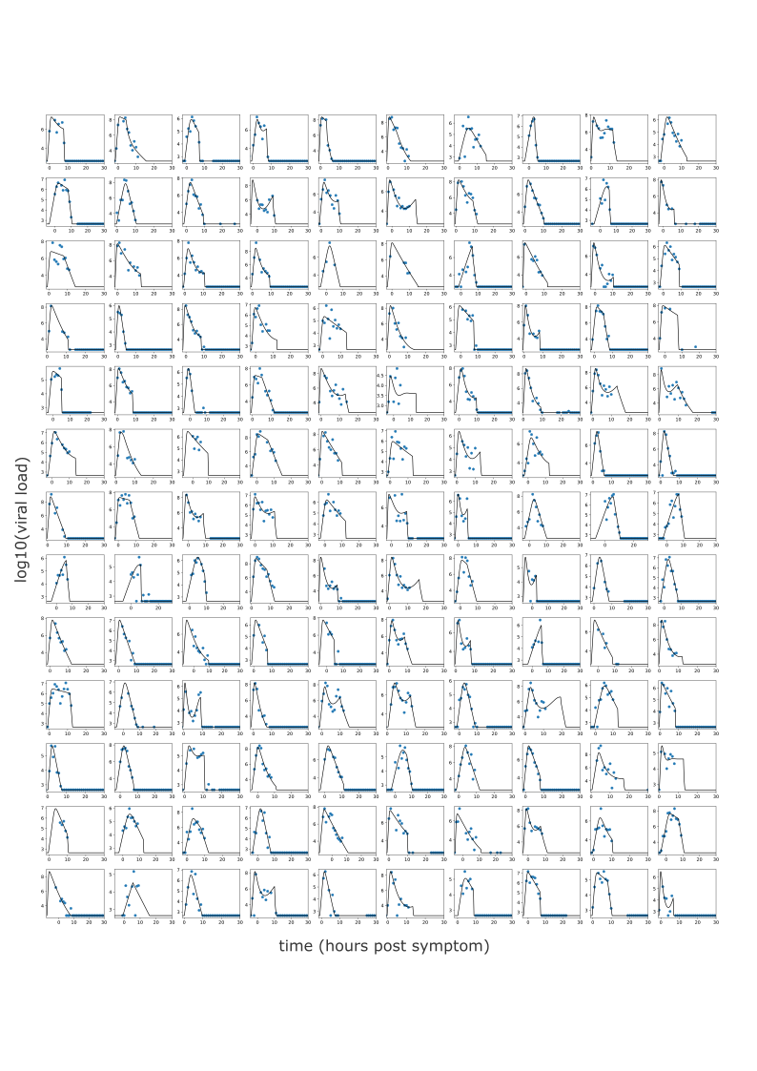

Fig S2. Pharmacokinetic (PK) model recapitulation of plasma concentration of nirmatrelvir. PK model fits individual nirmatrelvir/ritonavir plasma concentration data of 8 individuals (4 fed (F), 4 non-fed (N)) with the 250 mg/100 mg dose of nirmatrelvir/ritonavir.
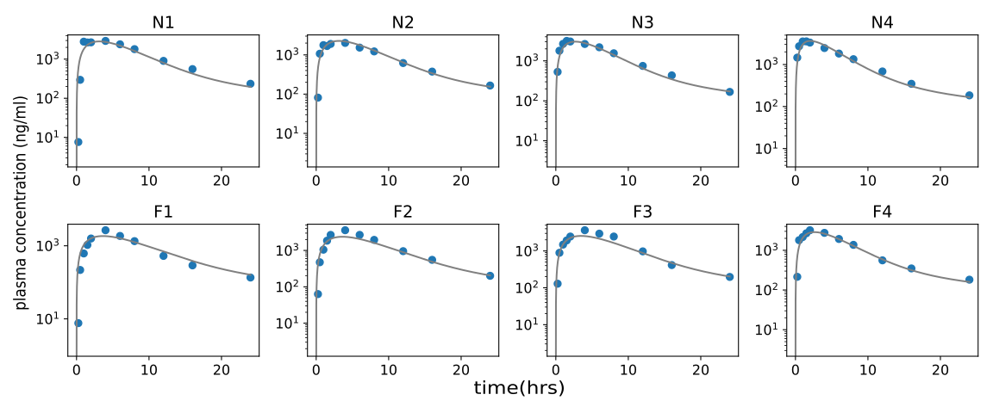
Fig S3. Pharmacodynamic (PD) model fitting to mean antiviral efficacy as a function of drug concentration in vitro. PD model fitting to mean efficacy of nirmatrelvir+efflux inhibitor was obtained from 5 in vitro infection experiments using the least square method.
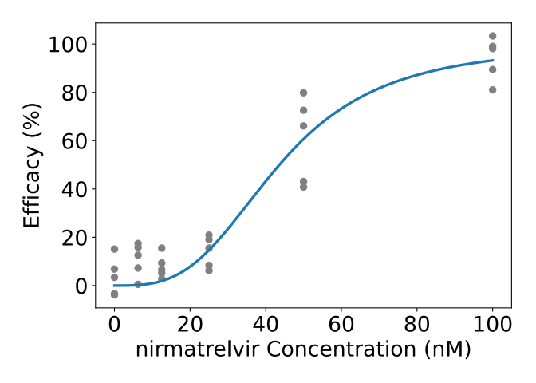
FigS4. Clinical trial simulation with delta variant infections. (a-b) mean (blue), individual (gray), and ranges (labeled dashed lines) of log10 viral load drop from the baseline of delta infections of the NBA cohort treated with (a) placebo or (b) five days of nirmatrelvir / ritonavir 300 mg twice daily. (c) R² of the fit of the model to viral load decrease with simulations performed at multiple possible potency reduction factors. The best model fit was at a potency reduction factor of 69.
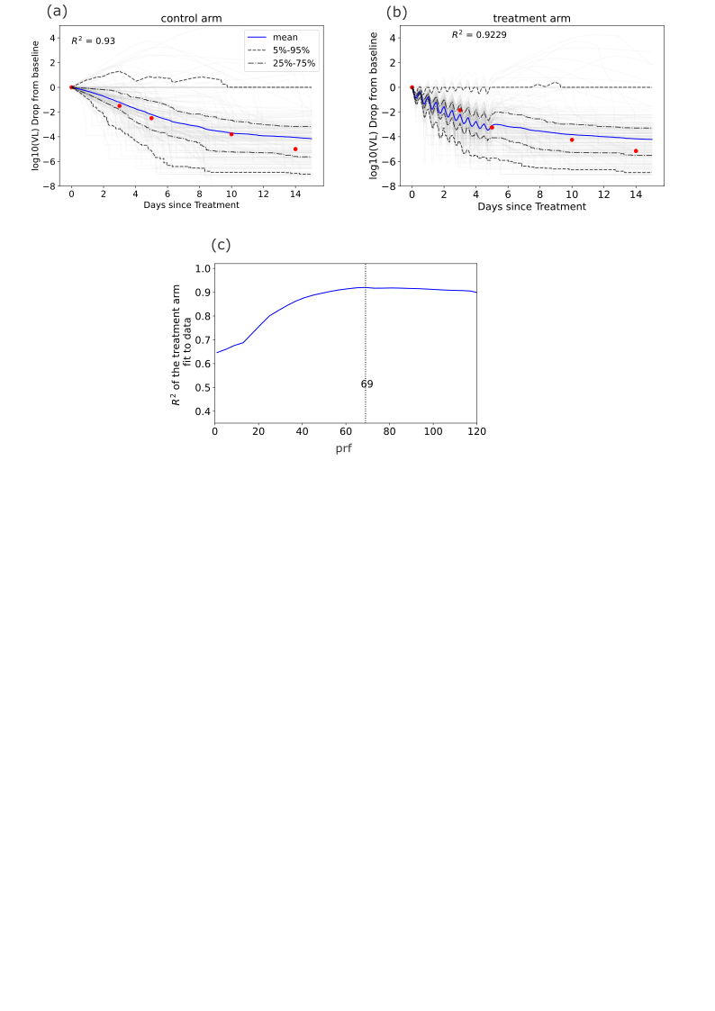
FigS5. Sensitivity of viral rebound detection to rebound definition and sampling frequency. Top row: rebound probability in the treatment arm measured by sampling every 0.001 of a day after treatment and defining rebound as cases when viral load exceeds the viral load at the end of the treatment by 2 log, 1 log, or 0.5 log (left to right). Bottom row: rebound probability measured by sampling on day 5 after treatment ends with the same thresholds as the top row from left to right.
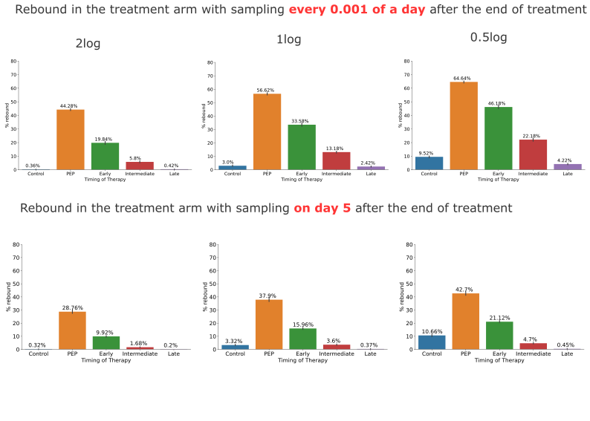
FigS6. Preservation of susceptible cells and decreased refractory cell generation with early nirmatrelvir therapy. The ratios of susceptible to refractory cells at the end of the 5-day treatment for different timings of treatment (day 1, day 4, day 7, and day 10) as shown in Fig 8.
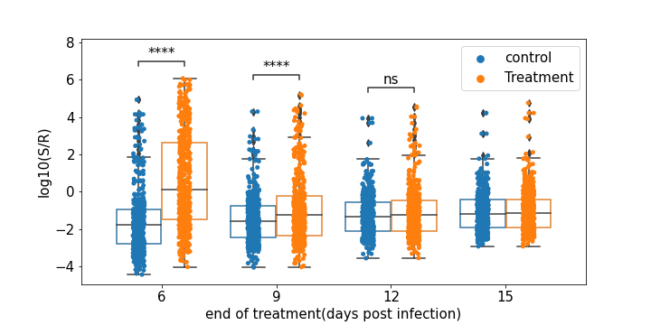

FigS7. Higher rebound probability in individuals with larger viral area under the curve after early treatment. The probability of rebound and the viral load at the end of the treatment for six different shedding pattern groups in the NBA cohort identified in Owens et al. by k-means clustering. Higher group number indicates higher viral area under the curve assuming untreated infection.

