Supplementary material
Supplementary Methods
Supplementary Figure 1. Gel image for electrophoresis of the PCR product around the breakpoints of inversion.
Supplementary Figure 2. IGV screenshots of the inversion in short-read whole genome sequencing.
Supplementary Figure 3. IGV screenshots of the deletion in short-read whole genome sequencing.
Supplementary Figure 4. Sample DNA QC results after size selection.
Supplementary Figure 5. IGV screen shots of inversions including PRKN exons identified in AMP-PD and UK biobank short-read whole genome sequencing.

Supplementary Table 1. Primer sequence of PCR around breakpoints
Supplementary Table 2. Summary for clinical symptoms of affected twins
Supplementary Table 3. Output data of long-read sequencing
Supplementary Table 4. Quality control of sample DNA
Supplementary Table 5. Inversions found in AMP-PD and UK Biobank

Supplementary figure 1: Gel image for electrophoresis of the PCR product around the breakpoints of inversion.

The figure at the top shows the gel with the PCR product using primers around 5’ breakpoint of the inversion. The figure at the middle shows the gel with the PCR product using primers around 3’ breakpoint of the inversion. The figure at the bottom shows the gel with the PCR product using 3' breakpoint primers of the reference.

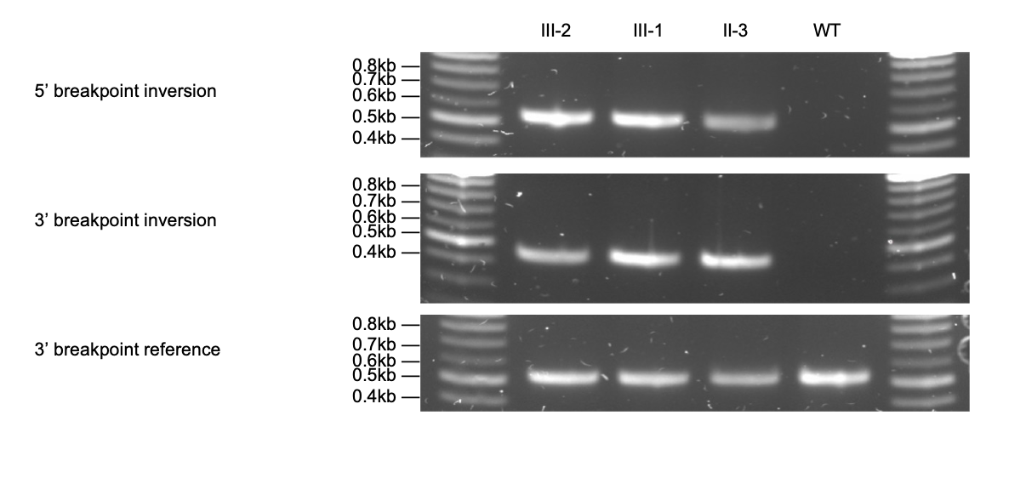
Supplementary Figure 2: IGV screenshots of the inversion in short-read whole genome sequencing

The upper figure shows the 5’ break point. The lower shows the 3’ break point.
WGS, whole genome sequencing; IGV, integrative genome viewer

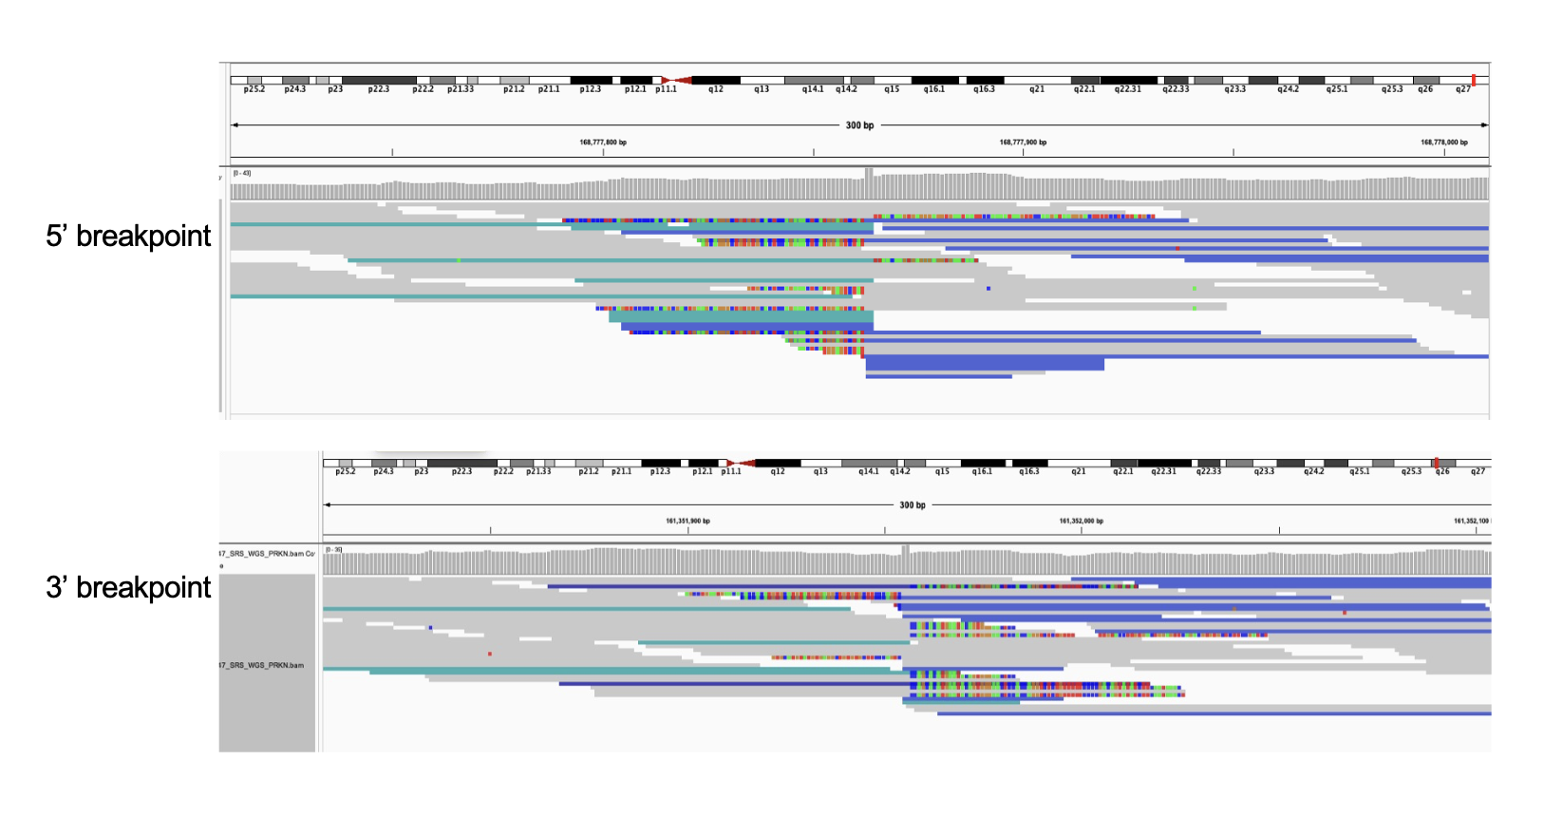

Supplementary figure 3. IGV screenshots of the deletion in short-read whole genome sequencing.
The upper figure shows the 5’ break point. The lower shows the 3’ break point.
WGS, whole genome sequencing

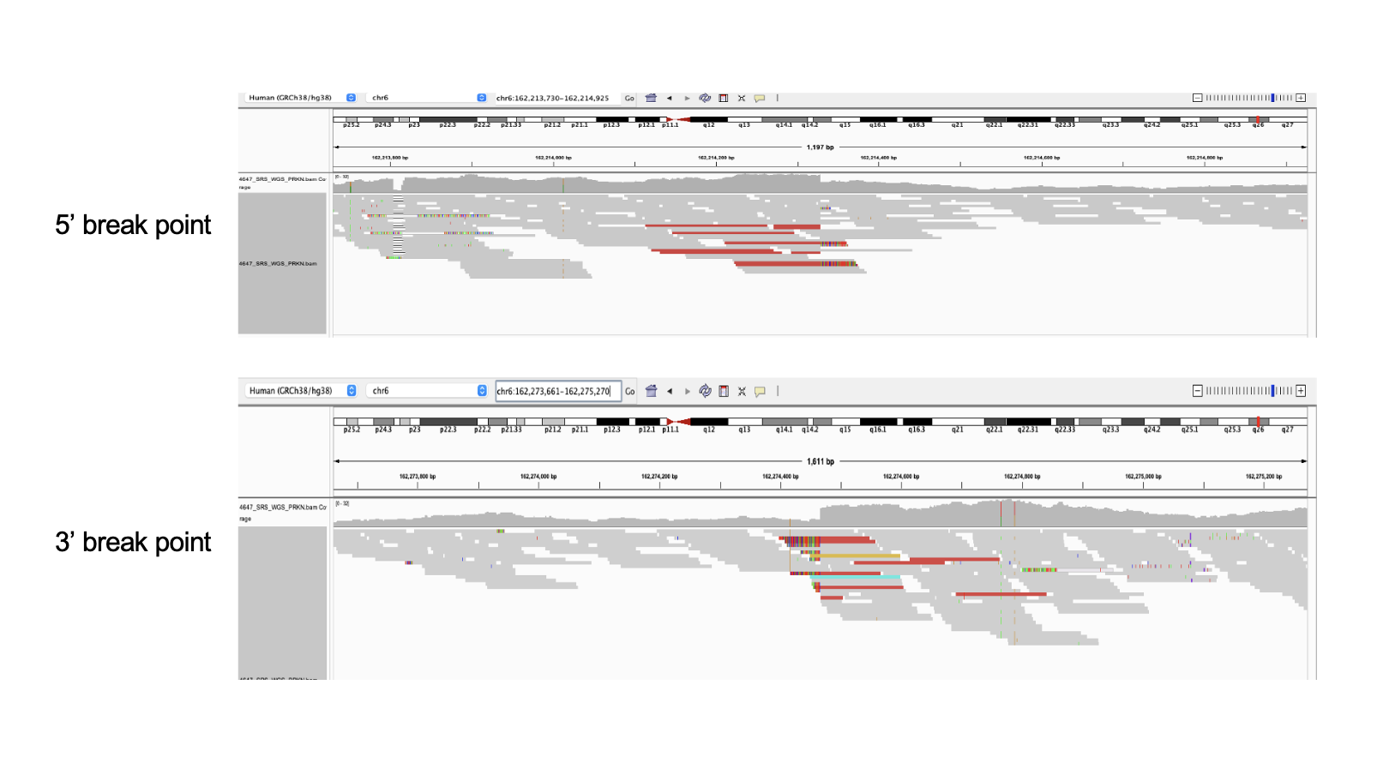

Supplementary figure 4. Sample DNA QC results after size selection.
DNA quality control results after size selection for long-read sequencing.
QC, quality control

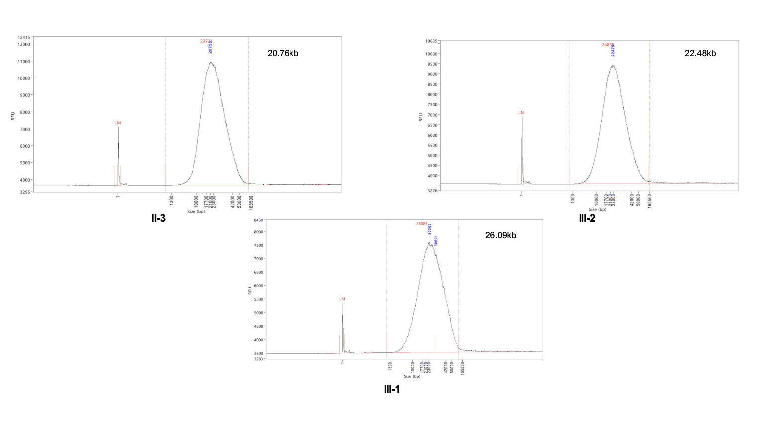
Supplementary figure 5: IGV screen shots of inversions including PRKN exons identified in AMP-PD and UK biobank short-read whole genome sequencing.

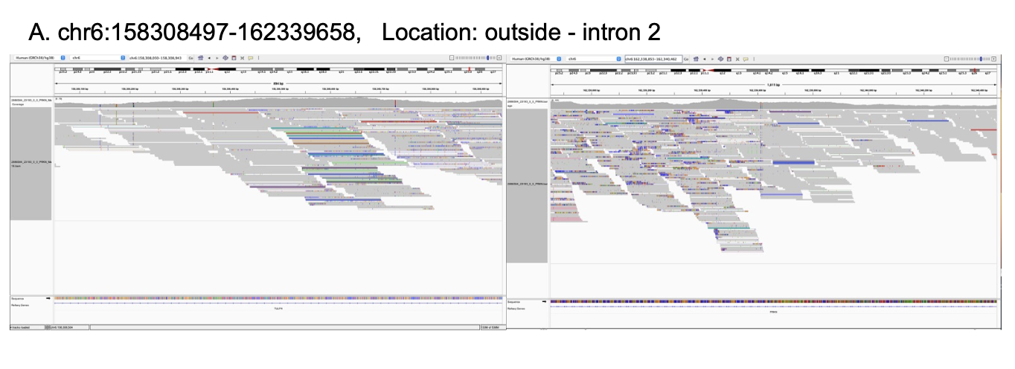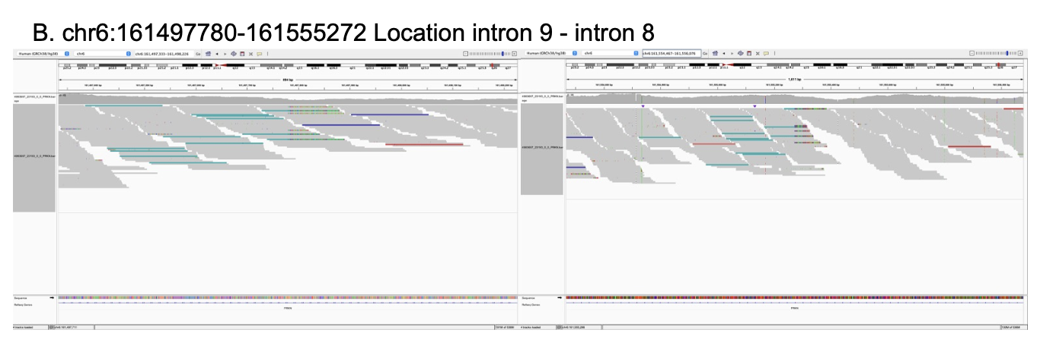
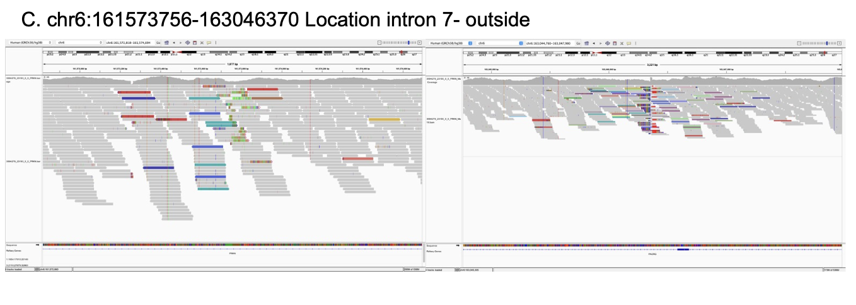
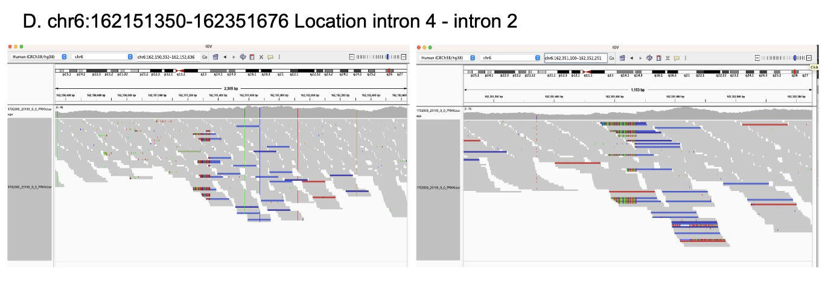
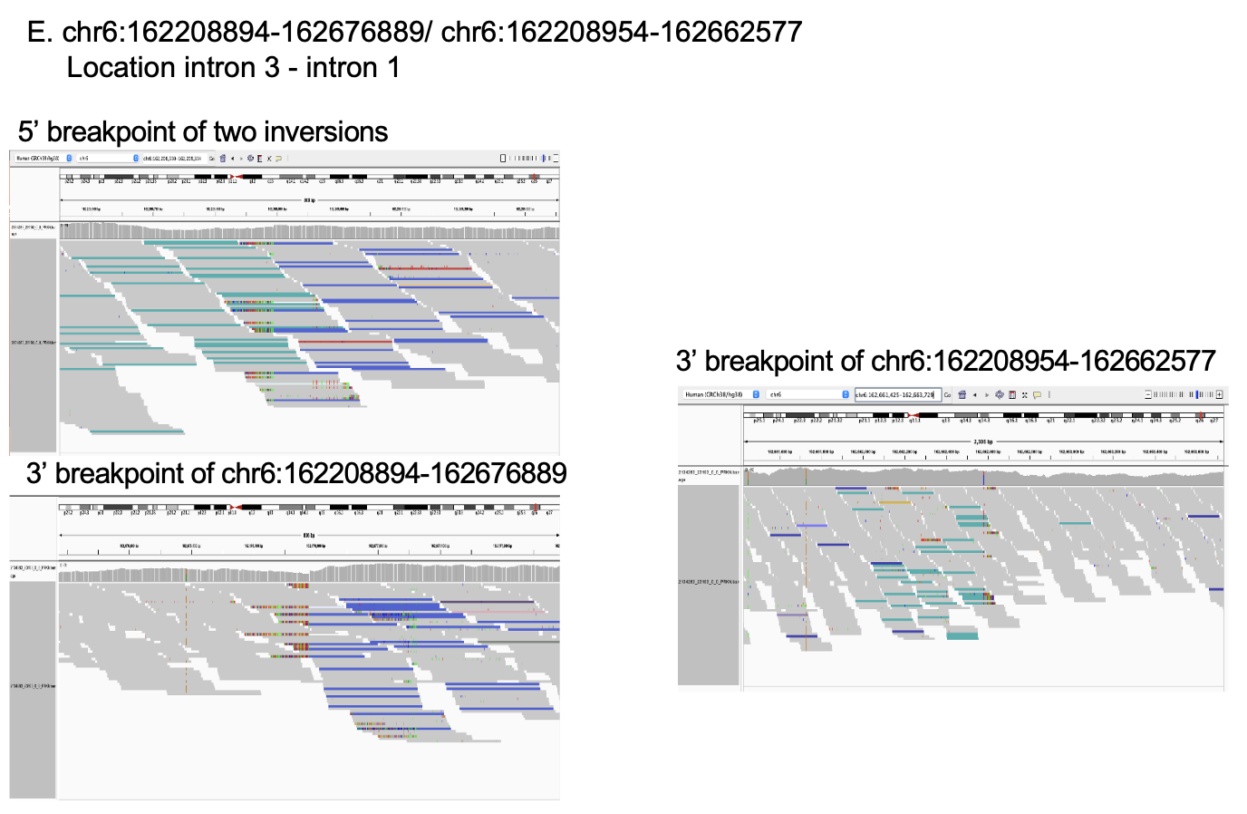
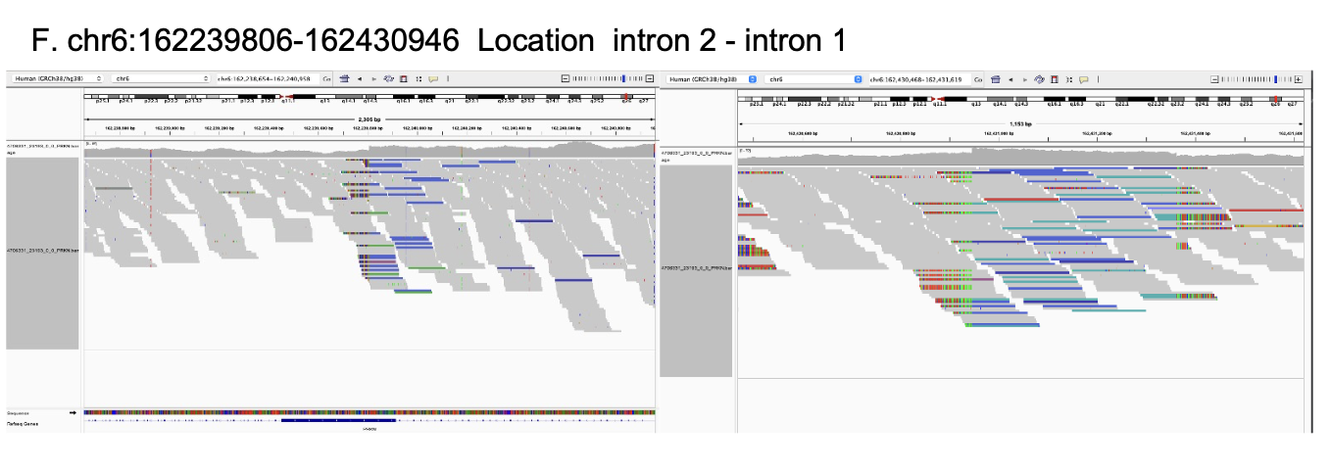
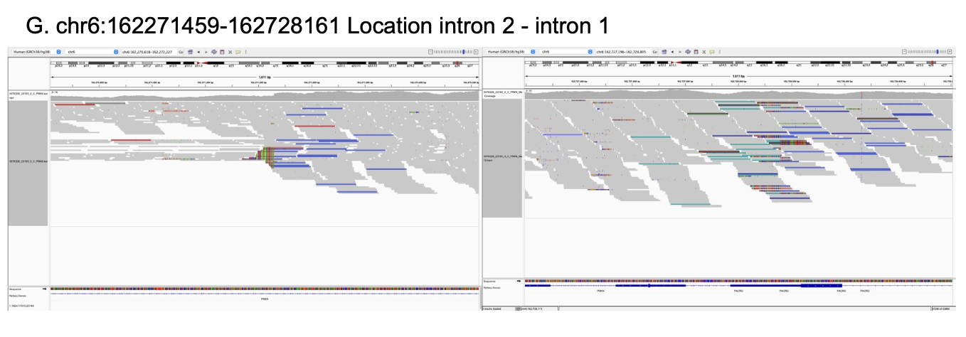
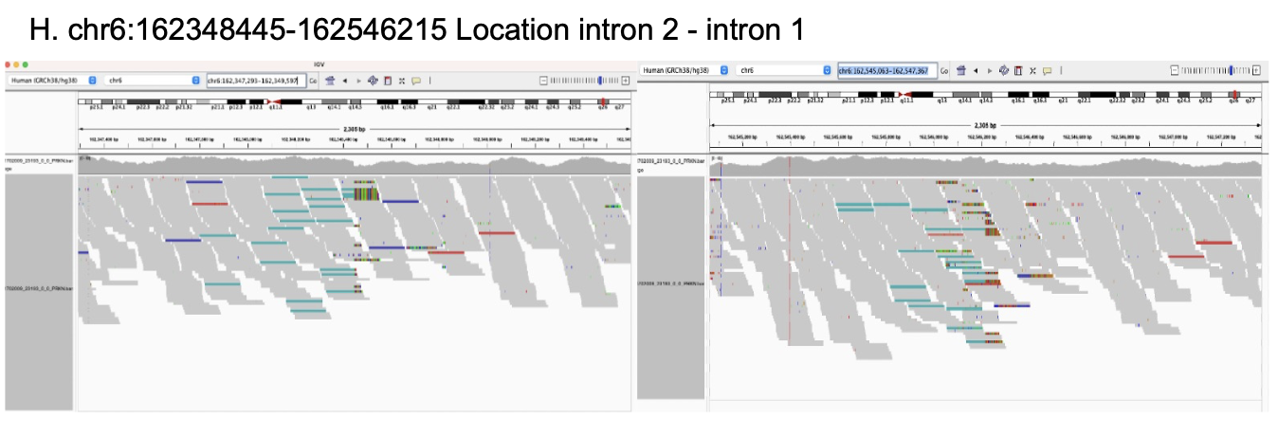
Supplementary Table 1: Primer sequence of PCR around breakpoints

Target region | Forward | Reverse
breakpoint 1 with inversion | CACCCAGCCAGCATATTATTTT | AGAGCCCGGGATAATGTGTC
breakpoint 2 with inversion | GAGACAGCACCGAACCAATT | AATGCTTGCTGTCCACATCC
breakpoint 2 of reference (hg38) | ACTGGAGAGCCCGGGATAAT | CCGACCTCCTAGCTGTCTCT

Supplementary Table 2: Summary for clinical symptoms of affected twins
AAO, age at onset; AAE, age at examination; F, female; M, male; MMSE, Mini-Mental State Examination; REM, rapid eye movement; MRI, magnetic resonance imaging; DAT-SPECT, dopamine transporter single-photon emission computed tomography with 123I-ioflupane; MIBG, 123iodine- metaiodobenzylguanidine myocardial scintigraphy; UPDRS, Unified Parkinson’s Disease Rating Scale; N/A, not available.

This table is accessible upon request to the corresponding author.
Supplementary Table 3: Output data of long-read sequencing
Data output from Oxford nanopore sequencer PromtehION.
Gb, giga base

SAMPLE | Overall output (Gb) | Read N50 (kb) | Estimated Coverage
II-3 | 118.77 | 18.99 | 36.97
III-1 | 117.61 | 19.3 | 37.00
III-2 | 133.98 | 19.71 | 38.98

Supplementary Table 4: Quality control of sample DNA

 | Qubit |  | Nanodrop |  |  | Femto Pulse
Sample | ng/ul | ug | 260/280 | 260/230 | ng/ul | Femto Peak (kb)
II-3 | 35.2 | 3.41 | 1.96 | 1.82 | 41.46 | 20.76
III-1 | 42.8 | 4.15 | 1.8 | 1.91 | 54.59 | 26.09
III-2 | 36.2 | 3.48 | 1.91 | 1.62 | 43.3 | 22.48

Supplementary Table 5: Inversions found in AMP-PD and UK Biobank
Details of the inversions including PRKN exons identified in AMP-PD and UK Biobank short-read whole genome sequencing datasets. Carriers in AMP-PD and Carriers in UKB indicates the number of subjects identified in each dataset and numbers in parentheses indicate the number of those with Parkinson’s disease. Location column shows the location of the inversion in PRKN.
PD, Parkinson’s disease; IGV, integrative genome viewer
chr | start | end | type | Size (bp) | Carriers in AMP-PD (carriers with PD) | Carriers in UKB (carriers with PD) | IGV false postive | Location
chr6 | 158308497 | 162339658 | INV | 4031161 | 0 (0) | 1 (0) | + | outside-intron2
chr6 | 161497780 | 161555272 | INV | 57492 | 0 (0) | 1 (0) | - | intron 9 - intron 8
chr6 | 161573756 | 163046370 | INV | 1472614 | 0 (0) | 1 (0) | - | intron 7- outside
chr6 | 162151350 | 162351676 | INV | 200326 | 0 (0) | 1 (0) | - | intron 4 - intron 2
chr6 | 162208894 | 162676889 | INV | 467995 | 1 (1) | 1 (0) | - | intron 3 - intron 1
chr6 | 162208954 | 162662577 | INV | 453623 | 1 (1) | 1 (0) | - | intron 3 - intron 1
chr6 | 162239806 | 162430946 | INV | 191140 | 0 (0) | 6 (0) | - | intron 2 - intron 1
chr6 | 162271459 | 162728161 | INV | 456702 | 0 (0) | 1 (0) | - | intron 2 - intron 1
chr6 | 162348445 | 162546215 | INV | 197770 | 0 (0) | 1 (0) | - | intron 2 - intron 1

