Supplementary Figures
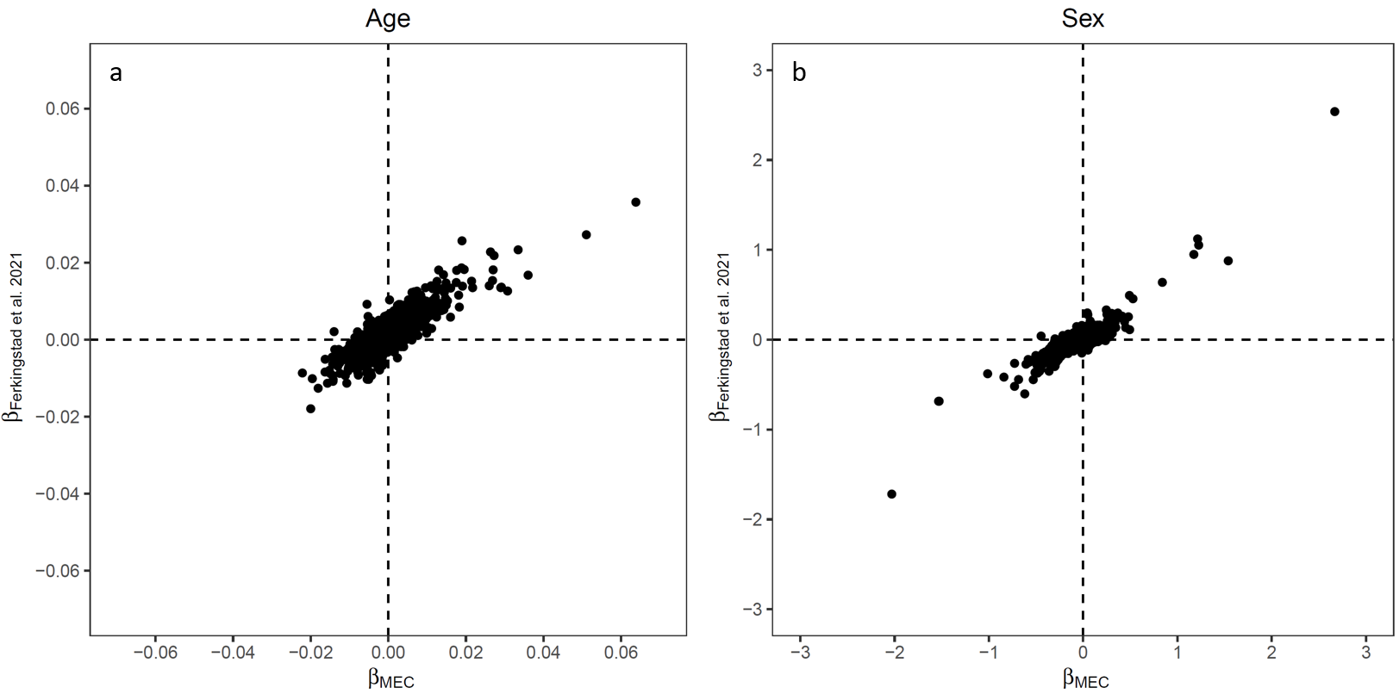
Supplementary Figure 1. Comparison of the beta coefficients between the Singapore Multi-ethnic cohort Phase 1 (MEC1) and a proteome wide association study performed in individuals from Iceland (Ferkingstad et al., 2021) for (a) Age and (b) Sex. Plasma protein levels in relative fluorescence units (RFU) were quantified using the SomaScan V4 assay in both studies. Each point corresponds to a SOMAmer (n = 4,978).
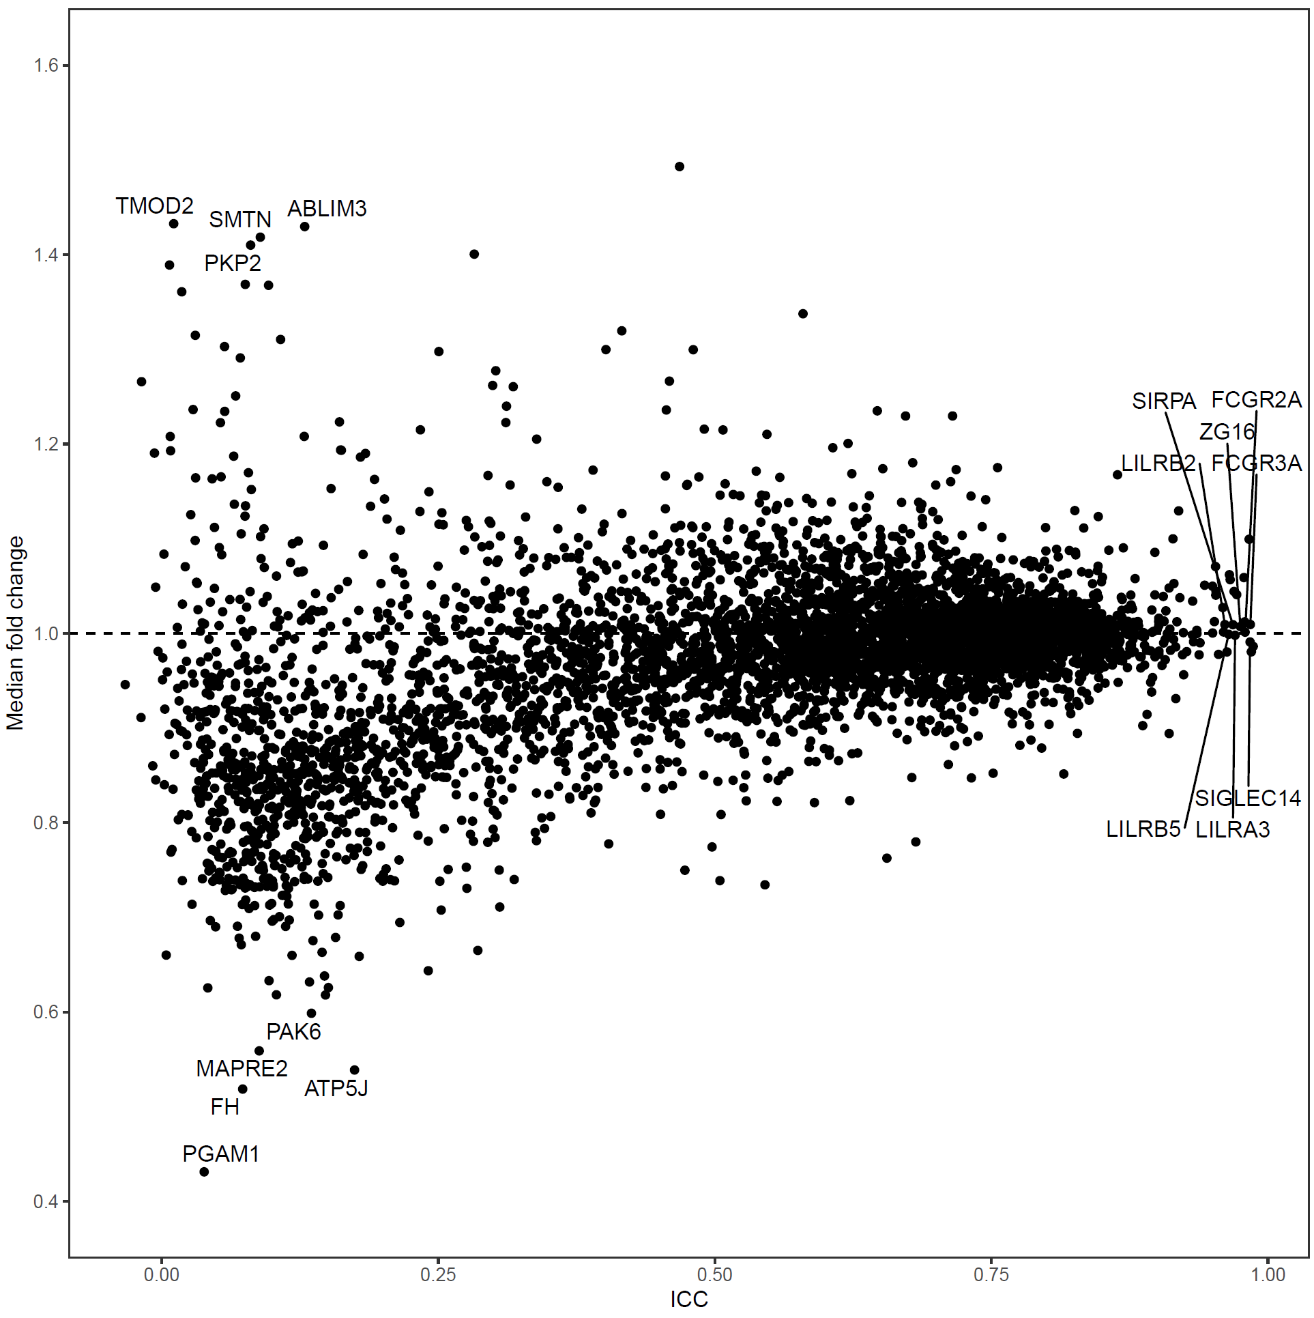
Supplementary Figure 2. Scatterplot of median fold change over a period of ~6 years against the intra-class correlation coefficient (ICC) for 4,978 SOMAmers measured by the SomaScan V4 assay. ICC was calculated using a two-way mixed-effects model. The text annotations correspond to Entrez Gene symbols.
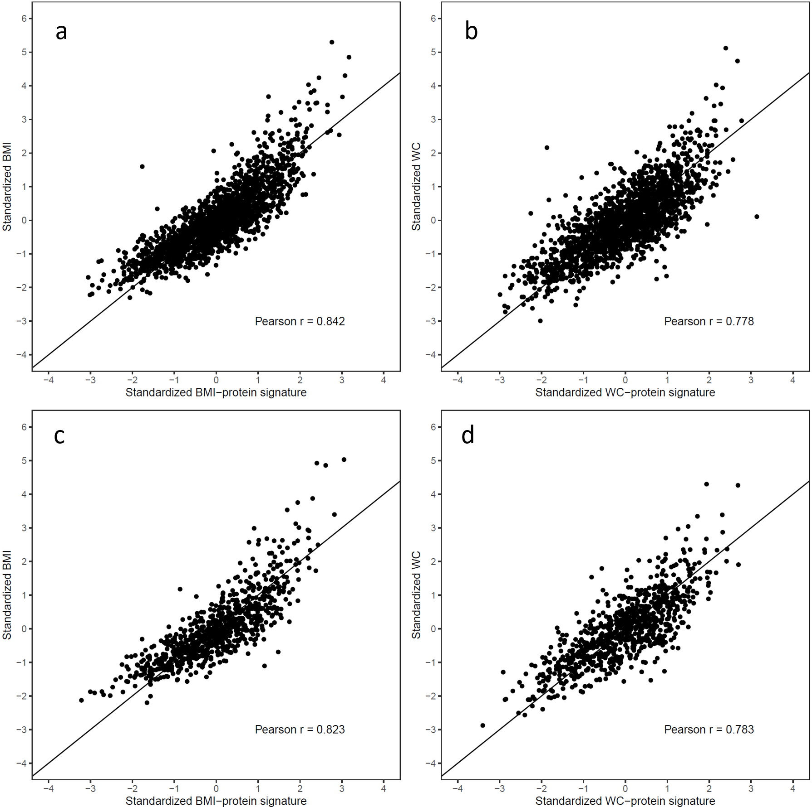
Supplementary Figure 3. Scatterplots of (a) BMI against BMI-protein signature at baseline (b) WC against WC-protein signature at baseline, (c) BMI against BMI-protein signature at follow-up, and (d) WC against WC-protein signature at follow-up in the T2DCC Set. The diagonal lines represent the y = x line. Abbreviations: BMI, body mass index; T2DCC, type 2 diabetes case control; WC, waist circumference.

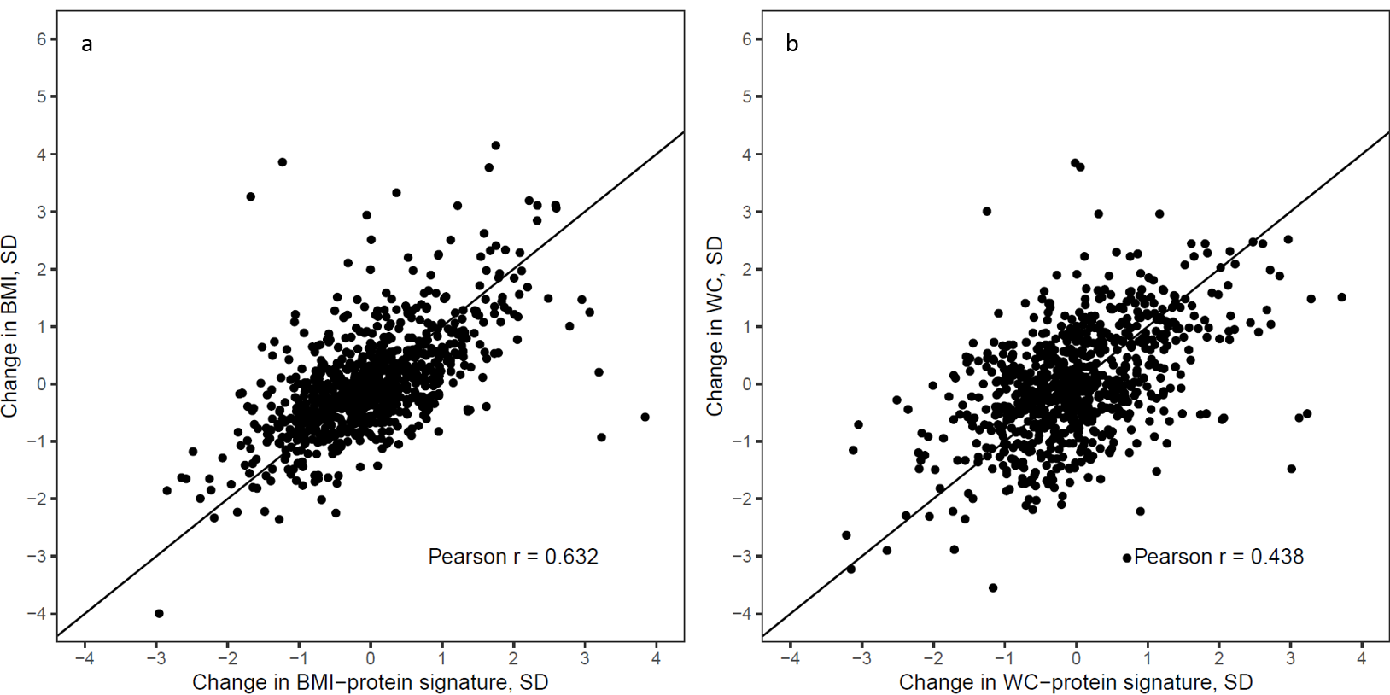 Supplementary Figure 4. Scatterplots of (a) change in BMI against change in BMI-protein signature, and (b) change in WC against change in WC-protein signature over a ~6-year period in the T2DCC set. The diagonal lines represent the y = x line. Abbreviations: BMI, body mass index; SD, standard deviation; T2DCC, type 2 diabetes case control; WC, waist circumference.

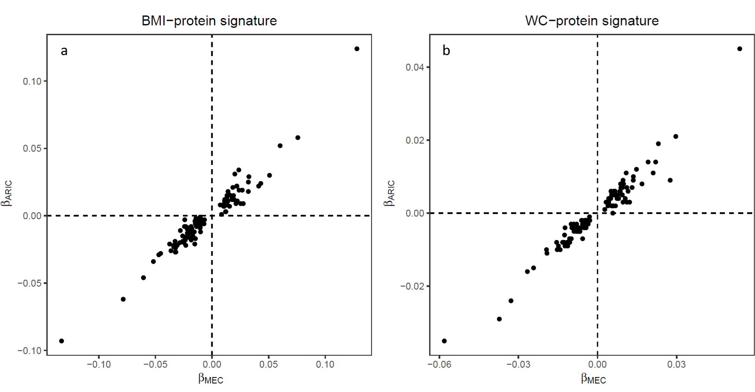
Supplementary Figure 5. Comparison of the beta coefficients for the associations between plasma proteins and BMI/WC between the Singapore Multi-ethnic cohort Phase 1 (MEC1) and the Atherosclerosis Risk in Communities (ARIC) study for (a) the BMI-protein signature and (b) the WC-protein signature. Plasma protein levels in relative fluorescence units (RFU) were quantified using the SomaScan V4 assay in both studies. Each point corresponds to each protein in the respective protein signatures (n = 124 for the BMI-protein signature and n = 125 for the WC-protein signature). Abbreviations: BMI, body mass index; WC, waist circumference.

