# Supplemental data

Table S1: Proteotypic peptides targeted in this study. Columns show peptide position on protein sequence, selection, charge, collision energy, transitions (precursor and product ions) and retention time used for the mass spectrometry analysis. (ac) means that the following residue is acetylated.

|  |  |  |  |  |  |  |  |  |  |
| --- | --- | --- | --- | --- | --- | --- | --- | --- | --- |
| Protein | Peptidique sequence | Position | Charge (z) | Precursor ion (m/z) | Product ion (m/z) | Retention time (min) | Collision energy (V) | Tension applied in Q1 / Q3 (V) | Dwell time (ms) |
| α/β-syn | (ac)MDVFMK | 1-6 | 2+ | 406,69 | 639,35 (y5) / 524,30 (y4) / 425,25 (y3) / 535,25 (b4) / 666,30 (b5) | 29,1 | 14 | 50 / 24 | 97 |
| α/β-syn | EGVVAAAEK | 13-21 | 2+ | 437,49 | 744,45 (y8) / 687,40 (y7) / 588,35 (y6) / 489,30 (y5) | 13,2 | 16 | 30 / 24 | 72 |
| α-syn | QGVAEAAGK | 24-32 | 2+ | 415,96 | 702,40 (y8) / 546,30 (y6) / 684,35 (b8) | 10,8 | 18 | 30 / 40 | 97 |
| α/β-syn | EGVLYVGSK | 35-43 | 2+ | 476,55 | 822,5 (y8) / 765,45 (y7) / 666,40 (y6) / 553,30 (y5) / 718,40 (b7) | 18,2 | 17 | 30 / 20 | 43 |
| α-syn | EGVVHGVATVAEK | 46-58 | 2+ | 648,35 | 618,35 (y6) / 522,30 (b5) / 579,30 (b6) / 678,40 (b7) | 15,9 | 30 | 24 / 28 | 72 |
| α-syn | EQVTNVGGAVVTGVTAVAQK | 61-80 | 2+ | 643,73 | 973,60 (y10) / 874,50 (y9) / 773,45 (y8) / 617,40 (y6) / 678,90 (y15) | 24 | 22 | 50 / 50 | 28 |
| α-syn | TVEGAGSIAAATGFVK | 81-96 | 2+ | 740,34 | 1021,60 (y11) / 764,45 (y8) / 693,40 (y7) / 622,40 (y6) / 551,35 (y5) | 24,1 | 27 | 50 / 28 | 28 |
| α-syn-126/98 | EGVLYVVAEK | 35-44 | 2+ | 553,81 | 920,55 (y8) / 821,50 (y7) / 708,40 (6) / 545,35 (y5) / 446,30 (y4) / 831,50 (b8) | 22,6 | 21 | 50 / 22 | 23 |
| α-syn-112/98 | EGYQDYEPEA | 103-112 | 1+ | 1200,47 | 851,35 (y7) / 316,15 (y3) / 478,20 (b4) / 593,25 (b5) / 756,30 (b6) / 885,35 (b7) | 20,7 | 39 | 22 / 34 | 23 |
| α-syn-41 | EGVLYVE | 35-41 | 1+ | 808,41 | 879,40 (y6) / 622,35 (y5) / 410,20 (y13) / 562,30 (b5) / 661,00 (b6) | 23,3 | 26 | 12 / 20 | 28 |
| alternative α-syn | LMKCLLR | 14-20 | 2+ | 438,76 | 763,45 (y6) / 632,40 (y5) / 504,30 (y4) / 401,30 (y4) / 373,25 (b3) / 476,25 (b4) | 29,7 | 21 | 16 / 22 | 35 |
| alternative α-syn mutated | LWILTMR | 21-27 | 2+ | 466,77 | 633,40 (y5) / 520,30 (y4) / 407,20 (y3) / 314,20 (b5) / 379,75 (b6) | 18,5 | 18 | 14 / 26 | 80 |
| β-syn | EGVVQGVASVAEK | 46-58 | 2+ | 636,84 | 987,55 (y10) / 888,50 (y9) / 760,45 (y8) / 703,40 (y7) / 669,40 (b7) | 19,6 | 25 | 40 / 30 | 28 |
| β-syn | EQASHLGGAVFSGAGNIAAATGLVK | 61-85 | 3+ | 776,08 | 1014,60 (y11) / 957,60 (y10) / 843,55 (y9) / 851,40 (b9) / 950,50 (b10) / 834,45 (b18) | 27 | 31 | 40 / 28 | 26 |
| β/γ-syn | QGVTEAAEK | 24-32 | 2+ | 466,74 | 804,45 (y8) / 747,40 (y7) / 515,25 (b5) / 648,35 (y6) / 547,30 (y5) / 586,30 (b6) | 11,1 | 20 | 40 / 22 | 47 |
| γ-syn | EGVVGAVEK | 13-21 | 2+ | 444,25 | 602,35 (y6) / 503,30 (y5) / 446,30 (y4) / 513,30 (b6) | 14,7 | 18 | 40 / 18 | 72 |
| γ-syn | ENVVQSVTSVAEK | 46-58 | 2+ | 695,36 | 1047,60 (y10) / 948,50 (y9) / 820,45 (y8) / 733,40 (y7) / 756,40 (b7) | 22 | 26 | 40 / 30 | 28 |
| γ-syn | EQANAVSEAVVSSVNTVATK | 61-80 | 3+ | 668,68 | 1005,60 (y10) / 906,50 (y9) / 819,50 (y8) / 829,40 (b8) / 900,40 (b9) / 793,90 (b16) | 24,7 | 24 | 40 / 18 | 23 |
| γ-syn | TVEEAENIAVTSGVVR | 81-96 | 2+ | 837,44 | 1015,60 (y10) / 788,50 (y8) / 717,45 (y7) / 618,40 (y6) / 788,95 (y15) | 23,2 | 32 | 40 / 24 | 28 |
| Haemoglobin subunit α | TYFPHFDLSHGSAQVK | 42-57 | 3+ | 612,00 | 412,20 (b3) / 646,30 (b5) / 793,40 (b6) / 711,90 (y13) / 523,90 (y14) / 442,55 (y12) | 21 | 22 | 16 / 30 | 23 |

Table S2: Synuclein concentrations of calibration points in plasma.

|  |  |  |  |  |  |
| --- | --- | --- | --- | --- | --- |
| Calibration point | α-syn (ng/ml) | α/β-syn (ng/ml) | β-syn (ng/ml) | β/γ-syn (ng/ml) | γ-syn (ng/ml) |
| 1 | 0 | 0 | 0 | 0 | 0 |
| 2 | 62 | 176 | 114 | 176 | 62 |
| 3 | 118 | 255 | 137 | 234 | 97 |
| 4 | 225 | 390 | 165 | 317 | 152 |
| 5 | 427 | 625 | 198 | 435 | 237 |
| 6 | 812 | 1049 | 237 | 606 | 369 |
| 7 | 1543 | 1828 | 285 | 861 | 576 |
| 8 | 2932 | 3274 | 342 | 1240 | 898 |
| 9 | 5571 | 5981 | 410 | 1811 | 1401 |

Table S3: Heavy labelled peptides concentrations of calibration points in plasma.

|  |  |  |  |  |  |
| --- | --- | --- | --- | --- | --- |
| Calibration point | α/β-syn N-terminal (ng/mL) | α-syn-41 (ng/mL) | α-syn-98/112 (ng/mL) | α-syn-98/126 (ng/mL) | α-syn-alt (ng/mL) |
| 1 | 0 | 0 | 0 | 0 | 0 |
| 2 | 0.18 | 0.34 | 0.52 | 0.47 | 0.8 |
| 3 | 0.31 | 0.56 | 0.84 | 0.77 | 1.17 |
| 4 | 0.46 | 0.82 | 1.23 | 1.13 | 1.53 |
| 5 | 0.61 | 1.06 | 1.59 | 1.46 | 2.22 |
| 6 | 0.92 | 1.51 | 2.27 | 2.09 | 2.82 |
| 7 | 1.23 | 1.87 | 2.81 | 2.59 | 4.58 |
| 8 | 3.06 | 3.86 | 5.79 | 5.32 | 5.39 |

Table S4: Method performance for plasma samples. The table shows the intra and inter-assay repeatability for each level (high, medium and low), sample stability in the autosampler at 4°C for 12h, 24h, 36h and 48h, the LOQ (limit of quantification) and linearity range for each alpha synuclein peptides.

|  |  |  |  |  |  |  |  |  |  |  |  |  |
| --- | --- | --- | --- | --- | --- | --- | --- | --- | --- | --- | --- | --- |
| Protein | Peptide sequence | Intra-day repeatability (%) | | | Inter-day repeatability ( %) | | | Mean Accuracy at 12h / 24h / 36h / 48h in the autosampler at 4°C, respectively (%) | | | Limit of quantification (ng/ml) | Linearity range (ng/ml) |
| QC low | QC medium | QC high | QC low | QC medium | QC high | QC low | QC medium | QC high |
| α/β-syn common peptides | EGVVAAAEK | 7 | 4 | 6 | 15 | 16 | 14 | 99 / 98 / 102 / 103 | 104 / 102 / 105 / 101 | 102 / 102 / 101 / 104 | 12.9 | 0 - 5981 |
| EGVLYVGSK | 8 | 5 | 2 | 17 | 13 | 12 | 94 / 93 / 100 / 103 | 102 / 97 / 98 / 96 | 96 / 104 / 108 / 104 | 19.35 | 0 - 5981 |
| α-syn | QGVAEAAGK | 5 | 4 | 3 | 19 | 15 | 13 | 101 / 102 / 95 / 100 | 87 / 93 / 82 /80 | 113 / 113 / 113 / 104 | 6.45 | 0 - 5571 |
| EQVTNVGGAVVTGVTAVAQK | 5 | 3 | 4 | 12 | 13 | 12 | 121 / 104 / 116 / 113 | 108 / 105 / 107 / 111 | 97 / 115 / 104 / 99 | 19.35 | 0 - 5571 |
| TVEGAGSIAAATGFVK | 13 | 8 | 5 | 22 | 15 | 10 | 73 / 89 / 66 / 56 | 70 / 80 / 108 / 90 | 110 / 109 / 97 / 106 | 19.35 | 0 - 5571 |

Table S5: Sample stability performance for synuclein peptides; such as matrix effect, effect of dilution, parallelism and samples thaw on ice or at room temperature until 6h, in goat serum. NA means not assigned.

|  |  |  |  |  |  |  |
| --- | --- | --- | --- | --- | --- | --- |
| Protein name | Peptide sequence | Matrix effect (%) | Effect of dilution accuracy following dilution factor (undiluted/ 2/ 3/ 4 respectively (%) | Parallelism accuracy following dilution factor (undiluted/ 2/ 3/ 4 respectively (%) | Samples stability thaw on ice accuracy at 0h/ 2h/ 4h/ 6h respectively (%) | Samples stability thaw at room temperature accuracy at 0h/ 2h/ 4h/ 6h respectively (%) |
| α/β-syn | (ac)MDVFMK | NA | NA | NA | 100/ 99/ 97/ 84 | 100/ 115/ 121/ 91 |
| EGVVAAAEK | -38 | 100/ 106/ 104/ 96 | 100/ 96/ 91/ 89 | 100/ 100/ 98/ 97 | 100/ 102/ 106/ 127 |
| EGVLYVGSK | -51 | 100/ 87/ 117/ 140 | 100/ 97/ 94/ 94 | 100/ 99/ 98/ 95 | 100/ 103/ 106/ 125 |
| α-syn | QGVAEAAGK | -35 | 100/ 98/ 105/ 99 | 100/ 96/ 96/ 86 | 100/ 100/ 102/ 102 | 100. 103. 104. 125 |
| EGVVHGVATVAEK | 9 | NA | NA | 100/ 91/ 97/ 96 | 100/ 101/ 109/ 137 |
| EQVTNVGGAVVTGVTAVAQK | -33 | 100/ 109/113/ 100 | 100/ 106/ 110/ 151 | 100/ 101/ 99/ 99 | 100/ 99/ 100/ 124 |
| TVEGAGSIAAATGFVK | -7 | 100/ 94/ 40/ 91 | 100/ 119/ 38/ 133 | 100/ 103/ 98/ 88 | 100/ 105/ 106/ 128 |
| β-syn | EGVVQGVASVAEK | -23 | 100/ 109/ 127/ 137 | 100/ 106/ 106/ 11 | 100/ 103/ 98/ 88 | 100/ 100/ 109/ 120 |
| EQASHLGGAVFSGAGNIAAATGLVK | -31 | NA | NA | NA | NA |
| γ-syn | EGVVGAVEK | -29 | 100/ 90/ 669/ 889 | 100/ 114/ 83/ 138 | 100/ 105/ 102/ 102 | 100/ 99/ 106/ 105 |
| ENVVQSVTSVAEK | -24 | 100/ 181/ 290/ 303 | 100/ 113/ 156/ 162 | 100/ 115/ 121/ 122 | 100/ 89/ 84/ 82 |
| EQANAVSEAVVSSVNTVATK | -34 | 100/ 27/ 45/ 86 | 100/ 220/ 113/ 174 | NA | NA |
| TVEEAENIAVTSGVVR | 19 | NA | 100/ 76/ 9/ 9 | 100/ 97/ 83/ 95 | 100/ 105/ 114/ 101 |
| β/γ-syn | QGVTEAAEK | -35 | 100/ 119/ 142/ 194 | 100/ 158/ 132/ 187 | 100/ 102/ 101/ 95 | 100/ 103/ 111/ 114 |

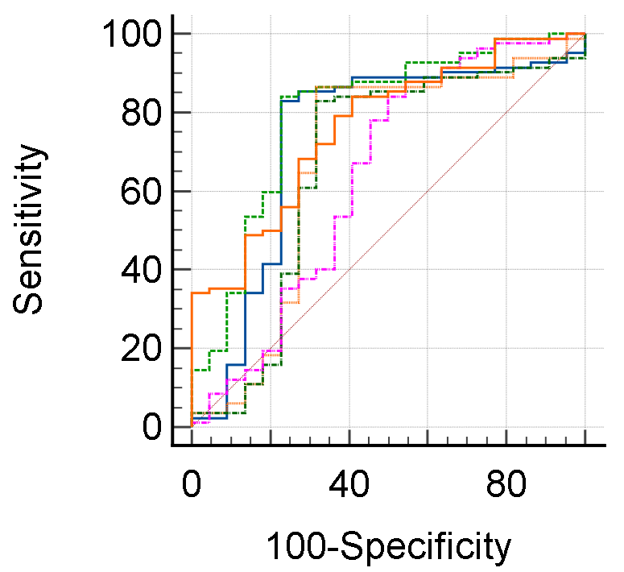



Figure S1: ROC curve monitoring the sensitivity (rate of true positif) and the rate of false positif (100-specificity) of the discrimination of PD group from the control group with the α/β-syn EGVLYVGSK peptide.

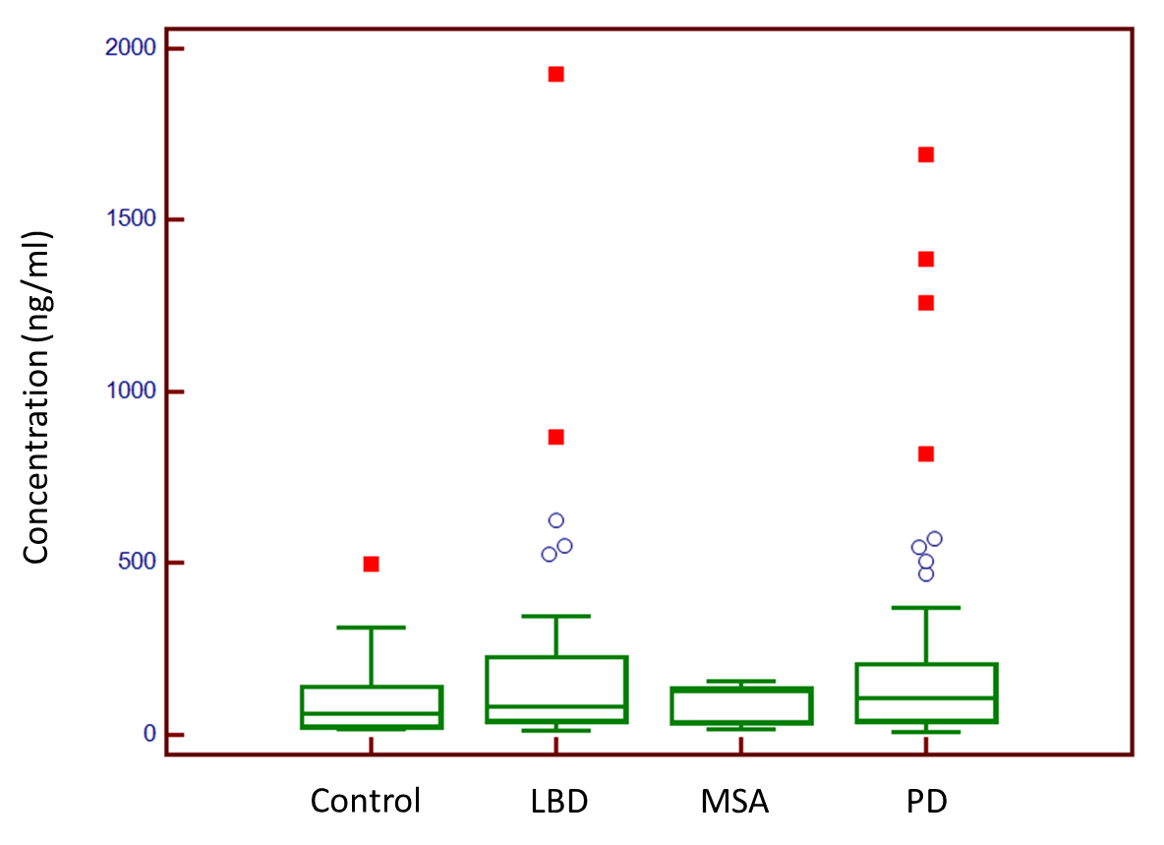

Figure S2: Box and whisker representing α-syn concentration level in group disease and control quantified by sensitive immunochemiluminescence assay from MesoScale Discovery.