# Supplementary Material

Deep learning algorithms for automatic segmentation of acute cerebral infarcts on diffusion-weighted images: Effects of training data sample size, transfer learning, and data features (Noh et al.)

|  |  |
| --- | --- |
| **Supplementary Method** | 2 |
| **Supplemental Figures** |  |
| Supplementary Figure 1. Experimental design testing effects of training sample size on deep learning models | 4 |
| Supplementary Figure 2. Experimental design for testing the effects of domain adaptation on performance of deep learning model | 5 |
| Supplementary Figure 3. Background noise and signal to noise ratio in the Internal dataset with stratification by participating site | 6 |
| Supplementary Figure 4. Lesion segmentation performance of 3D U-net algorithm for the Ancillary test dataset I and the Ancillary test dataset II | 7 |
| Supplementary Figure 5. Volume correlation plot between ground truth and estimated infarct volume in the Internal test dataset and the External dataset | 8 |
| Supplementary Figure 6. Lesion segmentation performance stratified by the presence of chronic ischemic lesions | 9 |
| Supplementary Figure 7. Lesion segmentation performance stratified by white matter hyperintensity volume load | 10 |
| **Supplemental Tables** |  |
| Supplementary Table 1. Summary of prior studies on deep learning algorithms to segment ischemic lesions on diffusion-weighted images | 11 |
| Supplementary Table 2. Characteristics of MRI vendors and protocols used for the Training-and-validation dataset, the Internal test dataset, and the External dataset | 13 |
| Supplementary Table 3. Baseline characteristics of the patients for the Single site training-and-validation dataset | 15 |
| Supplementary Table 4. Lesion segmentation performance of 3D U-net algorithm trained using the Single site dataset | 16 |
| Supplementary Table 5. Lesion segmentation performance depending on MRI vendors | 17 |
| Supplementary Table 6. Segmentation performance in the Internal test dataset with stratification by participating centers | 18 |
| Supplementary Table 7. Comparison of model performance between U-Net and Vision Transformer | 19 |
| **Supplemental References** | 20 |

**Supplementary Method**

**Model Development**

*3D U-Net.* The model consisted of an encoder/decoder layer that could perform max pooling four times, with feature size set to be 12, 24, 48, 96, and 192 in each step (Supplementary Fig. 1). The convolutional layer's kernel size was set to be 3 x 3 x 3. Conv3d model weights were initialized with He normal1 and ConvTranspose3d model weights and Xavier uniform.2 For model training, Adam optimizer3 with cyclical learning rate was used. The batch size was set to 2, and the experimental results showed that the optimal learning rate interval was 1e-5 to 1e-4. In addition, to address class imbalance caused by a small lesion size (vs. total brain volume), focal Tversky loss4 was used. The gamma of the loss function was set to 4/3, while alpha and beta were experimentally set to 0.6 and 0.4, respectively.

*Swin UNETR.* MONAI,5 a pytorch-based open source library, was used to train the model. The model's Swin Transformer set the number of transformer layers for each attention step to two and numbers of heads to two, four, eight, and sixteen. The model's weights were initialized using He normalization and focal Tversky loss function. For training the model, an Adam optimizer with a cyclical learning rate between 3e-4 and 3e-3 was used.

**Data Augmentation**

Each image has been augmented with a linear combination of the following methods.

*Slice-wise similarity transformation.* Due to the voxel anisotropy of the input image, the transformation was conducted on each slice with a randomly defined affine matrix to prevent artifacts resulting from inter-slice operations. For 2D transformation, the matrix is calculated as follows:

where and are coordinates in the original and transformed image spaces respectively, is the scaling factor, is the degree of rotation, and is the translation vector for the original image. The implementation code was written using scikit-image, an imaging toolkit for Python.

*MRI bias field artifact simulation.* The bias field artifact has been modeled as a linear combination of polynomial basis functions for each axis,6-8 as described by the authors of TorchIO. The final simulated image is calculated as follows:

where and are the original and simulated image, and is a randomly generated bias field. To train our model, the order of the polynomial function for each axis was set to 2.

*Axis flip.* After similarity transformation and bias field simulation, a random axis flip was conducted. One of the x, y, and z axes of each image was reversed with 75% probability, and the probability of flipping each axis was the same.

*Gamma/contrast change.* Adjustment of gamma was performed by nonlinearly transforming the signal value of each voxel with an image-specific coefficient. Here, the coefficient was calculated by taking the natural exponent of a random real number between -0.3 and 0.3. The following formula is used to augment these data:

where is the voxel signal and is a value between and .

**Technical Details**

Python 3.7.9/3.8.13, pytorch 1.12.0, torchvision 0.13.0, pandas 1.2.4, numpy 1.19.5/1.22.3, scipy 1.4.1/1.6.3, scikit-image 0.15.0/0.18.1, SimpleITK 2.1.1, and pydicom 2.1.2 were used for all procedures, including preprocessing and model development. Intel Xeon Silver 4314 @2.40GHz, 640GB RAM, and NVIDIA Quadro RTX A6000 48GB GDDR6 were used to train models.

**Supplementary Figures**

**Supplementary Figure 1. Experimental design testing effects of training sample size on deep learning models**

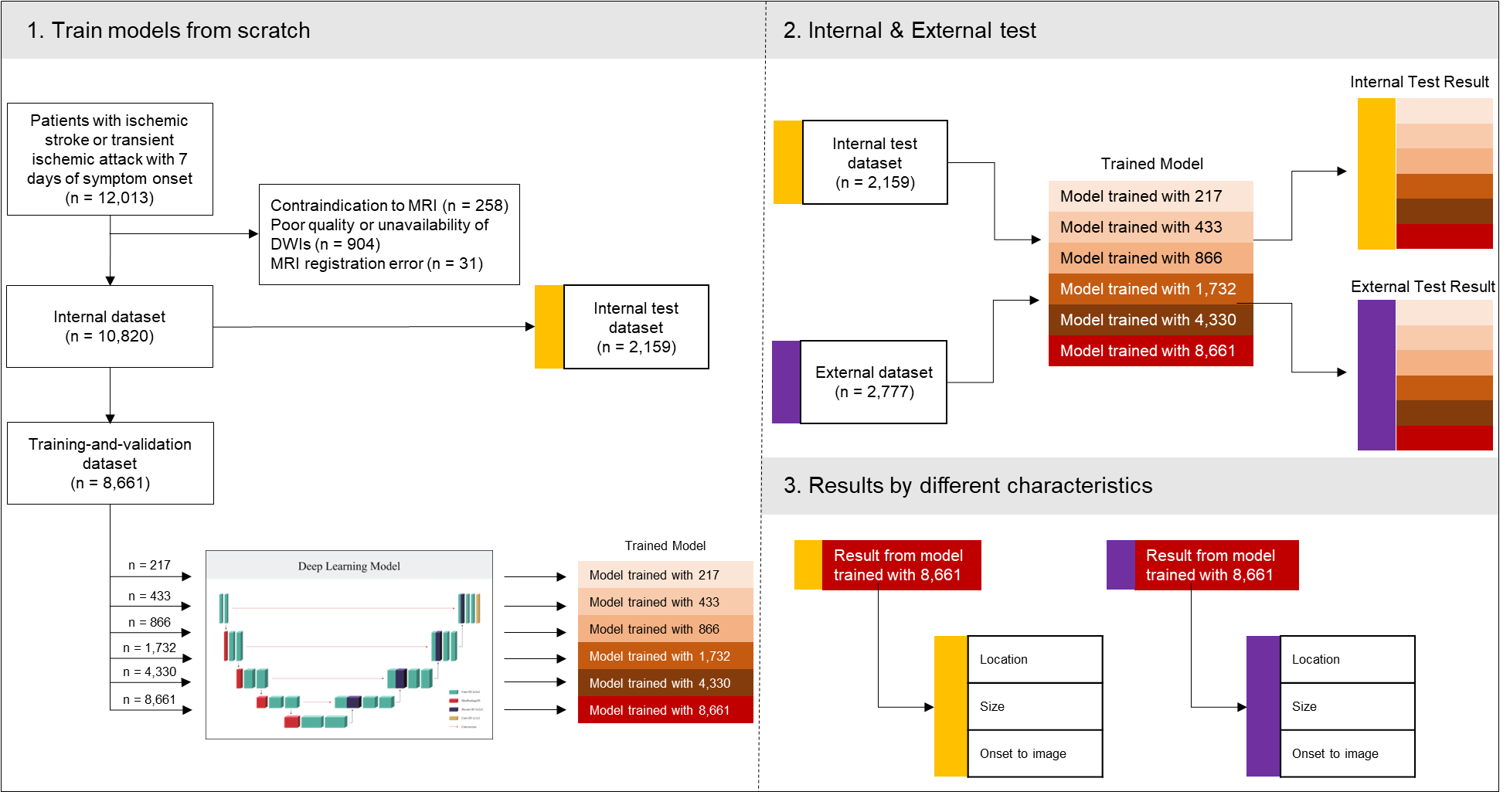

Red boxes represent baseline models trained with various sample sizes. White boxes tagged with yellow and violet markers in “2. Internal & External Test” represent the Internal test dataset and the External dataset. Red boxes tagged with yellow and violet markers indicate internal and external test results, respectively. TIA=transient ischemic stroke; MRI=magnetic resonance imaging; DWI=diffusion weighted imaging. See Figure 1 (main text) for a better understanding of datasets.

**Supplementary Figure 2. Experimental design for testing the effects of domain adaptation on performance of deep learning model**

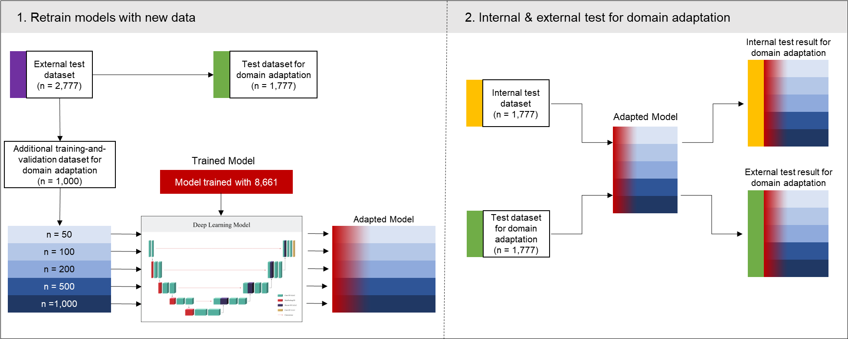

Flowchart of the process for testing the impact of sample size for domain adaptation on lesion segmentation model. Blue boxes indicate the Additional training-and-validation dataset for domain adaptation with various sample sizes. Red tinted boxes indicate baseline models trained on the source domain data. See Figure 1 (main text) for a better understanding of datasets.

**Supplementary Figure 3. Background noise and signal to noise ratio in the Internal dataset with stratification by participating site**



Data are depicted as mean and standard deviation. Capital letters below X-axis indicate each participating center. Numbers below capital letters indicate number of patients in each center. Background noise and signal to noise ratio were significantly different among sites (*p* < 0.001 by ANOVA). See Figure 1 (main text) for a better understanding of datasets.

**Supplementary Figure 4. Lesion segmentation performance of 3D U-net algorithm for the Ancillary test dataset I and the Ancillary test dataset II**

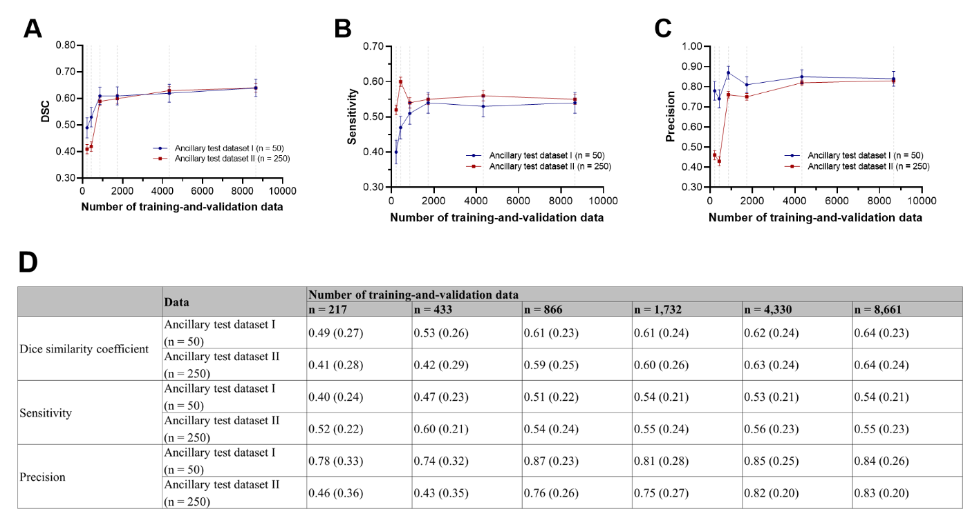

(A) Dice similarity coefficient (DSC). (B) Pixel-level sensitivity. (C) Pixel-level precision. (D) DSC, sensitivity, and specificity (SD) at each number of training-and-validate data. Data are presented as mean and stranded error. Gray dot lines indicate data points of 217, 433, 866, 1,732, 4,330, and 8,661. Sensitivity and precision were calculated voxel-wise. See Figure 1 (main text) for a better understanding of datasets.

**Supplementary Figure 5. Volume correlation plot between ground truth and estimated infarct volume in the Internal test dataset and the External dataset**

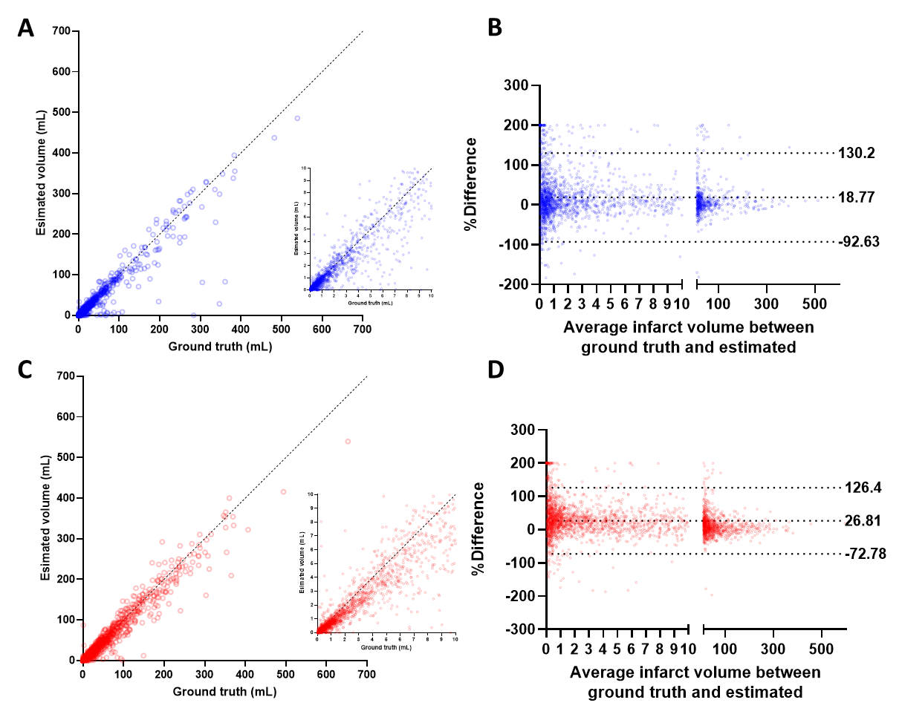

Scatter (A) and Bland-Altman (B) plots of ground truth infarct volume and deep learning estimated infarct volume in internal test data. Scatter (C) and Bland-Altman (D) plots of ground truth infarct volume and deep learning estimated infarct volume in the External dataset. In scatter plots, dotted lines indicate an indemnity line (x = y). In Bland and Altman plots dot lines indicate mean percent difference and its 95% confidence intervals. See Figure 1 (main text) for a better understanding of datasets.

**Supplementary Figure 6. Lesion segmentation performance stratified by the presence of chronic ischemic lesions**

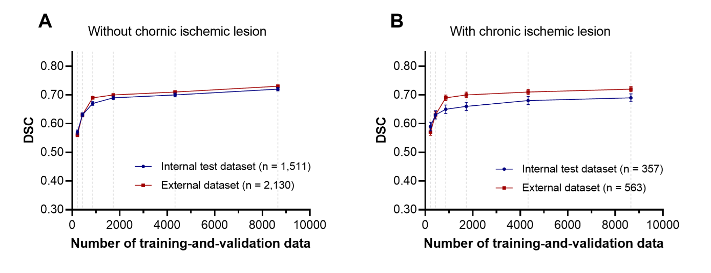

Chronic ischemic lesions on fluid-attenuated inversion recovery images were defined as a) 3–15 mm ischemic lesions outside the basal ganglia, brainstem, thalamus, internal capsule, or cerebral white matter or b) ischemic lesions larger than 15 mm in any area. Data are presented as mean and stranded error. Gray dot lines indicate data points of 217, 433, 866, 1,732, 4,330, and 8,661. See Figure 1 (main text) for a better understanding of datasets.

**Supplementary Figure 7. Lesion segmentation performance stratified by white matter hyperintensity volume load**

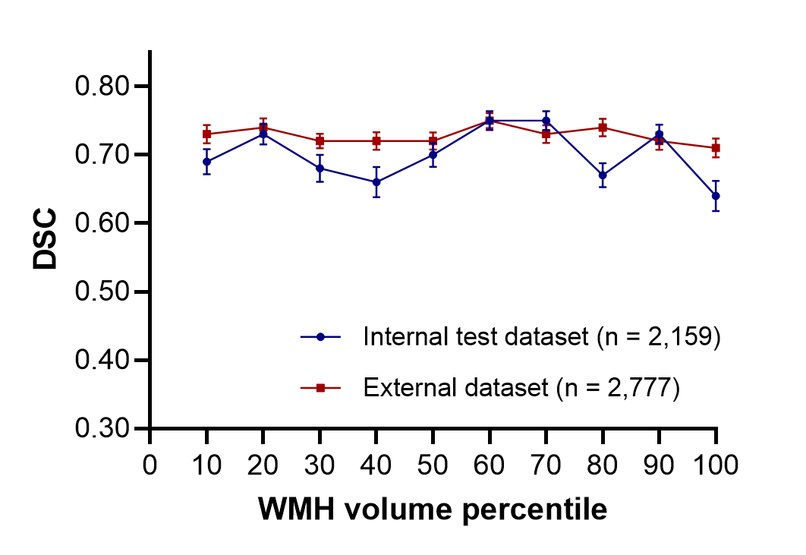

DSC = Dice similarity coefficient; WMH = white matter hyperintensity. See Figure 1 (main text) for a better understanding of datasets.

**Supplementary Tables**

**Supplementary Table 1. Summary of prior studies on deep learning algorithms to segment ischemic lesions on diffusion-weighted images**

|  |  |  |  |  |  |  |  |
| --- | --- | --- | --- | --- | --- | --- | --- |
| Ref. | No. of training & tuning data | Data source | Deep learning model | MRI vendors | External validation | Internal DSC | External DSC |
| [1] | 700 | Single | U-net | Siemens, GE | No | 0.85 | NA |
| [2] | 380 | Multiple | Ensemble of DeconvNets and MUSCLE Net | Siemens | No | 0.67 | NA |
| [3] | 335 | Single | Ensemble of U-net and Densenet | Siemens, GE, Philips | No | 0.86 | NA |
| [4] | 296 (test set included) | Single | U-net | Siemens, GE, Philips | No | 0.60 | NA |
| [5] | 152 | NA | 3D Densenet | Siemens, Philips | ISLES2015 | 0.79 | 0.55 |
| [6] | 1,390 | Single | DAGMNet_CH3 | Siemens, GE, Philips, other | STIR2 | 0.76 | 0.51 |
| [7] | 116 | Single | DeepMedic | GE | No | 0.82 | NA |
| [8] | 115 | Single | Res-FCN | Siemens | ISLES2015 | 0.80 | 0.65 |
| [9] | 460 | Single | DPC-Net | Siemens | No | 0.64 | NA |
| [10] | 2385 and 3157 | Multiple (6) | U-net | Siemens, GE | Cross-vendor testa | 0.87 and 0.90 | 0.73 and 0.76 |

DSC = Dice similarity coefficient; ISLES = Ischemic Stroke Lesion Segmentation; STIR = Stroke Imaging Repository; NA = not available

aModels were independently trained using either Siemens or GE data and externally validated using other vendors’ data.

[1] WONG, Kelvin K., et al. Automatic segmentation in acute ischemic stroke: Prognostic significance of topological stroke volumes on stroke outcome. *Stroke*, 2022, 53.9: 2896-2905.

[2] CHEN, Liang; BENTLEY, Paul; RUECKERT, Daniel. Fully automatic acute ischemic lesion segmentation in DWI using convolutional neural networks. *NeuroImage: Clinical*, 2017, 15: 633-643.

[3] WOO, Ilsang, et al. Fully automatic segmentation of acute ischemic lesions on diffusion-weighted imaging using convolutional neural networks: comparison with conventional algorithms. *Korean Journal of Radiology*, 2019, 20.8: 1275-1284.

[4] KIM, Yoon-Chul, et al. Evaluation of diffusion lesion volume measurements in acute ischemic stroke using encoder-decoder convolutional network. *Stroke*, 2019, 50.6: 1444-1451.

[5] ZHANG, Rongzhao, et al. Automatic segmentation of acute ischemic stroke from DWI using 3-D fully convolutional DenseNets. *IEEE transactions on medical imaging*, 2018, 37.9: 2149-2160.

[6] LIU, Chin-Fu, et al. Deep learning-based detection and segmentation of diffusion abnormalities in acute ischemic stroke. *Communications Medicine*, 2021, 1.1: 61.

[7] WINZECK, Stefan, et al. Ensemble of convolutional neural networks improves automated segmentation of acute ischemic lesions using multiparametric diffusion-weighted MRI. *American Journal of Neuroradiology*, 2019, 40.6: 938-945.

[8] LIU, Zhiyang, et al. Towards clinical diagnosis: Automated stroke lesion segmentation on multi-spectral MR image using convolutional neural network. *IEEE Access*, 2018, 6: 57006-57016.

[9] ZHAO, Bin, et al. Automatic acute ischemic stroke lesion segmentation using semi-supervised learning. *arXiv preprint arXiv:1908.03735*, 2019.

[10] ALIS, Deniz, et al. Inter-vendor performance of deep learning in segmenting acute ischemic lesions on diffusion-weighted imaging: a multicenter study. *Scientific reports*, 2021, 11.1: 12434.

**Supplementary Table 2. Detailed characteristics of MRI vendors and protocols used for the Training-and-validation dataset, the Internal test dataset, and the External dataset**

|  |  |  |  |  |
| --- | --- | --- | --- | --- |
| Variable | Training-and-validation  (*n* = 8,661) | Internal test dataset  (*n* = 2,159) | External dataset  (*n* = 2,777) | *P*-value |
| MRI model |  |  |  | <.001 |
| Phillips – Achieva | 642 | 167 | 0 (0.0%) |  |
| Phillips – Intera | 2,063 | 512 | 0 (0.0%) |  |
| Phillips – Others | 730 | 189 | 3 (0.1%) |  |
| GE-Signa Excite | 1,263 | 303 | 4 (0.1%) |  |
| GE-Signa HDxt | 19 | 7 | 1,494 (53.8%) |  |
| GE-Discovery MR750 | 414 | 121 | 4 (0.1%) |  |
| GE-Others | 13 | 7 | 1,204 (43.4%) |  |
| Siemens-Avanto | 1,554 | 364 | 4 (0.1%) |  |
| Siemens-Sonata | 684 | 166 | 0 (0.0%) |  |
| Siemens-Skyra | 757 | 202 | 0 (0.0%) |  |
| Siemens-Others | 297 | 119 | 56 (2.0%) |  |
| Other MRI vendors | 7 | 2 | 8 (0.3%) |  |
| Magnetic field strengtha |  |  |  | <.001 |
| 1.5T | 5,129 | 1,231 | 2,724 (98.5%) |  |
| 3.0T | 2,273 | 609 | 41 (1.5%) |  |
| Acquisition matrix (row) |  |  |  | <.001 |
| < 192 | 1,539 | 360 | 46 (1.7%) |  |
| 192 ~ 239 | 657 | 154 | 10 (0.4%) |  |
| 240 ~ 255 | 633 | 165 | 0 (0.0%) |  |
| 256 ~ 319 | 4,860 | 1,234 | 2,710 (97.6%) |  |
| 320 ~ 511 | 607 | 155 | 11 (0.4%) |  |
| 512 | 365 | 91 | 0 (0.0%) |  |
| Pixel spacing (mm)b |  |  |  | <.001 |
| < 0.8 | 1,311 | 3335 | 11 (0.4%) |  |
| 0.8 ~ 0.849 | 1,373 | 359 | 11 (0.4%) |  |
| 0.85 ~ 0.899 | 2,181 | 544 | 10 (0.4%) |  |
| 0.9 ~ 0.949 | 1,073 | 257 | 12 (0.4%) |  |
| 0.95 ~ 0.999 | 515 | 137 | 55 (2.0%) |  |
| ≥ 1.0 | 2,208 | 527 | 2,676 (96.4%) |  |
| Slice thickness (mm)c |  |  |  | <.001 |
| 3.0 ~ 3.9 | 2,335 | 573 | 1 (0.0%) |  |
| 4.0 ~ 4.9 | 625 | 156 | 2,699 (97.3%) |  |
| 5.0 ~ 5.9 | 4,417 | 1,109 | 66 (2.4%) |  |
| ≥ 6.0 | 32 | 4 | 8 (0.3%) |  |
| Repetition time (ms)d |  |  |  | <.001 |
| < 3000 | 613 | 142 | 2 (0.1%) |  |
| 3000 ~ 3999 | 2,465 | 600 | 10 (0.4%) |  |
| 4000 ~ 4999 | 1,618 | 403 | 6 (0.2%) |  |
| 5000 ~ 5999 | 1,065 | 278 | 43 (1.5%) |  |
| 6000 ~ 6999 | 617 | 154 | 1 (0.0%) |  |
| 7000 ~ 7999 | 545 | 134 | 10 (0.4%) |  |
| ≥ 8000 | 1,717 | 444 | 2,705 (97.4%) |  |
| Echo time (ms) |  |  |  | <.001 |
| < 50 | 66 | 11 | 0 (0.0%) |  |
| 50 ~ 59.99 | 874 | 224 | 0 (0.0%) |  |
| 60 ~ 69.99 | 1,931 | 478 | 0 (0.0%) |  |
| 70 ~ 79.99 | 2,885 | 726 | 7 (0.3%) |  |
| 80 ~ 89.99 | 994 | 248 | 2,685 (97.5%) |  |
| 90 ~ 99.99 | 1,117 | 281 | 49 (1.8%) |  |
| ≥ 100 | 756 | 175 | 14 (0.5%) |  |
| FOV (row, mm) |  |  |  | <.001 |
| < 210 | 644 | 153 | 5 (0.2%) |  |
| 210 ~ 219 | 1,816 | 464 | 11 (0.4%) |  |
| 220 ~ 229 | 2,893 | 713 | 10 (0.4%) |  |
| 230 ~ 239 | 2,238 | 562 | 54 (1.9%) |  |
| 240 ~ 249 | 984 | 238 | 16 (0.6%) |  |
| 250 ~ 259 | 57 | 14 | 56 (2.0%) |  |
| ≥ 260 | 29 | 15 | 2,623 (94.5%) |  |

MRI, magnetic resonance imaging; FOV, field of view.

aData of magnetic field strength were missing for 1,259, 319, and 12 patients in the Training-and-validation dataset, Internal test dataset, and External dataset, respectively. See Figure 1 (main text) for a better understanding of datasets.

bData of pixel spacing were missing for 521, 132, and 2 patients in the Training-and-validation dataset, the Internal test dataset, and the External dataset, respectively.

cData of slice thickness were missing for 1,251, 317, and 3 patients in the Training-and-validation dataset, the Internal test dataset, and the External dataset, respectively.

dData of repetition time were missing for 21 and 4 patients in the Training-and-validation dataset and the Internal test dataset, respectively.

**Supplementary Table 3. Baseline characteristics of the patients for the Single site training-and-validation dataset**

|  |  |
| --- | --- |
| Variable | Single site training-and-validation dataset (*n* = 382) |
| Age (year)a | 68.8 ± 13.2 |
| Malea | 225 (60.8%) |
| BMIa | 23.0 ± 3.6 |
| Admission NIHSSa, median (IQR) | 4 (2-8) |
| Subtypea |  |
| LAA | 135 (36.5%) |
| SVO | 95 (25.7%) |
| CE | 67 (18.1%) |
| Undetermined | 62 (16.8%) |
| Other determined | 11 (3.0%) |
| Previous strokea | 102 (27.6%) |
| Hypertensiona | 278 (75.1%) |
| Diabetes mellitusa | 137 (37.0%) |
| Hyperlipidemiaa | 184 (49.7%) |
| Smokinga | 155 (41.9%) |
| Atrial fibrillationa | 64 (17.3%) |
| Time from LKW to imaginga, median (IQR, hour) | 19.02 (3.7-50.8) |
| Infarct volumea, median (IQR, mL) | 1.70 (0.53-11.25) |

BMI, body mass index; NIHSS, National Institutes of Health Stroke Scale; IQR, interquartile range; LAA, large artery atherosclerosis; SVO, small vessel occlusion; CE, cardioembolism; LKW, Last known well.

Data are presented as mean ± standard deviation, number (percentage), or median (interquartile range). See Figure 1 (main text) for a better understanding of datasets.

aData of age, sex, BMI, admission NIHSS, subtype, previous stroke, hypertension, diabetes, hyperlipidemia, smoking, atrial fibrillation, LKW to imaging time, and infarct volume were missing for 12 patients.

**Supplementary Table 4. Lesion segmentation performance of 3D U-net algorithm trained using the Single site dataset**

|  |  |  |  |  |
| --- | --- | --- | --- | --- |
| Metric | Single site internal test dataset  (*n* = 94) | External dataset  (*n* = 2,777) | Ancillary test dataset I  (*n* = 50) | Ancillary test dataset II  (*n* = 250) |
| Dice similarity coefficient | 0.70 (0.23)  [0.64, 0.85] | 0.50 (0.31)  [0.21, 0.76] | 0.51 (0.26)  [0.27, 0.72] | 0.33 (0.30)  [0.05, 0.60] |
| *P* for difference | Reference | < .001 | < .001 | < .001 |
| Sensitivity | 0.69 (0.25)  [0.61, 0.87] | 0.46 (0.31)  [0.18, 0.72] | 0.43 (0.23)  [0.35, 0.58] | 0.59 (0.21)  [0.47, 0.74] |
| *P* for difference | Reference | < .001 | < .001 | < .001 |
| Precision | 0.78 (0.18)  [0.71, 0.89] | 0.68 (0.34)  [0.52, 0.94] | 0.76 (0.32)  [0.65, 0.98] | 0.34 (0.37)  [0.03, 0.71] |
| *P* for difference | Reference | .005 | .63 | < .001 |

The model was trained and validated using 382 patients from a single center. Results are presented as mean (standard deviation) and [interquartile range]. Sensitivity and precision were calculated voxel-wise. See Figure 1 (main text) for a better understanding of datasets.

**Supplementary Table 5. Lesion segmentation performance depending on MRI vendors**

|  |  |  |  |  |  |  |
| --- | --- | --- | --- | --- | --- | --- |
|  | Number of training-and-validation data | | | | | |
| MRI Vendor | *n* = 217 | *n* = 433 | *n* = 866 | *n* = 1,732 | *n* = 4,330 | *n* = 8,661 |
| Phillips |  |  |  |  |  |  |
| Internal test dataset (n = 868) | 0.62 (0.28) | 0.64 (0.27) | 0.68 (0.26) | 0.69 (0.26) | 0.71 (0.24) | 0.73 (0.24) |
| External dataset (n = 3) | N/A | N/A | N/A | N/A | N/A | N/A |
| GE |  |  |  |  |  |  |
| Internal test dataset (n = 438) | 0.55 (0.29) | 0.62 (0.26) | 0.65 (0.26) | 0.67 (0.26) | 0.68 (0.26) | 0.70 (0.24) |
| External dataset (n = 2,703) | 0.56 (0.28) | 0.63 (0.27) | 0.70 (0.23) | 0.70 (0.24) | 0.71 (0.23) | 0.73 (0.21) |
| Siemens |  |  |  |  |  |  |
| Internal test dataset (n = 851) | 0.55 (0.29) | 0.59 (0.28) | 0.62 (0.28) | 0.64 (0.26) | 0.65 (0.27) | 0.66 (0.25) |
| External dataset (n = 60) | 0.48 (0.31) | 0.50 (0.31) | 0.58 (0.31) | 0.61 (0.28) | 0.64 (0.28) | 0.64 (0.28) |

Results are presented as mean (standard deviation) of Dice similarity coefficient. See Figure 1 (main text) for a better understanding of datasets.

aData are either missing or coming from other vendors for 2 and 11 patients in the Internal test dataset and External test dataset, respectively.

**Supplementary Table 6. Segmentation performance in the Internal test dataset with stratification by participating centers**

|  |  |  |  |  |  |  |
| --- | --- | --- | --- | --- | --- | --- |
|  | Number of training-and-validation samples | | | | | |
|  | *n* = 217 | *n* = 433 | *n* = 866 | *n* = 1,732 | *n* = 4,330 | *n* = 8,661 |
| Hospital 1  (n = 307) | 0.57 (0.28) | 0.62 (0.26) | 0.67 (0.25) | 0.68 (0.26) | 0.69 (0.26) | 0.72 (0.24) |
| Hospital 2  (n = 96) | 0.59 (0.31) | 0.66 (0.27) | 0.70 (0.25) | 0.68 (0.27) | 0.71 (0.25) | 0.71 (0.25) |
| Hospital 3  (n = 329) | 0.64 (0.28) | 0.68 (0.24) | 0.70 (0.24) | 0.71 (0.23) | 0.73 (0.23) | 0.74 (0.23) |
| Hospital 4  (n = 354) | 0.58 (0.29) | 0.59 (0.28) | 0.64 (0.29) | 0.66 (0.27) | 0.68 (0.26) | 0.69 (0.26) |
| Hospital 5  (n = 145) | 0.65 (0.24) | 0.72 (0.19) | 0.76 (0.15) | 0.76 (0.17) | 0.78 (0.15) | 0.78 (0.15) |
| Hospital 6  (n = 236) | 0.45 (0.31) | 0.45 (0.32) | 0.51 (0.32) | 0.57 (0.29) | 0.55 (0.32) | 0.59 (0.29) |
| Hospital 7  (n = 180) | 0.65 (0.29) | 0.68 (0.25) | 0.72 (0.26) | 0.73 (0.25) | 0.75 (0.23) | 0.77 (0.20) |
| Hospital 8  (n = 10) | 0.61 (0.29) | 0.61 (0.27) | 0.69 (0.24) | 0.68 (0.28) | 0.72 (0.27) | 0.73 (0.21) |
| Hospital 9  (n = 368) | 0.56 (0.27) | 0.60 (0.27) | 0.60 (0.28) | 0.62 (0.26) | 0.62 (0.27) | 0.64 (0.25) |
| Hospital 10  (n = 134) | 0.50 (0.29) | 0.60 (0.25) | 0.62 (0.26) | 0.66 (0.24) | 0.66 (0.24) | 0.69 (0.23) |

Results are presented as mean (standard deviation). See Figure 1 (main text) for a better understanding of datasets.

**Supplementary Table 7. Comparison of model performance between U-Net and Vision Transformer**

|  |  |  |
| --- | --- | --- |
| Metric | U-Net | Swin UNETR |
| Dice similarity coefficient |  |  |
| Internal test dataset (*n* = 2,159) | 0.70 (0.25)  [0.63, 0.86] | 0.67 (0.27)  [0.58, 0.86] |
| External dataset (*n* = 2,777) | 0.73 (0.21)  [0.68, 0.86] | 0.67 (0.27)  [0.60, 0.86] |
| Sensitivity |  |  |
| Internal test dataset (*n* = 2,159) | 0.69 (0.27)  [0.58, 0.89] | 0.67 (0.29)  [0.53, 0.89] |
| External dataset (*n* = 2,777) | 0.69 (0.23)  [0.58, 0.85] | 0.62 (0.28)  [0.48, 0.84] |
| Precision |  |  |
| Internal test dataset (*n* = 2,159) | 0.78 (0.21)  [0.71, 0.93] | 0.76 (0.24)  [0.70, 0.93] |
| External dataset (*n* = 2,777) | 0.86 (0.16)  [0.81, 0.96] | 0.87 (0.16)  [0.83, 0.87] |

Results are presented as mean (standard deviation) and [interquartile range]. Both models' training utilized 8,661 samples for training-and-validation. Sensitivity and precision were calculated voxel-wise. See Figure 1 (main text) for a better understanding of datasets.

**Supplementary references**

1. He K, Zhang X, Ren S, Sun J. Delving deep into rectifiers: Surpassing human-level performance on imagenet classification. 2015:1026-1034.

2. Glorot X, Bengio Y. Understanding the difficulty of training deep feedforward neural networks. JMLR Workshop and Conference Proceedings; 2010:249-256.

3. Kingma DP, Ba J. Adam: A method for stochastic optimization. *arXiv preprint arXiv:14126980*. 2014;

4. Abraham N, Khan NM. A novel focal tversky loss function with improved attention u-net for lesion segmentation. IEEE; 2019:683-687.

5. Consortium M. MONAI: Medical Open Network for AI. doi:10.5281/zenodo.4323059 <https://doi.org/10.5281/zenodo.6903385>

6. Sudre CH, Cardoso MJ, Ourselin S, Initiative AsDN. Longitudinal segmentation of age-related white matter hyperintensities. *Medical Image Analysis*. 2017;38:50-64.

7. Van Leemput K, Maes F, Vandermeulen D, Suetens P. Automatic segmentation of brain tissues and MR bias field correction using a digital brain atlas. Springer; 1998:1222-1229.

8. Van Leemput K, Maes F, Vandermeulen D, Suetens P. Automated model-based tissue classification of MR images of the brain. *IEEE transactions on medical imaging*. 1999;18(10):897-908.