# Supplemental Materials

|  |  |
| --- | --- |
| **Item** | **Title/Description** |
| Supplemental Methods | Quality Control (QC) Protocol |
| Supplemental Table 1 | Topology Readouts for all PRM Classifications |
| Supplemental Table 2 | Multivariable Regression for non-COPD Subset |

# Supplemental Methods: Quality Control (QC) Protocol

QC was performed in two steps (e.g., see 3 and 4 in exclusion diagram below), using GOLD grade, segmented lung volume change (V = inspiration volume – expiration volume, as a function of segmented voxels), and a correlation test metric (Q) defined as the absolute value of the difference between standard scores of FEV1% predicted and %PRMNorm, reported to be highly correlated in COPD studies*.

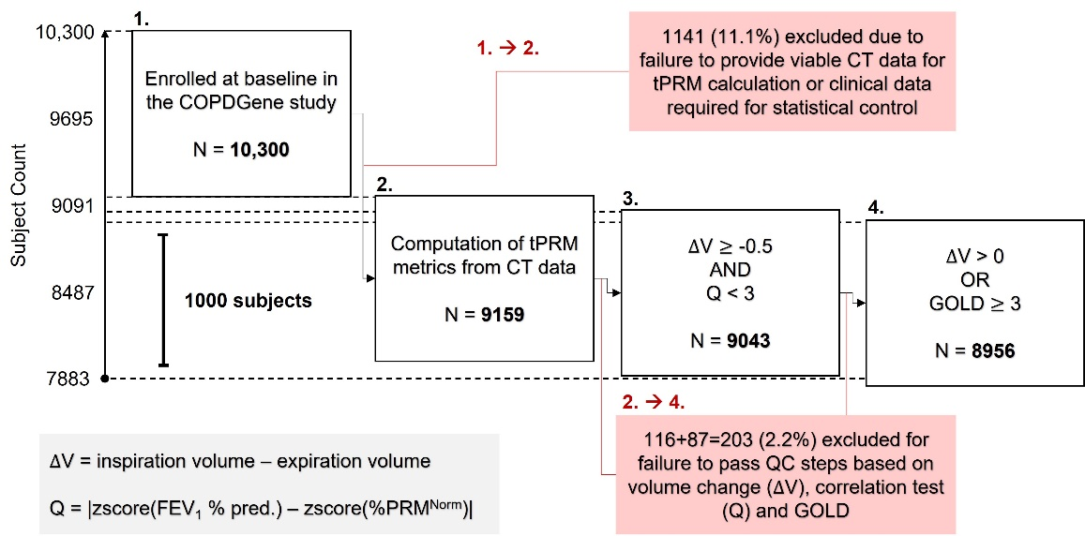

Specifically, imaging QC tests for exclusion were applied consecutively as follows:

1. **∆V < -0.5 L OR Q ≥ 3**

A large negative volume change, here defined as greater than 0.5 L, often indicates transposition of intended respiratory stages (expiration/inspiration), due to faulty maneuver or data handling error. In addition, we test here if a deviation of equal to or greater than 3 standard deviations from the expected positive correlation between FEV1% predicted and %PRMNorm has occurred.

1. **∆V ≤ 0 L and GOLD < 3**

This second step goes on to test if a non-severe COPD participant (GOLD < 3) has zero or negative volume change. N.B. here and in step 1 we have considered that there may be participants with severe disease that have some abnormal volume changes (close to 0 due to very limited lung function).

* Galbán, C. J. et al. Computed tomography–based biomarker provides unique signature for diagnosis of COPD phenotypes and disease progression. Nature Medicine 18, 1711-1715, doi:10.1038/nm.2971 (2012).

# Supplemental Table 1: Topology Readouts for all PRM Classifications

|  |  |  |  |  |  |  |  |
| --- | --- | --- | --- | --- | --- | --- | --- |
|  |  | Non-COPD | | COPD | | | |
| Topology | PRM | GOLD 0 | PRISm | GOLD 1 | GOLD 2 | GOLD 3 | GOLD 4 |
| Volume Density [V] | Norm | 0.62 (0.13) | 0.54 (0.15) | 0.57 (0.12) | 0.5 (0.14) | 0.33 (0.13) | 0.21 (0.09) |
| fSAD | 0.1 (0.09) | 0.09 (0.08) | 0.17 (0.11) | 0.22 (0.12) | 0.31 (0.11) | 0.36 (0.09) |
| Emph | 0.01 (0.01) | 0.01 (0.02) | 0.03 (0.04) | 0.05 (0.07) | 0.15 (0.12) | 0.26 (0.14) |
| PD | 0.25 (0.13) | 0.35 (0.16) | 0.2 (0.08) | 0.21 (0.09) | 0.19 (0.09) | 0.15 (0.05) |
| Euler-Poncairé Characteristic [c] | Norm | -0.0095 (0.0063) | -0.0095 (0.008) | -0.0091 (0.0055) | -0.0084 (0.0071) | -0.0016 (0.0078) | 0.0039 (0.0055) |
| fSAD | 0.0081 (0.0059) | 0.0096 (0.0065) | 0.0058 (0.0057) | 0.0047 (0.0074) | -0.0009 (0.0071) | -0.0036 (0.0048) |
| Emph | 0.0024 (0.003) | 0.0018 (0.0025) | 0.0046 (0.0039) | 0.005 (0.0039) | 0.0052 (0.0039) | 0.0033 (0.0032) |
| PD | 0.0044 (0.0033) | 0.0028 (0.0046) | 0.0043 (0.0018) | 0.004 (0.0022) | 0.0031 (0.0017) | 0.0024 (0.0009) |

**Notes:** Data are presented as the mean (standard deviation). The entire study population was separated in subsets of those with (FEV1/FVC < 0.7) and without (FEV1/FVC ≥ 0.7) COPD. GOLD, Global Initiative for Chronic Obstructive Lung Disease; PRISm, preserved ratio impaired spirometry; GOLD 0, at-risk smokers with normal spirometry; PRM, Parametric Response Map; Norm, normal lung parenchyma; fSAD, functional small airways disease; Emph, emphysema; and PD, parenchymal disease.

# Supplemental Table 2: Multivariable Regression for non-COPD Subset

|  |  |  |  |  |
| --- | --- | --- | --- | --- |
| Performance | FEV1pp | FEV1/FVC | FEF25-75 (L) | VEmph |
| Adjusted R2 | 0.143 | 0.126 | 0.265 | 0.263 |
| SE | 14.39 | 0.048 | 0.883 | 0.014 |
| Age (yrs) |  | -0.119** | -0.290** | 0.042* |
| Sex (M/F) | -0.027 (0.05) | 0.014 (0.298) | -0.381** | -0.062** |
| BMI (kg/cm2) | -0.075** | 0.104** |  | -0.130** |
| Smoking Pack-Years | -0.105** | -0.098** | -0.098** |  |
| CT vendor | -0.052** |  | -0.015 (0.252) | 0.185** |
| Race |  | 0.117** | -0.068** |  |
| VNorm | 0.325** | -0.044* | 0.109** | -0.157** |
| VfSAD | 0.134** | -0.218** | -0.075** | 0.373** |
| cNorm |  |  |  | -0.038 (0.01) |
| cfSAD | -0.105** | -0.075** | -0.058** |  |

**Notes:** Multivariable regression modelling using volume density (V) and Euler-Poincaré Characteristic (c) for PRM-derived Normal and fSAD (introduced stepwise) to model pulmonary function test measures in the COPD subset. Each column presents results for a different regression model. FEV1pp, forced expiratory volume in one second percent predicted; FEV1, forced expiratory volume in one second; FVC, forced vital capacity; FEF25-75, forced mid-expiratory flow; Emph, emphysema; SE, standard error of the estimate; BMI, body mass index; Norm, normal; and fSAD, functional small airways disease. Model performance is reported as adjusted R2 and standard error of the estimate. Feature association is reported as standardized beta coefficients (β); cells for stepwise variables removed from final model. All regression models were controlled for age, sex, race, BMI, pack years and CT vendor. P values ≥ 0.01, < 0.01 and ≥ 0.001, and < 0.001 are presented as values in parentheses, *, and **, respectively.