Electronic Supplementary Material 7

The effect of exercise on aerobic capacity in individuals with spinal cord injury: A systematic review with meta-analysis and meta-regression

PLoS Medicine

Hodgkiss, D.D¹, Bhangu, G^{2,3}, Lunny, C⁴, Jutzeler C.R^{5,6}, Chiou S.Y^{1,7,8,9} Walter, M^{2,10}, Lucas S.E^{1,7}, Krassioukov, A.V.^{2,11,12}, Nightingale, T.E.^{1,2,9}

¹ School of Sport, Exercise and Rehabilitation Sciences, University of Birmingham, UK.
² International Collaboration on Repair Discoveries (ICORD), University of British Columbia, Vancouver, British Columbia, Canada. ³ MD Undergraduate Program, Faculty of Medicine, University of British Columbia, Vancouver, Canada. ⁴ Knowledge Translation Program, Li Ka Shing Knowledge Institute, St. Michael’s Hospital, Toronto, and the University of British Columbia, Vancouver, British Columbia, Canada.
⁵ Department of Health Sciences and Technology, ETH Zurich, Zurich, Switzerland. ⁶ Schulthess Clinic, Zurich, Switzerland. ⁷ Centre for Human Brain Health, University of Birmingham, United Kingdom. ⁸ MRC Versus Arthritis Centre for Musculoskeletal Ageing Research, University of Birmingham, United Kingdom.
⁹ Centre for Trauma Science Research, University of Birmingham, United Kingdom. ¹⁰ Department of Urology, University Hospital Basel, University of Basel, Basel, Switzerland. ¹¹ Department of Medicine, Division of Physical Medicine and Rehabilitation, University of British Columbia, Vancouver, British Columbia, Canada. ¹² GF Strong Rehabilitation Centre, Vancouver Coastal Health, Vancouver, British Columbia, Canada.

Corresponding author: Tom E. Nightingale PhD, T.E.Nightingale@bham.ac.uk
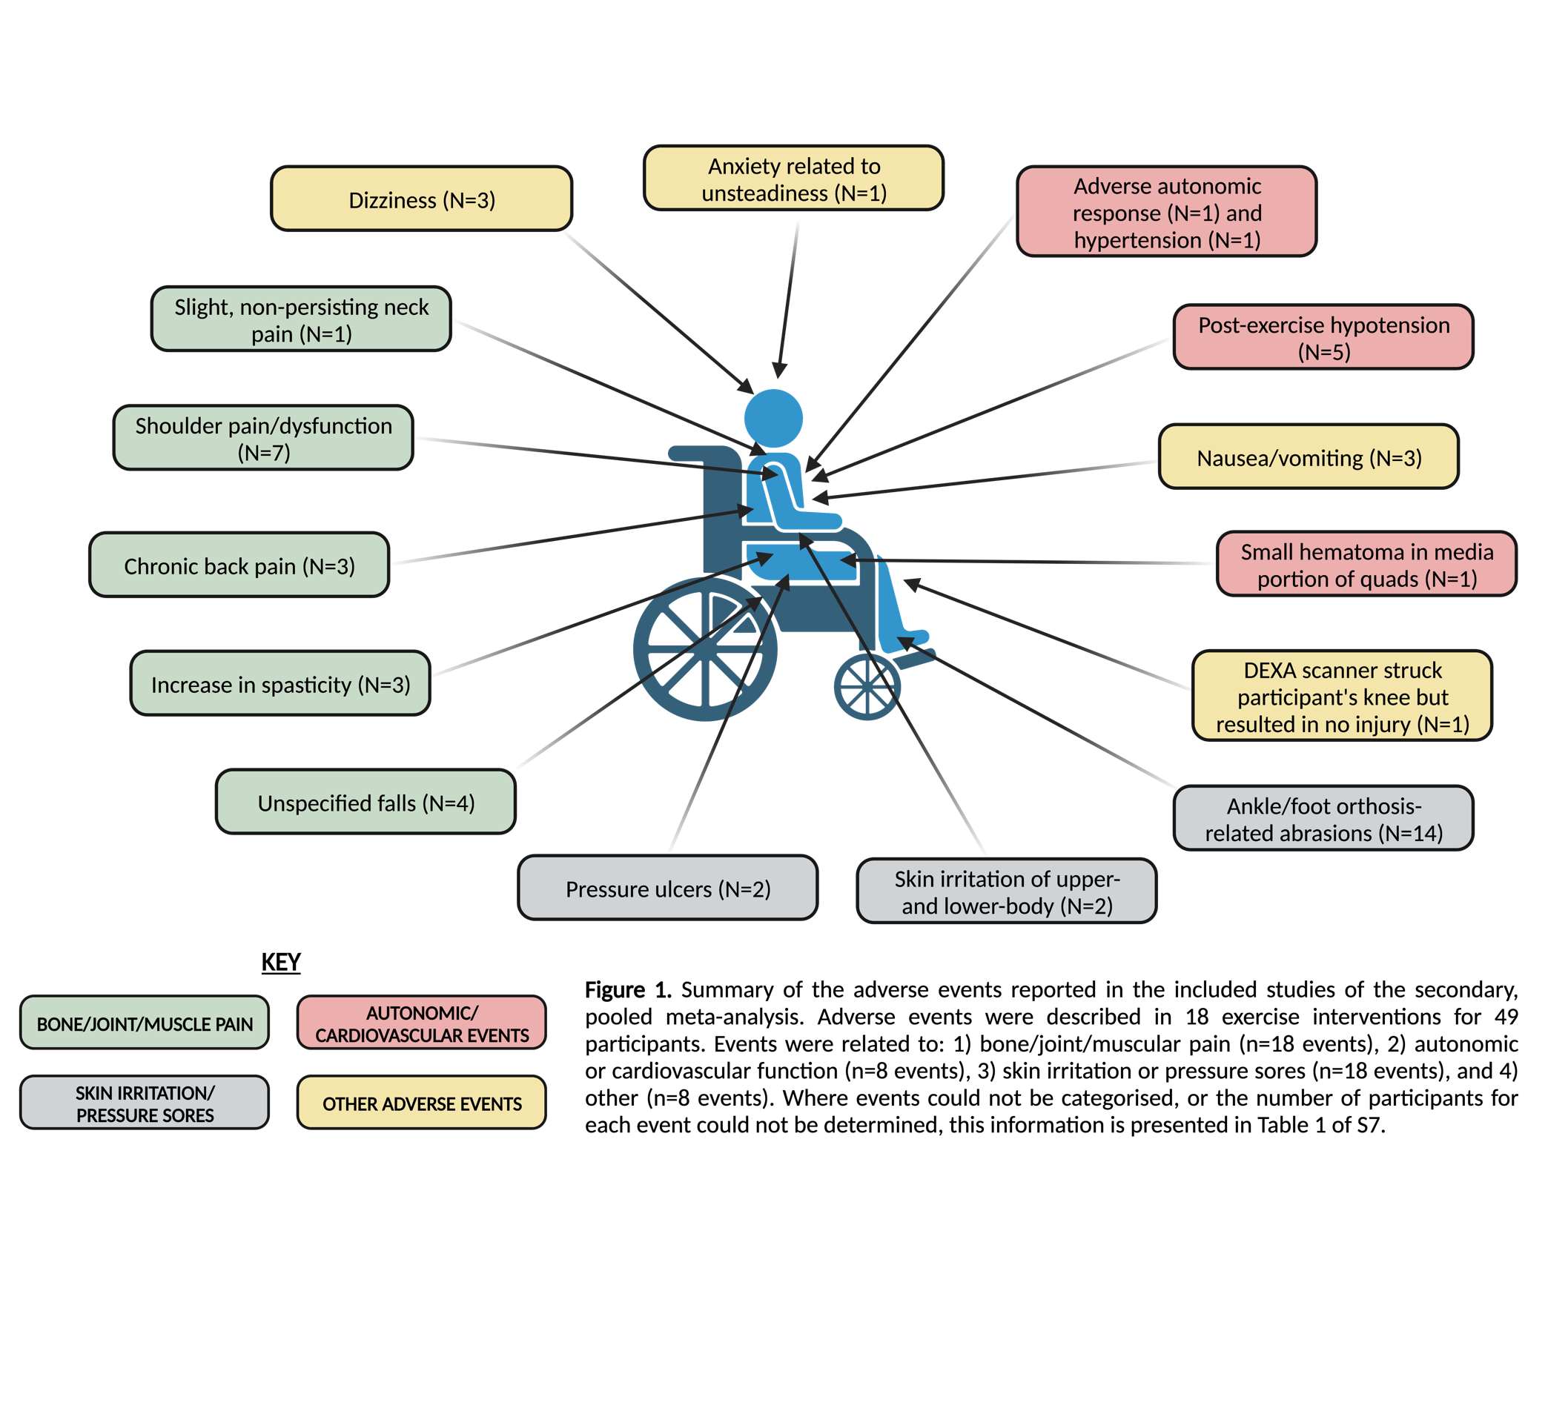
Table 1. Adverse events described in the exercise intervention studies included in the primary meta-analysis.
Author/  Year | Exercise Modality | Total N | Adverse Events
 |  |  | Total Adverse Events (%N) | Bone, joint or muscular pain | Autonomic or CV function | Skin irritation/ pressure sores | Other
Beillot et al. (1996) | Walking with reciprocating gait orthosis | 14 | 10 (71%)  (“10 participants had to stop the training programme, the major complications included spontaneous fractures of lower limbs, occurrence of a syringomyelia and pressure sores at the foot and ankle”) | NS | 0 | NS | NS
Berry et al. (2008) | Home-based FES-cycling | 11 | 1 (9%)  (“one subject dropped out of the study after baseline testing due to an adverse autonomic response to stimulation, data not included”) | 0 | 1 | 0 | 0
Bombardier et al. (2021) | Behaviour change (with tele-health intervention) | 7 | 1 (14%)  (“arm of the DXA scanner struck a participant's knee as it was returning to the start position but the physician detected no injury”) | 0 | 0 | 0 | 1
Brazg et al. (2017) | Low-intensity locomotor training | 15 | 1 (7%)  (“one individual terminated participation due to an increase in his back pain”) | 1 | 0 | 0 | 0
Brurok et al. (2011) | Aerobic HIIT hybrid cycling (arm crank ergometry and FES cycling) | 6 | 2 (33%)  (“two persons exacerbated a latent shoulder dysfunction during training but commenced shortly after a period of rest and therapy”) | 2 | 0 | 0 | 0
Duran et al. (2001) | Mixed exercise programme (mobility, strength, coordination, aerobic resistance,  and relaxation activities) | 13 | 1 (8%)  (“one patient developed transient sinus bradycardia and hypotension after the arm crank exercise test”) | 0 | 1 | 0 | 0
Gauthier et al. (2018) | Home-based, high-intensity wheelchair ergometry (HIIT group) | 4 | 1 (25%)  (“one dropout in the HIIT group was due to development of significant shoulder pain over the course of the training program”) | 1 | 0 | 0 | 0
Gibbons et al. (2016) | FES-rowing | 5 | NS  (“a number of participants showed some level of autonomic dysreflexia during the FES response test”) | 0 | NS | 0 | 0
Gorman et al. (2016) | Robotically assisted BWSTT | 12 | 2 (17%)  (“skin irritation in hip, groin, penis, back, wrist, glutei and scapula”) | 0 | 0 | 2 | 0
Janssen et al. (2008) | FES-cycling | 12 | NS  (“lightheadedness in some subjects”) | 0 | 0 | 0 | NS
Koontz et al. (2021) | High-intensity handcycling | 10 | 1 (10%)  (“one participant experienced bad spasms during a session - but repeated this session on another day”) | 1 | 0 | 0 | 0
Kressler et al. (2013) | Treadmill- based locomotor training with transcutaneous FES (TS) | 17 | 1 (6%)  (“increase in spasticity and increase in chronic back pain in a patient”) | 1 | 0 | 0 | 0
Lotter et al. (2020) | Impairment- based training (e.g., recumbent cycling or stepping) | 16 | 5 (31%)  (“4 incidents of soreness/ankle foot orthoses– related abrasions and one incident of nausea”) | 0 | 0 | 4 | 1
 | Task-specific training (e.g., stepping practice including speed- dependent treadmill training, over-ground training, skill-dependent treadmill training, and stair climbing) | 16 | 16 (100%)  (“11 falls without significant injury outside of task-specific training, with subsequent discomfort in 4 incidences; one incident of hypertension; 10 incidents of soreness/ankle foot orthoses– related abrasions; one incident of anxiety related to the perception of unsteadiness such that assistance was required”) | 4 | 1 | 10 | 1
Mcleod et al. (2020) | Sprint interval training (high-intensity) using arm crank ergometry  (HIIT group) | 10 | 1 (10%)  (“post-exercise hypotension”) | 0 | 1 | 0 | 0
Mohr et al. (1997) | FES-cycling | 10 | 4 (40%)  (“three subjects experienced post-exercise hypotension…one subject experienced a small hematoma in the media portion of the quads after 15 min of exercise in the 2nd exercise bout”) | 0 | 4 | 0 | 0
Nooijen et al. (2015) | Handcycling | 45 | 2 (4%)  (“2 participants did not complete training due to severe pressure ulcers”) | 0 | 0 | 2 | 0
Vestergaard et al. (2022) | FES-  skiergometry | 7 | NS - It cannot be determined whether these adverse events were in one participant or multiple.  (“Only a few minor adverse effects occurred: slight non-persisting pain in neck (n = 1), arms and shoulders (n = 4) during and between training sessions, dizziness that disappeared after 5 min (n = 1), feeling tired in the head/dizziness that disappeared after training with no other signs of autonomic hyperreflexia (n = 2), increased spasms (n = 2), and vomiting just after training (n = 2)” | 7 | 0 | 0 | 5
Number of participants in each intervention (N), and the percentage of those who experienced an adverse event (%N). BWSTT, body-weight supported treadmill training; CV, cardiovascular; FES, functional electrical stimulation; HIIT, high-intensity interval training NS, not specified.

