Evaluating reduced effectiveness after repeat influenza vaccination while accounting for confounding by recent infection and within-season waning

Qifang Bi, Barbra A. Dickerman, Huong Q. McLean, Emily T. Martin, Manjusha Gaglani, Karen J. Wernli, Balasubramani Goundappa, Brendan Flannery, Marc Lipsitch*, Sarah Cobey* , the US Flu Vaccine Effectiveness Network Investigators **

**Study group team members are listed in the acknowledgements.

6 Supplemental Material

Section 1. Summary of study participants, study enrollment, and influenza seasonality

Table 1.1: Characteristics of the vaccinated individuals in the US Flu VE Network by their influenza infection status in the current season and vaccination status in the prior season, from the 2011-2012 through the 2018-2019 seasons.

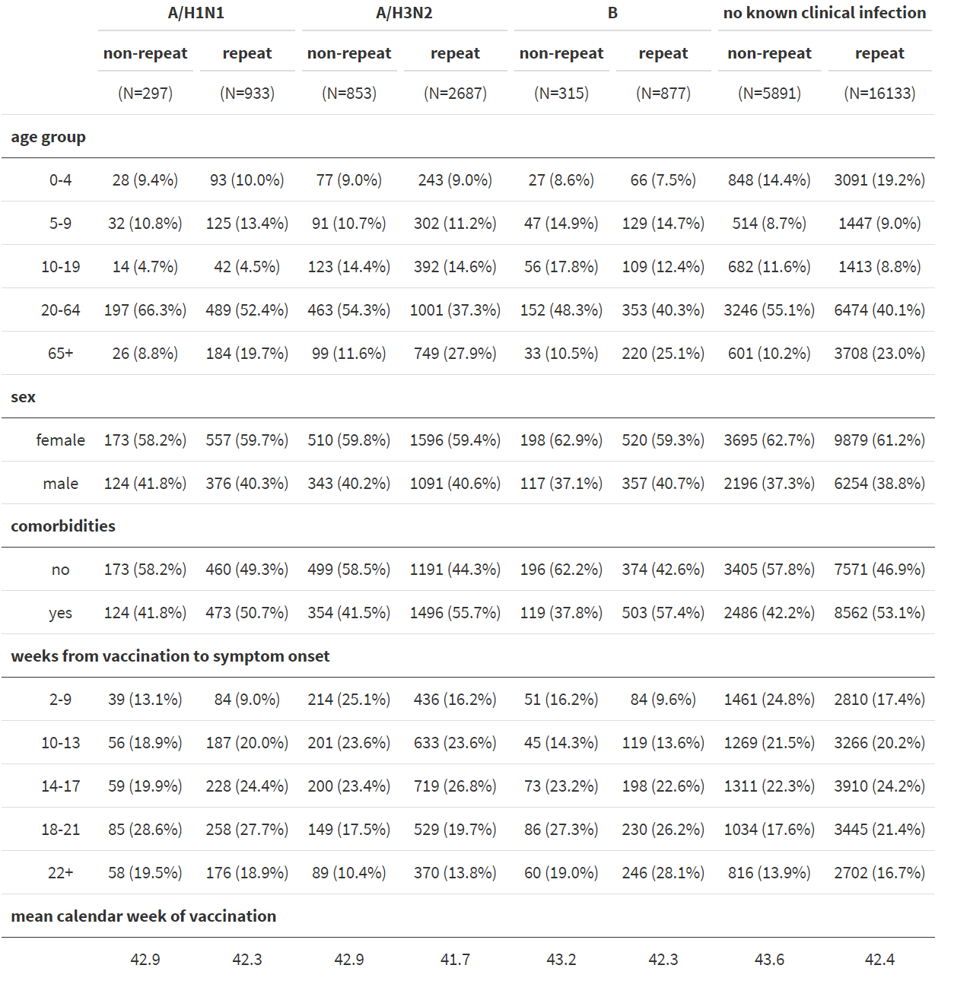

Table 1.2: Characteristics of the vaccinated individuals at the Marshfield Clinic Health System by their influenza infection status in the current season and vaccination status in the previous season, from the 2008-2009 through the 2017-2018 seasons, excluding the 2009 Pandemic season (from April to November 2009) and the 2009-2010 (from November 2009 to May 2010).

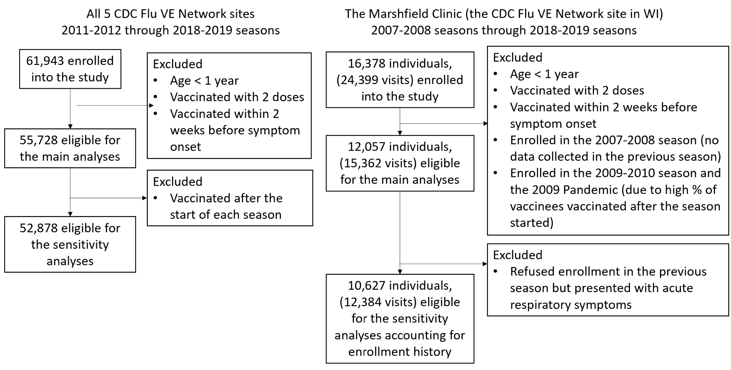

Figure 1.1: Enrollment of study participants and exclusion criteria

Figure 1.2: Seasonality by influenza (sub)type over the study period across all 5 US Flu VE Network sites.

Section 2. Models that adjust and do not adjust for waning vaccination protection

Clinical infection status in the current season when waning vaccine effectiveness is adjusted for is modeled as

](https://www.codecogs.com/eqnedit.php?latex=logit(Y)%20%3D%20%5Csum_%7Bj%3D1%7D%5E5%20b_j%20*%20X_%7B0j%7D%20%2B%20%5Csum_%7Bj%3D1%7D%5E5%20b_r%20*%20X_%7B1j%7D%20%2B%20%20b_p%20*%20X_%7B10%7D%20%2B%20C%5Cldots%20(1)#0)

, where Y is the probability of clinical infection in the current season; *Xij* is an indicator for vaccination status in the previous season (i=1 vs. 0) and the timing of vaccination in the current season (j=0 if not vaccinated in the current season, 1 if vaccinated 2-9 weeks after vaccination, 2 if 10-13 weeks after, 3 if 14-17 weeks after, 4 if 18-21 weeks after, and 5 if 22+ weeks after). C represents other baseline variables adjusted in the model (i.e., age group, sex, comorbidities, calendar month of symptom onset, and influenza season). Then, *ebj* is the OR for clinical infection in the jth interval after current-season vaccination compared with those not vaccinated in the current season. *ebr* is the OR for clinical infection among repeat vaccinees compared with non-repeat vaccinees who were only vaccinated in the current season. *ebp* is the OR for clinical infection among those vaccinated in the prior season but not this season compared with those not vaccinated in either season (Figure 1B).

Clinical infection status in the current season when waning vaccine effectiveness is not adjusted for is modeled as follows:

](https://www.codecogs.com/eqnedit.php?latex=logit(Y)%20%3D%20%5Cbeta_%7B10%7D*Z_%7B10%7D%2B%5Cbeta_%7B11%7D*Z_%7B11%7D%2B%5Cbeta_%7B01%7D*Z_%7B01%7D%2BC%5Cldots%20(2)#0)

where *Zik* is an indicator for vaccination status in the previous season (i=1 vs. 0) and in the current season (k=1 vs. 0). is the OR for clinical infection among repeat vaccinees compared with current-season vaccinees who were not vaccinated in the previous season. The results generated by these models are shown in section 4.1 and Figure 1B-C in the main text.

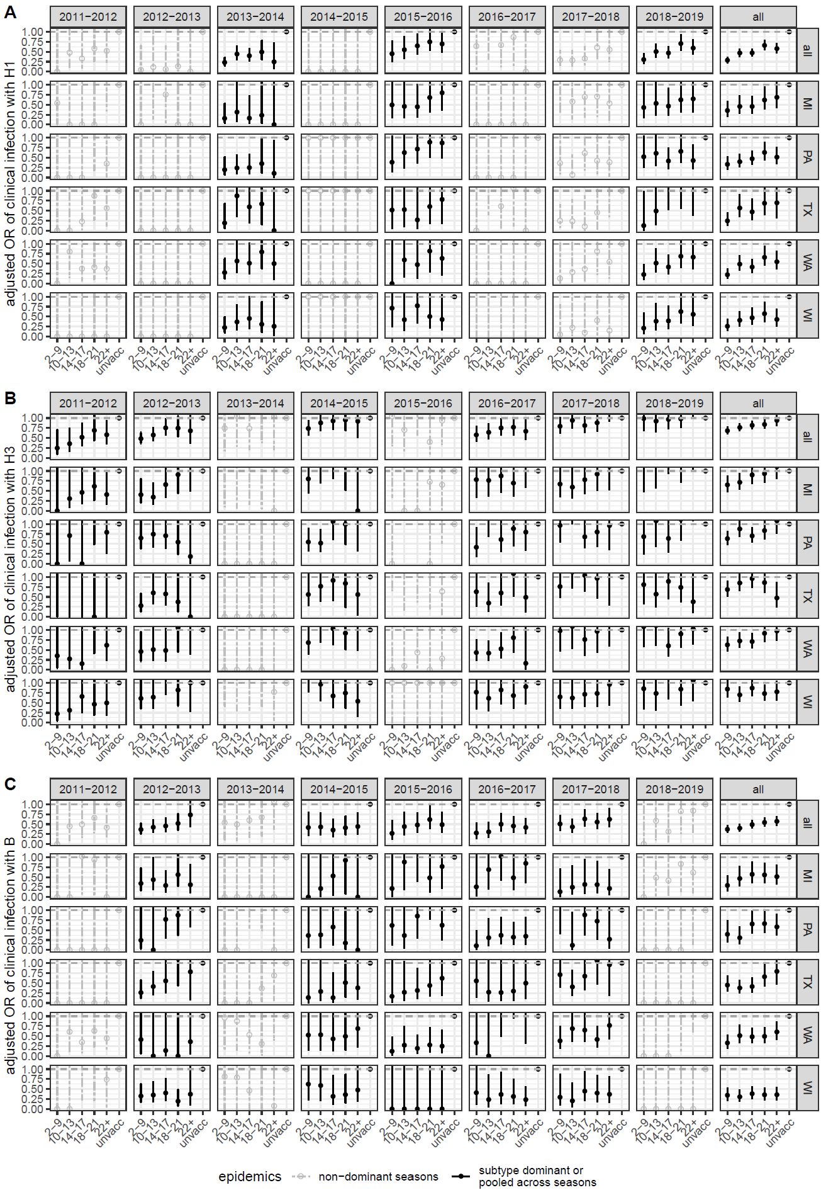

Figure 2.1: Waning vaccine protection by subtype, season, and site. Panels A-C represent the adjusted odds ratio for clinical infection with A/H1N1pdm09 (A), A/H3N2 (B), and type B (C) comparing individuals tested 2-9, 10-13, 14-17, 18-21, and 22+ weeks after vaccination with respect to those not vaccinated in the current season. The solid lines represent relative odds in seasons when there was significant circulation of the (sub)type. (Sub)type composition of PCR-confirmed influenza infection across all 5 Flu VE Network sites is shown in Supplementary Figure 1.2. In all panels, error bars indicate 95% confidence intervals.

Figure 2.2: Estimated effect of repeated vaccination by age group across all 5 study sites from the 2011-2012 through the 2018-2019 seasons. Error bars indicate 95% confidence intervals.

Figure 2.3: Impact of the timing of vaccination in the current season and waning of vaccine-induced immunity. The figure shows the adjusted odds ratio for clinical infection comparing repeat vaccinees with non-repeat vaccinees before (red) and after (blue) adjusting for timing of vaccination by season and site. The solid lines represent estimates in seasons when A/H3N2 was the dominant subtype, when A/H1N1pdm09 and A/H3N2 cocirculated, or there was significant circulation of type B. (Sub)type composition of PCR-confirmed influenza infections across all 5 sites in the US Flu VE Network are shown in Supplementary Figure 1.2. In all panels, error bars indicate 95% confidence intervals.

Figure 2.4: Impact of waning protection before (solid lines) and after (dashed lines) excluding individuals vaccinated after the start of a season (i.e., after the first symptomatic case was detected at each site). A) Estimated relative odds of Vaccine effectiveness estimates against clinical infection 2-9, 10-13, 14-17, and 22+ weeks after vaccination. B) Adjusted odds ratio for clinical infection comparing repeated vaccinees with non-repeated vaccinees. The solid lines show results that have been shown in Figure 1B in red. In the first two panels, error bars indicate 95% confidence intervals. C) Distribution of weeks from vaccination to symptom onset. Black represents individuals who were vaccinated after the start of a season and were thus excluded from this sensitivity analysis.

Section 3. Application of inverse-probability weighted regression model

Figure 3.1: A directed acyclic graph that encodes our assumptions about the underlying causal relationships of vaccination and infection status in a test-negative design that spans two seasons. *V* denotes vaccination status. *I* denotes infection status. *S* denotes selection into the study. *C* denotes baseline confounders. HSB denotes healthcare seeking behavior.

Estimating the effect of repeated vaccination can be conceptualized as the estimation of the joint effect of vaccination in the previous season (*V0*) and the current season (*V1*) on infection outcome in the current season (*I1*). We denote vaccination status by *V* and infection status by *I*. Subscripts 0 and 1 represent status at the previous and current seasons respectively. The arrows V*0* → *I0* and *V1* → *I1* represent the effect of vaccination on infection in each season. *I0* →*I1* represents the effect of infection in the previous season on infection in the current season, the evidence for which is shown in section 4.2 in the main text. *I0* →*V1* represents the effect of influenza infection in the previous season on the decision to vaccinate in the next season, the evidence for which is shown in section 4.2 in the main text.

Conventional regression methods may fail to estimate the joint effects of *V0* and *V1* on *I1* in the setting of treatment-confounder feedback, that is, a setting like ours in which a time-varying confounder (*I0*) is also a mediator, as it is affected by previous vaccination (*V0*) [[46,50]](https://paperpile.com/c/kjBGeu/8YZ4+joYf).

We instead use an inverse-probability weighted regression model [[46]](https://paperpile.com/c/kjBGeu/8YZ4), whereby adjustment for clinical infection status in the previous season is addressed by weighting while adjustment for baseline covariates *C* is made by regression.

Weights are calculated based on the inverse of each individual's probability of being vaccinated at each season, given their previous vaccination status, infection status, baseline covariates C, and the season in which they are enrolled (denoted as SZ) (i.e., the denominator of eqn 3). These inverse-probability weights are then “stabilized” using the probabilities of being vaccinated given vaccination history and baseline covariates (i.e., the numerator of eqn 3). Weighting based on the stabilized weights generally results in narrower confidence intervals around the effect estimates. The numerator and denominator of the weights are estimated using logistic regression.

The general form of an individual’s stabilized weights *sw*in the current season can be expressed as

](https://www.codecogs.com/eqnedit.php?latex=sw%3D%5Cfrac%7Bf(V_1%3Dv_1%20%7C%20V_0%20%3D%20v_0%20%2C%20C%20%3D%20c)%7D%7Bf(V_1%3Dv_1%20%7C%20V_0%20%3D%20v_0%20%2C%20I_0%20%3D%20i_0%2C%20C%20%3D%20c%2C%20SZ%3Dsz)%7D%5Cldots%20(3)#0)

where and represent vaccination and infection status in the previous season, respectively, and represents vaccination in the current season. *C* is a vector of confounders (i.e., sex, age, comorbidities) measured at the underlying baseline of the two seasons being evaluated. Although comorbidities were only measured at the current season, we considered the presence of comorbidities a baseline covariate, assuming that it remained the same over the two seasons evaluated. *SZ* represents the influenza season at enrollment. For this analysis, infection status =1 in the case of PCR-confirmed clinical infection of any influenza (sub)type. =1 in the case of vaccination two weeks before symptom onset in the previous season, and =1 in the case of vaccination two weeks before symptom onset in the current season

Using IP-weighted logistic regression models, we then estimated relative odds of infection among repeat vaccinees compared with non-repeat vaccinees. The study outcome is (sub)type specific PCR-confirmed clinical infection in the current season. Independent variables are age group, sex, comorbidities, and an indicator for current- and previous-season vaccination status. We did not adjust for the calendar month of symptom onset in the model. Instead, to account for the temporal trend of influenza vaccination that could be associated with influenza seasonality, we excluded individuals who were vaccinated before the start of a season, defined as the 5th percentile of the calendar week of symptom onset among PCR-confirmed cases each season, under the assumption that the decision to vaccinate early in a season is not correlated with risk factors for infection. We did not include timing of vaccination in one set of analyses, because it is not a baseline covariate (i.e., not measured at the underlying baseline of the 2-season period being evaluated). However, since test-negative designs may adjust for the timing of vaccination in order to account for waning VE, we used a model similar to the one described in Supplementary Section 2 to adjust for timing of vaccination. The difference is that here the independent variables did not include influenza season or calendar month of symptom onset. The independent variables are an indicator for having been vaccinated 2-9, 10-13, 14-17, 18-21, or >21 weeks before symptom onset in this season, a dichotomous indicator for having been vaccinated only in the prior season, a dichotomous indicator for having been vaccinated in both the current and the prior season, age group, sex, and comorbidities.

Selection into the test-negative design in each season, denoted by *S0* and *S1*, is a result of an individual experiencing acute respiratory illness, seeking care at ambulatory facilities, and getting tested for influenza infection, and the chain of events is denoted by → . Healthcare seeking behavior, denoted by HSB, may affect , , and because subjects with certain health seeking proclivities may be more likely to seek care, vaccinate, and practice healthier behaviors that reduce the odds of infection. Other clinical or demographic factors, such as age, sex, and comorbidities, denoted by confounders C, can also affect , , and . The test-negative design assumes that by restricting recruitment to those who seek health care, the study subjects have identical healthcare seeking behavior (HSB=1), thus reducing confounding due to health-seeking behavior [[45]](https://paperpile.com/c/kjBGeu/P1GL). In the present application, we assume no unmeasured confounding given this restriction and further adjustment for measured variables.

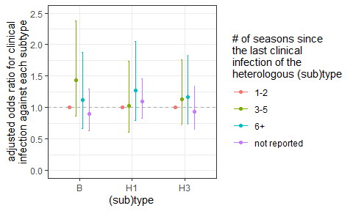

Figure 3.2: Protection conferred by infection of a heterologous subtype. Number of seasons from the last clinical infection of the heterologous subtype is not associated with odds of clinical infection. Error bars indicate 95% confidence intervals.

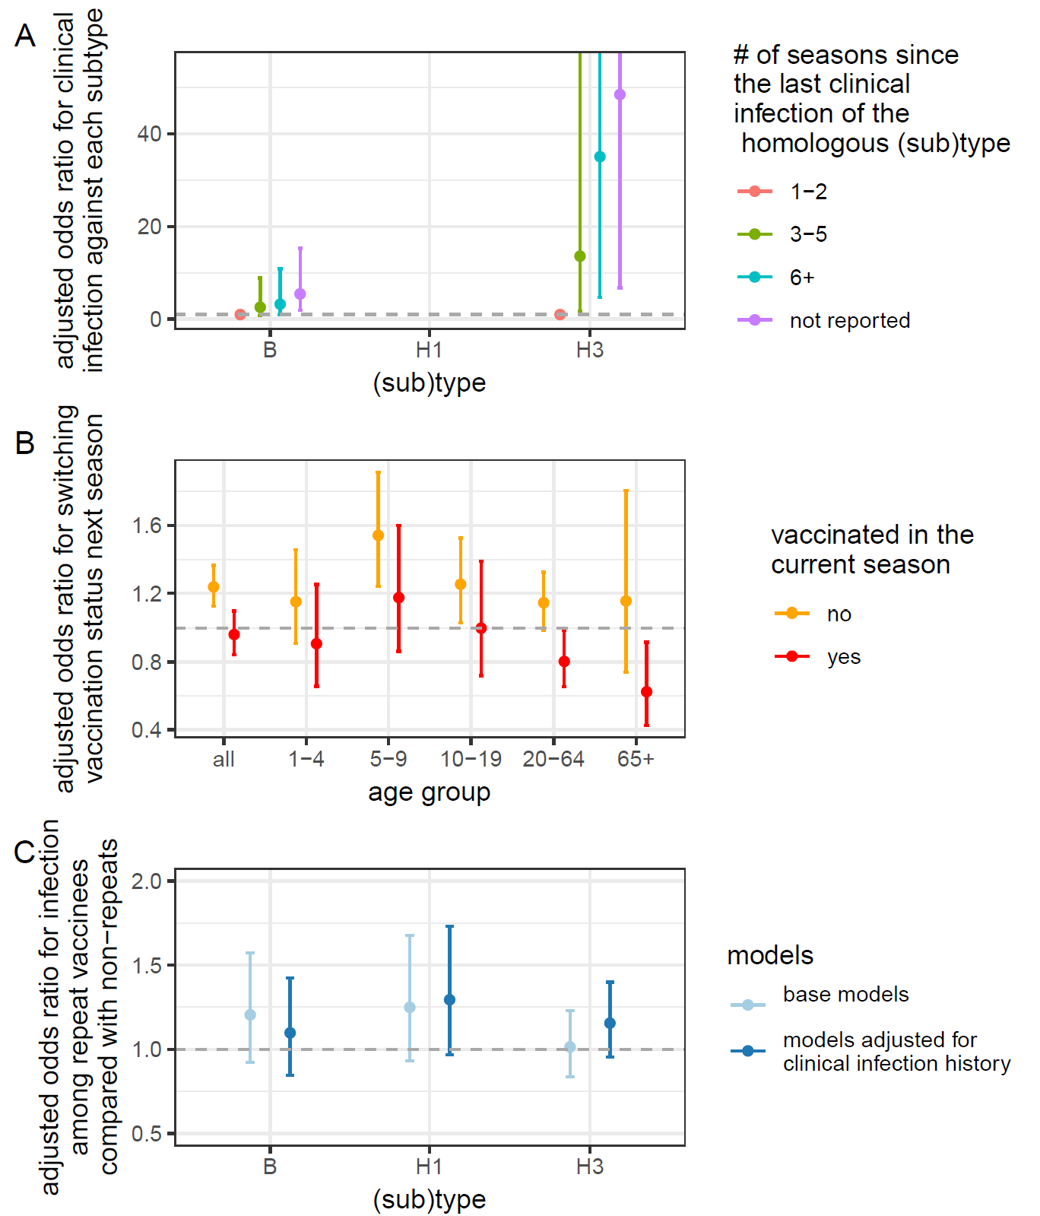

Figure 3.3: Impact of clinical infection on the estimated effect of repeated vaccination among participants from the Marshfield Clinic Health System excluding those who presented with acute respiratory illness but refused enrollment in the previous season. The results from this sensitivity analysis were qualitatively similar to the main analysis presented in Figure 2. A) Association between recent clinical infection and odds of current-season clinical infection. More distant clinical infections of the homologous subtype are associated with a higher odds of clinical infection. B) Tendency to switch vaccination status in the current season after infection in the prior season. Unvaccinated individuals were more likely to vaccinate in the current season if they were clinically infected in the previous season than if they were not. C) Estimated effect of repeated vaccination after adjusting for recent clinical infections. Adjusted odds ratio for clinical infection comparing repeated vaccinees with non-repeated vaccinees before (light blue) and after adjusting for the infection status in the previous season (dark blue) using inverse-probability weighting. Adjustment did not significantly impact the estimates. In all panels, error bars indicate 95% confidence intervals.

Figure 3.4. Adjusted odds ratio for clinical infection comparing repeat vaccinees with non-repeat vaccinees from the Marshfield Clinic Health System using inverse-probability weighting before (red) and after (blue) adjusting for the timing of vaccination within a season in the weighted outcome models.

Section 4. Method for calculating the extent of subclinical and clinical infection that could contribute to the observed repeat vaccination effect

Table 4.1: The table illustrates how the rates of subclinical and clinical infection can drive the estimated effect of repeated vaccination through the infection block hypothesis and the hypothesis of enhanced immunogenicity post-infection

Table 4.1 shows the attack rate and population size of repeat and non-repeat vaccinees given varying exposure and infection status in the previous seasons.

Let be the current-season clinical attack rate among individuals who were neither vaccinated nor infected (clinically or subclinically) in the prior season, 1 *− α* be the effectiveness of *subclinical* infections that occurred in the previous season against clinical infection in the current season, 1 *− β* be the effectiveness of *clinical* infections that occurred in the previous season against clinical infection in the current season, and 1 *− γ* be the current-season VE against clinical infection. If we assume that vaccines were more effective among individuals who were infected in the previous season than those who were not infected, current-season VE against clinical infection would increase to 1 *− γ*++ and 1 *− γ*+ among those clinically and subclinically infected in the previous season, respectively (0<*γ*++<*γ*+<*γ*<1).

We assumed that the effectiveness of subclinical or clinical infection that occurred in the previous season in preventing infection in the current season was not influenced by previous-season vaccination status. For example, repeat vaccinees’ current-season attack rates among individuals who had clinical infection in the previous season are the same as that among non-repeat vaccinees. In addition, those not infected in the previous season may have escaped infection for various reasons: they were not exposed, or they were exposed but protected by natural or vaccine-induced protection. We assumed the clinical attack rate to be the same among those who were not infected in the previous season regardless of their exposure history prior to the previous season.

Table 4.2. Calculation of the size of repeat and non-repeat vaccinees who are infected and uninfected in the current season. AR represents attack rate.

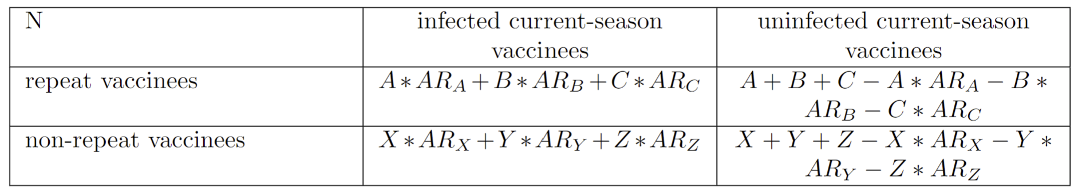

The odds ratio for clinical infection comparing repeat vaccinees with non-repeat vaccinees is:

[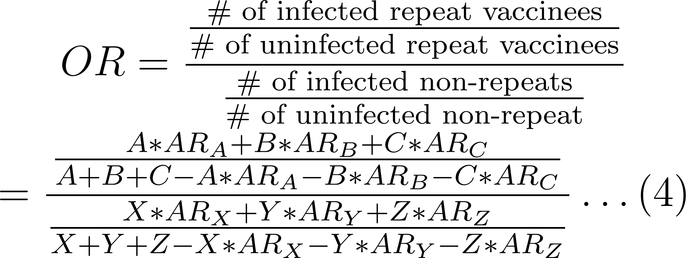](https://www.codecogs.com/eqnedit.php?latex=OR%20%3D%20%5Cfrac%7B%5Cfrac%7B%5Ctext%7B%5C%23%20of%20infected%20repeat%20vaccinees%7D%7D%7B%5Ctext%7B%5C%23%20of%20uninfected%20repeat%20vaccinees%7D%7D%7D%7B%5Cfrac%7B%5Ctext%7B%5C%23%20of%20infected%20non-repeats%7D%7D%7B%5Ctext%7B%5C%23%20of%20uninfected%20non-repeat%7D%7D%7D%20%5C%5C%5C%5C%20%3D%20%5Cfrac%7B%5Cfrac%7BA*AR_%7BA%7D%2BB*AR_%7BB%7D%2BC*AR_%7BC%7D%7D%7BA%2BB%2BC-A*AR_A-B*AR_B-C*AR_C%7D%7D%7B%5Cfrac%7BX*AR_X%2BY*AR_Y%2BZ*AR_Z%7D%7BX%2BY%2BZ-X*AR_X-Y*AR_Y-Z*AR_Z%7D%7D%20%5Cldots%20(4)#0)

Let . We assumed recent clinical infections conferred perfect protection against clinical infections in the current season (i.e., *AR*A = 0, *AR*X = 0). Then the OR can be simplified to:

[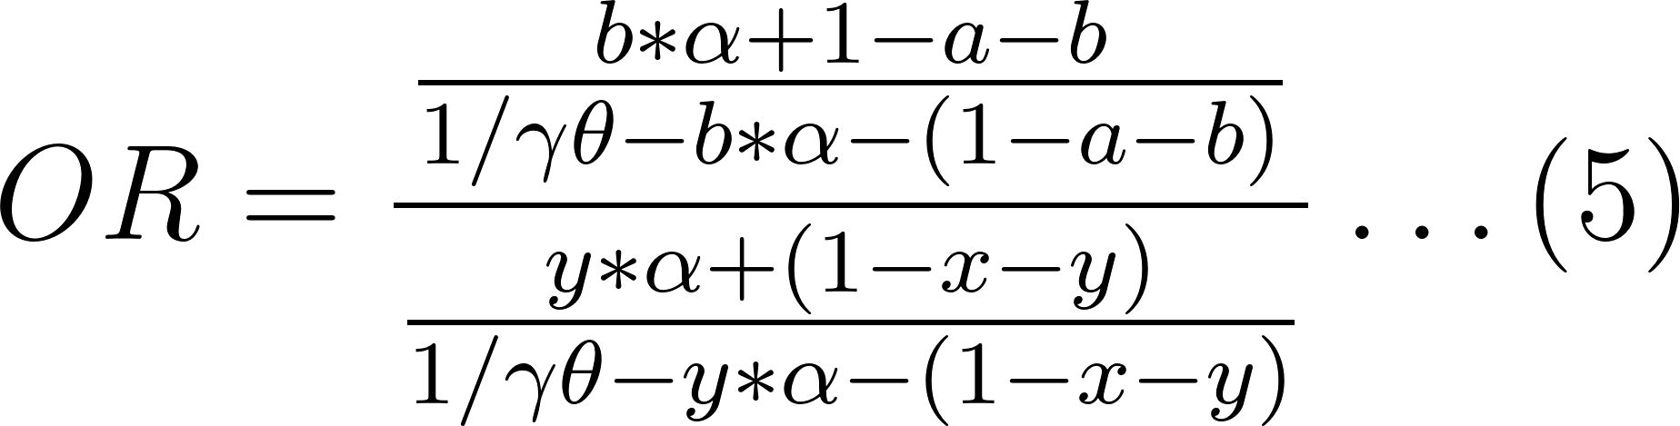](https://www.codecogs.com/eqnedit.php?latex=OR%3D%5Cfrac%7B%5Cfrac%7Bb*%5Calpha%2B1-a-b%7D%7B1%2F%5Cgamma%5Ctheta-b*%5Calpha-(1-a-b)%7D%7D%7B%5Cfrac%7By*%5Calpha%2B(1-x-y)%7D%7B1%2F%5Cgamma%5Ctheta-y*%5Calpha-(1-x-y)%7D%7D%20%5Cldots%20(5)#0)

which can be rearranged to obtain a relationship between the fraction of repeat vaccinees who were subclinically infected in the previous season (denoted by y) and the fraction of non-repeat vaccinees who were subclinically infected in the previous season (denoted by b):

[](https://www.codecogs.com/eqnedit.php?latex=y%3D%5Cmathit%7Bf(b%3B%20%5Calpha%2C%20%5Cgamma%5Ctheta%2Ca%2Cx%2COR)%7D%20%5Cldots%20(6)#0)

For the main analyses, we illustrated this relationship in Figure 3 assuming a 1% clinical attack rate among vaccinated individuals (a) and 2% among unvaccinated individuals (x), both are weighted averages by their infection status in the previous season. As a result, the current-season clinical attack rate among vaccinees infected in the previous season, although not specified, should be lower than 1% and can be calculated based on our assumption of a 1.5% current-season clinical attack rate among vaccinees not infected in the previous season (γθ). We illustrated this relationship under 3 levels of protection after subclinical infection (i.e., *α* = 30%, 50%, and 70%).

Table 4.3. Descriptions of parameters and estimates used in the models

|  |  |  |  |  |
| --- | --- | --- | --- | --- |
| Notation | Description | Parameter values in the main analyses | Parameter values in the sensitivity analyses for high-incidence settings | Parameter values in the analyses where we tested the impact of enhanced vaccine immunogenicity post-infection |
| a | Clinical attack rate among vaccinees | 1% | 3% | 1% |
| b | Subclinical attack rate among current season vaccinees who were vaccinated in the prior season as shown on the x-axis of Figure 3 in the main text | Explored the range between 0 and 50% | Explored the range between 0 and 50% | Explored the range between 0 and 50% |
| x | Clinical attack rate among unvaccinated individuals | 2% | 6% | 2% |
| y | Subclinical attack rate among current-season vaccinees who were unvaccinated in the prior season as shown on the y-axis of Figure 3 in the main text | Explored the range between 0 and 50% | Explored the range between 0 and 50% | Explored the range between 0 and 50% |
| *1-α* | Level of protection after subclinical infection | 30%, 50%, 70% | 30%, 50%, 70% | 30%, 50%, 70% |
| *γθ* | Current-season clinical attack rate among vaccinees not infected in the previous season. (This rate is higher than the clinical attack rate for vaccinees overall, which is represented by *a*, because it includes only vaccinees without additional protection from recent infection.) | 1.5% | 5% | 1.5% |
| *1-γ* | Overall vaccine effectiveness against clinical infection | 50% | 50% | 50% |
| *1-β* | The effectiveness of clinical infections in the prior season against clinical infection in the current season | Not relevant | Not relevant | Not relevant |
| *θ* | Clinical attack rate among individuals not vaccinated either in the current or the prior season and was uninfected in the prior season | 3% | 10% | 3% |
| *OR* | Odds ratio of infection comparing repeat and non-repeat vaccinees | 0.7, 0.8, 0.9, 1, 1.1, 1.2, 1.3 | 0.7, 0.8, 0.9, 1, 1.1, 1.2, 1.3 | 1.1 |
| 1 *− γ*+ | Enhanced overall vaccine effectiveness against clinical infection assuming that recent infection boosts vaccine immunogenicity and thus vaccine-induced effectiveness | Not relevant | Not relevant | Explored the range between 50% to 100% |

In the main analyses, we found that, in the US Flu VE Network, the odds of infection against A/H3N2 (and type B) among repeat vaccinees compared with non-repeat vaccinees is about 1.1. When OR is 1.1, the rate of subclinical infection among non-repeat vaccinees in the previous season is consistently larger than the rate among repeat vaccinees under a range of reasonable parameter estimates (i.e., fraction of all repeat vaccinees who were subclinically infected were under 30%). The phenomenon is more pronounced as OR increases.

Observing higher proportions of both clinical and subclinical infection among non-repeat vaccinees in the prior season suggests that non-repeat vaccinees may have a more primed immune system at the start of enrollment season, compared with repeat-vaccinees. This is consistent with the infection block hypothesis.

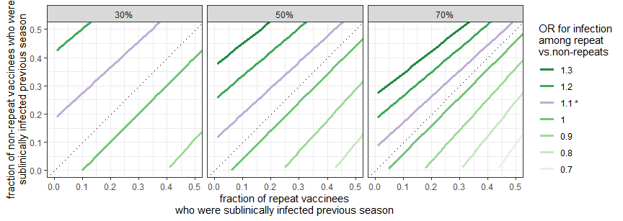

Figure 4.1. The fraction of repeat and non-repeat vaccinees who would have to have been subclinically infected in the previous season to reproduce the observed estimates of repeat vaccination in the US Flu VE Network. The estimated effect of repeated vaccination (OR=1.1) in the US Flu VE network is colored in purple. The results shown here are generated assuming vaccine effectiveness against clinical infection is 50%; clinical attack rate among vaccinees in a season is 34%; and current-season clinical attack rate among the subset of current-season vaccinees not infected in the previous season is 5%. We also assumed that clinical infection in the previous season perfectly protects against clinical infection in the following season. Each facet represents a predetermined protection after subclinical infection (i.e., 30%, 50%, 70%). The legend represents the estimated effect of repeat vaccination given the difference in subclinical attack rate among repeat vaccinees (x-axis) and non-repeat vaccinees (y-axis) and assumptions stated above.

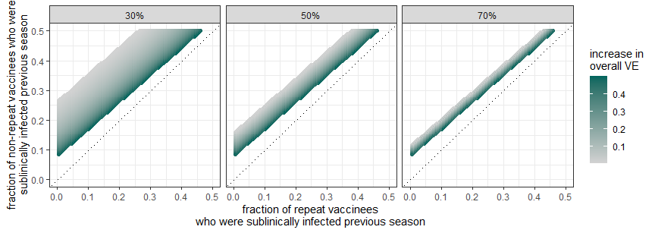

Figure 4.2: The absolute increase in VE from a baseline VE of 50% needed to reproduce the observed estimated effect of repeated vaccination in the US Flu VE Network (OR=1.1). Color represents the absolute increase in VE from the baseline VE of 50%. The estimated increase in VE against clinical infection varies by the protection after subclinical infection (i.e., 30%, 50%, 70%, one in each facet). The uncolored portion of the figure represents the population where a boost in VE after infection will not generate the observed effect of repeated vaccination (OR of 1.1). The results shown here are generated assuming the vaccine effectiveness against clinical infection is 50%; the current-season clinical attack rate among vaccinees in a season is 1%; and the current-season clinical attack rate among the subset of current-season vaccinees not infected in the previous season is 1.5%. We also assumed that clinical infection in the previous season perfectly protects against clinical infection in the current season.

Section 5. Exploring the mediation effect of prior-season clinical infection

We adapted the model described in section 4 of the supplementary material to explore the possibility that prior-season clinical infection acts as an important mediator between prior-season vaccination and risk of current-season clinical infection.

Unlike the previous section, we assumed that prior clinical infection does not confer perfect protection against future clinical infection (i.e., *1-β > 0* ). We kept other assumptions from the previous section: We assumed a 1% clinical attack rate among vaccinated individuals (a) and 2% among unvaccinated individuals (x), both are weighted averages by their infection status in the previous season. As a result, the current-season clinical attack rate among vaccinees *infected* in the previous season, although not specified, should be lower than 1% and can be calculated based on our assumption of a 1.5% current-season clinical attack rate among vaccinees *not infected* in the previous season (*γθ).*We illustrated this relationship under 3 levels of protection after subclinical infection (i.e., *α* = 30%, 50%, and 70%) and combinations of a range of subclinical attack rate among current-season vaccinees who were vaccinated (b) and unvaccinated (y) in the prior season. Regardless of the protection after subclinical infection (*α*), prior-season subclinical attack rate among repeat and non-repeat vaccinees (b and y), estimated ORs indicating the effect of repeated vaccination (y-axis in the following figure) vary little with the effectiveness of prior-season clinical infection (x-axis in the following figure).

Figure 5.1: Potential of prior-season clinical infection for mediating the effect of prior-season vaccination and the odds of current-season clinical infection. 1-*α* represents the level of protection against clinical infection conferred by prior-season subclinical infection. b and y represent the subclinical attack rate among current-season vaccinees who were vaccinated (b) and unvaccinated (y) in the prior season, respectively. The effectiveness of prior-season clinical infection against current-season clinical infection as shown on the x-axis is denoted by *1-β*. Lack of variation in the odds ratio indicating the estimated effect of repeated vaccination (shown on the y axis) indicates that prior-season clinical infection is unlikely to be an important mediator of the effect of prior-season vaccination on odds of current-season clinical infection.