Table S2. Patients age ranges

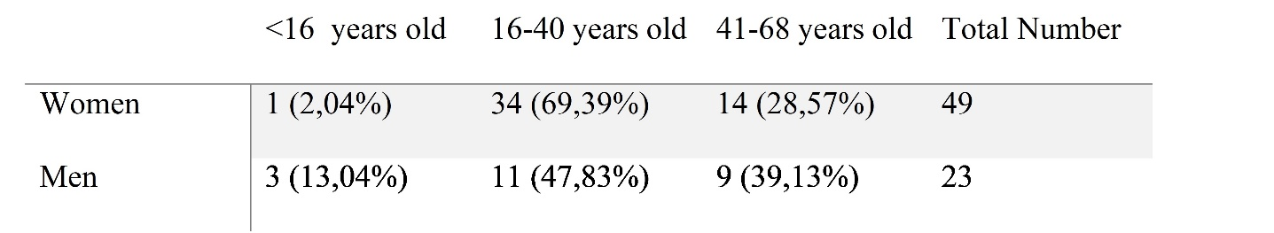

Table S3. Distribution of origin in Bolivia in regions

C:\Users\agaporni\Desktop\NOELIA\Finalizando\trabajo\Suplementary material\Table S4.tif