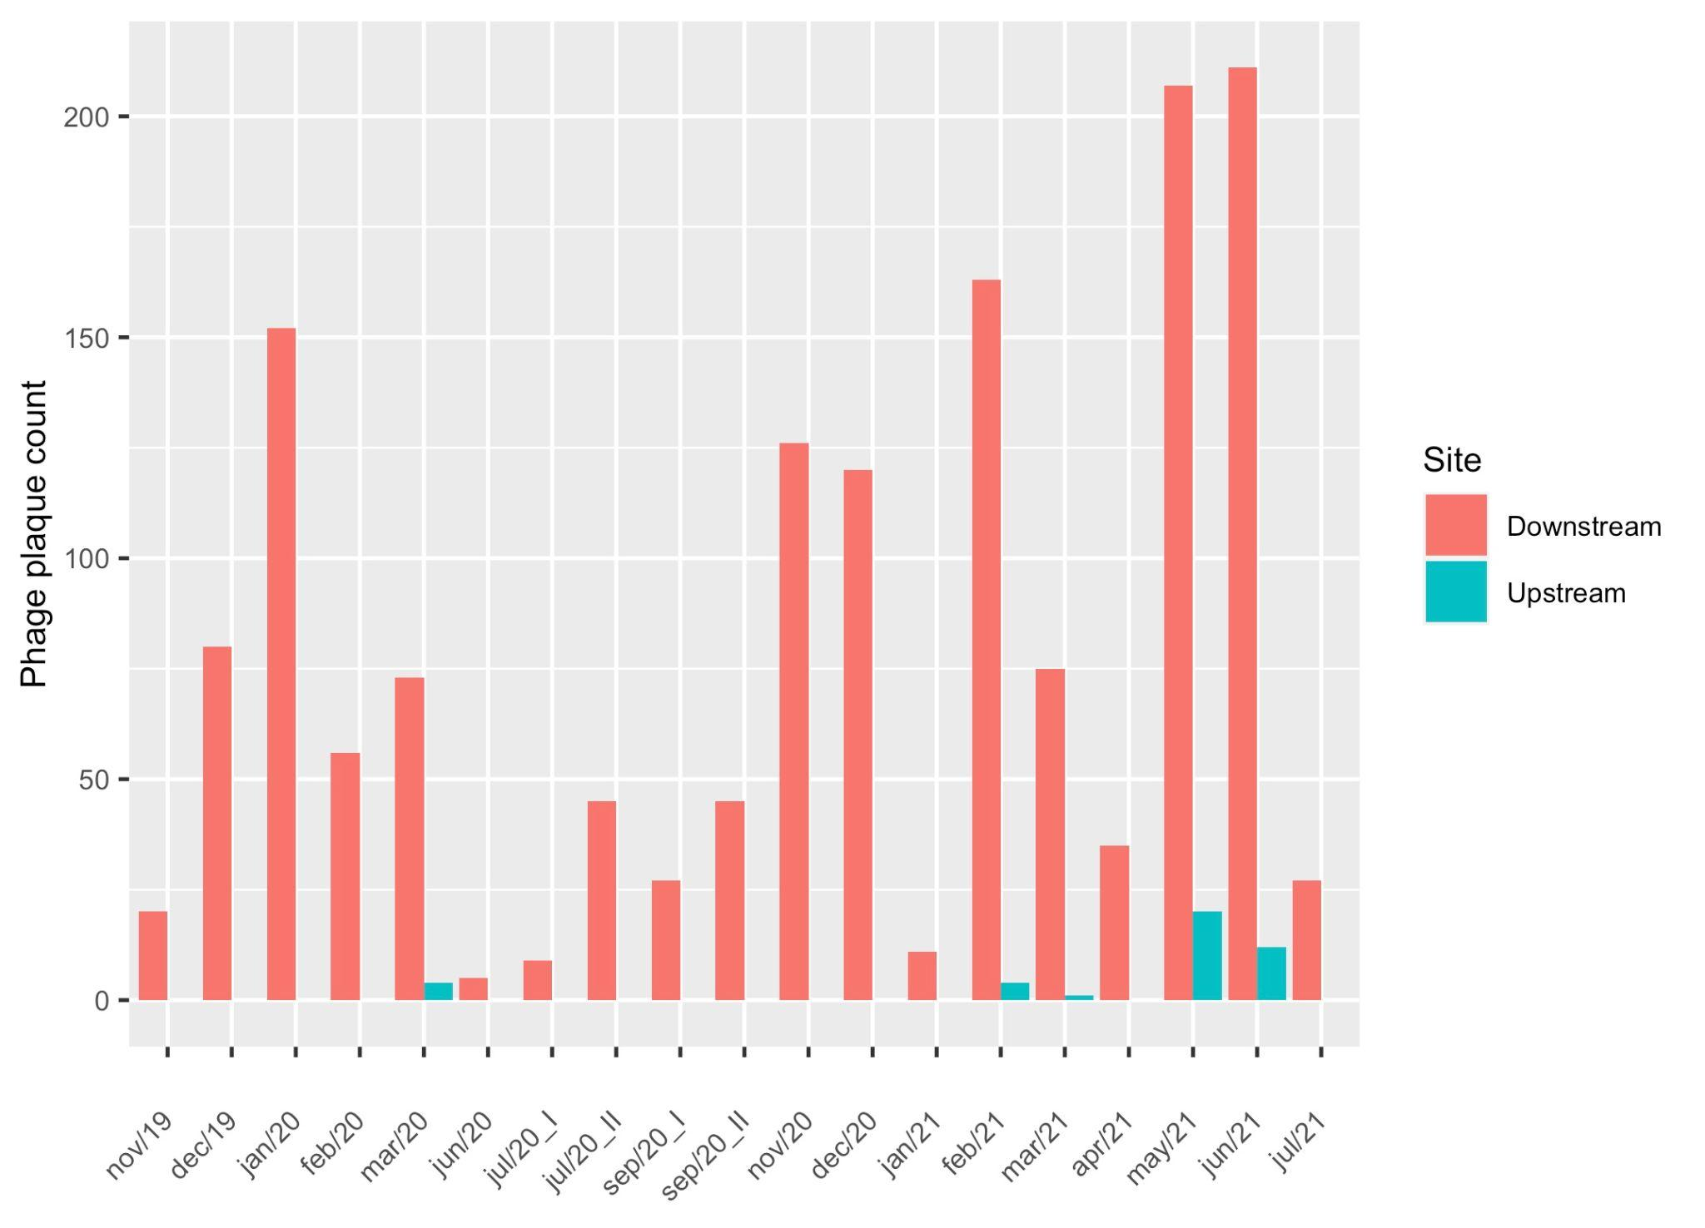

**Supplementary figure 1.** Temporal variation in phage detection in Kathmandu, Nepal during the study period.