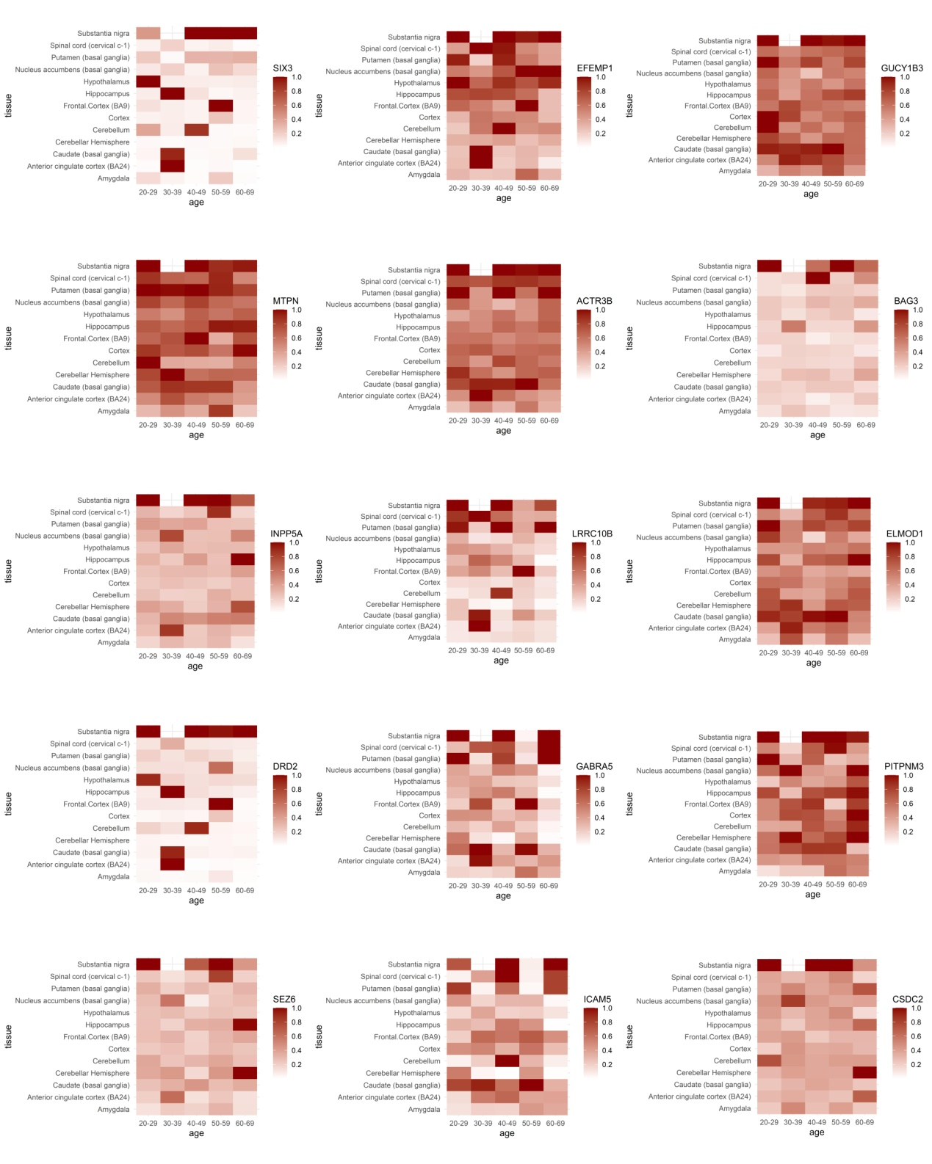

**Supplementary Figure S2.** Heatmap of the gene expression patterns for 15 AD risk genes identified through the SVM models.