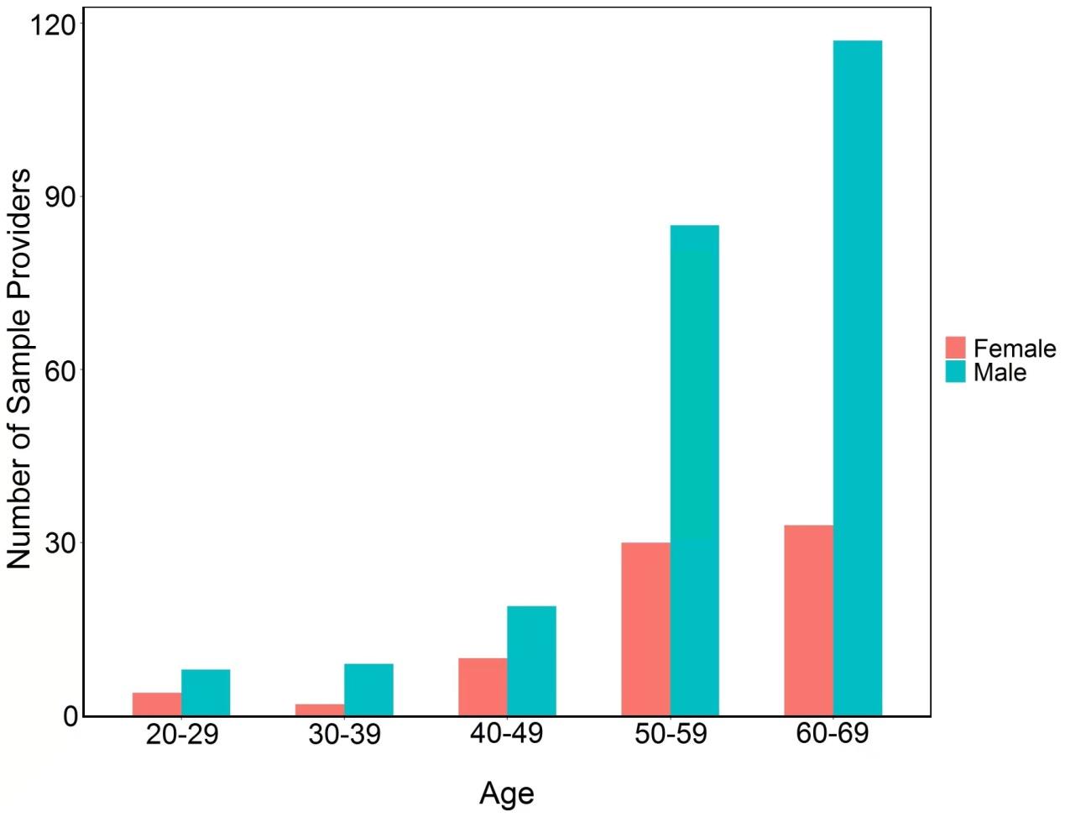

**Supplemental Figure S1.** Sex and age distribution of the tissue sample providers.