SUPPLEMENTARY MATERIAL
Wastewater-based surveillance can be used to model COVID-19-associated workforce absenteeism

1. SUPPLEMENTARY TABLES
Table 1S. City of Calgary’s employee absenteeism cases that were classified as a function of COVID-19; unrelated, COVID-19-related and COVID-19 confirmed per week.
Week number | Date (week starting) | Unrelated | COVID-19 related cases | Confirmed COVID-19 cases
27 | 29/06/2020 | 35 | 32 | 0
28 | 06/07/2020 | 40 | 35 | 1
29 | 13/07/2020 | 53 | 26 | 0
30 | 20/07/2020 | 32 | 41 | 2
31 | 27/07/2020 | 53 | 42 | 0
32 | 03/08/2020 | 27 | 31 | 3
33 | 10/08/2020 | 43 | 43 | 0
34 | 17/08/2020 | 63 | 30 | 2
35 | 24/08/2020 | 49 | 41 | 0
36 | 31/08/2020 | 46 | 47 | 2
37 | 07/09/2020 | 41 | 37 | 0
38 | 14/09/2020 | 52 | 46 | 1
39 | 21/09/2020 | 59 | 73 | 3
40 | 28/09/2020 | 59 | 98 | 2
41 | 05/10/2020 | 53 | 63 | 3
42 | 13/10/2020 | 39 | 60 | 2
43 | 20/10/2020 | 59 | 91 | 3
44 | 26/10/2020 | 45 | 96 | 5
45 | 02/11/2020 | 50 | 94 | 8
46 | 09/11/2020 | 39 | 139 | 3
47 | 16/11/2020 | 53 | 118 | 15
48 | 23/11/2020 | 49 | 120 | 17
49 | 30/11/2020 | 55 | 141 | 23
50 | 07/12/2020 | 36 | 150 | 32
51 | 14/12/2020 | 40 | 118 | 29
52 | 21/12/2020 | 30 | 65 | 8
53 | 28/12/2020 | 12 | 51 | 12
2 | 04/01/2021 | 45 | 57 | 15
3 | 11/01/2021 | 58 | 59 | 18
4 | 18/01/2021 | 51 | 61 | 11
5 | 25/01/2021 | 44 | 64 | 9
6 | 01/02/2021 | 56 | 53 | 4
7 | 08/02/2021 | 52 | 42 | 6
8 | 15/02/2021 | 44 | 27 | 3
9 | 22/02/2021 | 55 | 50 | 7
10 | 01/03/2021 | 62 | 45 | 5
11 | 08/03/2021 | 58 | 46 | 7
12 | 15/03/2021 | 50 | 52 | 10
13 | 22/03/2021 | 44 | 71 | 18
14 | 29/03/2021 | 44 | 65 | 8
15 | 05/04/2021 | 35 | 137 | 25
16 | 12/04/2021 | 38 | 109 | 29
17 | 19/04/2021 | 48 | 119 | 32
18 | 26/04/2021 | 49 | 127 | 41
19 | 03/05/2021 | 50 | 200 | 48
20 | 10/05/2021 | 36 | 186 | 45
21 | 17/05/2021 | 48 | 120 | 23
22 | 24/05/2021 | 43 | 54 | 12
23 | 31/05/2021 | 42 | 24 | 2
24 | 07/06/2021 | 49 | 28 | 3
25 | 14/06/2021 | 44 | 24 | 7
26 | 21/06/2021 | 44 | 21 | 2
27 | 28/06/2021 | 46 | 13 | 0
28 | 05/07/2021 | 49 | 24 | 1
29 | 12/07/2021 | 42 | 16 | 0
30 | 19/07/2021 | 34 | 45 | 5
31 | 26/07/2021 | 48 | 27 | 3
32 | 02/08/2021 | 36 | 21 | 5
33 | 09/08/2021 | 50 | 30 | 5
34 | 16/08/2021 | 43 | 29 | 7
35 | 23/08/2021 | 37 | 22 | 4
36 | 30/08/2021 | 43 | 32 | 4
37 | 06/09/2021 | 57 | 80 | 13
38 | 13/09/2021 | 56 | 92 | 22
39 | 20/09/2021 | 76 | 76 | 17
40 | 27/09/2021 | 57 | 79 | 16
41 | 04/10/2021 | 51 | 66 | 18
42 | 11/10/2021 | 45 | 54 | 5
43 | 18/10/2021 | 67 | 48 | 5
44 | 25/10/2021 | 66 | 65 | 10
45 | 01/11/2021 | 79 | 44 | 10
46 | 08/11/2021 | 66 | 41 | 5
47 | 15/11/2021 | 64 | 44 | 4
48 | 22/11/2021 | 51 | 47 | 9
49 | 29/11/2021 | 68 | 53 | 8
50 | 06/12/2021 | 66 | 42 | 4
51 | 13/12/2021 | 38 | 44 | 7
52 | 20/12/2021 | 50 | 91 | 34
53 | 27/12/2021 | 25 | 231 | 167
2 | 03/01/2022 | 33 | 247 | 169
3 | 10/01/2022 | 44 | 222 | 125
4 | 17/01/2022 | 26 | 143 | 99
5 | 24/01/2022 | 28 | 139 | 102
6 | 31/01/2022 | 69 | 189 | 142
7 | 07/02/2022 | 60 | 156 | 122
8 | 14/02/2022 | 60 | 46 | 36
9 | 21/02/2022 | 49 | 28 | 23
10 | 28/02/2022 | 33 | 37 | 30
11 | 07/03/2022 | 53 | 19 | 14
12 | 14/03/2022 | 60 | 19 | 18
13 | 21/03/2022 | 48 | 15 | 13
14 | 28/03/2022 | 63 | 54 | 47
2 SUPPLEMENTARY FIGURES
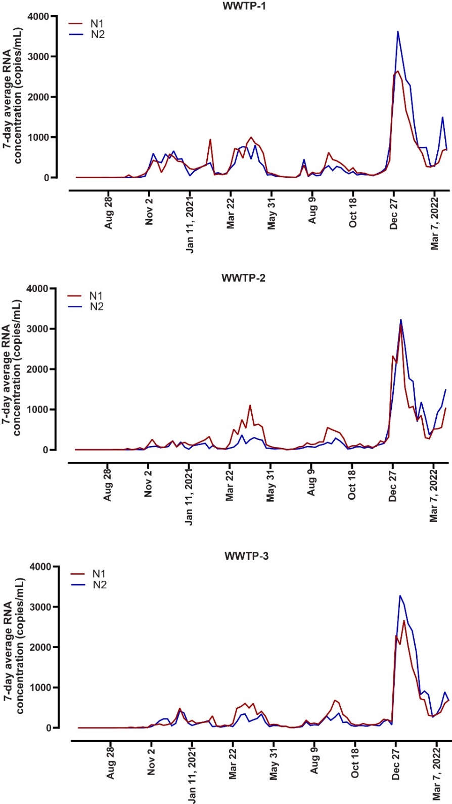
Figure 1S. SARS-CoV-2 RNA concentration for Calgary’s three wastewater treatment plants (WWTPs). Weekly average SARS-CoV-2 RNA signal (N1 (red line) and N2 (blue line)) from Calgary's three WWTPs: (A) WWTP-1, (B) WWTP-2 and (C) WWTP-3. Data were collected from June 29, 2020 to March 28, 2022 from all three WWTPs.
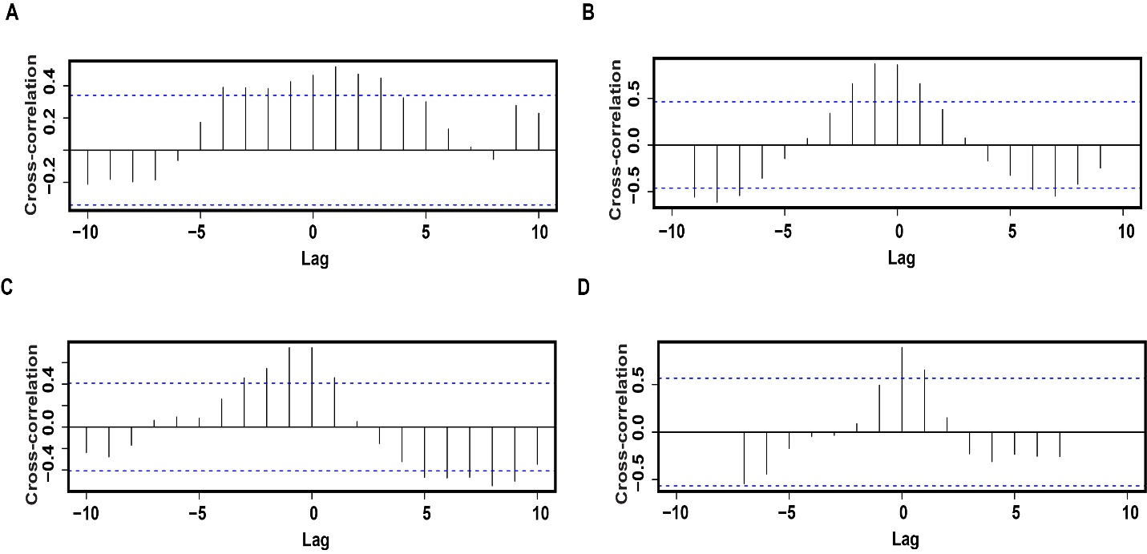
Figure 2S. Cross correlation analysis for SARS-CoV-2 RNA in wastewater and municipal COVID-19-realted absenteeism. RNA concentration measured with the N1 target and COVID-19-related absences during the Wave-2 (A), Wave-3 (B), Wave-4 (C) and Wave-5 (D). Blue doted lines denote the limits that determine the significance of the autocorrelation coefficients (95% confidence level).

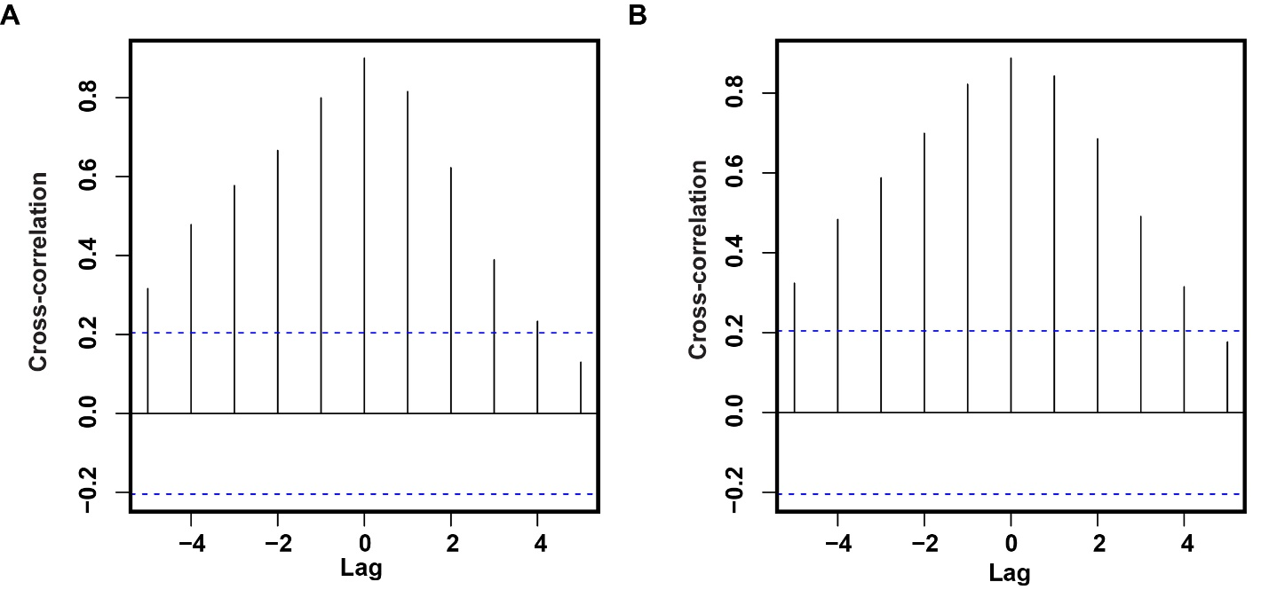
Figure 3S. Cross correlation analysis for SARS-CoV-2 RNA in wastewater and municipal COVID-19-confirmed absenteeism. RNA concentration measured either by the N1(A) or N2 (B) targets and COVID-19-confirmed absences. Blue doted lines denote the limits that determine the significance of the autocorrelation coefficients (95% confidence level).

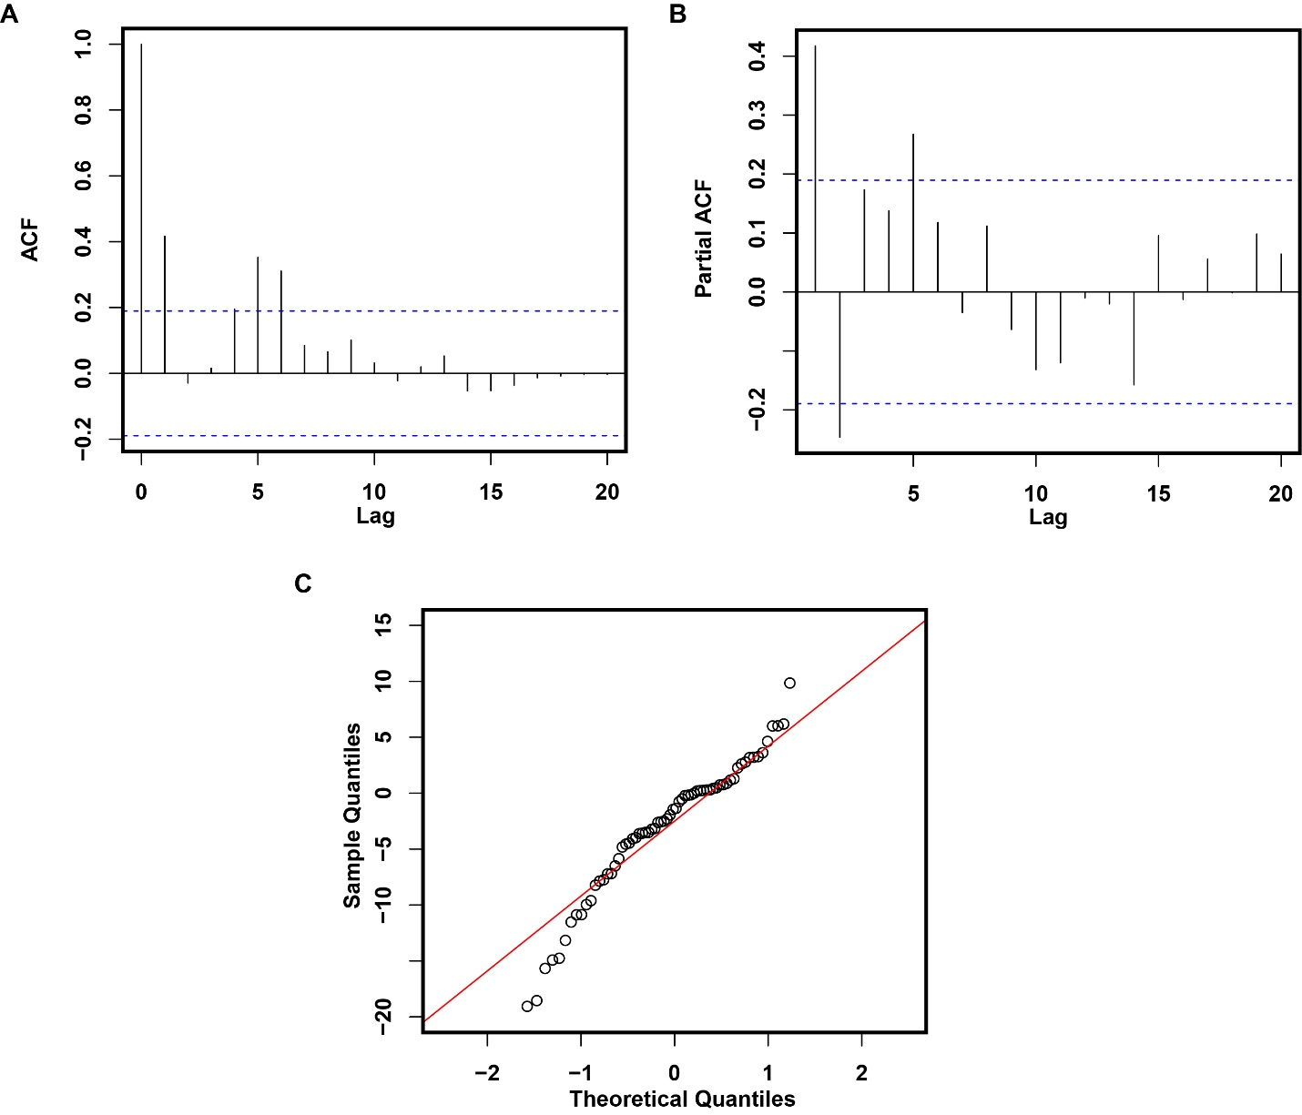
Figure 4S. Residual diagnostics plots from the prediction model. Autocorrelation (ACF) (A), Partial-correlation (PACF) (B) and normality (Quantile-quantile) plots from the residuals of the prediction model. Blue doted lines denote the limits that determine the significance of the autocorrelation or partial autocorrelation coefficients (95% confidence level).

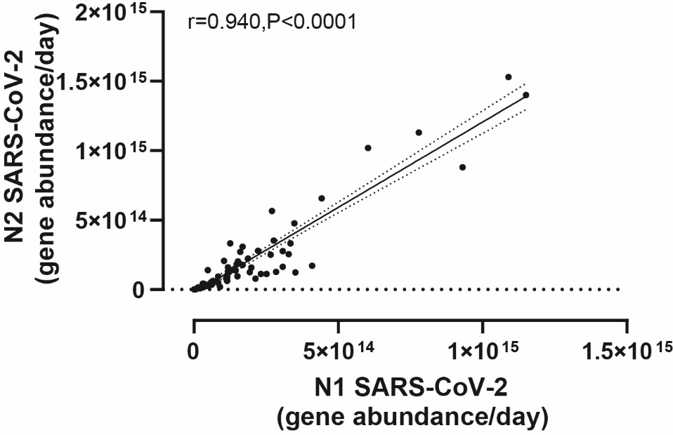
Figure 5S. Comparison of SARS-CoV-2 RNA concentration in wastewater measured by the N1 and N2 targets. Scatter plot of the weekly average of the gene abundance in wastewater measured with the N1 and N2 targets. Spearman correlation and 95% prediction intervals (dashed line) on the linear regressions (solid line) are shown in the figure.

