Supplementary File 2. JBI Quality Assessment Tools

Risk of bias for randomized controlled trials
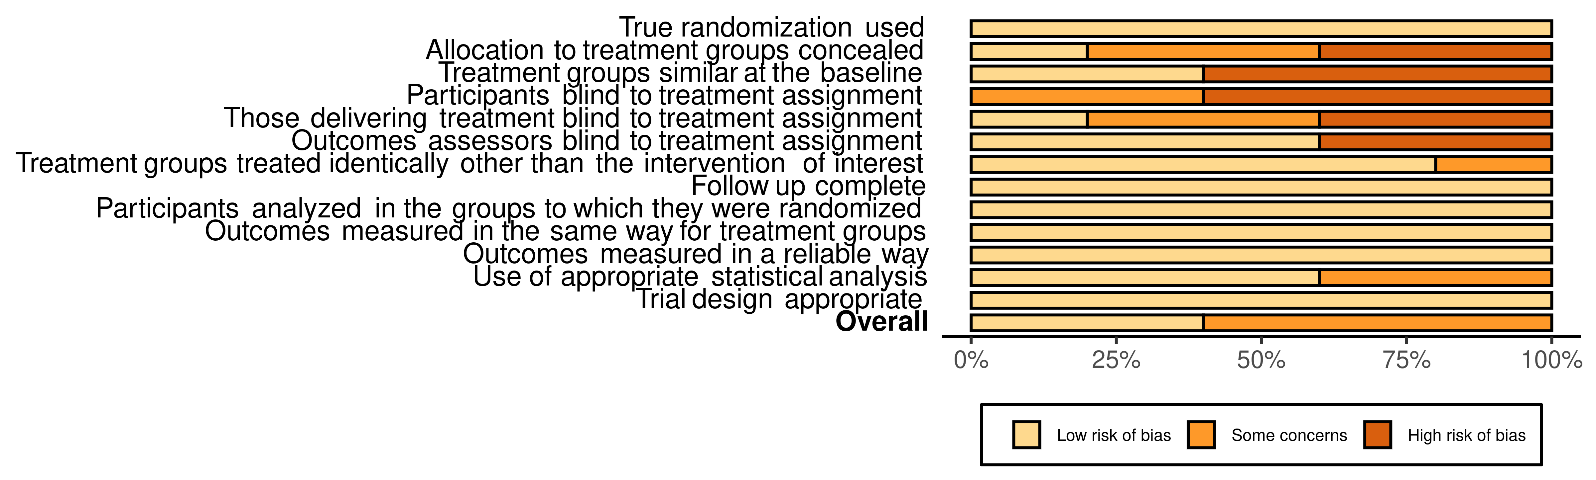
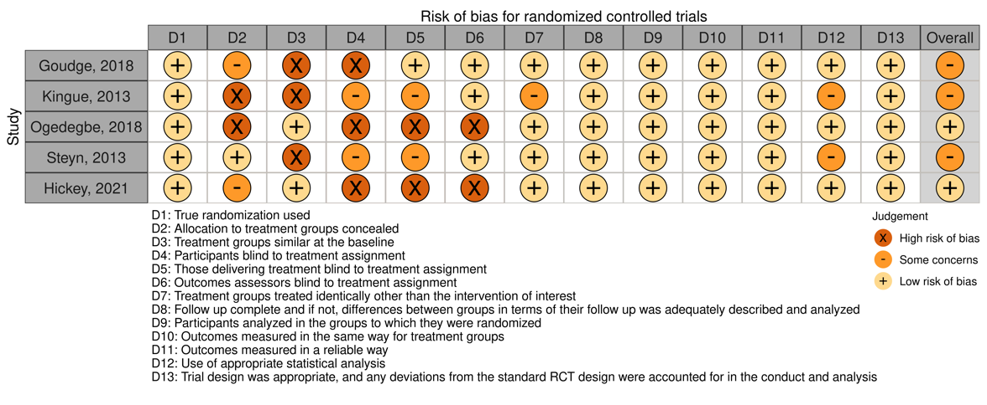
Risk of bias for quasi-experimental studies 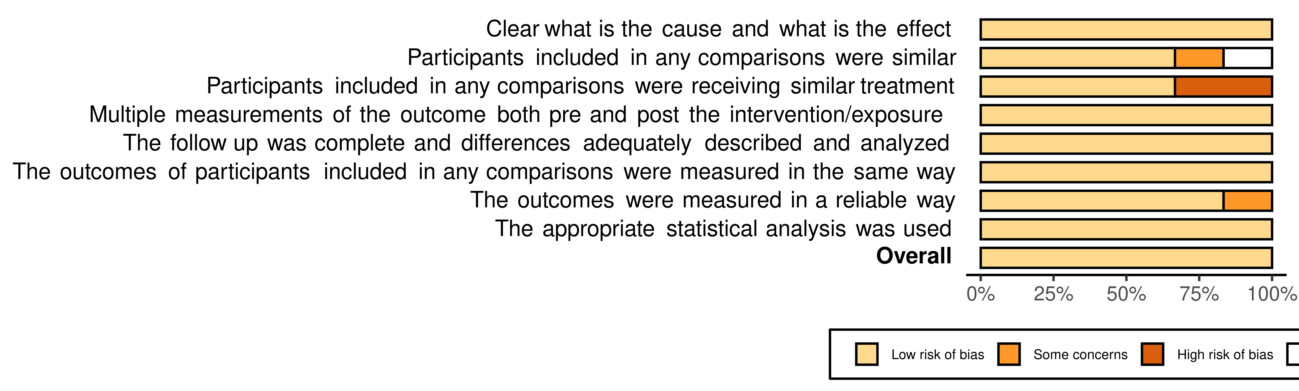
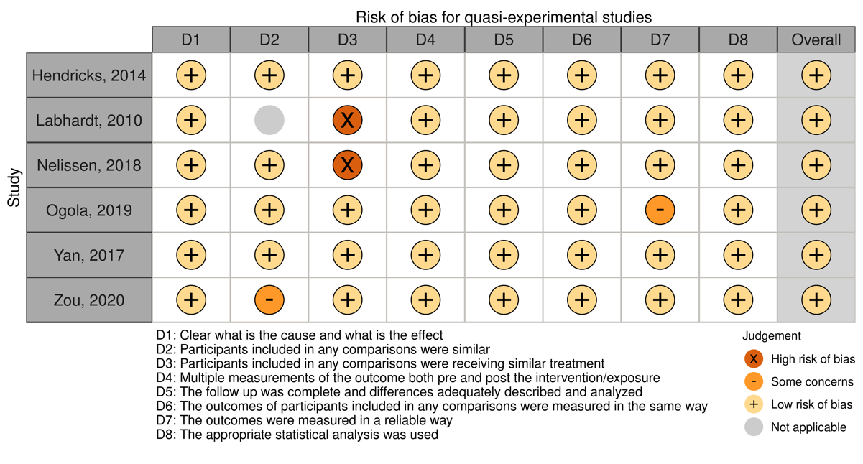

Risk of bias assessment for cohort studies
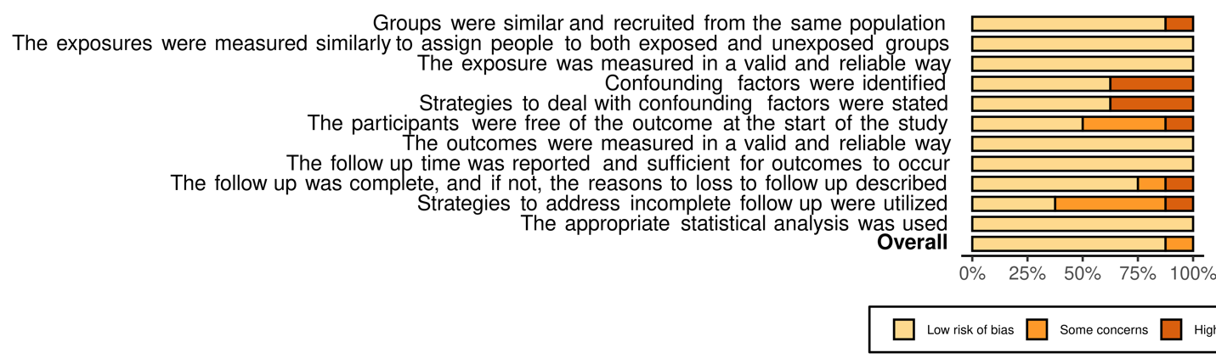
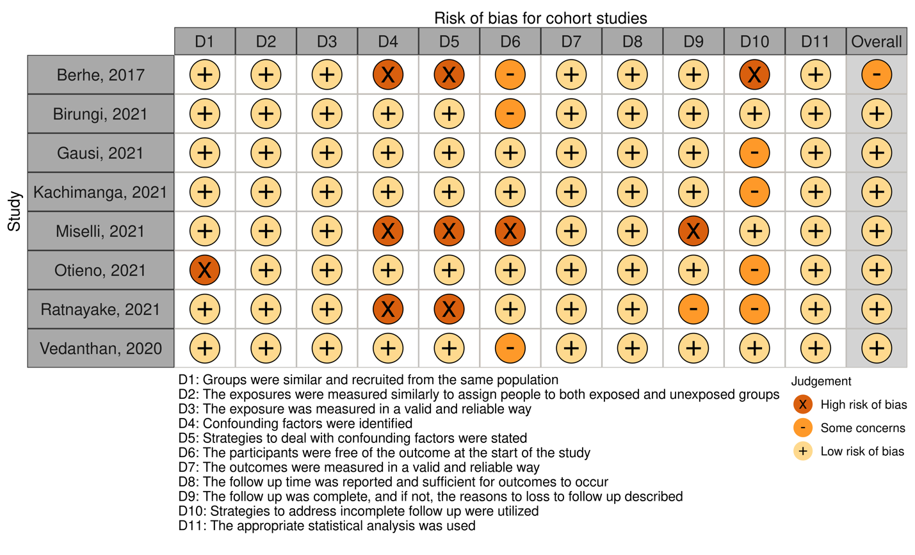
Risk of bias for cross-sectional studies
