Supporting information (Figures S1-S5):
Uncovering the gastrointestinal passage, intestinal epithelial cellular uptake and AGO2 loading of milk miRNAs in neonates using xenomiRs as tracers
Patrick Philipp Weil¹, Susanna Reincke¹, Christian Alexander Hirsch¹, Federica Giachero¹, Malik Aydin^{1,2}, Jonas Scholz³, Franziska Jönsson³, Claudia Hagedorn³, Duc Ninh Nguyen⁴, Thomas Thymann⁴, Anton Pembaur¹, Valerie Orth⁵, Victoria Wünsche¹, Ping-Ping Jiang^{4,6} Stefan Wirth², Andreas C. W. Jenke⁷, Per Torp Sangild⁴, Florian Kreppel³, Jan Postberg^{1,*}
*corresponding author

¹Clinical Molecular Genetics and Epigenetics, Faculty of Health, Centre for Biomedical Education & Research (ZBAF), Witten/Herdecke University, Alfred-Herrhausen-Str. 50, 58448 Witten, Germany
²HELIOS University Hospital Wuppertal, Children’s Hospital, Centre for Clinical & Translational Research (CCTR), Witten/Herdecke University, Heusnerstr. 40, 42283 Wuppertal, Germany
³Chair of Biochemistry and Molecular Medicine, Faculty of Health, Centre for Biomedical Education and Research (ZBAF), Witten/Herdecke University, Stockumer Str. 10, 58453 Witten, Germany
⁴Comparative Pediatrics and Nutrition, Department of Veterinary and Animal Sciences, University of Copenhagen, Copenhagen, Denmark
⁵HELIOS University Hospital Wuppertal, Department of Surgery II, Centre for Clinical & Translational Research (CCTR), Witten/Herdecke University, Heusnerstr. 40, 42283 Wuppertal, Germany
⁶School of Public Health, Sun Yat-sen University, Guangzhou, China
⁷Klinikum Kassel, Zentrum für Kinder- und Jugendmedizin, Neonatologie und allgemeine Pädiatrie, Mönchebergstr. 41-43, 34125 Kassel, Germany

Supporting information and captions

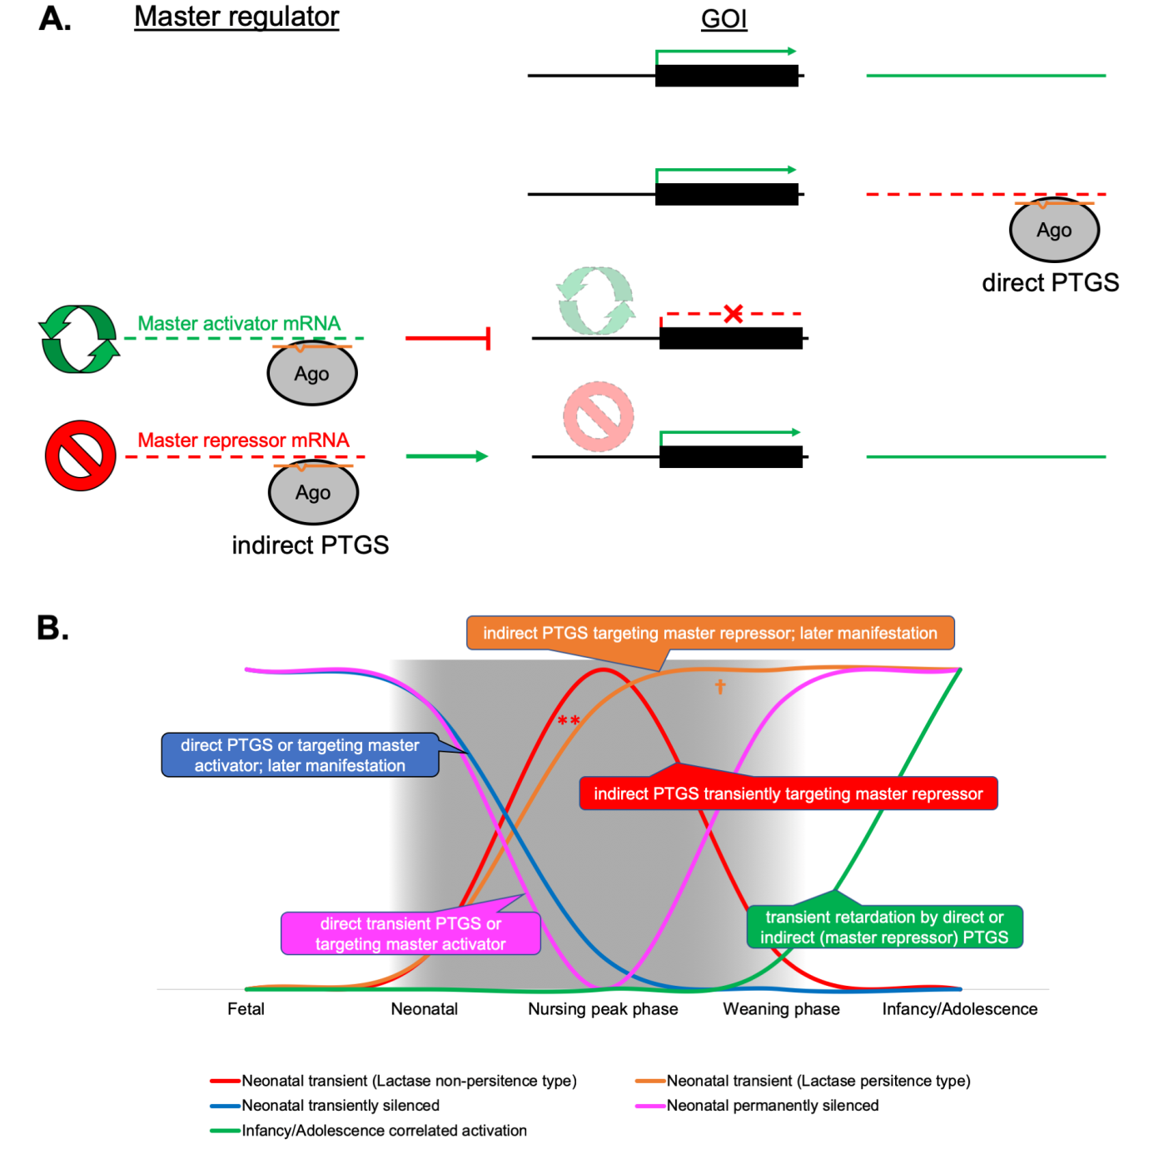
Figure S1. Illustration of theoretical regulatory contributions of breast milk microRNAs in the offspring. A. Posttranscription gene silencing (PTGS) depends on the targeting of mRNAs by microRNAs leading to their suppression through mRNA decay or translational blocking. With respect to any virtual gene-of-interest (GOI) a given microRNA can act directly on a GOIs mRNA or upstream in its regulatory hierarchy on a GOIs master activator’s mRNA or, respectively, on a master repressor mRNA. B. The regulatory contribution of breast milk microRNAs can theoretically explain any gene expression pattern observable during and around the nursing period.

Figure S2. Results of principal component analyses of microRNAs shared by all taxa under investigation. Quadrants I and IV (section magnified on the right) harbour all specimens whereby all human specimens (blue: hsa1-7) are clustering. Slightly separated is a separated scattered cluster harbouring all herbivorous specimens (yellow to green: bta1-4, cae1-2, eas, eca, ogm, ojo) and one dog specimen (red arrow: clu). Above is a mini-cluster comprising both porcine specimens (pink: ssc1-2) and separated the cat specimen (red: fca).

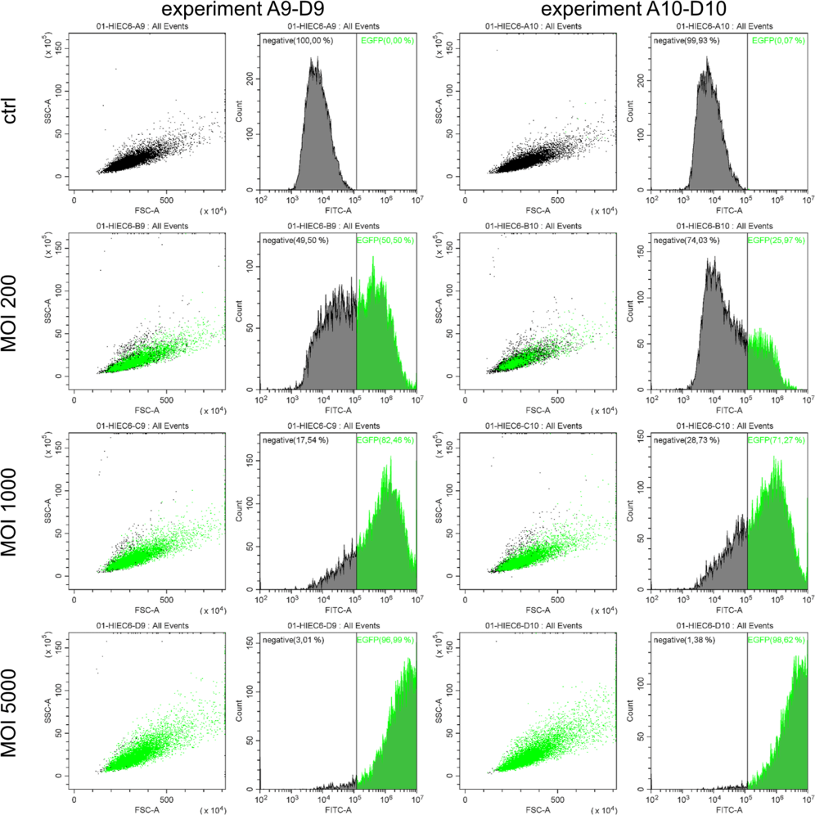
Figure S3. Transduction efficiency. The efficiency of Ad5-mediated gene transfer to HIEC-6 was measured by flow cytometry. Serial experiments using different MOIs (ctrl, 200, 1000, 5000) in two independent HIEC-6 culture batches (no. 9/10) are shown. Measurements of GFP-positive cells revealed that in HIEC-6 near quantitative transduction (>95% at a MOI≥5.000) could be achieved 96h post-transduction

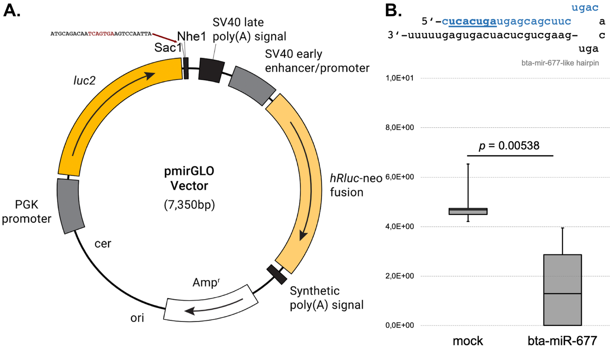
Figure S4. Activity tests for bta-mir-677 using a predicted target sequence cloned into a luciferase 3’-UTR gene segment. A. Cloning of putative bta-miR-677 target motif into the 3’-UTR region of the firefly luciferase gene using Sac1 and Nhe1 for restriction digest. B. Results of firefly luciferase silencing by bta-mir-677-like hairpin RNA co-transfected with pmirGLO (Promega) in HeLa cells. Renilla luciferase expression from the same vector was used for normalization in control experiments and upon bta-miR-677-like hairpin co-transfection. Altogether, 22 independent experiments (mock: n=11; bta-miR-677 hairpin: n=11) were conducted.

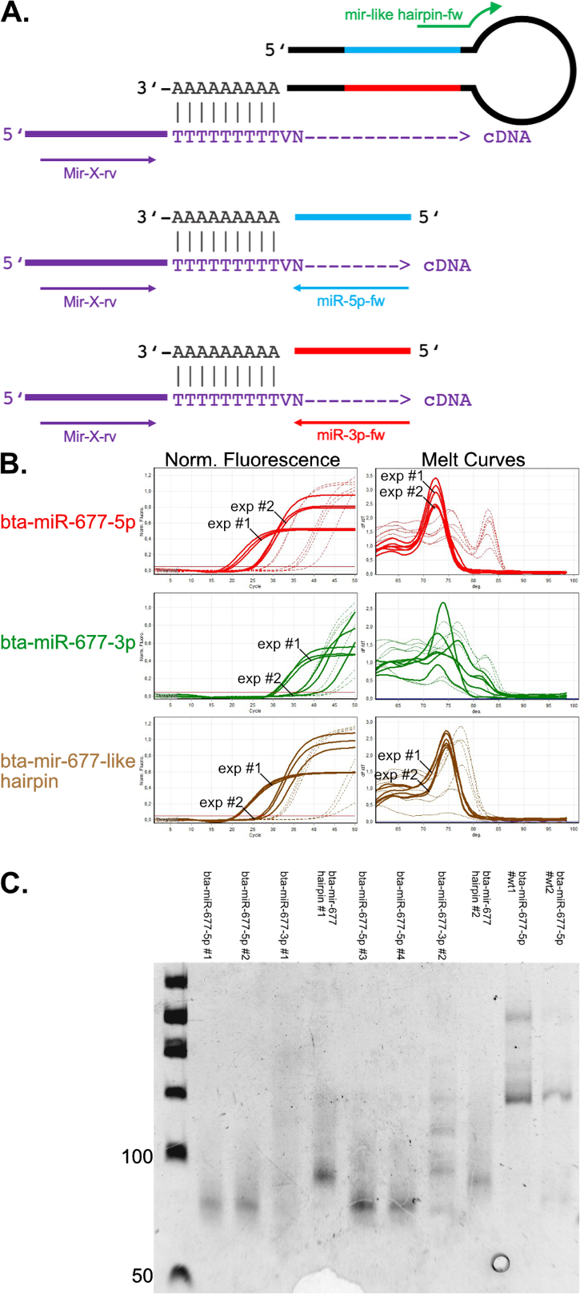
Figure S5. Tests for the presence of bta-mir-677-like hairpins and mature bta-miR-677-5p or bta-miR-677-3p, respectively. Tests were performed using the Mir-X kit (Takara Bio USA, Inc.) in combination with qPCR and PAGE. A. Briefly, poly[A] polymerase was used to tail the 3’-ends of microRNA precursors and mature microRNAs. Subsequently, 5’-adaptored oligo[T]VN was used to prime cDNA synthesis. For qPCR forward primers discriminating precursors and mature microRNAs were used in combination with Mir-X proprietary adaptor-specific reverse primers. B. The use of forward primers for mature bta-miR-677-5p (red curves) as well as the bta-mir-677-like hairpin (brownish curves) resulted in reproducible C_{T} values associated with sharp melting curves in different experiments, whereas the use of primers for mature bta-miR-677-3p resulted in probably unspecific signals (concluded from the irregular melting curves). Control experiments using RNA from wildtype HIEC-6 did not produce reproducible qPCR signals and melting curves (dashed lines in all charts). C. The PCR amplicons were separated by PAGE (6% PAA) in order to confirm the predicted size shift between microRNA precursors and mature microRNAs, respectively. The band sizes of the mature bta-miR-677-5p (expected size between 60 and 70 bp) as well as the observed shift with respect to the bta-mir-677-like (hairpin) precursor were in agreement with the theoretical expectations, whereas no specific amplicon could be seen for bta-miR-677-3p and wildtype control experiments.

