Table of Contents
SUPPLEMENTARY TEXT 3
Supplementary Methods 3
Supplementary Results 3
Metabolite associated with GCIPLT 3
Metabolomic signature and risk of incident morbidity and mortality 4
Incremental value of GCIPLT metabolomic signatures 4
SUPPLEMENTARY FIGURES 5
Supplementary Figure S1 5
Supplementary Figure S2 8
Supplementary Figure S3 9
Supplementary Figure S4 10
Supplementary Figure S5 11
Supplementary Figure S6 12
Supplementary Figure S7 13
Supplementary Figure S8 14
Supplementary Figure S9 15
Supplementary Figure S10 16
Supplementary Figure S11 17
Supplementary Figure S12 18
Supplementary Figure S13 19
Supplementary Figure S14 20
Supplementary Figure S15 21
Supplementary Figure S16 22
Supplementary Figure S17 23
Supplementary Figure S18 24
Supplementary Figure S19 25
Supplementary Figure S20 26
Supplementary Figure S21 27
SUPPLEMENTARY TABLES 28
Supplementary Table S1 28
Supplementary Table S2 32
Supplementary Table S3 33
Supplementary Table S4 34
Supplementary Table S5 36
Supplementary Table S6 38
Supplementary Table S7 40
Supplementary Table S8 42
Supplementary Table S9 44
Supplementary Table S10 46
Supplementary Table S11 48
Supplementary Table S12 49
Supplementary Table S13 50
Supplementary Table S14 51
Supplementary Table S15 52
Supplementary Table S16 53
Supplementary Table S17 54
Supplementary Table S18 55
Supplementary Table S19 56
Supplementary Table S20 57

SUPPLEMENTARY TEXT

Supplementary Methods
In the present study, age was divided into five categories: ≤ 49, 50–54, 55–59, 60–64, and ≥ 65 years; education into four categories: level O, level A, university, and missing; and ethnicity into three categories: white, other, and missing. The Townsend deprivation index was divided into four quartiles. The average household income was divided into five categories: <18k, 18k-30k, 31k-51k, 52k-100k, >100k, and missing. Baseline diseases were defined using questionnaires, interviews, and inpatient data based on the ICD-10 codes.

Body mass index (BMI) was calculated as weight divided by height squared and waist-to-hip ratio (WHR) as waist circumference divided by hip circumference. The blood pressure was measured using a digital blood pressure monitor (Omron, Japan). Visual acuity was assessed using the traditional LogMAR charts. The refractive error was measured using an autorefractor (Tomey, Japan), and spherical equivalent values were calculated based on the autorefraction results. Intraocular pressure (IOP) was measured using an ocular response analyzer (Rerchert, USA). Total cholesterol, low-density lipoprotein cholesterol (LDL-c), and high-density lipoprotein cholesterol (HDL-c) levels were measured using Konelab (Thermo Fisher, USA). Glycosylated haemoglobin A1c was measured using liquid chromatography (Bio-Rad, USA). Urine microalbumin and creatinine levels were measured using Beckman Coulter (USA), and the albumin-to-creatinine ratio was calculated. All field codes are summerized in Supplementary Table S1.

Supplementary Results

Metabolite associated with GCIPLT
Higher levels of phospholipids in medium high-density lipoprotein (HDL) (β=-0.284; 95% CI:-0.410, -0.157; P=1.02E-06) and total HDL (β=-0.279; 95% CI:-0.411, -0.148; P=3.19E-05), total lipids in medium HDL (β=-0.271; 95% CI:-0.399, -0.143; P=3.17E-05) and total HDL (β=-0.260; 95% CI:-0.393, -0.127; P=1.34E-04), free cholesterol in medium HDL (β=-0.264; 95% CI:-0.394, -0.134; P=6.90E-05) and total HDL (β=-0.240; 95% CI:-0.375, -0.105; P=4.84E-04), and cholesterol (β=-0.251; 95% CI:-0.381, -0.121; P=1.56E-04) and cholesteryl esters (β=-0.247; 95% CI:-0.377, -0.117; P=1.90E-04) in medium HDL were significantly associated with reduced macular GCIPLT. In addition, apolipoprotein A1 (apoA1) (β=-0.253; 95% CI:-0.383, -0.124; P=1.29E-04), medium HDL particle concentration (β=-0.266; 95% CI:-0.394, -0.138; P=4.78E-05), total HDL particles (β=-0.213; 95% CI:-0.338, -0.088; P=8.47E-04), ratios of saturated fatty acids (FAs) to total FAs (β=-0.411; 95% CI:-0.576, -0.246; P=1.02E-06), and ratios of phospholipids to total lipids in small HDL (β=-0.257; 95% CI:-0.380, -0.134; P=4.16E-05) were significantly associated with reduced macular GCIPLT. In contrast, the ratios of linoleic acid to total FA (β=0.327; 95% CI:0.176, 0.477; P=2.03E-05), omega-6 FA to total FA (β=0.259; 95% CI:0.110, 0.408; P=6.85E-04), and apolipoprotein B (apoB) to apoA1 (β=0.222; 95% CI:0.093, 0.351; P=7.43E-04) were positively correlated with GCIPLT. See Supplementary Table S2 for details.

Metabolomic signature and risk of incident morbidity and mortality
Of the 16 aforementioned metabolic markers, 15 were independently associated with all-cause mortality (13 negative, 2 positive), 14 with cardiovascular disease mortality (12 negative, 2 positive), 12 with cancer mortality (10 negative, 2 positive), and seven with other mortality types (4 negative, 3 positive). Among systemic diseases, 15 were independently associated with the risk of T2DM (13 negative, 2 positive), 13 were independently associated with the risk of OSAHS (all negative), 11 were independently associated with the risk of dementia (all negative), 13 were independently associated with the risk of stroke (12 negative, 1 positive), 12 were independently associated with the risk of heart failure (11 negative, 1 positive), and 15 were independently associated with the risk of heart attack (14 negative, 1 positive). Consistent correlations were obtained in the validation set. See Supplementary Table S14-S23 for details.

Incremental value of GCIPLT metabolomic signatures

C-statistics increased in new models
The C-statistic increased from 0.724 (0.714–0.734) to 0.730 (0.720–0.740) (P=1.61E-10) for all-cause mortality; from 0.776 (0.758–0.794) to 0.780 (0.763–0.798) (P=0.006) for cardiovascular mortality; from 0.740 (0.721–0.758) to 0.752 (0.733–0.770) (P=3.27E-05) for other-cause mortality; and from 0.685 (0.671–0.700) to 0.692 (0.678–0.706) (P=5.66E-05) for cancer mortality (Supplementary Figure S11).

The meta-GCIPLT score increased the C-statistic from 0.812 (0.805–0.820) to 0.826 (0.818–0.833) (P < 2.20E-16) for predicting T2DM, from 0.766 (0.748–0.783) to 0.774 (0.756–0.792) (P=1.17E-05) for predicting OSAHS, from 0.757 (0.743–0.771) to 0.764 (0.751–0.777) (P=7.29E-13) for predicting myocardial infarction, from 0.776 (0.762–0.790) to 0.778 (0.764–0.792) (P=0.035) for predicting heart failure, from 0.726 (0.709–0.744) to 0.731 (0.713–0.748) (P=0.017) for predicting stroke, and from 0.809 (0.793–0.825) to 0.814 (0.798–0.829) (P=0.006) for predicting dementia (Supplementary Figure S10). Similar results were obtained for the validation set (Supplementary Figures S12–S13).

NRI values in new models for the validation set
The NRI values were 2.01% (SE=0.006, P=3.07E-04) for predicting all-cause mortality, 3.27% (SE=0.008, P=2.87E-05) for predicting cardiovascular mortality, 1.84% (SE=0.005, P=4.48E-04) for predicting cancer mortality, 4.08% (SE=0.006, P=5.06E-11) for predicting T2DM, 3.02% (SE=0.014, P=0.031) for predicting OSAHS, 3.09% (SE=0.009, P=4.45E-04) for predicting myocardial infarction, 1.27% (SE=0.003, P=3.07E-04) for predicting heart failure, and 3.54% (SE=0.012, P=0.004). The NRI values for the models predicting stroke, cardiovascular disease mortality, and other mortality types were not statistically significant (Supplementary Figures S16–S17).

SUPPLEMENTARY FIGURES

Supplementary Figure S1
Flowchart demonstrating the eligibility criteria.
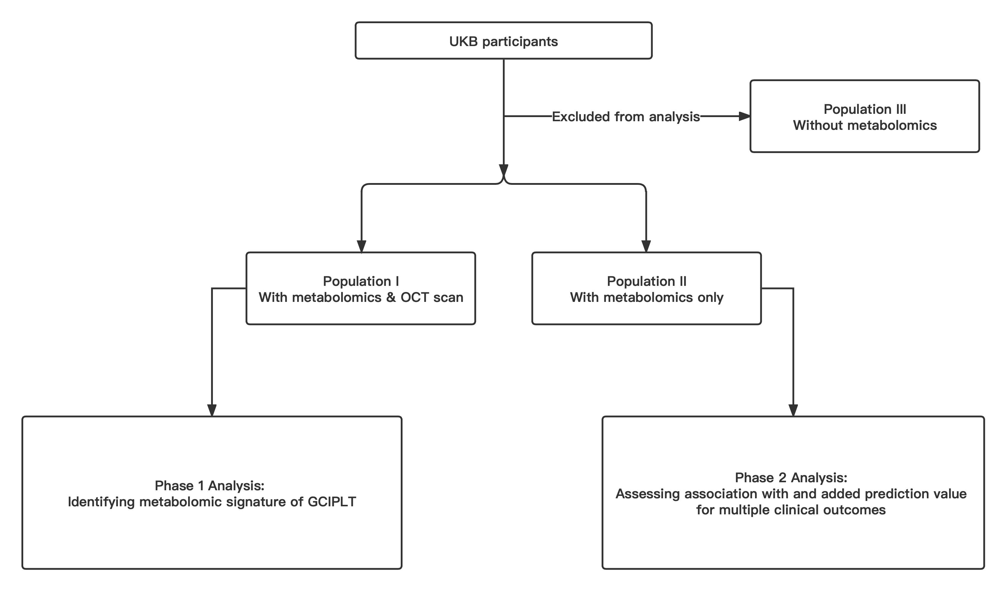
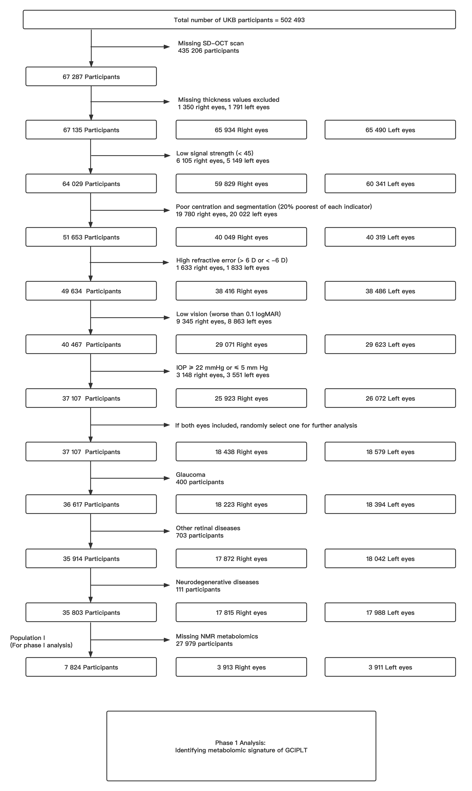
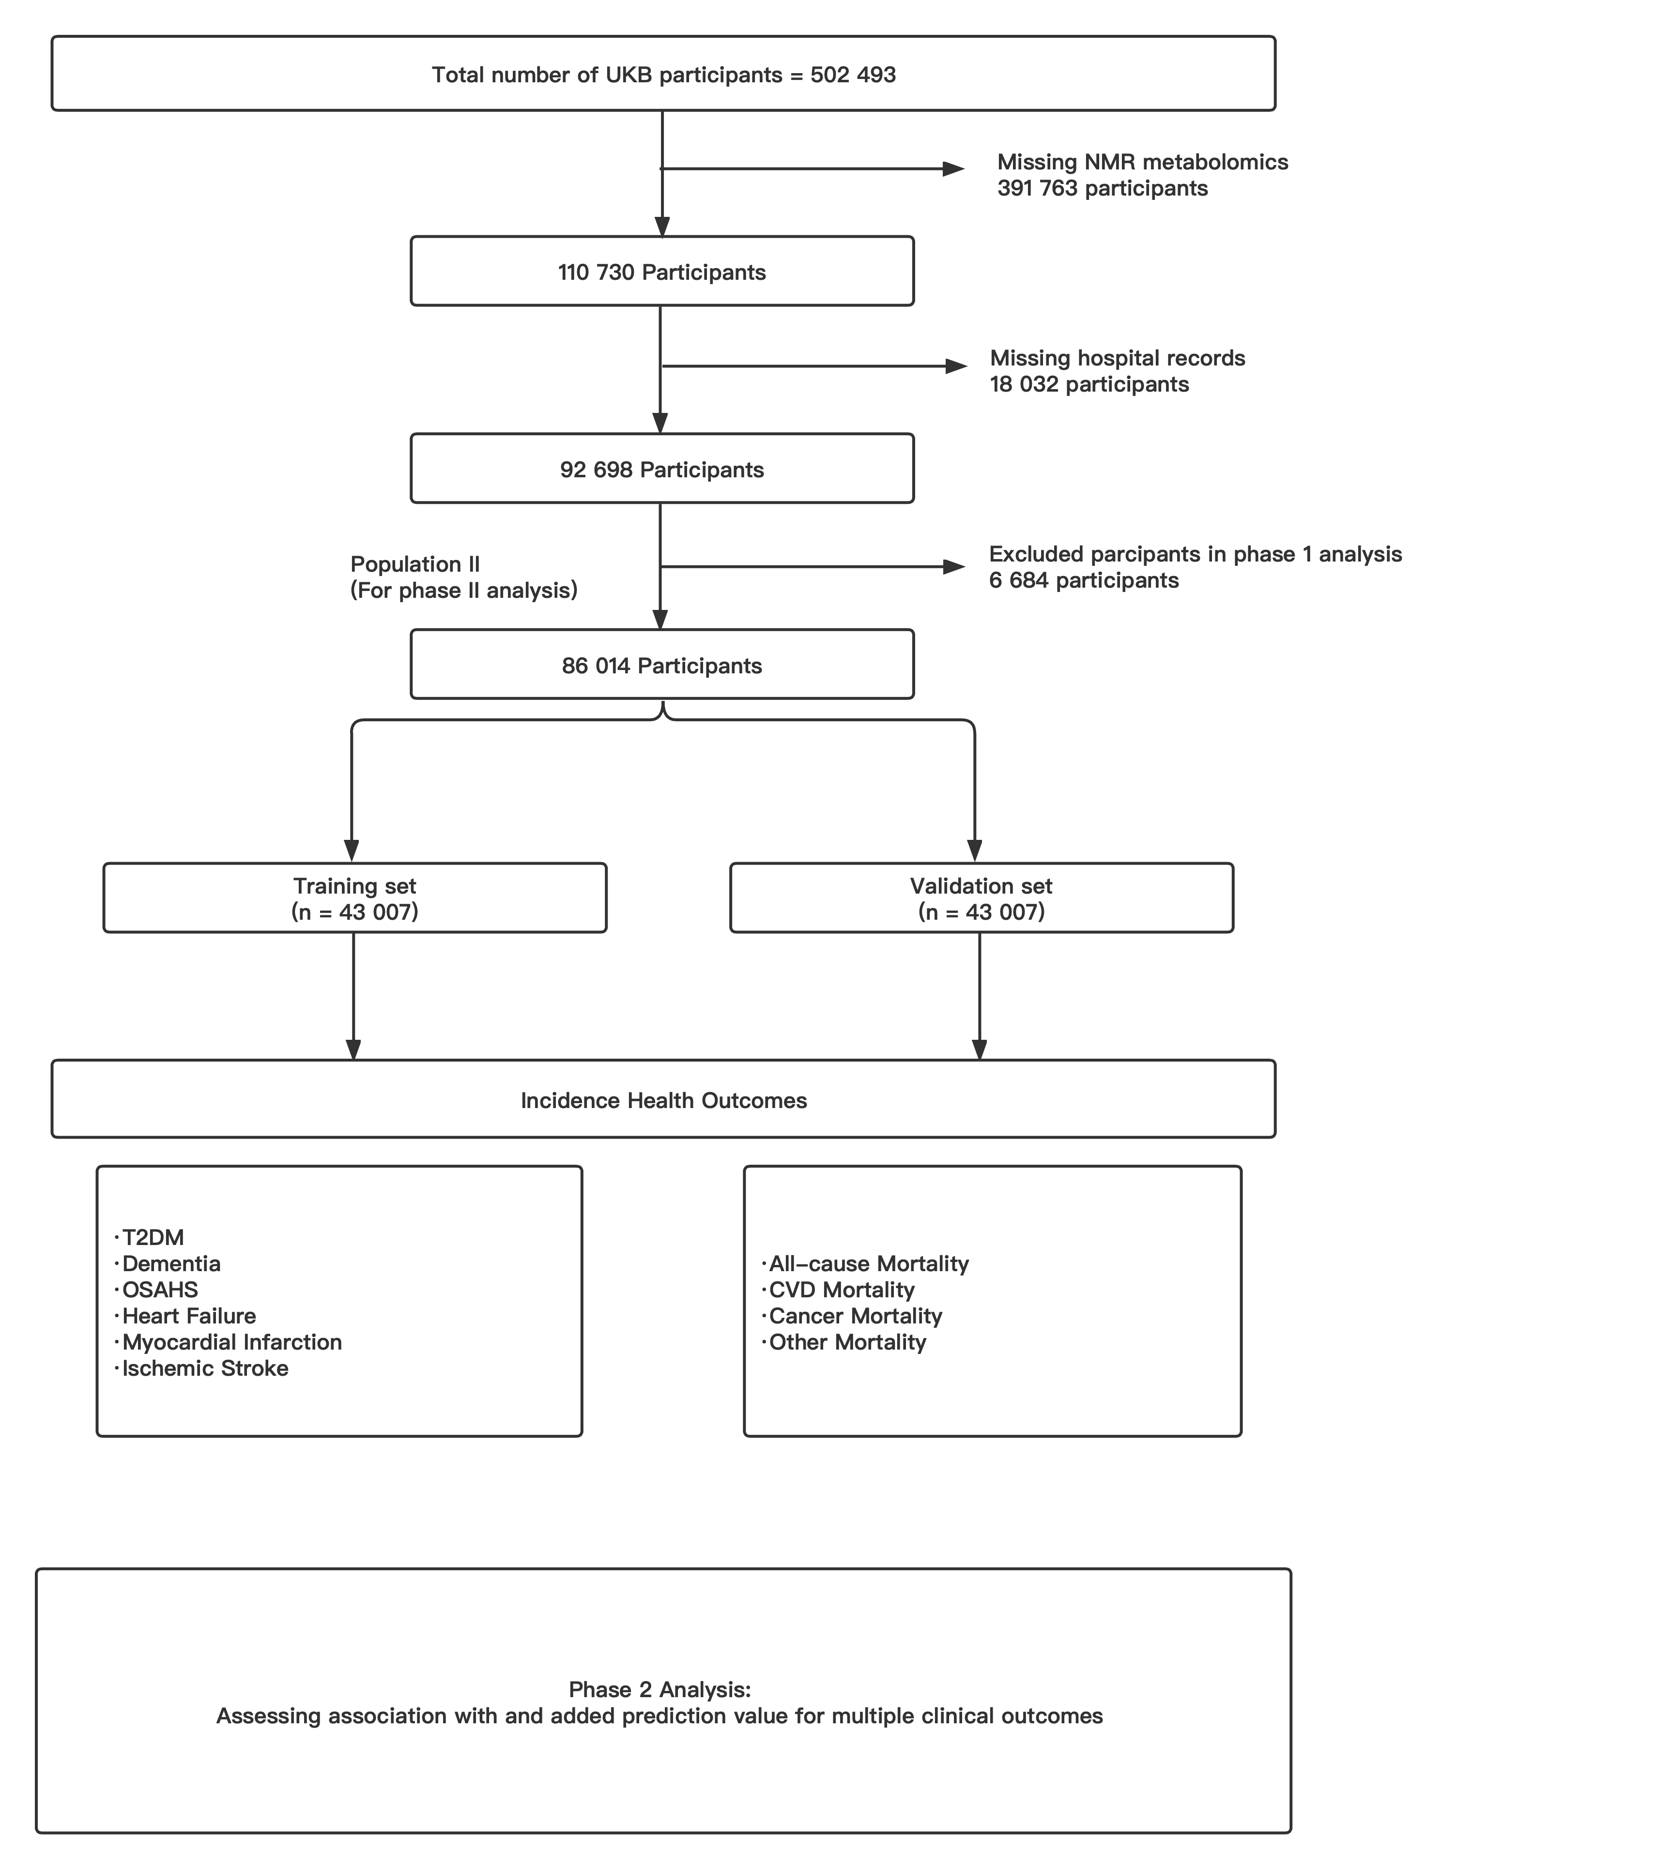

Supplementary Figure S2
Heatmaps demonstrating the overall correlations of GCIPLT and metabolites.

Supplementary Figure S3
Forest plot demonstrating correlation between GCIPLT and metabolic biomarkers that reached the set significance threshold of P value.
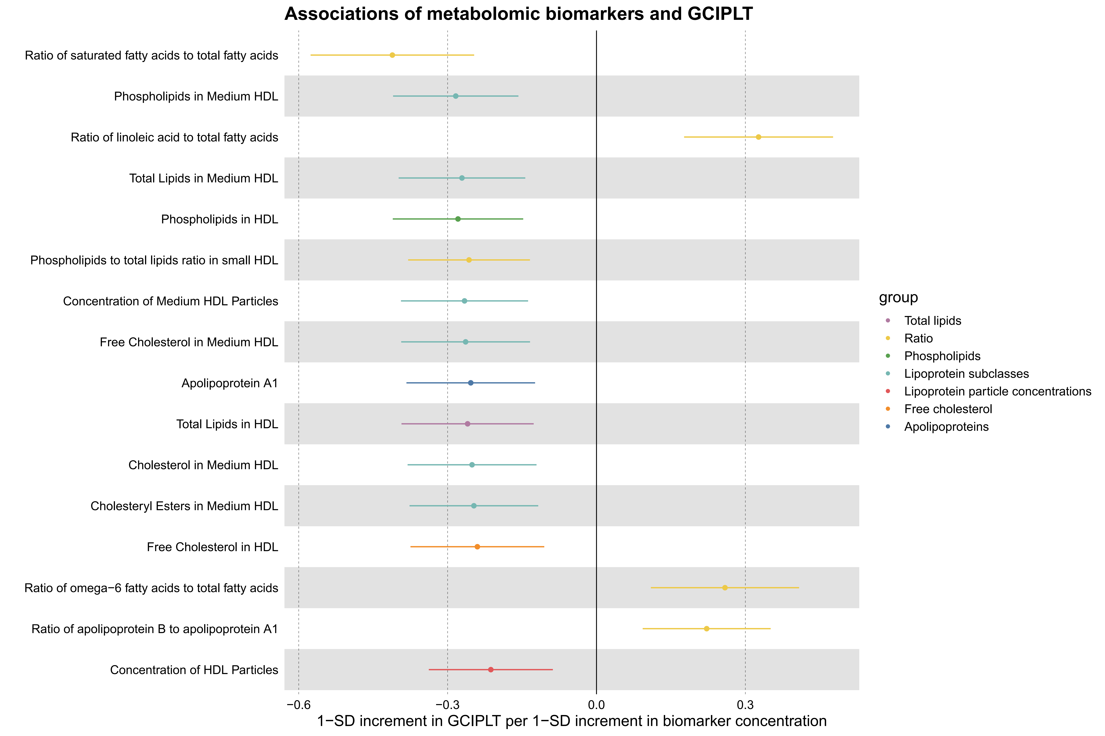

Supplementary Figure S4
Comparisons of morbidity of systemic diseases in the top and bottom 10% of the meta-GCIPL score in training set.

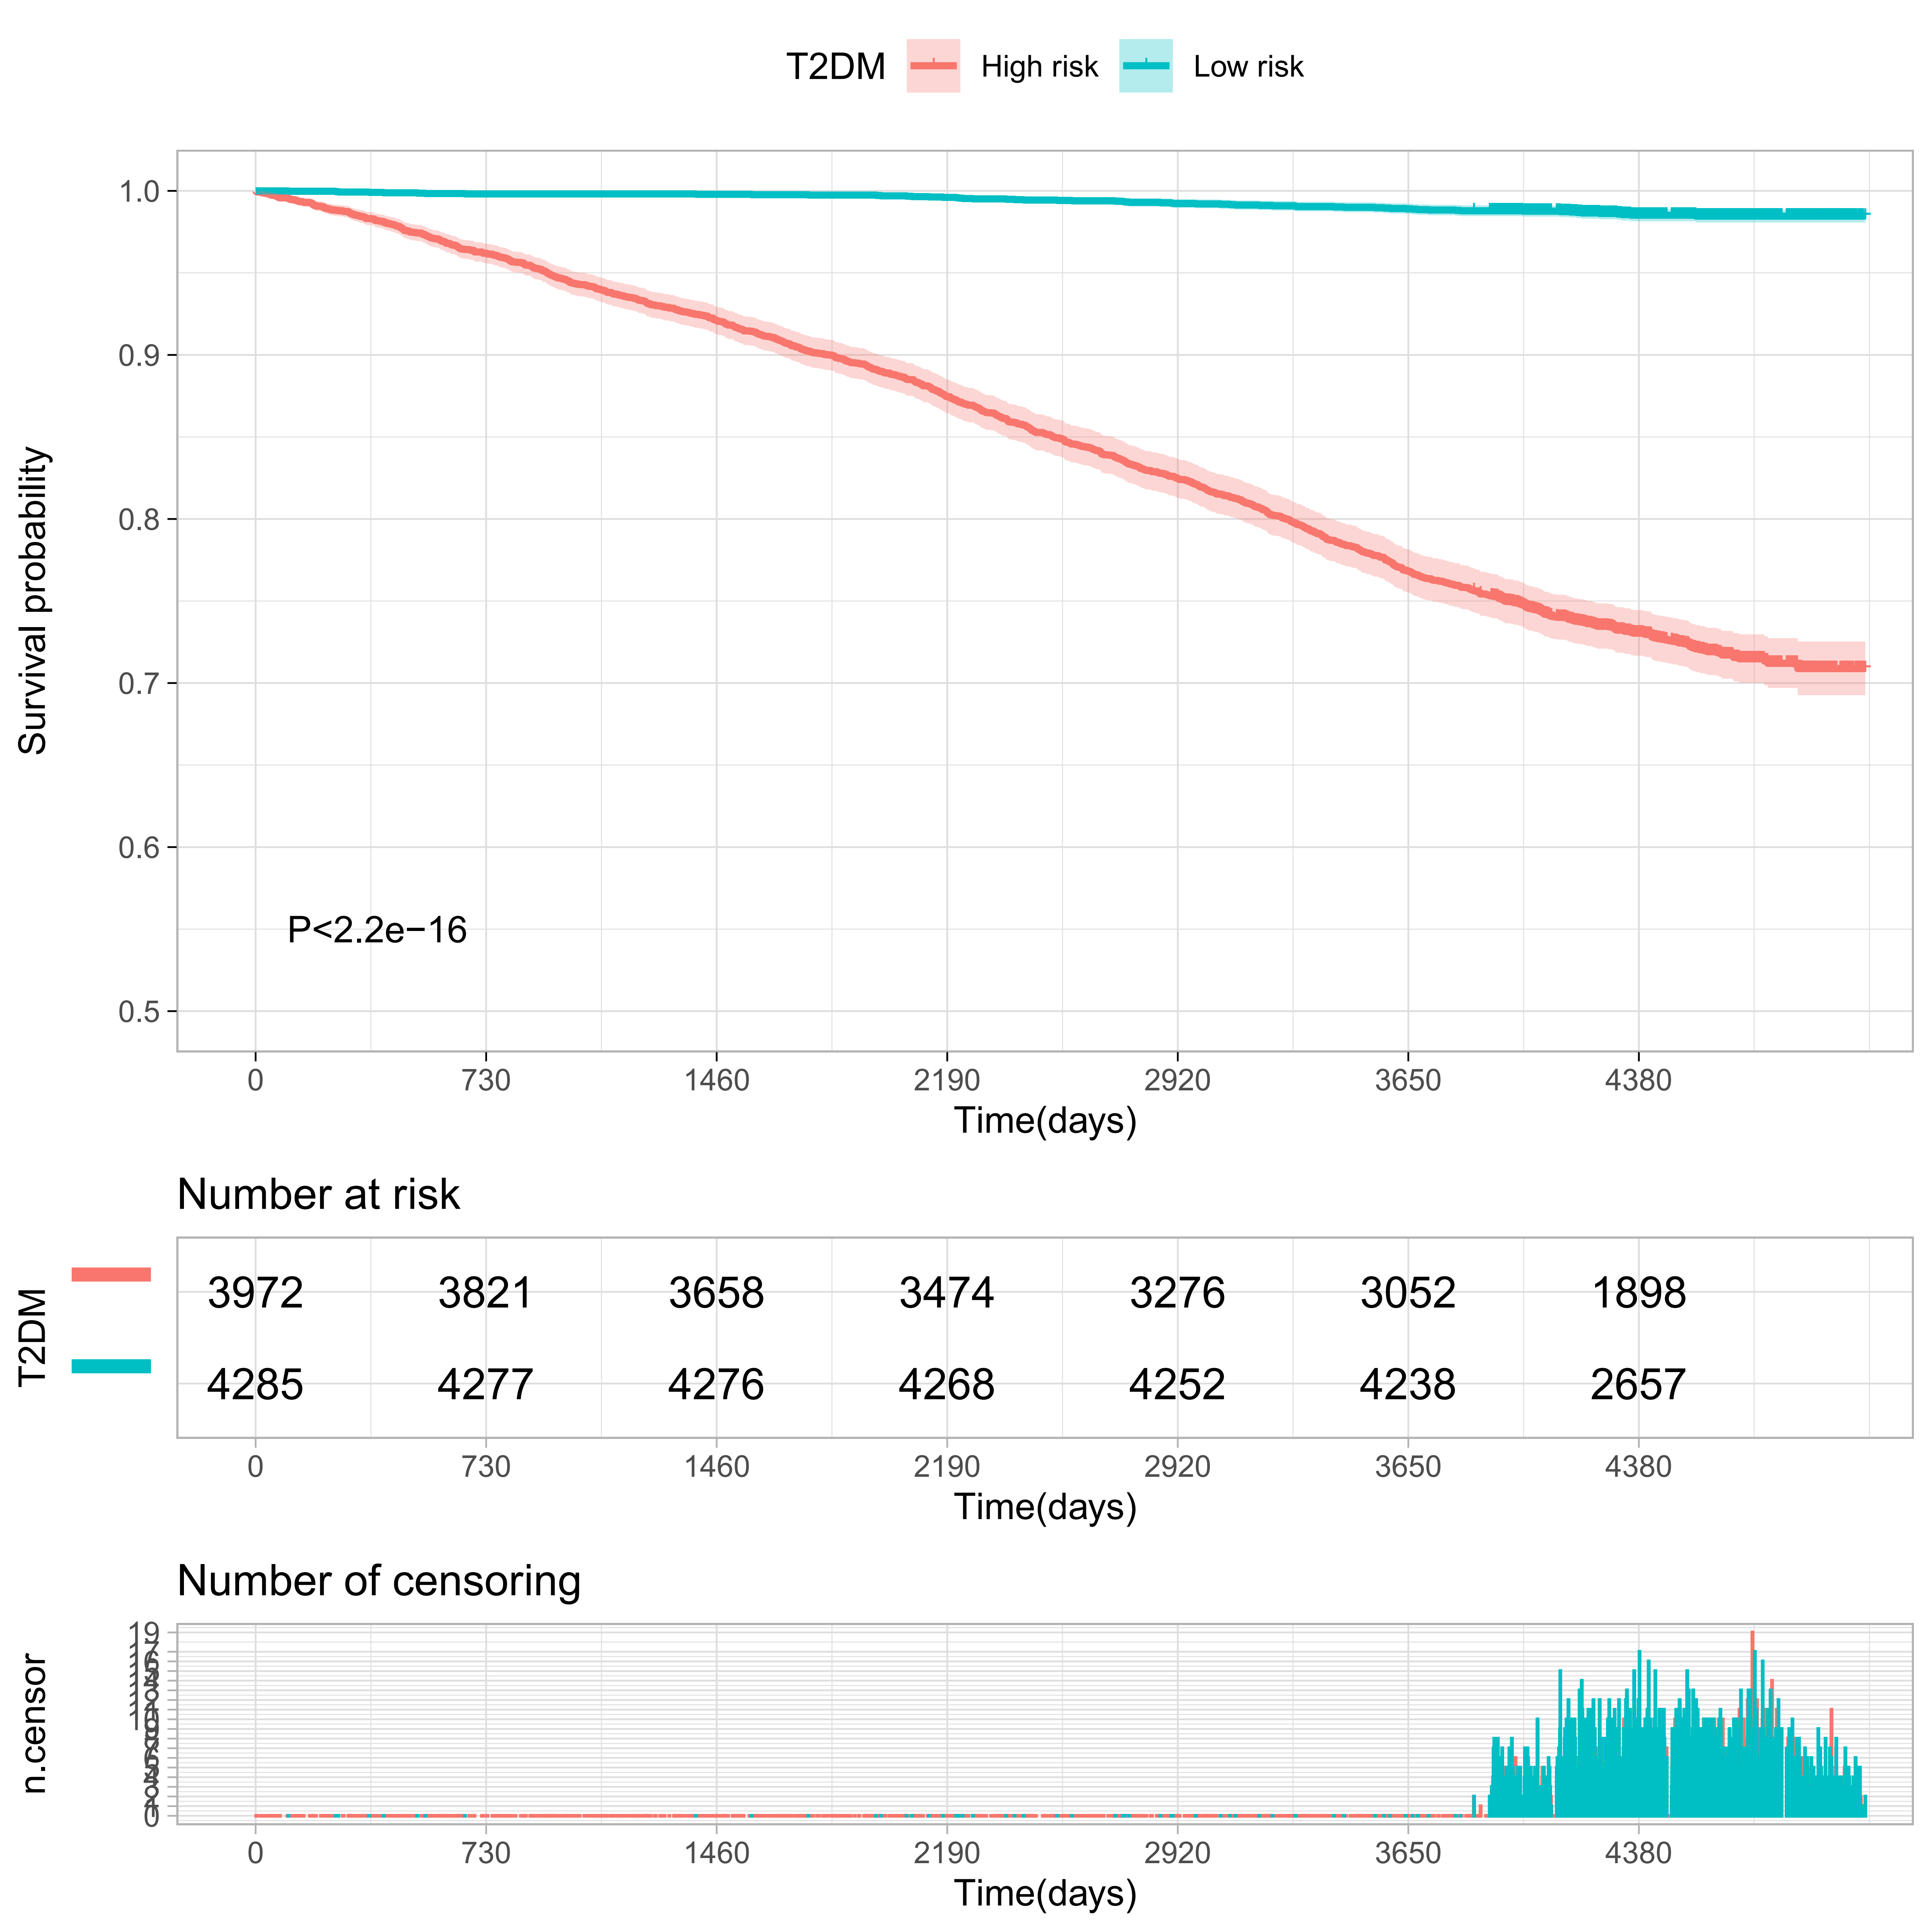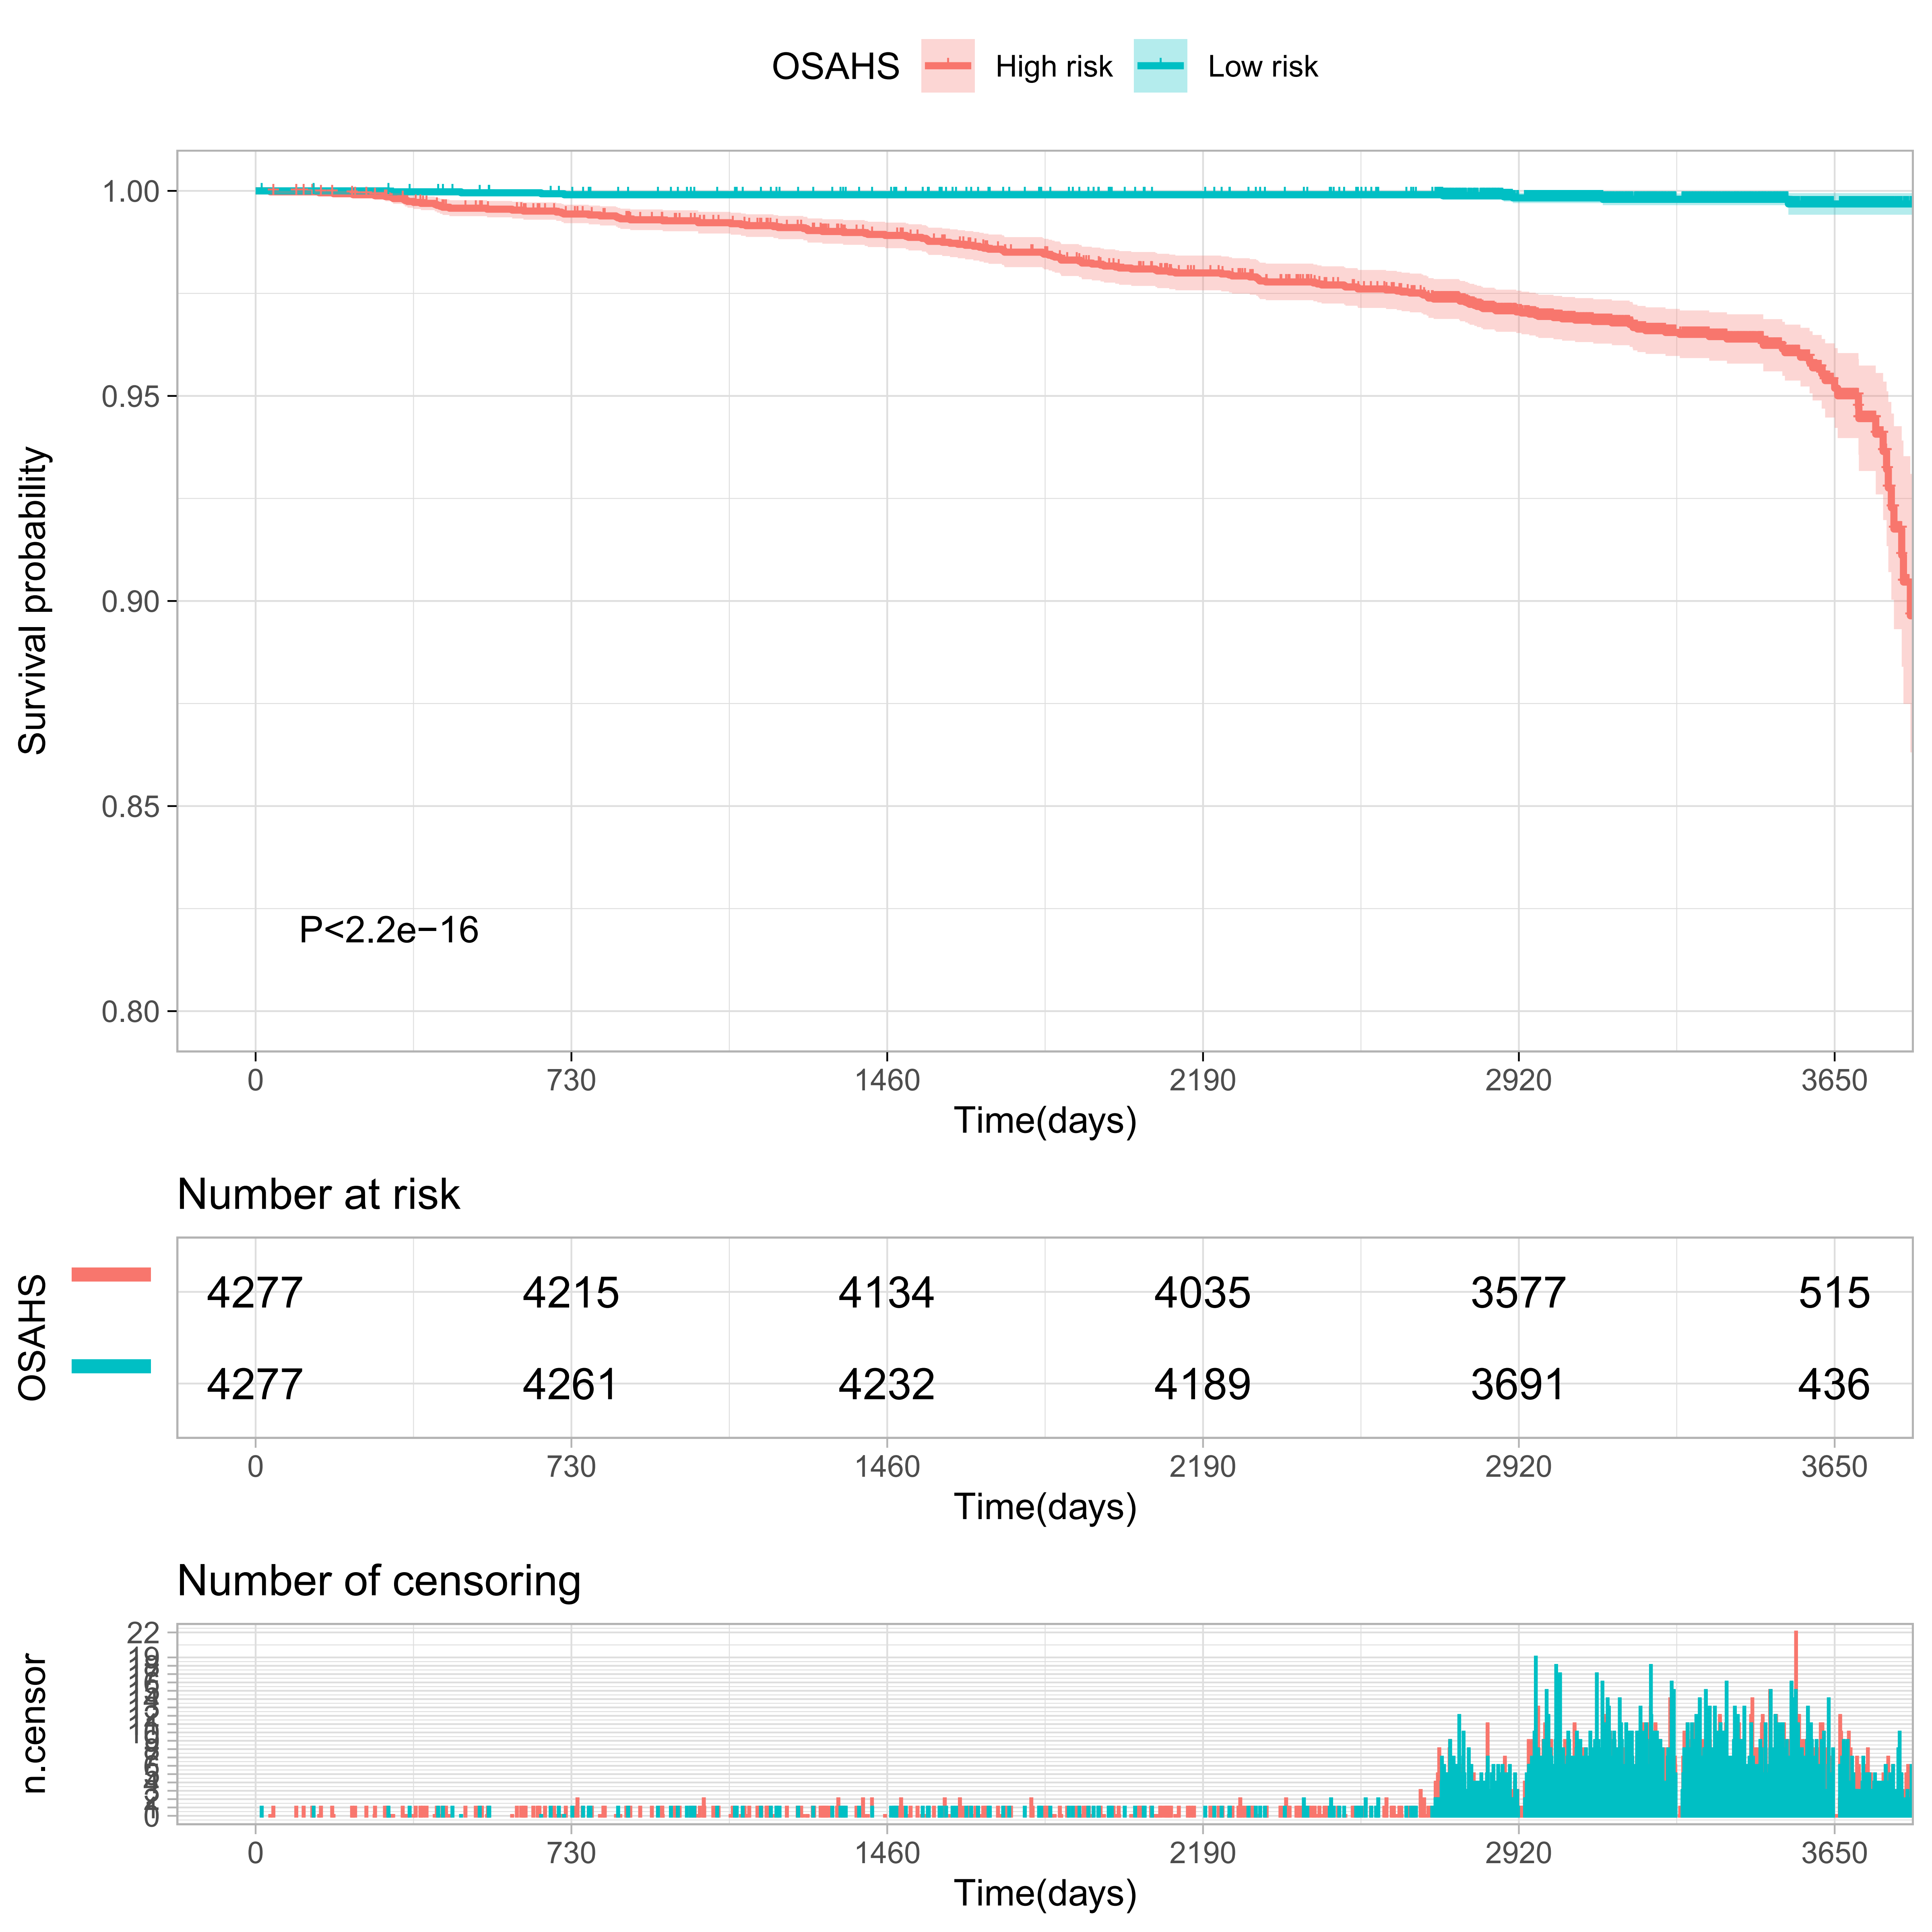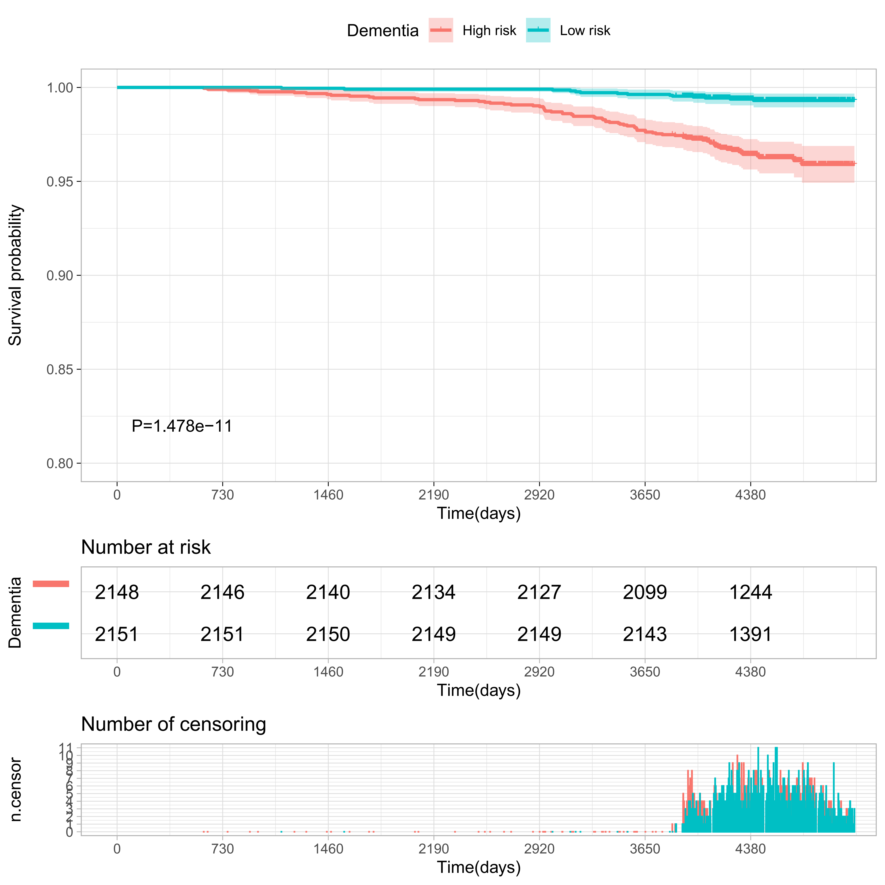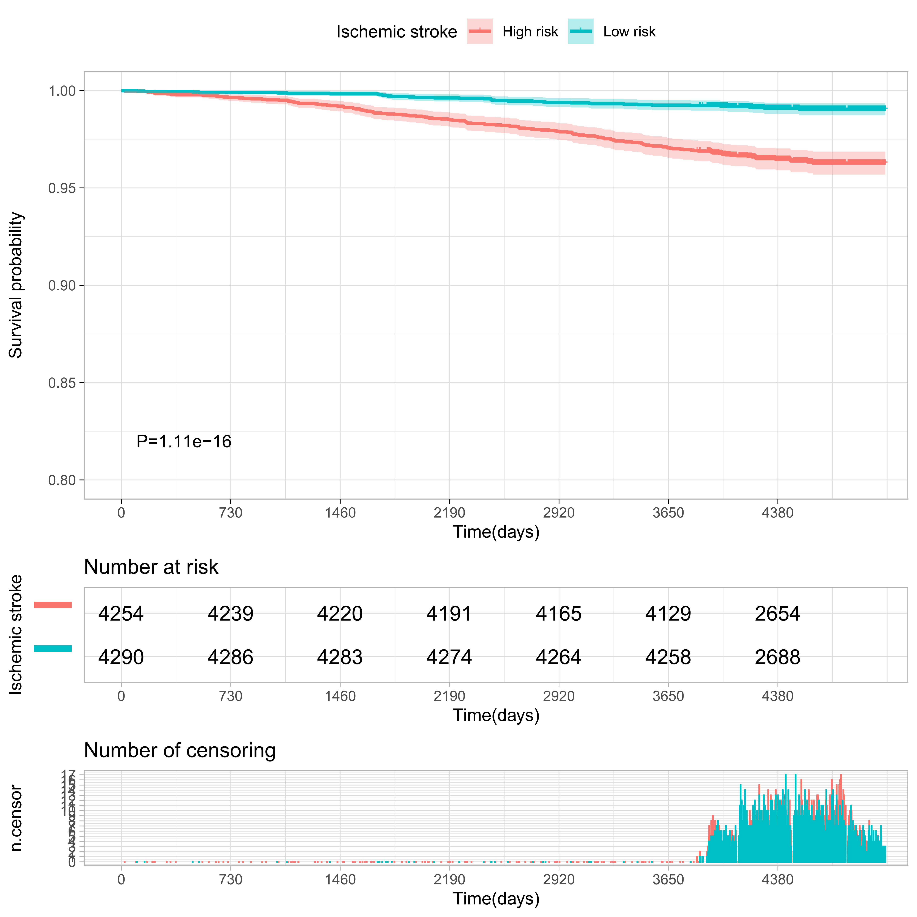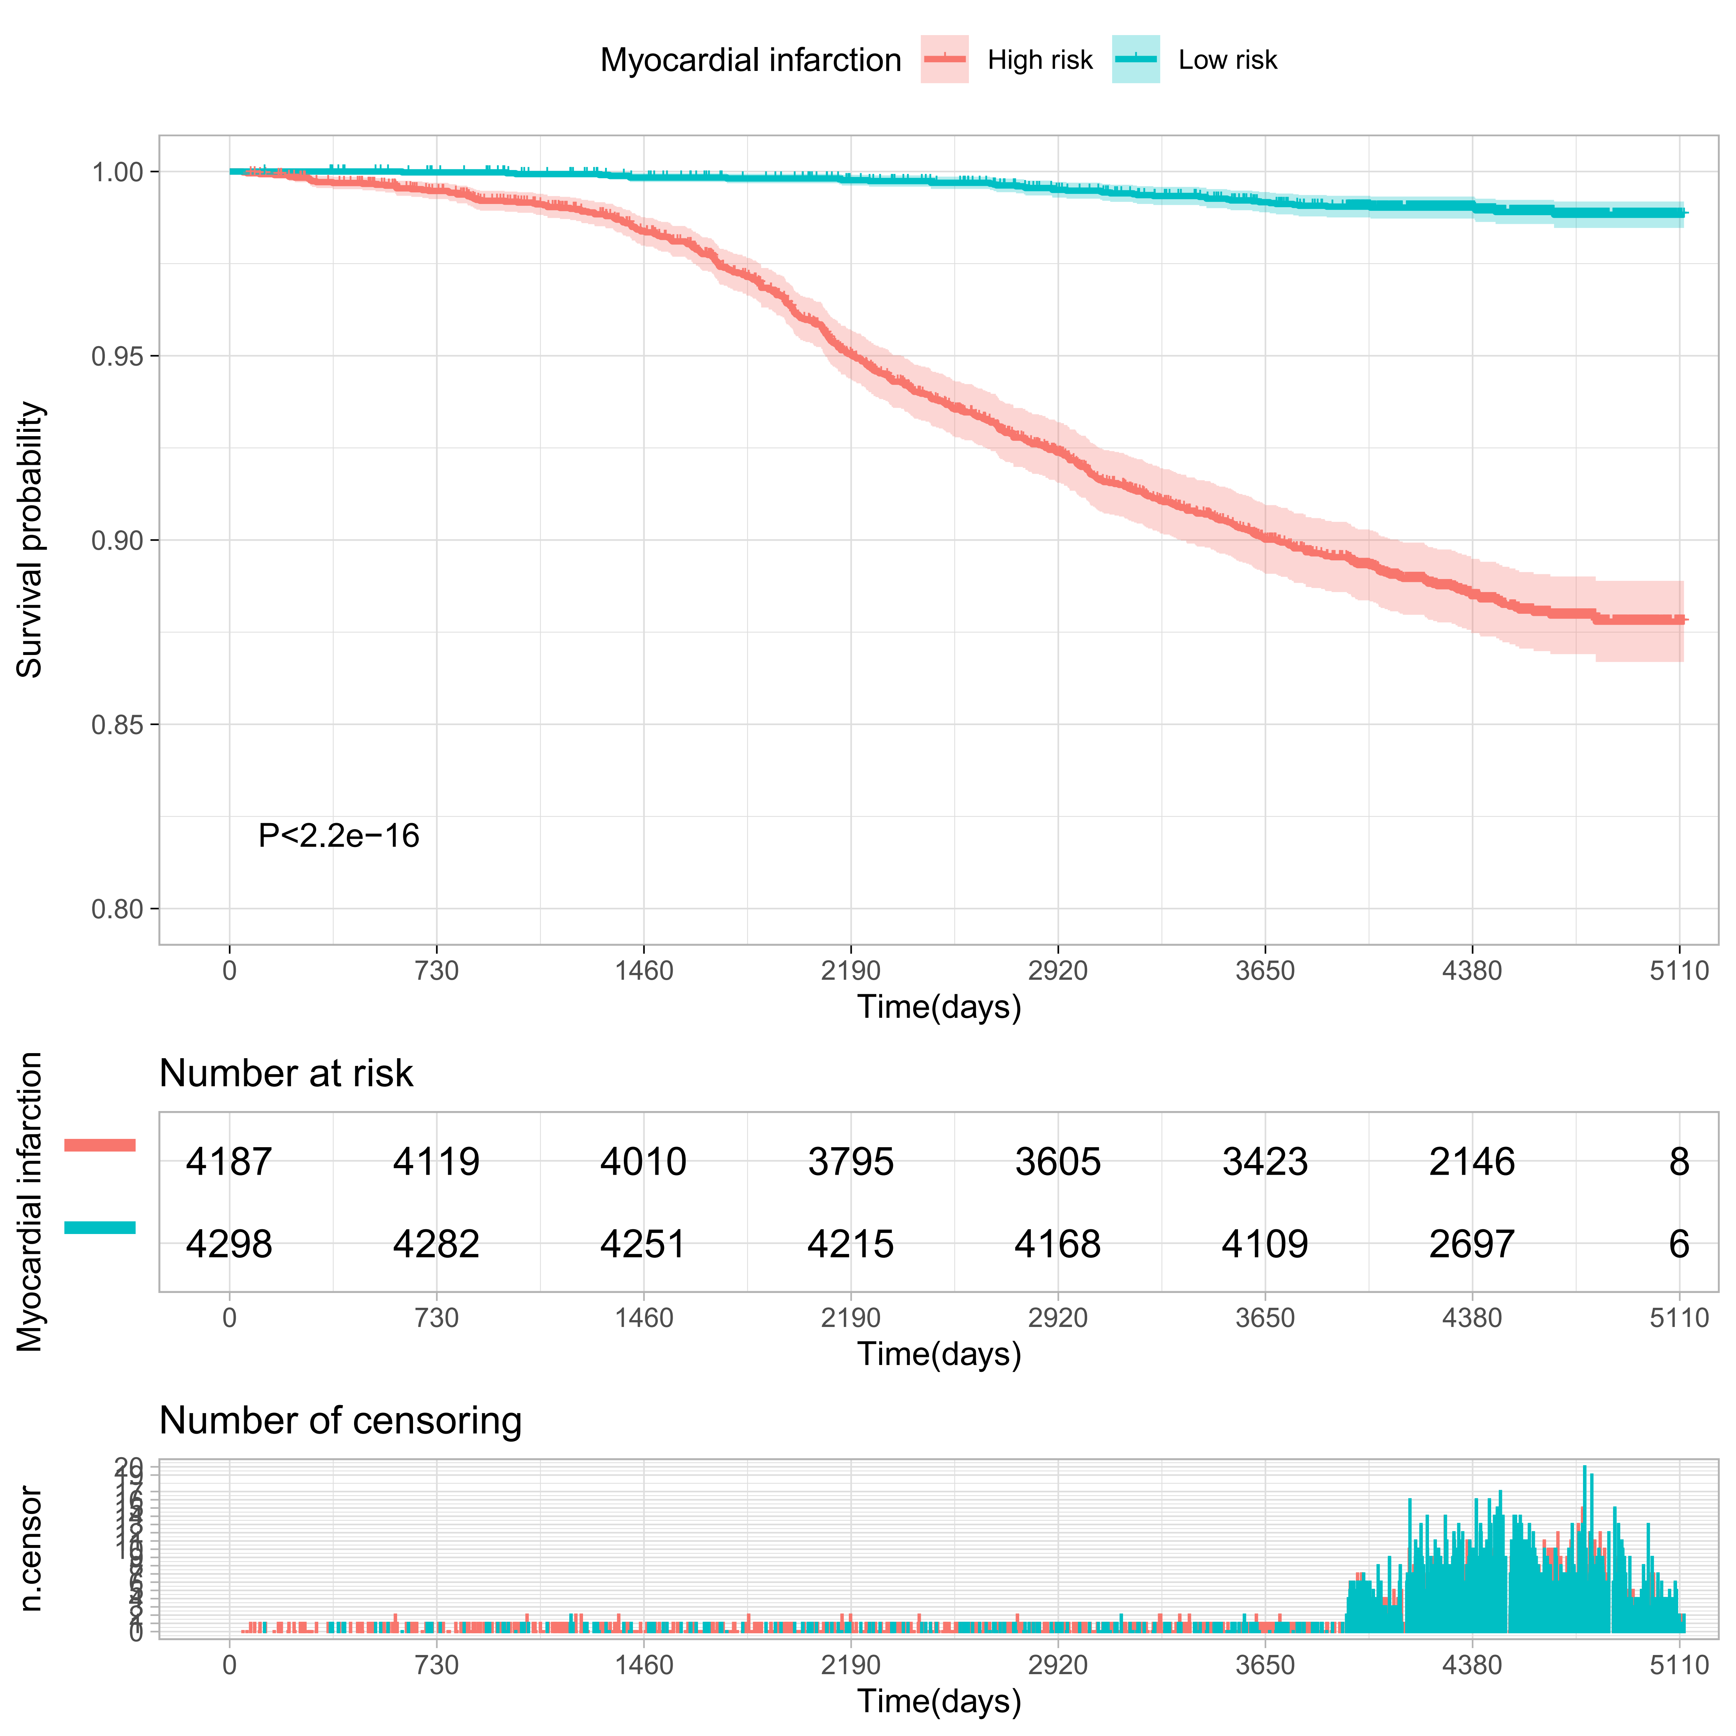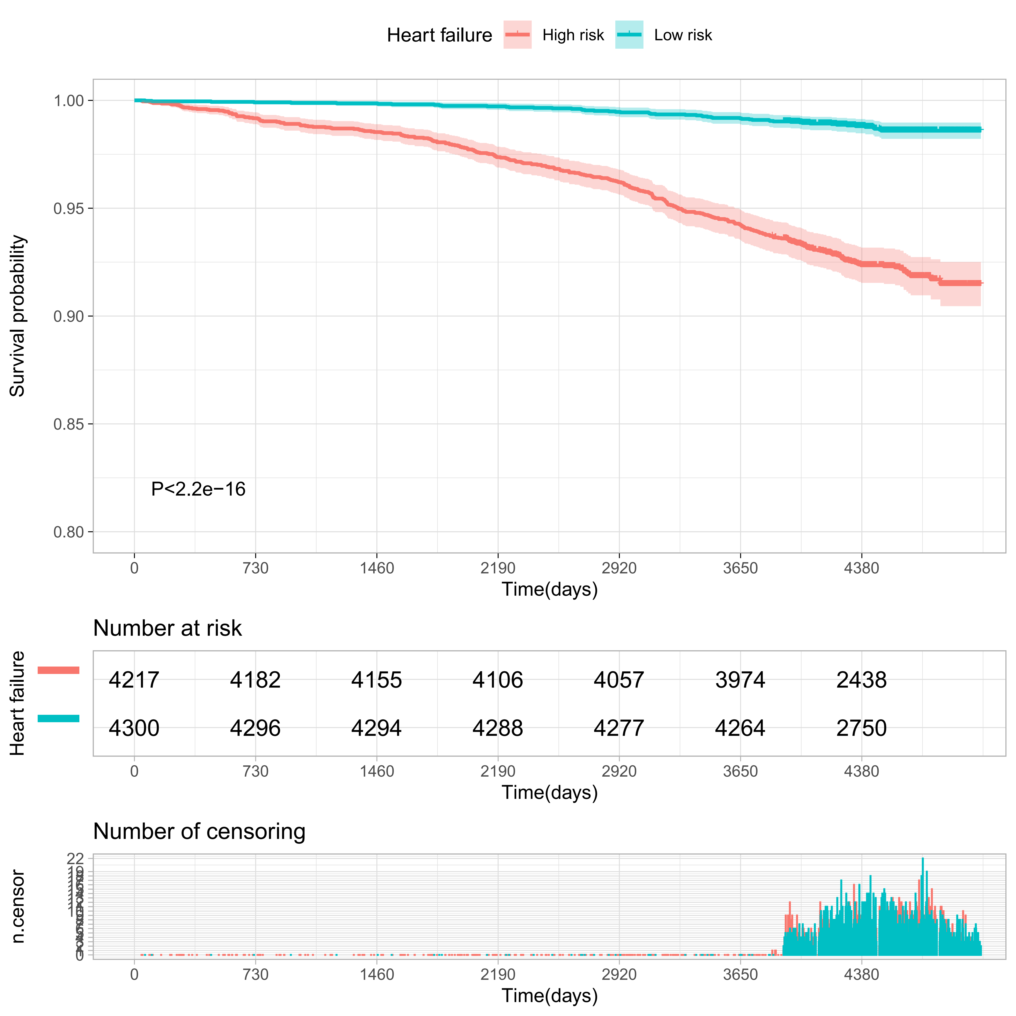

Supplementary Figure S5
Comparisons of mortality in the top and bottom 10% of the meta-GCIPL score in training set.
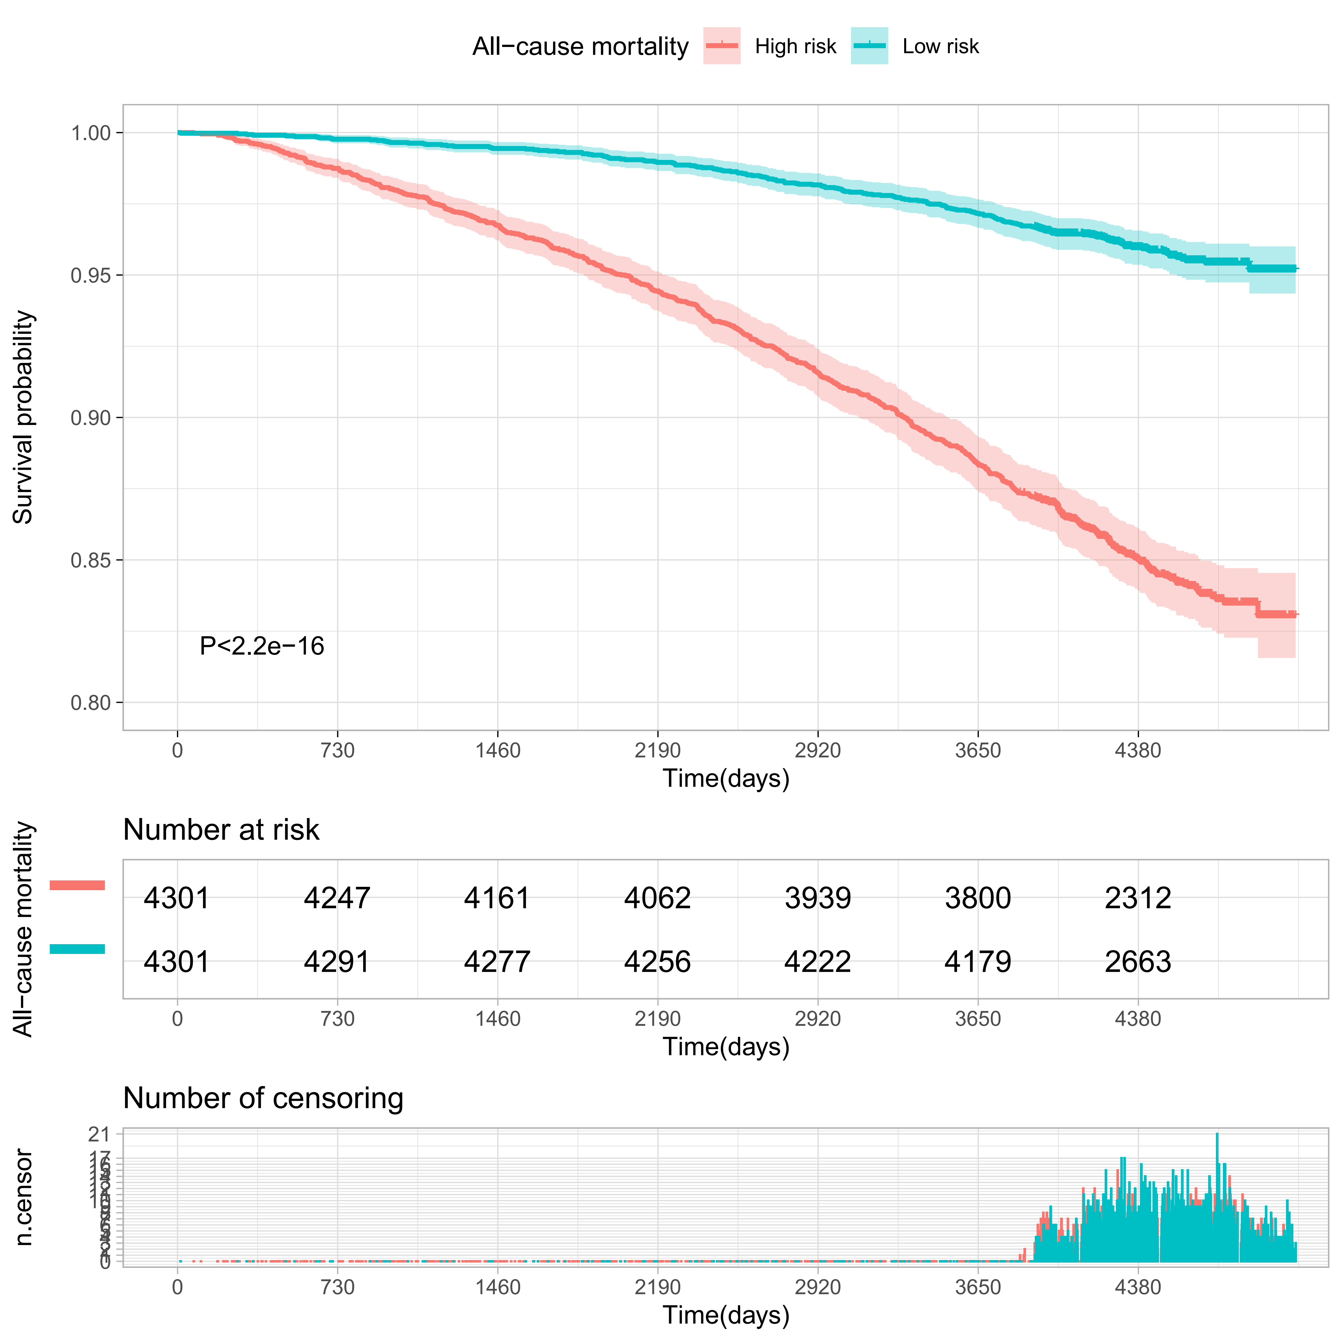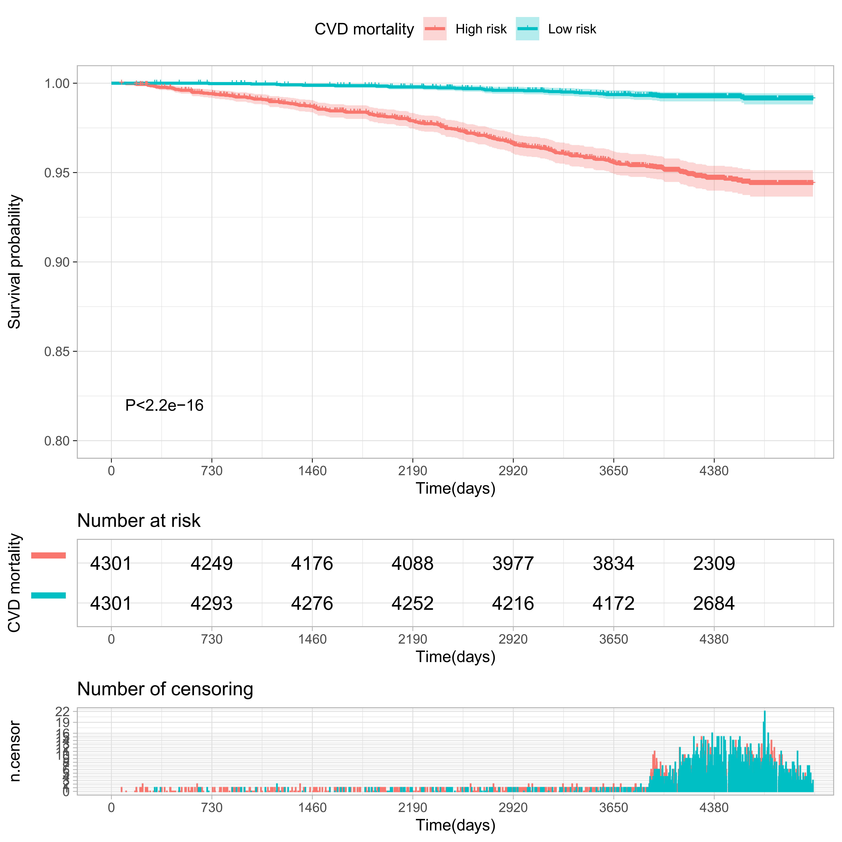
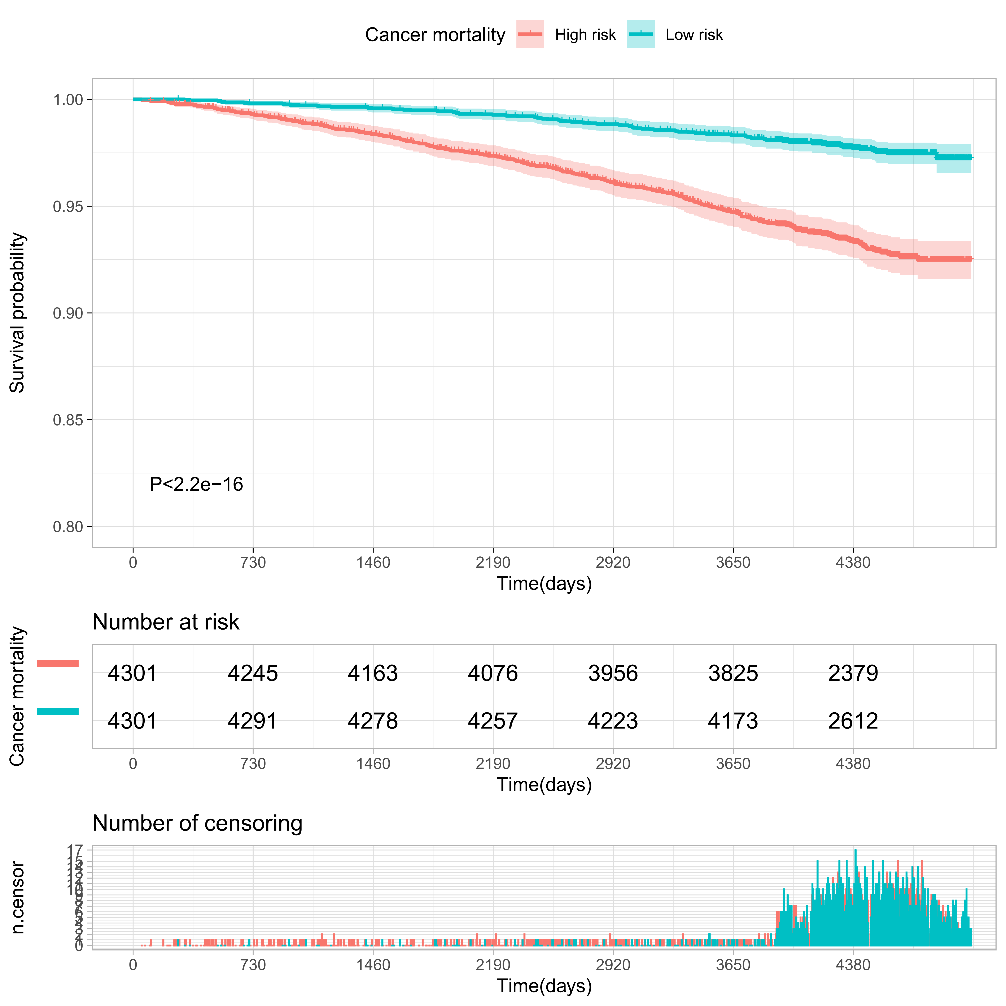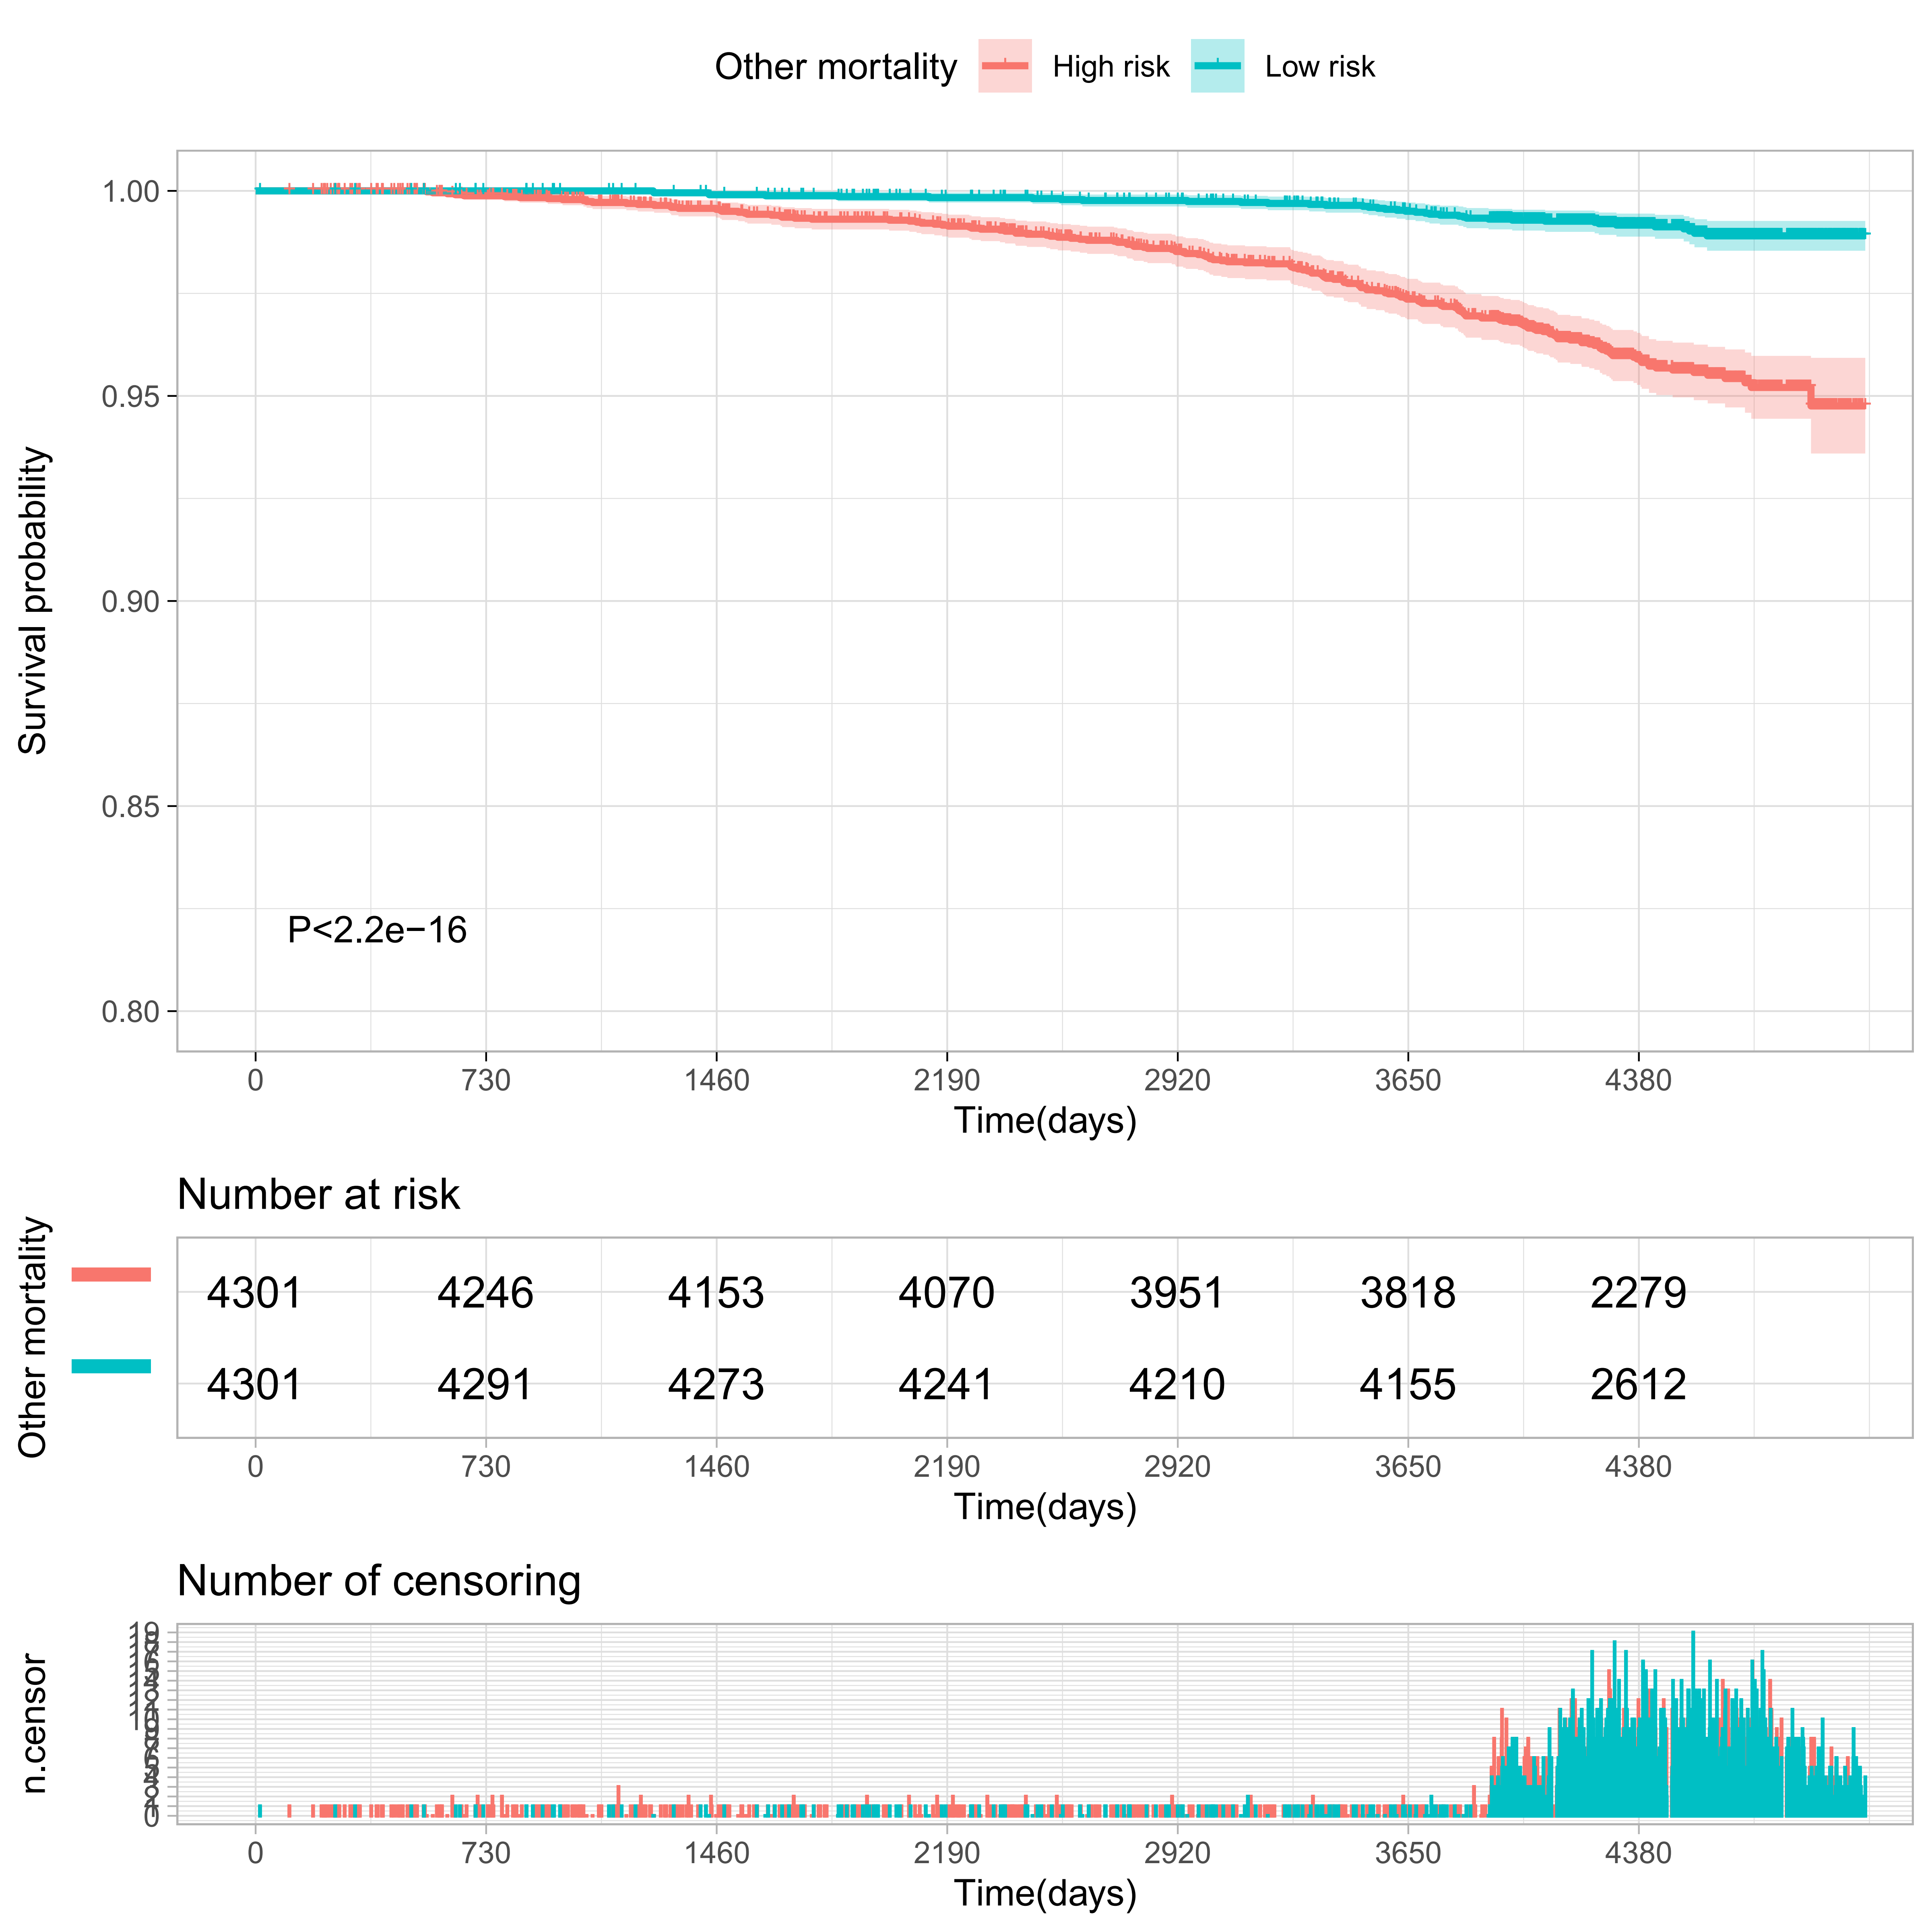

Supplementary Figure S6
Comparisons of morbidity of systemic diseases in the top and bottom 10% of the meta-GCIPL score in validation set.
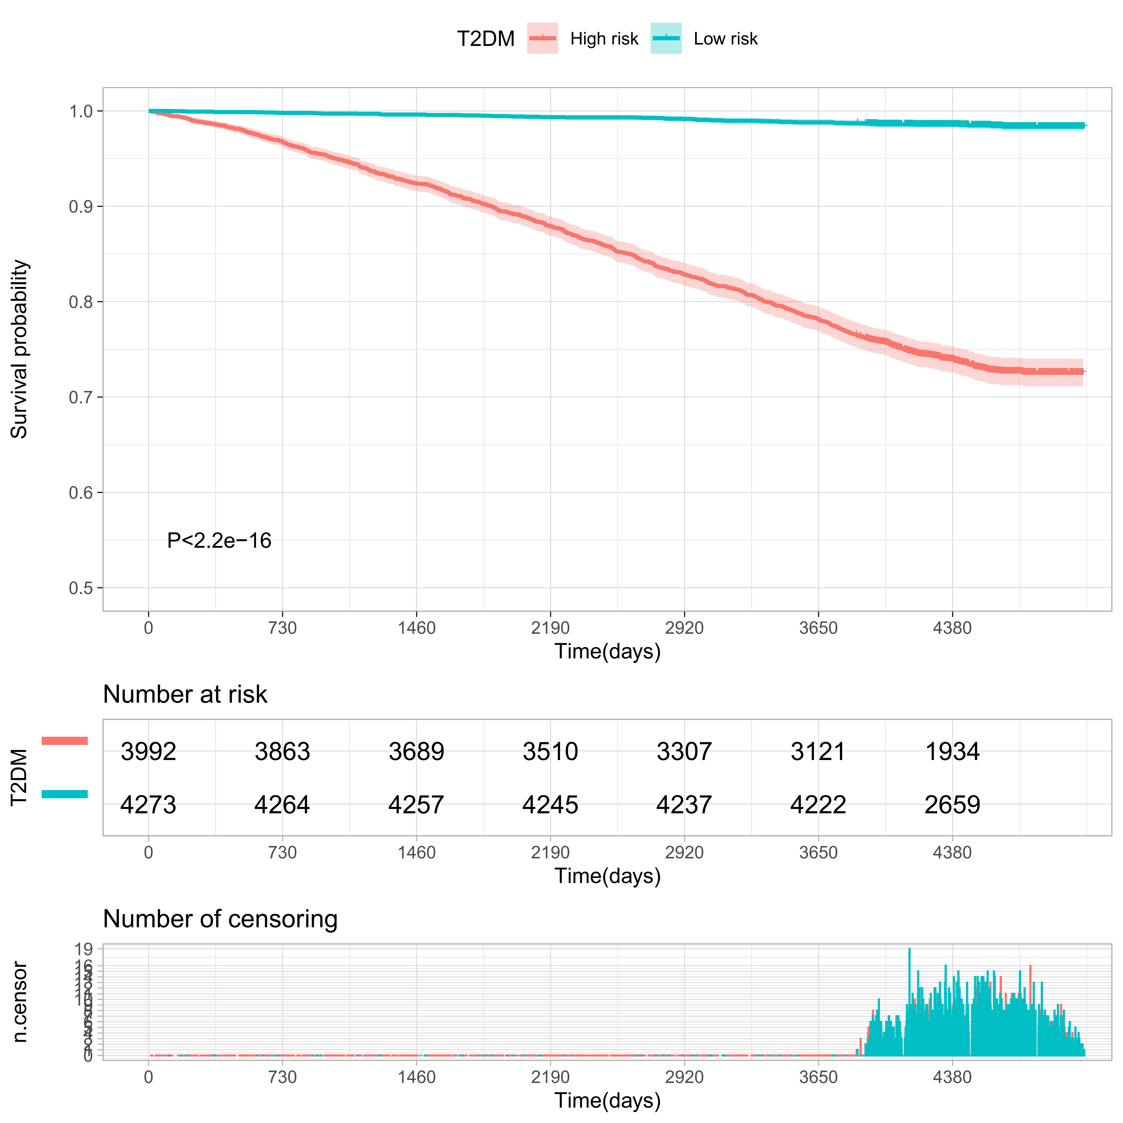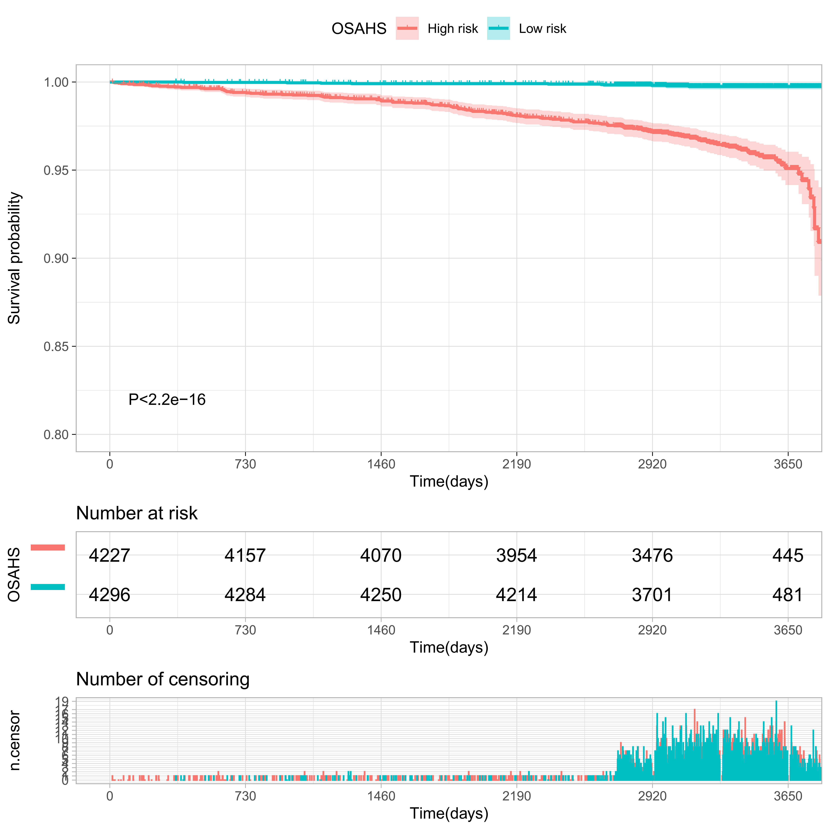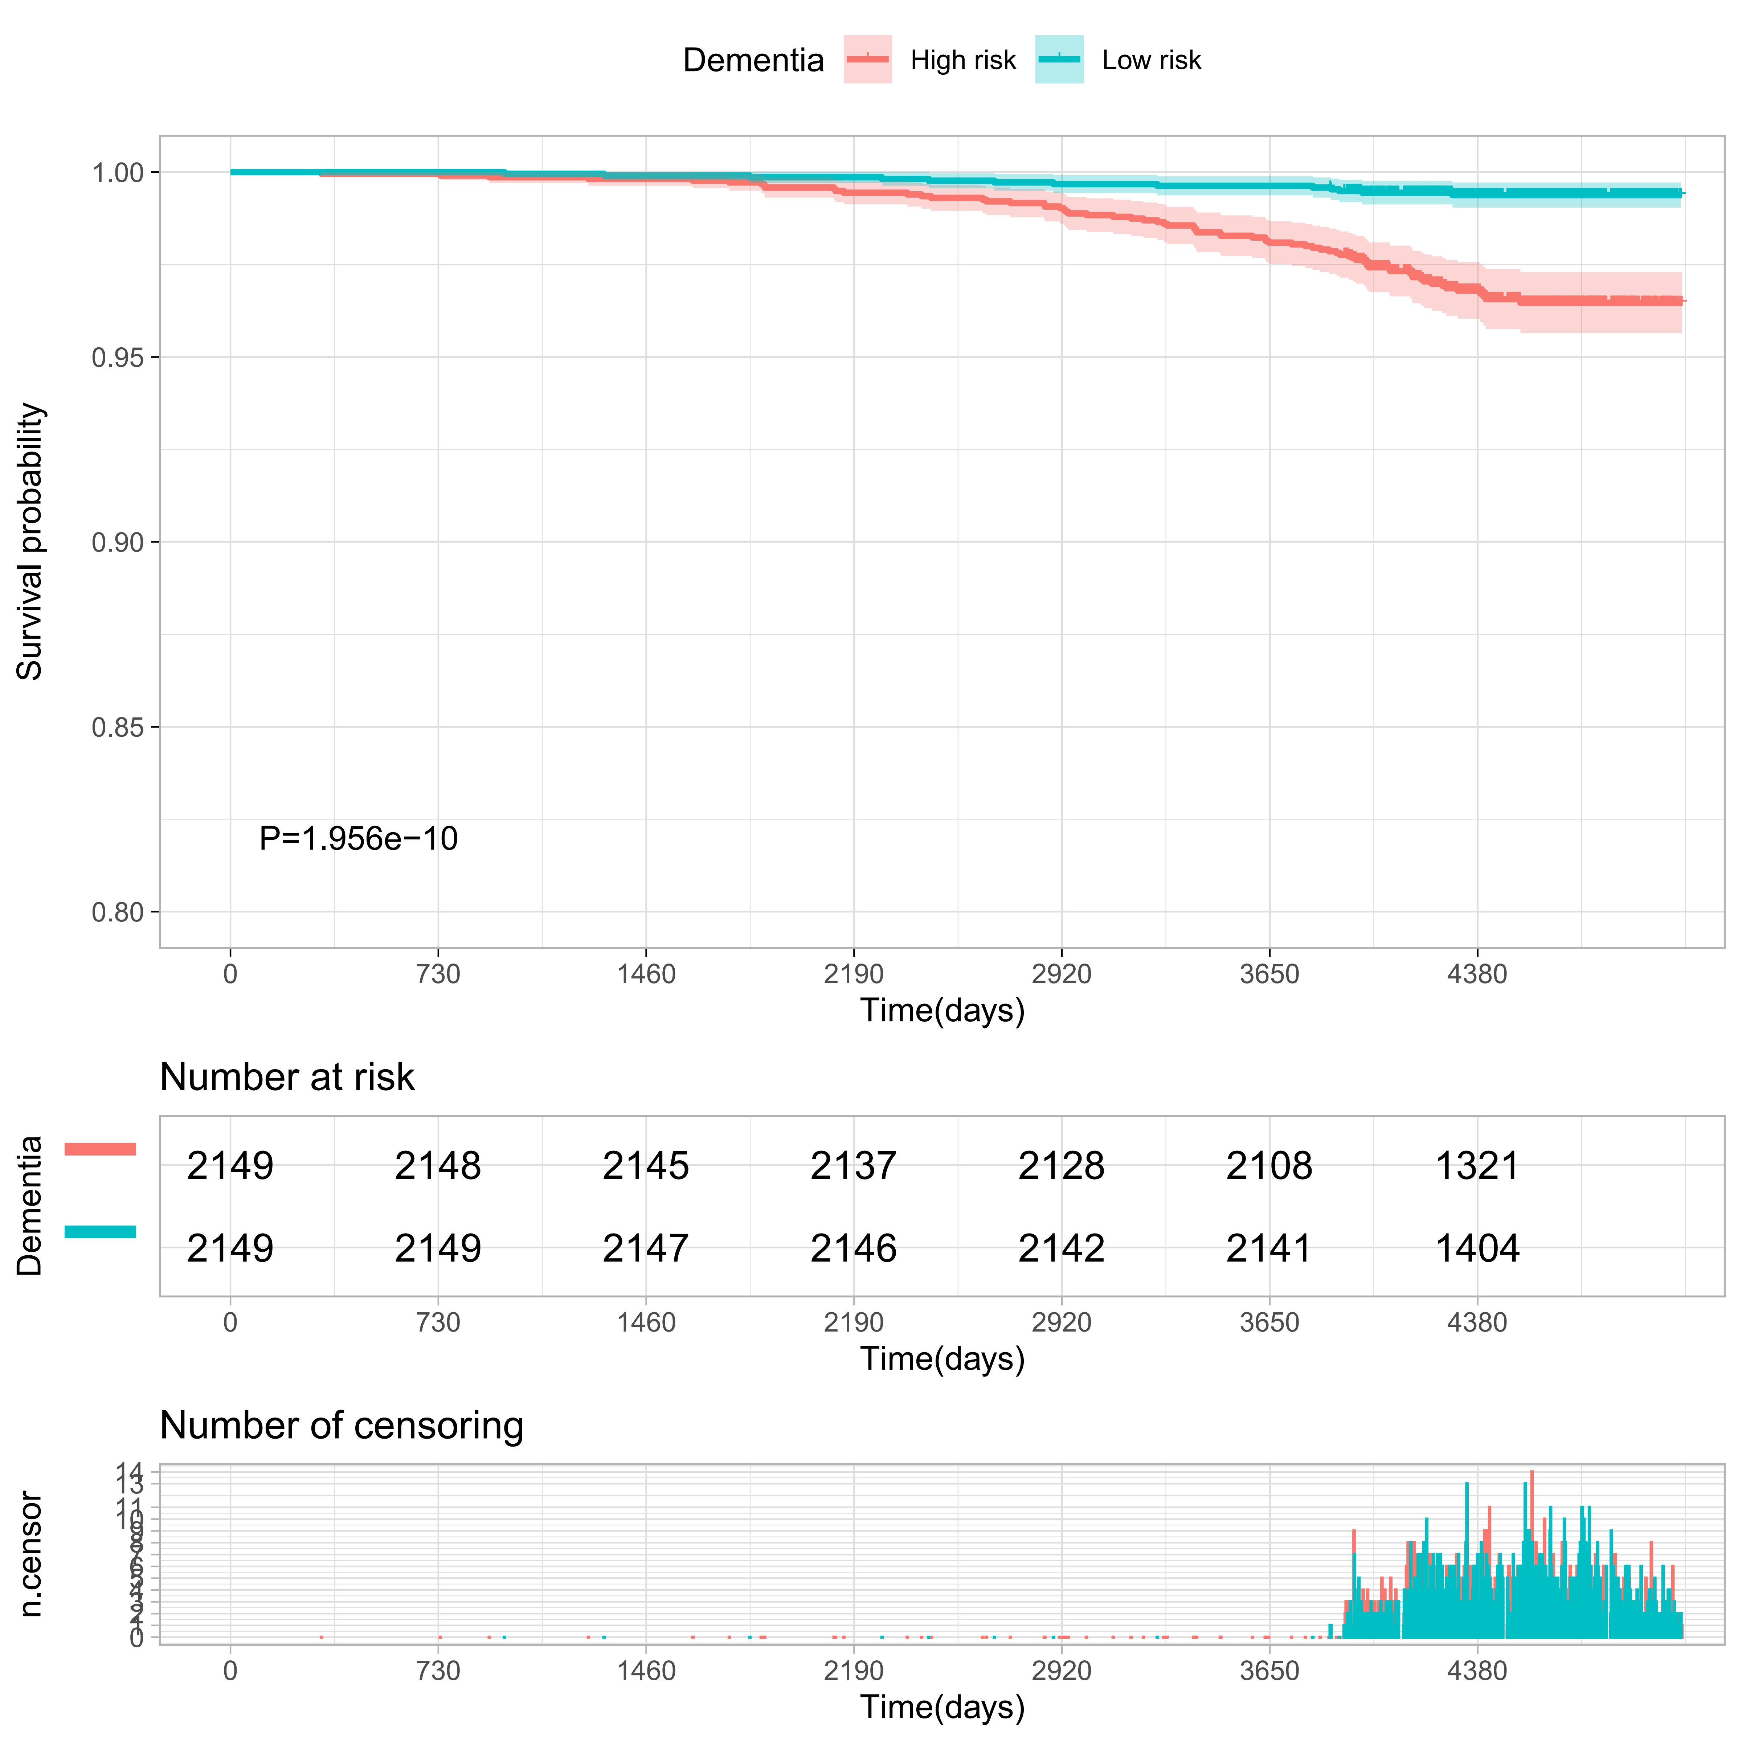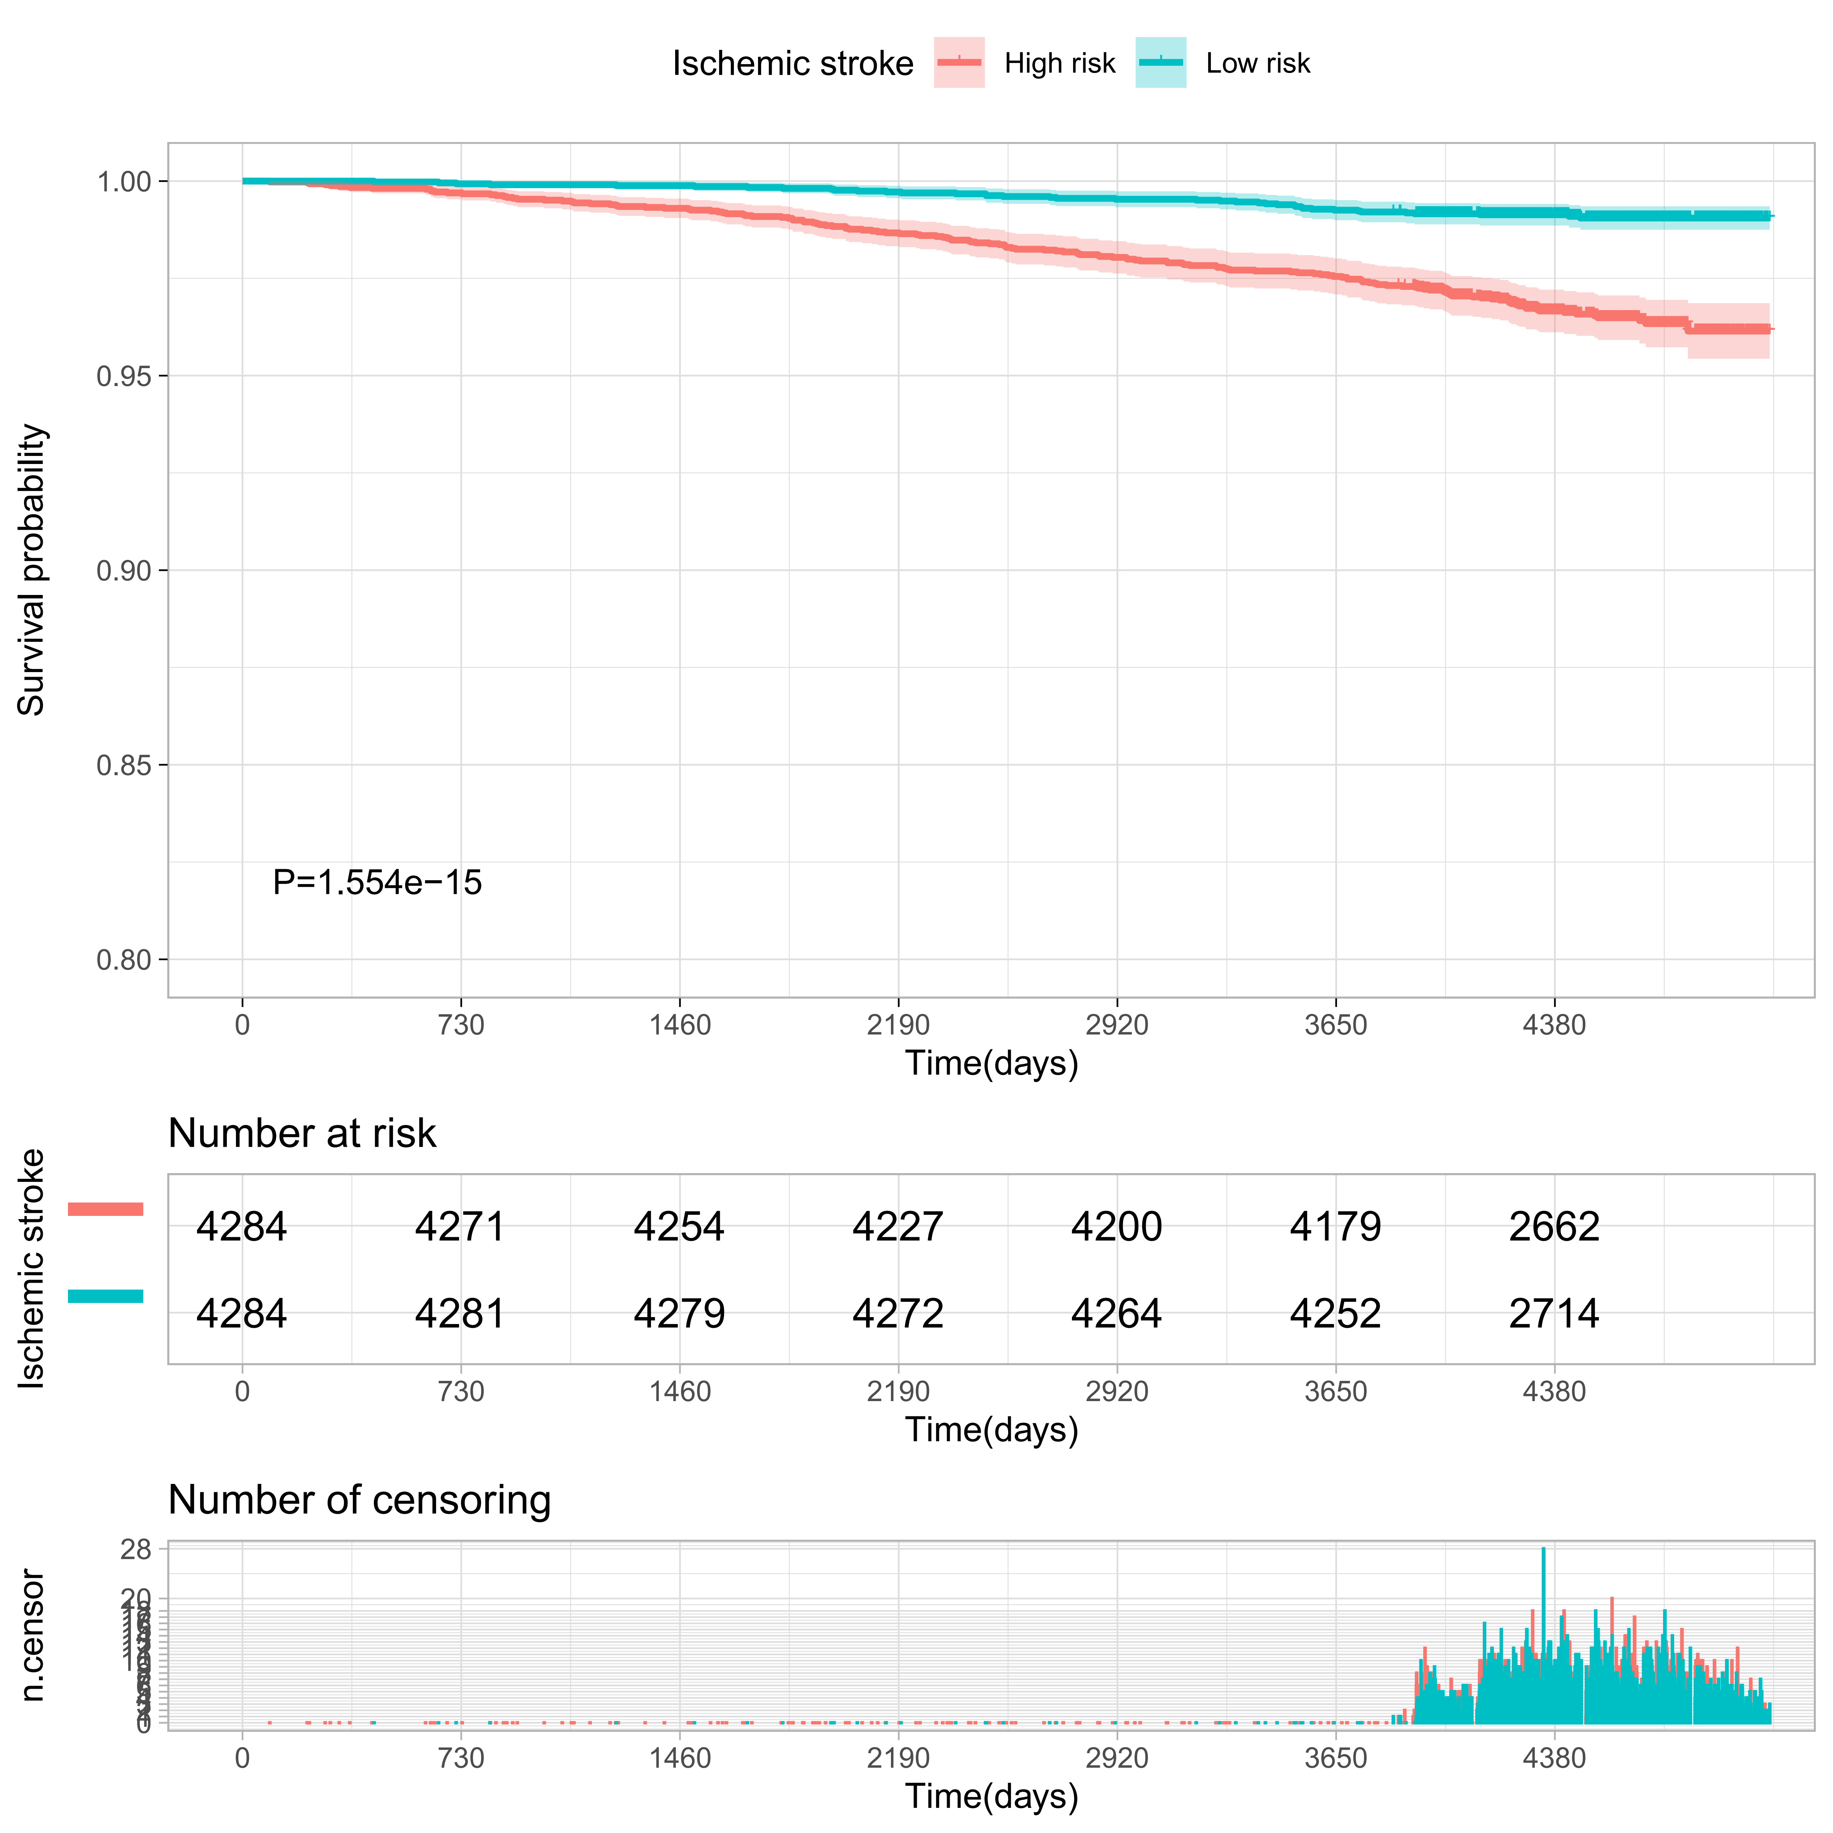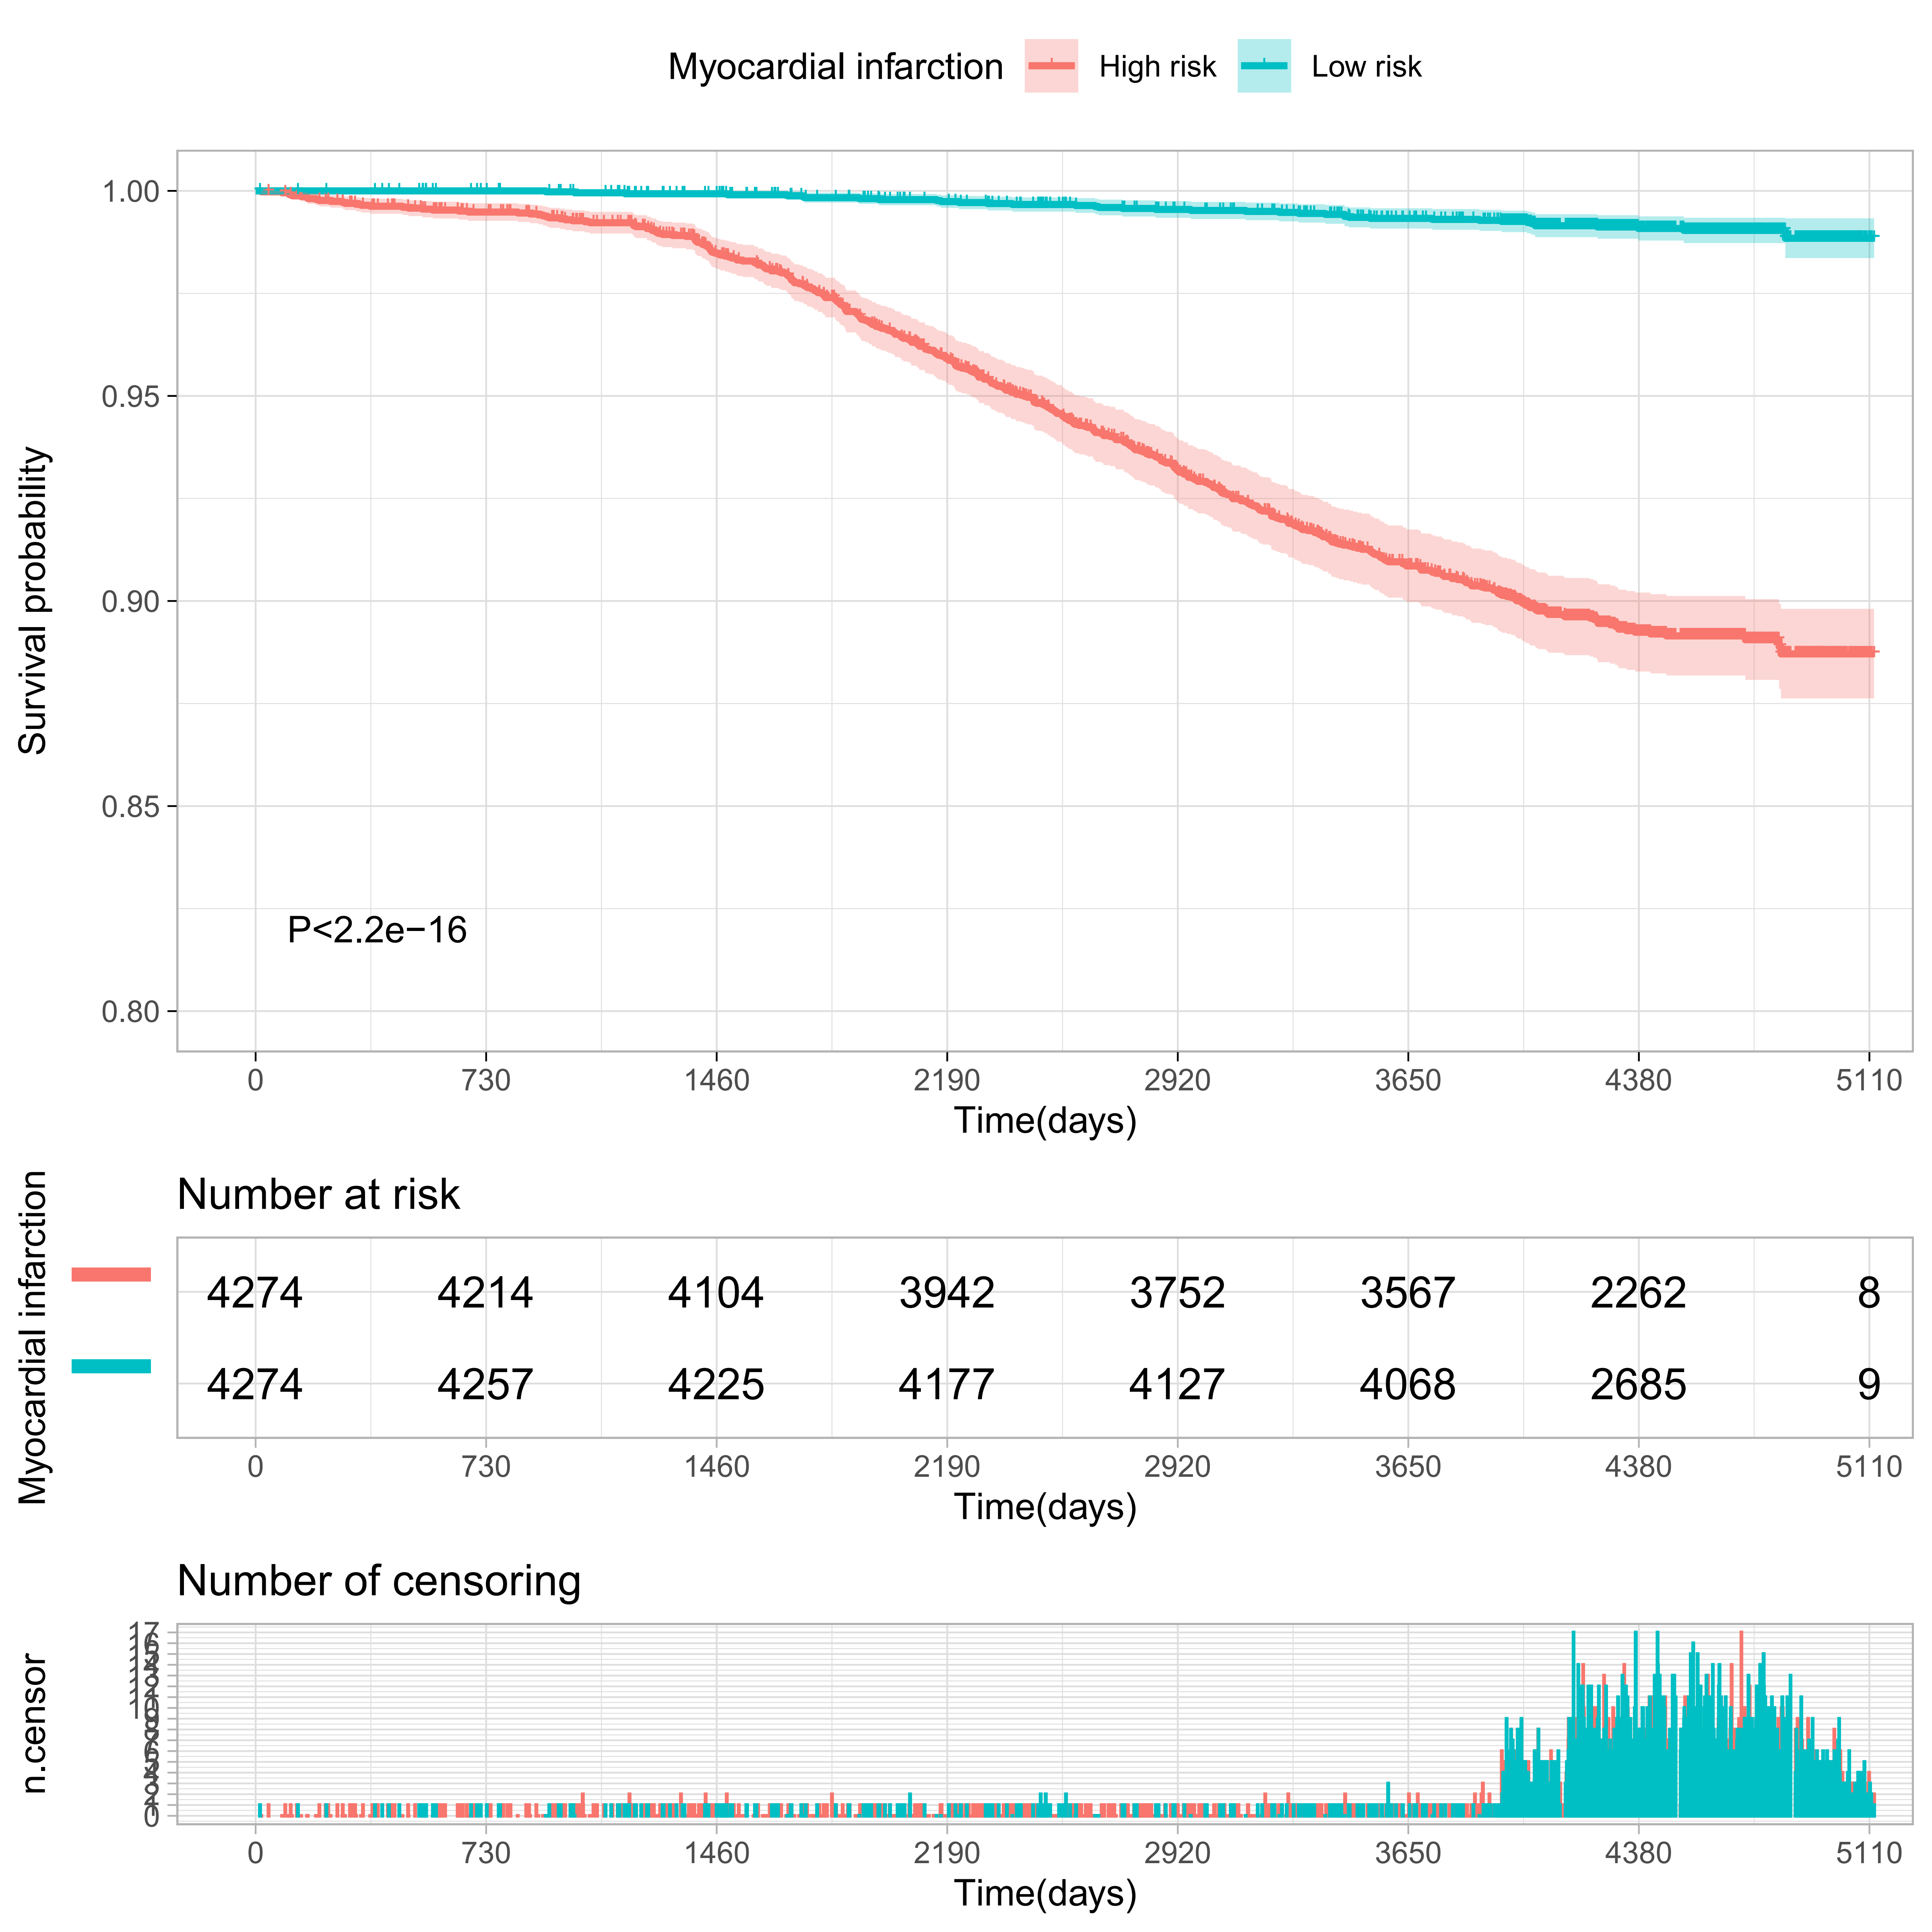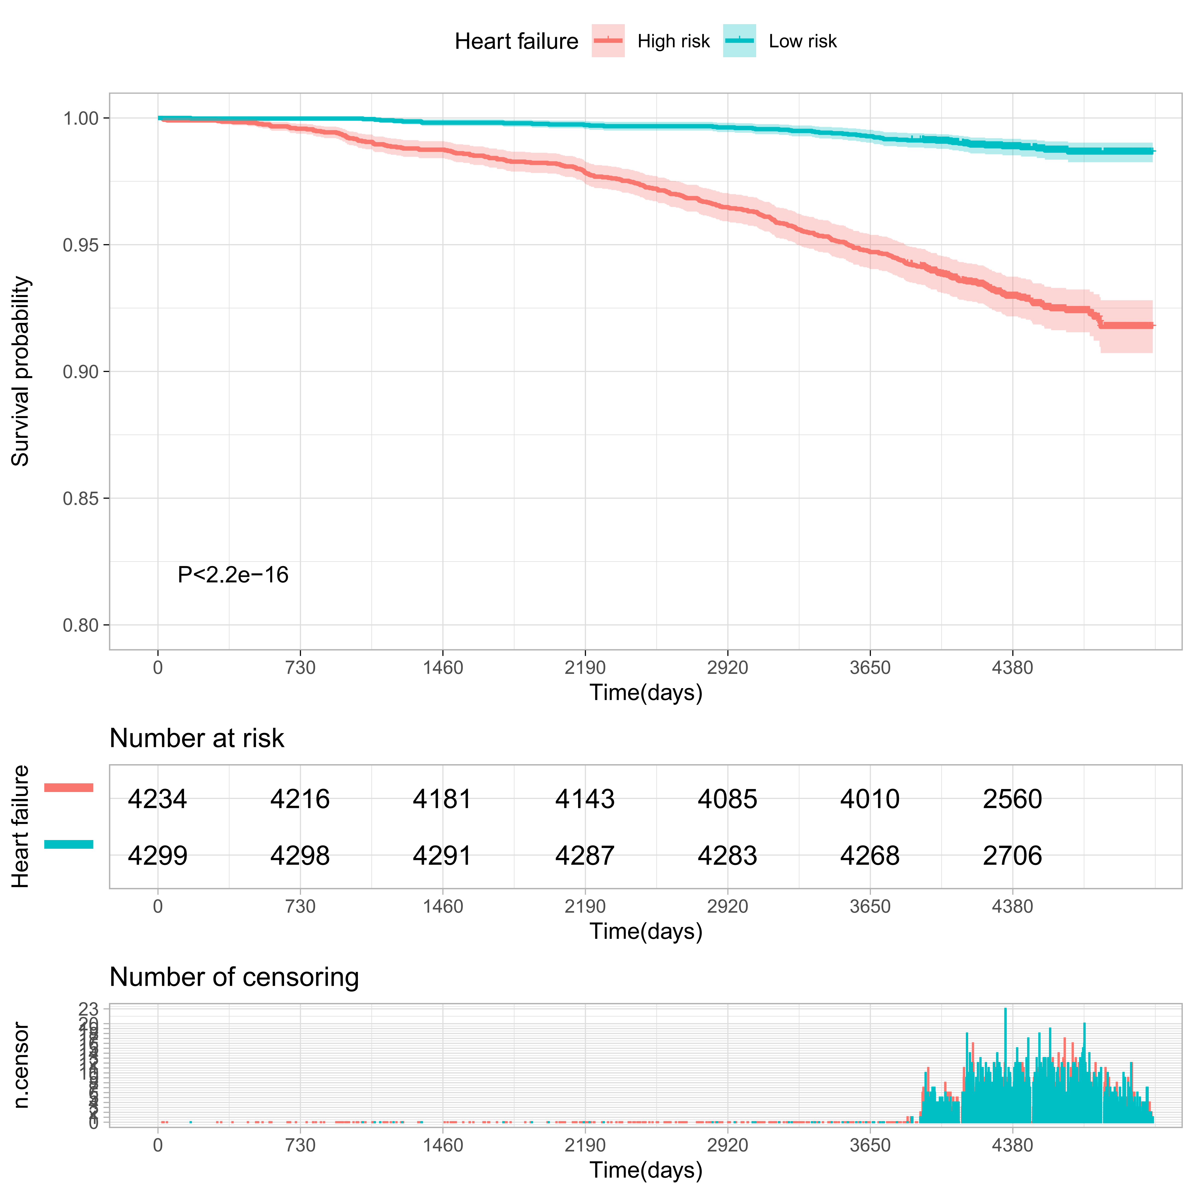

Supplementary Figure S7
Comparisons of mortality in the top and bottom 10% of the meta-GCIPL score in validation set.
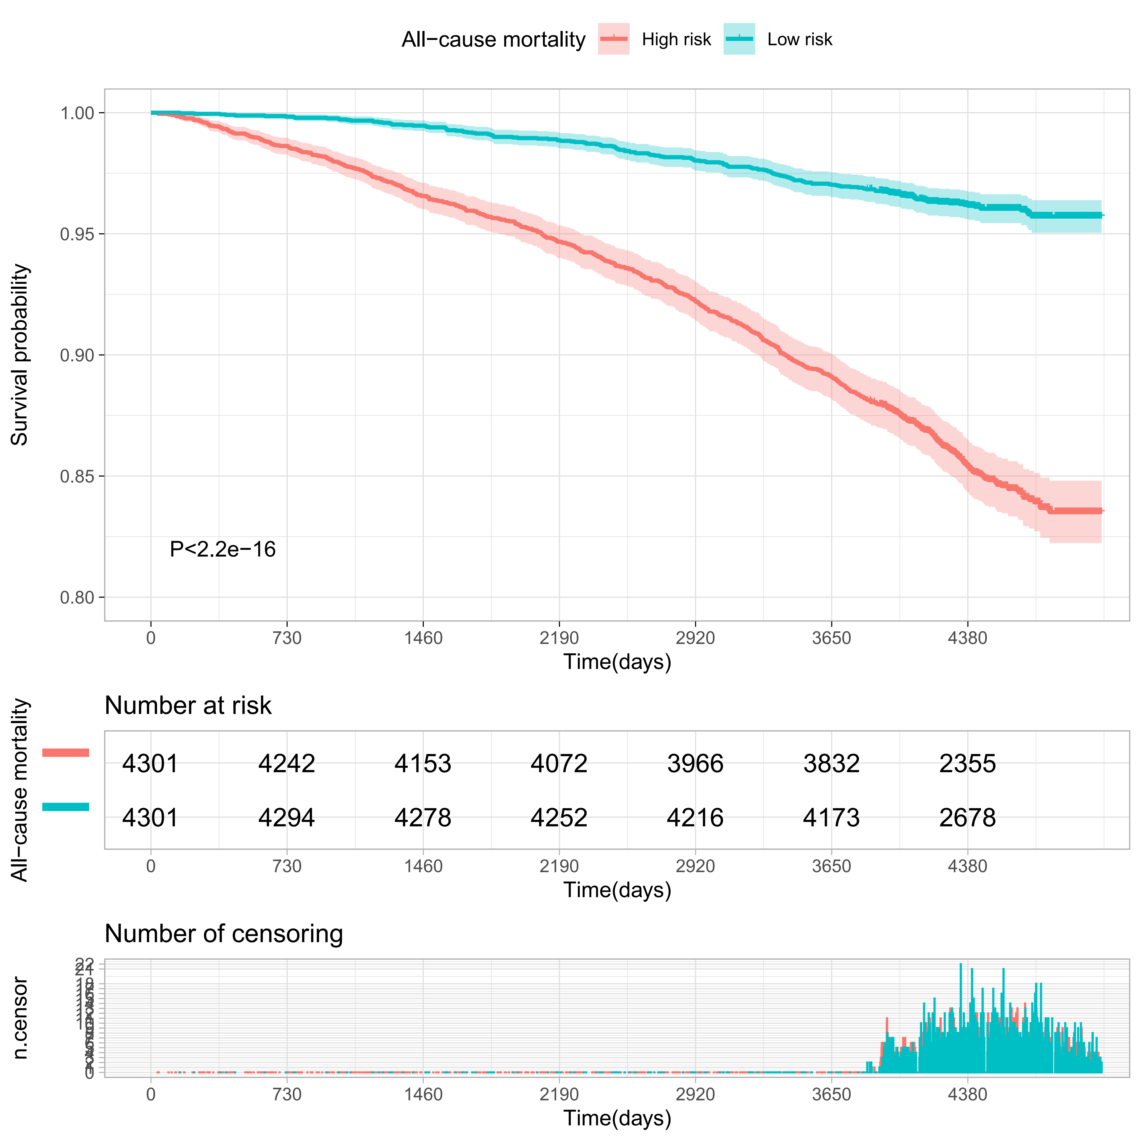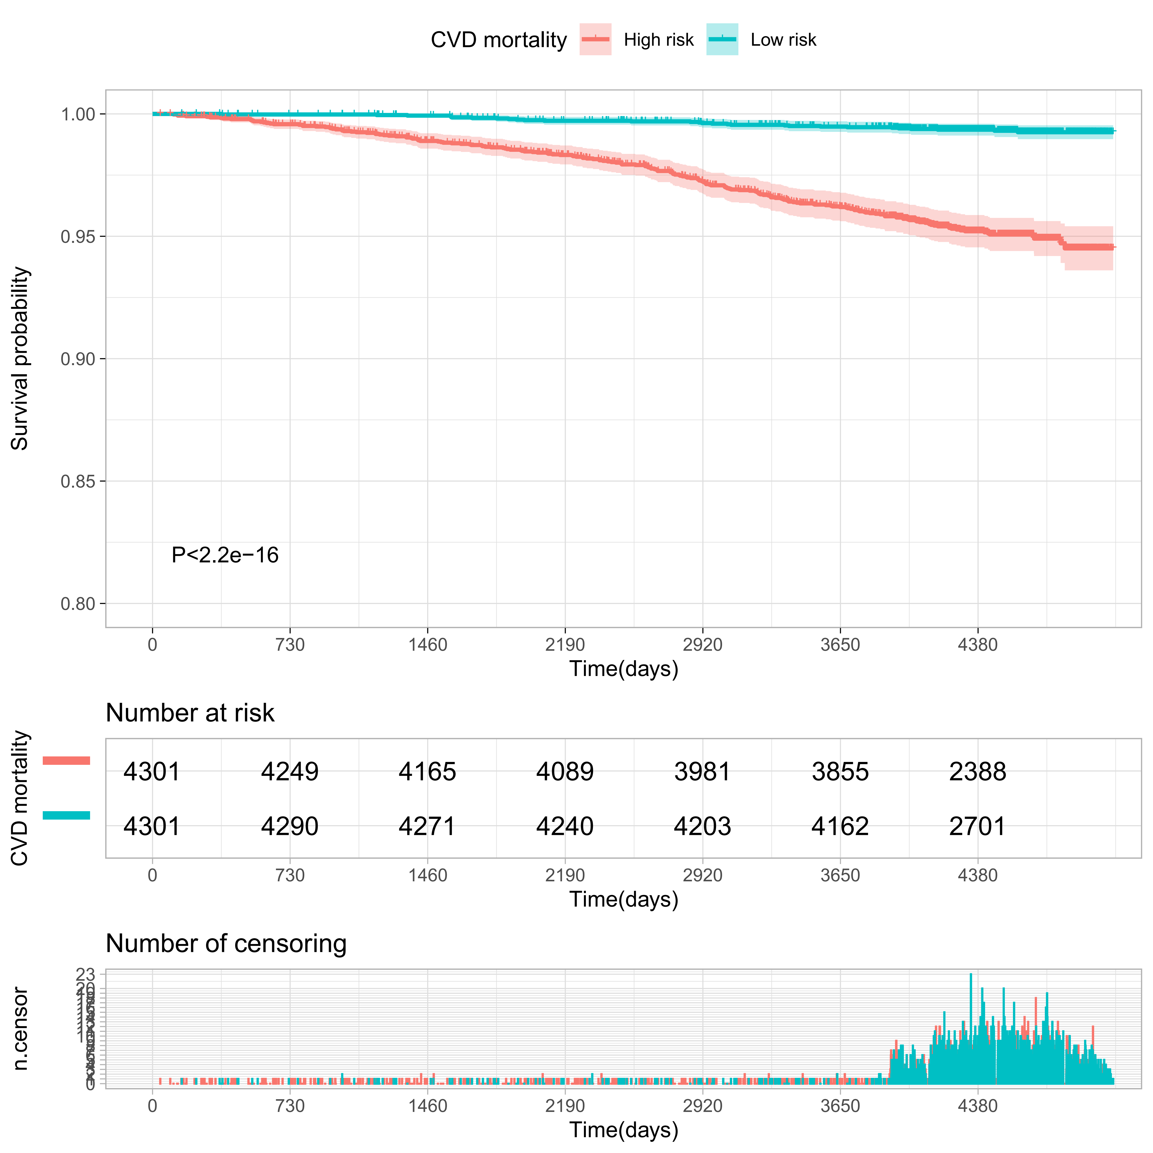
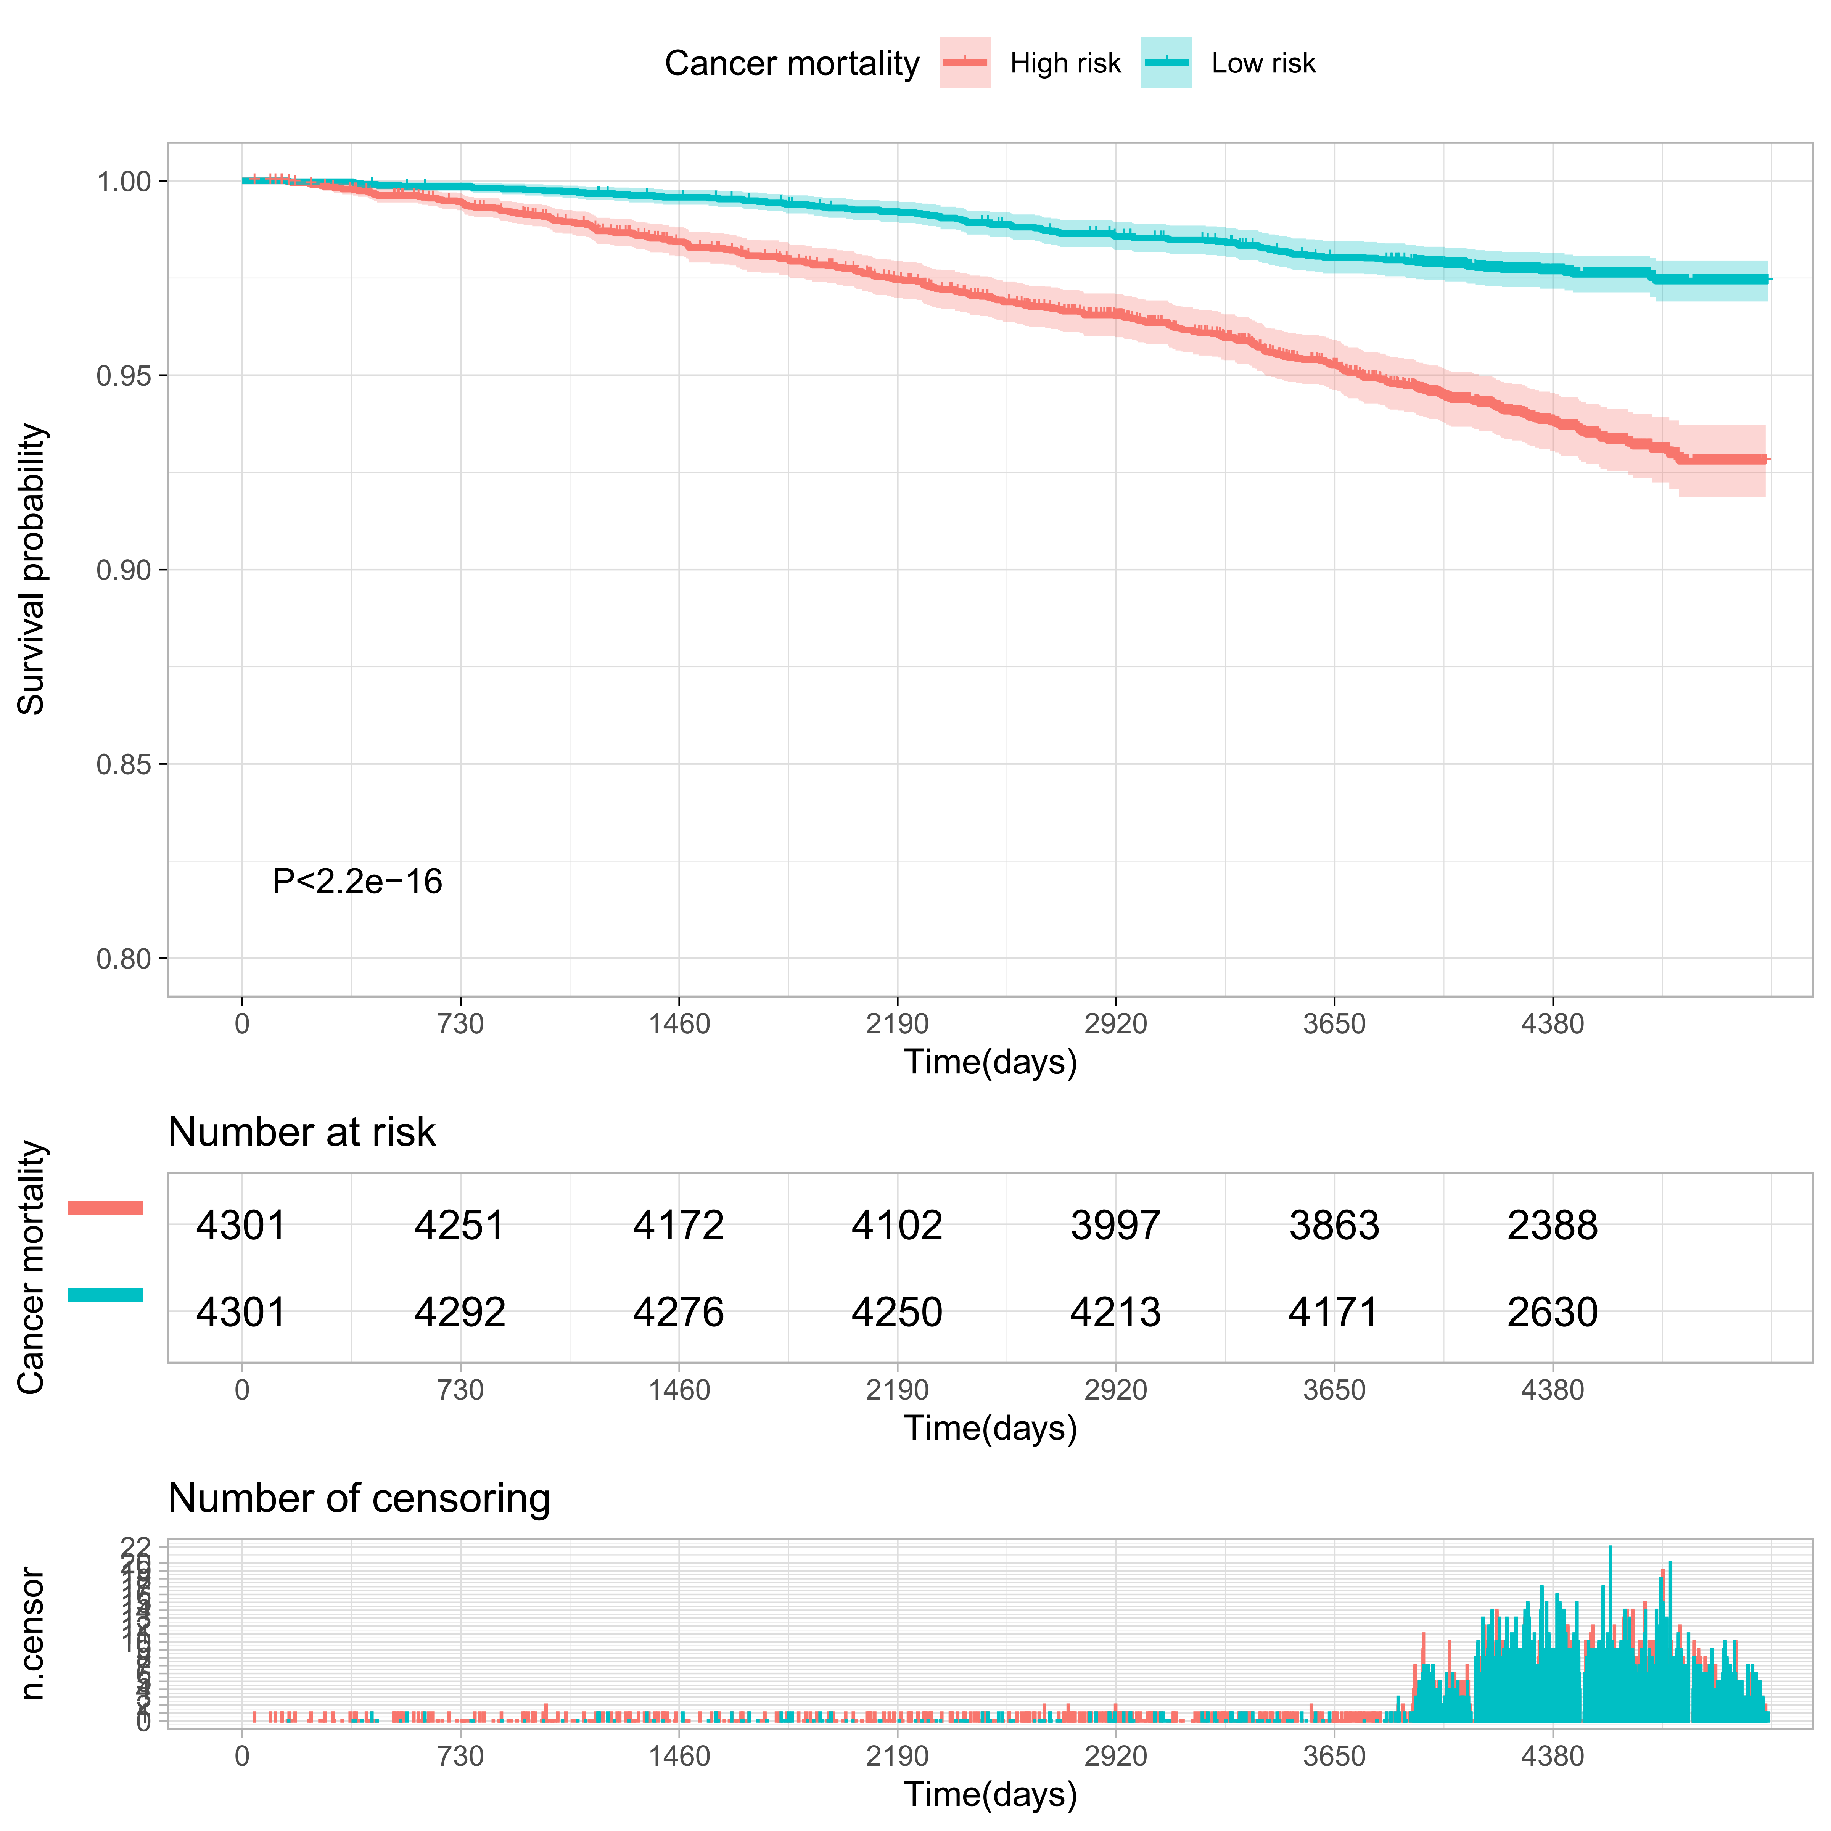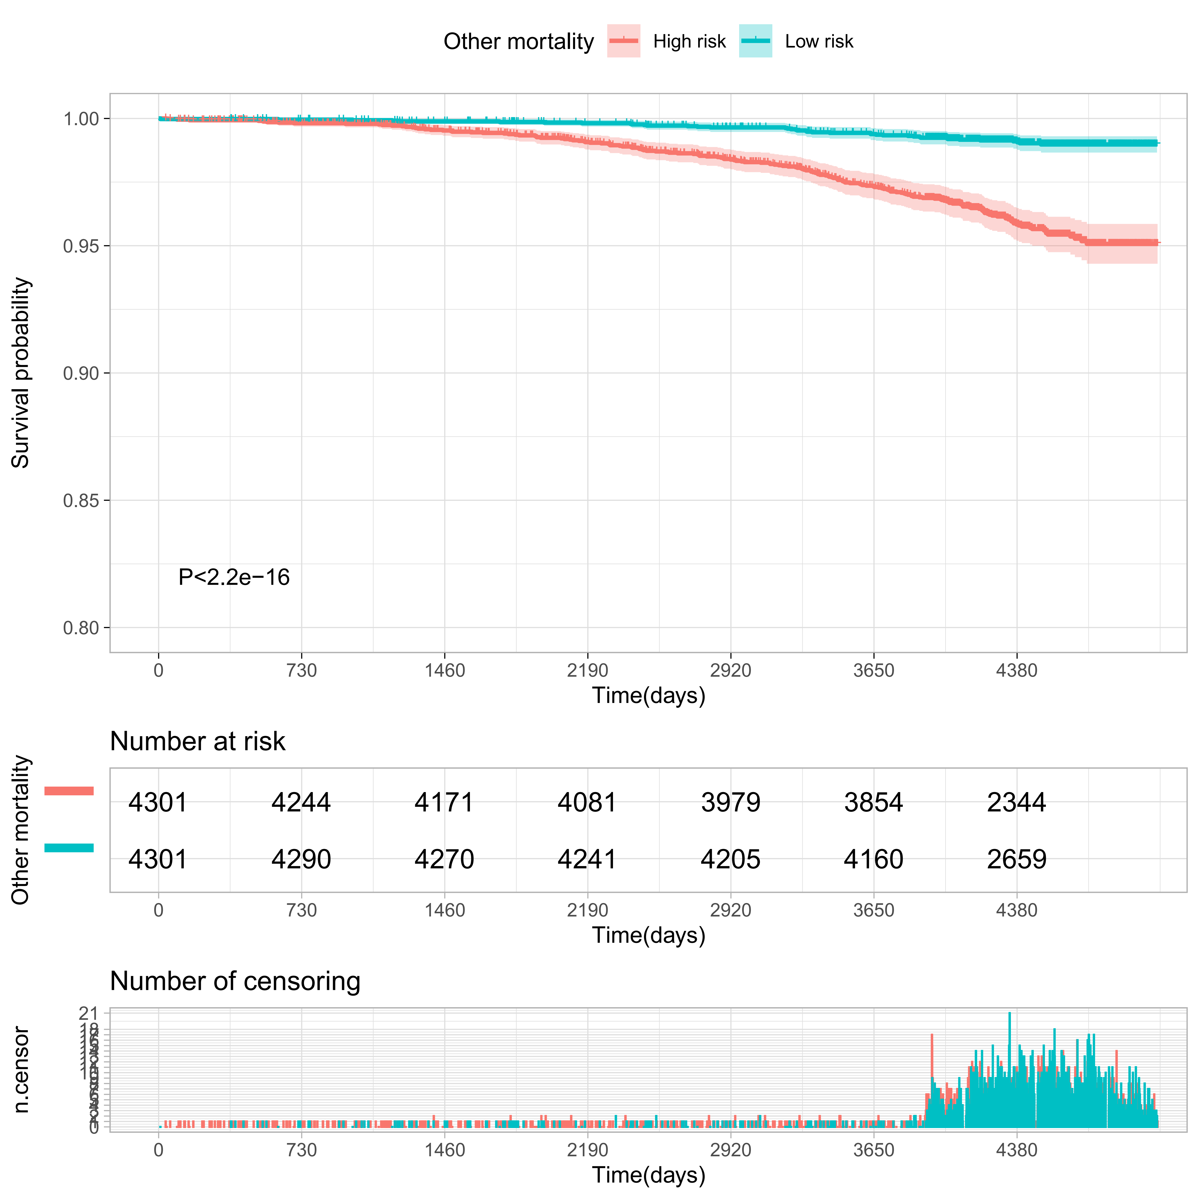

Supplementary Figure S8
Receiver operating characteristic (ROC) curves of established risk factors and meta-GCIPLT score for predicting systemic diseases in validation set.
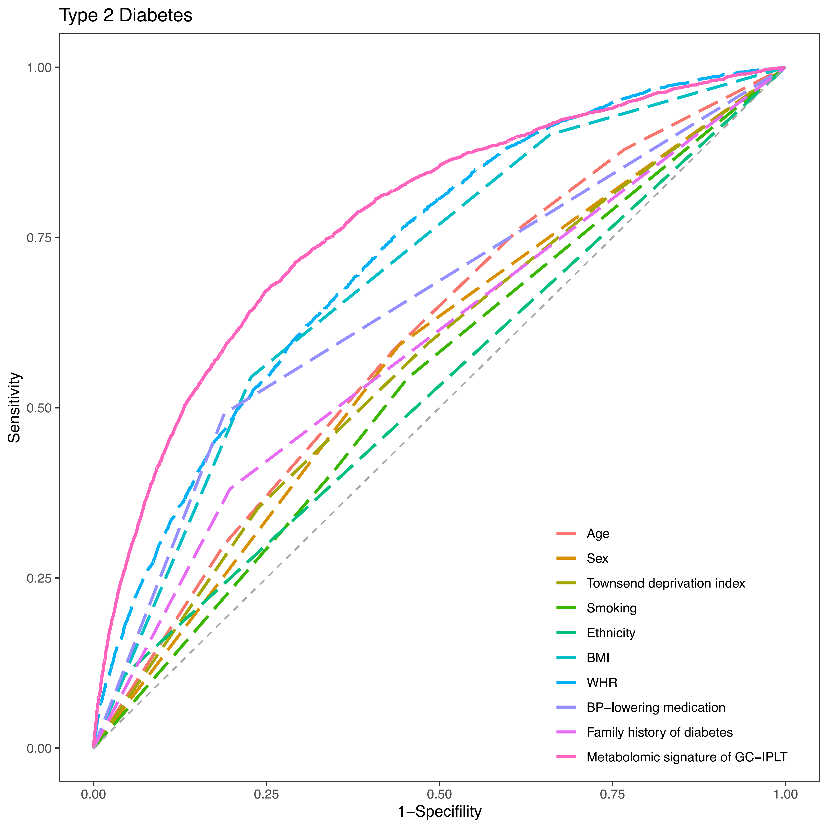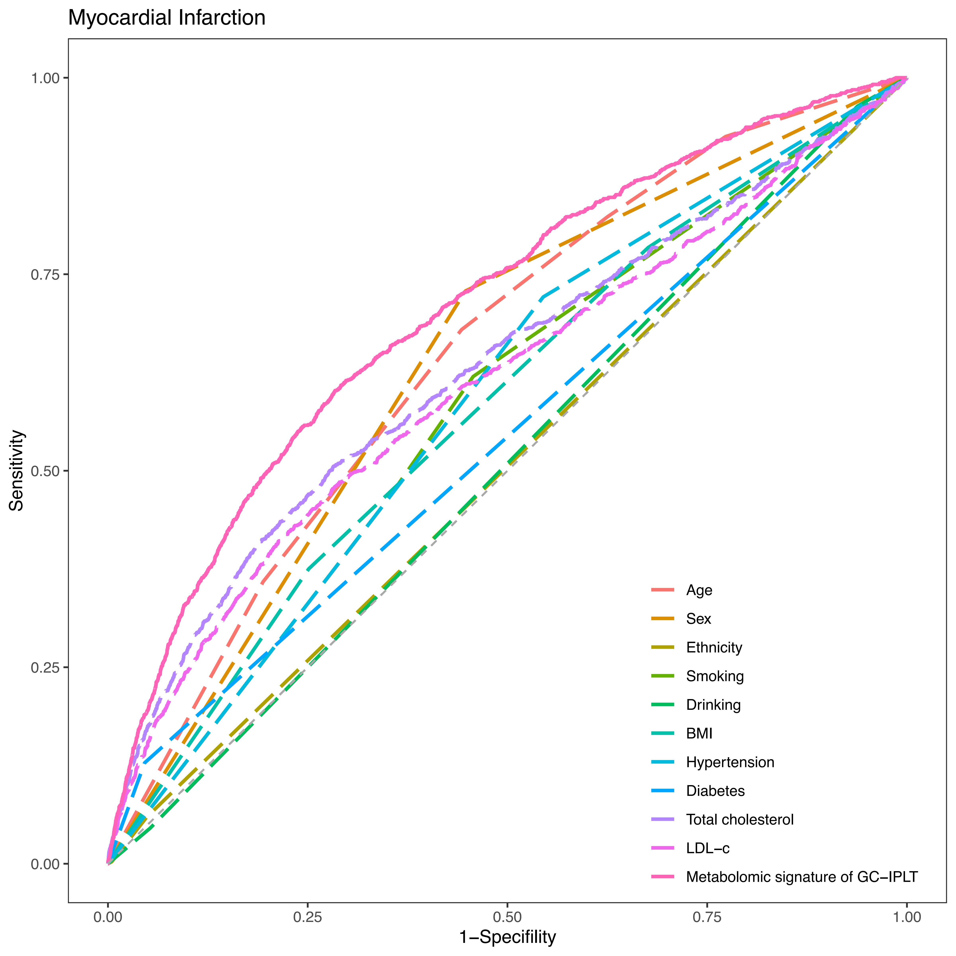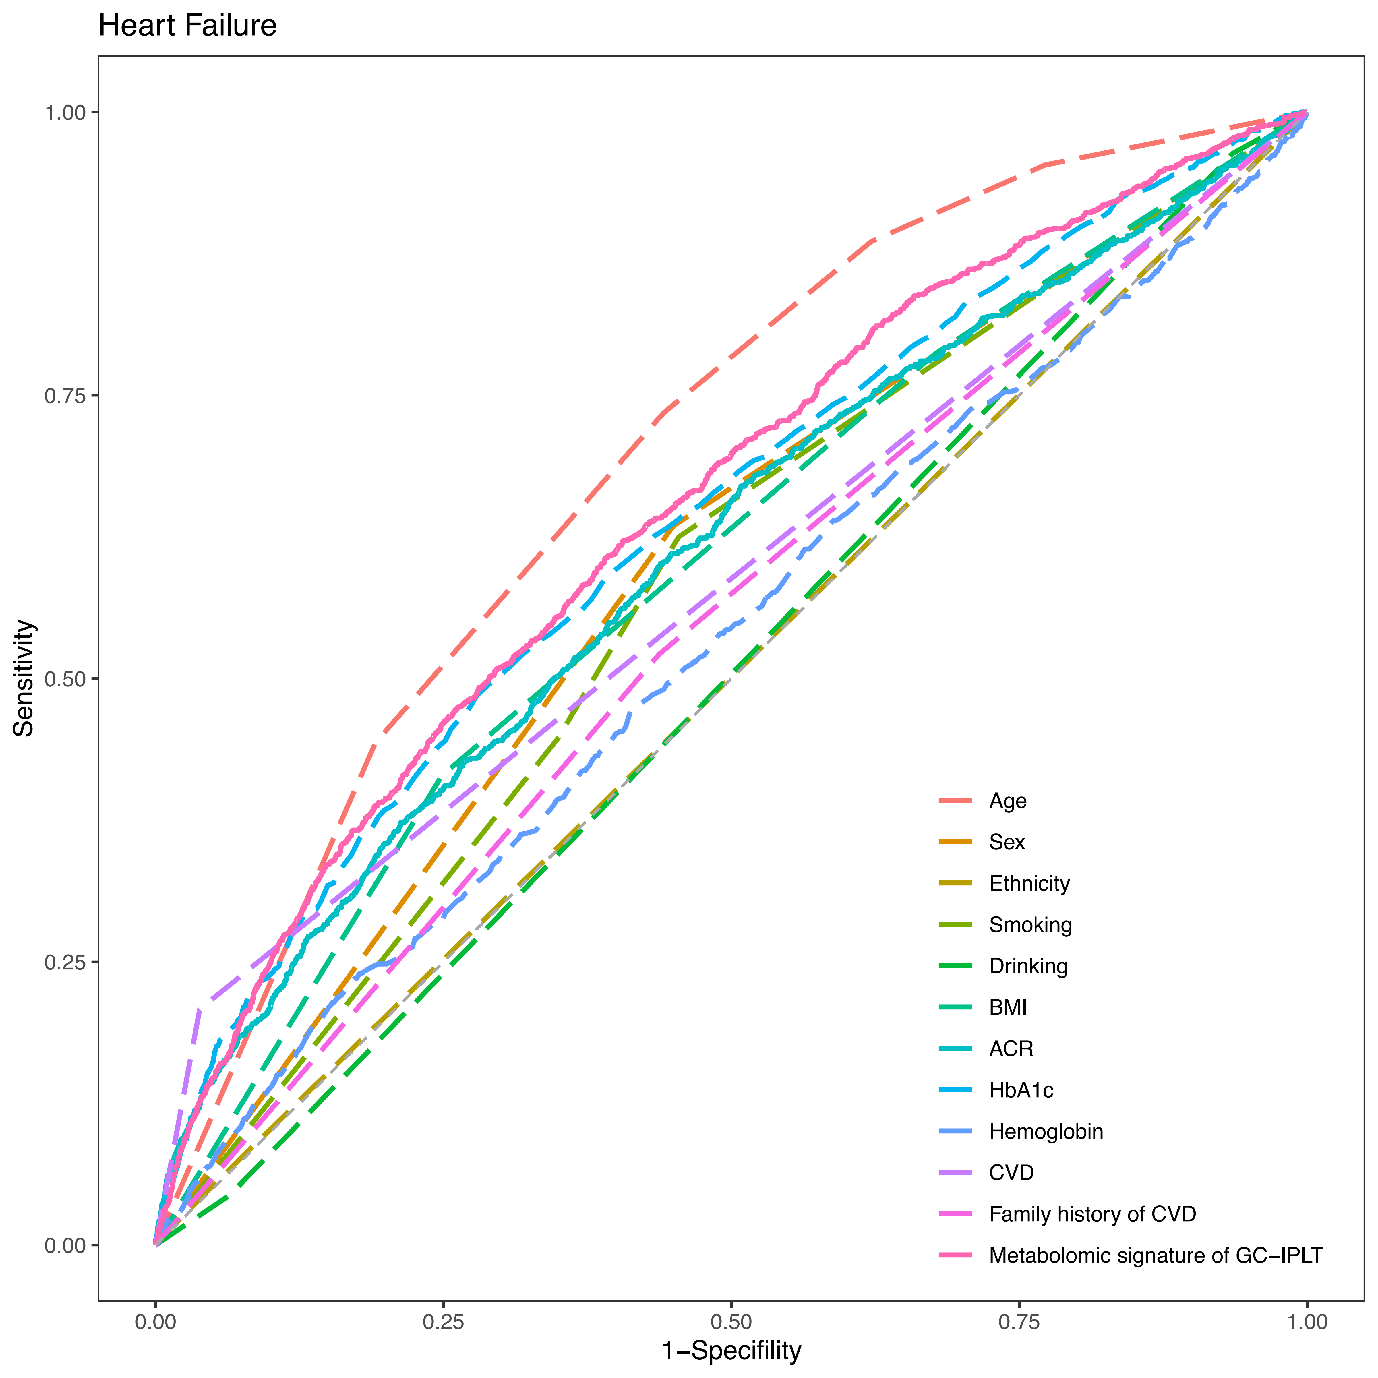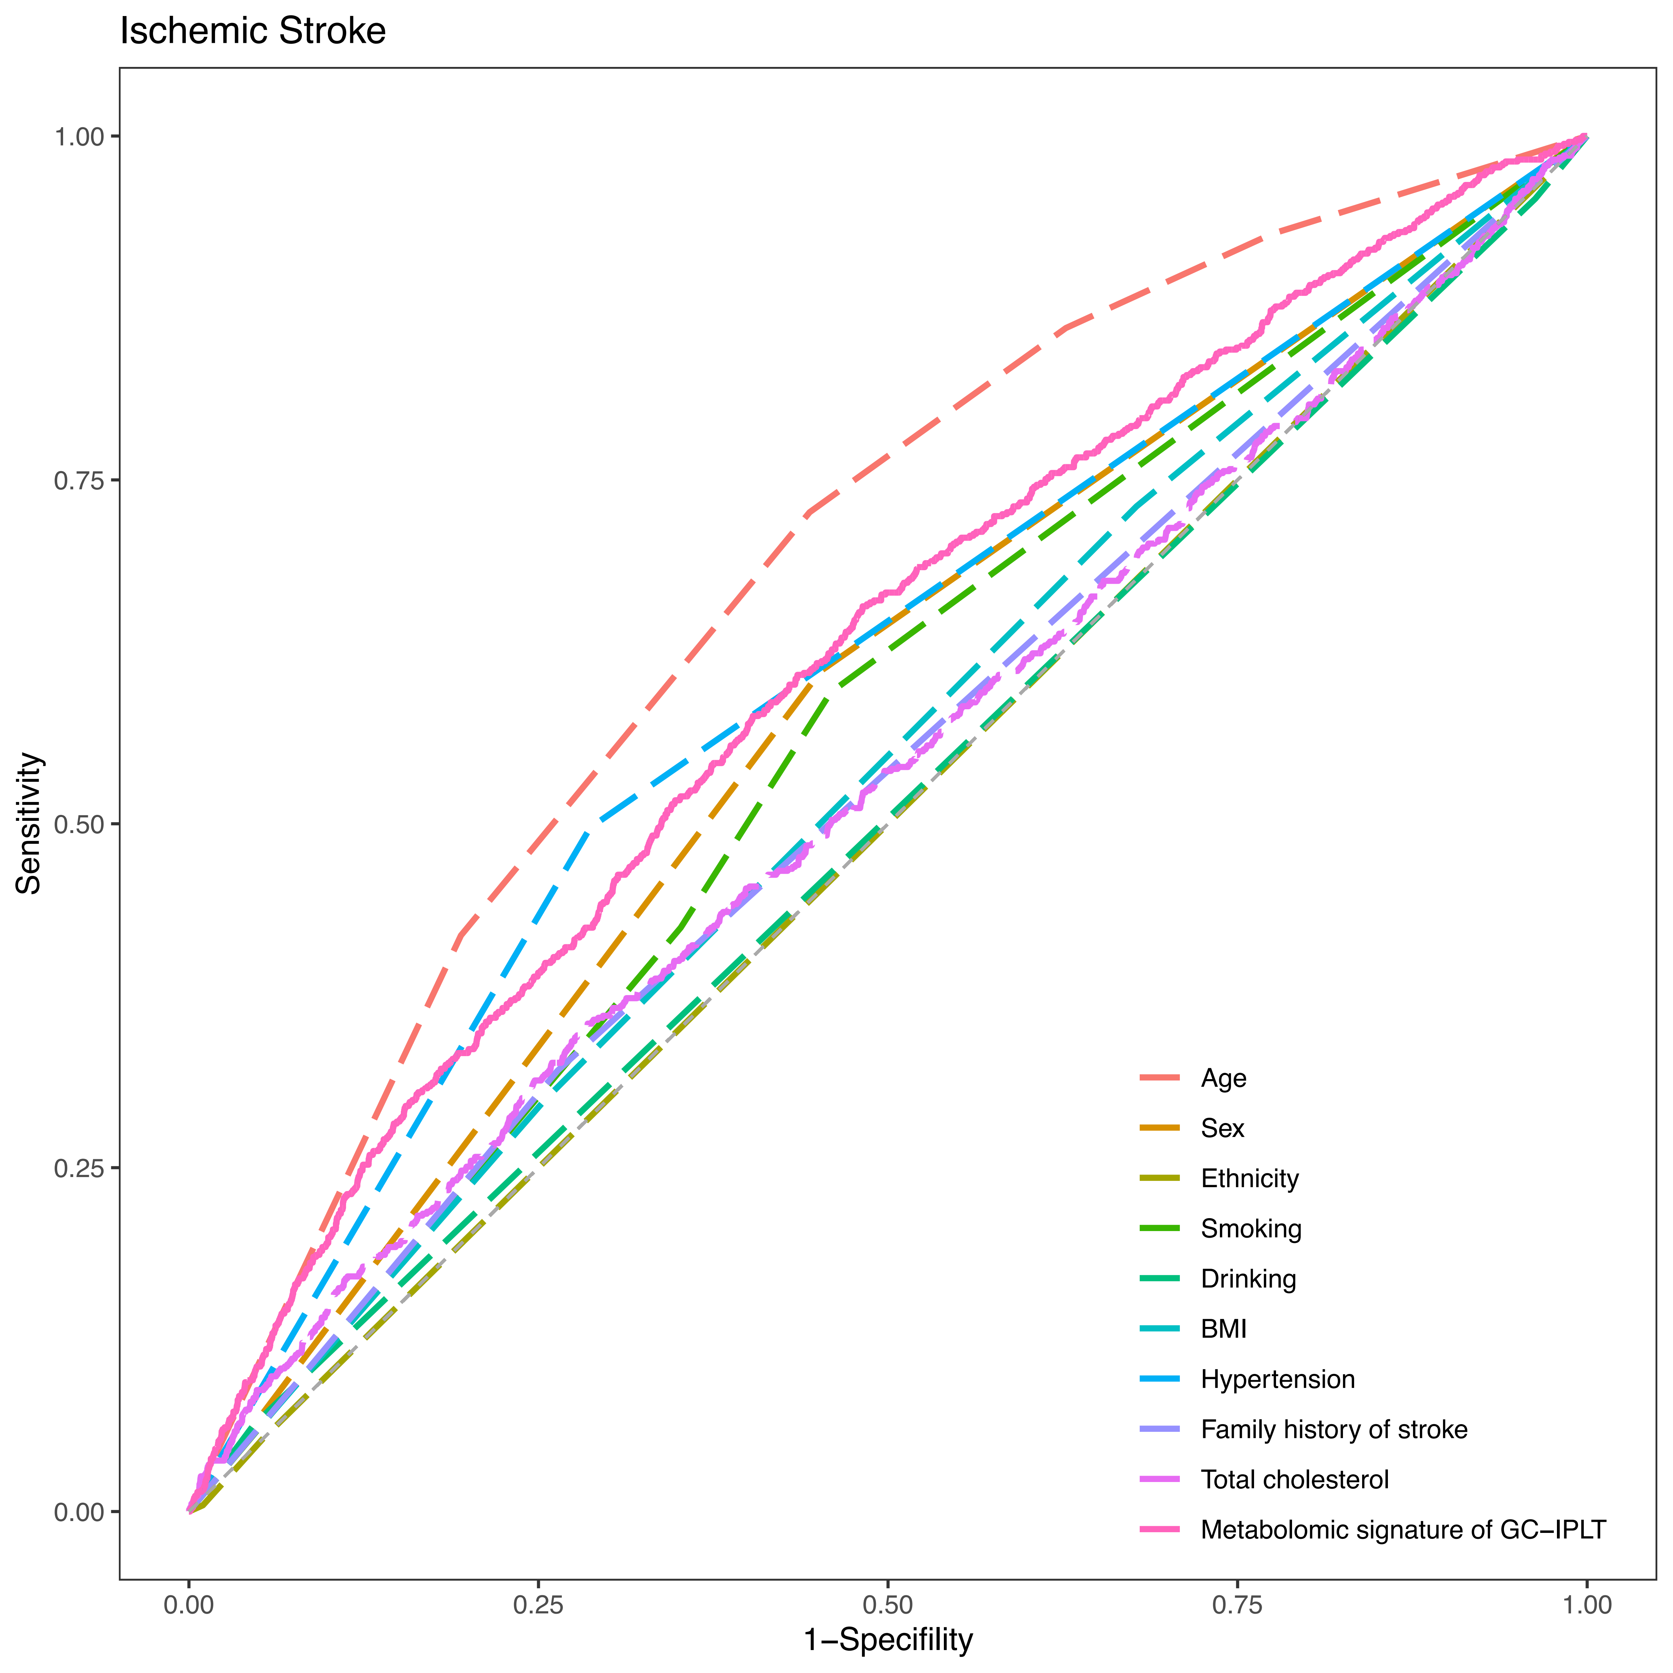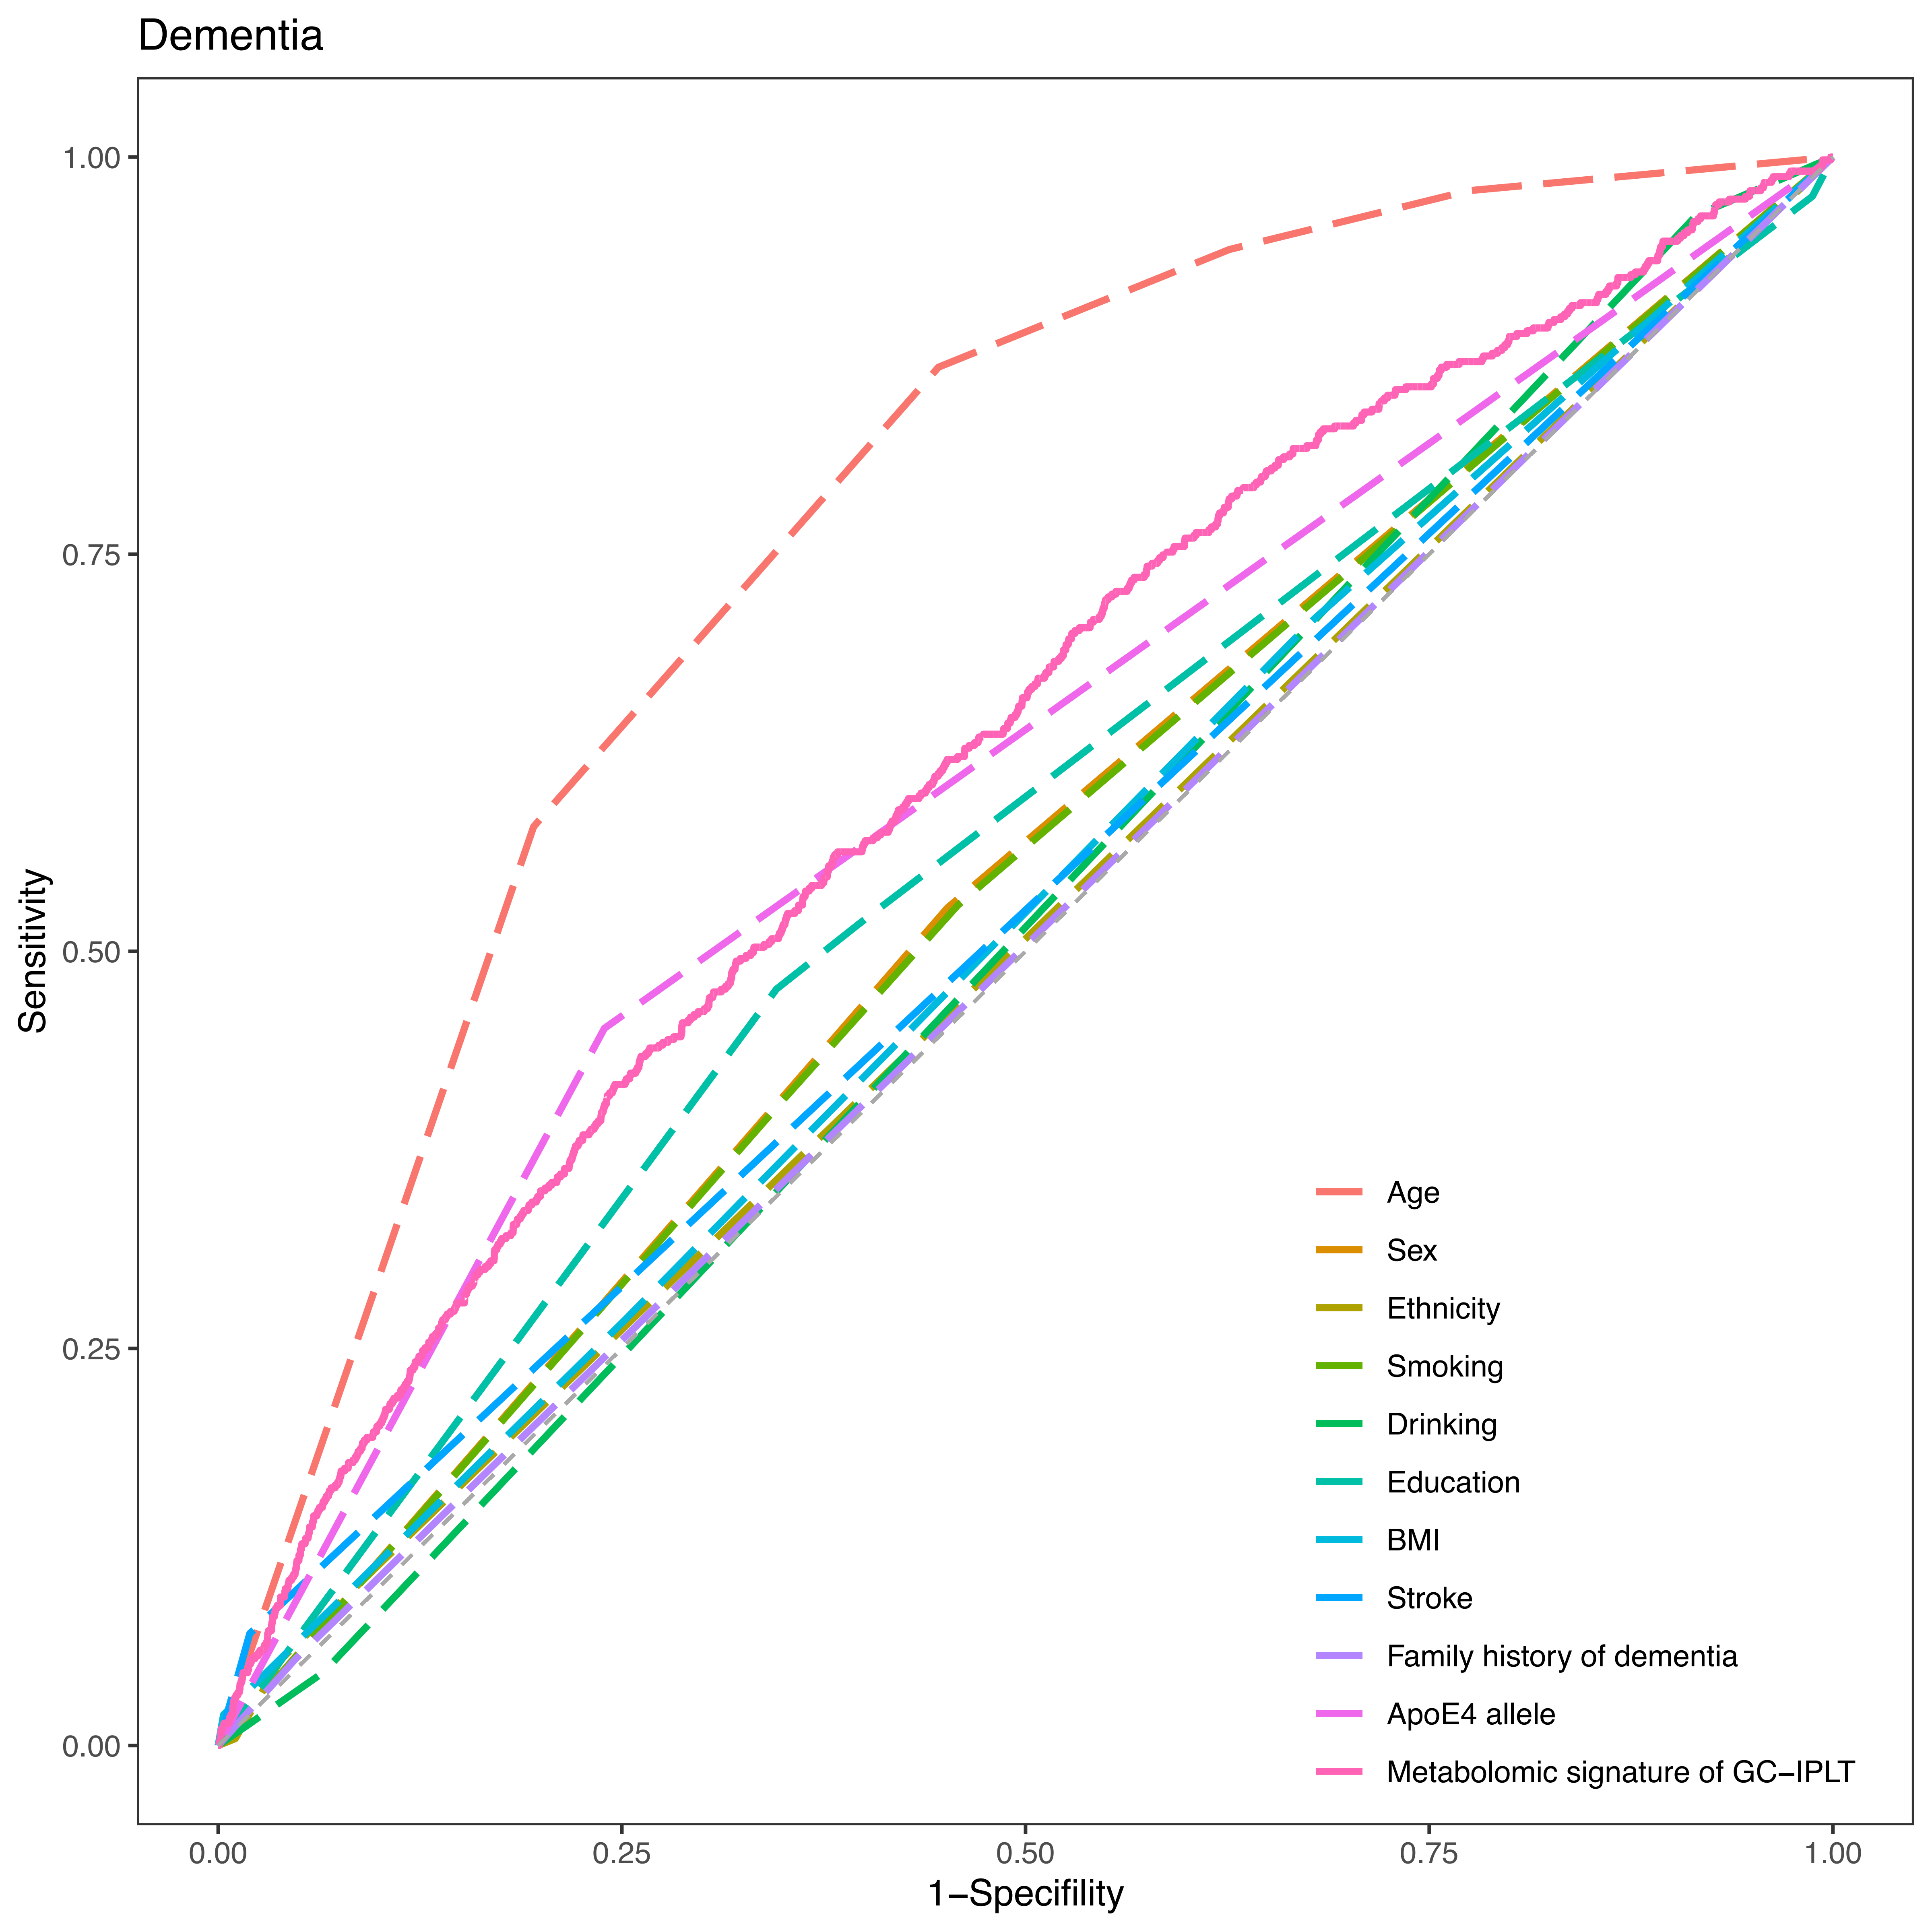

Supplementary Figure S9
Receiver operating characteristic (ROC) curves of established risk factors and meta-GCIPLT score for predicting mortality in validation set.
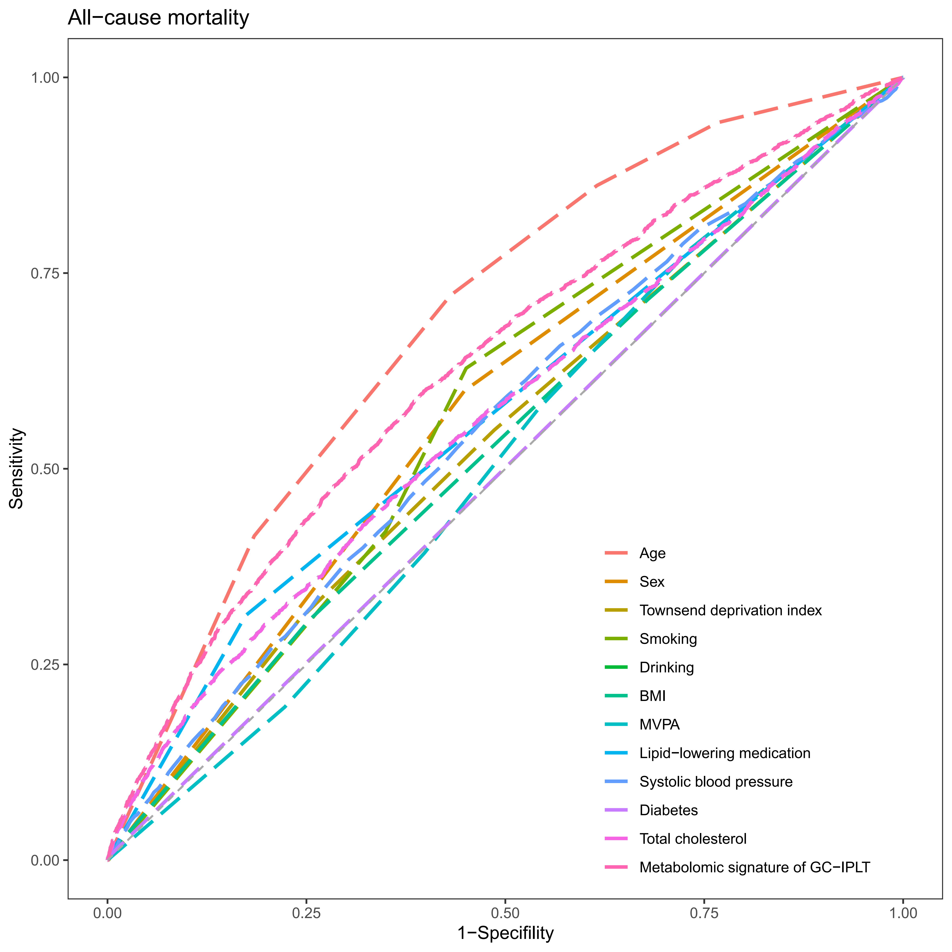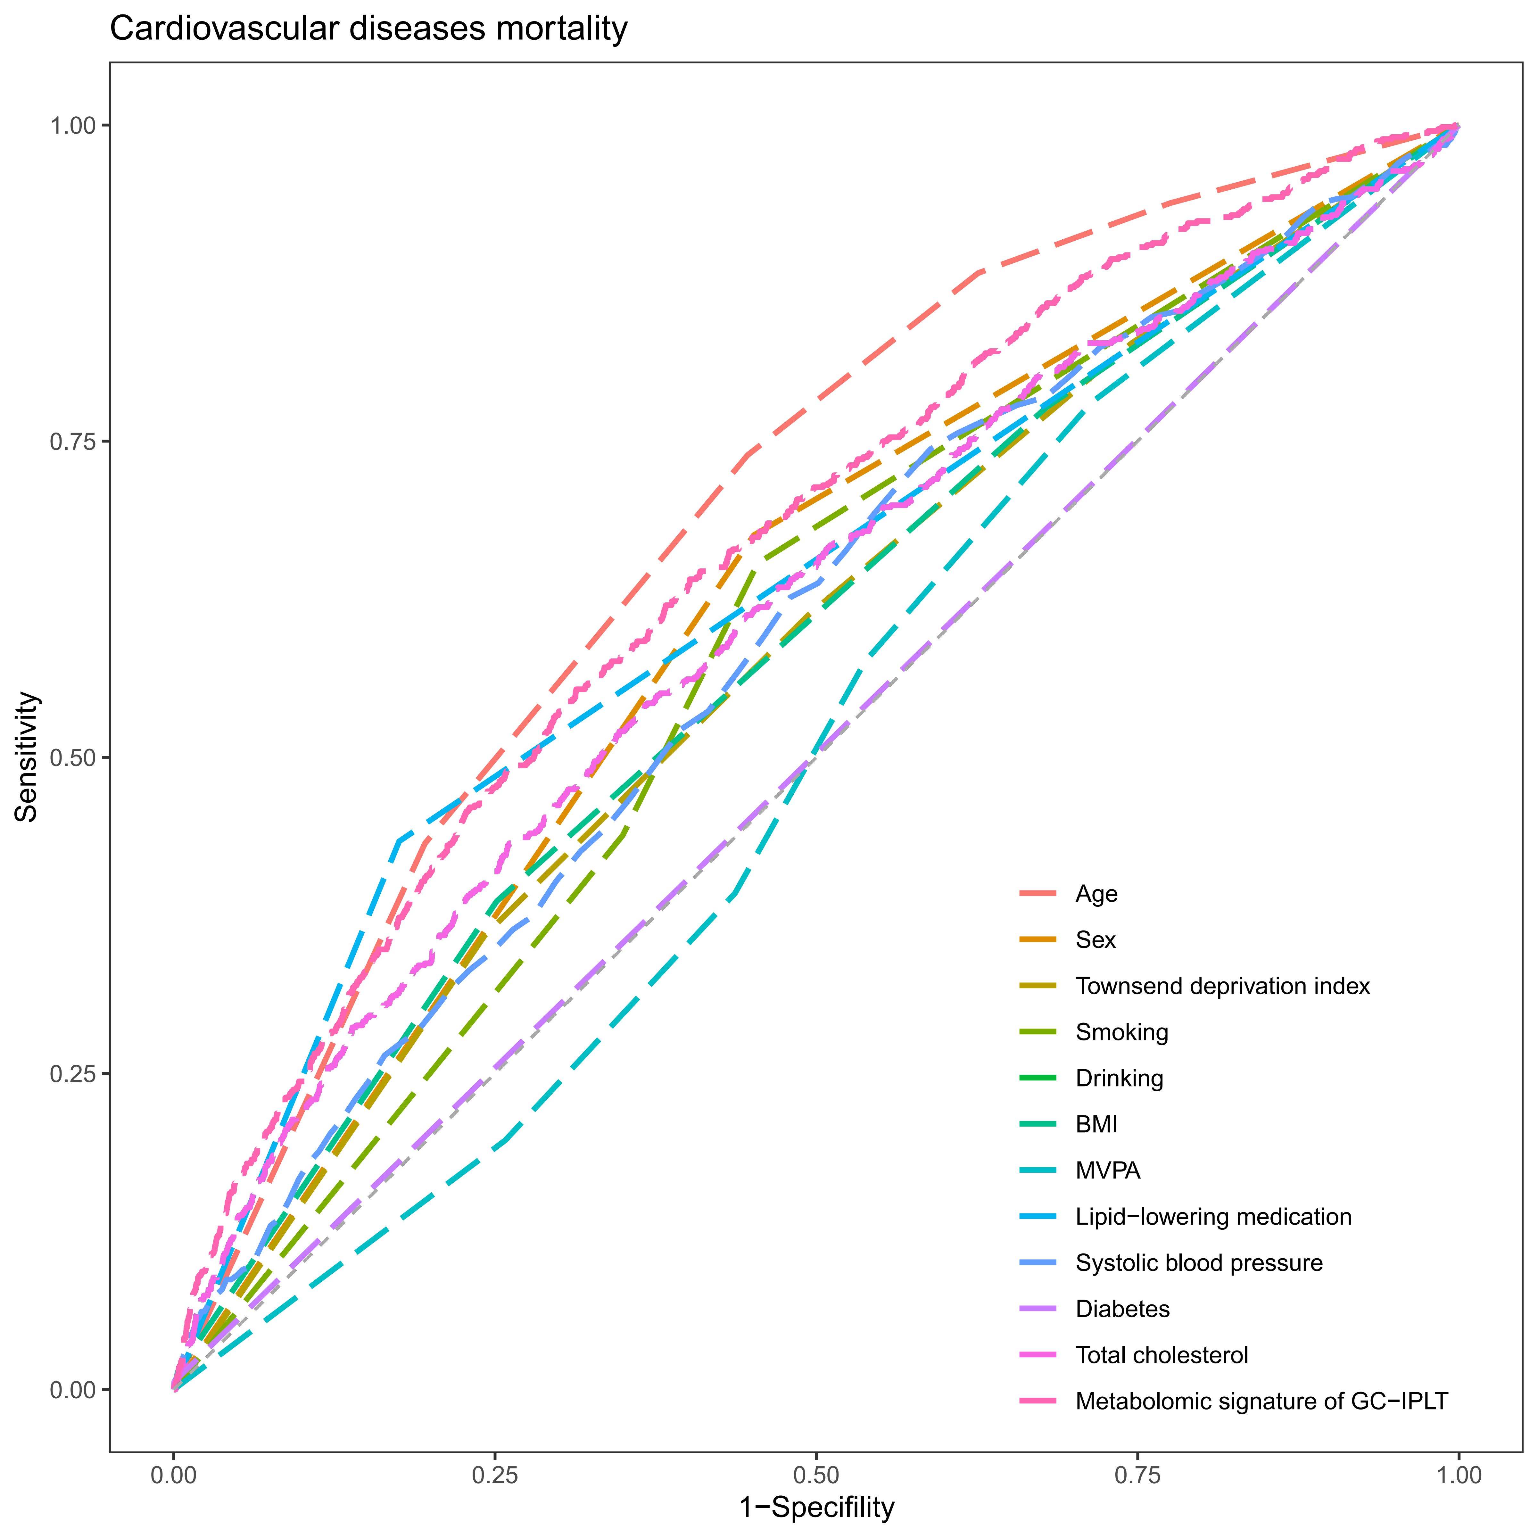
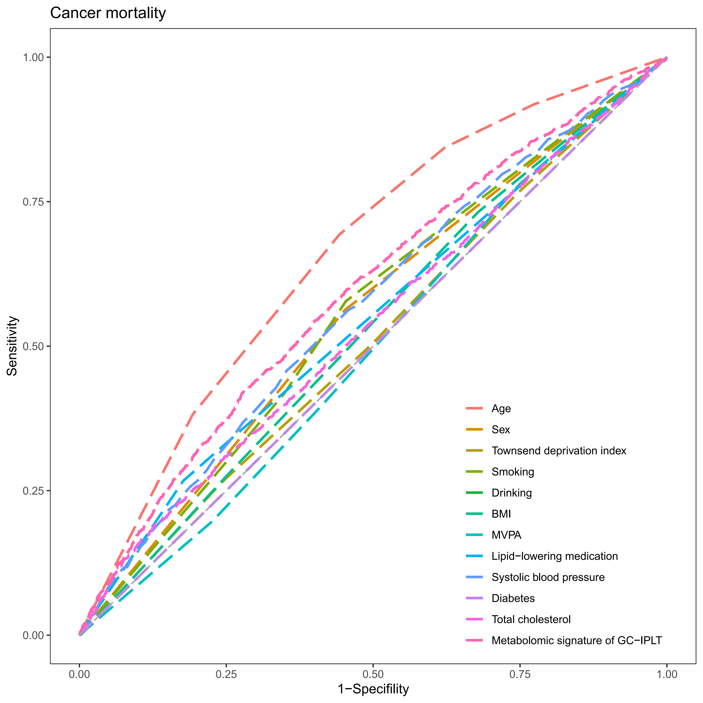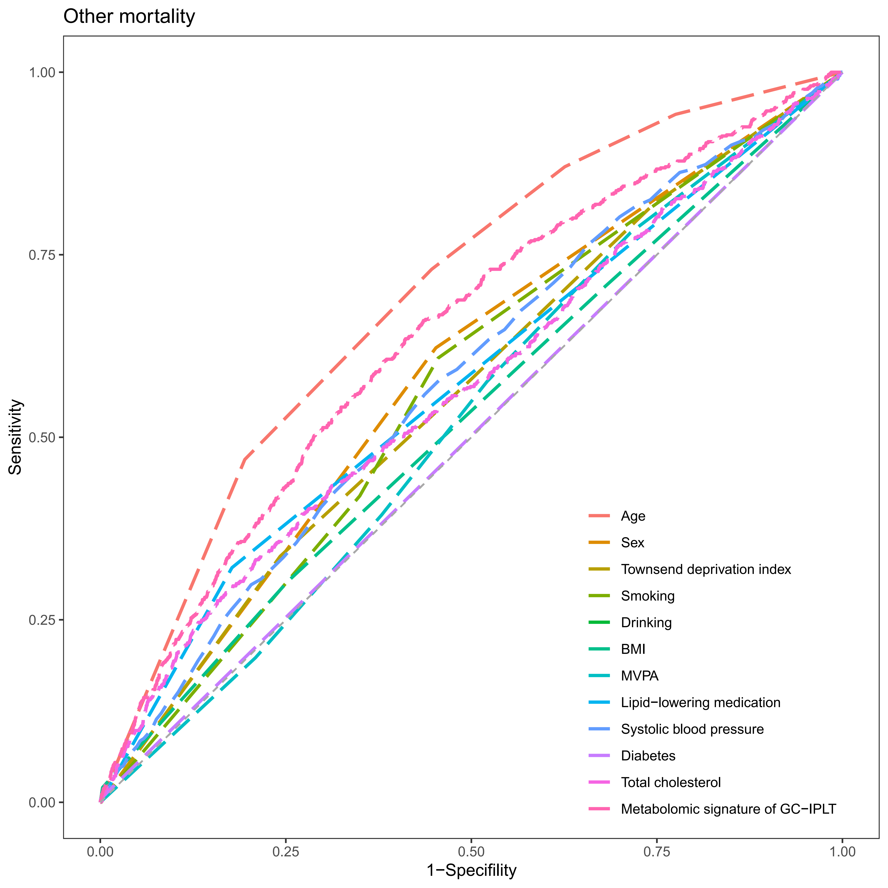

Supplementary Figure S10
Receiver operating characteristic (ROC) curves of conventional model, meta-GCIPLT score, and combined model predicting systemic diseases in training set.
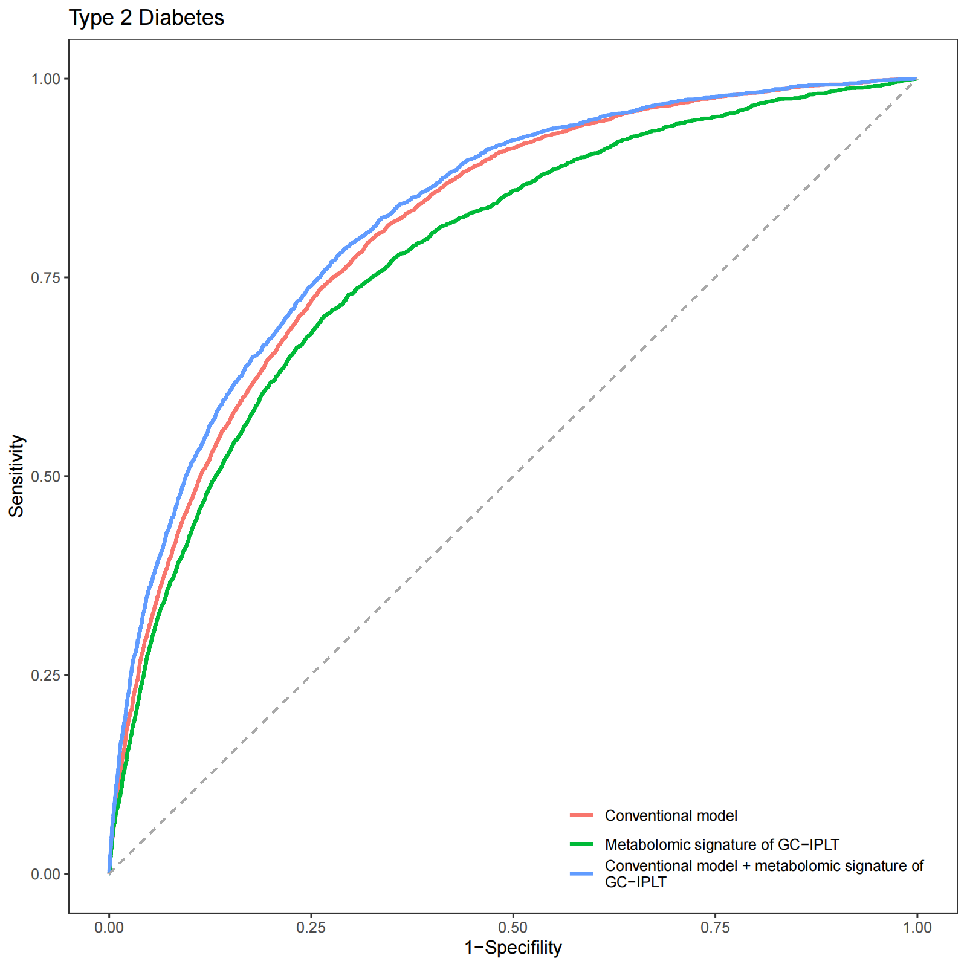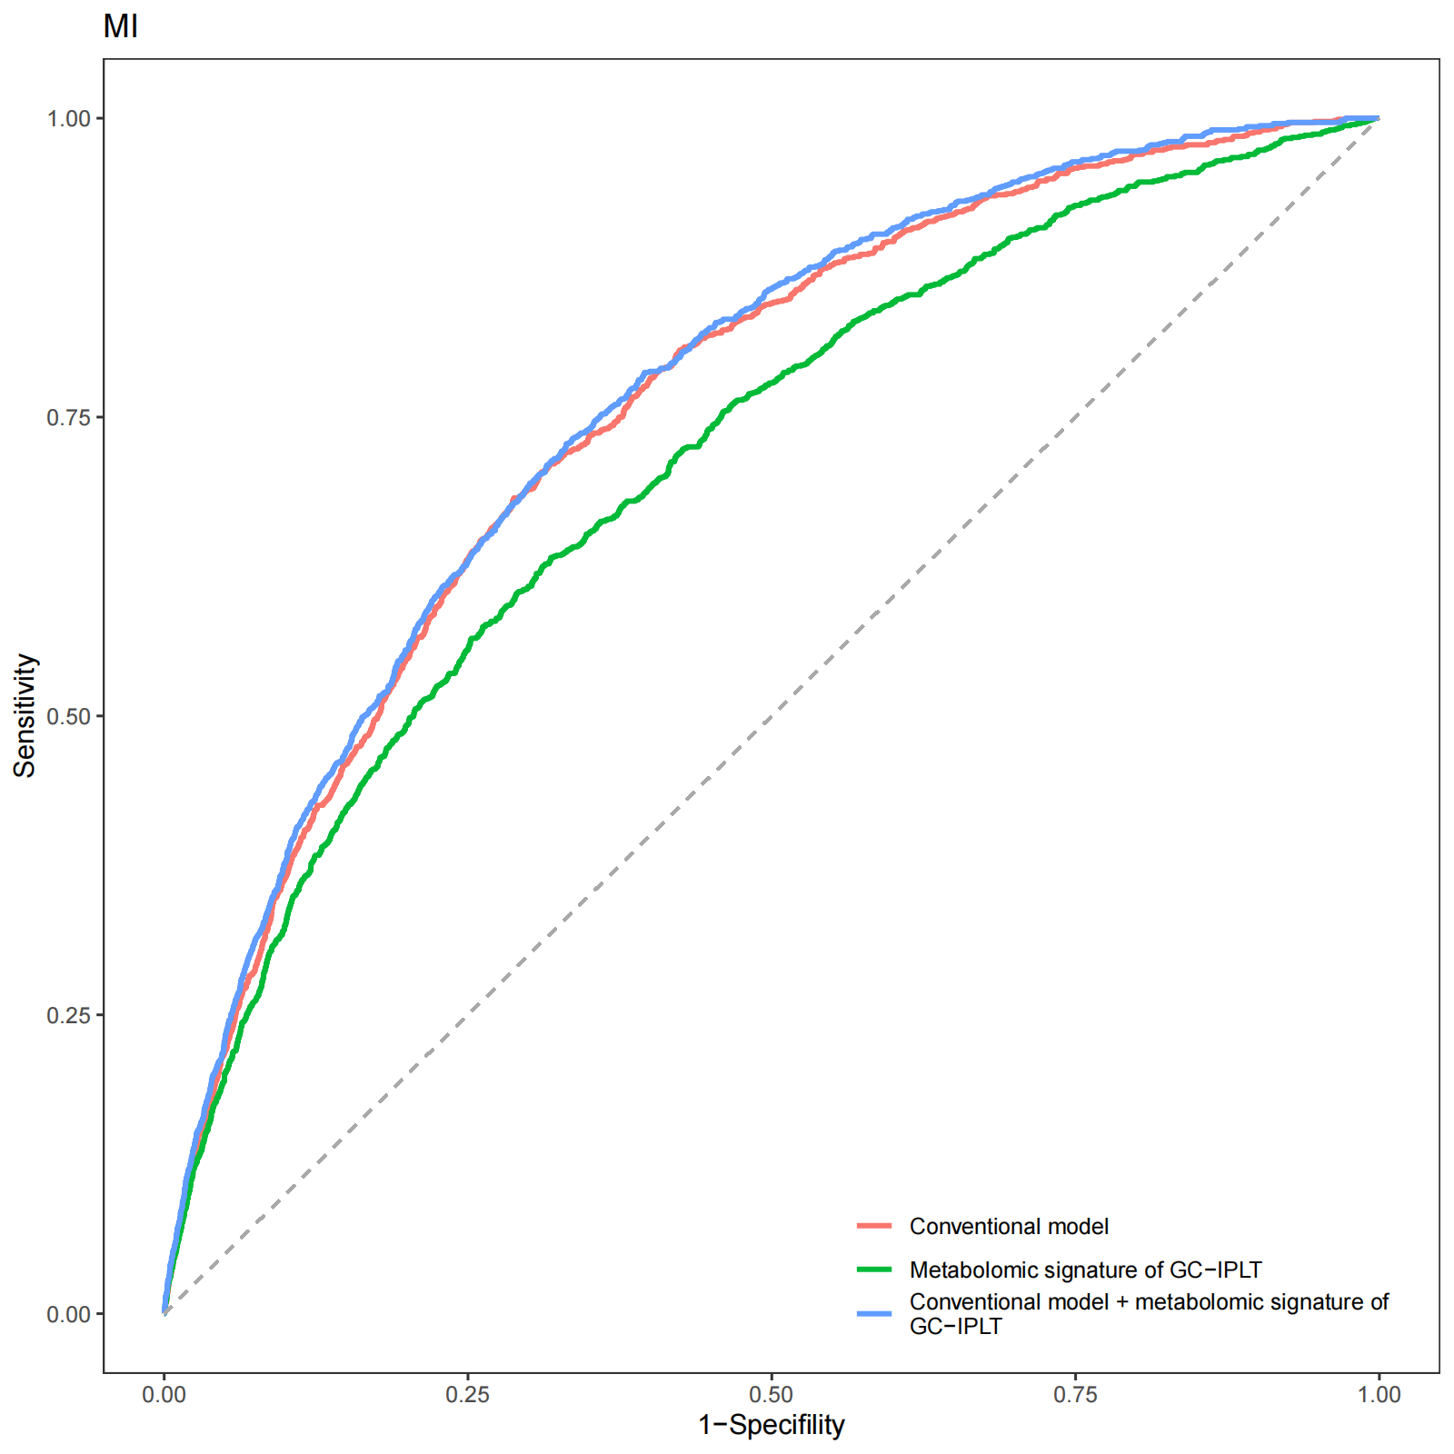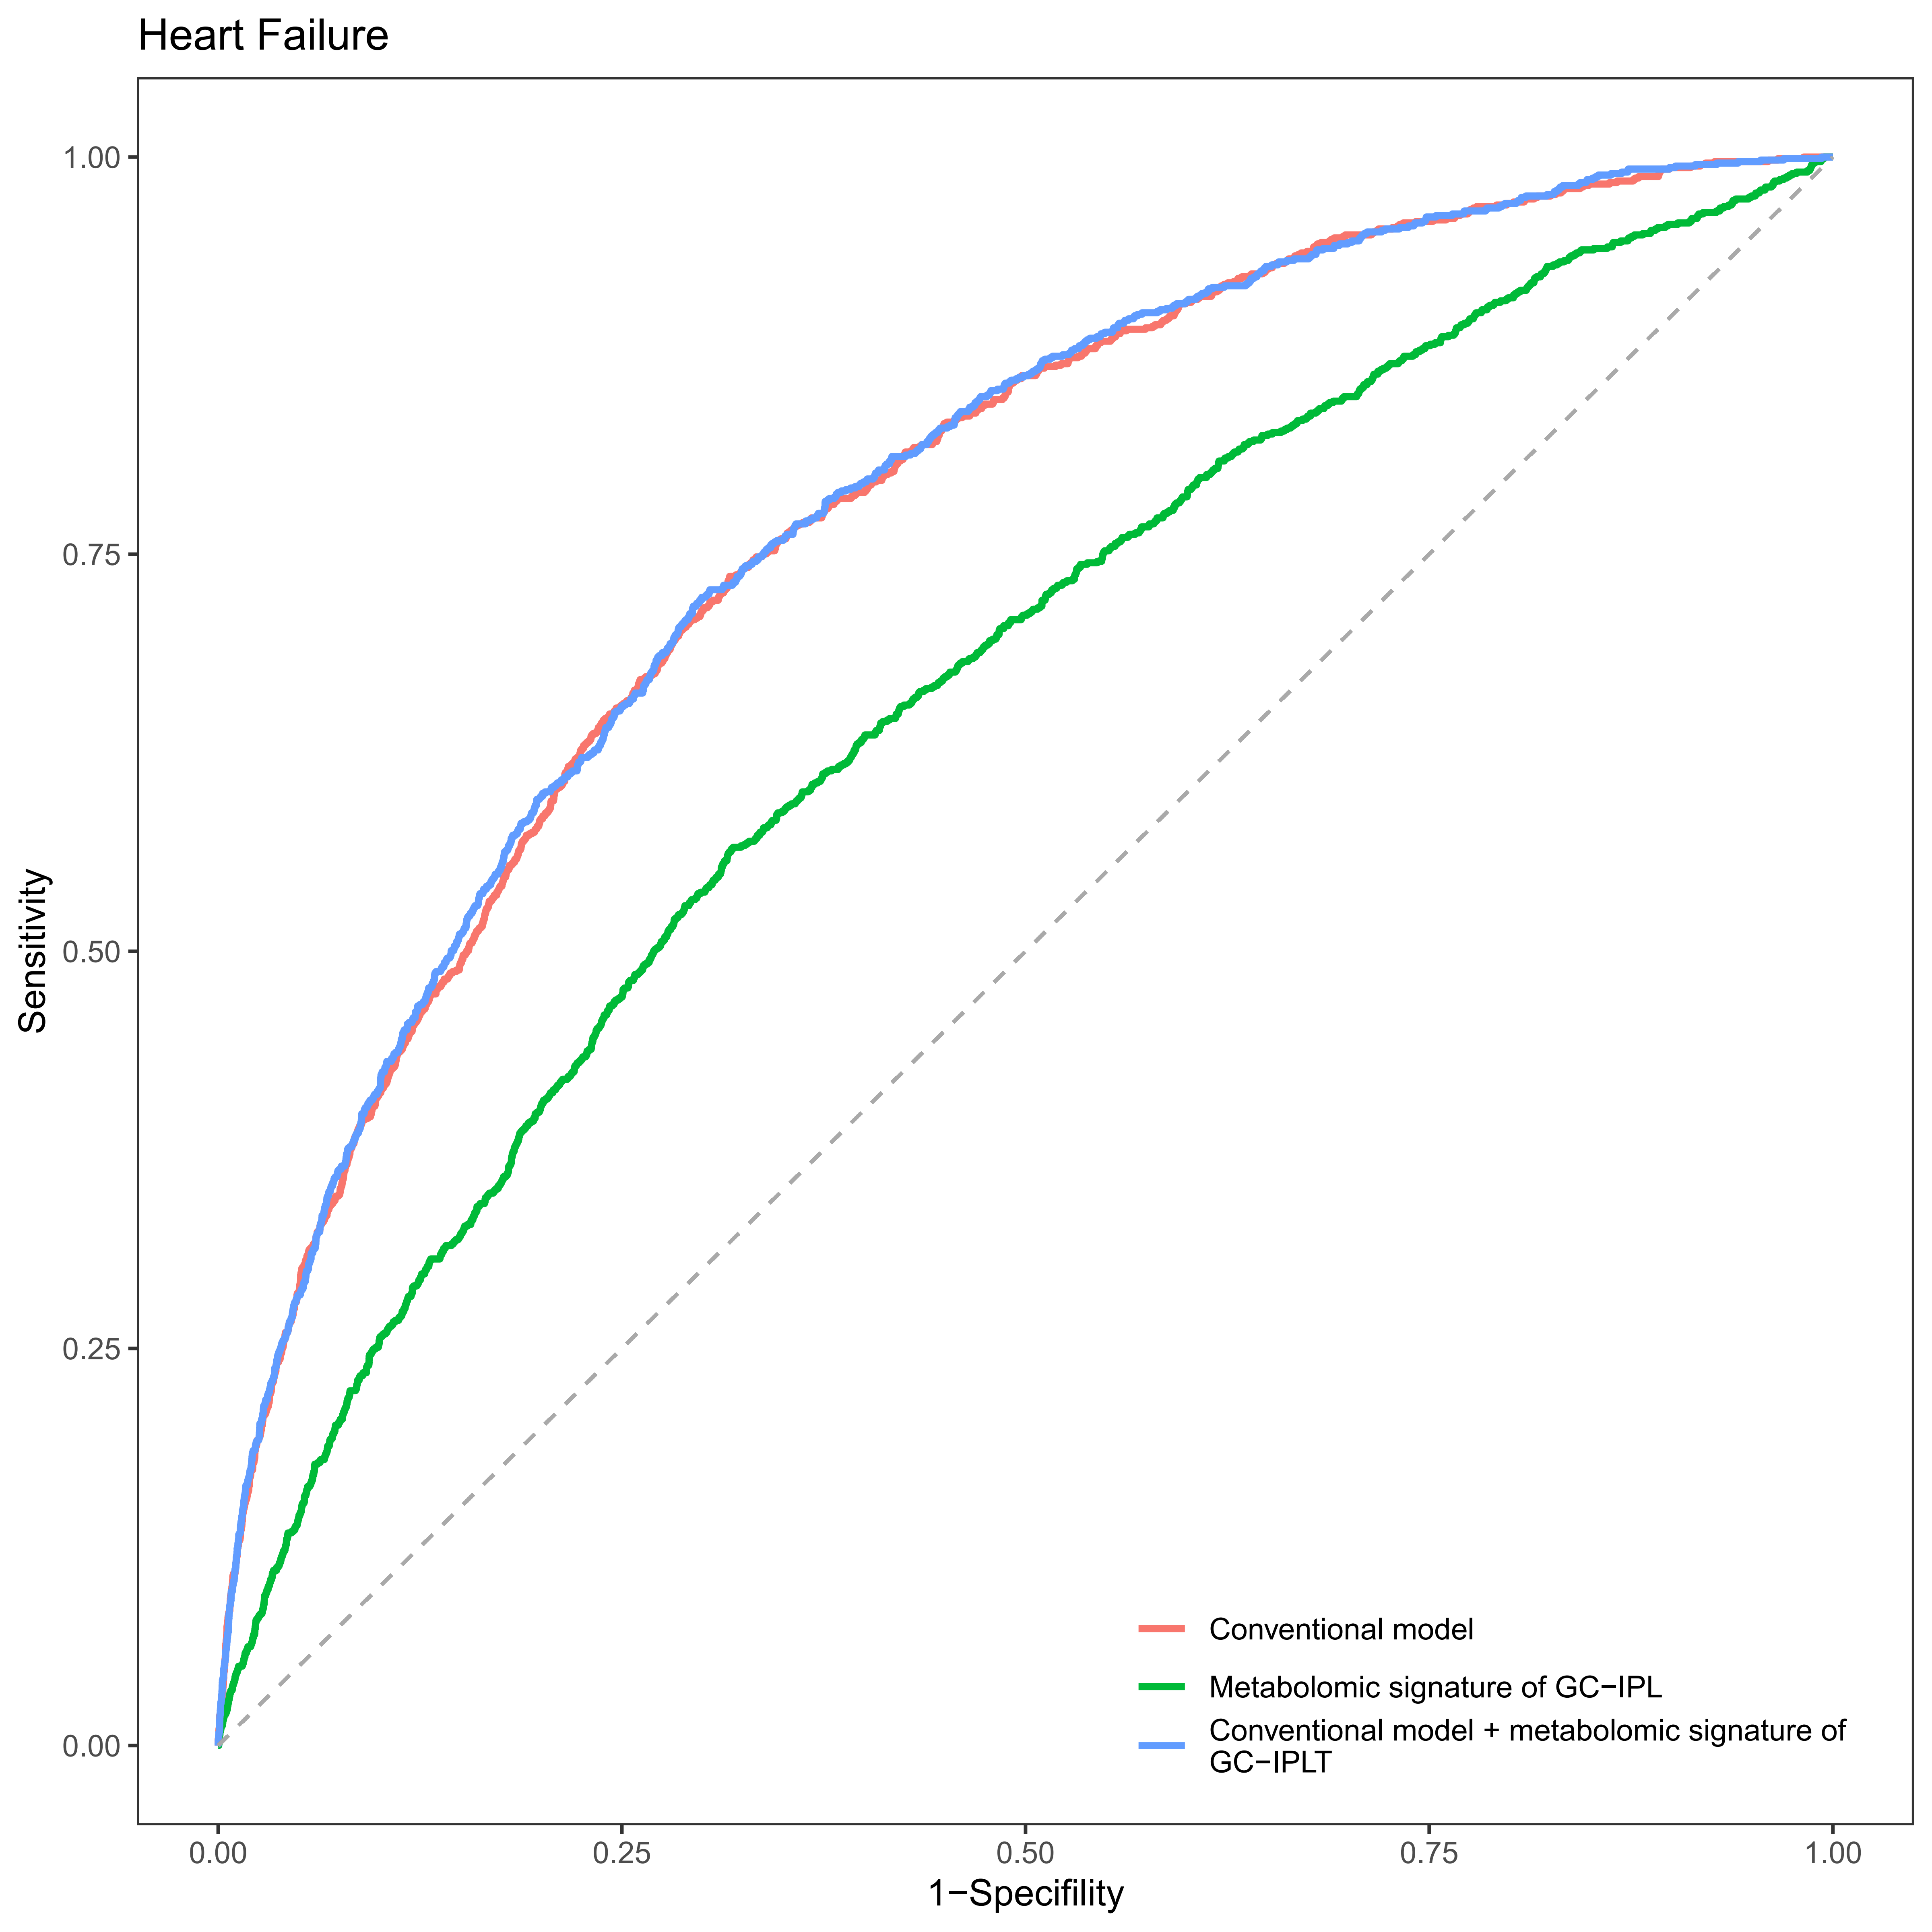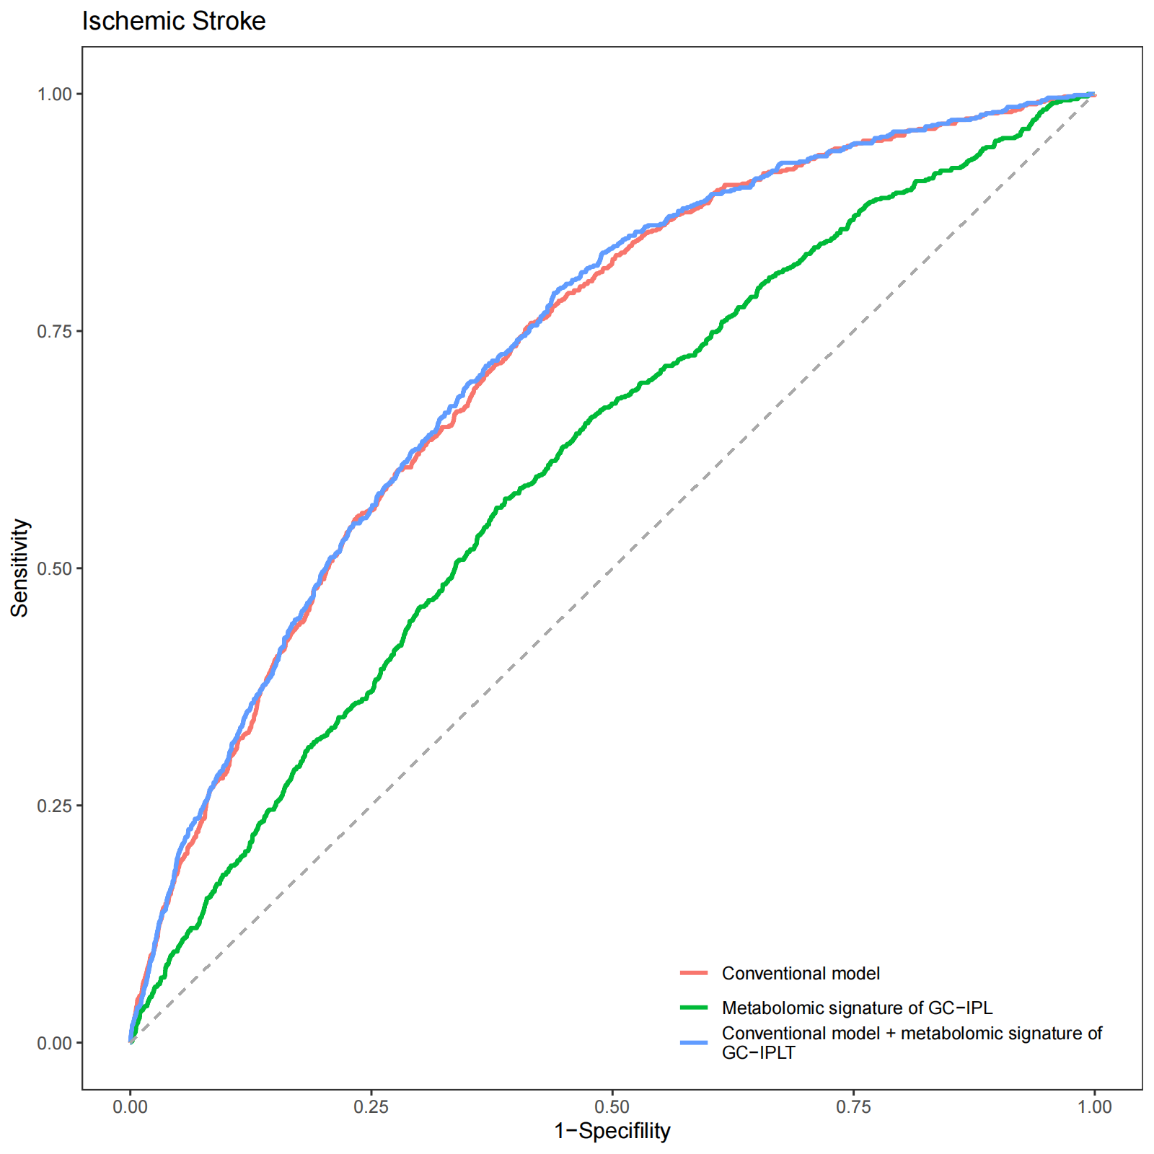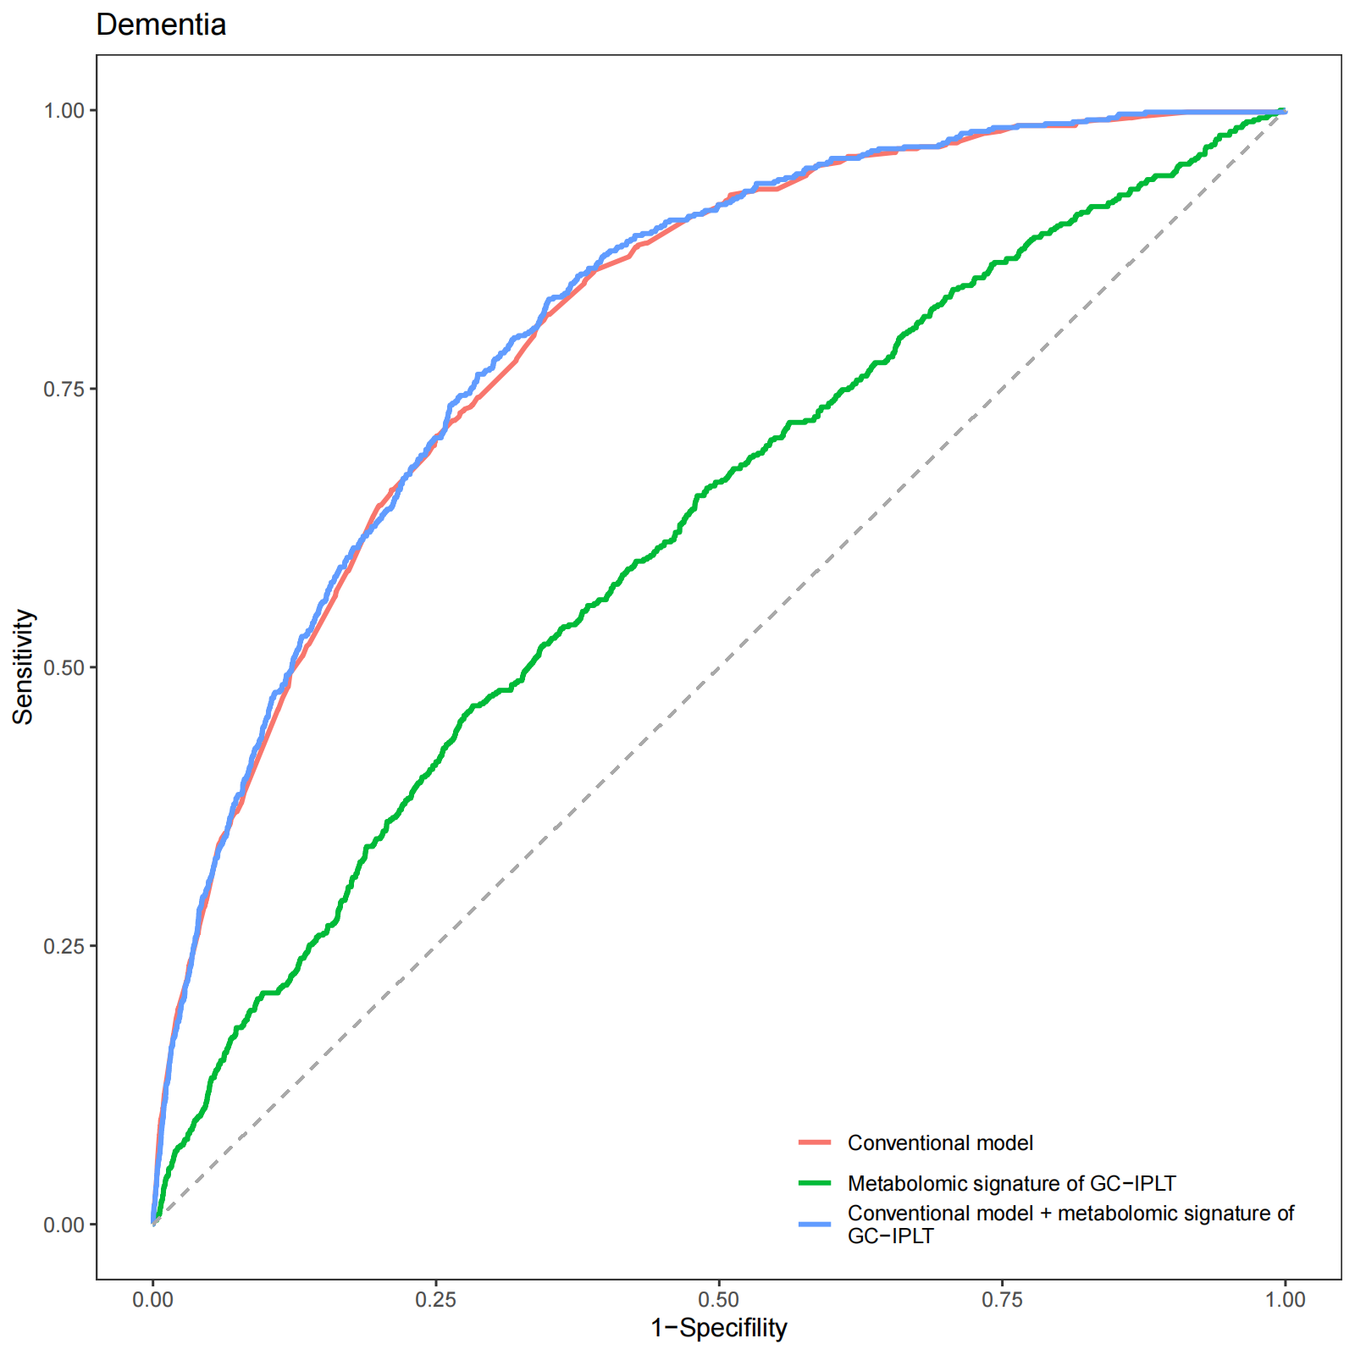

Supplementary Figure S11
Receiver operating characteristic (ROC) curves of conventional model, meta-GCIPLT score, and combined model predicting mortality in training set.
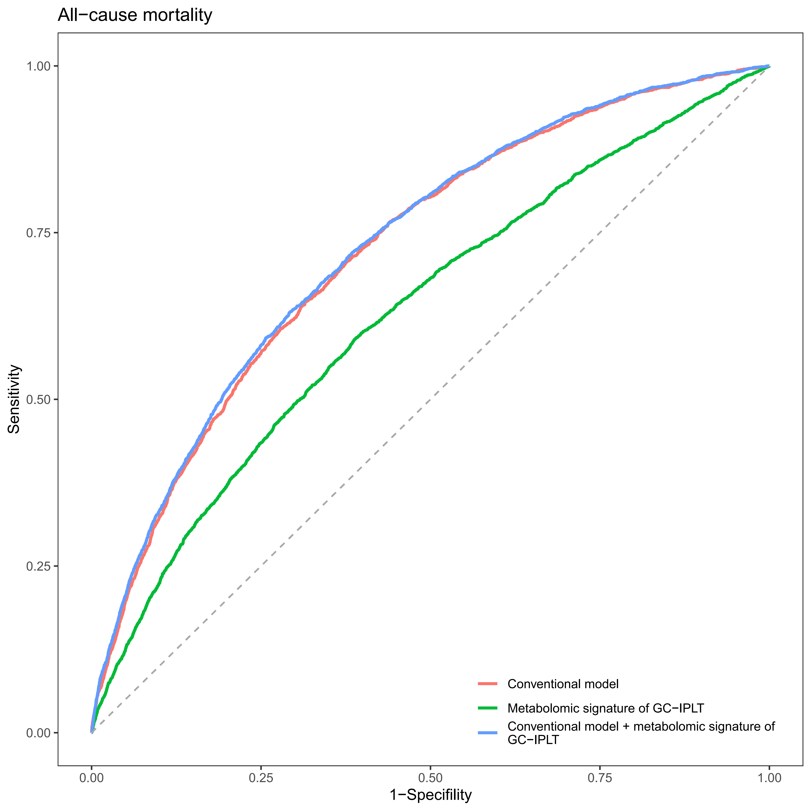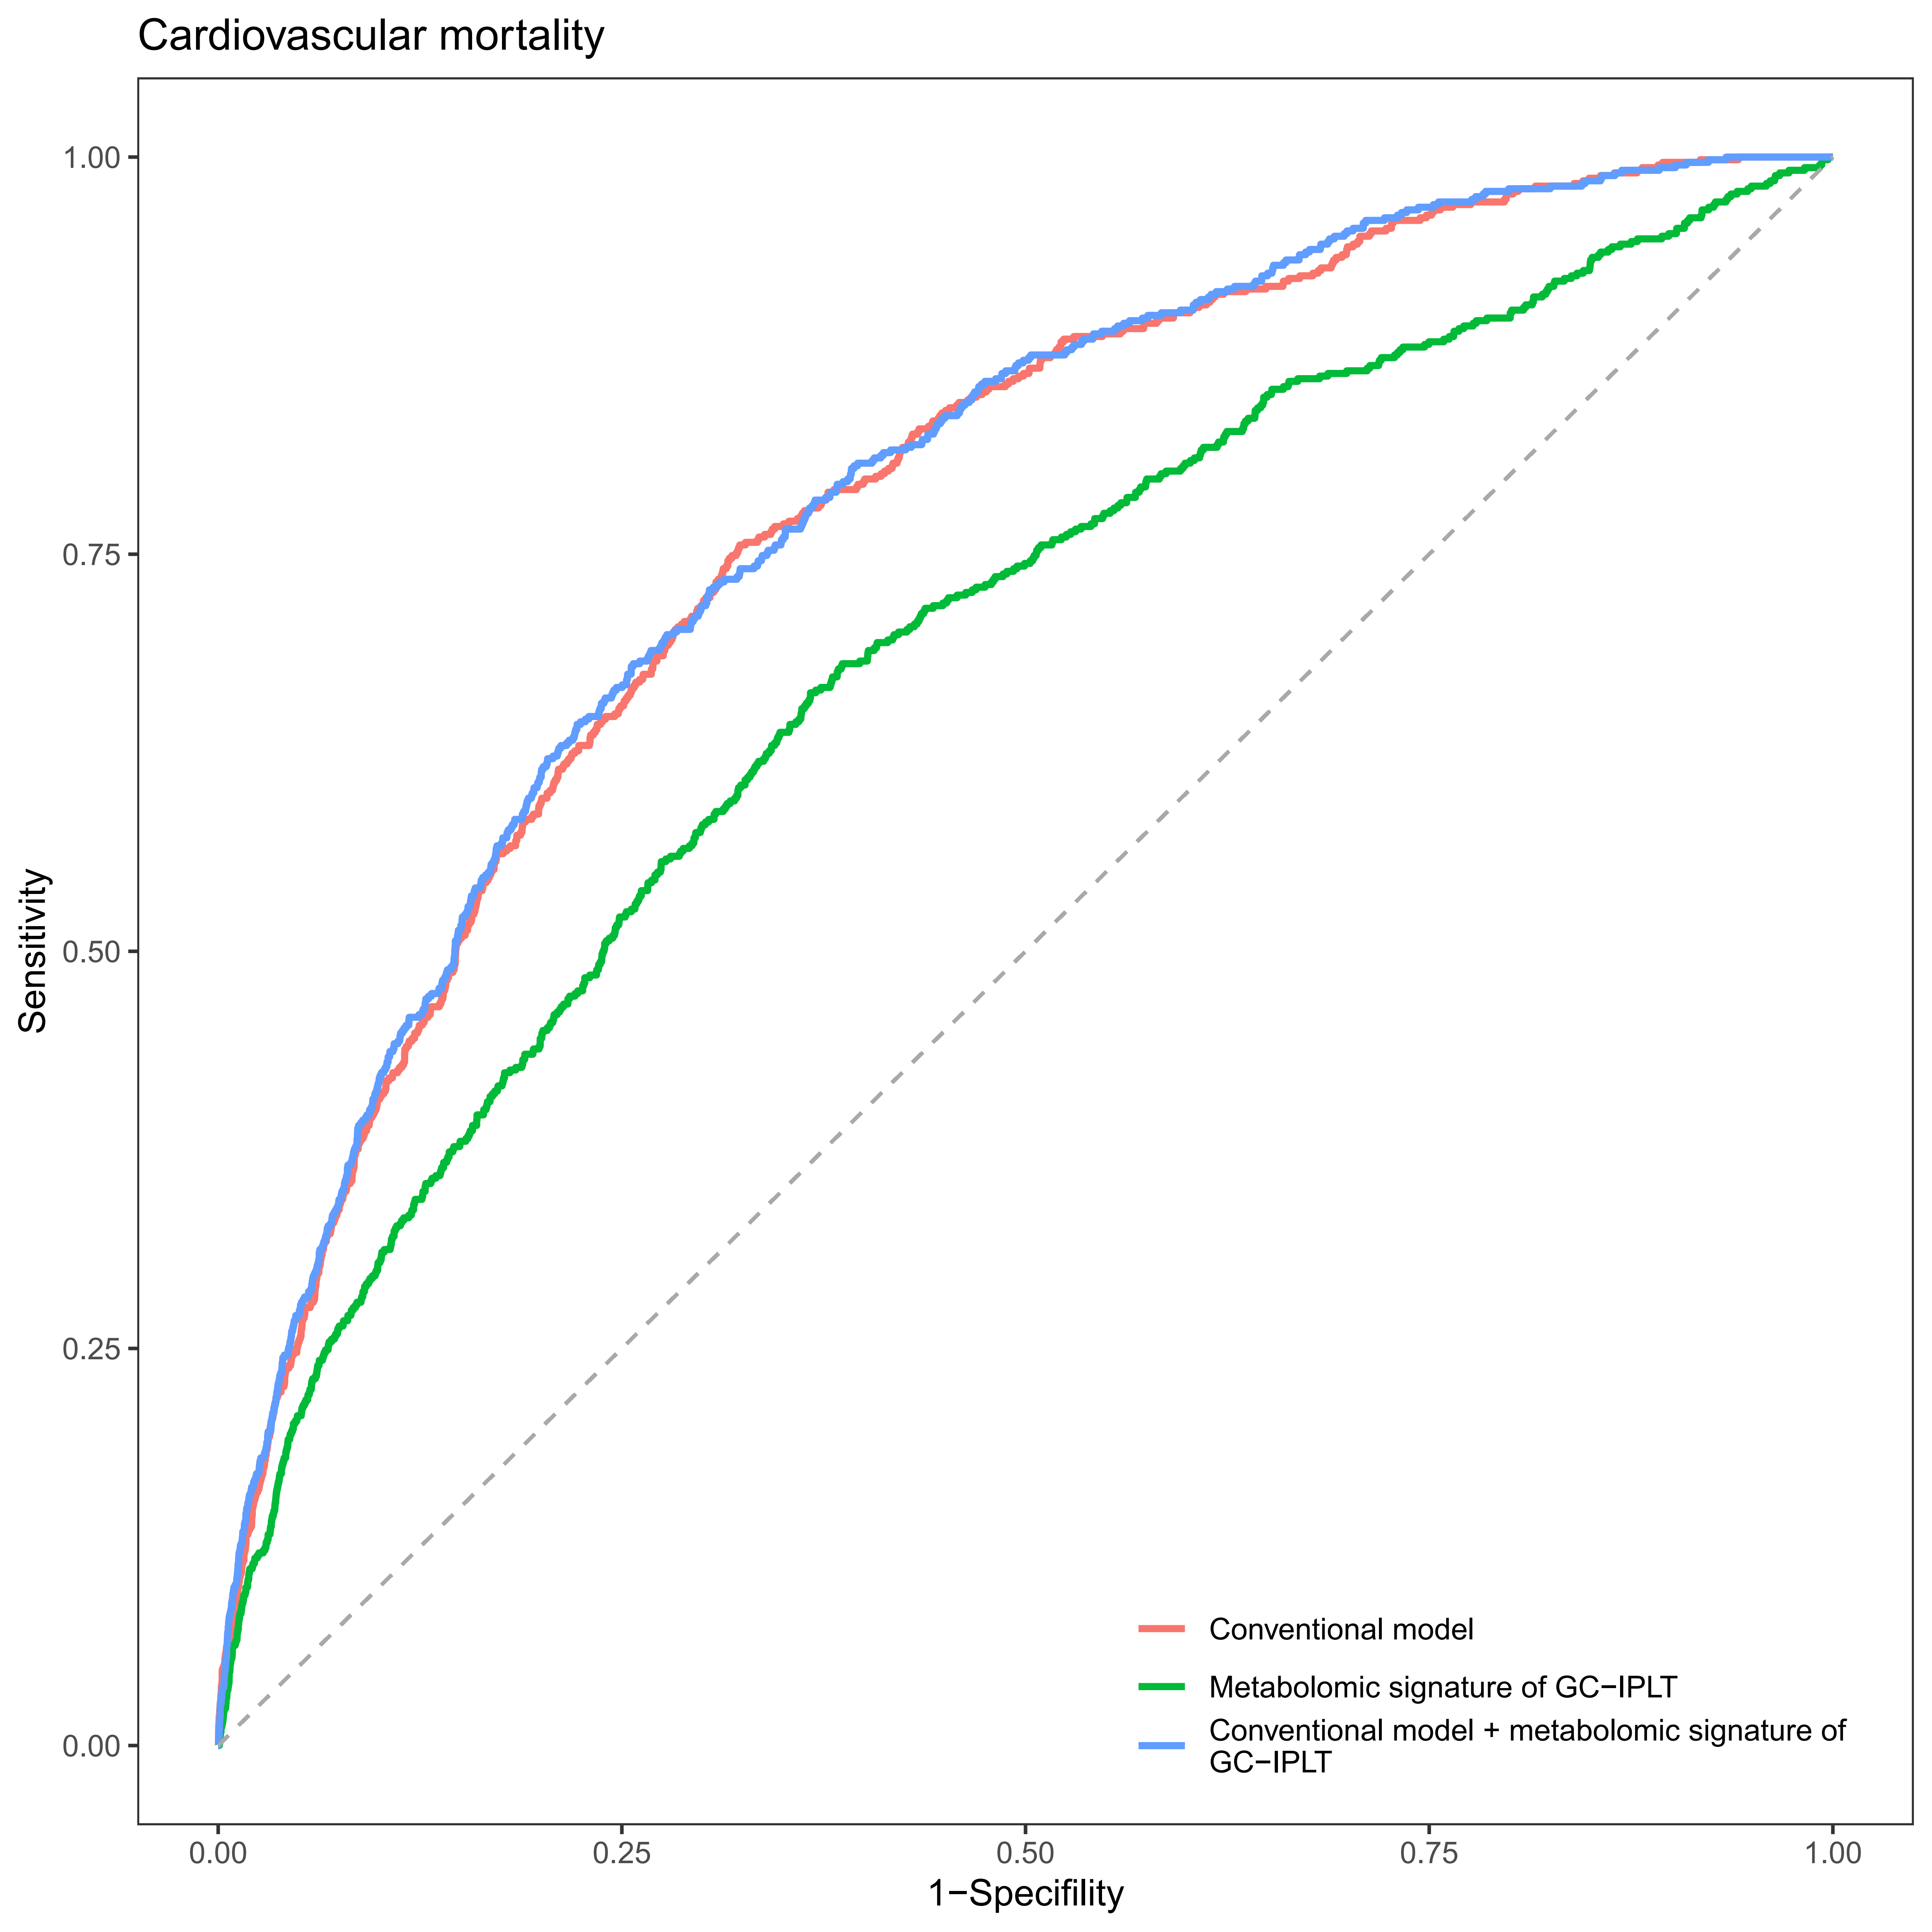
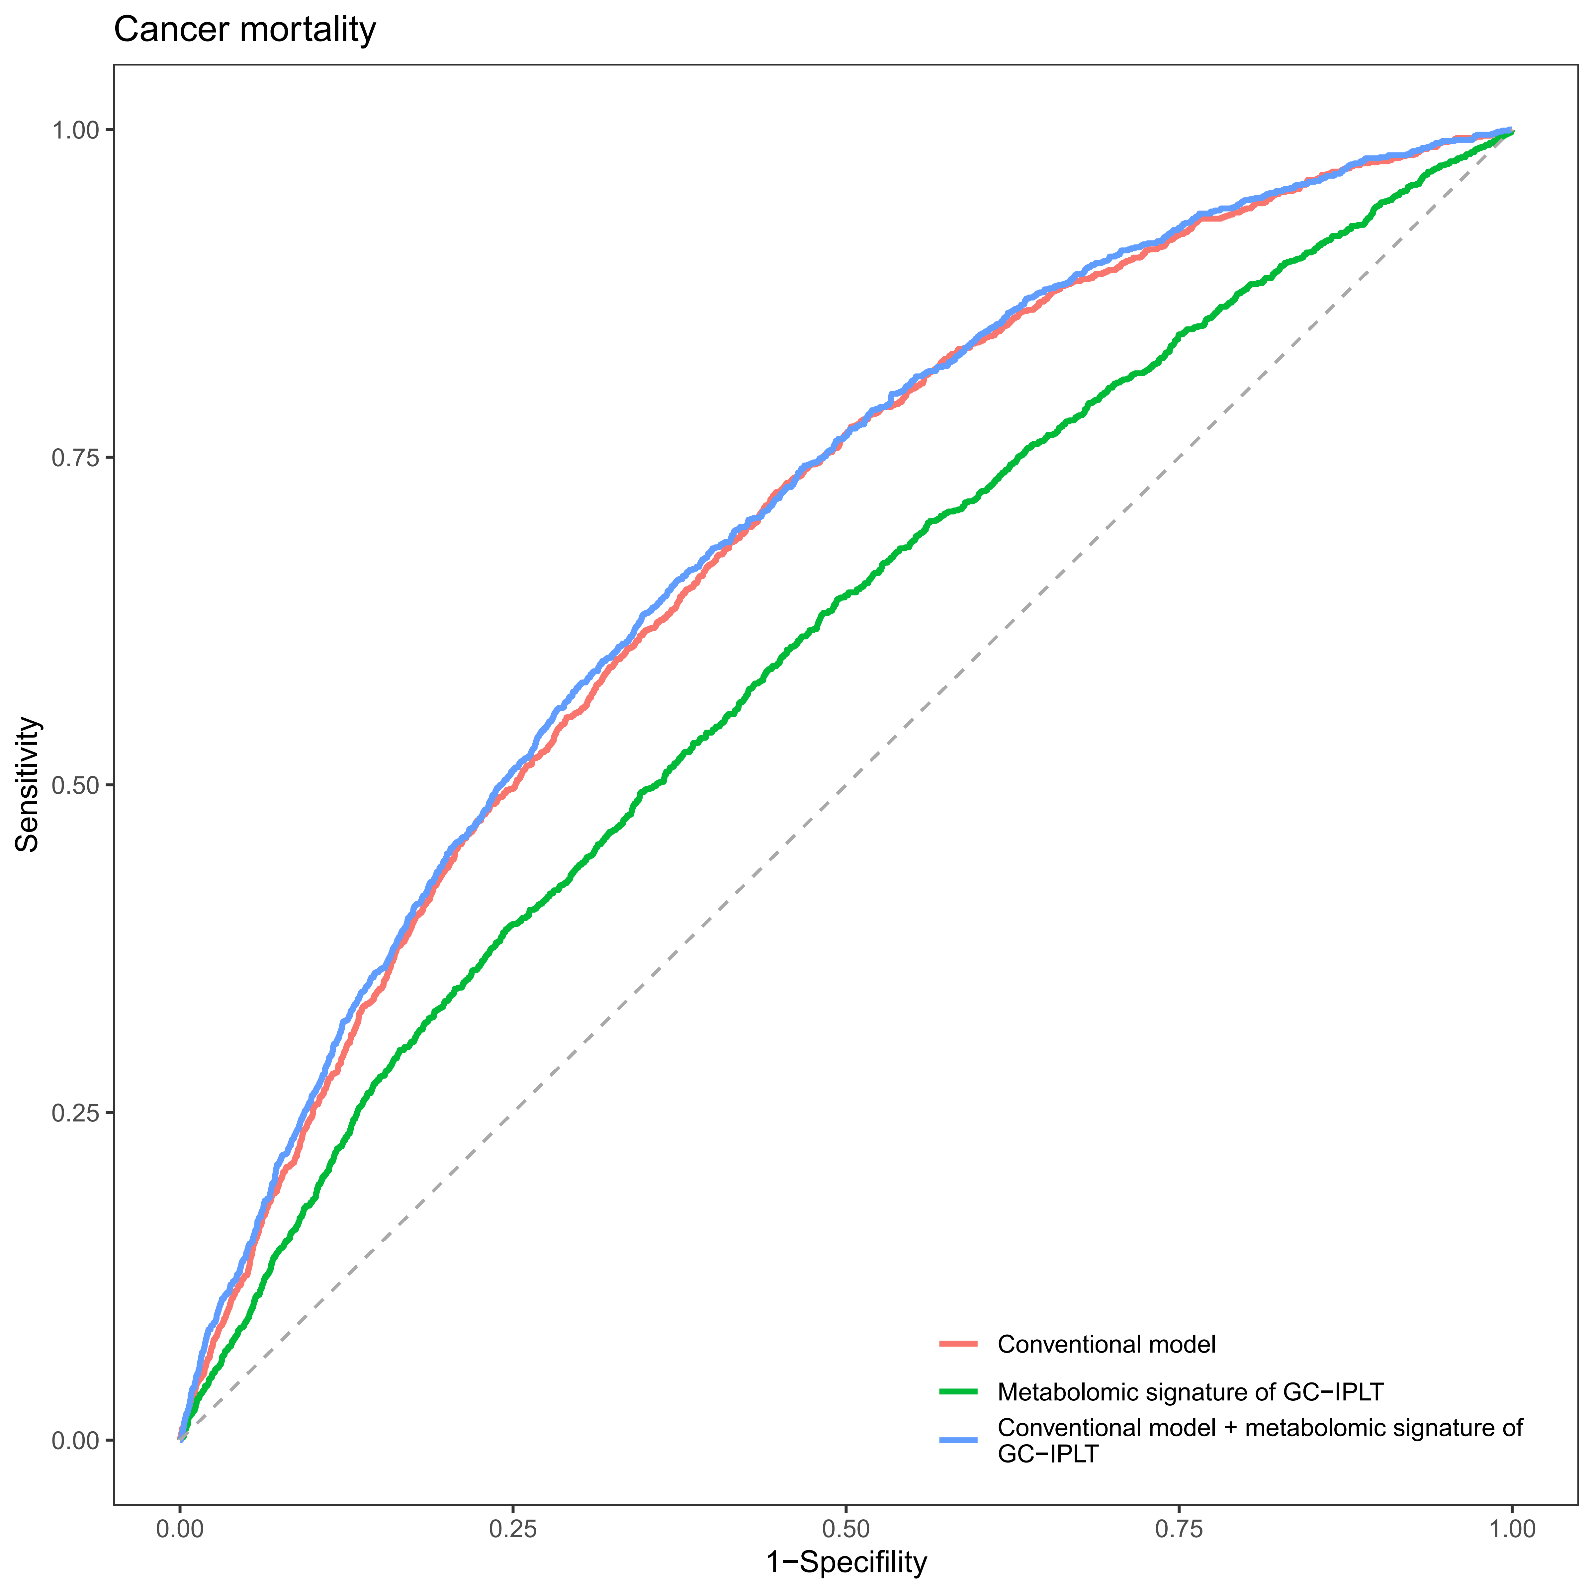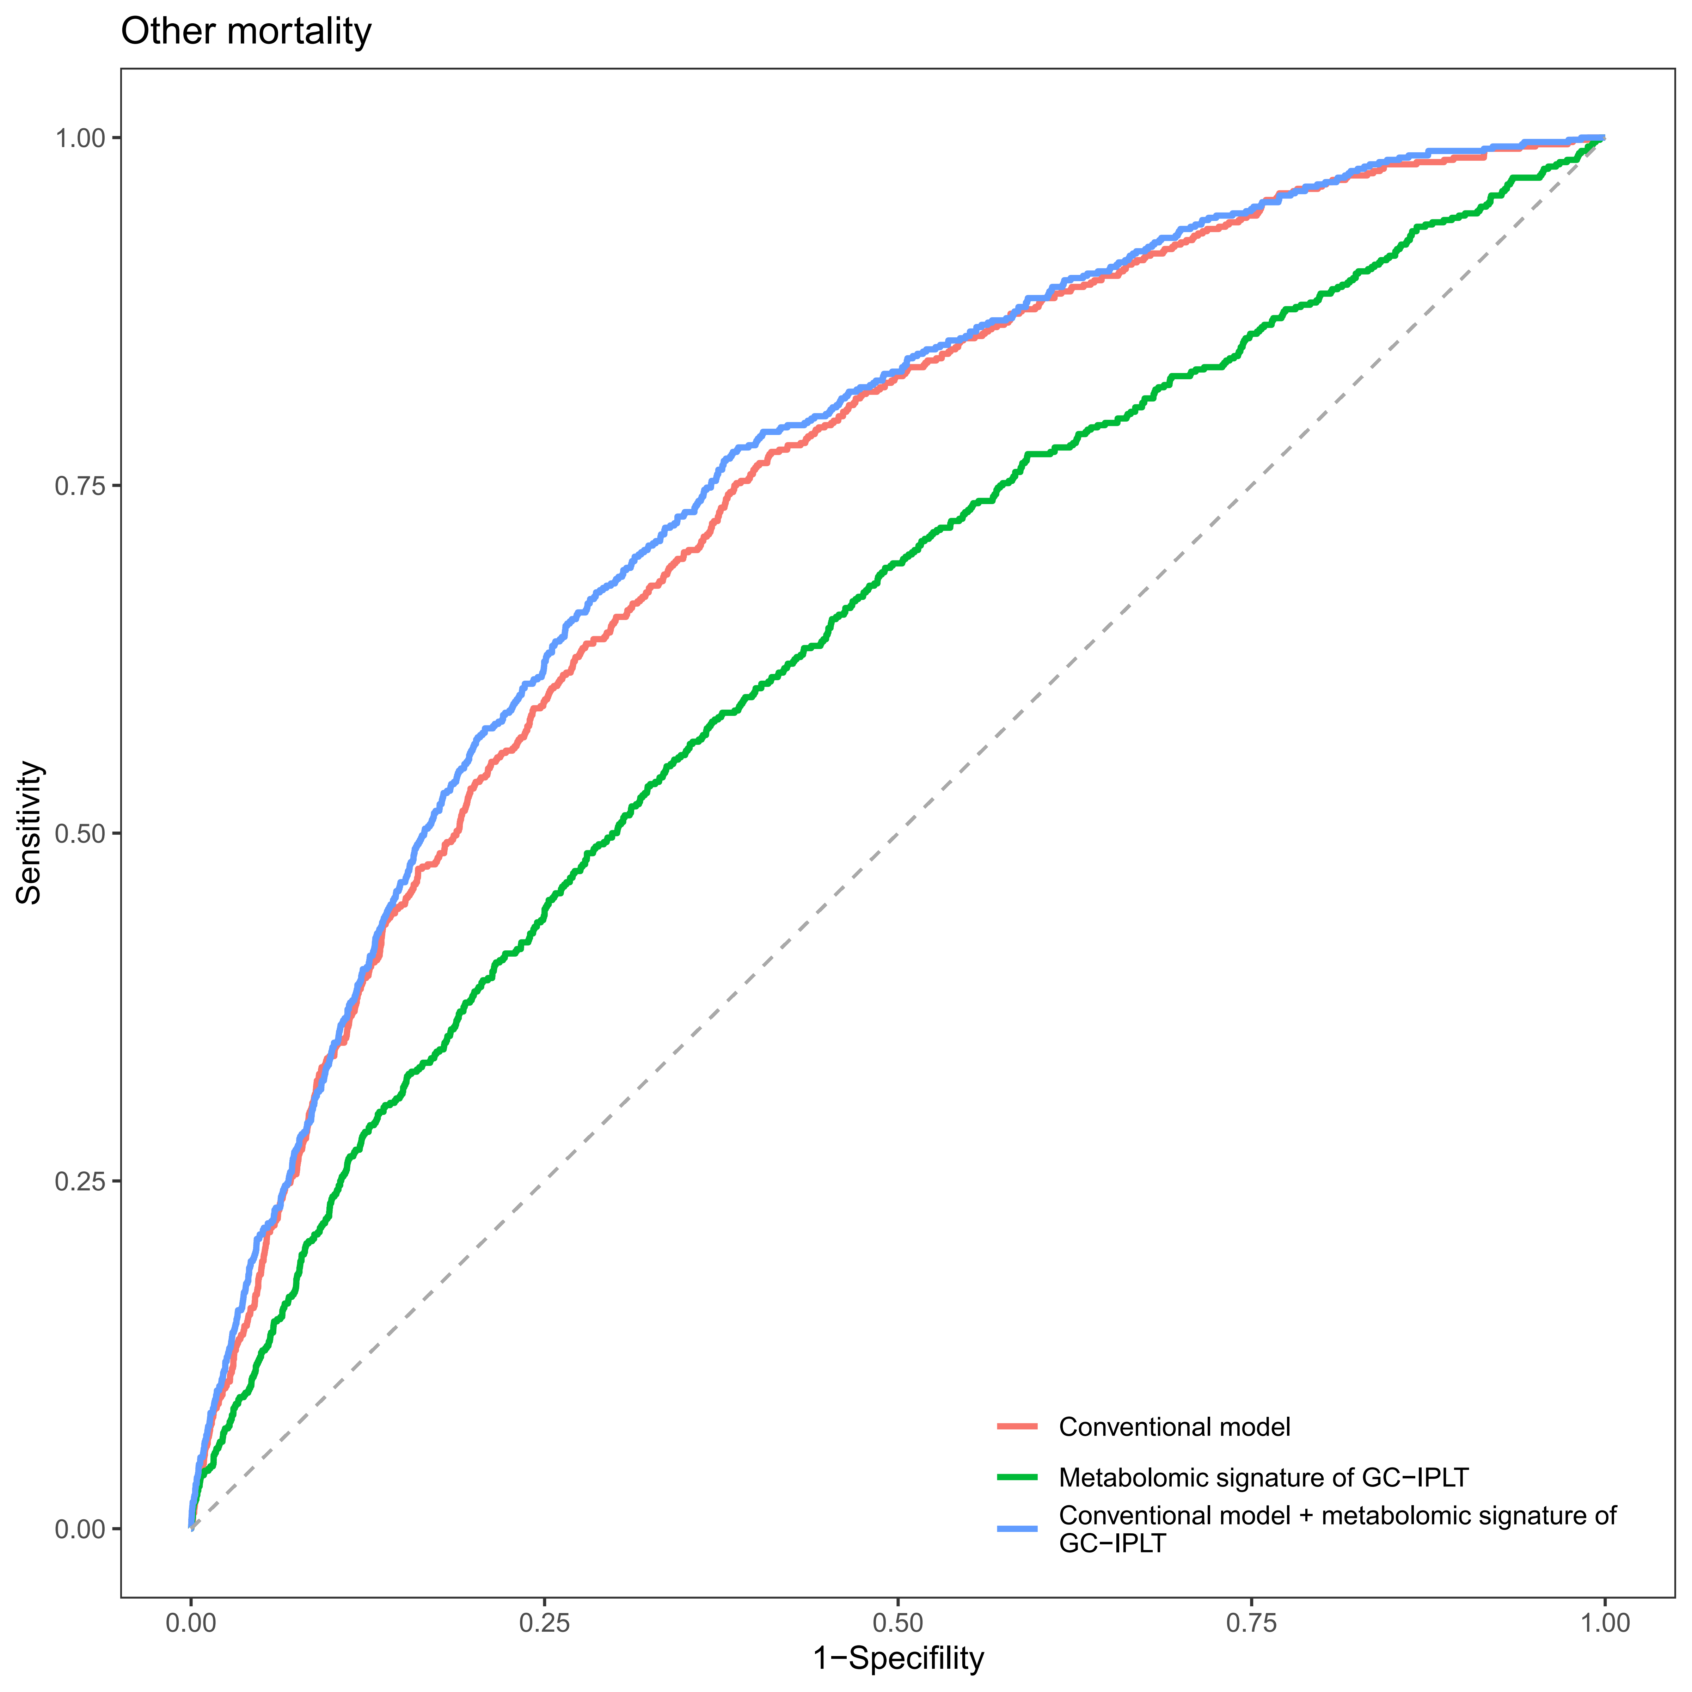

Supplementary Figure S12
Receiver operating characteristic (ROC) curves of conventional model, meta-GCIPLT score, and combined model predicting systemic diseases in validation set.
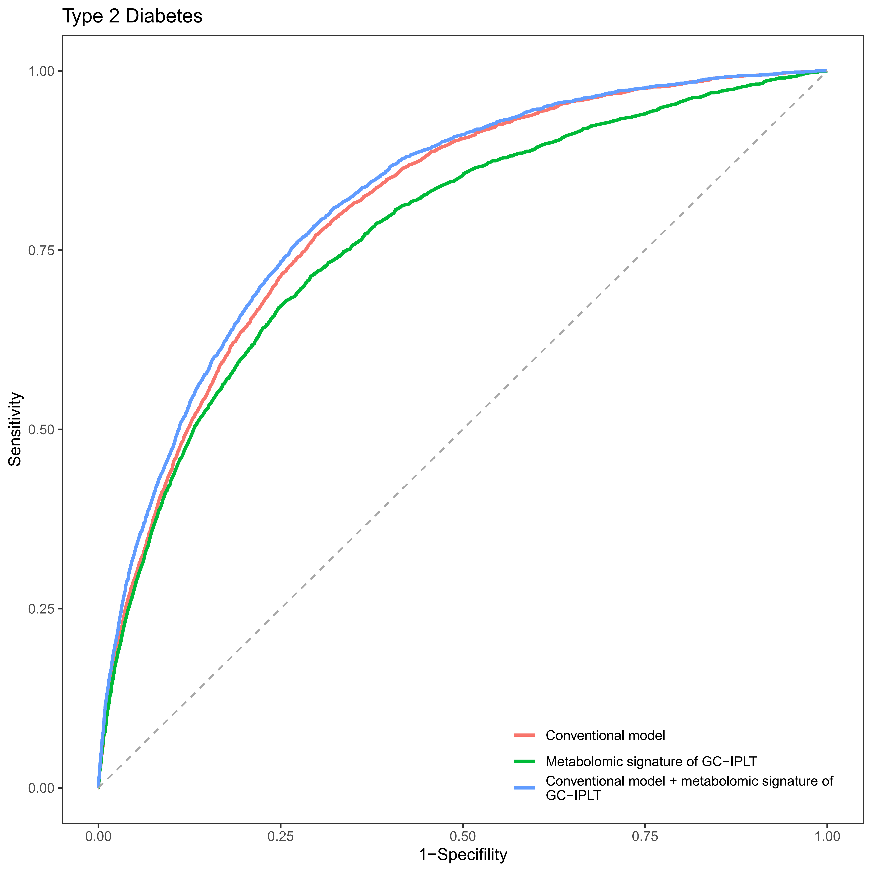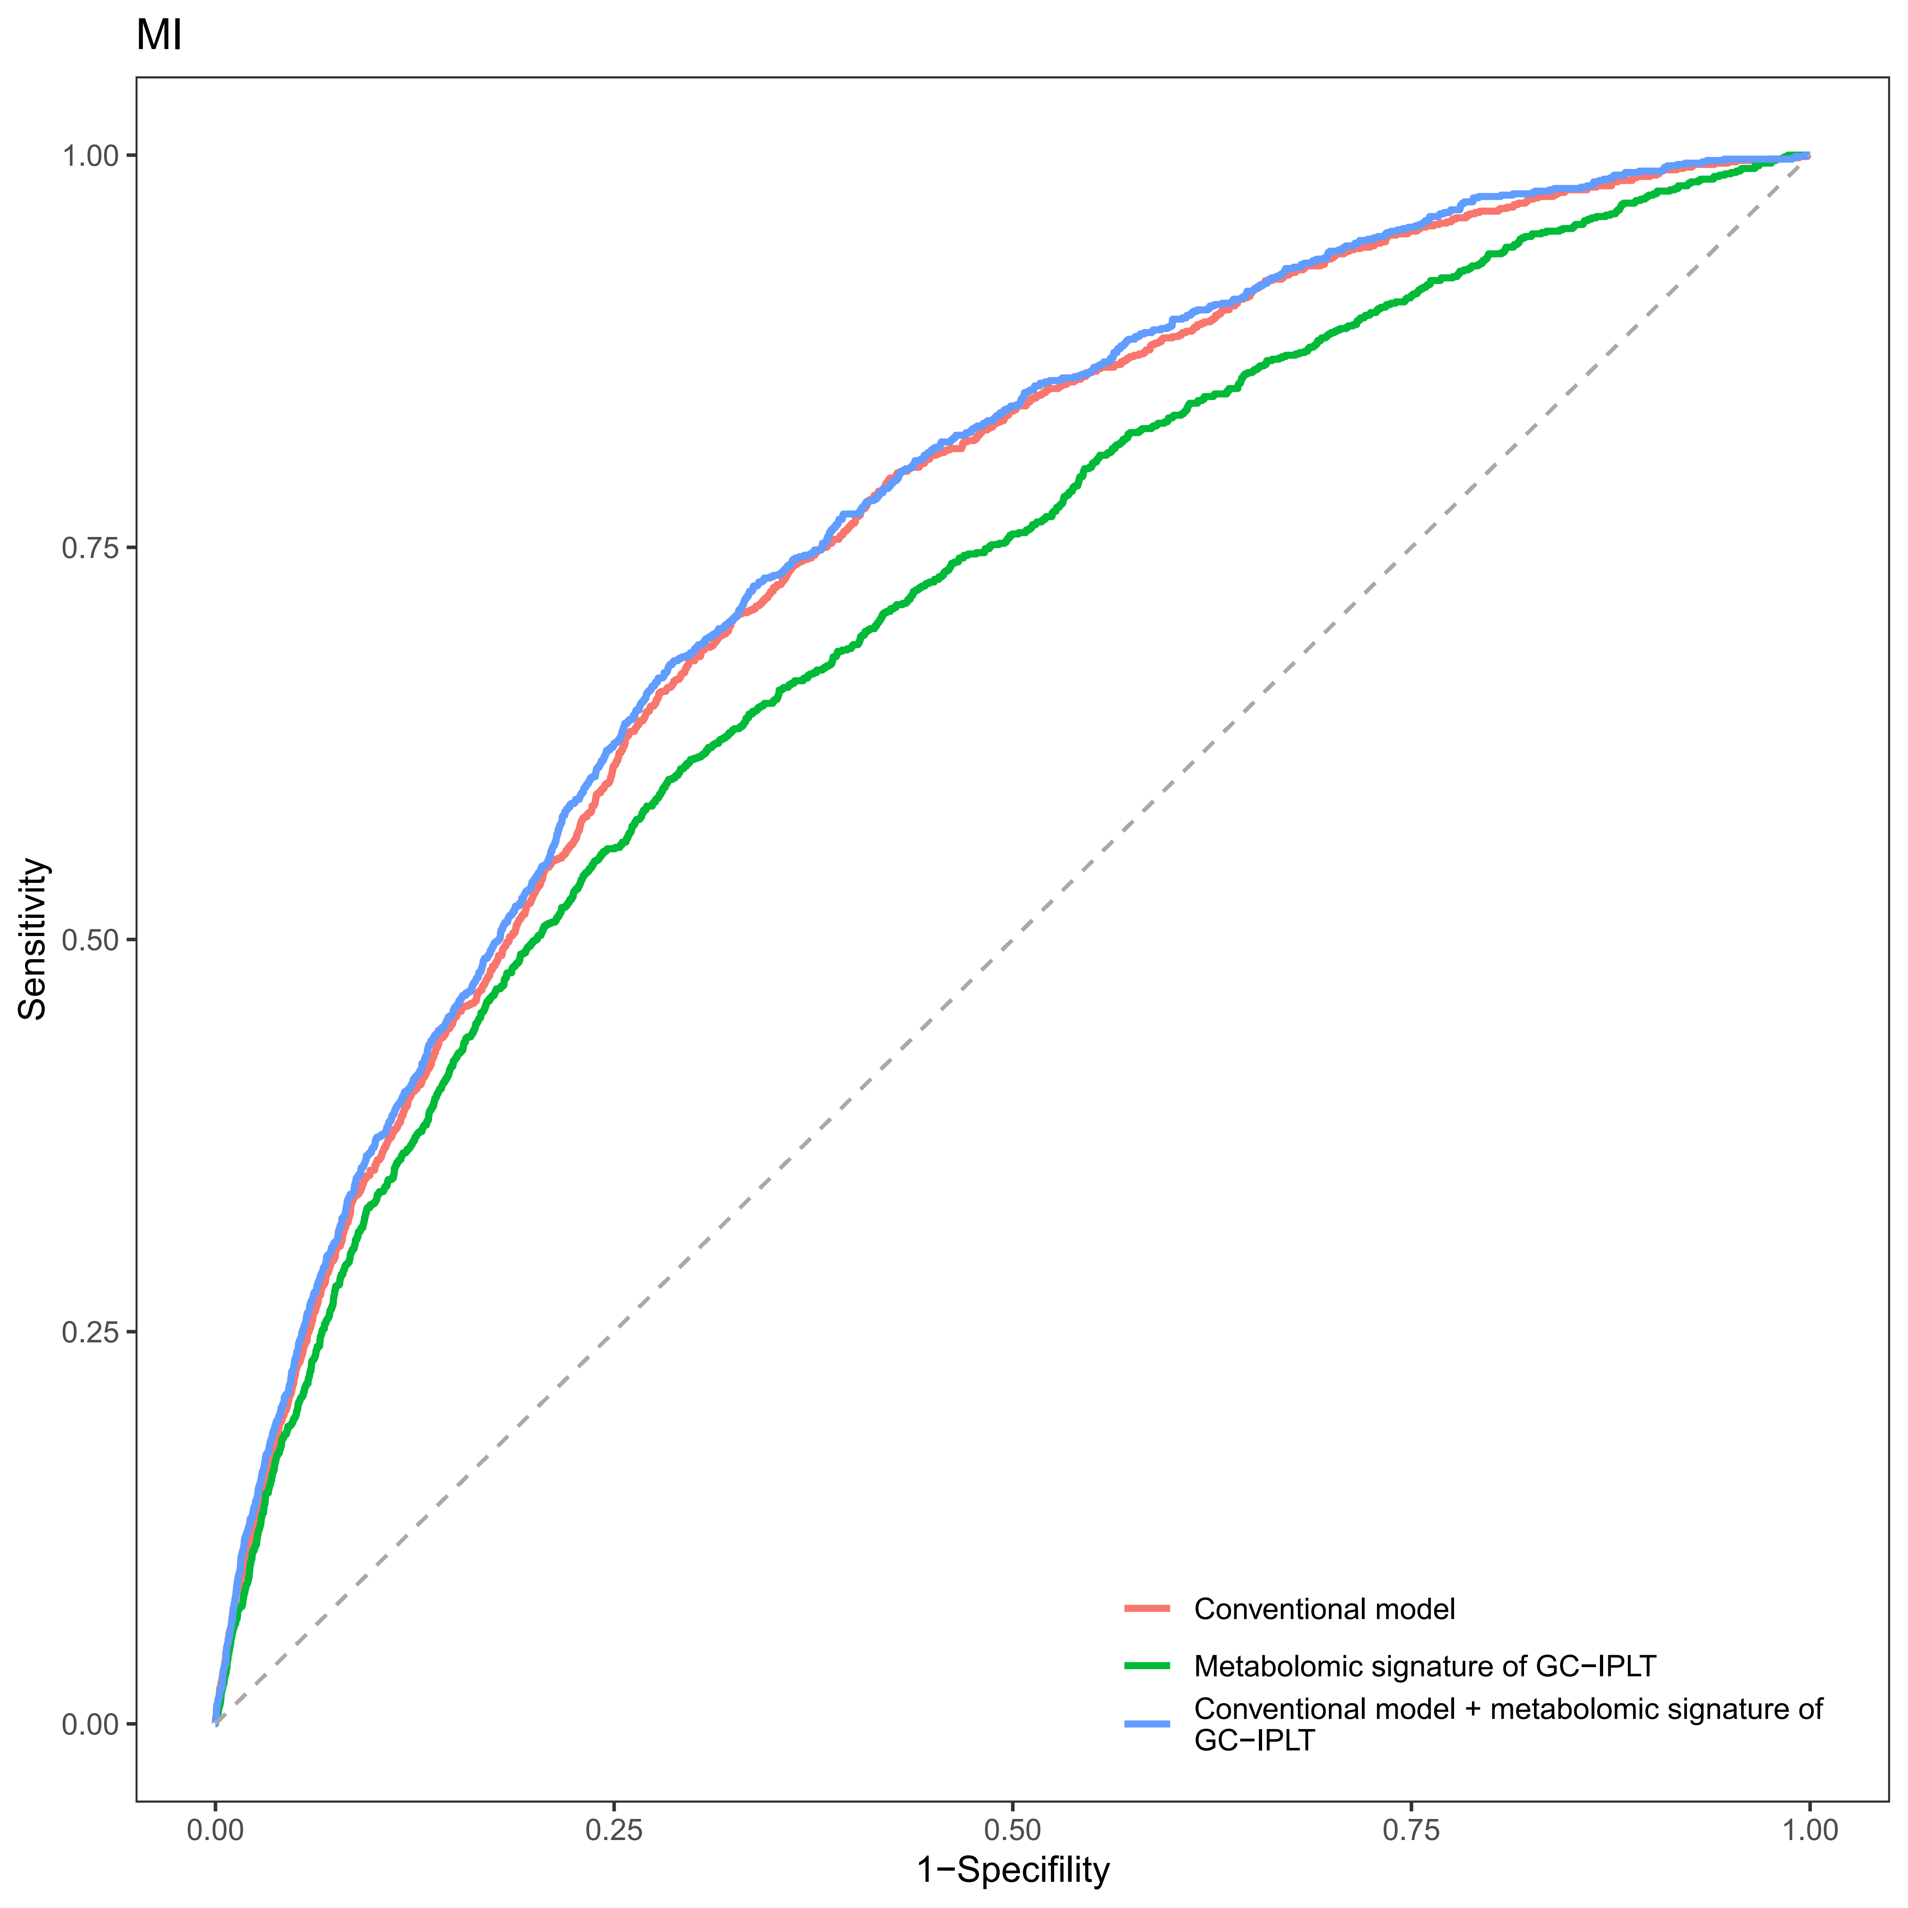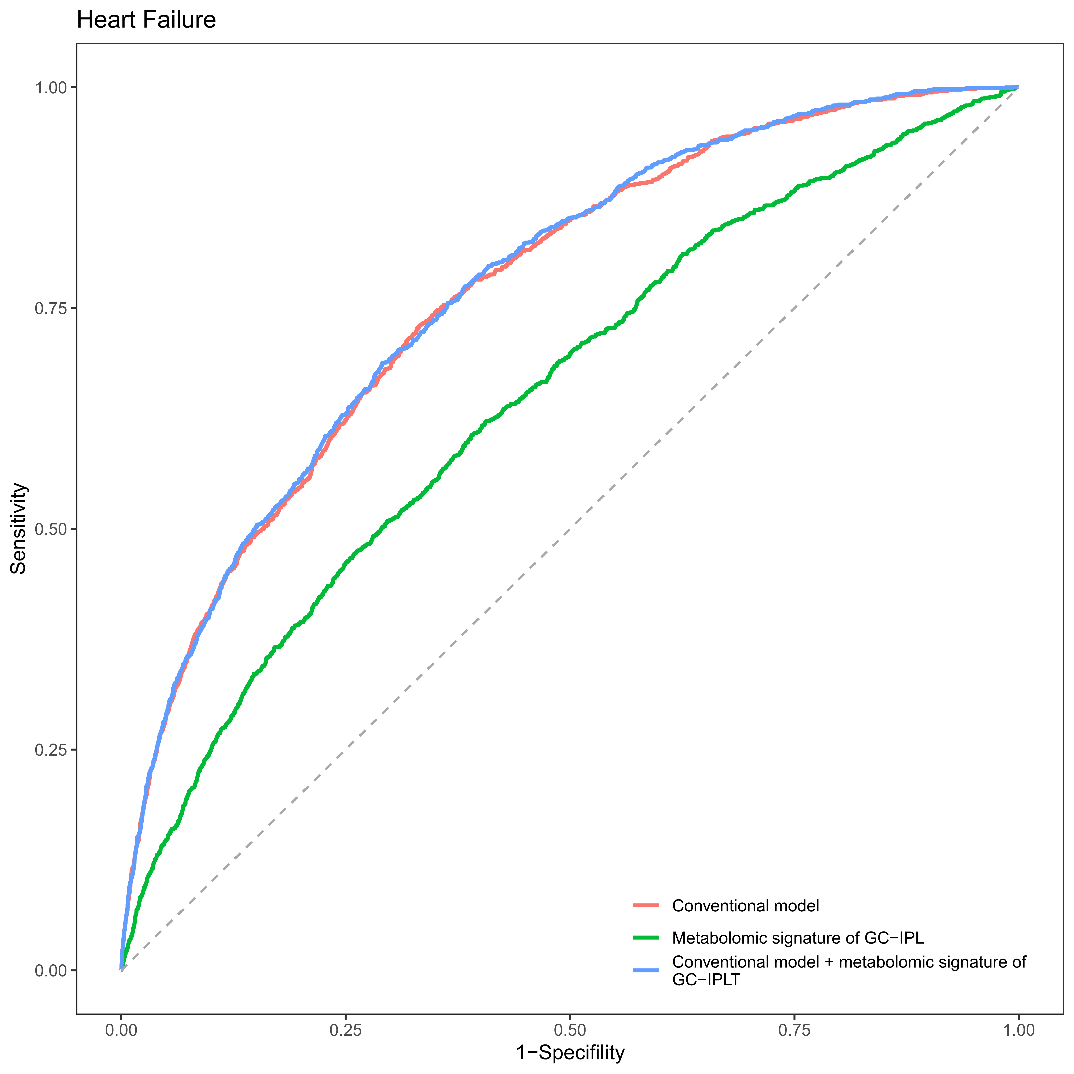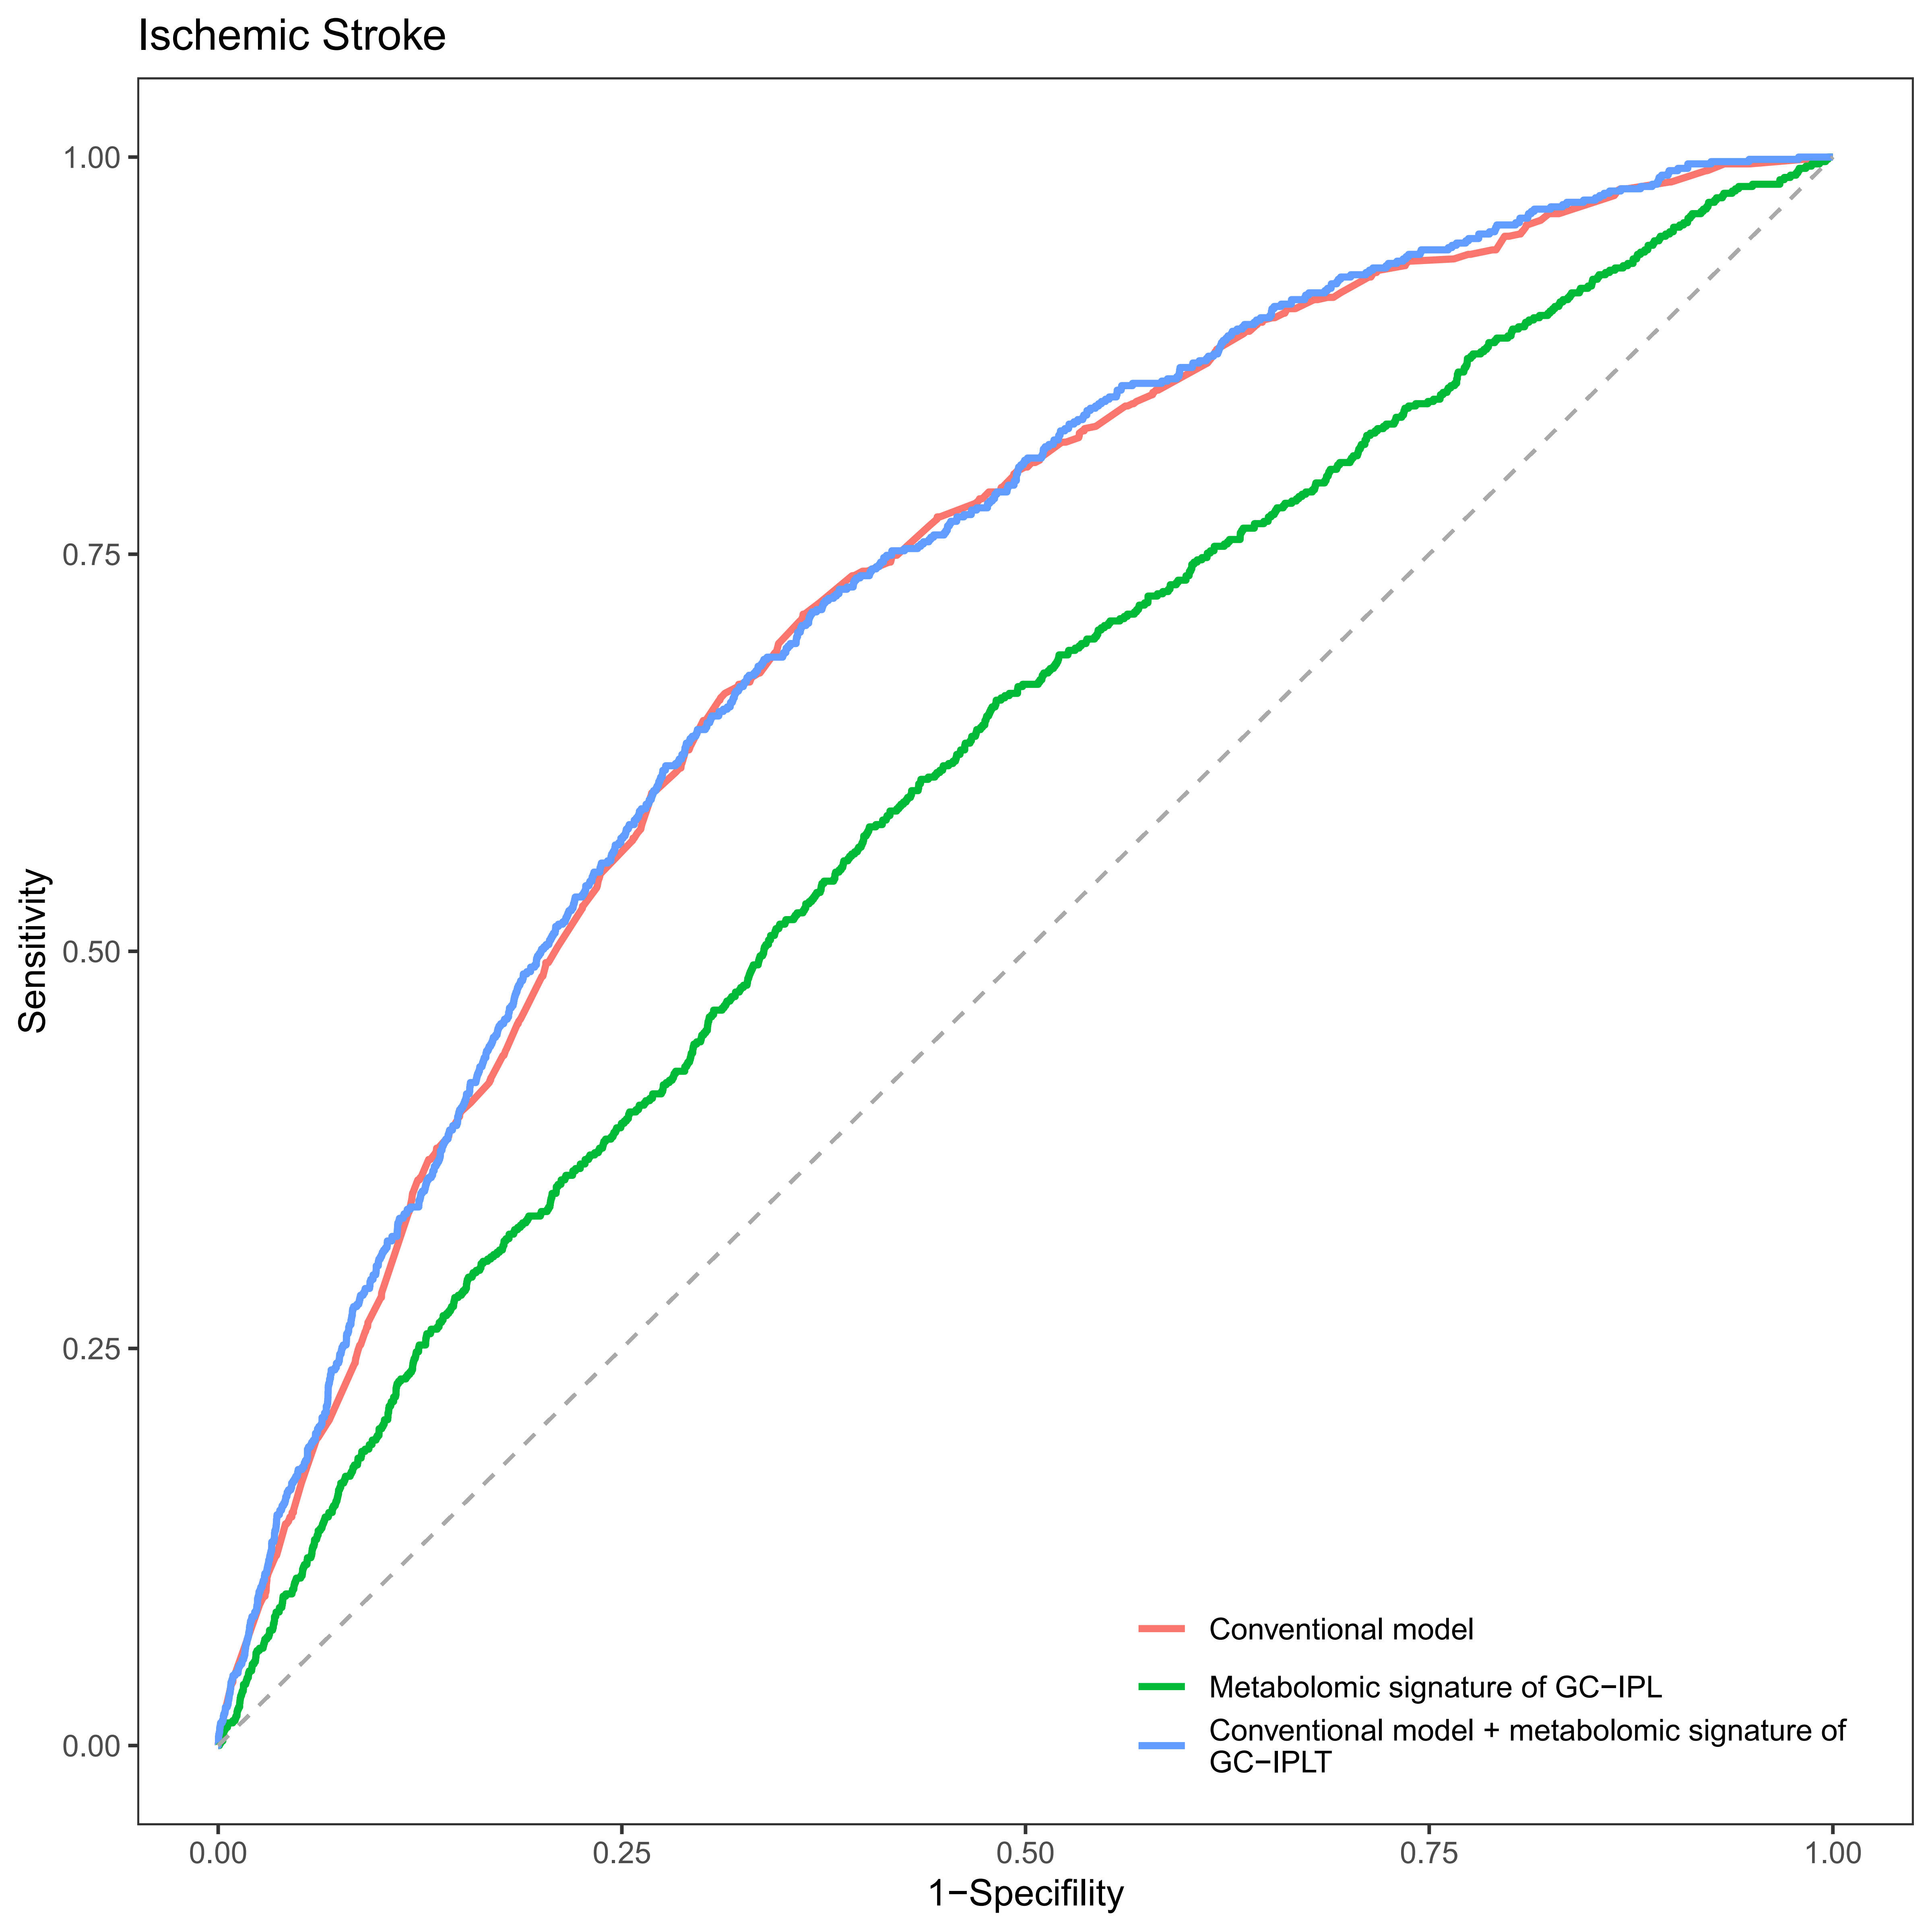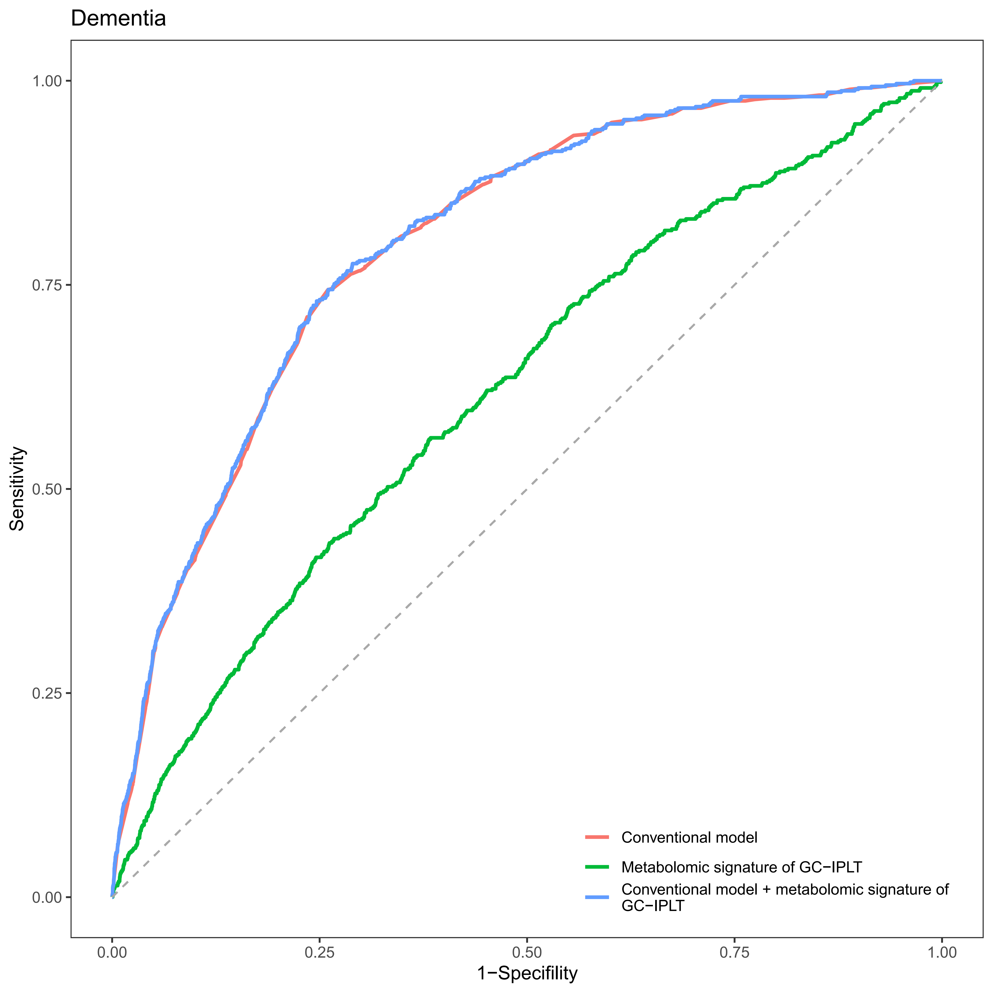

Supplementary Figure S13
Receiver operating characteristic (ROC) curves of conventional model, meta-GCIPLT score, and combined model predicting mortality in validation set.
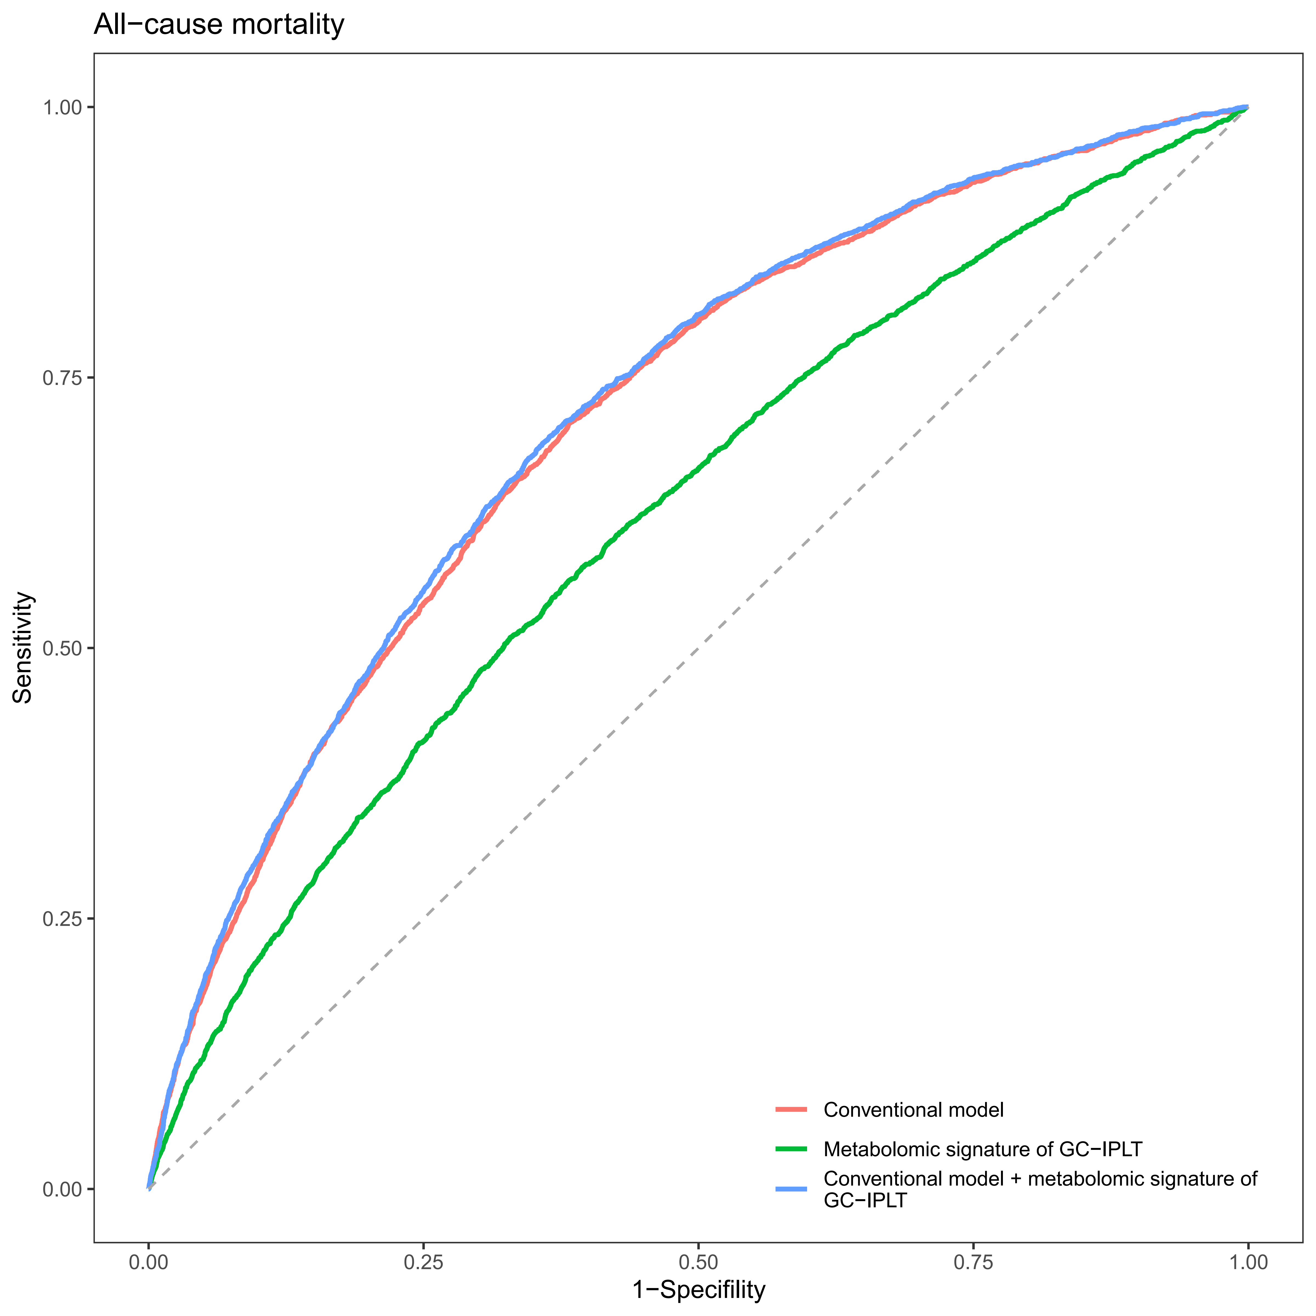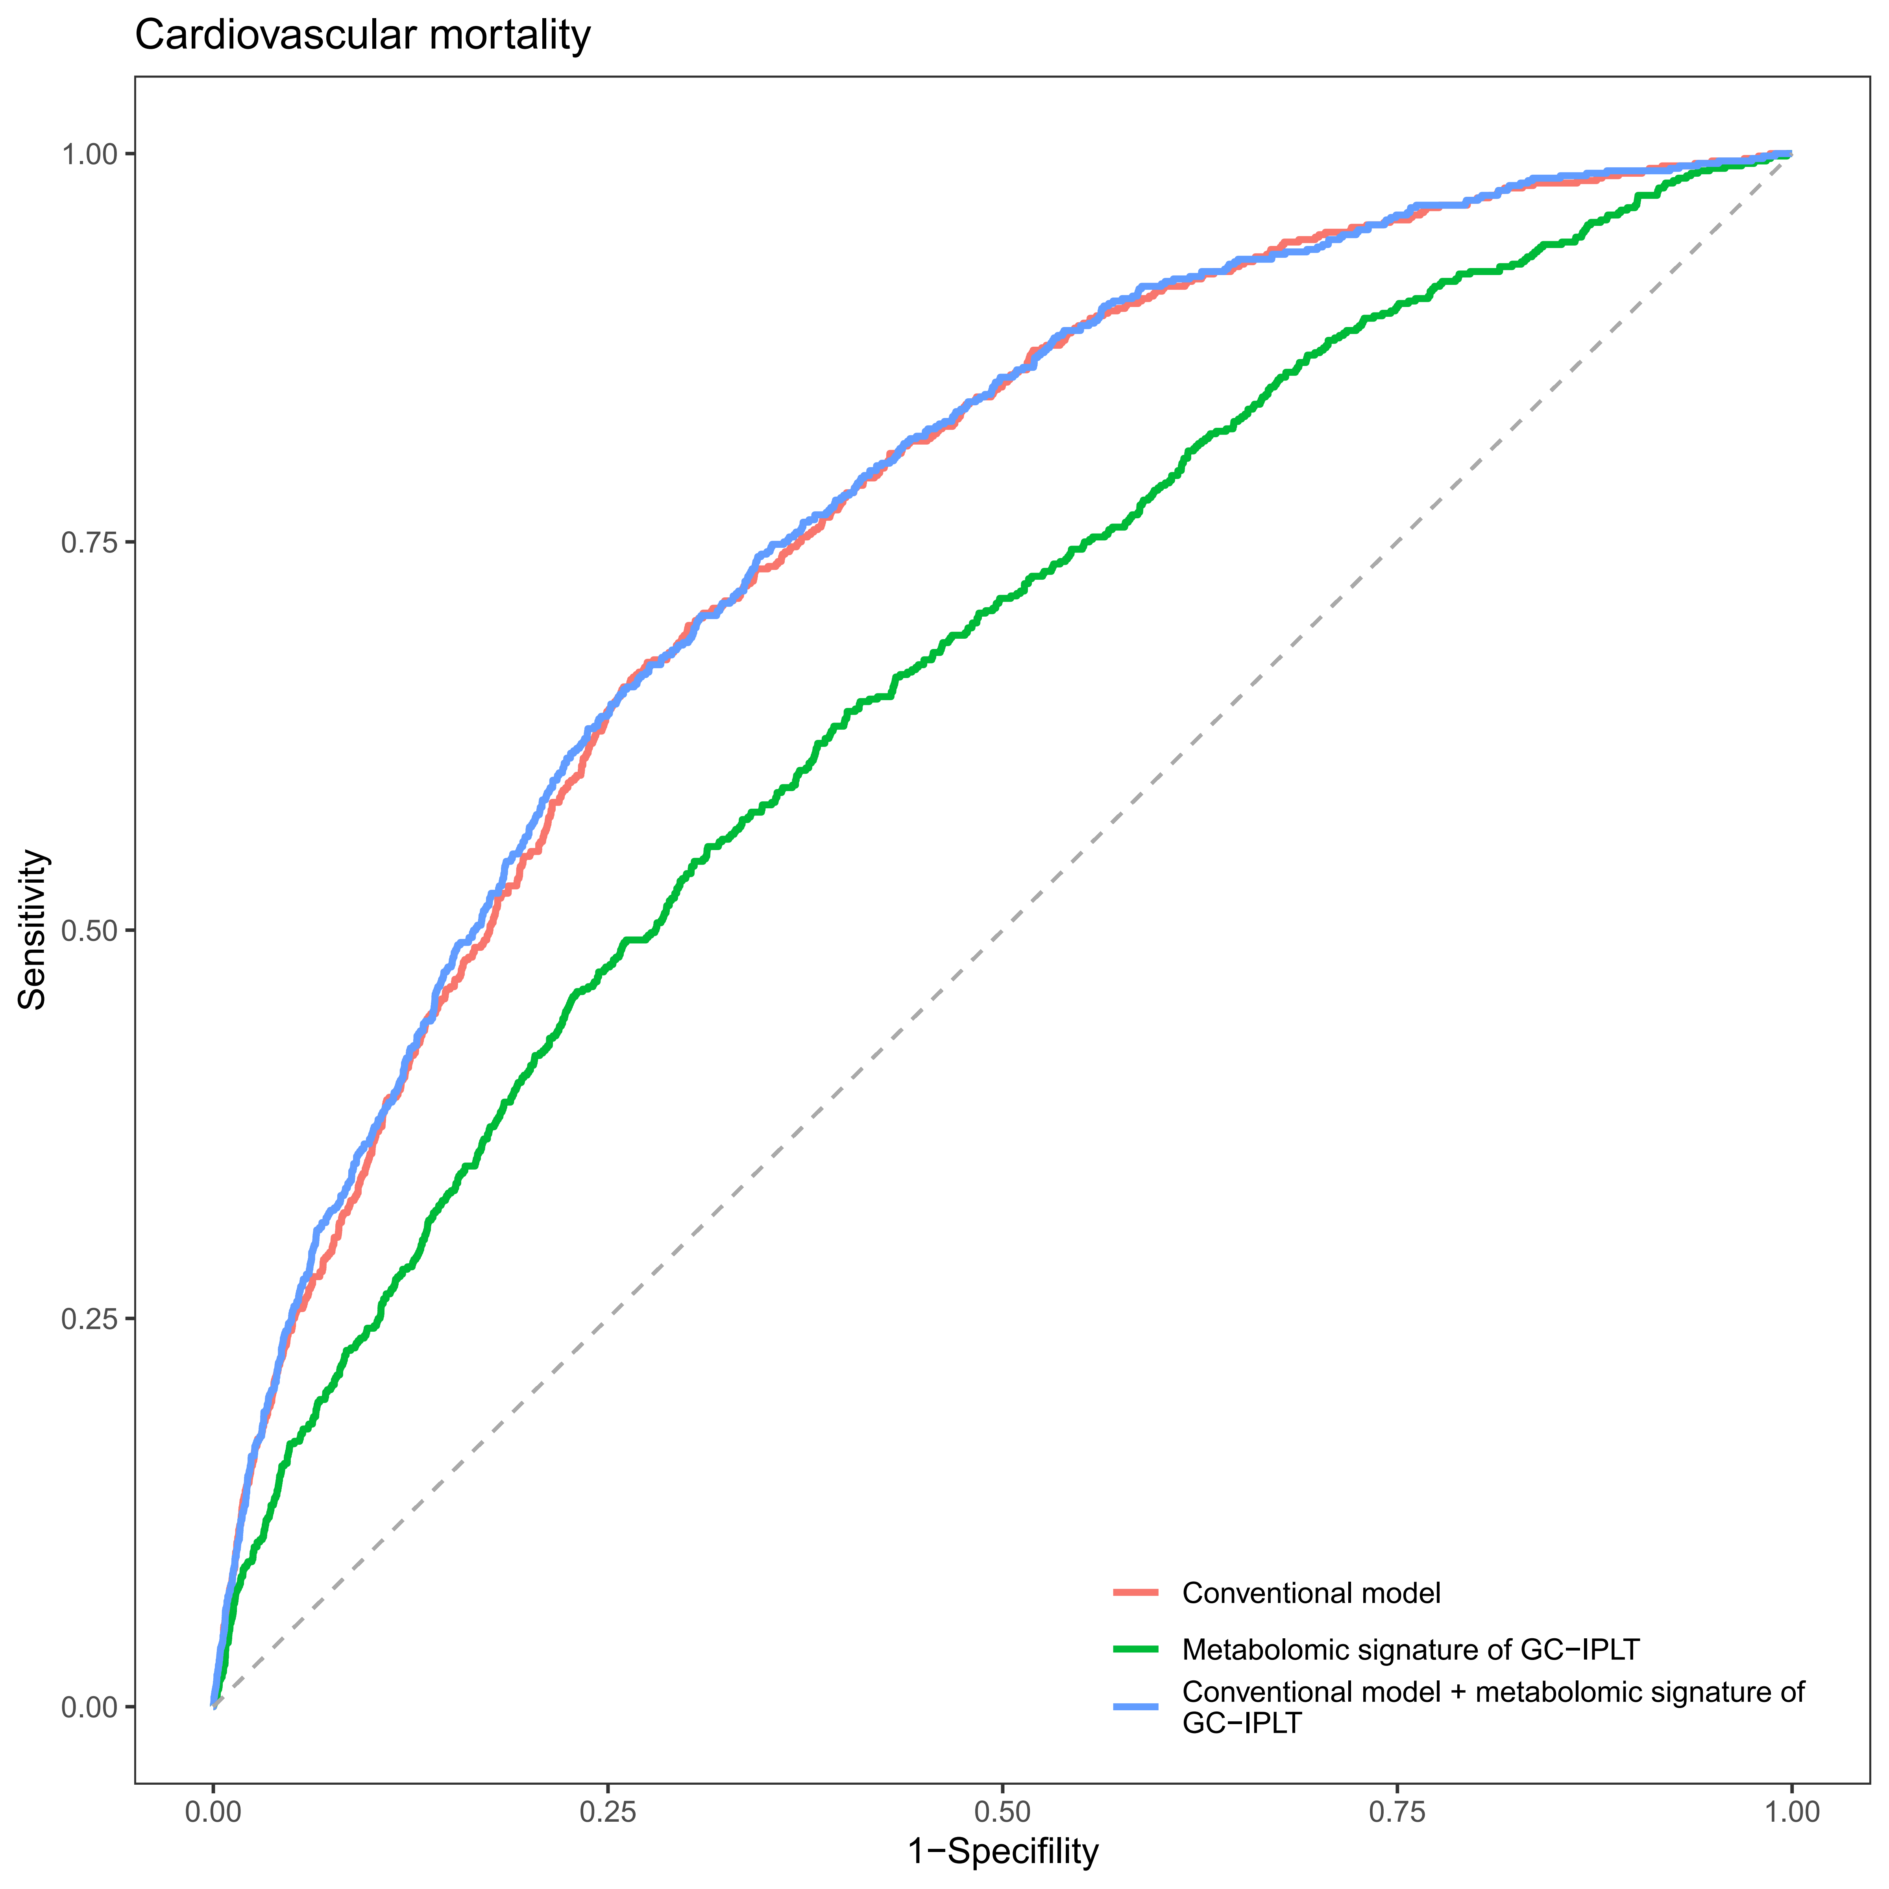
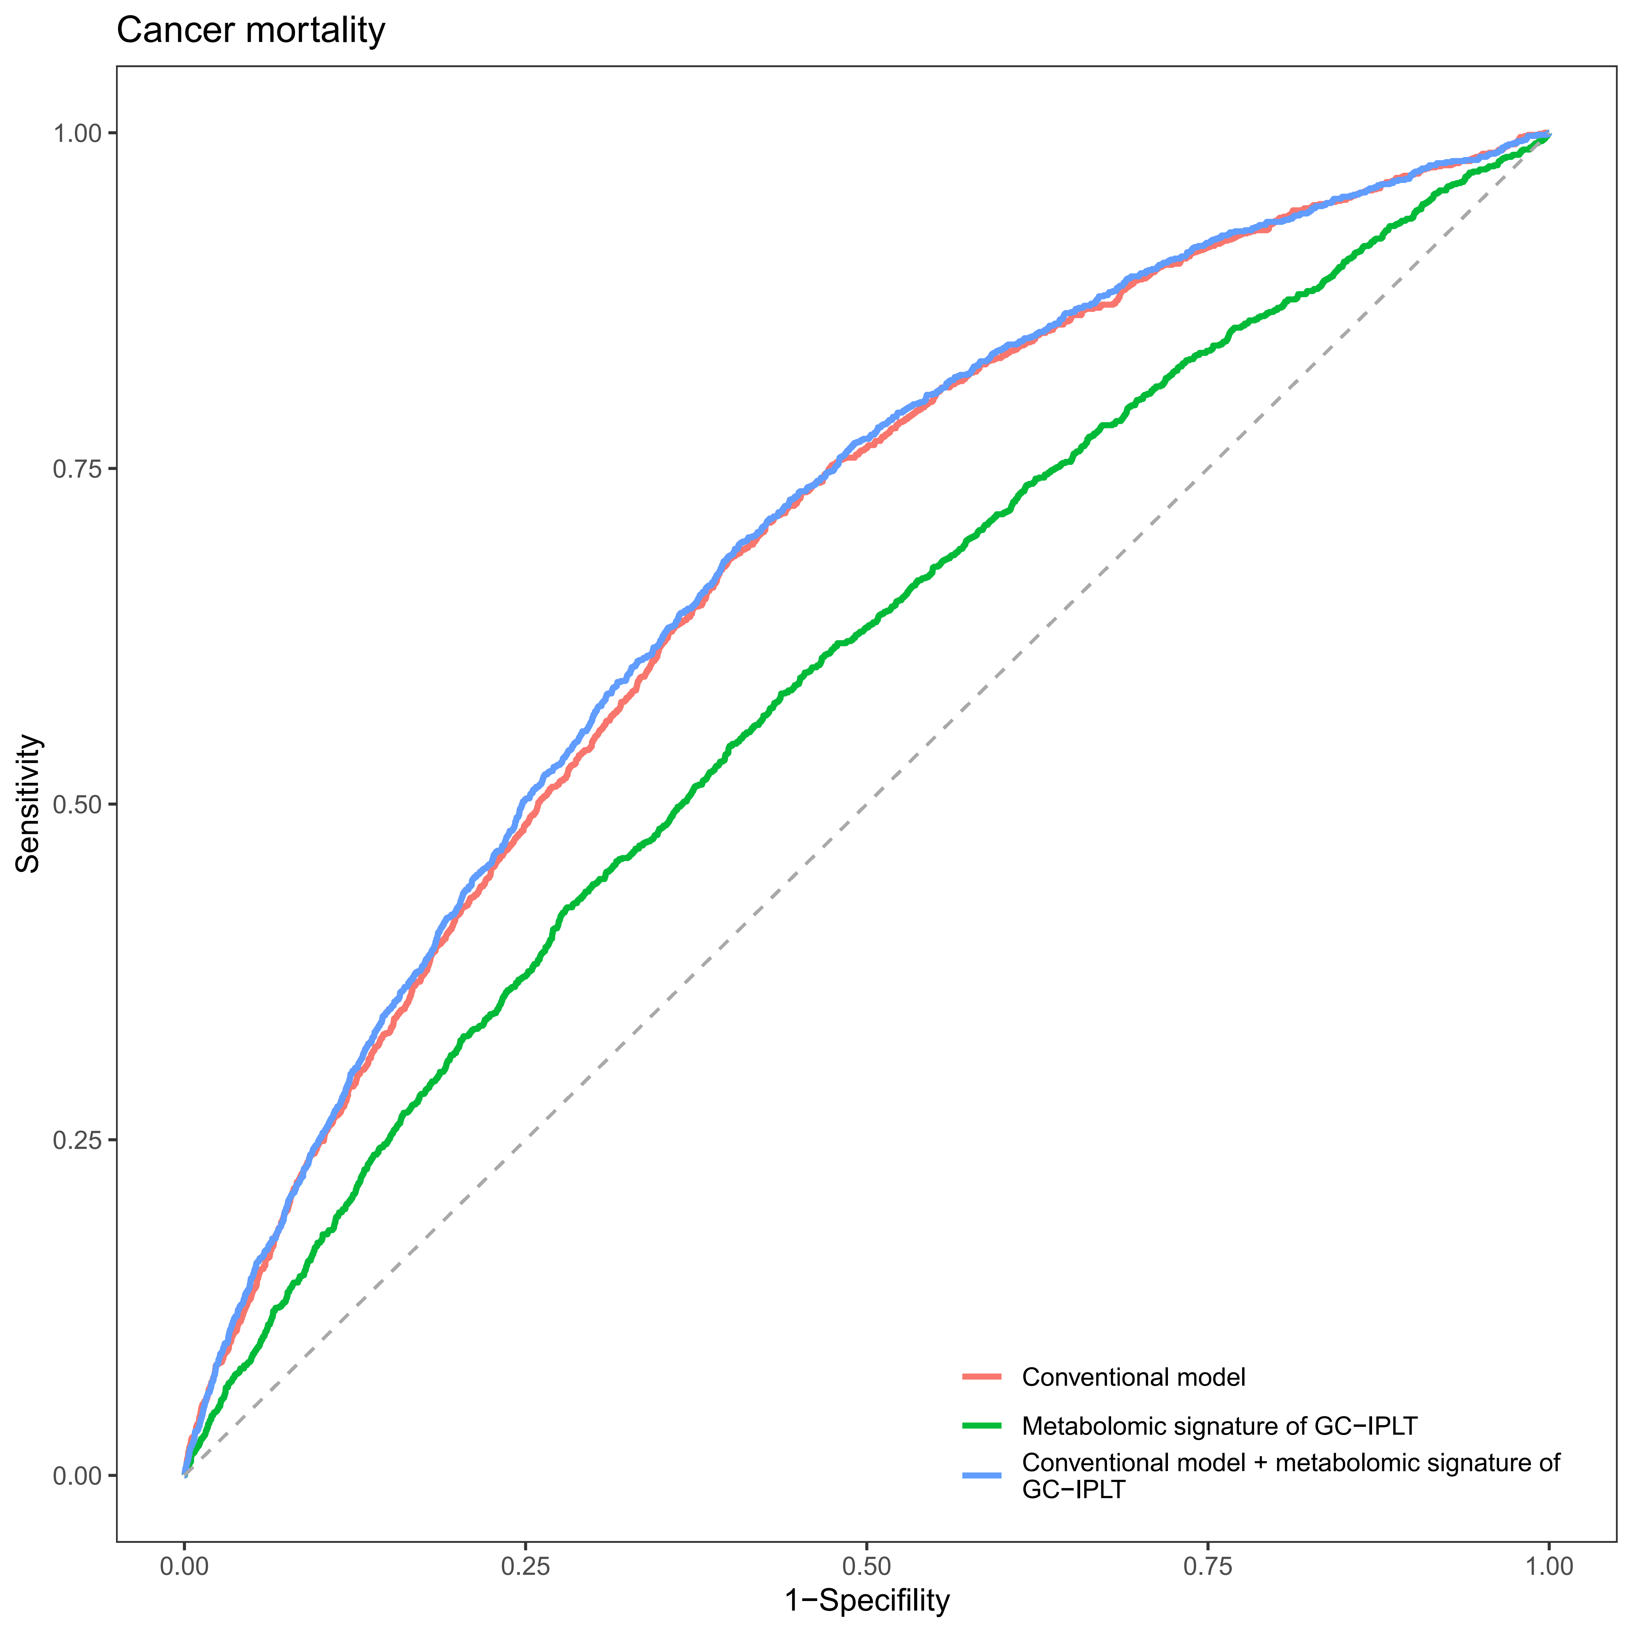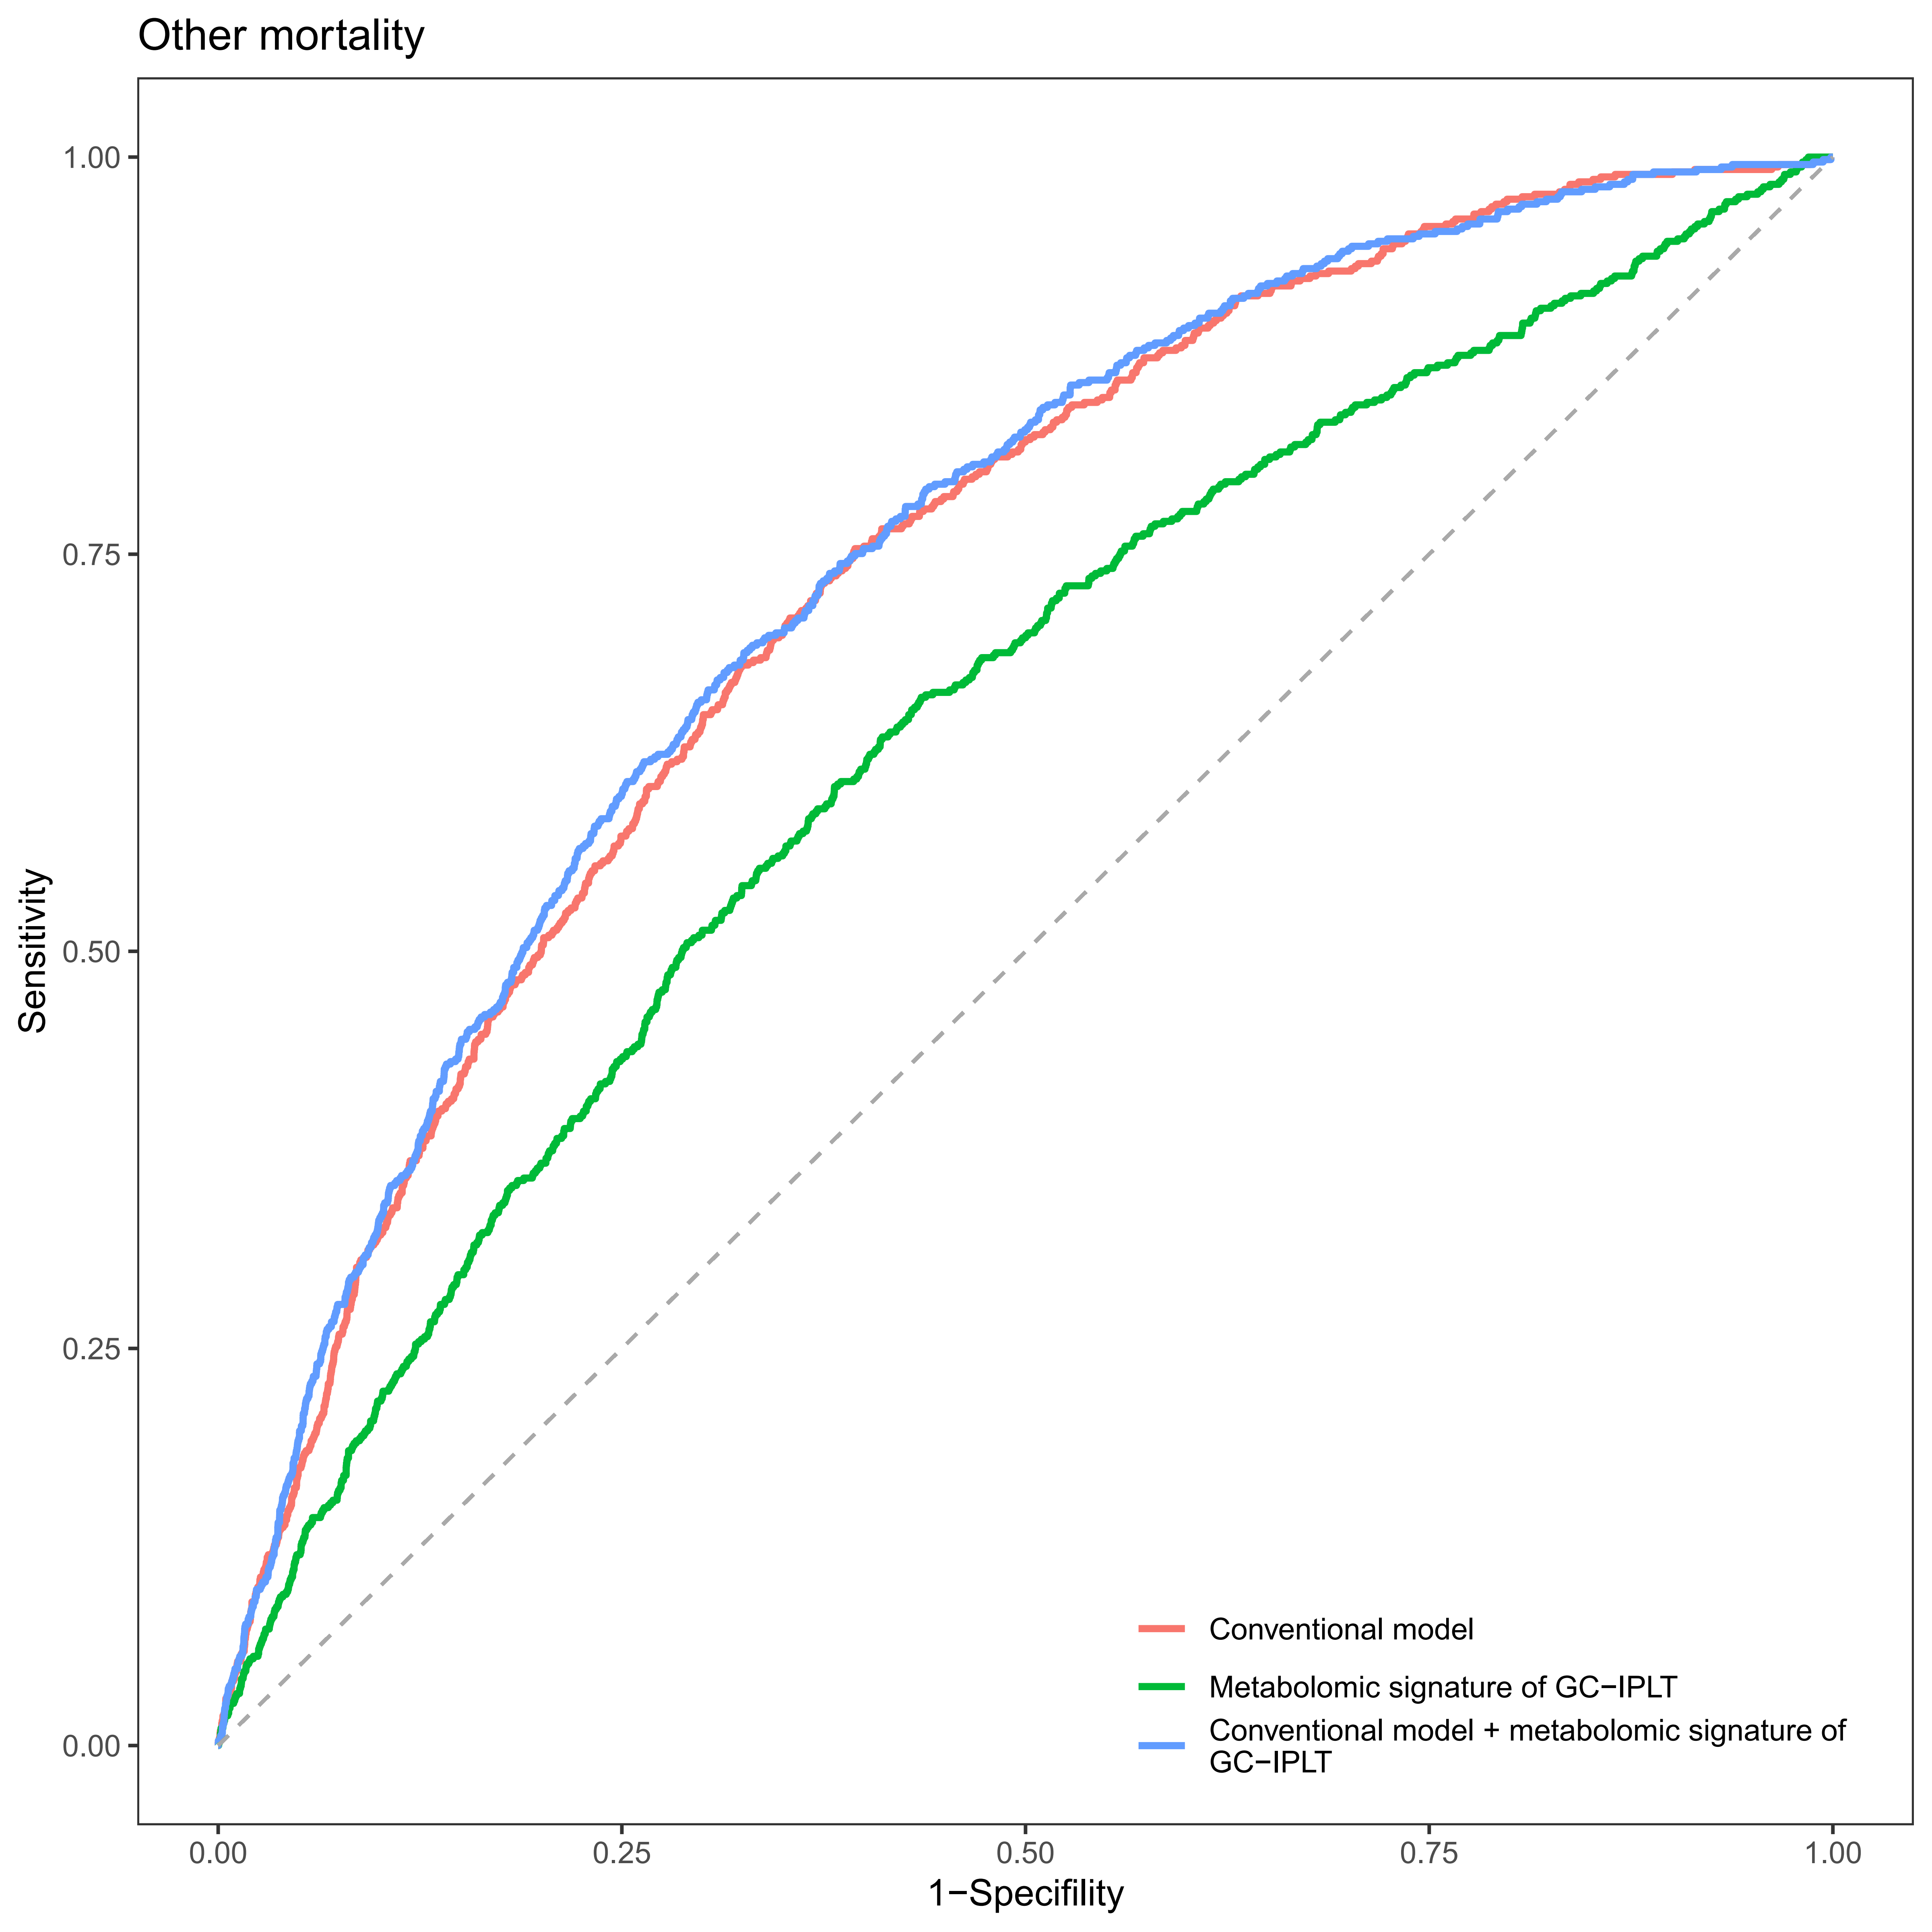

Supplementary Figure S14
Reclassification in the new model for systemic diseases with the inclusion of meta-GCIPLT score in training set.
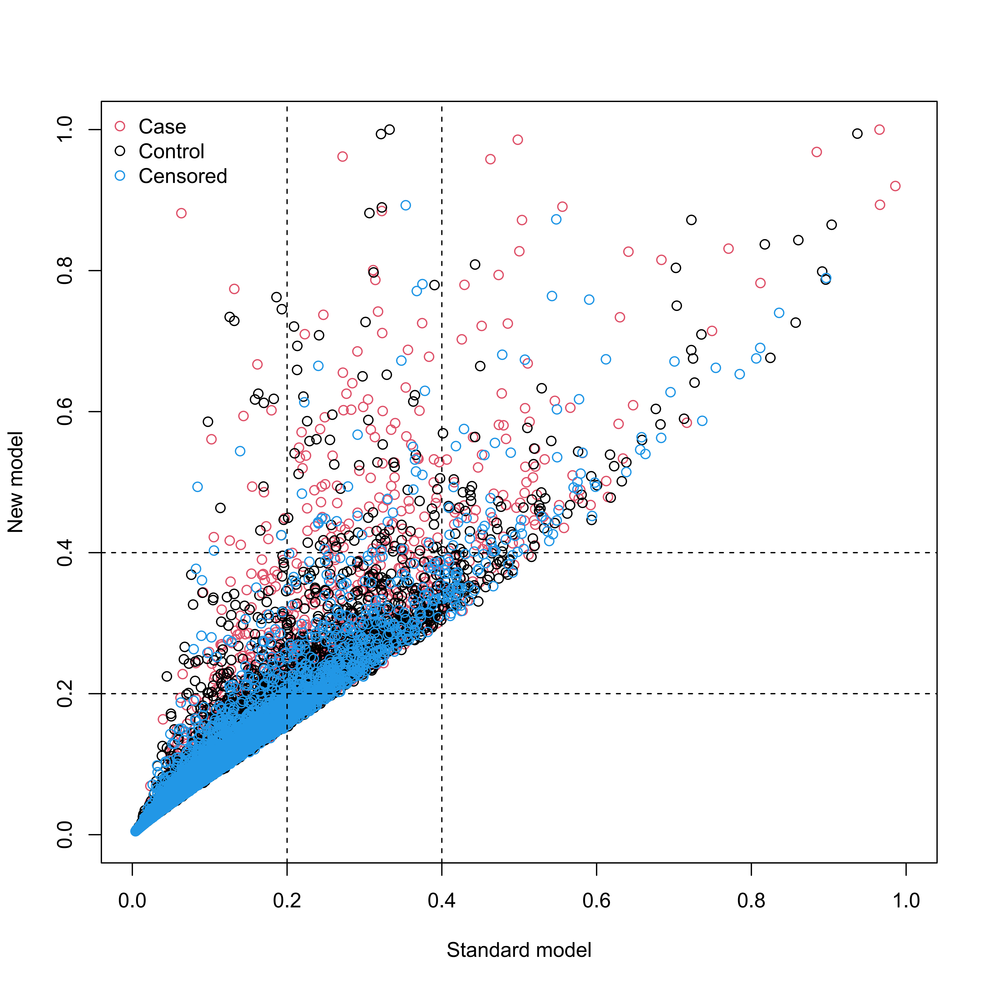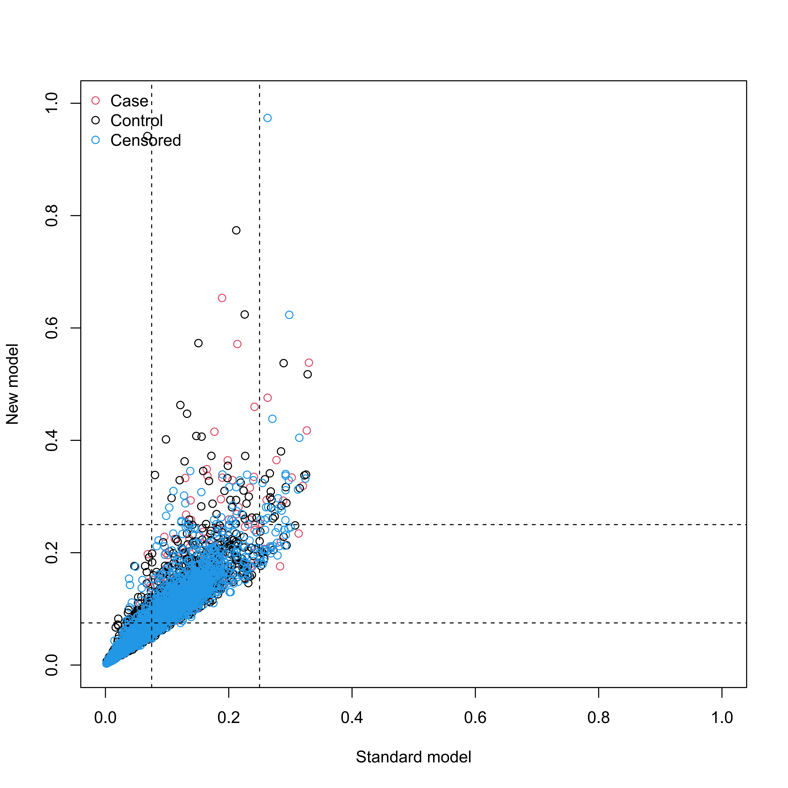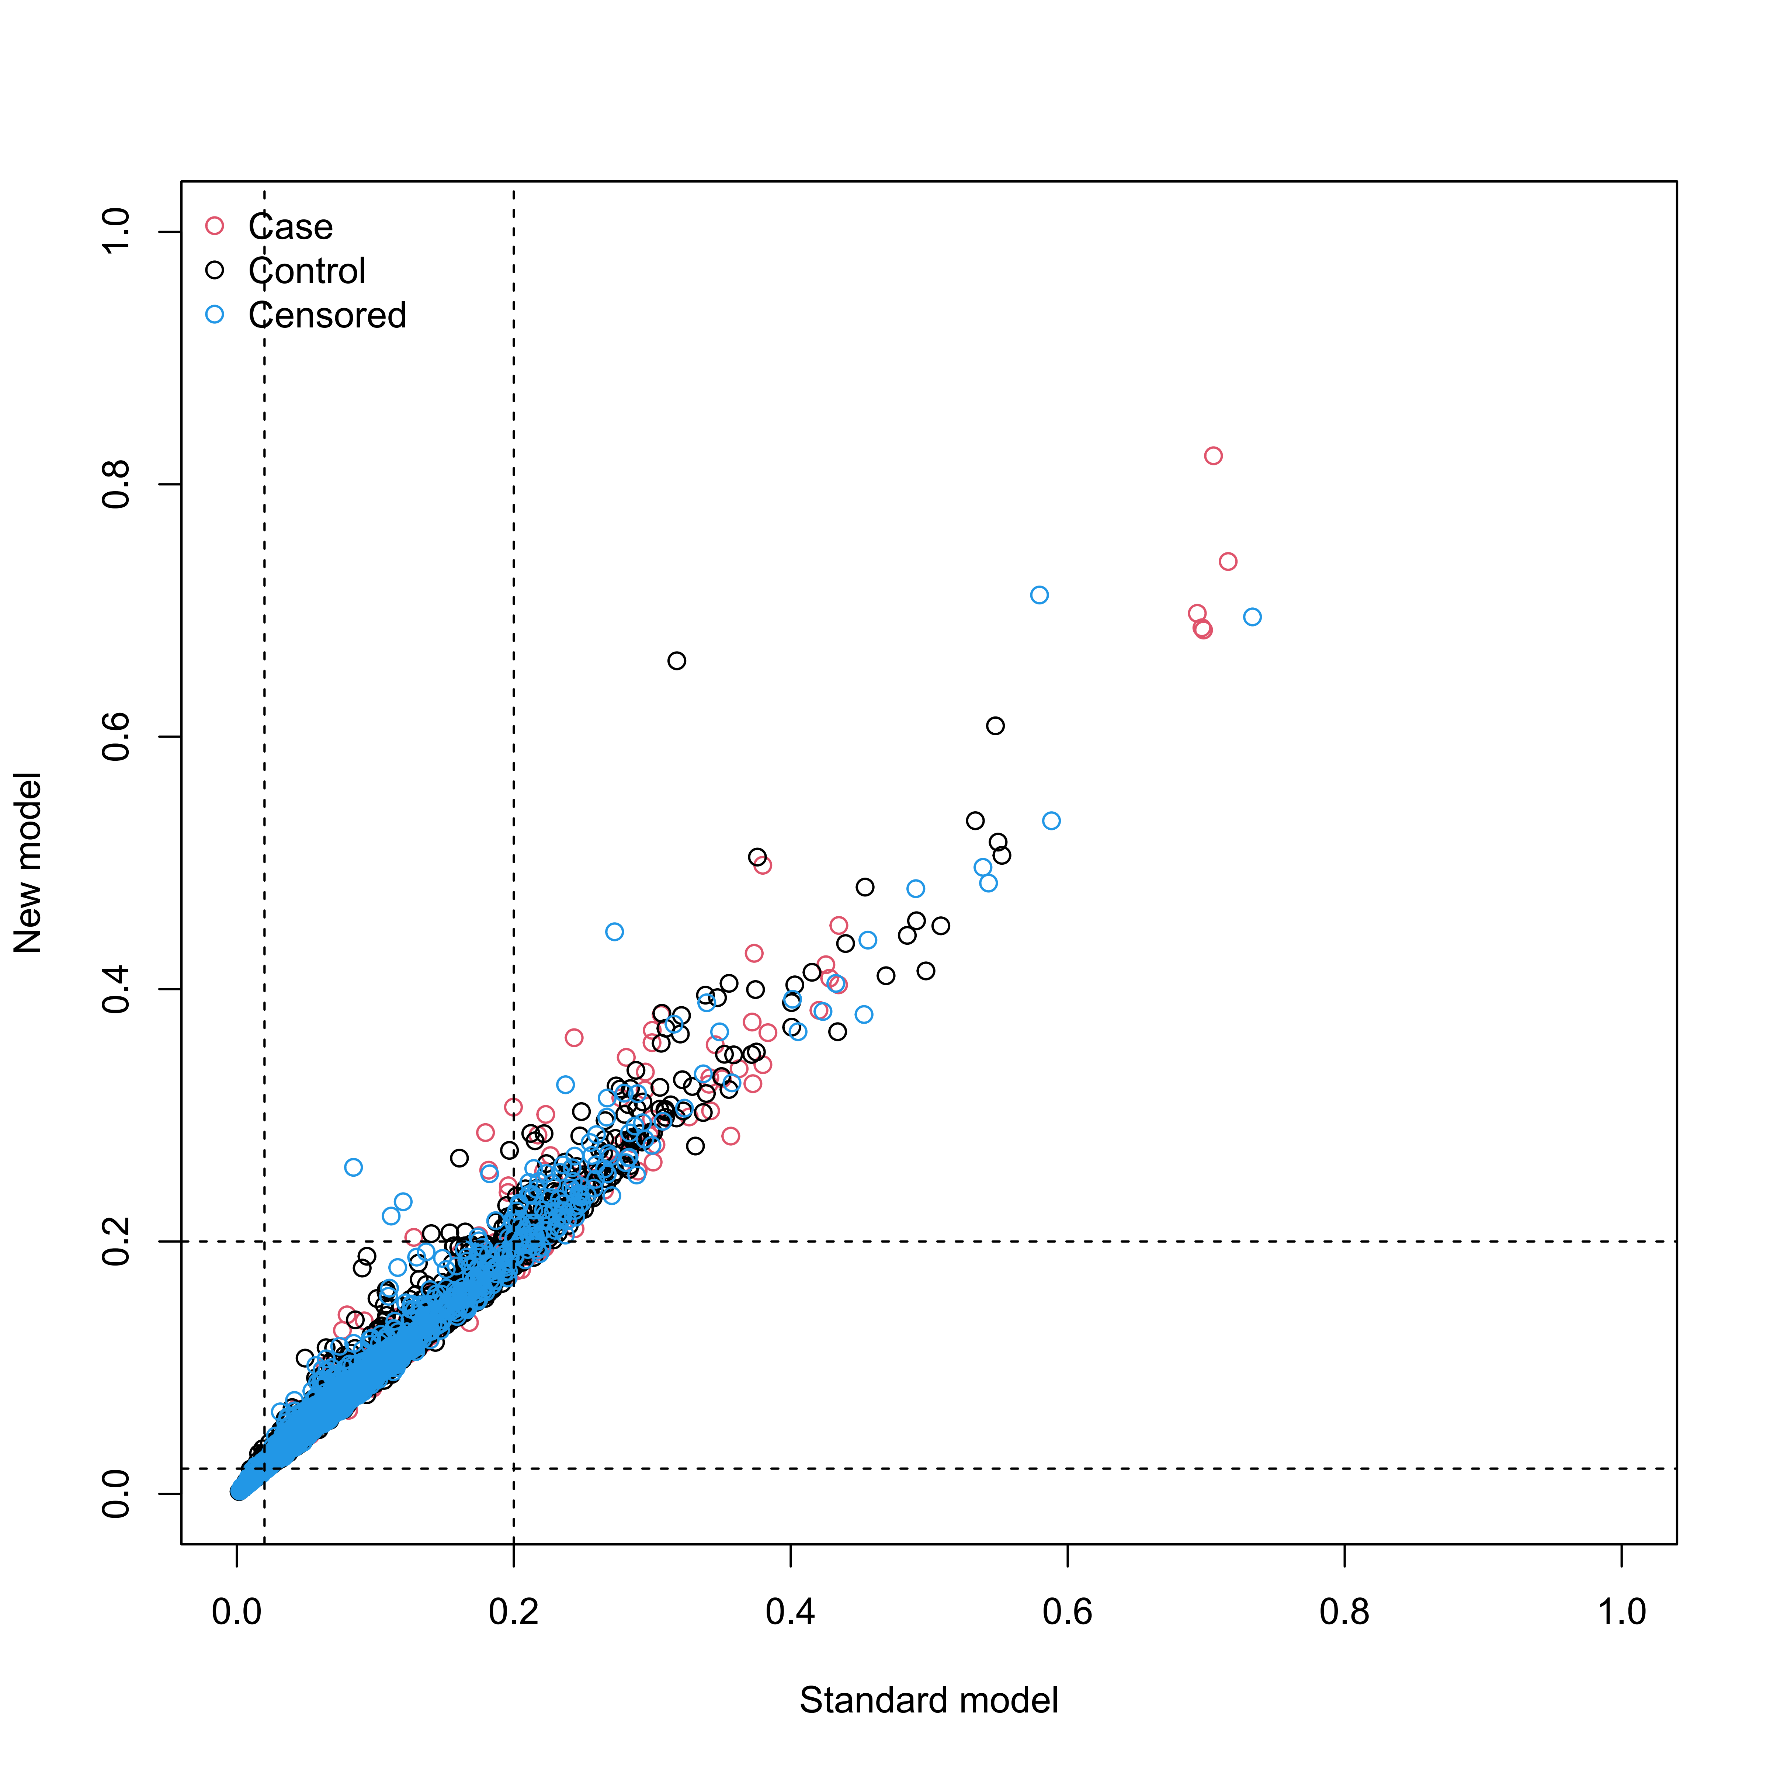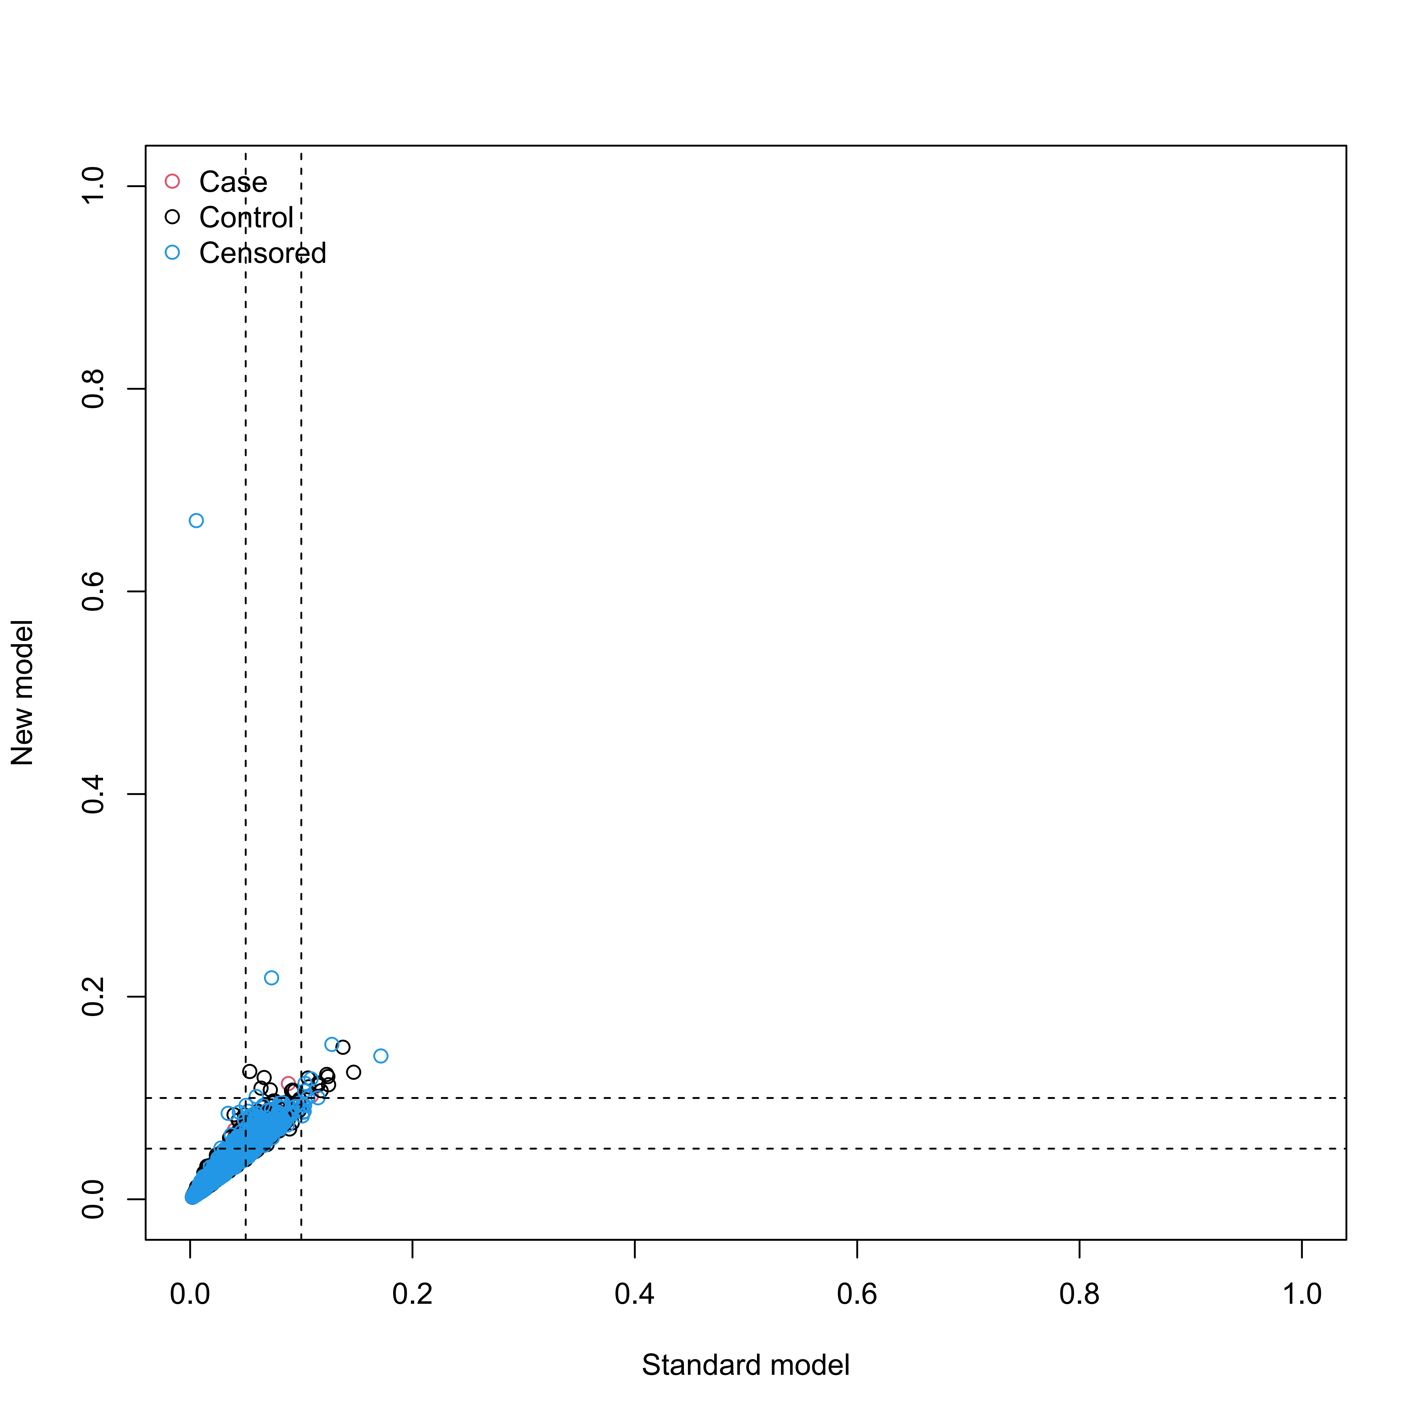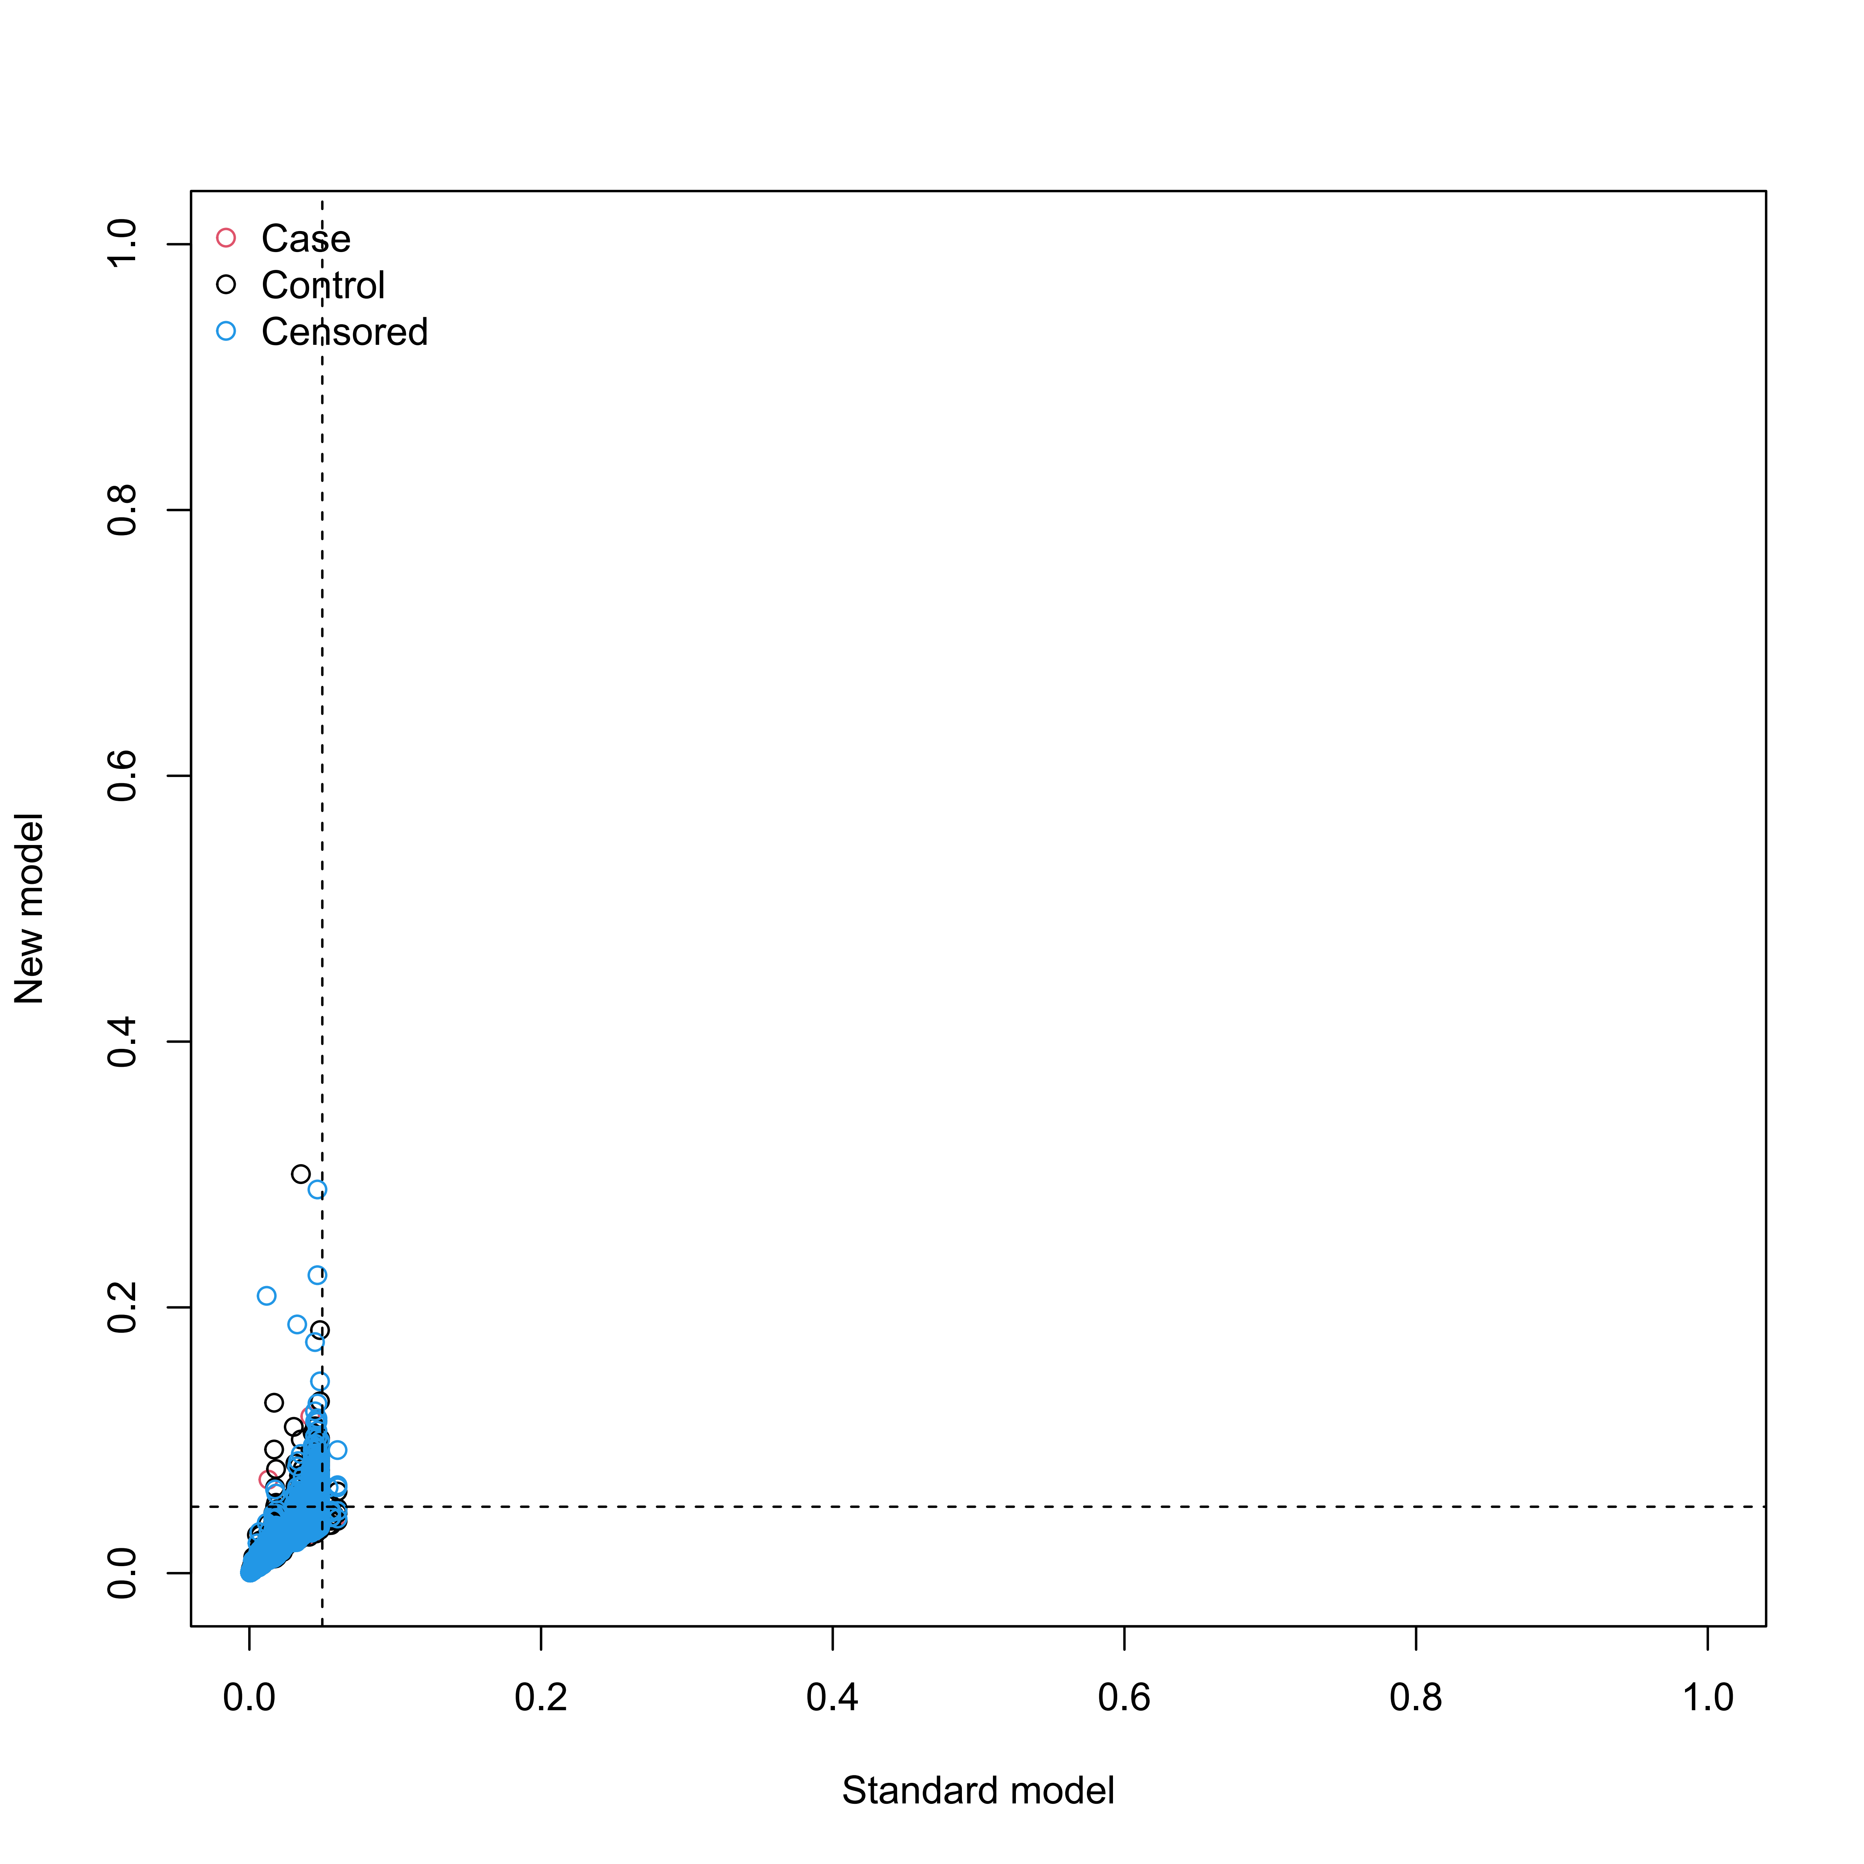

Supplementary Figure S15
Reclassification in the new model for mortality with the inclusion of meta-GCIPLT score in training set.
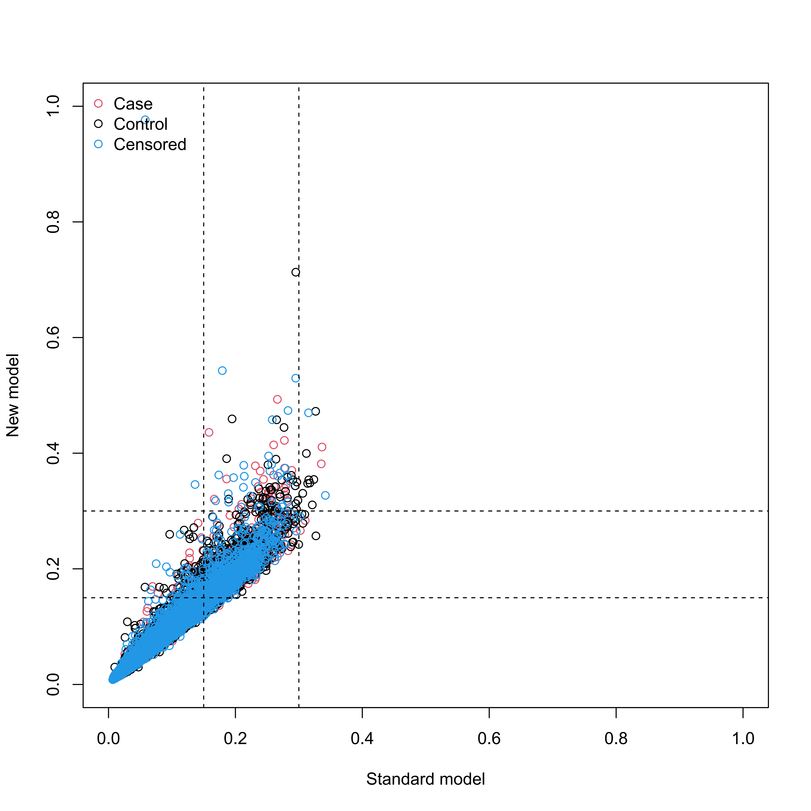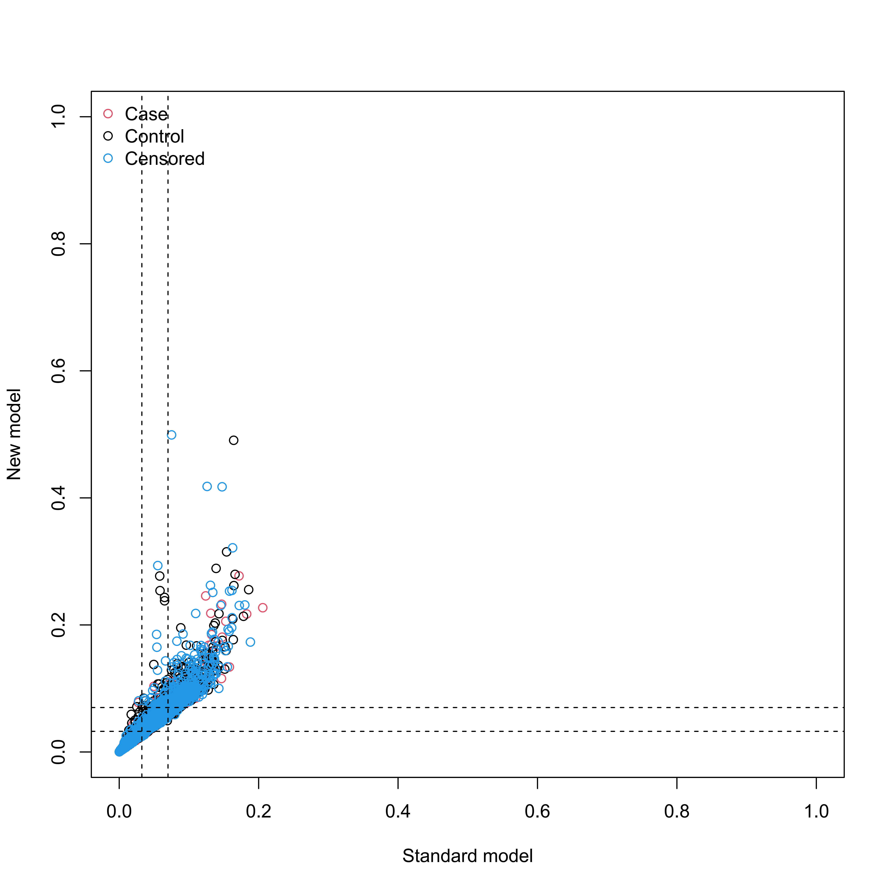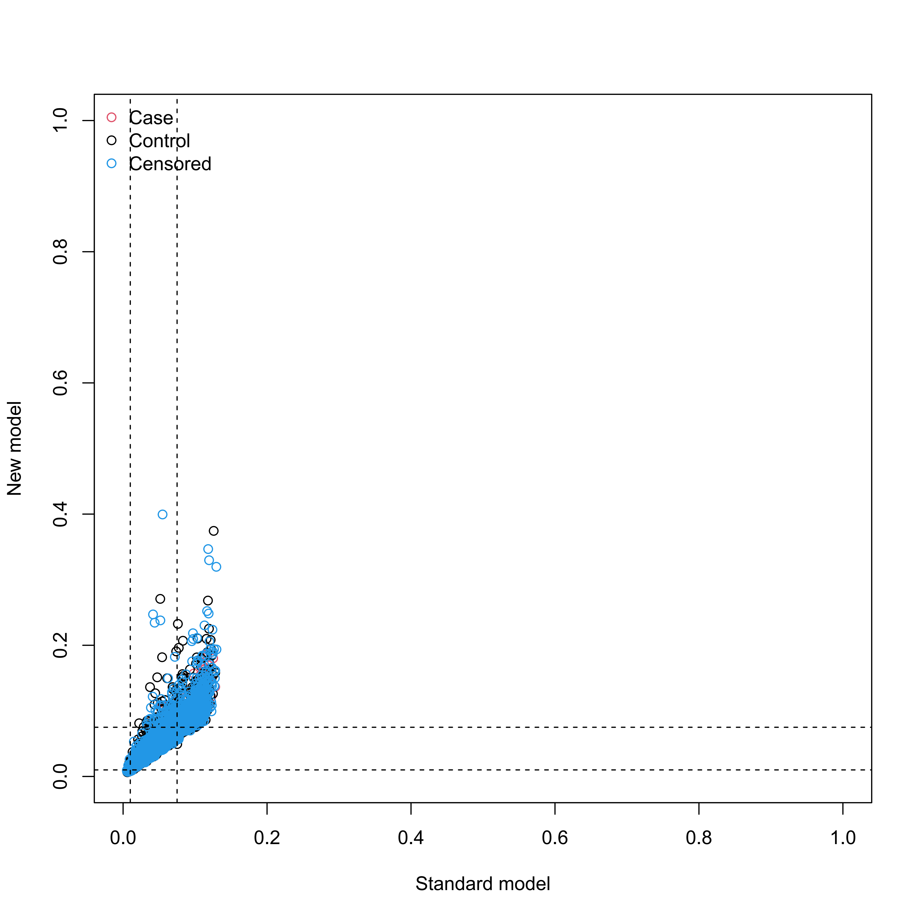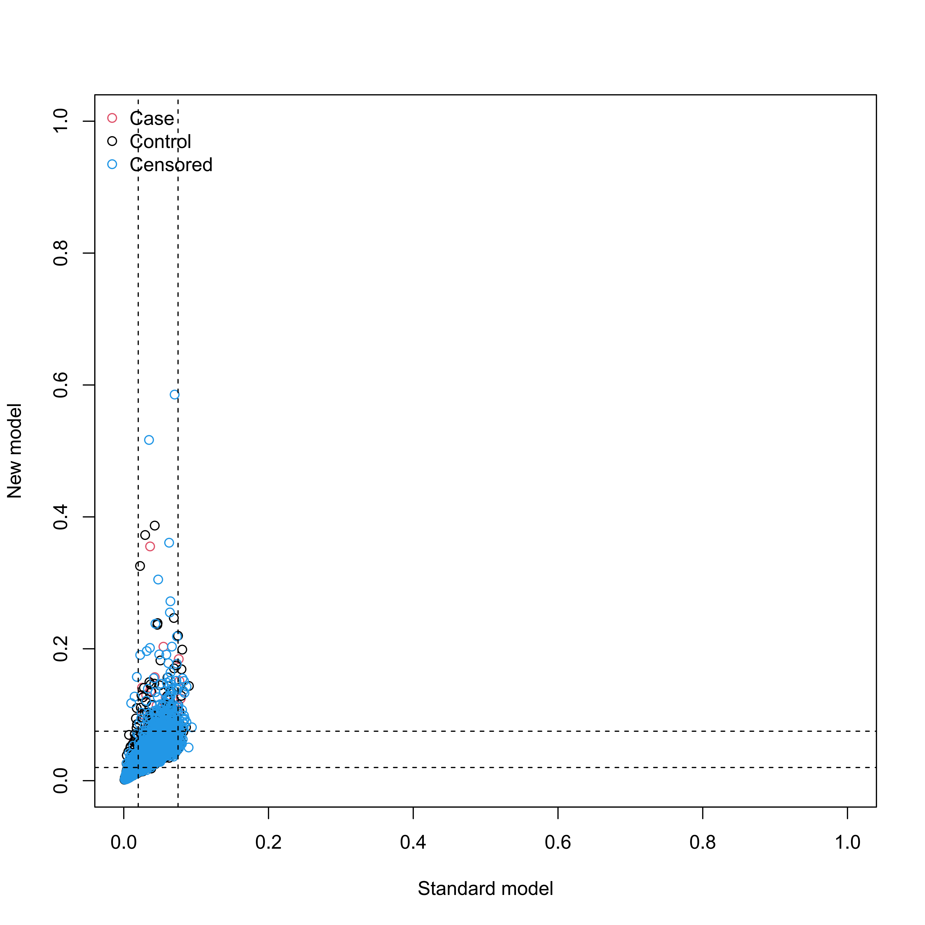

Supplementary Figure S16
Reclassification in the new model for systemic diseases with the inclusion of meta-GCIPLT score in validation set.
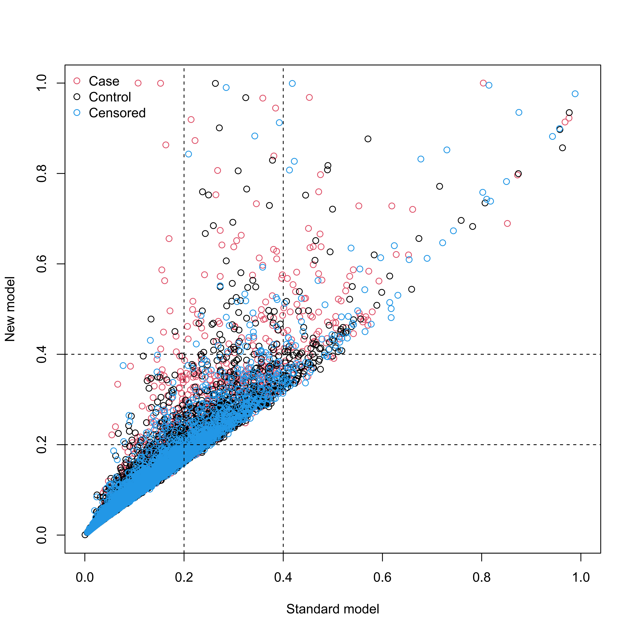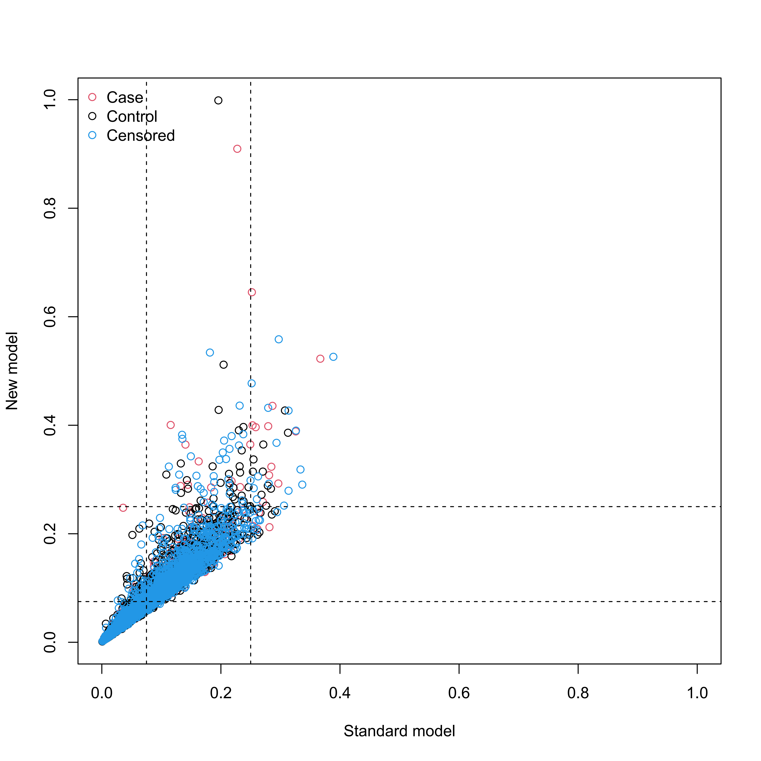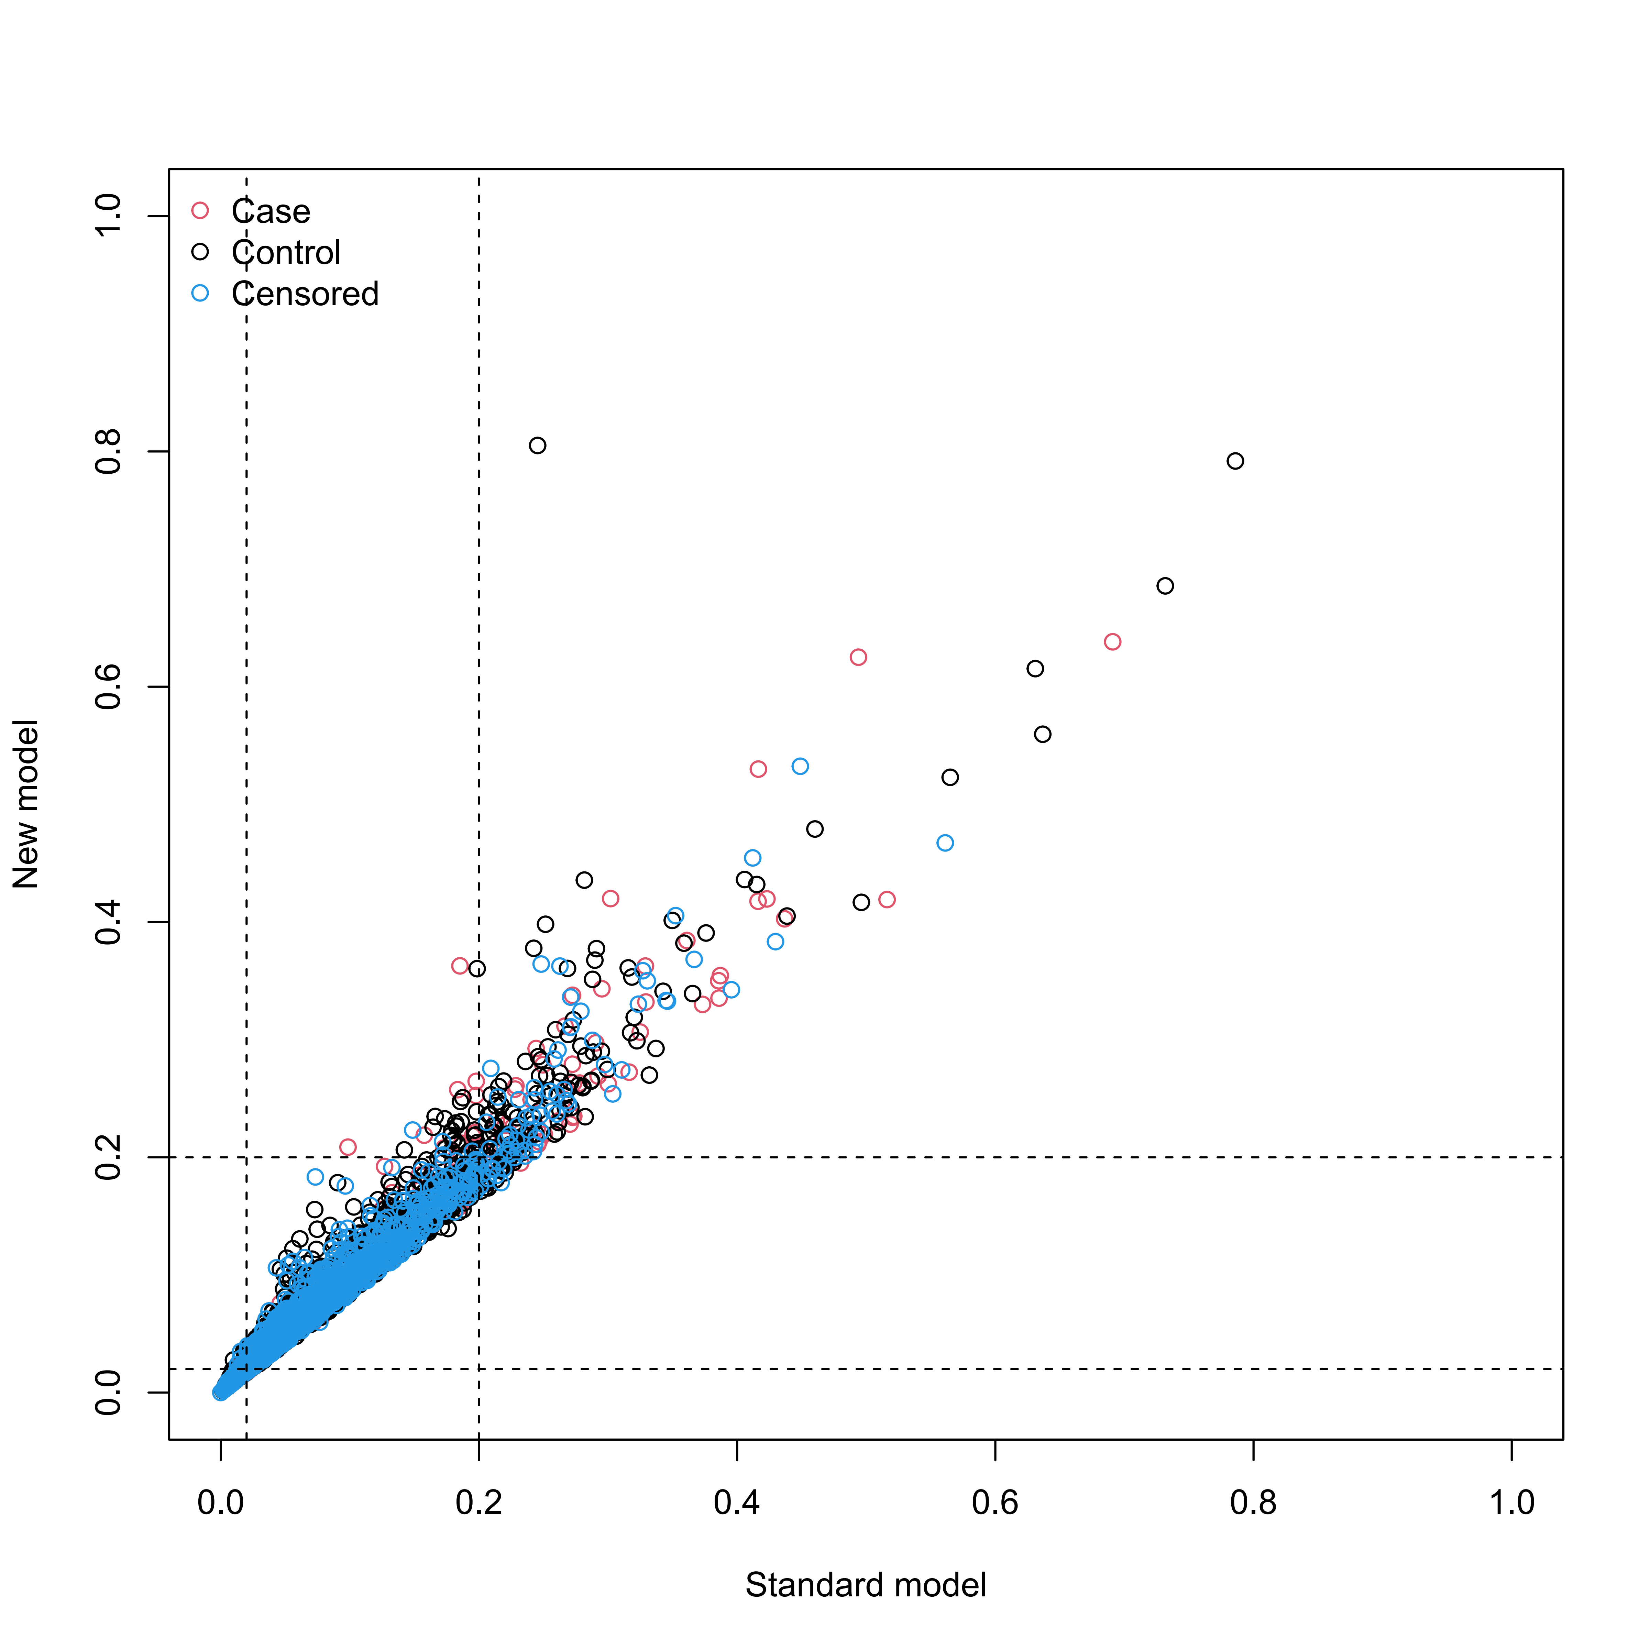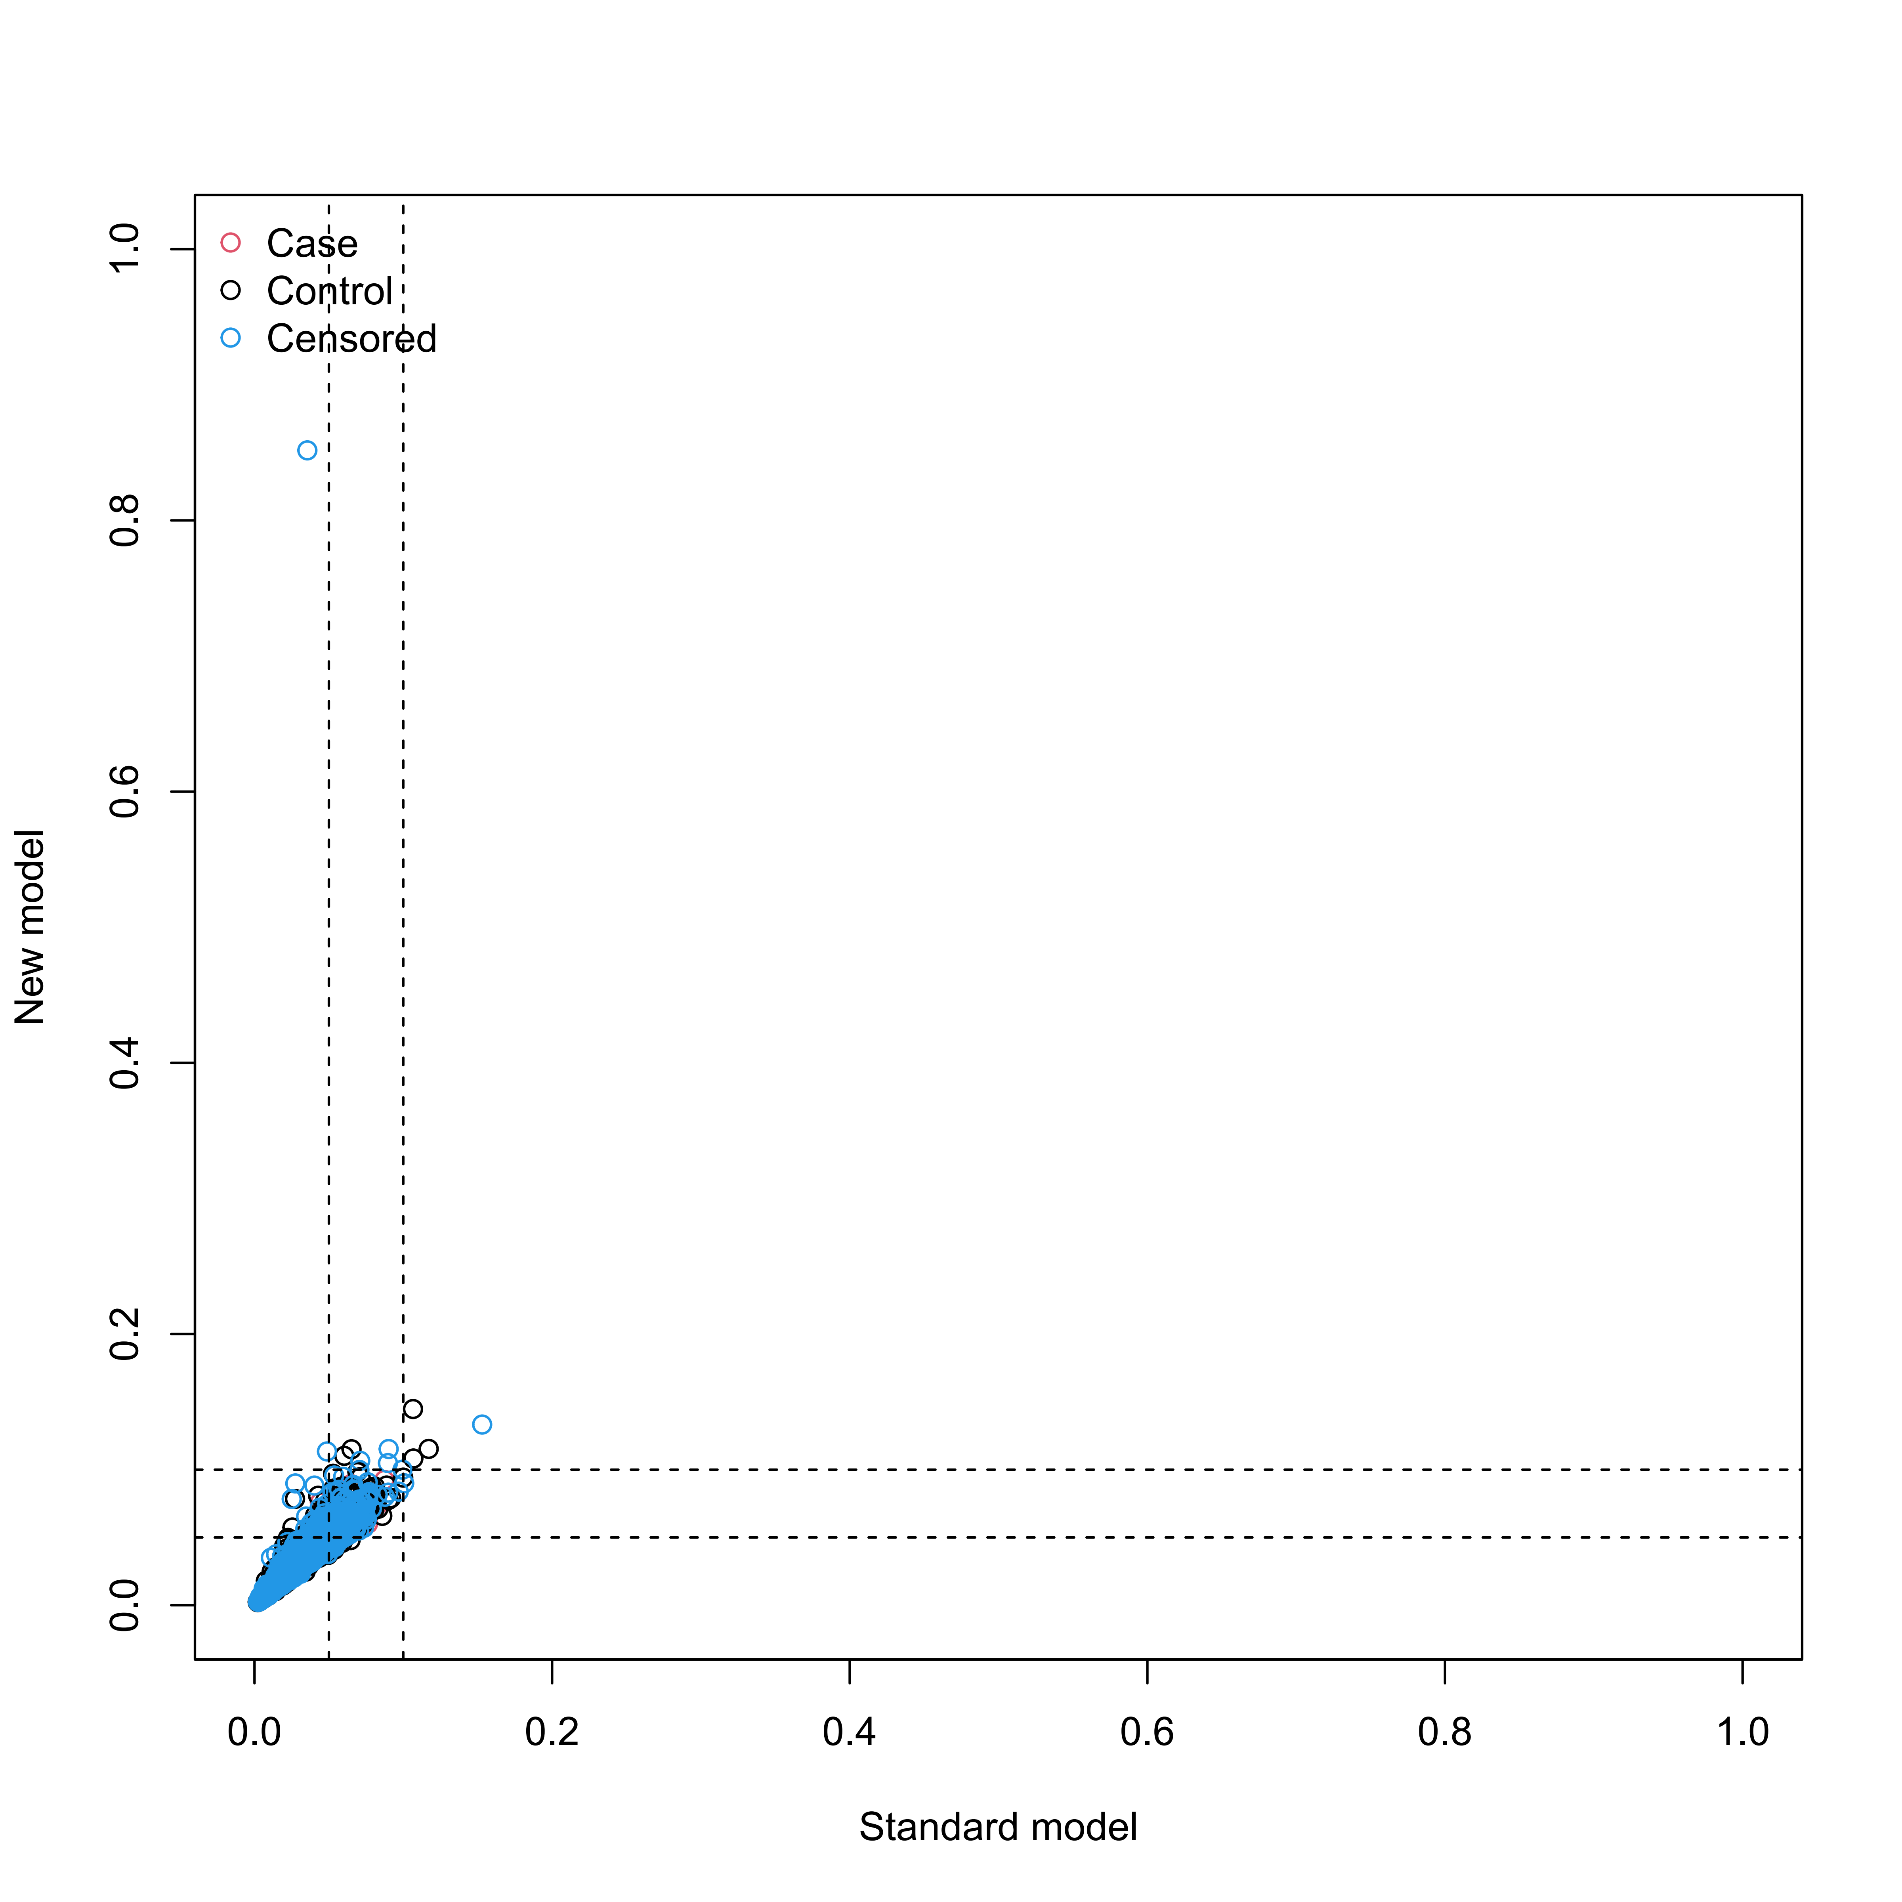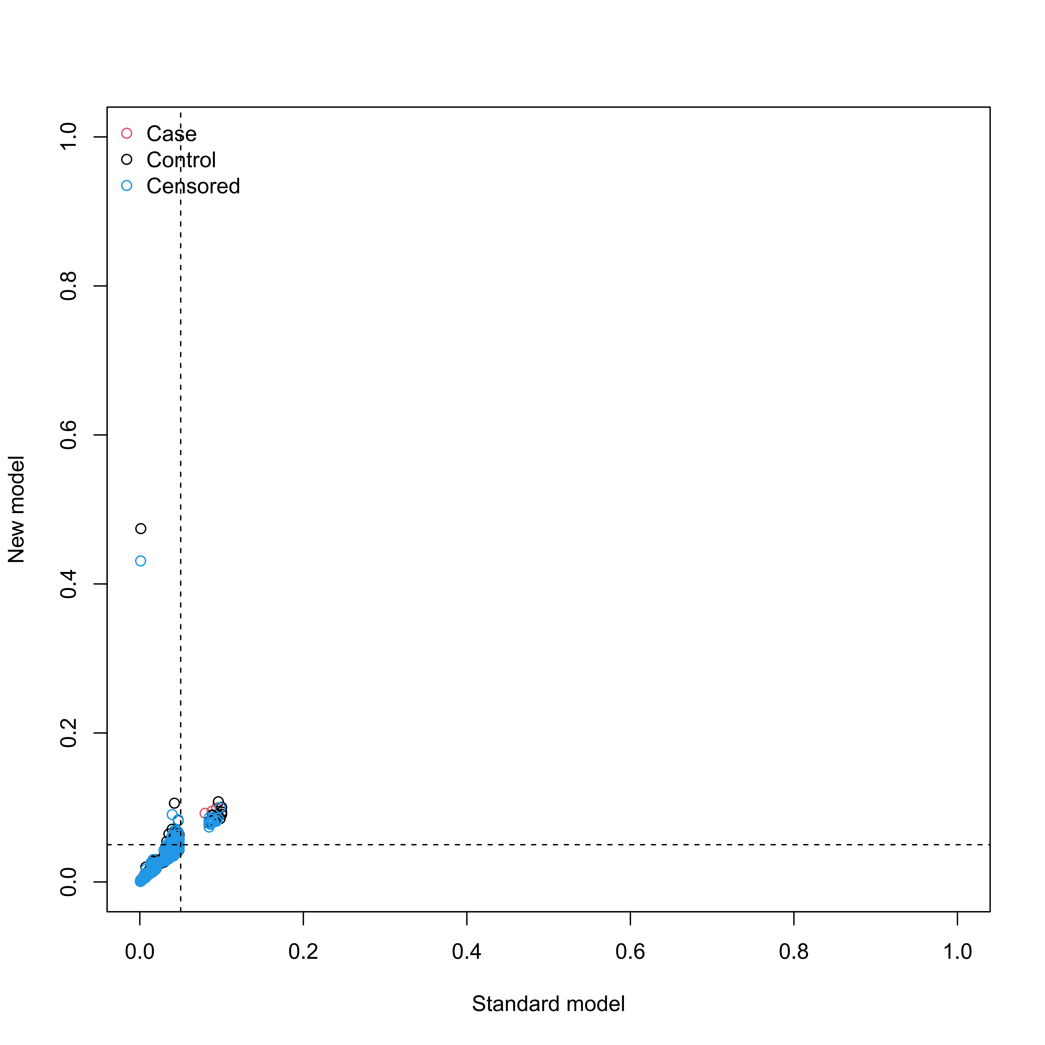

Supplementary Figure S17
Reclassification in the new model for mortality with the inclusion of meta-GCIPLT score in validation set.
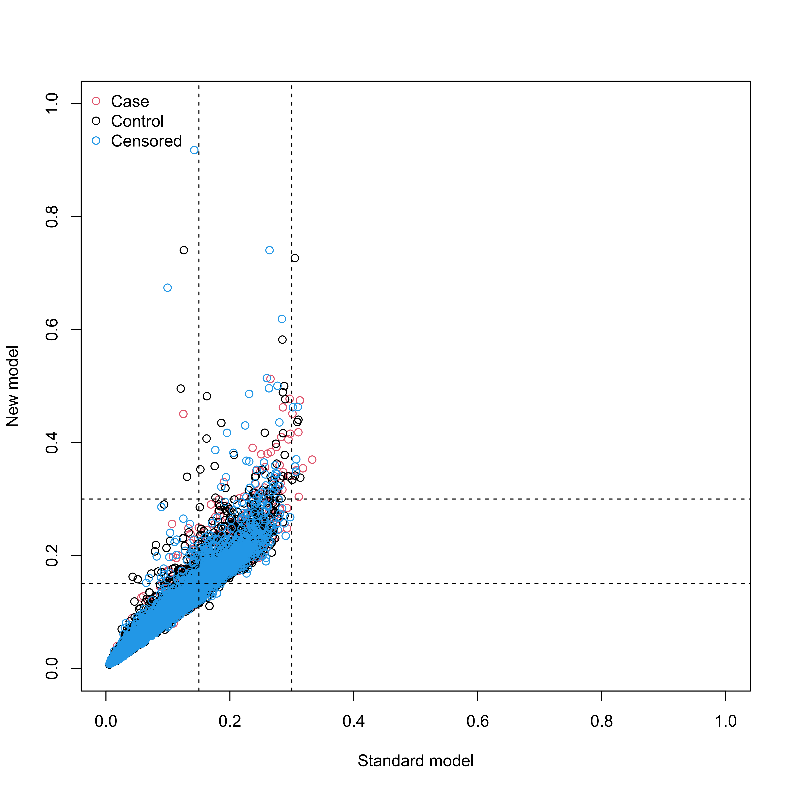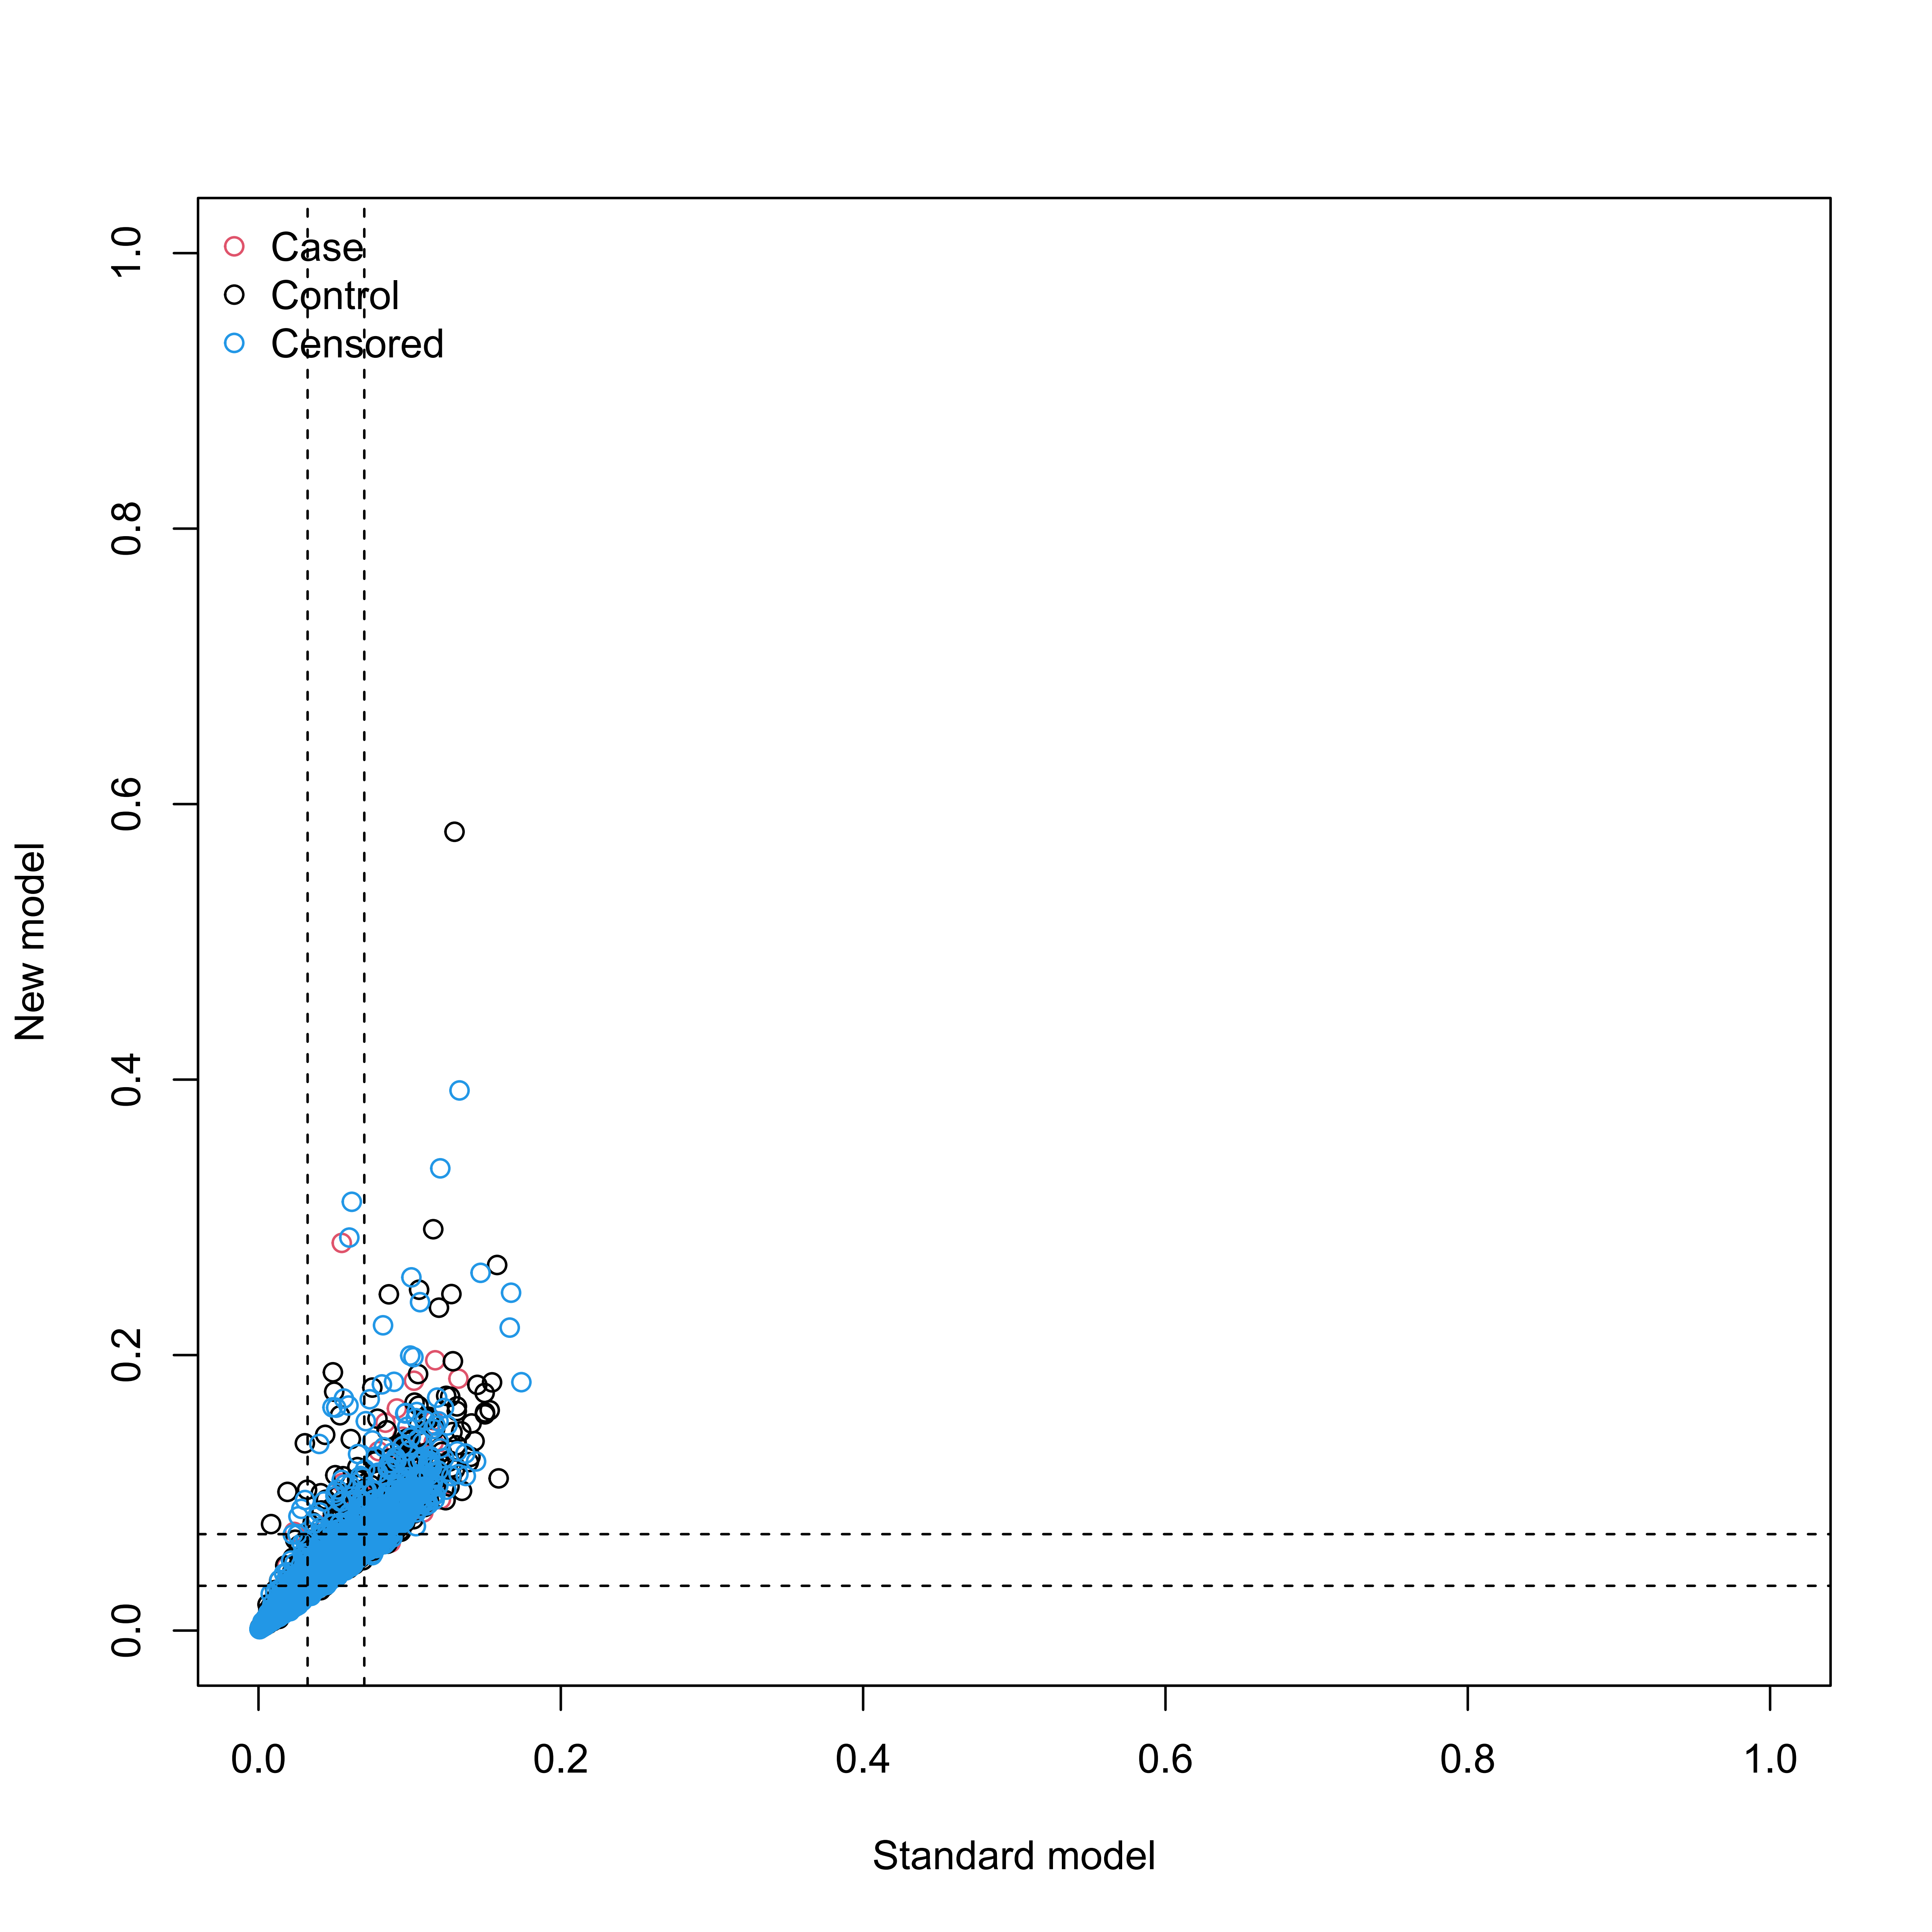
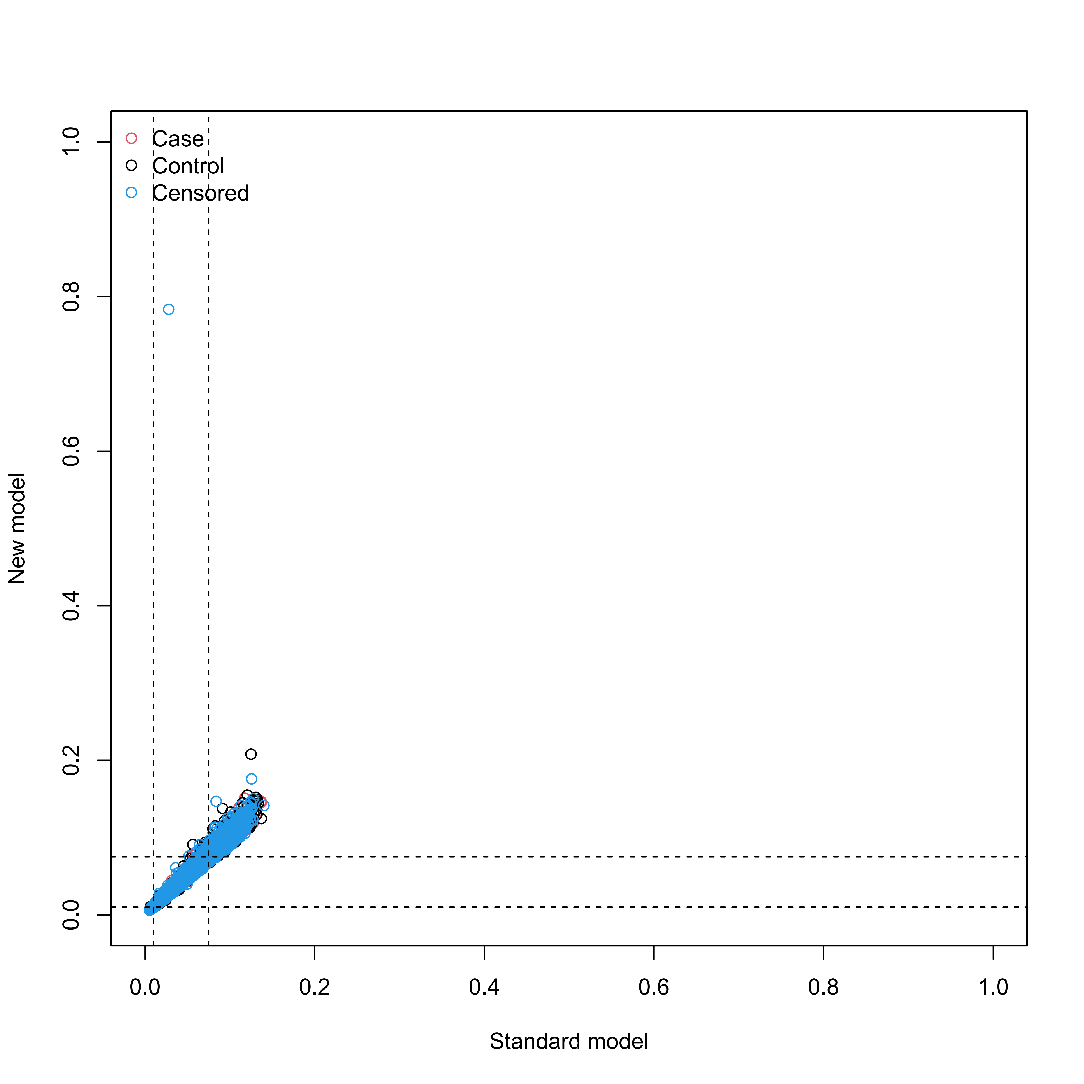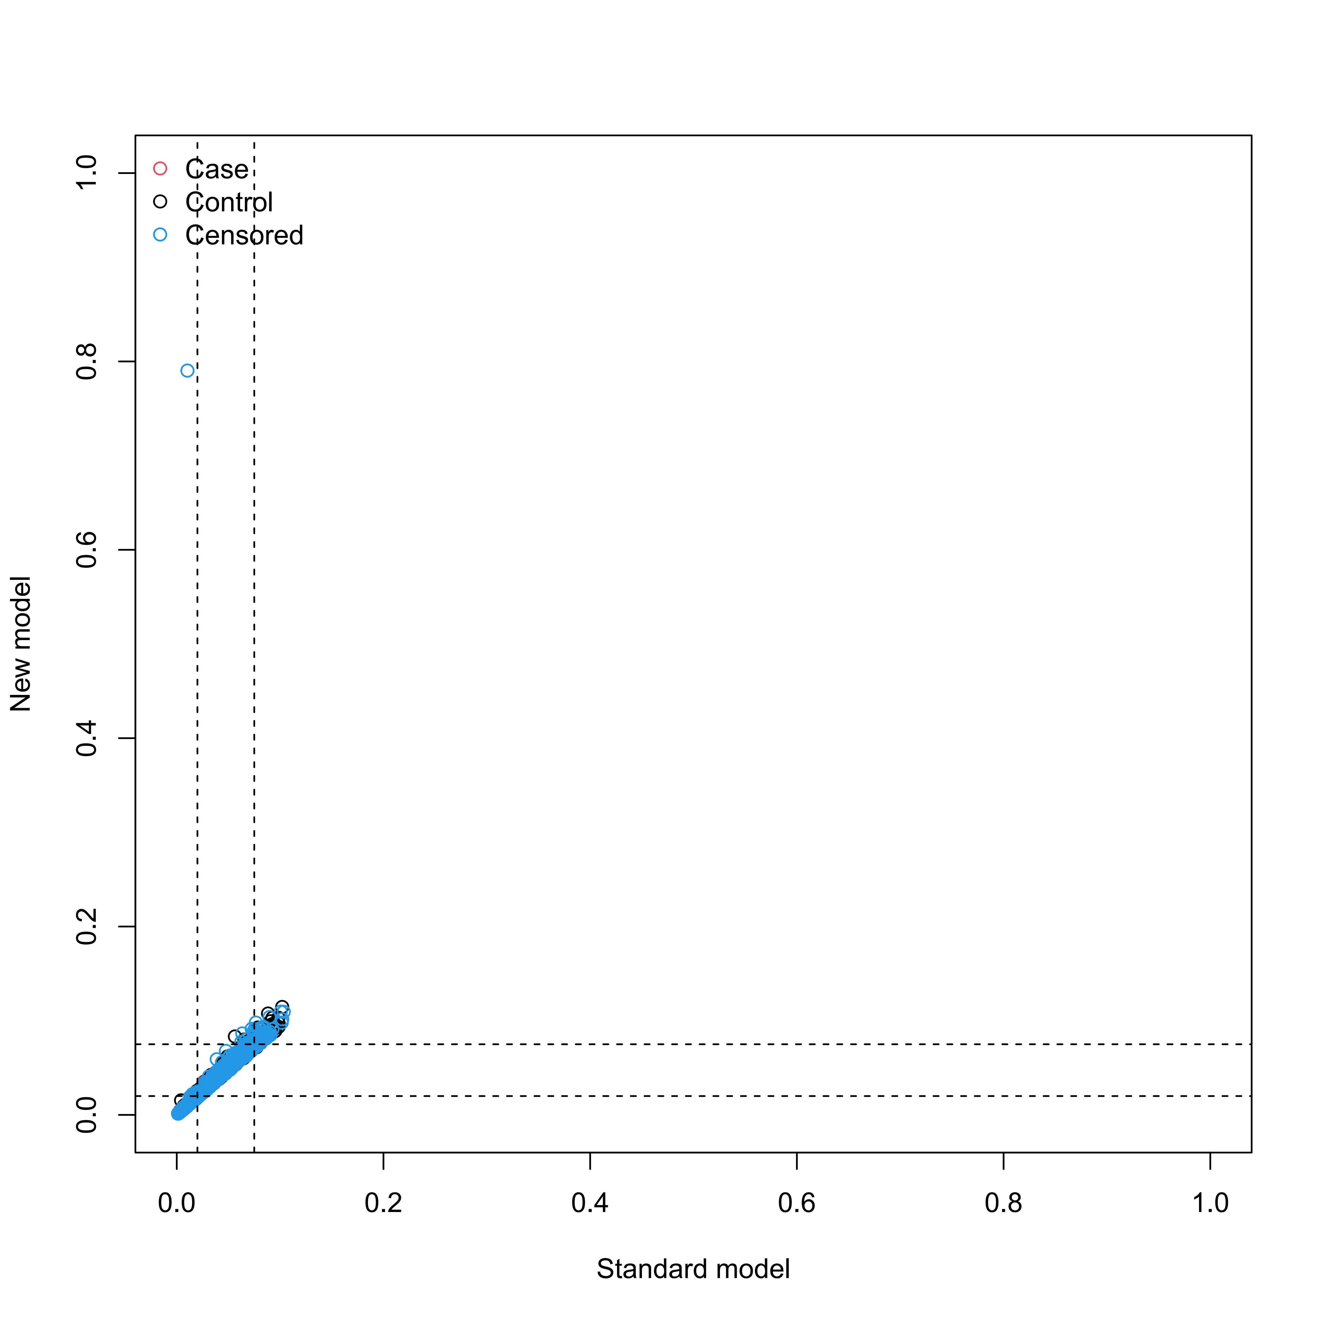

Supplementary Figure S18
Calibration plots illustrating expected and observed probabilities for systemic diseases in training set.
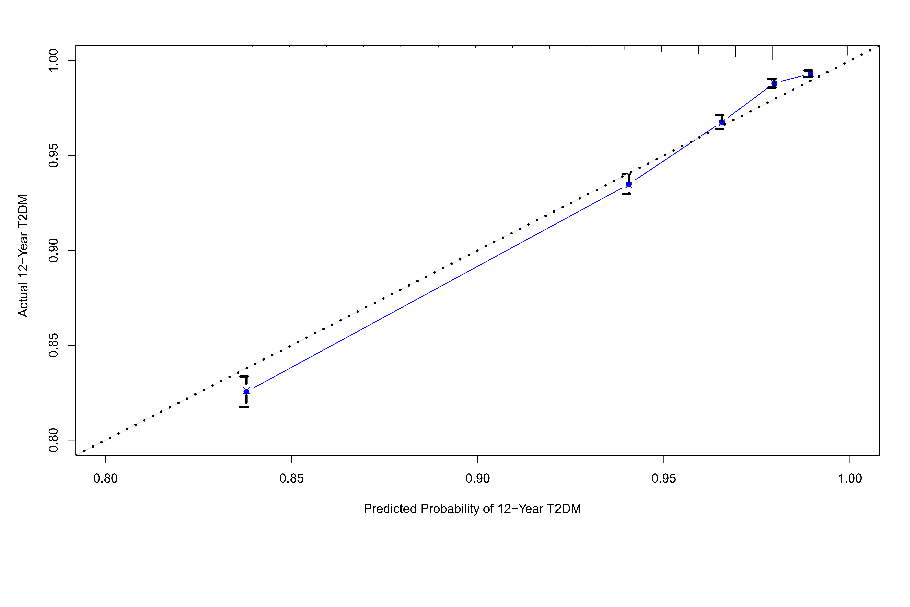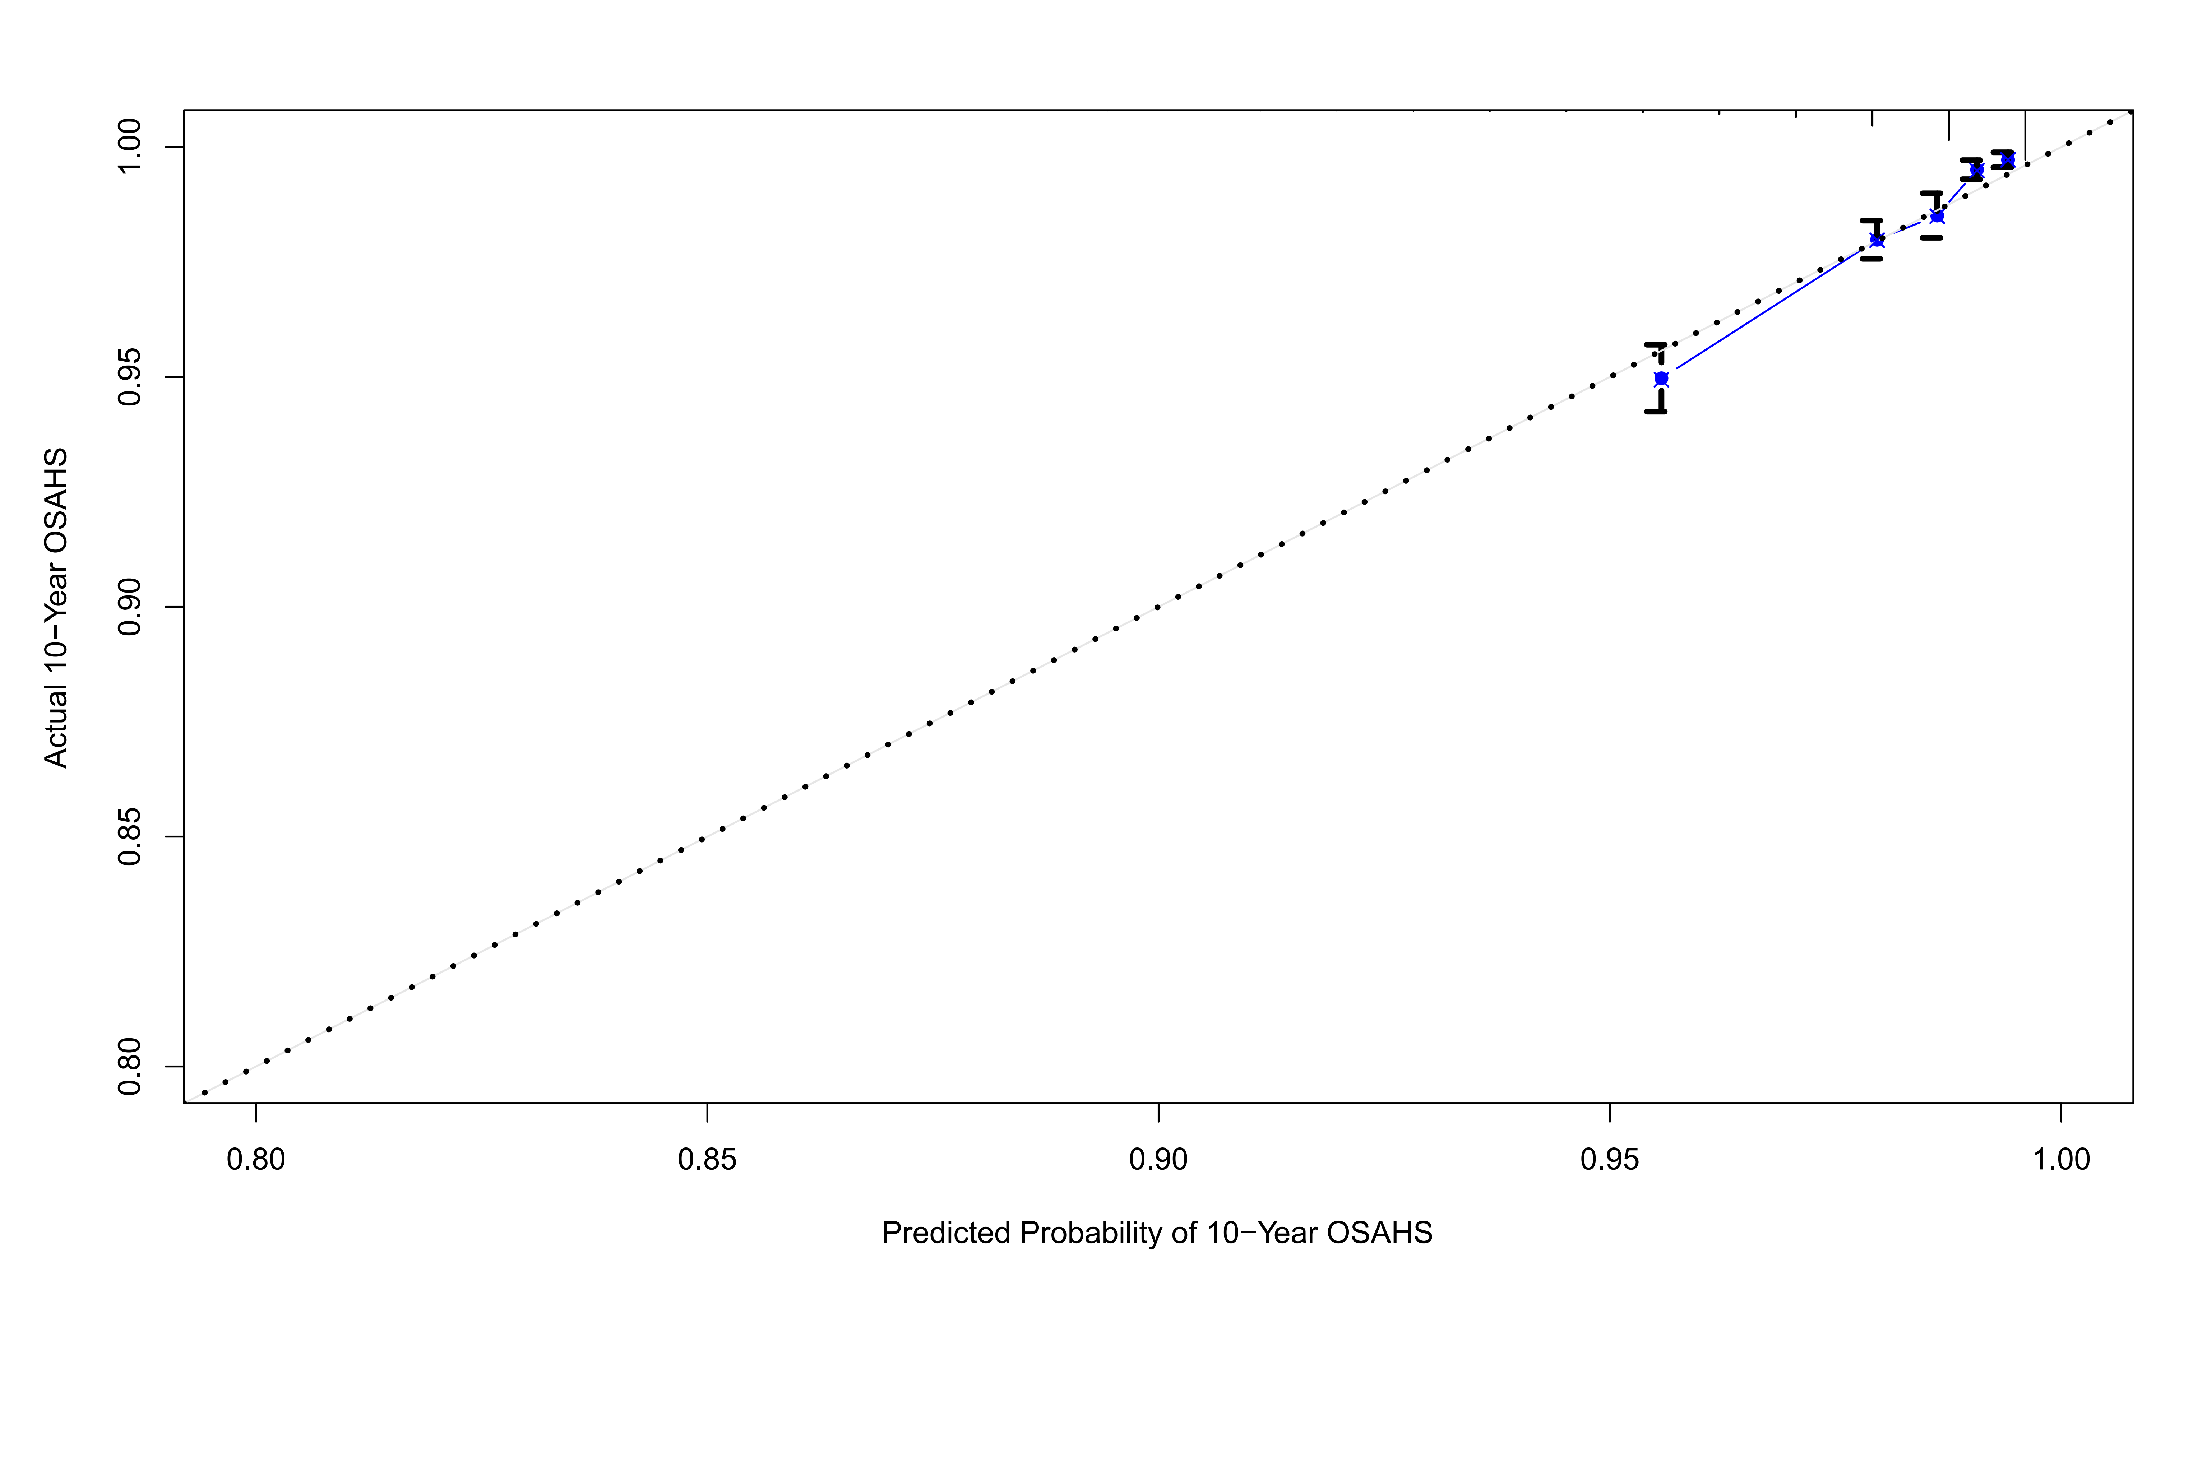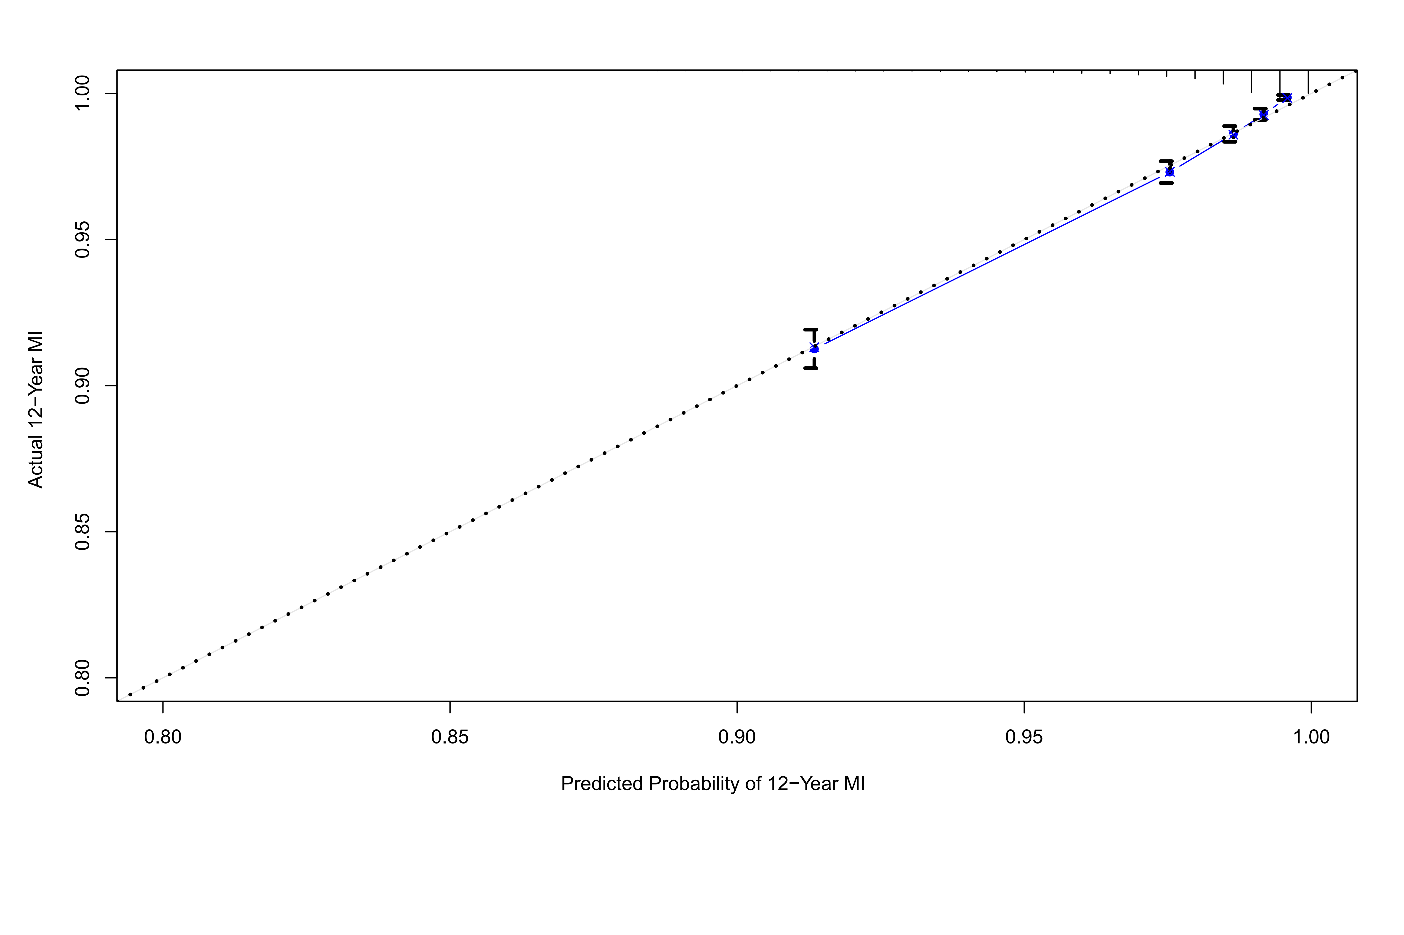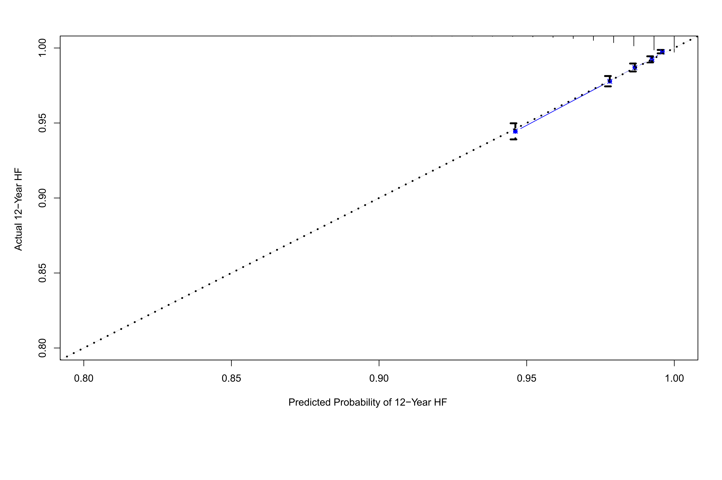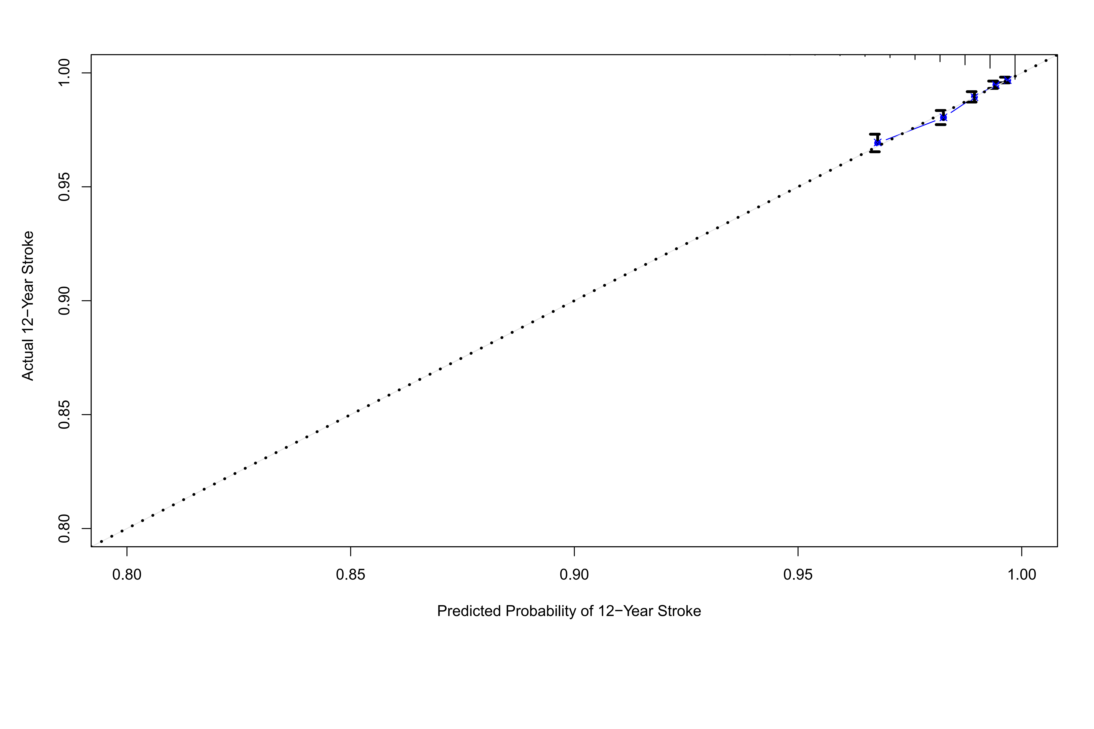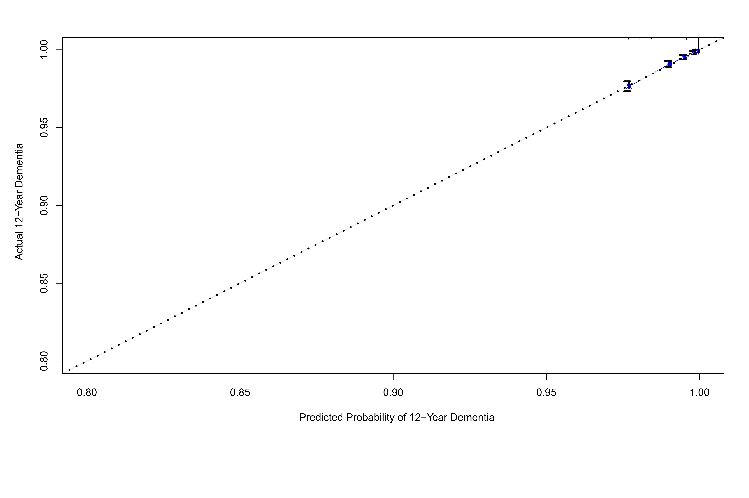

Supplementary Figure S19
Calibration plots illustrating expected and observed probabilities for mortality in training set.
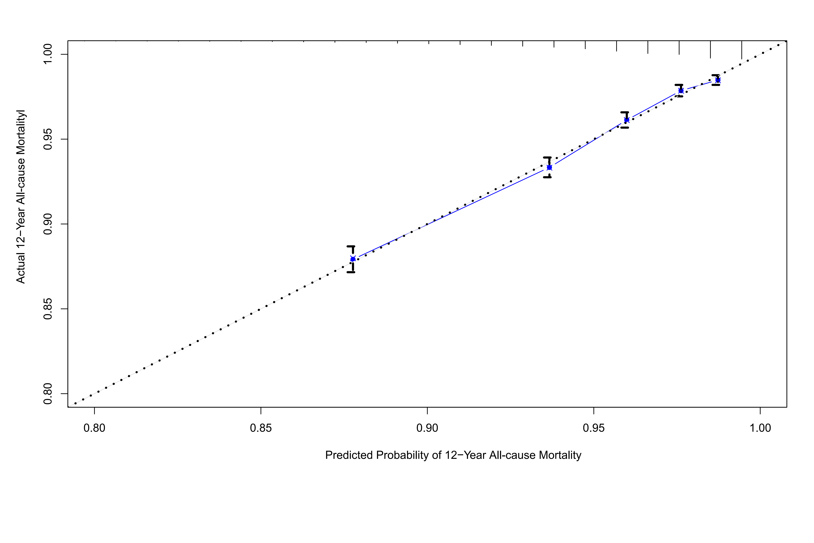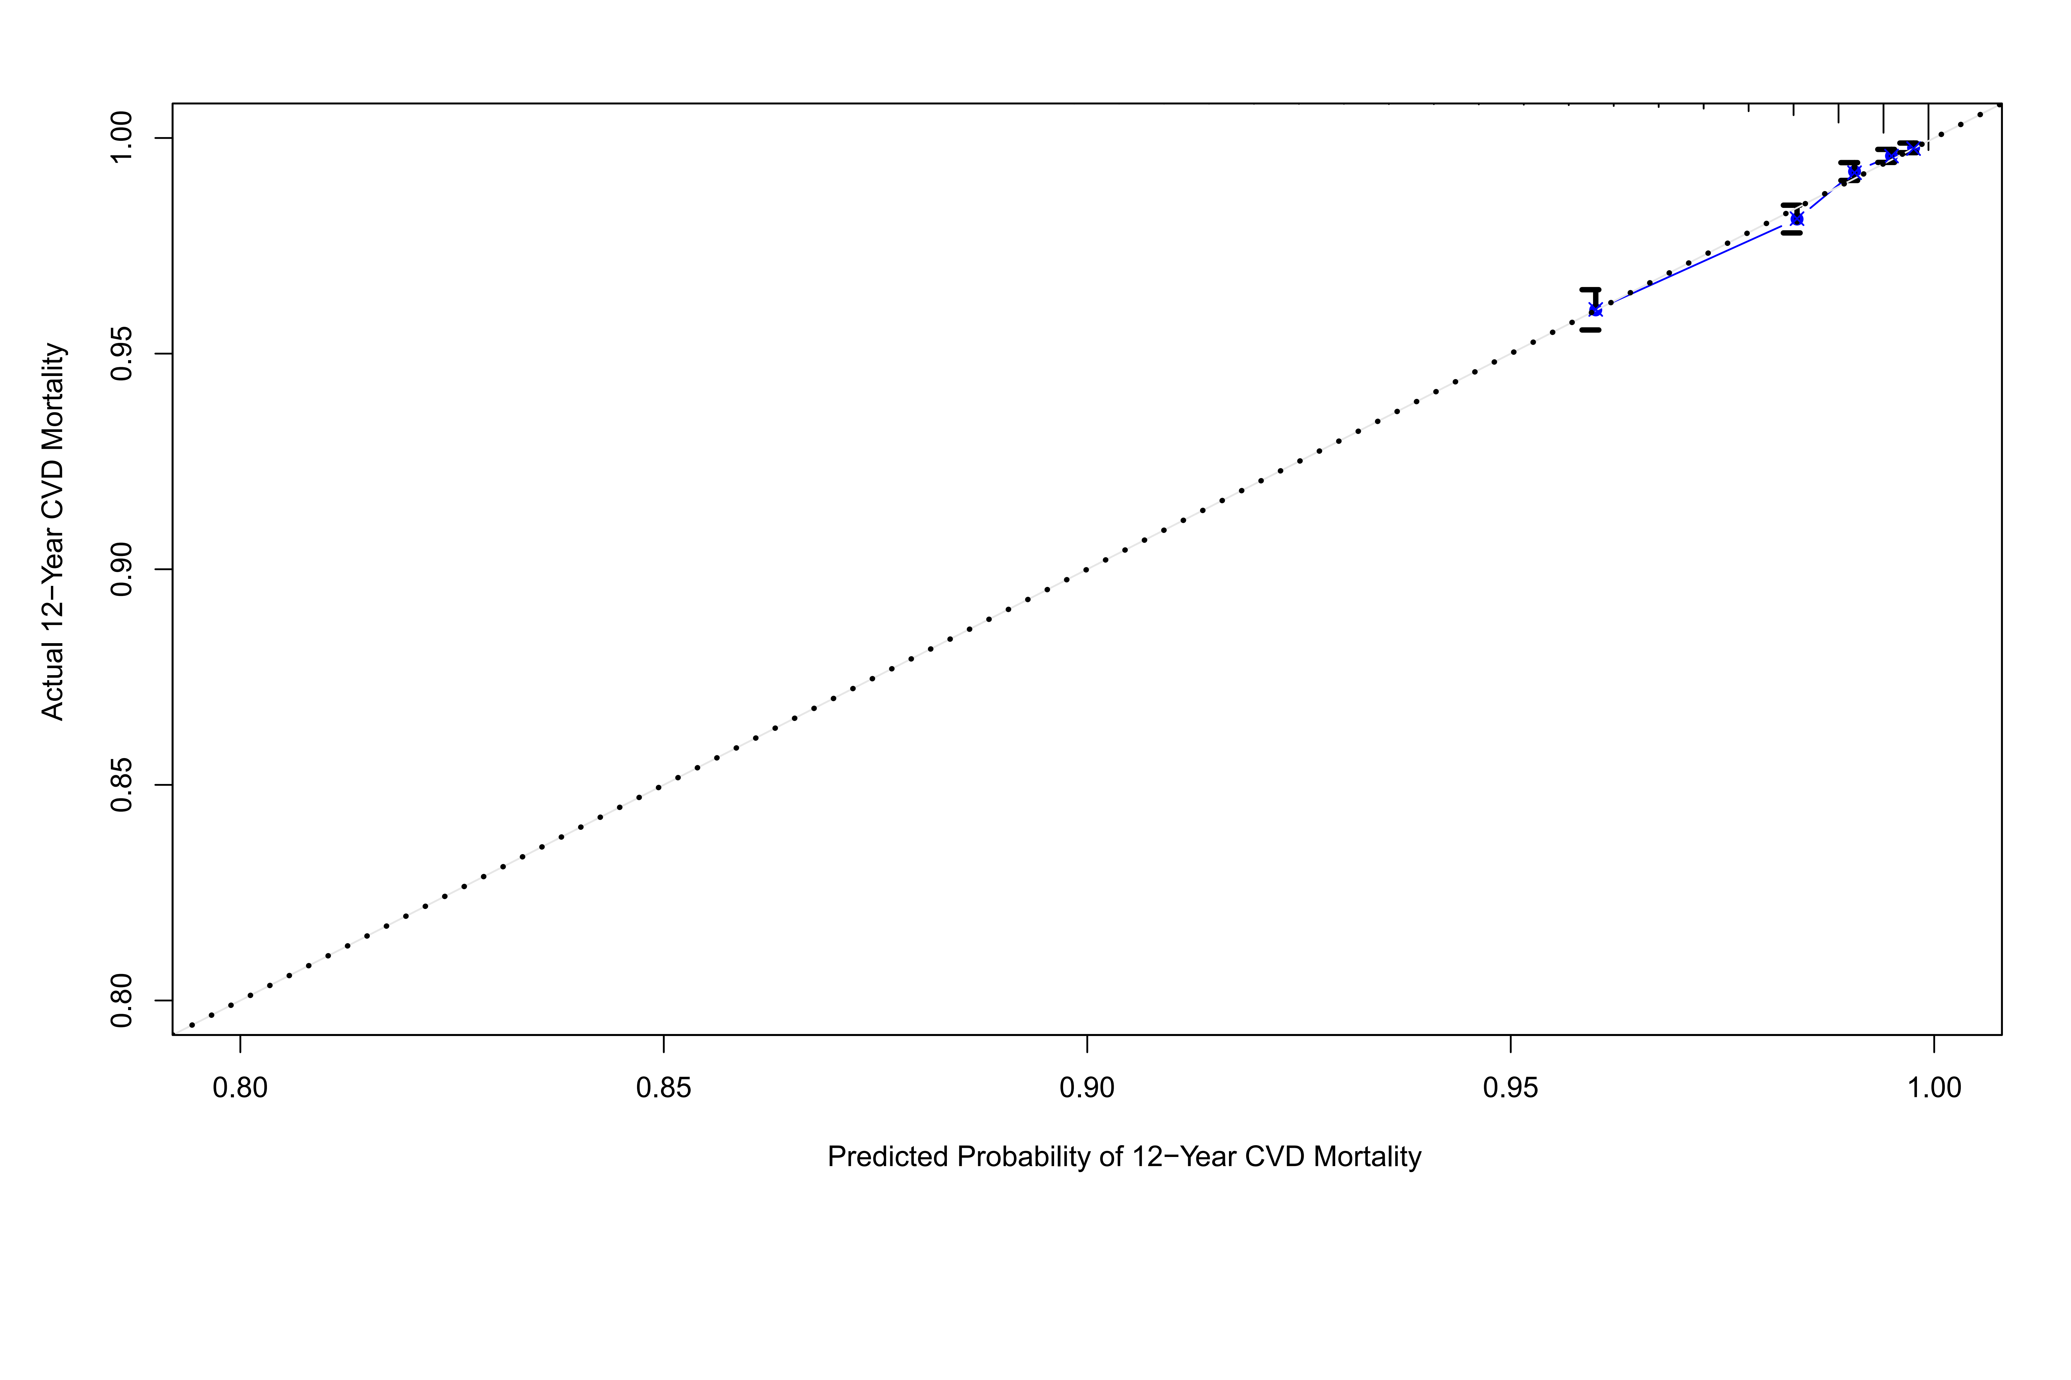
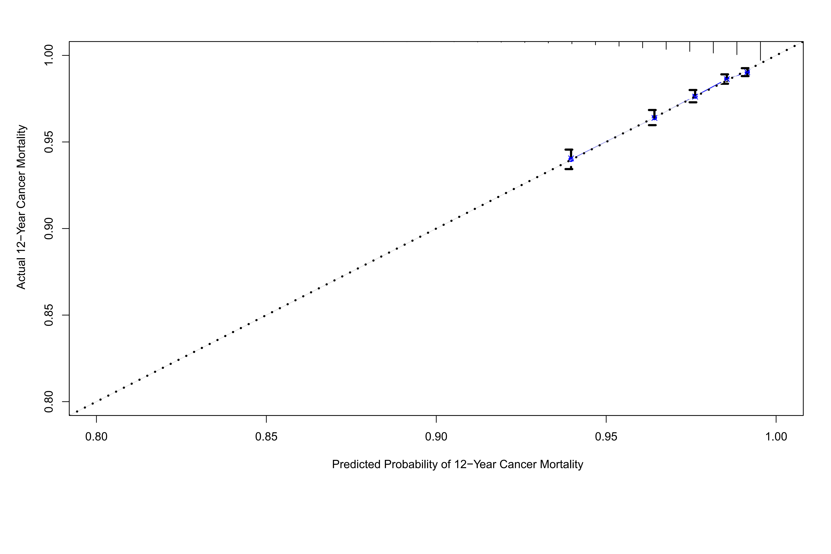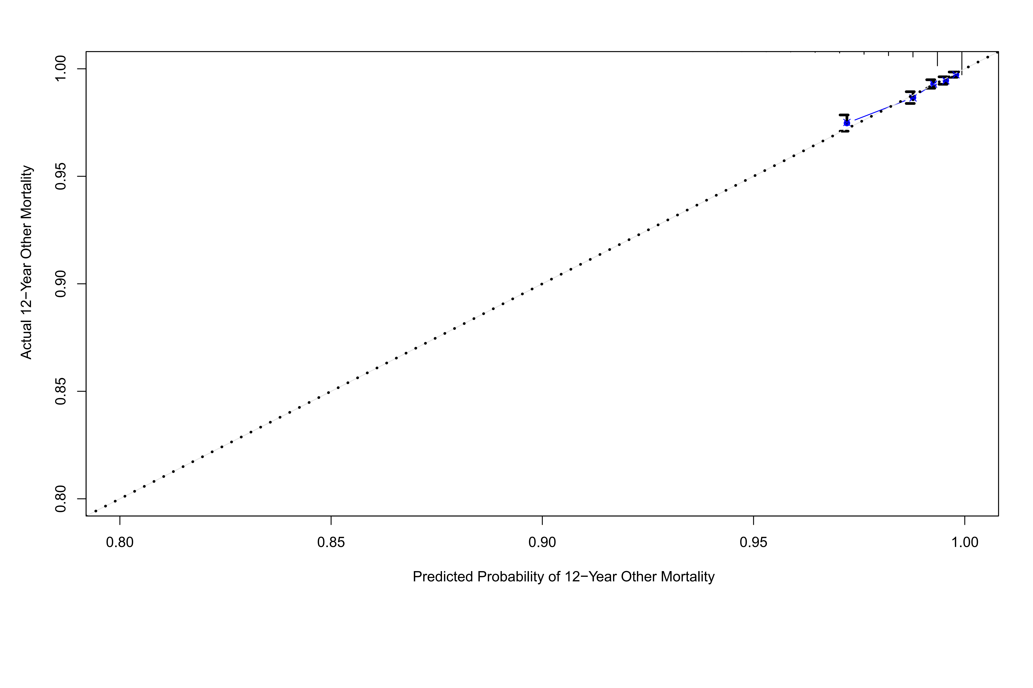

Supplementary Figure S20
Calibration plots illustrating expected and observed probabilities for systemic diseases in validation set.
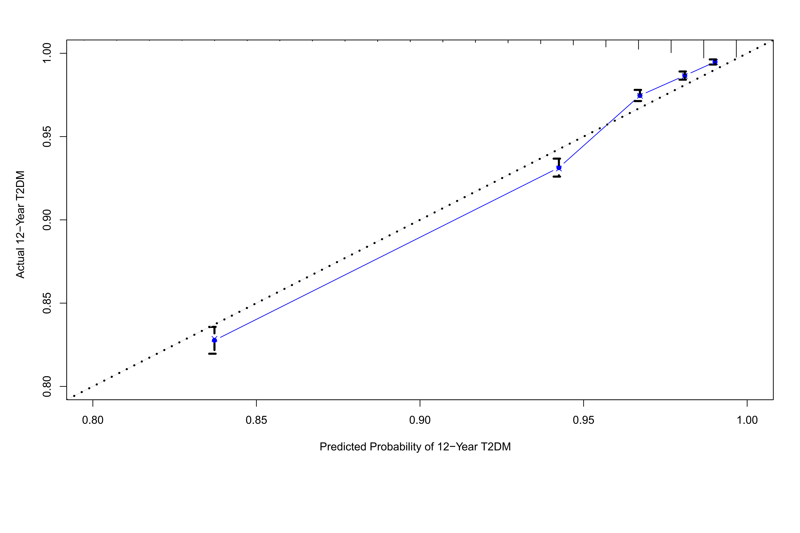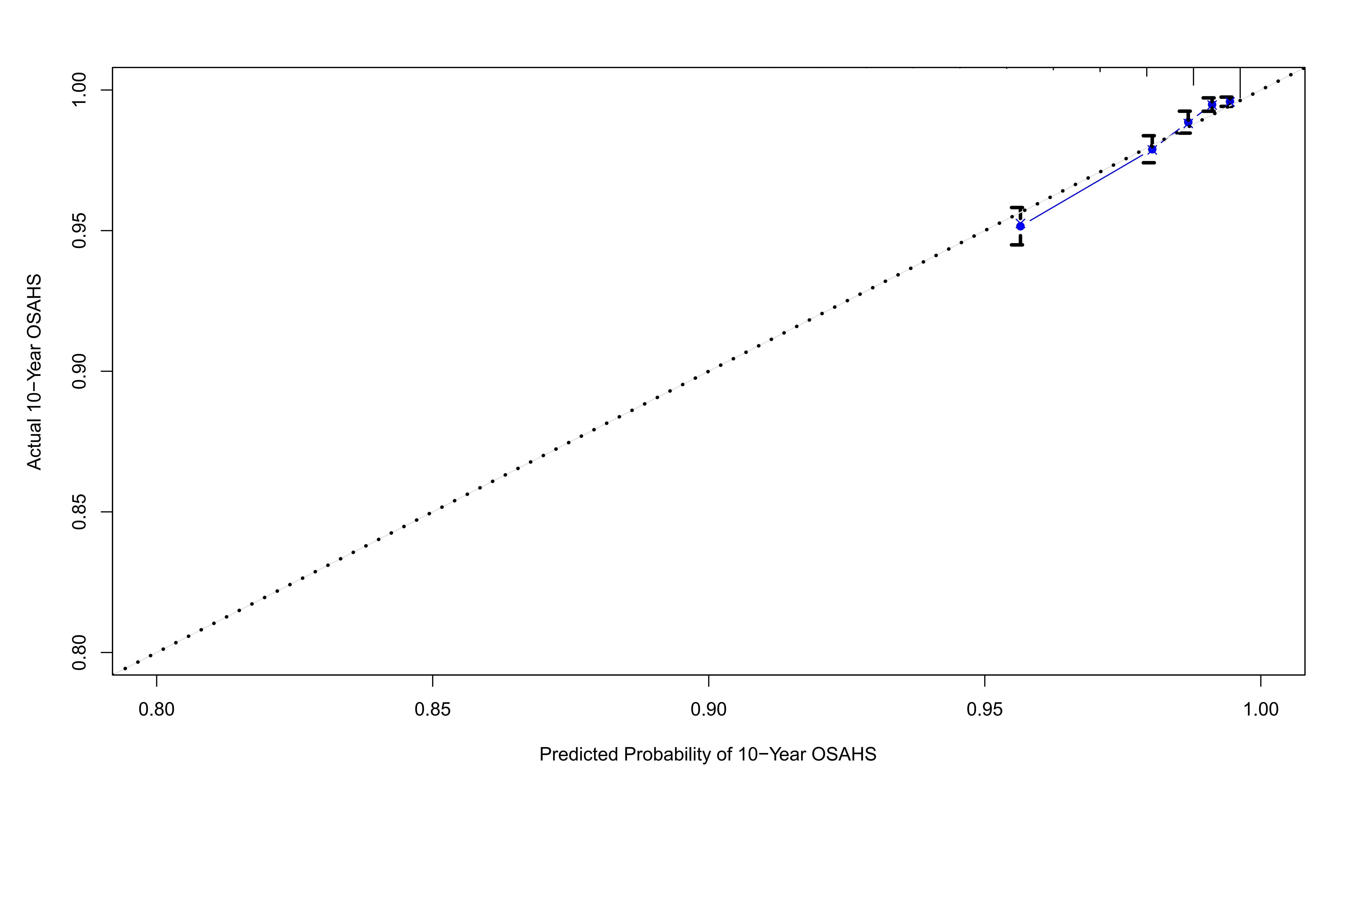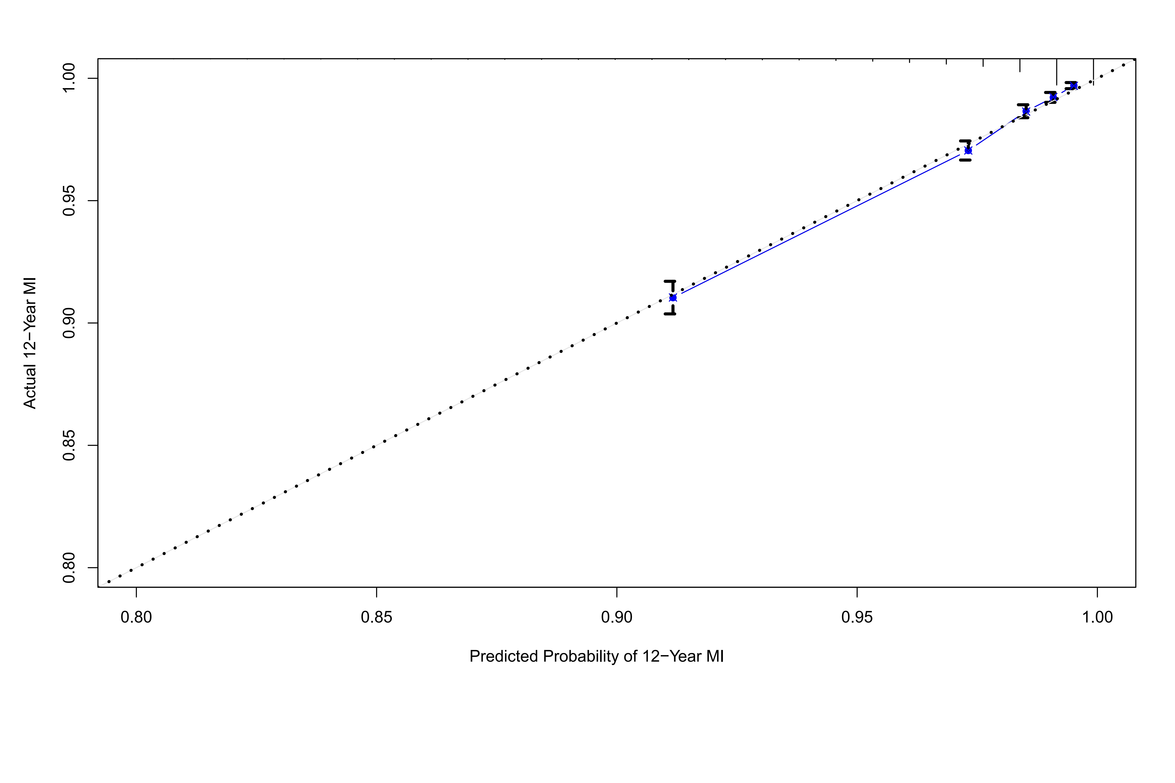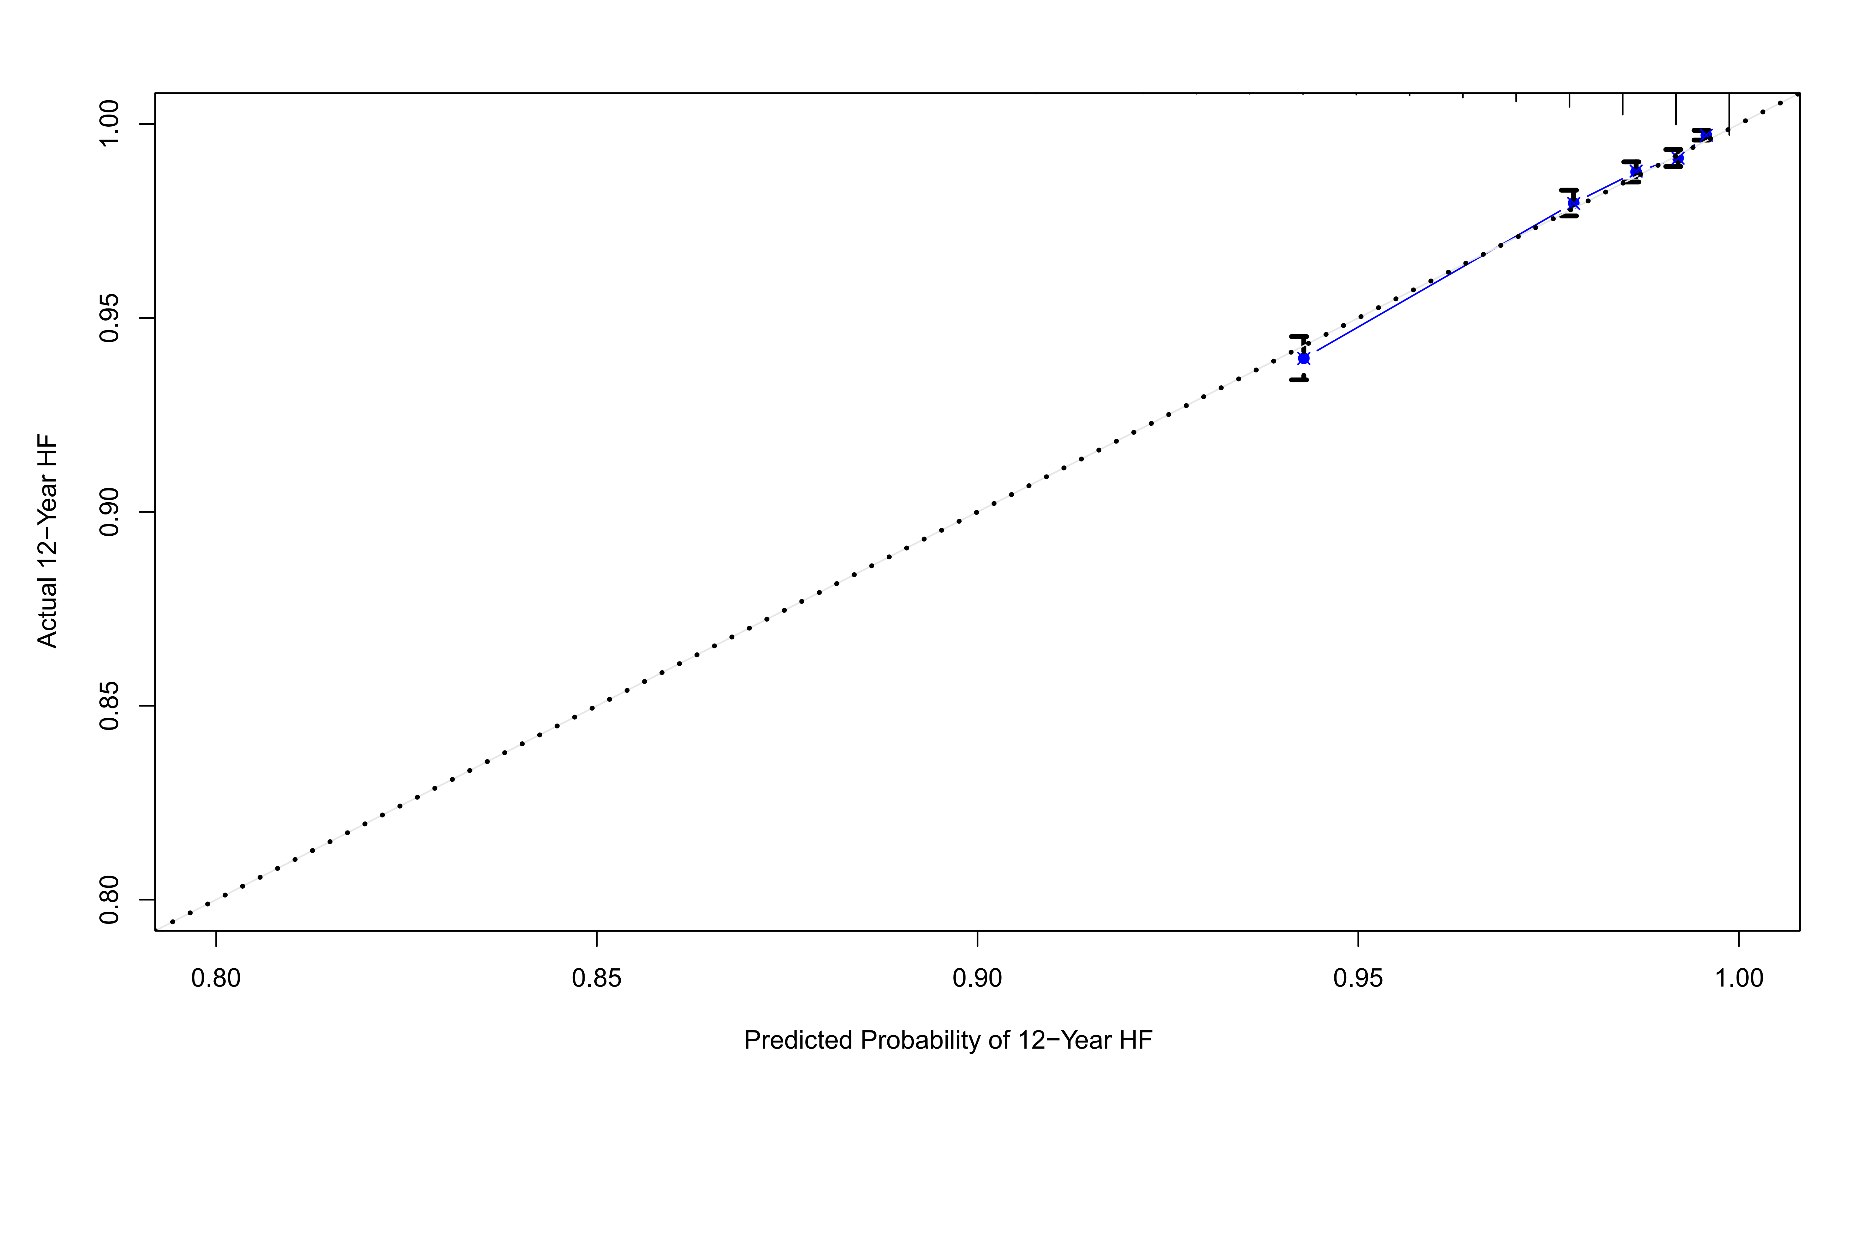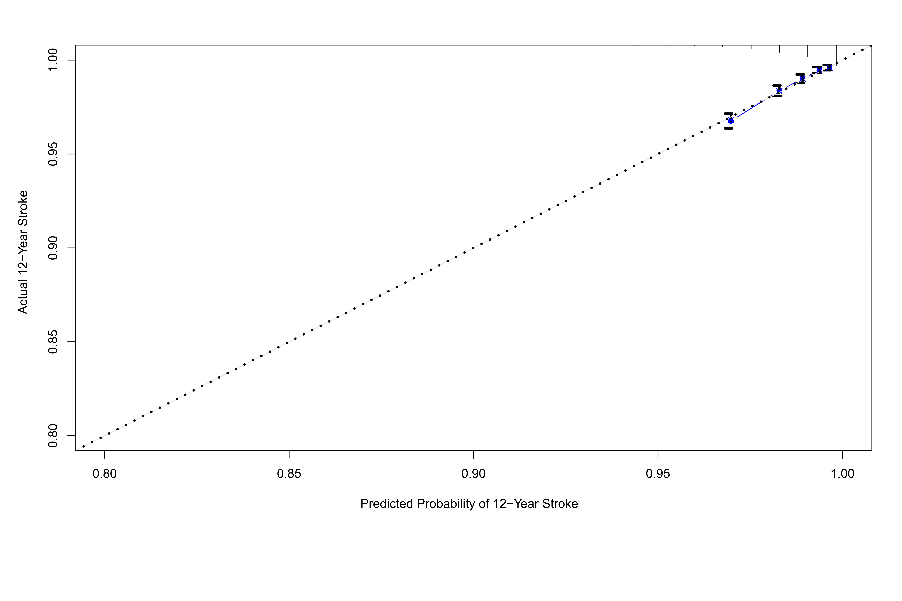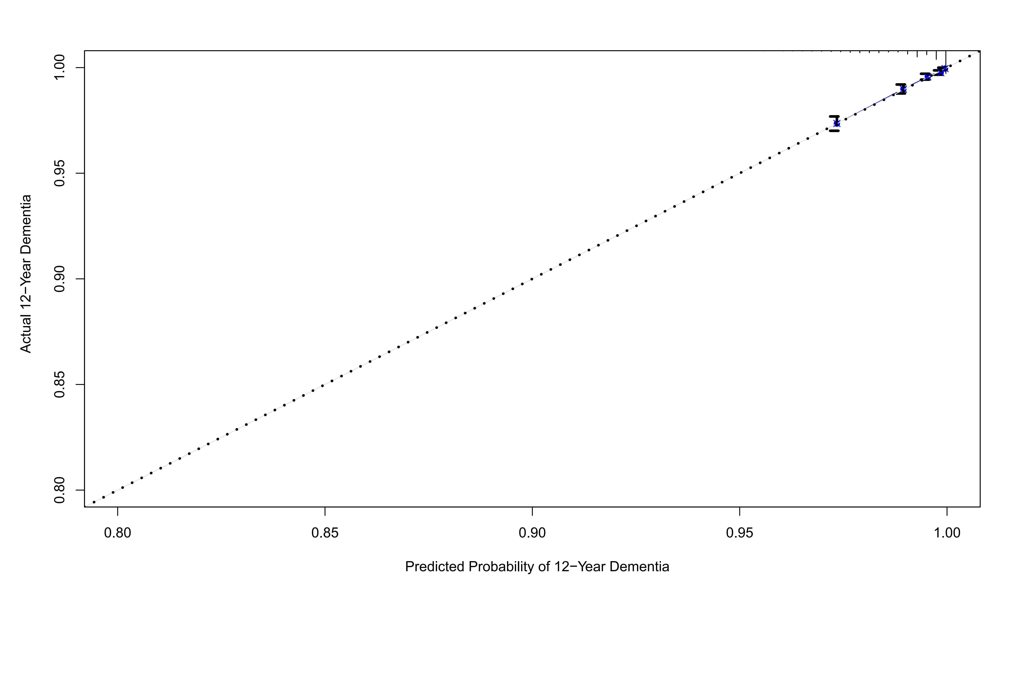

Supplementary Figure S21
Calibration plots illustrating expected and observed probabilities for mortality in validation set.
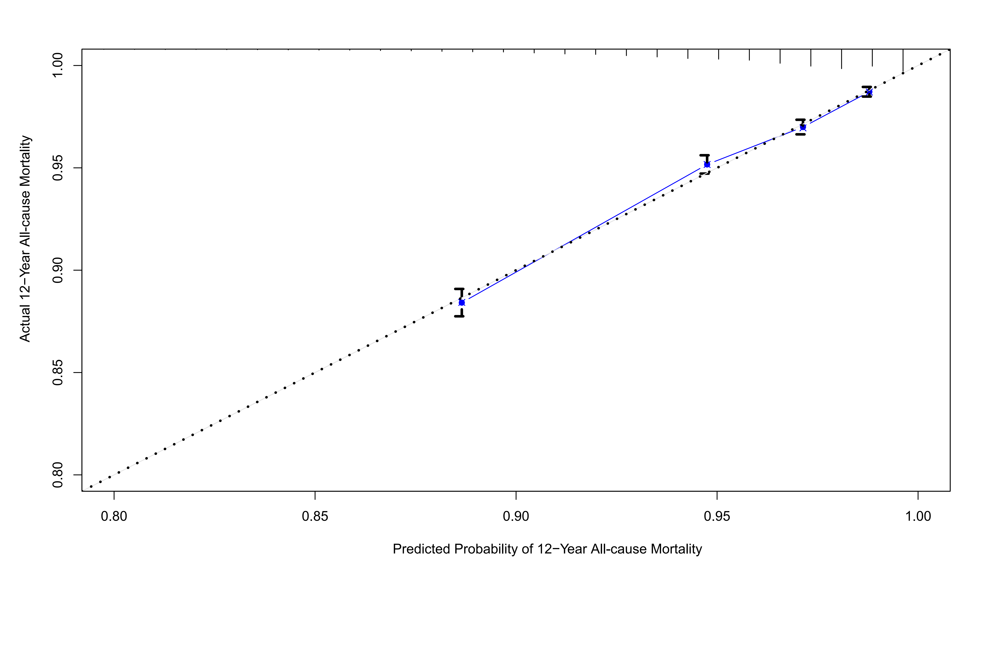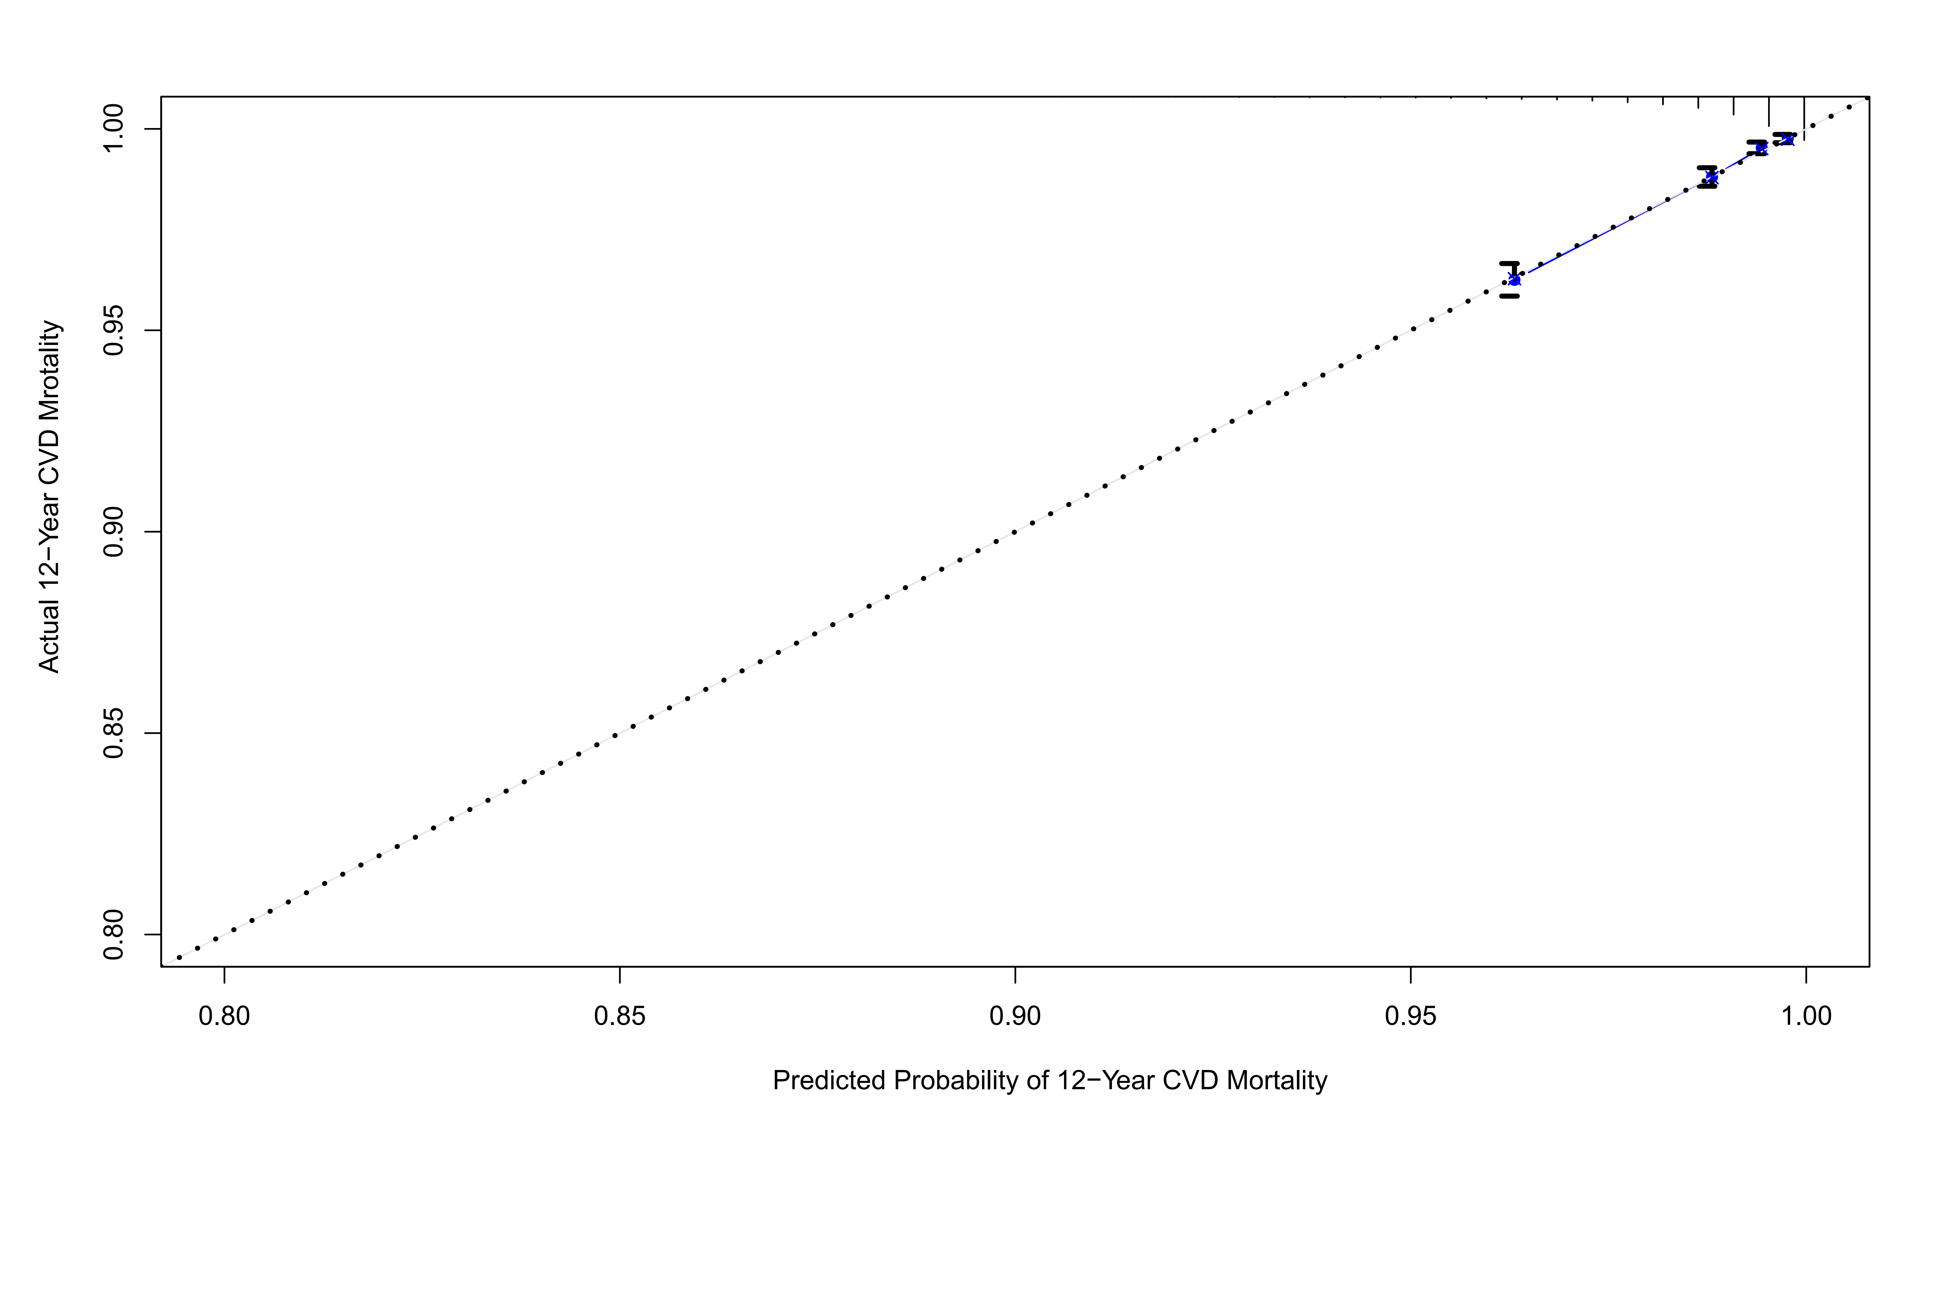
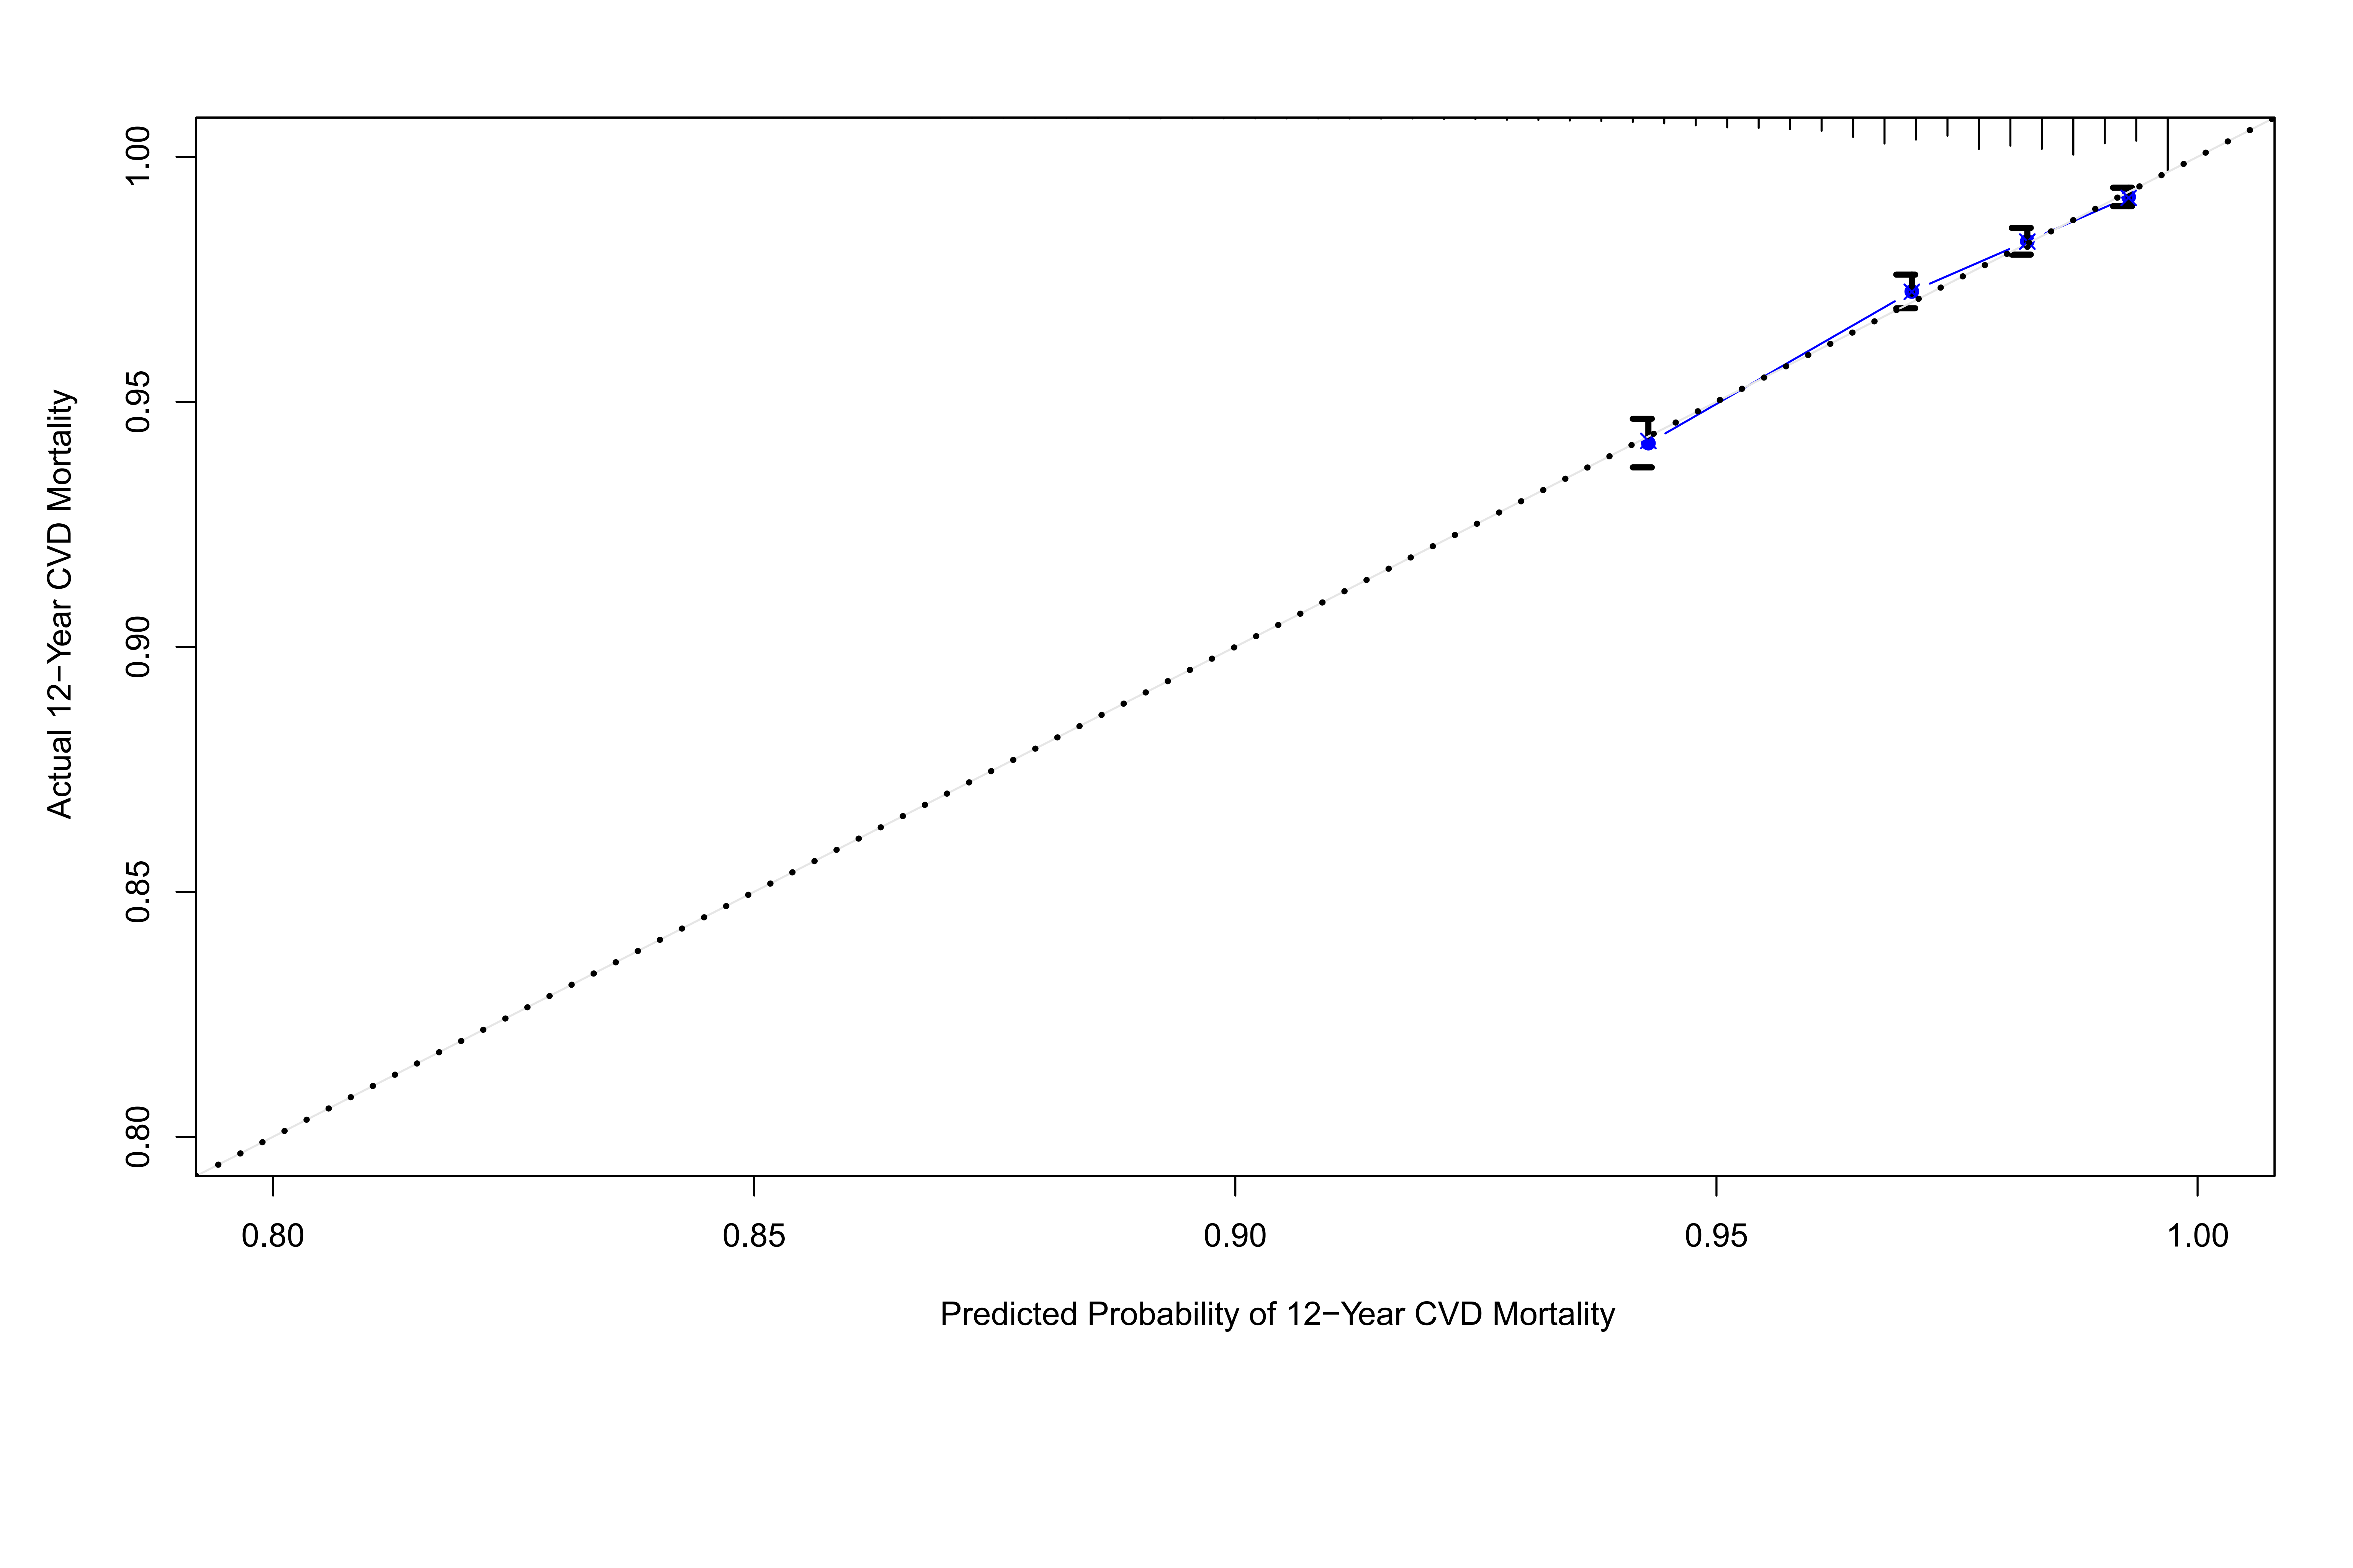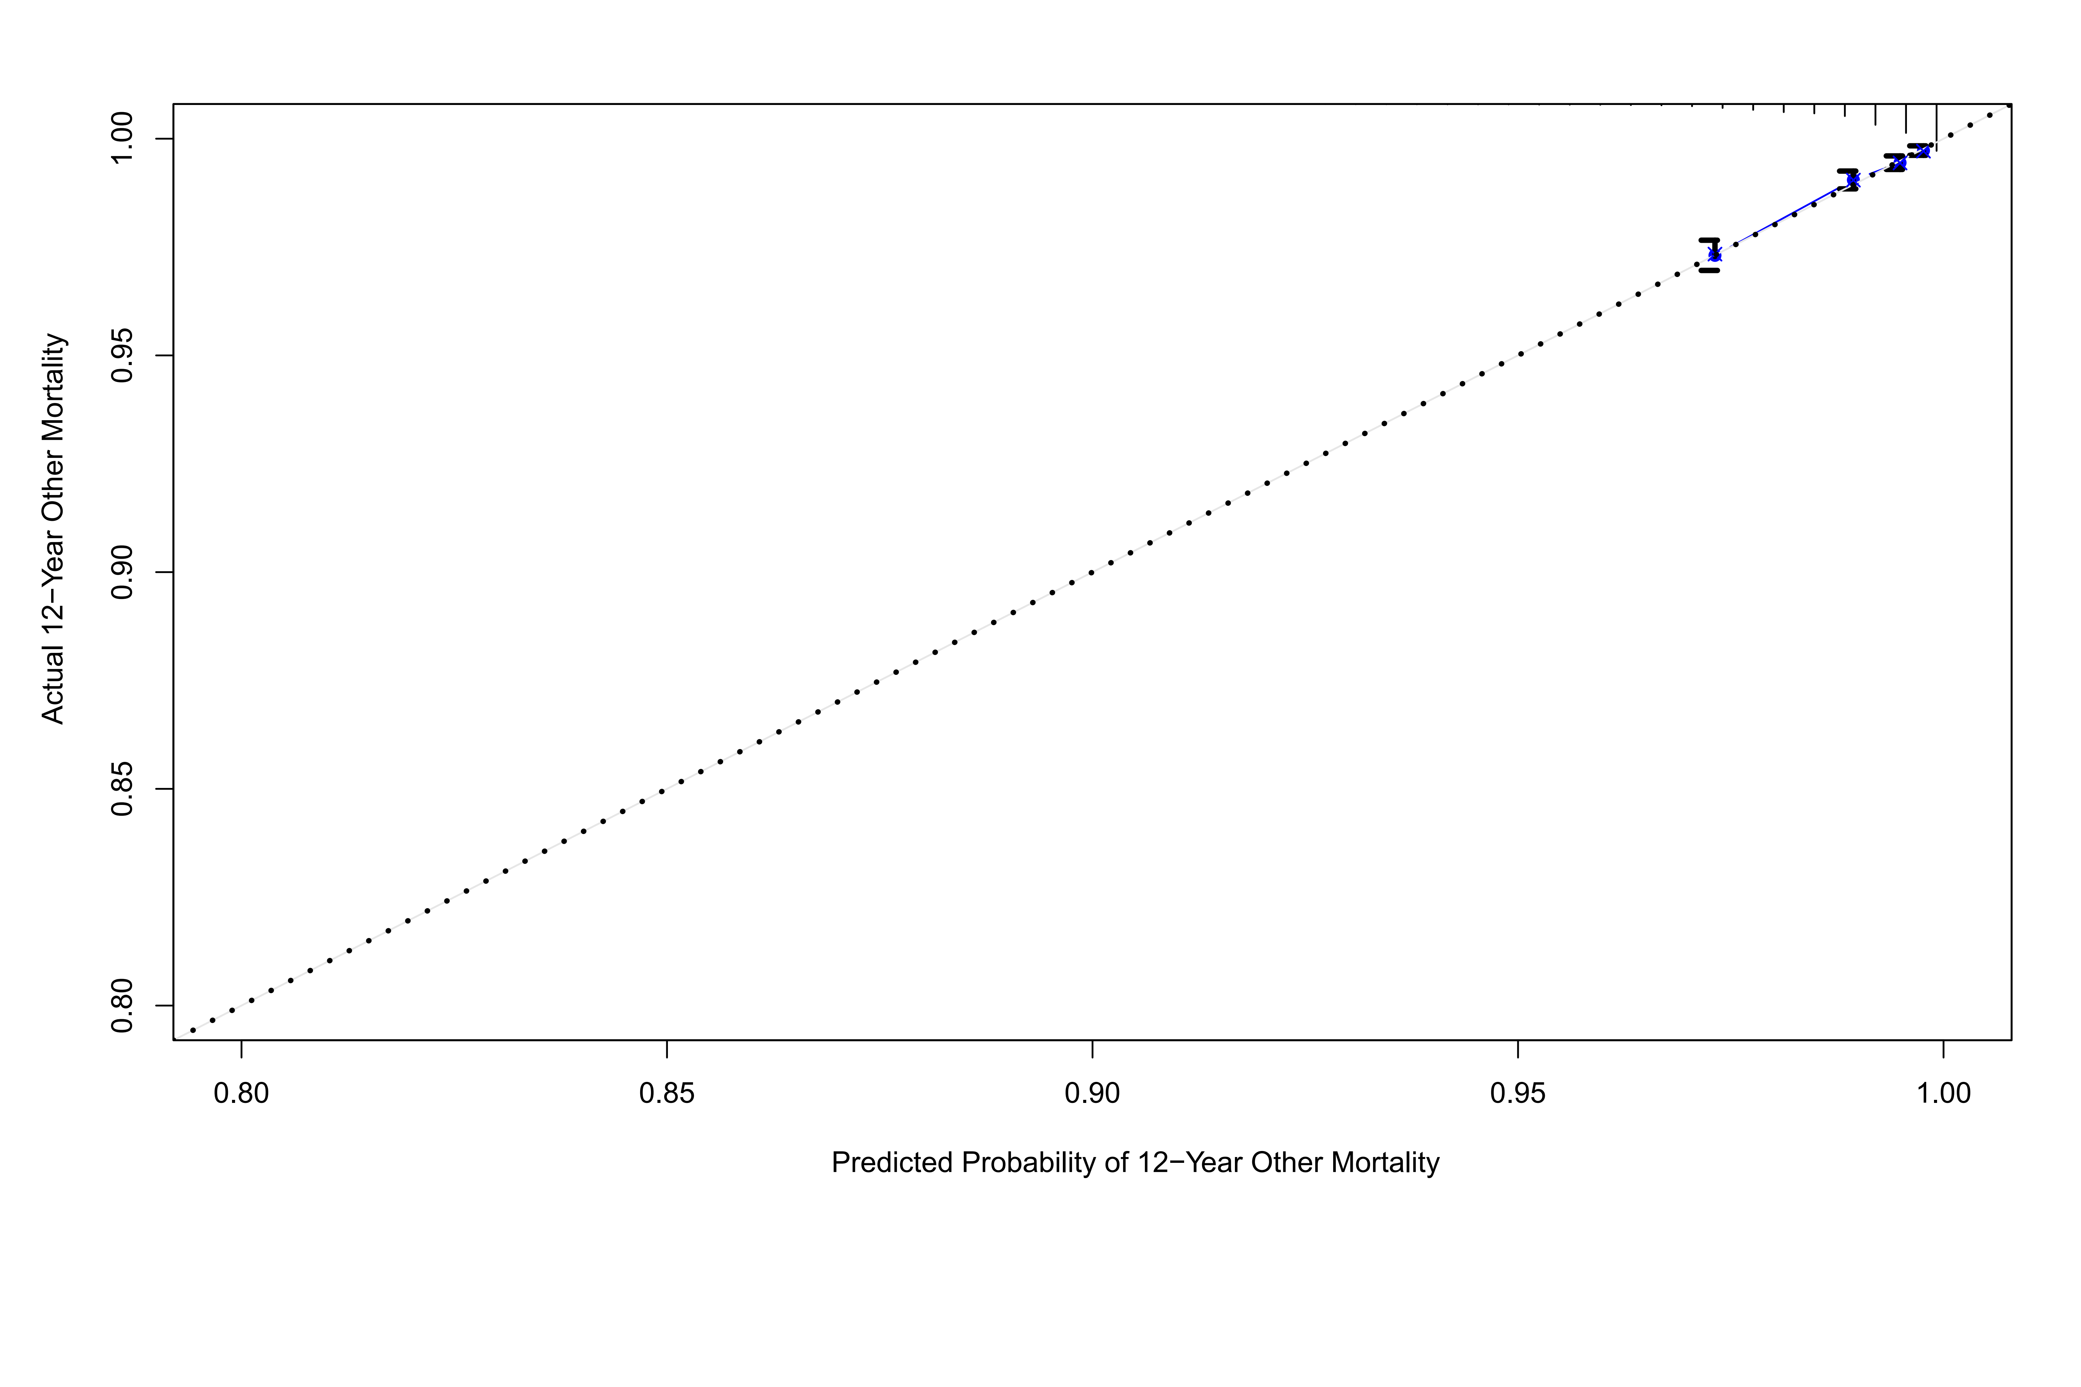

SUPPLEMENTARY TABLES

Supplementary Table S1
Definition of variables in touchscreen questionnaire, verbal interview and inpatient records of diagnosis.
Variable | Data category | Data field | Data code
Age at recruitment | Population characteristics | 21022
Sex | Population characteristics | 31
Townsend deprivation index | Population characteristics | 189
Average total household income before tax | Touchscreen questionnaire | 738
Smoking status | Touchscreen questionnaire | 20116
Alcohol drinker status | Touchscreen questionnaire | 20117
Ethnic background | Touchscreen questionnaire | 21000
Qualifications | Touchscreen questionnaire | 6138
BMI (Body mass index) | Physical measures | 21001
Waist circumference | Physical measures | 48
Hip circumference | Physical measures | 49
HDL cholesterol | Blood assays | 30760
LDL direct | Blood assays | 30780
Glycated haemoglobin (HbA1c) | Blood biochemistry | 30750
Haemoglobin concentration | Blood count | 30020
Creatinine (enzymatic) in urine | Urine assays | 30510
Microalbumin in urine | Urine assays | 30500
logMAR, final (left) | Eye measures | 5208
logMAR, final (right) | Eye measures | 5201
Cylindrical power (left) | Eye measures | 5086
Cylindrical power (right) | Eye measures | 5087
Spherical power (left) | Eye measures | 5085
Spherical power (right) | Eye measures | 5084
Intra-ocular pressure,  corneal-compensated (left) | Eye measures | 5262
Intra-ocular pressure,  corneal-compensated (right) | Eye measures | 5254
Average ganglion cell-inner plexiform layer thickness (left) | Eye measures | 28504
Average ganglion cell-inner plexiform layer thickness (right) | Eye measures | 28505
Diabetes | Hospital inpatients (ICD-10) | 41270 | E11-E14
 | Touchscreen questionnaire | 6148 | 1
 | Touchscreen questionnaire | 2443 | 1
 | Verbal interview | 20002 | 1276, 1220, 1222, 1223, 1468, 1521, 1607
Date of diabetes first reported | Health-related outcomes | 2404 | 130706, 130708, 130710, 130712. 130714
Type 2 diabetes | Hospital inpatients (ICD-10) | 41270 | E11
 | Verbal interview | 20002 | 1223
Date of type 2 diabetes first reported | Health-related outcomes | 2404 | 130709
Cardiovascular diseases | Hospital inpatients (ICD-10) | 41270 | I20-I25, I50, I60-I64
 | Touchscreen questionnaire | 6150 | 1, 2, 3
Date of Cardiovascular diseases first reported | Health-related outcomes | 2409 | 131296, 131298, 131300, 131302, 131304, 131306, 131360, 131362, 131364, 131366, 131368
 | Verbal interview | 20002 | 1074, 1075, 1076, 1081,  1082, 1086, 1491, 1583
Hypertension | Hospital inpatients (ICD-10) | 41270 | I10, I15
 | Touchscreen questionnaire | 6150 | 4
 | Verbal interview | 20002 | 1065, 1072
Date of hypertension first reported | Health-related outcomes | 2409 | 131286, 131290, 131292, 131294
Glaucoma | Hospital inpatients (ICD-10) | 41270 | H40, H42
 | Touchscreen questionnaire | 6148 | 2
 | Verbal interview | 20002 | 1277
Retinal diseases | Hospital inpatients (ICD-10) | 41270 | H30-H36
 | Touchscreen questionnaire | 6148 | 1, 5
 | Verbal interview | 20002 | 1275, 1281, 1282, 1528
Multiple sclerosis | Hospital inpatients (ICD-10) | 41270 | G35
 | Verbal interview | 20002 | 1261
Dementia | Hospital inpatients (ICD-10) | 41270 | F00-F03, F05.1, G30, G31.0, G31.1, G31.8, I67.3, A81.0, F10.6
 | Verbal interview | 20002 | 1263
Date of dementia first reported | Health-related outcomes | 2406 | 131038
Heart failure | Hospital inpatients (ICD-10) | 41270 | I42, I50
 | Verbal interview | 20002 | 1076, 1079, 1588
Date of heart failure first reported | Health-related outcomes | 2409 | 131354
Myocardial infarction | Hospital inpatients (ICD-10) | 41270 | I20-I23
 | Touchscreen questionnaire | 6150 | 1
 | Verbal interview | 20002 | 1075
Date of myocardial infarction first reported | Health-related outcomes | 2409 | 131298, 131300,131302
Stroke | Hospital inpatients (ICD-10) | 41270 | I60-I64
 | Touchscreen questionnaire | 6150 | 3
 | Verbal interview | 20002 | 1081, 1083, 1086
Date of stroke first reported | Health-related outcomes | 2409 | 131360, 131362, 131364, 131366, 131368
Ischemic stroke | Hospital inpatients (ICD-10) | 41270 | I63
 | Verbal interview | 20002 | 1583
Date of ischemic stroke first reported | Health-related outcomes | 2409 | 131366
Obstructive sleep apnea/hypoxia syndrome | Hospital inpatients (ICD-10) | 41270 | G47.3
 | Verbal interview | 20002 | 1958
Date of obstructive sleep apnea syndrome first reported | Health-related outcomes |  | 131060
Date of death | Death register | 40000
Death | Death register (ICD-10) | 40001 | A00-U49
Cardiovascular disease deaths | Death register (ICD-10) | 40001 | I05-I89
Cancer deaths | Death register (ICD-10) | 40001 | C00-D48
Other deaths | Death register (ICD-10) | 40001 | A00-B99, D55-H75, J09-U49

Supplementary Table S2
Metabolic biomarkers reaching the set significance threshold of P value (< 0.0009).
Metabolic Biomarkers | β | 95%CI |  | P-value*
Ratio of saturated fatty acids to total fatty acids | -0.411 | -0.576 | -0.246 | 1.02E-06
Phospholipids in Medium HDL | -0.284 | -0.410 | -0.157 | 1.09E-05
Ratio of linoleic acid to total fatty acids | 0.327 | 0.176 | 0.477 | 2.03E-05
Total Lipids in Medium HDL | -0.271 | -0.399 | -0.143 | 3.17E-05
Phospholipids in HDL | -0.279 | -0.411 | -0.148 | 3.19E-05
Phospholipids to total lipids ratio in small HDL | -0.257 | -0.380 | -0.134 | 4.16E-05
Concentration of Medium HDL Particles | -0.266 | -0.394 | -0.138 | 4.78E-05
Free Cholesterol in Medium HDL | -0.264 | -0.394 | -0.134 | 6.90E-05
Apolipoprotein A1 | -0.253 | -0.383 | -0.124 | 1.29E-04
Total Lipids in HDL | -0.260 | -0.393 | -0.127 | 1.34E-04
Cholesterol in Medium HDL | -0.251 | -0.381 | -0.121 | 1.56E-04
Cholesteryl Esters in Medium HDL | -0.247 | -0.377 | -0.117 | 1.90E-04
Free Cholesterol in HDL | -0.240 | -0.375 | -0.105 | 4.87E-04
Ratio of omega-6 fatty acids to total fatty acids | 0.259 | 0.110 | 0.408 | 6.85E-04
Ratio of apolipoprotein B to apolipoprotein A1 | 0.222 | 0.093 | 0.351 | 7.43E-04
Concentration of HDL Particles | -0.213 | -0.338 | -0.088 | 8.47E-04
*Fully adjusted for sex, age, race, Townsend Deprivation Index, household income, body mass index, smoking, alcohol, lipid-lowering medication, spherical equivalent and intraocular pressure.
GCIPL = ganglion cell-inner plexus layer; HDL = high-density lipoprotein; CI = confidence interval.

Supplementary Table S3
No. of incident outcomes in total, training set and validation set.
Outcome | Total | Training set | Validation set
Systemic diseases
Type 2 diabetes | 5,714 (7.28%) | 2,918 (7.45%) | 2,796 (7.11%)
OSAHS | 1,366 (1.62%) | 688 (1.64%) | 678 (1.61%)
Dementia | 1,219 (1.44%) | 608 (1.44%) | 611 (1.44%)
Ischemic stroke | 1,578 (1.88%) | 796 (1.89%) | 782 (1.86%)
Heart failure | 2,537 (3.05%) | 1,255 (3.02%) | 1,282 (3.09%)
Myocardial infarction | 2,866 (3.47%) | 1,420 (3.44%) | 1,446 (3.50%)
Mortality
All-cause mortality | 6,254 (7.84%) | 3,166 (7.95%) | 3,088 (7.74%)
CVD mortality | 1,544 (1.94%) | 800 (2.01%) | 744 (1.86%)
Cancer mortality | 3,151 (3.95%) | 1,572 (3.95%) | 1,579 (3.96%)
Other mortality | 1,559 (1.95%) | 794 (1.99%) | 765 (1.92%)
T2DM = type 2 diabetes mellites; OSAHS = obstructive sleep apnea/hypoxia syndrome; CVD = cardiovascular disease.

Supplementary Table S4
Baseline characteristics of subjects stratified by incident type 2 diabetes.
Characteristic | Training set |  | Validation set
 | No | Yes | No | Yes
No. of subjects | 39194 | 2918 | 39316 | 2796
Age at recruitment (%)
≤49 | 9193 (23.5) | 364 (12.5) | 9092 (23.1) | 317 (11.3)
50-54 | 5911 (15.1) | 333 (11.4) | 5832 (14.8) | 349 (12.5)
55-59 | 7031 (17.9) | 484 (16.6) | 7227 (18.4) | 502 (18.0)
60-64 | 9676 (24.7) | 869 (29.8) | 9602 (24.4) | 806 (28.8)
≥65 | 7383 (18.8) | 868 (29.7) | 7563 (19.2) | 822 (29.4)
Gender (%)
Female | 21996 (56.1) | 1198 (41.1) | 21979 (55.9) | 1152 (41.2)
Male | 17198 (43.9) | 1720 (58.9) | 17337 (44.1) | 1644 (58.8)
Race (%)
White | 37381 (95.4) | 2596 (89.0) | 37514 (95.4) | 2493 (89.2)
Others | 1646 (4.2) | 301 (10.3) | 1646 (4.2) | 282 (10.1)
Missing | 167 (0.4) | 21 (0.7) | 156 (0.4) | 21 (0.8)
Townsend Deprivation Index (%)
Quantile 1 | 10301 (26.3) | 559 (19.2) | 10099 (25.7) | 585 (20.9)
Quantile 2 | 9864 (25.2) | 614 (21.0) | 10103 (25.7) | 585 (20.9)
Quantile 3 | 9723 (24.8) | 709 (24.3) | 9654 (24.6) | 650 (23.2)
Quantile 4 | 9255 (23.6) | 1033 (35.4) | 9403 (23.9) | 974 (34.8)
Missing | 51 (0.1) | 3 (0.1) | 57 (0.1) | 2 (0.1)
Average total household income before tax (£)
< 18k | 7647 (19.5) | 891 (30.5) | 7600 (19.3) | 873 (31.2)
18k~30k | 8650 (22.1) | 702 (24.1) | 8747 (22.2) | 662 (23.7)
31k~51k | 8735 (22.3) | 475 (16.3) | 8800 (22.4) | 464 (16.6)
52k~100k | 6678 (17.0) | 258 (8.8) | 6755 (17.2) | 271 (9.7)
> 100k | 1669 (4.3) | 46 (1.6) | 1681 (4.3) | 41 (1.5)
Missing | 5815 (14.8) | 546 (18.7) | 5733 (14.6) | 485 (17.3)
Body mass index (%)
Normal | 13418 (34.2) | 257 (8.8) | 13293 (33.8) | 261 (9.3)
Overweight | 16897 (43.1) | 1049 (35.9) | 17008 (43.3) | 982 (35.1)
Obesity | 8737 (22.3) | 1590 (54.5) | 8871 (22.6) | 1531 (54.8)
Missing | 142 (0.4) | 22 (0.8) | 144 (0.4) | 22 (0.8)
Smoking (%)
Never | 13464 (34.4) | 1196 (41.0) | 13718 (34.9) | 1104 (39.5)
Ever/Current | 4201 (10.7) | 426 (14.6) | 4106 (10.4) | 397 (14.2)
Missing | 21529 (54.9) | 1296 (44.4) | 21492 (54.7) | 1295 (46.3)
Drinking (%)
Never | 1353 (3.5) | 201 (6.9) | 1360 (3.5) | 171 (6.1)
Ever/Current | 36137 (92.2) | 2465 (84.5) | 36296 (92.3) | 2391 (85.5)
Missing | 1704 (4.3) | 252 (8.6) | 1660 (4.2) | 234 (8.4)
Lipid-lowering medication (%)
No | 33488 (85.4) | 1516 (52.0) | 33555 (85.3) | 1438 (51.4)
Yes | 5706 (14.6) | 1402 (48.0) | 5761 (14.7) | 1358 (48.6)

Supplementary Table S5
Baseline characteristics of subjects stratified by incident OSAHS.
Characteristic | Training set |  | Validation set
 | No | Yes | No | Yes
No. of subjects | 42081 | 688 | 42101 | 678
Age at recruitment (%)
≤49 | 9426 (22.4) | 164 (23.8) | 9367 (22.2) | 158 (23.3)
50-54 | 6200 (14.7) | 91 (13.2) | 6179 (14.7) | 110 (16.2)
55-59 | 7508 (17.8) | 138 (20.1) | 7660 (18.2) | 133 (19.6)
60-64 | 10512 (25.0) | 180 (26.2) | 10466 (24.9) | 164 (24.2)
≥65 | 8435 (20.0) | 115 (16.7) | 8429 (20.0) | 113 (16.7)
Gender (%)
Female | 23323 (55.4) | 221 (32.1) | 23204 (55.1) | 203 (29.9)
Male | 18758 (44.6) | 467 (67.9) | 18897 (44.9) | 475 (70.1)
Race (%)
White | 39899 (94.8) | 643 (93.5) | 39954 (94.9) | 621 (91.6)
Others | 1998 (4.7) | 40 (5.8) | 1957 (4.6) | 53 (7.8)
Missing | 184 (0.4) | 5 (0.7) | 190 (0.5) | 4 (0.6)
Townsend Deprivation Index (%)
Quantile 1 | 10694 (25.4) | 136 (19.8) | 10791 (25.6) | 137 (20.2)
Quantile 2 | 10498 (24.9) | 148 (21.5) | 10631 (25.3) | 134 (19.8)
Quantile 3 | 10462 (24.9) | 176 (25.6) | 10275 (24.4) | 159 (23.5)
Quantile 4 | 10369 (24.6) | 228 (33.1) | 10349 (24.6) | 246 (36.3)
Missing | 58 (0.1) | 0 (0.0) | 55 (0.1) | 2 (0.3)
Average total household income before tax (£)
< 18k | 8501 (20.2) | 180 (26.2) | 8621 (20.5) | 184 (27.1)
18k~30k | 9386 (22.3) | 160 (23.3) | 9335 (22.2) | 161 (23.7)
31k~51k | 9223 (21.9) | 156 (22.7) | 9143 (21.7) | 131 (19.3)
52k~100k | 6936 (16.5) | 80 (11.6) | 6941 (16.5) | 91 (13.4)
> 100k | 1679 (4.0) | 12 (1.7) | 1741 (4.1) | 14 (2.1)
Missing | 6356 (15.1) | 100 (14.5) | 6320 (15.0) | 97 (14.3)
BMI (%)
Normal | 13683 (32.5) | 49 (7.1) | 13638 (32.4) | 68 (10.0)
Overweight | 18002 (42.8) | 205 (29.8) | 17976 (42.7) | 182 (26.8)
Obesity | 10240 (24.3) | 431 (62.6) | 10308 (24.5) | 421 (62.1)
Missing | 156 (0.4) | 3 (0.4) | 179 (0.4) | 7 (1.0)
Smoking (%)
Never | 14691 (34.9) | 282 (41.0) | 14804 (35.2) | 275 (40.6)
Ever/Current | 4535 (10.8) | 98 (14.2) | 4560 (10.8) | 81 (11.9)
Missing | 22855 (54.3) | 308 (44.8) | 22737 (54.0) | 322 (47.5)
Drinking (%)
Never | 1552 (3.7) | 51 (7.4) | 1569 (3.7) | 49 (7.2)
Ever/Current | 38583 (91.7) | 594 (86.3) | 38548 (91.6) | 599 (88.3)
Missing | 1946 (4.6) | 43 (6.2) | 1984 (4.7) | 30 (4.4)
Lipid-lowering medication (%)
No | 34642 (82.3) | 446 (64.8) | 34622 (82.2) | 453 (66.8)
Yes | 7439 (17.7) | 242 (35.2) | 7479 (17.8) | 225 (33.2)

Supplementary Table S6
Baseline characteristics of subjects stratified characteristics by incident dementia.
Characteristic | Training set |  | Validation set
 | No | Yes | No | Yes
No. of subjects | 42365 | 608 | 42379 | 611
Age at recruitment (%)
≤49 | 9604 (22.7) | 13 (2.1) | 9551 (22.5) | 10 (1.6)
50-54 | 6307 (14.9) | 21 (3.5) | 6297 (14.9) | 18 (2.9)
55-59 | 7642 (18.0) | 45 (7.4) | 7795 (18.4) | 45 (7.4)
60-64 | 10560 (24.9) | 176 (28.9) | 10534 (24.9) | 166 (27.2)
≥65 | 8252 (19.5) | 353 (58.1) | 8202 (19.4) | 372 (60.9)
Gender (%)
Female | 23275 (54.9) | 293 (48.2) | 23187 (54.7) | 265 (43.4)
Male | 19090 (45.1) | 315 (51.8) | 19192 (45.3) | 346 (56.6)
Race (%)
White | 40153 (94.8) | 586 (96.4) | 40188 (94.8) | 590 (96.6)
Others | 2028 (4.8) | 16 (2.6) | 2001 (4.7) | 17 (2.8)
Missing | 184 (0.4) | 6 (1.0) | 190 (0.4) | 4 (0.7)
Townsend Deprivation Index (%)
Quantile 1 | 10739 (25.3) | 126 (20.7) | 10836 (25.6) | 136 (22.3)
Quantile 2 | 10556 (24.9) | 151 (24.8) | 10659 (25.2) | 161 (26.4)
Quantile 3 | 10537 (24.9) | 149 (24.5) | 10341 (24.4) | 145 (23.7)
Quantile 4 | 10475 (24.7) | 182 (29.9) | 10486 (24.7) | 169 (27.7)
Missing | 58 (0.1) | 0 (0.0) | 57 (0.1) | 0 (0.0)
Average total household income before tax (£)
< 18k | 8505 (20.1) | 225 (37.0) | 8652 (20.4) | 205 (33.6)
18k~30k | 9447 (22.3) | 139 (22.9) | 9398 (22.2) | 152 (24.9)
31k~51k | 9370 (22.1) | 50 (8.2) | 9256 (21.8) | 64 (10.5)
52k~100k | 7027 (16.6) | 30 (4.9) | 7019 (16.6) | 38 (6.2)
> 100k | 1689 (4.0) | 9 (1.5) | 1756 (4.1) | 9 (1.5)
Missing | 6327 (14.9) | 155 (25.5) | 6298 (14.9) | 143 (23.4)
BMI (%)
Normal | 13563 (32.0) | 177 (29.1) | 13521 (31.9) | 195 (31.9)
Overweight | 18011 (42.5) | 266 (43.8) | 17974 (42.4) | 247 (40.4)
Obesity | 10641 (25.1) | 154 (25.3) | 10706 (25.3) | 161 (26.4)
Missing | 150 (0.4) | 11 (1.8) | 178 (0.4) | 8 (1.3)
Smoking (%)
Never | 14830 (35.0) | 246 (40.5) | 14899 (35.2) | 263 (43.0)
Ever/Current | 4579 (10.8) | 72 (11.8) | 4608 (10.9) | 67 (11.0)
Missing | 22956 (54.2) | 290 (47.7) | 22872 (54.0) | 281 (46.0)
Drinking (%)
Never | 1563 (3.7) | 48 (7.9) | 1586 (3.7) | 46 (7.5)
Ever/Current | 38849 (91.7) | 516 (84.9) | 38811 (91.6) | 520 (85.1)
Missing | 1953 (4.6) | 44 (7.2) | 1982 (4.7) | 45 (7.4)
Lipid-lowering medication (%)
No | 34811 (82.2) | 393 (64.6) | 34806 (82.1) | 385 (63.0)
Yes | 7554 (17.8) | 215 (35.4) | 7573 (17.9) | 226 (37.0)

Supplementary Table S7
Baseline characteristics of subjects stratified by incident ischemic stroke.
Characteristic | Training set |  | Validation set
 | No | Yes | No | Yes
No. of subjects | 42043 | 796 | 42067 | 782
Age at recruitment (%)
≤49 | 9559 (22.7) | 49 (6.2) | 9493 (22.6) | 53 (6.8)
50-54 | 6264 (14.9) | 57 (7.2) | 6248 (14.9) | 55 (7.0)
55-59 | 7580 (18.0) | 95 (11.9) | 7707 (18.3) | 107 (13.7)
60-64 | 10461 (24.9) | 234 (29.4) | 10432 (24.8) | 237 (30.3)
≥65 | 8179 (19.5) | 361 (45.4) | 8187 (19.5) | 330 (42.2)
Gender (%)
Female | 23232 (55.3) | 312 (39.2) | 23110 (54.9) | 297 (38.0)
Male | 18811 (44.7) | 484 (60.8) | 18957 (45.1) | 485 (62.0)
Race (%)
White | 39842 (94.8) | 767 (96.4) | 39903 (94.9) | 742 (94.9)
Others | 2013 (4.8) | 27 (3.4) | 1979 (4.7) | 33 (4.2)
Missing | 188 (0.4) | 2 (0.3) | 185 (0.4) | 7 (0.9)
Townsend Deprivation Index (%)
Quantile 1 | 10641 (25.3) | 190 (23.9) | 10779 (25.6) | 170 (21.7)
Quantile 2 | 10496 (25.0) | 193 (24.2) | 10581 (25.2) | 191 (24.4)
Quantile 3 | 10466 (24.9) | 183 (23.0) | 10272 (24.4) | 194 (24.8)
Quantile 4 | 10382 (24.7) | 230 (28.9) | 10378 (24.7) | 227 (29.0)
Missing | 58 (0.1) | 0 (0.0) | 57 (0.1) | 0 (0.0)
Average total household income before tax (£)
< 18k | 8437 (20.1) | 239 (30.0) | 8581 (20.4) | 232 (29.7)
18k~30k | 9360 (22.3) | 201 (25.3) | 9329 (22.2) | 183 (23.4)
31k~51k | 9273 (22.1) | 126 (15.8) | 9159 (21.8) | 140 (17.9)
52k~100k | 6986 (16.6) | 60 (7.5) | 6978 (16.6) | 67 (8.6)
> 100k | 1684 (4.0) | 15 (1.9) | 1748 (4.2) | 18 (2.3)
Missing | 6303 (15.0) | 155 (19.5) | 6272 (14.9) | 142 (18.2)
BMI (%)
Normal | 13507 (32.1) | 210 (26.4) | 13483 (32.1) | 207 (26.5)
Overweight | 17880 (42.5) | 334 (42.0) | 17823 (42.4) | 342 (43.7)
Obesity | 10507 (25.0) | 246 (30.9) | 10582 (25.2) | 228 (29.2)
Missing | 149 (0.4) | 6 (0.8) | 179 (0.4) | 5 (0.6)
Smoking (%)
Never | 14702 (35.0) | 303 (38.1) | 14759 (35.1) | 336 (43.0)
Ever/Current | 4513 (10.7) | 120 (15.1) | 4518 (10.7) | 133 (17.0)
Missing | 22828 (54.3) | 373 (46.9) | 22790 (54.2) | 313 (40.0)
Drinking (%)
Never | 1562 (3.7) | 35 (4.4) | 1585 (3.8) | 38 (4.9)
Ever/Current | 38528 (91.6) | 723 (90.8) | 38516 (91.6) | 697 (89.1)
Missing | 1953 (4.6) | 38 (4.8) | 1966 (4.7) | 47 (6.0)
Lipid-lowering medication (%)
No | 34675 (82.5) | 521 (65.5) | 34646 (82.4) | 526 (67.3)
Yes | 7368 (17.5) | 275 (34.5) | 7421 (17.6) | 256 (32.7)

Supplementary Table S8
Baseline characteristics of subjects stratified by incident heart failure.
Characteristic | Training set |  | Validation set
 | No | Yes | No | Yes
No. of subjects | 41584 | 1255 | 41553 | 1282
Age at recruitment (%)
≤49 | 9551 (23.0) | 58 (4.6) | 9485 (22.8) | 64 (5.0)
50-54 | 6236 (15.0) | 82 (6.5) | 6206 (14.9) | 94 (7.3)
55-59 | 7486 (18.0) | 181 (14.4) | 7655 (18.4) | 165 (12.9)
60-64 | 10320 (24.8) | 370 (29.5) | 10249 (24.7) | 410 (32.0)
≥65 | 7991 (19.2) | 564 (44.9) | 7958 (19.2) | 549 (42.8)
Gender (%)
Female | 23085 (55.5) | 467 (37.2) | 22971 (55.3) | 454 (35.4)
Male | 18499 (44.5) | 788 (62.8) | 18582 (44.7) | 828 (64.6)
Race (%)
White | 39421 (94.8) | 1194 (95.1) | 39406 (94.8) | 1224 (95.5)
Others | 1976 (4.8) | 57 (4.5) | 1960 (4.7) | 52 (4.1)
Missing | 187 (0.4) | 4 (0.3) | 187 (0.5) | 6 (0.5)
Townsend Deprivation Index (%)
Quantile 1 | 10568 (25.4) | 270 (21.5) | 10677 (25.7) | 263 (20.5)
Quantile 2 | 10396 (25.0) | 281 (22.4) | 10492 (25.2) | 297 (23.2)
Quantile 3 | 10354 (24.9) | 301 (24.0) | 10139 (24.4) | 305 (23.8)
Quantile 4 | 10209 (24.6) | 402 (32.0) | 10188 (24.5) | 417 (32.5)
Missing | 57 (0.1) | 1 (0.1) | 57 (0.1) | 0 (0.0)
Average total household income before tax (£)
< 18k | 8271 (19.9) | 404 (32.2) | 8355 (20.1) | 453 (35.3)
18k~30k | 9263 (22.3) | 296 (23.6) | 9220 (22.2) | 288 (22.5)
31k~51k | 9207 (22.1) | 191 (15.2) | 9125 (22.0) | 172 (13.4)
52k~100k | 6962 (16.7) | 86 (6.9) | 6943 (16.7) | 103 (8.0)
> 100k | 1680 (4.0) | 17 (1.4) | 1739 (4.2) | 24 (1.9)
Missing | 6201 (14.9) | 261 (20.8) | 6171 (14.9) | 242 (18.9)
BMI (%)
Normal | 13461 (32.4) | 264 (21.0) | 13448 (32.4) | 237 (18.5)
Overweight | 17746 (42.7) | 476 (37.9) | 17689 (42.6) | 486 (37.9)
Obesity | 10227 (24.6) | 508 (40.5) | 10246 (24.7) | 545 (42.5)
Missing | 150 (0.4) | 7 (0.6) | 170 (0.4) | 14 (1.1)
Smoking (%)
Never | 14446 (34.7) | 555 (44.2) | 14489 (34.9) | 577 (45.0)
Ever/Current | 4419 (10.6) | 218 (17.4) | 4463 (10.7) | 195 (15.2)
Missing | 22719 (54.6) | 482 (38.4) | 22601 (54.4) | 510 (39.8)
Drinking (%)
Never | 1516 (3.6) | 85 (6.8) | 1531 (3.7) | 86 (6.7)
Ever/Current | 38165 (91.8) | 1086 (86.5) | 38065 (91.6) | 1131 (88.2)
Missing | 1903 (4.6) | 84 (6.7) | 1957 (4.7) | 65 (5.1)
Lipid-lowering medication (%)
No | 34479 (82.9) | 702 (55.9) | 34439 (82.9) | 718 (56.0)
Yes | 7105 (17.1) | 553 (44.1) | 7114 (17.1) | 564 (44.0)

Supplementary Table S9
Baseline characteristics of subjects stratified by incident myocardial infarction.
Characteristic | Training set |  | Validation set
 | No | Yes | No | Yes
No. of subjects | 41318 | 1420 | 41331 | 1446
Age at recruitment (%)
≤49 | 9516 (23.0) | 100 (7.0) | 9444 (22.8) | 106 (7.3)
50-54 | 6194 (15.0) | 123 (8.7) | 6160 (14.9) | 144 (10.0)
55-59 | 7451 (18.0) | 200 (14.1) | 7595 (18.4) | 209 (14.5)
60-64 | 10214 (24.7) | 433 (30.5) | 10177 (24.6) | 459 (31.7)
≥65 | 7943 (19.2) | 564 (39.7) | 7955 (19.2) | 528 (36.5)
Gender (%)
Female | 23141 (56.0) | 414 (29.2) | 23019 (55.7) | 394 (27.2)
Male | 18177 (44.0) | 1006 (70.8) | 18312 (44.3) | 1052 (72.8)
Race (%)
White | 39175 (94.8) | 1345 (94.7) | 39219 (94.9) | 1363 (94.3)
Others | 1958 (4.7) | 69 (4.9) | 1923 (4.7) | 80 (5.5)
Missing | 185 (0.4) | 6 (0.4) | 189 (0.5) | 3 (0.2)
Townsend Deprivation Index (%)
Quantile 1 | 10495 (25.4) | 327 (23.0) | 10610 (25.7) | 316 (21.9)
Quantile 2 | 10305 (24.9) | 351 (24.7) | 10432 (25.2) | 345 (23.9)
Quantile 3 | 10315 (25.0) | 318 (22.4) | 10097 (24.4) | 340 (23.5)
Quantile 4 | 10145 (24.6) | 424 (29.9) | 10137 (24.5) | 443 (30.6)
Missing | 58 (0.1) | 0 (0.0) | 55 (0.1) | 2 (0.1)
Average total household income before tax (£)
< 18k | 8198 (19.8) | 449 (31.6) | 8326 (20.1) | 453 (31.3)
18k~30k | 9180 (22.2) | 346 (24.4) | 9169 (22.2) | 332 (23.0)
31k~51k | 9157 (22.2) | 229 (16.1) | 9054 (21.9) | 244 (16.9)
52k~100k | 6936 (16.8) | 113 (8.0) | 6918 (16.7) | 125 (8.6)
> 100k | 1671 (4.0) | 25 (1.8) | 1733 (4.2) | 30 (2.1)
Missing | 6176 (14.9) | 258 (18.2) | 6131 (14.8) | 262 (18.1)
BMI (%)
Normal | 13435 (32.5) | 268 (18.9) | 13389 (32.4) | 297 (20.5)
Overweight | 17542 (42.5) | 640 (45.1) | 17537 (42.4) | 602 (41.6)
Obesity | 10194 (24.7) | 505 (35.6) | 10228 (24.7) | 539 (37.3)
Missing | 147 (0.4) | 7 (0.5) | 177 (0.4) | 8 (0.6)
Smoking (%)
Never | 14292 (34.6) | 660 (46.5) | 14374 (34.8) | 665 (46.0)
Ever/Current | 4387 (10.6) | 229 (16.1) | 4407 (10.7) | 230 (15.9)
Missing | 22639 (54.8) | 531 (37.4) | 22550 (54.6) | 551 (38.1)
Drinking (%)
Never | 1522 (3.7) | 74 (5.2) | 1532 (3.7) | 90 (6.2)
Ever/Current | 37912 (91.8) | 1255 (88.4) | 37863 (91.6) | 1279 (88.5)
Missing | 1884 (4.6) | 91 (6.4) | 1936 (4.7) | 77 (5.3)
Lipid-lowering medication (%)
No | 34581 (83.7) | 620 (43.7) | 34527 (83.5) | 660 (45.6)
Yes | 6737 (16.3) | 800 (56.3) | 6804 (16.5) | 786 (54.4)

Supplementary Table S10
Baseline characteristics of subjects stratified by all-cause mortality.
Characteristic | Training set |  | Validation set
 | No | Yes | No | Yes
No. of subjects | 39841 | 3166 | 39919 | 3088
Age at recruitment (%)
≤49 | 9409 (23.6) | 217 (6.9) | 9382 (23.5) | 182 (5.9)
50-54 | 6112 (15.3) | 222 (7.0) | 6071 (15.2) | 247 (8.0)
55-59 | 7231 (18.1) | 463 (14.6) | 7414 (18.6) | 429 (13.9)
60-64 | 9806 (24.6) | 936 (29.6) | 9748 (24.4) | 956 (31.0)
≥65 | 7283 (18.3) | 1328 (41.9) | 7304 (18.3) | 1274 (41.3)
Gender (%)
Female | 22333 (56.1) | 1263 (39.9) | 22235 (55.7) | 1229 (39.8)
Male | 17508 (43.9) | 1903 (60.1) | 17684 (44.3) | 1859 (60.2)
Race (%)
White | 37725 (94.7) | 3046 (96.2) | 37810 (94.7) | 2985 (96.7)
Others | 1940 (4.9) | 105 (3.3) | 1935 (4.8) | 83 (2.7)
Missing | 176 (0.4) | 15 (0.5) | 174 (0.4) | 20 (0.6)
Townsend Deprivation Index (%)
Quantile 1 | 10209 (25.6) | 662 (20.9) | 10273 (25.7) | 705 (22.8)
Quantile 2 | 9945 (25.0) | 768 (24.3) | 10127 (25.4) | 693 (22.4)
Quantile 3 | 9948 (25.0) | 741 (23.4) | 9754 (24.4) | 736 (23.8)
Quantile 4 | 9682 (24.3) | 994 (31.4) | 9709 (24.3) | 953 (30.9)
Missing | 57 (0.1) | 1 (0.0) | 56 (0.1) | 1 (0.0)
Average total household income before tax (£)
< 18k | 7665 (19.2) | 1077 (34.0) | 7849 (19.7) | 1015 (32.9)
18k~30k | 8832 (22.2) | 761 (24.0) | 8862 (22.2) | 688 (22.3)
31k~51k | 9012 (22.6) | 413 (13.0) | 8839 (22.1) | 484 (15.7)
52k~100k | 6817 (17.1) | 241 (7.6) | 6791 (17.0) | 269 (8.7)
> 100k | 1644 (4.1) | 56 (1.8) | 1717 (4.3) | 49 (1.6)
Missing | 5871 (14.7) | 618 (19.5) | 5861 (14.7) | 583 (18.9)
BMI (%)
Normal | 12898 (32.4) | 853 (26.9) | 12842 (32.2) | 877 (28.4)
Overweight | 16962 (42.6) | 1328 (41.9) | 16950 (42.5) | 1281 (41.5)
Obesity | 9853 (24.7) | 952 (30.1) | 9967 (25.0) | 903 (29.2)
Missing | 128 (0.3) | 33 (1.0) | 160 (0.4) | 27 (0.9)
Smoking (%)
Never | 13765 (34.5) | 1320 (41.7) | 13878 (34.8) | 1289 (41.7)
Ever/Current | 4087 (10.3) | 574 (18.1) | 4028 (10.1) | 650 (21.0)
Missing | 21989 (55.2) | 1272 (40.2) | 22013 (55.1) | 1149 (37.2)
Drinking (%)
Never | 1387 (3.5) | 228 (7.2) | 1409 (3.5) | 225 (7.3)
Ever/Current | 36635 (92.0) | 2758 (87.1) | 36631 (91.8) | 2715 (87.9)
Missing | 1819 (4.6) | 180 (5.7) | 1879 (4.7) | 148 (4.8)
Lipid-lowering medication (%)
No | 33085 (83.0) | 2146 (67.8) | 33074 (82.9) | 2131 (69.0)
Yes | 6756 (17.0) | 1020 (32.2) | 6845 (17.1) | 957 (31.0)

Supplementary Table S11
Associations of GCIPLT metabolomic signature and incident T2DM.
Metabolic Biomarkers | Training set |  |  |  |  | Validation set
 | HR | 95% CI |  | SE | P value* | HR | 95% CI |  | SE | P value*
Ratio of saturated fatty acids to total fatty acids | 1.047 | 1.039 | 1.055 | 0.004 | 2.00E-32 | 1.037 | 1.025 | 1.049 | 0.006 | 9.10E-10
Phospholipids in Medium HDL | 0.909 | 0.885 | 0.934 | 0.014 | 3.09E-12 | 0.905 | 0.871 | 0.941 | 0.020 | 5.81E-07
Ratio of linoleic acid to total fatty acids | 0.693 | 0.675 | 0.712 | 0.014 | 0.00E+00 | 0.700 | 0.673 | 0.728 | 0.020 | 0.00E+00
Total Lipids in Medium HDL | 0.862 | 0.839 | 0.886 | 0.014 | 1.31E-26 | 0.861 | 0.827 | 0.896 | 0.020 | 1.22E-13
Phospholipids in HDL | 0.833 | 0.809 | 0.857 | 0.015 | 4.50E-35 | 0.833 | 0.799 | 0.869 | 0.021 | 2.27E-17
Phospholipids to total lipids ratio in small HDL | 1.107 | 1.079 | 1.135 | 0.013 | 4.47E-15 | 1.097 | 1.057 | 1.138 | 0.019 | 9.32E-07
Concentration of Medium HDL Particles | 0.820 | 0.796 | 0.844 | 0.015 | 0.00E+00 | 0.821 | 0.787 | 0.857 | 0.022 | 8.44E-20
Free Cholesterol in Medium HDL | 0.804 | 0.780 | 0.829 | 0.015 | 0.00E+00 | 0.806 | 0.772 | 0.842 | 0.022 | 4.33E-22
Apolipoprotein A1 | 0.809 | 0.787 | 0.833 | 0.015 | 0.00E+00 | 0.811 | 0.778 | 0.845 | 0.021 | 3.65E-23
Total Lipids in HDL | 0.783 | 0.761 | 0.807 | 0.015 | 0.00E+00 | 0.786 | 0.753 | 0.821 | 0.022 | 4.98E-28
Cholesterol in Medium HDL | 0.773 | 0.751 | 0.796 | 0.015 | 0.00E+00 | 0.777 | 0.745 | 0.810 | 0.022 | 1.01E-31
Cholesteryl Esters in Medium HDL | 0.766 | 0.745 | 0.789 | 0.015 | 0.00E+00 | 0.771 | 0.739 | 0.804 | 0.022 | 1.26E-33
Free Cholesterol in HDL | 0.737 | 0.713 | 0.762 | 0.017 | 0.00E+00 | 0.742 | 0.707 | 0.779 | 0.025 | 1.27E-33
Ratio of omega-6 fatty acids to total fatty acids | 0.712 | 0.695 | 0.729 | 0.012 | 0.00E+00 | 0.719 | 0.694 | 0.745 | 0.018 | 0.00E+00
Ratio of apolipoprotein B to apolipoprotein A1 | 1.000 | 0.973 | 1.028 | 0.014 | 9.99E-01 | 0.993 | 0.954 | 1.033 | 0.020 | 7.10E-01
Concentration of HDL Particles | 0.807 | 0.785 | 0.830 | 0.014 | 0.00E+00 | 0.809 | 0.776 | 0.842 | 0.021 | 1.39E-24
*Fully adjusted for sex, age, race, Townsend Deprivation Index, household income, BMI, smoking, alcohol, and lipid-lowering medication.
GCIPLT = ganglion cell-inner plexus layer thickness; T2DM = type 2 diabetes mellitus; HDL = high-density lipoprotein; HR = hazard ratio; CI = confidence interval; SE = standard error.

Supplementary Table S12
Associations of GCIPLT metabolomic signature and incident OSAHS.
Metabolic Biomarkers | Training set |  |  |  |  | Validation set
 | HR | 95% CI |  | SE | P-value* | HR | 95% CI |  | SE | P-value*
Ratio of saturated fatty acids to total fatty acids | 1.020 | 0.984 | 1.057 | 0.018 | 2.71E-01 | 1.017 | 0.965 | 1.071 | 0.027 | 5.32E-01
Phospholipids in Medium HDL | 0.895 | 0.846 | 0.947 | 0.029 | 1.12E-04 | 0.871 | 0.802 | 0.947 | 0.042 | 1.18E-03
Ratio of linoleic acid to total fatty acids | 0.909 | 0.858 | 0.962 | 0.029 | 1.06E-03 | 0.912 | 0.837 | 0.994 | 0.044 | 3.50E-02
Total Lipids in Medium HDL | 0.875 | 0.826 | 0.927 | 0.029 | 5.62E-06 | 0.851 | 0.781 | 0.926 | 0.043 | 1.88E-04
Phospholipids in HDL | 0.873 | 0.822 | 0.928 | 0.031 | 1.32E-05 | 0.850 | 0.777 | 0.930 | 0.046 | 4.00E-04
Phospholipids to total lipids ratio in small HDL | 1.053 | 1.000 | 1.109 | 0.026 | 5.04E-02 | 1.041 | 0.965 | 1.123 | 0.039 | 2.99E-01
Concentration of Medium HDL Particles | 0.851 | 0.799 | 0.905 | 0.032 | 3.68E-07 | 0.827 | 0.754 | 0.907 | 0.047 | 5.47E-05
Free Cholesterol in Medium HDL | 0.845 | 0.793 | 0.901 | 0.033 | 2.41E-07 | 0.820 | 0.746 | 0.902 | 0.048 | 4.04E-05
Apolipoprotein A1 | 0.847 | 0.797 | 0.900 | 0.031 | 7.75E-08 | 0.825 | 0.754 | 0.903 | 0.046 | 2.76E-05
Total Lipids in HDL | 0.852 | 0.800 | 0.906 | 0.032 | 4.41E-07 | 0.827 | 0.755 | 0.907 | 0.047 | 5.67E-05
Cholesterol in Medium HDL | 0.840 | 0.790 | 0.894 | 0.031 | 3.22E-08 | 0.811 | 0.740 | 0.888 | 0.047 | 7.21E-06
Cholesteryl Esters in Medium HDL | 0.839 | 0.788 | 0.892 | 0.032 | 2.41E-08 | 0.808 | 0.737 | 0.886 | 0.047 | 5.83E-06
Free Cholesterol in HDL | 0.826 | 0.770 | 0.886 | 0.036 | 1.06E-07 | 0.804 | 0.724 | 0.892 | 0.053 | 4.05E-05
Ratio of omega-6 fatty acids to total fatty acids | 0.937 | 0.888 | 0.987 | 0.027 | 1.52E-02 | 0.932 | 0.861 | 1.009 | 0.040 | 8.25E-02
Ratio of apolipoprotein B to apolipoprotein A1 | 1.006 | 0.952 | 1.064 | 0.029 | 8.21E-01 | 1.052 | 0.969 | 1.141 | 0.042 | 2.28E-01
Concentration of HDL Particles | 0.833 | 0.785 | 0.885 | 0.031 | 2.67E-09 | 0.818 | 0.748 | 0.894 | 0.046 | 1.03E-05
*Fully adjusted for sex, age, race, Townsend Deprivation Index, household income, BMI, smoking, alcohol, and lipid-lowering medication.
GCIPLT = ganglion cell-inner plexus layer thickness; T2DM = type 2 diabetes mellitus; HDL = high-density lipoprotein; HR = hazard ratio; CI = confidence interval; SE = standard error.

Supplementary Table S13
Associations of GCIPLT metabolomic signature and incident dementia.
Metabolic Biomarkers | Training set |  |  |  |  | Validation set
 | HR | 95% CI |  | SE | P-value* | HR | 95% CI |  | SE | P-value*
Ratio of saturated fatty acids to total fatty acids | 1.026 | 0.984 | 1.070 | 0.021 | 2.29E-01 | 1.037 | 0.991 | 1.084 | 0.023 | 1.13E-01
Phospholipids in Medium HDL | 0.905 | 0.851 | 0.962 | 0.031 | 1.46E-03 | 0.884 | 0.809 | 0.966 | 0.045 | 6.21E-03
Ratio of linoleic acid to total fatty acids | 0.925 | 0.867 | 0.987 | 0.033 | 1.81E-02 | 0.902 | 0.823 | 0.989 | 0.047 | 2.83E-02
Total Lipids in Medium HDL | 0.905 | 0.851 | 0.962 | 0.031 | 1.39E-03 | 0.887 | 0.812 | 0.968 | 0.045 | 7.46E-03
Phospholipids in HDL | 0.924 | 0.867 | 0.984 | 0.032 | 1.46E-02 | 0.894 | 0.816 | 0.980 | 0.047 | 1.69E-02
Phospholipids to total lipids ratio in small HDL | 0.972 | 0.916 | 1.031 | 0.030 | 3.39E-01 | 0.926 | 0.851 | 1.008 | 0.043 | 7.51E-02
Concentration of Medium HDL Particles | 0.909 | 0.853 | 0.968 | 0.032 | 3.04E-03 | 0.887 | 0.810 | 0.972 | 0.047 | 1.03E-02
Free Cholesterol in Medium HDL | 0.918 | 0.861 | 0.979 | 0.033 | 8.98E-03 | 0.893 | 0.814 | 0.980 | 0.047 | 1.65E-02
Apolipoprotein A1 | 0.909 | 0.854 | 0.968 | 0.032 | 2.75E-03 | 0.898 | 0.821 | 0.982 | 0.046 | 1.87E-02
Total Lipids in HDL | 0.926 | 0.869 | 0.987 | 0.033 | 1.86E-02 | 0.899 | 0.820 | 0.986 | 0.047 | 2.41E-02
Cholesterol in Medium HDL | 0.916 | 0.861 | 0.976 | 0.032 | 6.27E-03 | 0.892 | 0.815 | 0.976 | 0.046 | 1.30E-02
Cholesteryl Esters in Medium HDL | 0.918 | 0.862 | 0.977 | 0.032 | 6.89E-03 | 0.892 | 0.816 | 0.977 | 0.046 | 1.33E-02
Free Cholesterol in HDL | 0.951 | 0.891 | 1.016 | 0.034 | 1.37E-01 | 0.919 | 0.835 | 1.011 | 0.049 | 8.34E-02
Ratio of omega-6 fatty acids to total fatty acids | 0.974 | 0.915 | 1.037 | 0.032 | 4.12E-01 | 0.933 | 0.853 | 1.021 | 0.046 | 1.34E-01
Ratio of apolipoprotein B to apolipoprotein A1 | 1.038 | 0.977 | 1.104 | 0.031 | 2.30E-01 | 1.091 | 1.000 | 1.190 | 0.044 | 4.93E-02
Concentration of HDL Particles | 0.900 | 0.847 | 0.957 | 0.031 | 8.17E-04 | 0.904 | 0.828 | 0.988 | 0.045 | 2.52E-02
*Fully adjusted for sex, age, race, Townsend Deprivation Index, household income, BMI, smoking, alcohol, and lipid-lowering medication.
GCIPLT = ganglion cell-inner plexus layer thickness; T2DM = type 2 diabetes mellitus; HDL = high-density lipoprotein; HR = hazard ratio; CI = confidence interval; SE = standard error.

Supplementary Table S14
Associations of GCIPLT metabolomic signature and incident ischemic stroke.
Metabolic Biomarkers | Training set |  |  |  |  | Validation set
 | HR | 95% CI |  | SE | P-value* | HR | 95% CI |  | SE | P-value*
Ratio of saturated fatty acids to total fatty acids | 1.027 | 0.996 | 1.060 | 0.016 | 9.25E-02 | 1.029 | 0.984 | 1.076 | 0.023 | 2.16E-01
Phospholipids in Medium HDL | 0.928 | 0.881 | 0.979 | 0.027 | 5.73E-03 | 0.917 | 0.849 | 0.990 | 0.039 | 2.63E-02
Ratio of linoleic acid to total fatty acids | 0.907 | 0.858 | 0.960 | 0.028 | 6.51E-04 | 0.888 | 0.820 | 0.963 | 0.041 | 3.91E-03
Total Lipids in Medium HDL | 0.921 | 0.873 | 0.971 | 0.027 | 2.26E-03 | 0.904 | 0.837 | 0.977 | 0.039 | 1.07E-02
Phospholipids in HDL | 0.931 | 0.881 | 0.984 | 0.028 | 1.19E-02 | 0.908 | 0.838 | 0.985 | 0.041 | 1.94E-02
Phospholipids to total lipids ratio in small HDL | 0.984 | 0.936 | 1.036 | 0.026 | 5.45E-01 | 0.999 | 0.929 | 1.076 | 0.037 | 9.86E-01
Concentration of Medium HDL Particles | 0.915 | 0.867 | 0.967 | 0.028 | 1.61E-03 | 0.894 | 0.825 | 0.969 | 0.041 | 6.19E-03
Free Cholesterol in Medium HDL | 0.926 | 0.876 | 0.979 | 0.028 | 6.82E-03 | 0.899 | 0.828 | 0.975 | 0.042 | 1.07E-02
Apolipoprotein A1 | 0.922 | 0.873 | 0.973 | 0.028 | 3.27E-03 | 0.895 | 0.827 | 0.969 | 0.040 | 6.18E-03
Total Lipids in HDL | 0.927 | 0.876 | 0.980 | 0.028 | 7.42E-03 | 0.899 | 0.828 | 0.975 | 0.042 | 1.02E-02
Cholesterol in Medium HDL | 0.906 | 0.858 | 0.957 | 0.028 | 3.86E-04 | 0.883 | 0.815 | 0.956 | 0.041 | 2.19E-03
Cholesteryl Esters in Medium HDL | 0.902 | 0.854 | 0.952 | 0.028 | 2.03E-04 | 0.879 | 0.812 | 0.952 | 0.041 | 1.57E-03
Free Cholesterol in HDL | 0.947 | 0.893 | 1.004 | 0.030 | 6.77E-02 | 0.906 | 0.831 | 0.988 | 0.044 | 2.51E-02
Ratio of omega-6 fatty acids to total fatty acids | 0.911 | 0.863 | 0.961 | 0.027 | 6.00E-04 | 0.893 | 0.827 | 0.965 | 0.040 | 4.29E-03
Ratio of apolipoprotein B to apolipoprotein A1 | 1.100 | 1.044 | 1.159 | 0.027 | 3.75E-04 | 1.097 | 1.016 | 1.183 | 0.039 | 1.72E-02
Concentration of HDL Particles | 0.918 | 0.871 | 0.968 | 0.027 | 1.66E-03 | 0.894 | 0.827 | 0.967 | 0.040 | 4.93E-03
*Fully adjusted for sex, age, race, Townsend Deprivation Index, household income, BMI, smoking, alcohol, and lipid-lowering medication.
GCIPLT = ganglion cell-inner plexus layer thickness; T2DM = type 2 diabetes mellitus; HDL = high-density lipoprotein; HR = hazard ratio; CI = confidence interval; SE = standard error.

Supplementary Table S15
Associations of GCIPLT metabolomic signature and incident heart failure.
Metabolic Biomarkers | Training set |  |  |  |  | Validation set
 | HR | 95% CI |  | SE | P-value* | HR | 95% CI |  | SE | P-value*
Ratio of saturated fatty acids to total fatty acids | 1.022 | 0.994 | 1.050 | 0.014 | 1.24E-01 | 1.002 | 0.956 | 1.051 | 0.024 | 9.23E-01
Phospholipids in Medium HDL | 0.895 | 0.858 | 0.933 | 0.021 | 2.23E-07 | 0.900 | 0.848 | 0.956 | 0.031 | 6.63E-04
Ratio of linoleic acid to total fatty acids | 0.958 | 0.918 | 1.000 | 0.022 | 5.18E-02 | 0.936 | 0.879 | 0.996 | 0.032 | 3.63E-02
Total Lipids in Medium HDL | 0.891 | 0.854 | 0.929 | 0.021 | 7.51E-08 | 0.896 | 0.843 | 0.952 | 0.031 | 3.74E-04
Phospholipids in HDL | 0.912 | 0.872 | 0.953 | 0.023 | 4.31E-05 | 0.912 | 0.856 | 0.972 | 0.033 | 4.69E-03
Phospholipids to total lipids ratio in small HDL | 1.051 | 1.009 | 1.093 | 0.020 | 1.56E-02 | 1.062 | 1.003 | 1.124 | 0.029 | 4.05E-02
Concentration of Medium HDL Particles | 0.891 | 0.853 | 0.932 | 0.023 | 3.29E-07 | 0.896 | 0.841 | 0.955 | 0.032 | 7.31E-04
Free Cholesterol in Medium HDL | 0.897 | 0.857 | 0.938 | 0.023 | 2.09E-06 | 0.896 | 0.839 | 0.956 | 0.033 | 9.25E-04
Apolipoprotein A1 | 0.887 | 0.849 | 0.926 | 0.022 | 5.64E-08 | 0.887 | 0.833 | 0.945 | 0.032 | 1.88E-04
Total Lipids in HDL | 0.909 | 0.869 | 0.950 | 0.023 | 2.54E-05 | 0.907 | 0.851 | 0.968 | 0.033 | 3.14E-03
Cholesterol in Medium HDL | 0.893 | 0.855 | 0.933 | 0.022 | 3.59E-07 | 0.898 | 0.843 | 0.956 | 0.032 | 8.23E-04
Cholesteryl Esters in Medium HDL | 0.894 | 0.856 | 0.933 | 0.022 | 3.99E-07 | 0.900 | 0.845 | 0.958 | 0.032 | 1.01E-03
Free Cholesterol in HDL | 0.931 | 0.888 | 0.977 | 0.024 | 3.46E-03 | 0.921 | 0.860 | 0.987 | 0.035 | 2.02E-02
Ratio of omega-6 fatty acids to total fatty acids | 1.017 | 0.982 | 1.054 | 0.018 | 3.39E-01 | 1.005 | 0.956 | 1.058 | 0.026 | 8.37E-01
Ratio of apolipoprotein B to apolipoprotein A1 | 0.986 | 0.945 | 1.029 | 0.022 | 5.11E-01 | 0.957 | 0.900 | 1.018 | 0.031 | 1.67E-01
Concentration of HDL Particles | 0.857 | 0.821 | 0.895 | 0.022 | 1.79E-12 | 0.858 | 0.806 | 0.912 | 0.032 | 1.11E-06
*Fully adjusted for sex, age, race, Townsend Deprivation Index, household income, BMI, smoking, alcohol, and lipid-lowering medication.
GCIPLT = ganglion cell-inner plexus layer thickness; T2DM = type 2 diabetes mellitus; HDL = high-density lipoprotein; HR = hazard ratio; CI = confidence interval; SE = standard error.

Supplementary Table S16
Associations of GCIPLT metabolomic signature and incident myocardial infarction.
Metabolic Biomarkers | Training set |  |  |  |  | Validation set
 | HR | 95% CI |  | SE | P-value* | HR | 95% CI |  | SE | P-value*
Ratio of saturated fatty acids to total fatty acids | 1.008 | 0.976 | 1.041 | 0.016 | 6.23E-01 | 1.023 | 0.991 | 1.055 | 0.016 | 1.61E-01
Phospholipids in Medium HDL | 0.800 | 0.768 | 0.832 | 0.020 | 4.46E-28 | 0.813 | 0.767 | 0.861 | 0.029 | 1.78E-12
Ratio of linoleic acid to total fatty acids | 0.919 | 0.882 | 0.957 | 0.021 | 4.56E-05 | 0.910 | 0.858 | 0.965 | 0.030 | 1.66E-03
Total Lipids in Medium HDL | 0.785 | 0.754 | 0.817 | 0.020 | 1.26E-32 | 0.795 | 0.750 | 0.842 | 0.029 | 6.45E-15
Phospholipids in HDL | 0.783 | 0.751 | 0.817 | 0.022 | 8.96E-30 | 0.791 | 0.744 | 0.840 | 0.031 | 4.64E-14
Phospholipids to total lipids ratio in small HDL | 0.948 | 0.913 | 0.985 | 0.019 | 5.93E-03 | 0.975 | 0.923 | 1.029 | 0.028 | 3.57E-01
Concentration of Medium HDL Particles | 0.767 | 0.735 | 0.801 | 0.022 | 1.05E-33 | 0.779 | 0.732 | 0.828 | 0.032 | 2.84E-15
Free Cholesterol in Medium HDL | 0.769 | 0.736 | 0.803 | 0.022 | 6.73E-32 | 0.775 | 0.727 | 0.825 | 0.032 | 3.42E-15
Apolipoprotein A1 | 0.774 | 0.743 | 0.807 | 0.021 | 5.75E-34 | 0.778 | 0.733 | 0.826 | 0.031 | 2.46E-16
Total Lipids in HDL | 0.772 | 0.739 | 0.805 | 0.022 | 6.33E-33 | 0.775 | 0.729 | 0.824 | 0.031 | 4.68E-16
Cholesterol in Medium HDL | 0.757 | 0.726 | 0.789 | 0.021 | 1.11E-38 | 0.765 | 0.720 | 0.813 | 0.031 | 6.43E-18
Cholesteryl Esters in Medium HDL | 0.754 | 0.723 | 0.787 | 0.021 | 0.00E+00 | 0.764 | 0.719 | 0.812 | 0.031 | 4.05E-18
Free Cholesterol in HDL | 0.773 | 0.738 | 0.811 | 0.024 | 1.79E-26 | 0.771 | 0.720 | 0.826 | 0.035 | 1.11E-13
Ratio of omega-6 fatty acids to total fatty acids | 0.946 | 0.911 | 0.983 | 0.019 | 4.12E-03 | 0.956 | 0.906 | 1.010 | 0.028 | 1.09E-01
Ratio of apolipoprotein B to apolipoprotein A1 | 1.171 | 1.126 | 1.218 | 0.020 | 2.36E-15 | 1.132 | 1.070 | 1.198 | 0.029 | 1.74E-05
Concentration of HDL Particles | 0.779 | 0.747 | 0.811 | 0.021 | 3.08E-33 | 0.781 | 0.736 | 0.828 | 0.030 | 2.74E-16
*Fully adjusted for sex, age, race, Townsend Deprivation Index, household income, BMI, smoking, alcohol, and lipid-lowering medication.
GCIPLT = ganglion cell-inner plexus layer thickness; T2DM = type 2 diabetes mellitus; HDL = high-density lipoprotein; HR = hazard ratio; CI = confidence interval; SE = standard error.

Supplementary Table S17
Associations of GCIPLT metabolomic signature and all-cause mortality.
Metabolic Biomarkers | Training set |  |  |  |  | Validation set
 | HR | 95% CI |  | SE | P-value* | HR | 95% CI |  | SE | P-value*
Ratio of saturated fatty acids to total fatty acids | 1.037 | 1.025 | 1.050 | 0.006 | 6.03E-09 | 1.039 | 1.020 | 1.058 | 0.009 | 4.89E-05
Phospholipids in Medium HDL | 0.950 | 0.926 | 0.976 | 0.014 | 1.69E-04 | 0.939 | 0.904 | 0.976 | 0.020 | 1.40E-03
Ratio of linoleic acid to total fatty acids | 0.872 | 0.848 | 0.897 | 0.014 | 9.95E-22 | 0.862 | 0.828 | 0.898 | 0.021 | 7.38E-13
Total Lipids in Medium HDL | 0.939 | 0.915 | 0.965 | 0.014 | 4.65E-06 | 0.928 | 0.893 | 0.965 | 0.020 | 1.55E-04
Phospholipids in HDL | 0.967 | 0.940 | 0.994 | 0.014 | 1.66E-02 | 0.952 | 0.914 | 0.991 | 0.021 | 1.72E-02
Phospholipids to total lipids ratio in small HDL | 1.115 | 1.087 | 1.143 | 0.013 | 4.07E-17 | 1.117 | 1.077 | 1.159 | 0.019 | 2.93E-09
Concentration of Medium HDL Particles | 0.942 | 0.916 | 0.968 | 0.014 | 1.85E-05 | 0.927 | 0.890 | 0.965 | 0.020 | 2.06E-04
Free Cholesterol in Medium HDL | 0.947 | 0.921 | 0.974 | 0.014 | 1.42E-04 | 0.931 | 0.894 | 0.970 | 0.021 | 6.25E-04
Apolipoprotein A1 | 0.933 | 0.908 | 0.959 | 0.014 | 7.40E-07 | 0.917 | 0.881 | 0.954 | 0.020 | 2.01E-05
Total Lipids in HDL | 0.956 | 0.929 | 0.983 | 0.014 | 1.60E-03 | 0.940 | 0.903 | 0.979 | 0.021 | 3.15E-03
Cholesterol in Medium HDL | 0.930 | 0.905 | 0.956 | 0.014 | 2.18E-07 | 0.918 | 0.882 | 0.955 | 0.020 | 2.68E-05
Cholesteryl Esters in Medium HDL | 0.928 | 0.903 | 0.954 | 0.014 | 1.07E-07 | 0.917 | 0.881 | 0.954 | 0.020 | 2.04E-05
Free Cholesterol in HDL | 0.979 | 0.951 | 1.008 | 0.015 | 1.54E-01 | 0.959 | 0.919 | 1.001 | 0.022 | 5.75E-02
Ratio of omega-6 fatty acids to total fatty acids | 0.917 | 0.893 | 0.942 | 0.014 | 3.39E-10 | 0.923 | 0.888 | 0.960 | 0.020 | 7.16E-05
Ratio of apolipoprotein B to apolipoprotein A1 | 0.956 | 0.931 | 0.982 | 0.014 | 1.06E-03 | 0.946 | 0.909 | 0.983 | 0.020 | 4.95E-03
Concentration of HDL Particles | 0.894 | 0.870 | 0.918 | 0.014 | 5.06E-16 | 0.877 | 0.843 | 0.912 | 0.020 | 7.85E-11
*Fully adjusted for sex, age, race, Townsend Deprivation Index, household income, BMI, smoking, alcohol, and lipid-lowering medication.
GCIPLT = ganglion cell-inner plexus layer thickness; T2DM = type 2 diabetes mellitus; HDL = high-density lipoprotein; HR = hazard ratio; CI = confidence interval; SE = standard error.

Supplementary Table S18
Associations of GCIPLT metabolomic signature and CVD mortality.
Metabolic Biomarkers | Training set |  |  |  |  | Validation set
 | HR | 95% CI |  | SE | P-value* | HR | 95% CI |  | SE | P-value*
Ratio of saturated fatty acids to total fatty acids | 1.029 | 0.998 | 1.061 | 0.016 | 6.75E-02 | 1.031 | 0.990 | 1.074 | 0.021 | 1.42E-01
Phospholipids in Medium HDL | 0.871 | 0.825 | 0.919 | 0.028 | 5.20E-07 | 0.870 | 0.804 | 0.942 | 0.040 | 5.78E-04
Ratio of linoleic acid to total fatty acids | 0.860 | 0.813 | 0.909 | 0.028 | 9.68E-08 | 0.828 | 0.764 | 0.898 | 0.041 | 5.09E-06
Total Lipids in Medium HDL | 0.857 | 0.812 | 0.905 | 0.028 | 2.75E-08 | 0.858 | 0.793 | 0.929 | 0.040 | 1.55E-04
Phospholipids in HDL | 0.879 | 0.830 | 0.930 | 0.029 | 9.21E-06 | 0.871 | 0.802 | 0.947 | 0.043 | 1.22E-03
Phospholipids to total lipids ratio in small HDL | 1.059 | 1.006 | 1.115 | 0.026 | 2.86E-02 | 1.051 | 0.975 | 1.134 | 0.038 | 1.91E-01
Concentration of Medium HDL Particles | 0.852 | 0.805 | 0.903 | 0.029 | 5.12E-08 | 0.849 | 0.781 | 0.924 | 0.043 | 1.48E-04
Free Cholesterol in Medium HDL | 0.856 | 0.807 | 0.908 | 0.030 | 2.09E-07 | 0.850 | 0.780 | 0.927 | 0.044 | 2.20E-04
Apolipoprotein A1 | 0.849 | 0.803 | 0.898 | 0.029 | 1.20E-08 | 0.842 | 0.776 | 0.914 | 0.042 | 3.91E-05
Total Lipids in HDL | 0.869 | 0.820 | 0.920 | 0.029 | 1.72E-06 | 0.861 | 0.791 | 0.936 | 0.043 | 4.79E-04
Cholesterol in Medium HDL | 0.838 | 0.792 | 0.887 | 0.029 | 9.67E-10 | 0.844 | 0.777 | 0.917 | 0.042 | 6.14E-05
Cholesteryl Esters in Medium HDL | 0.836 | 0.790 | 0.885 | 0.029 | 5.45E-10 | 0.845 | 0.778 | 0.917 | 0.042 | 6.21E-05
Free Cholesterol in HDL | 0.891 | 0.837 | 0.948 | 0.032 | 2.72E-04 | 0.872 | 0.796 | 0.956 | 0.047 | 3.52E-03
Ratio of omega-6 fatty acids to total fatty acids | 0.897 | 0.851 | 0.945 | 0.027 | 4.81E-05 | 0.904 | 0.837 | 0.976 | 0.039 | 1.01E-02
Ratio of apolipoprotein B to apolipoprotein A1 | 1.019 | 0.965 | 1.076 | 0.028 | 5.06E-01 | 0.980 | 0.904 | 1.062 | 0.041 | 6.22E-01
Concentration of HDL Particles | 0.815 | 0.771 | 0.862 | 0.028 | 6.06E-13 | 0.812 | 0.748 | 0.881 | 0.042 | 5.40E-07
*Fully adjusted for sex, age, race, Townsend Deprivation Index, household income, BMI, smoking, alcohol, and lipid-lowering medication.
GCIPLT = ganglion cell-inner plexus layer thickness; T2DM = type 2 diabetes mellitus; HDL = high-density lipoprotein; HR = hazard ratio; CI = confidence interval; SE = standard error.

Supplementary Table S19
Associations of GCIPLT metabolomic signature and cancer mortality.
Metabolic Biomarkers | Training set |  |  |  |  | Validation set
 | HR | 95% CI |  | SE | P-value* | HR | 95% CI |  | SE | P-value*
Ratio of saturated fatty acids to total fatty acids | 1.033 | 1.013 | 1.053 | 0.010 | 8.94E-04 | 1.033 | 1.003 | 1.065 | 0.015 | 3.35E-02
Phospholipids in Medium HDL | 0.972 | 0.936 | 1.008 | 0.019 | 1.28E-01 | 0.950 | 0.901 | 1.003 | 0.027 | 6.30E-02
Ratio of linoleic acid to total fatty acids | 0.890 | 0.855 | 0.926 | 0.020 | 9.74E-09 | 0.894 | 0.844 | 0.947 | 0.029 | 1.36E-04
Total Lipids in Medium HDL | 0.959 | 0.924 | 0.996 | 0.019 | 2.88E-02 | 0.937 | 0.888 | 0.989 | 0.028 | 1.91E-02
Phospholipids in HDL | 0.973 | 0.936 | 1.012 | 0.020 | 1.70E-01 | 0.953 | 0.901 | 1.009 | 0.029 | 9.61E-02
Phospholipids to total lipids ratio in small HDL | 1.104 | 1.065 | 1.144 | 0.018 | 5.77E-08 | 1.107 | 1.052 | 1.165 | 0.026 | 1.01E-04
Concentration of Medium HDL Particles | 0.960 | 0.924 | 0.997 | 0.020 | 3.67E-02 | 0.938 | 0.887 | 0.991 | 0.028 | 2.35E-02
Free Cholesterol in Medium HDL | 0.960 | 0.923 | 0.998 | 0.020 | 3.90E-02 | 0.938 | 0.886 | 0.993 | 0.029 | 2.69E-02
Apolipoprotein A1 | 0.948 | 0.912 | 0.985 | 0.020 | 6.83E-03 | 0.925 | 0.874 | 0.978 | 0.029 | 5.91E-03
Total Lipids in HDL | 0.959 | 0.922 | 0.998 | 0.020 | 3.80E-02 | 0.938 | 0.886 | 0.994 | 0.029 | 2.95E-02
Cholesterol in Medium HDL | 0.946 | 0.911 | 0.983 | 0.020 | 4.74E-03 | 0.924 | 0.874 | 0.977 | 0.028 | 5.59E-03
Cholesteryl Esters in Medium HDL | 0.945 | 0.910 | 0.982 | 0.020 | 4.07E-03 | 0.924 | 0.874 | 0.976 | 0.028 | 5.10E-03
Free Cholesterol in HDL | 0.970 | 0.931 | 1.010 | 0.021 | 1.42E-01 | 0.951 | 0.896 | 1.010 | 0.030 | 1.01E-01
Ratio of omega-6 fatty acids to total fatty acids | 0.925 | 0.890 | 0.962 | 0.020 | 9.00E-05 | 0.940 | 0.889 | 0.994 | 0.029 | 3.09E-02
Ratio of apolipoprotein B to apolipoprotein A1 | 0.964 | 0.929 | 1.001 | 0.019 | 5.77E-02 | 0.964 | 0.914 | 1.018 | 0.028 | 1.89E-01
Concentration of HDL Particles | 0.924 | 0.890 | 0.960 | 0.019 | 4.29E-05 | 0.898 | 0.850 | 0.948 | 0.028 | 1.19E-04
*Fully adjusted for sex, age, race, Townsend Deprivation Index, household income, BMI, smoking, alcohol, and lipid-lowering medication.
GCIPLT = ganglion cell-inner plexus layer thickness; T2DM = type 2 diabetes mellitus; HDL = high-density lipoprotein; HR = hazard ratio; CI = confidence interval; SE = standard error.

Supplementary Table S20
Associations of GCIPLT metabolomic signature and other mortality.
Metabolic Biomarkers | Training set |  |  |  |  | Validation set
 | HR | 95% CI |  | SE | P-value* | HR | 95% CI |  | SE | P-value*
Ratio of saturated fatty acids to total fatty acids | 1.050 | 1.031 | 1.070 | 0.010 | 3.14E-07 | 1.052 | 1.024 | 1.081 | 0.014 | 2.10E-04
Phospholipids in Medium HDL | 0.991 | 0.940 | 1.045 | 0.027 | 7.34E-01 | 0.989 | 0.916 | 1.069 | 0.039 | 7.86E-01
Ratio of linoleic acid to total fatty acids | 0.848 | 0.802 | 0.897 | 0.028 | 7.43E-09 | 0.832 | 0.767 | 0.901 | 0.041 | 7.64E-06
Total Lipids in Medium HDL | 0.986 | 0.935 | 1.040 | 0.027 | 6.13E-01 | 0.983 | 0.910 | 1.063 | 0.040 | 6.69E-01
Phospholipids in HDL | 1.044 | 0.988 | 1.103 | 0.028 | 1.27E-01 | 1.034 | 0.954 | 1.120 | 0.041 | 4.19E-01
Phospholipids to total lipids ratio in small HDL | 1.193 | 1.134 | 1.254 | 0.026 | 6.59E-12 | 1.205 | 1.120 | 1.296 | 0.037 | 5.84E-07
Concentration of Medium HDL Particles | 0.994 | 0.941 | 1.050 | 0.028 | 8.21E-01 | 0.982 | 0.907 | 1.064 | 0.041 | 6.58E-01
Free Cholesterol in Medium HDL | 1.012 | 0.957 | 1.069 | 0.028 | 6.80E-01 | 0.998 | 0.920 | 1.082 | 0.041 | 9.57E-01
Apolipoprotein A1 | 0.989 | 0.936 | 1.045 | 0.028 | 6.89E-01 | 0.980 | 0.905 | 1.061 | 0.041 | 6.12E-01
Total Lipids in HDL | 1.039 | 0.983 | 1.099 | 0.028 | 1.78E-01 | 1.027 | 0.947 | 1.114 | 0.041 | 5.16E-01
Cholesterol in Medium HDL | 0.991 | 0.938 | 1.047 | 0.028 | 7.52E-01 | 0.981 | 0.906 | 1.062 | 0.041 | 6.29E-01
Cholesteryl Esters in Medium HDL | 0.988 | 0.936 | 1.044 | 0.028 | 6.72E-01 | 0.977 | 0.903 | 1.058 | 0.041 | 5.69E-01
Free Cholesterol in HDL | 1.082 | 1.022 | 1.145 | 0.029 | 6.79E-03 | 1.058 | 0.973 | 1.150 | 0.043 | 1.85E-01
Ratio of omega-6 fatty acids to total fatty acids | 0.919 | 0.871 | 0.971 | 0.028 | 2.43E-03 | 0.907 | 0.838 | 0.982 | 0.040 | 1.60E-02
Ratio of apolipoprotein B to apolipoprotein A1 | 0.886 | 0.839 | 0.935 | 0.028 | 1.23E-05 | 0.880 | 0.813 | 0.952 | 0.040 | 1.55E-03
Concentration of HDL Particles | 0.914 | 0.866 | 0.965 | 0.028 | 1.18E-03 | 0.903 | 0.834 | 0.978 | 0.040 | 1.18E-02
*Fully adjusted for sex, age, race, Townsend Deprivation Index, household income, BMI, smoking, alcohol, and lipid-lowering medication.
GCIPLT = ganglion cell-inner plexus layer thickness; T2DM = type 2 diabetes mellitus; HDL = high-density lipoprotein; HR = hazard ratio; CI = confidence interval; SE = standard error.

