Appendix 1: Details of positive samples
Positive samples - procedure, ventilation and Ct values
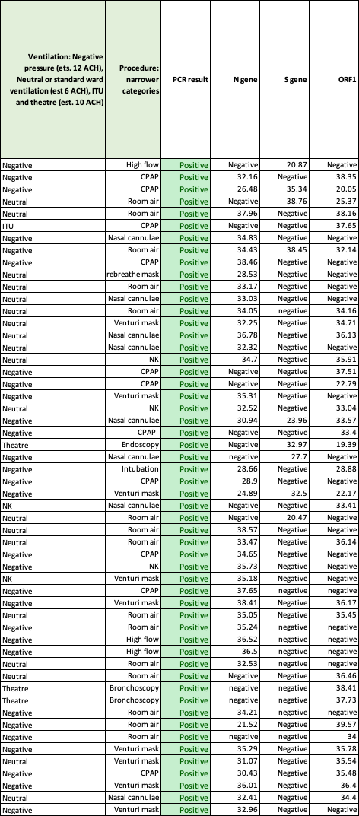
NK Not known CPAP Continuous positive airway pressure

