Supplemental Figure 2. COVID-19 ARDS Right-to-Left Shunt Positivity Rate

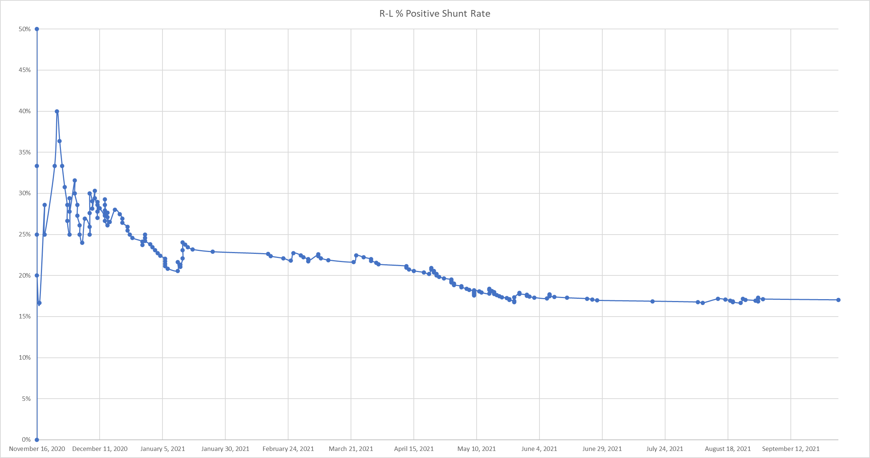

ARDS: acute respiratory distress syndrome; COVID-19: coronavirus disease-2019; R-L: right-to-left-shunt