Supplementary Material
van Kessel, R., Kyriopoulos, I., Wong, B.L.H., Mossialos, E. Has the pandemic enhanced and sustained digital health seeking behaviour? An interrupted time-series analysis of Google Trends data.

eFigure 1. Interrupted time-series regression analysis for the relative search volumes of online doctor, online health, telehealth, telemedicine, and health app in the time period February 2017 to August 2019. The first interruption occurs at 8 March 2018 and the second at 16 December 2018.
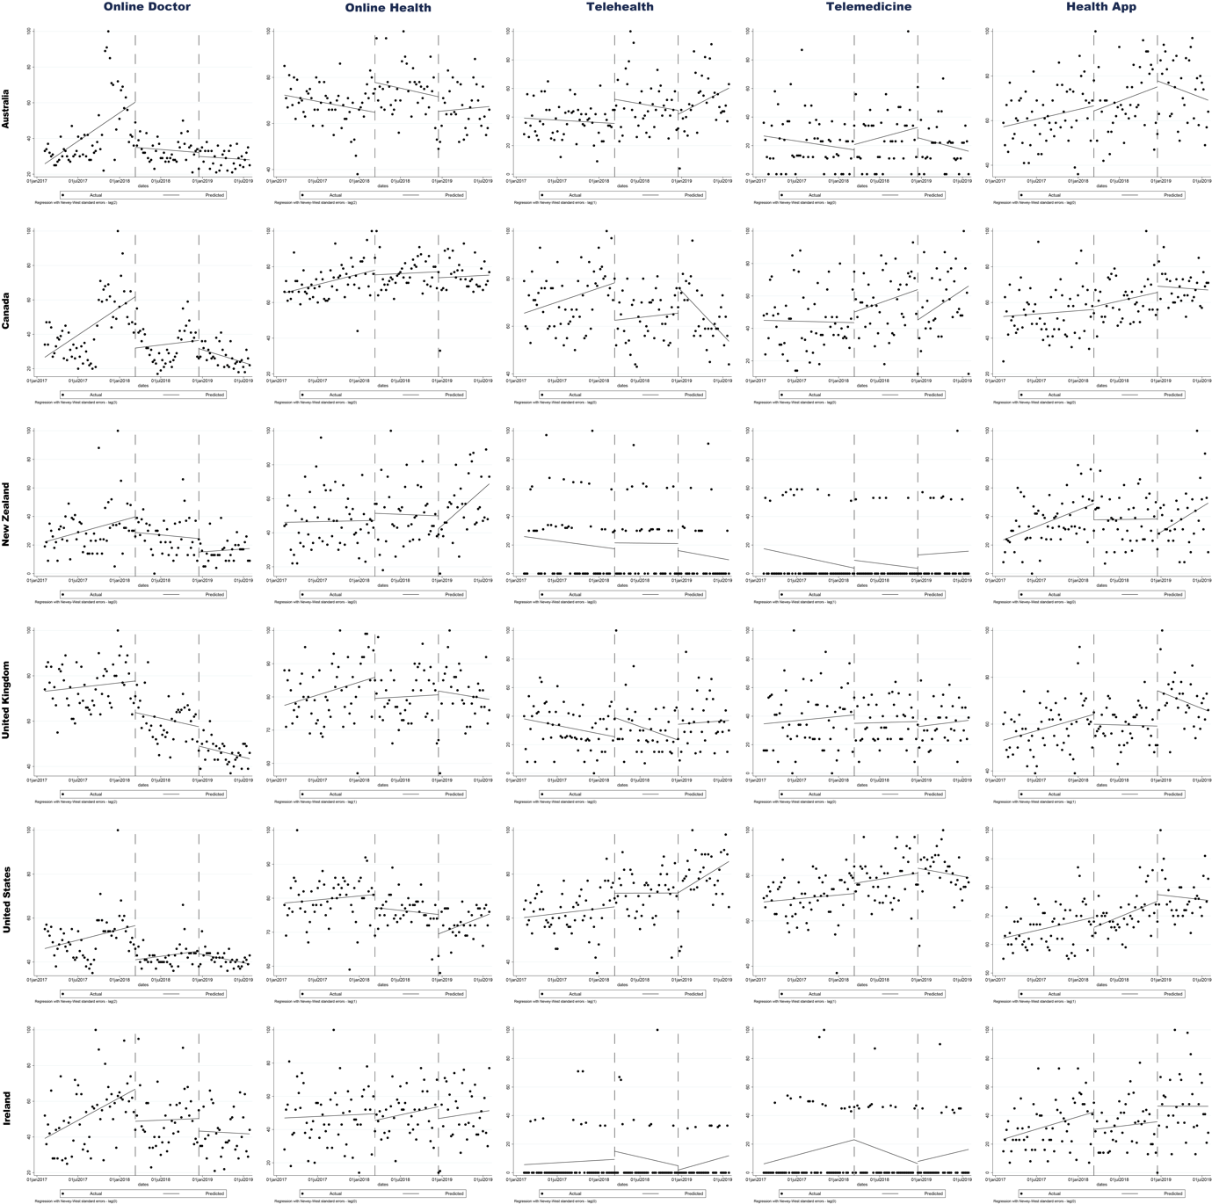

eTable 1.
 |  | Online Doctor |  |  | Online Health |  |  | Telehealth |  |  | Telemedicine |  |  | Health App
 |  | Coefficient | 95% CI | p-value | Coefficient | 95% CI | p-value | Coefficient | 95% CI | p-value | Coefficient | 95% CI | p-value | Coefficient | 95% CI | p-value
Australia | Intercept | 25.80 | 20.05 - 31.55 | < 0,001 | 72.32 | 68.39 - 76.26 | < 0.001 | 39.25 | 32.72 - 45.78 | < 0.001 | 26.75 | 16.99 - 36.51 | < 0.001 | 57.23 | 51.51 - 62.94 | < 0.001
 | Pre-event trend - March | 0,09 | 0,04 - 0,13 | < 0,001 | -0.02 | -0.05 - 0.01 | 0.21 | -0.01 | -0.03 - 0.02 | 0.46 | -0.02 | -0.06 - 0.01 | 0.18 | 0.02 | -0.004 - 0.05 | 0.09
 | Immediate shock - March | -25.36 | -40.89 - -9.83 | < 0,001 | 12.99 | 2.19 - 23.80 | 0.02 | 16.94 | 1.82 - 32.06 | 0.03 | 3.66 | -10.19 - 17.53 | 0.60 | -2.28 | -14.91 - 10.35 | 0.72
 | Post-event trend - March | -0.01 | -0.04 - 0.02 | 0.50 | -0.02 | -0.06 - 0.02 | 0.30 | -0.03 | -0.10 - 0.04 | 0.43 | 0.04 | -0.04 - 0.13 | 0.33 | 0.04 | -0.03 - 0.11 | 0.26
 | Immediate shock - December | -2.16 | -8.15 - 3.84 | 0.48 | -6.36 | -15.76 - 3.04 | 0.18 | -2.74 | -18.29 - 12.81 | 0.73 | -7.19 | -27.41 - 13.02 | 0.48 | 2.70 | -11.34 - 16.74 | 0.70
 | Post-event trend - December | -0.01 | -0.03 - 0.01 | 0.42 | 0.01 | -0.06 - 0.07 | 0.78 | 0.08 | -0.02 - 0.18 | 0.11 | -0.04 | -0.13 - 0.05 | 0.36 | -0.04 | -0.11 - 0.03 | 0.28
Canada | Intercept | 26.66 | 17.27 - 36.05 | < 0,001 | 65.39 | 61.24 - 69.54 | < 0.001 | 65.49 | 59.82 - 71.16 | < 0.001 | 45.01 | 35.83 - 54.19 | < 0.001 | 52.14 | 45.39 - 58.89 | < 0.001
 | Pre-event trend - March | 0.09 | 0.04 - 0.13 | < 0,001 | 0.03 | 0.01 - 0.06 | < 0.01 | 0.03 | 0.01 - 0.06 | 0.02 | -0.004 | -0.04 - 0.03 | 0.84 | 0.01 | -0.02 - 0.04 | 0.54
 | Immediate shock - March | -29.84 | -47.53 - -12.15 | < 0,01 | -2.67 | -11.89 - 6.56 | 0.57 | -15.72 | -24.95 - -6.49 | < 0.01 | 6.54 | -5.67 - 18.76 | 0.29 | 1.54 | -8.74 - 11.82 | 0.77
 | Post-event trend - March | 0.02 | -0,05 - 0.08 | 0.65 | 0.01 | -0.03 - 0.05 | 0.76 | 0.01 | -0.03 - 0.05 | 0.59 | 0.05 | -0.01 - 0.11 | 0.10 | 0.03 | -0.02 - 0.08 | 0.23
 | Immediate shock - December | -4.78 | -15.80 - 6.24 | 0.39 | -3.39 | -15.43 - 8.65 | 0.58 | 10.82 | 2.62 - 19.01 | 0.01 | -18.67 | -36.89 - -0.45 | 0.05 | 3.48 | -7.55 - 14.51 | 0.53
 | Post-event trend - December | -0.04 | -0.06 - -0.02 | < 0,001 | 0.01 | -0.06 - 0.08 | 0.85 | -0.10 | -0.14 - -0.06 | < 0.001 | 0.09 | -0.04 - 0.22 | 0.16 | -0.01 | -0.06 - 0.04 | 0.72
New Zealand | Intercept | 22.21 | 16.59 - 27.84 | < 0,001 | 46.13 | 38.11 - 54.16 | < 0.001 | 25.93 | 12.29 - 39.56 | < 0.001 | 17.43 | 7.29 - 27.58 | < 0.01 | 23.62 | 16.03 - 31.20 | < 0.001
 | Pre-event trend - March | 0.04 | 0.01 - 0.08 | 0.01 | 0.003 | -0.03 - 0.03 | 0.86 | -0.02 | -0.08 - 0.04 | 0.48 | -0.03 | -0.08 - 0.01 | 0.10 | 0.06 | 0.03 - 0.10 | < 0.001
 | Immediate shock - March | -10.91 | -22.85 - 1.03 | 0.07 | 4.20 | -9.45 - 17.86 | 0.54 | 4.12 | -16.79 - 25.04 | 0.70 | 5.51 | -8.21 - 19.22 | 0.43 | -11.31 | -24.13 - 1.52 | 0.08
 | Post-event trend - March | -0.02 | -0.06 - 0.03 | 0.53 | -0.01 | -0.07 - 0.06 | 0.87 | -0.002 | -0.09 - 0.09 | 0.97 | -0.02 | -0.08 - 0.04 | 0.51 | 0.002 | -0.06 - 0.06 | 0.94
 | Immediate shock - December | -9.43 | -20.46 - 1.59 | 0.09 | -7.58 | -19.90 - 4.73 | 0.23 | -4.91 | -24.38 - 14.57 | 0.62 | 9.32 | -7.22 - 25.86 | 0.27 | -10.68 | -23.79 - 2.43 | 0.11
 | Post-event trend - December | 0.01 | -0.03 - 0.05 | 0.59 | 0.12 | 0.04 - 0.19 | < 0.01 | -0.03 | -0.12 - 0.06 | 0.52 | 0.01 | -0.10 - 0.13 | 0.84 | 0.10 | -0.01 - 0.20 | 0.06
United Kingdom | Intercept | 73.17 | 66.92 - 79.42 | < 0,001 | 77.46 | 73.25 - 81.67 | < 0.001 | 38.10 | 29.24 - 46.96 | < 0.001 | 34.63 | 23.96 - 45.31 | < 0.001 | 53.13 | 48.06 - 58.19 | < 0.001
 | Pre-event trend - March | 0.01 | -0.02 - 0.04 | 0.45 | 0.02 | -0.002 - 0.04 | 0.07 | -0.03 | -0.07 - 0.01 | 0.10 | 0.02 | -0.03 - 0.06 | 0.51 | 0.03 | -0.001 - 0.06 | 0.06
 | Immediate shock - March | -13.92 | -23.94 - -3.91 | < 0,01 | -6.37 | -13.78 - 1.03 | 0.09 | 13.44 | -3.35 - 30.24 | 0.12 | -5.91 | -20.45 - 8.64 | 0.42 | -4.23 | -13.34 - 4.88 | 0.36
 | Post-event trend - March | -0.02 | -0.06 - 0.01 | 0.19 | 0.004 | -0.03 - 0.03 | 0.80 | -0.06 | -0.14 - 0.03 | 0.18 | 0.01 | -0.06 - 0.07 | 0.88 | -0.003 | -0.03 - 0.03 | 0.86
 | Immediate shock - December | -8.54 | -14.31 - -2.77 | < 0,01 | 1.14 | -9.88 - 12.16 | 0.84 | 11.02 | -5.87 - 27.92 | 0.20 | -3.60 | -17.65 - 10.45 | 0.61 | 15.11 | 3.14 - 27.07 | 0.01
 | Post-event trend - December | -0.02 | -0.05 - 0.002 | 0.07 | -0.01 | -0.08 - 0.05 | 0.73 | 0.01 | -0.08 - 0.10 | 0.79 | 0.02 | -0.05 - 0.09 | 0.59 | -0.04 | -0.11 - 0.03 | 0.28
United States | Intercept | 46.13 | 40.72 - 51.54 | < 0,001 | 78.58 | 74.39 - 82.76 | < 0.001 | 60.27 | 55.14 - 65.39 | < 0.001 | 68.36 | 63.63 - 73.09 | < 0.001 | 62.24 | 59.27 - 65.20 | < 0.001
 | Pre-event trend - March | 0.03 | -0.002 - 0.05 | 0.07 | 0.01 | -0.01 - 0.02 | 0.50 | 0.01 | -0.02 - 0.04 | 0.42 | 0.01 | -0.02 - 0.03 | 0.47 | 0.02 | 0.0002 - 0.04 | 0.05
 | Immediate shock - March | -15.57 | -23.72 - -7.42 | < 0,001 | -3.84 | -8.94 - 1.26 | 0.14 | 6.22 | -4.14 - 16.59 | 0.24 | 4.49 | -4.20 - 13.18 | 0.31 | -3.53 | -9.48 - 2.41 | 0.24
 | Post-event trend - March | 0.01 | -0.01 - 0.04 | 0.22 | -0.01 | -0.03 - 0.01 | 0.49 | 0.0003 | -0.04 - 0.05 | 0.99 | 0.02 | -0.02 - 0.05 | 0.38 | 0.03 | 0.01 - 0.05 | < 0.01
 | Immediate shock - December | -1.23 | -6.68 - 4.22 | 0.66 | -5.72 | -11.49 - 0.05 | 0.05 | 0.10 | -14.31 - 14.50 | 0.99 | 2.16 | -8.79 - 13.10 | 0.70 | 2.36 | -6.46 - 11.19 | 0.60
 | Post-event trend - December | -0.02 | -0.04 - -0.002 | 0.03 | 0.03 | -0.01 - 0.06 | 0.10 | 0.06 | -0.02 - 0.15 | 0.14 | -0.02 | -0.08 - 0.04 | 0.55 | -0.01 | -0.06 - 0.05 | 0.75
Ireland | Intercept | 39.22 | 31.73 - 46.72 | < 0,001 | 46.97 | 37.63 - 56.31 | < 0.001 | 5.64 | -1.36 - 12.63 | 0.11 | 6.19 | -3.00 - 15.38 | 0.19 | 23.47 | 16.46 - 30.49 | < 0.001
 | Pre-event trend - March | 0.07 | 0.04 - 0.10 | < 0,001 | 0.01 | -0.03 - 0.05 | 0.76 | 0.01 | -0.02 - 0.04 | 0.58 | 0.04 | -0.01 - 0.09 | 0.08 | 0.05 | 0.01 - 0.08 | 0.01
 | Immediate shock - March | -18.01 | -31.32 - -4.69 | < 0,01 | -4.03 | -15.46 - 7.40 | 0.49 | 5.69 | -11.82 - 23.19 | 0.52 | -0.07 | -20.92 - 20.78 | 0.99 | -12.19 | -24.87 - 0.49 | 0.06
 | Post-event trend - March | 0.01 | -0.06 - 0.07 | 0.87 | 0.03 | -0.02 - 0.08 | 0.22 | 0.04 | -0.13 - 0.05 | 0.42 | -0.06 | -0.15 - 0.03 | 0.20 | 0.02 | -0.04 - 0.08 | 0.51
 | Immediate shock - December | -7.00 | -19.79 - 5.78 | 0.28 | -7.16 | -23.78 - 9.46 | 0.40 | -3.01 | -18.29 - 12.27 | 0.70 | 1.50 | -17.08 - 20.07 | 0.87 | 10.93 | -8.09 - 29.95 | 0.26
 | Post-event trend - December | -0.01 | -0.07 - 0.06 | 0.83 | 0.02 | -0.08 - 0.12 | 0.68 | 0.04 | -0.02 - 0.11 | 0.17 | 0.04 | -0.06 - 0.13 | 0.42 | -0.001 | -0.11 - 0.11 | 0.99

