**Induction of poxviral immunity by synthetic MVA-based dual-antigen COVID-19 vaccine COH04S1**

**Supplementary Material**

Table S1. Volunteers characteristics

| Characteristic | COH04S1,  N = 20 | DL1,  N = 10 | DL2,  N = 5 | DL3,  N = 5 | placebo,  N = 4 |
| --- | --- | --- | --- | --- | --- |
| Age1 | 36 (22, 54) | 39 (22, 50) | 40 (28, 54) | 32 (26, 41) | 31 (24, 41) |
| Gender |  |  |  |  |  |
| Female2 | 12 (60%) | 6 (60%) | 3 (60%) | 3 (60%) | 2 (50%) |
| Male2 | 8 (40%) | 4 (40%) | 2 (40%) | 2 (40%) | 2 (50%) |
| 1Median (Range); 2n (%). DL= dose level | | | | | | |



**Figure S1. Related to Figure 1. MVA-specific binding IgG in COH04S1 vaccinees.** MVA-specificbinding IgG were measured by ELISA in subjects before vaccination, post-prime vaccination, and at one and five months post-booster vaccination with COH04S1 at dose-level (DL) 1 (DL1/DL1 and DL1/placebo/DL1), DL2 (DL2/DL2), and DL3 (DL3/DL3). Subjects who received placebo vaccination were used as negative controls. Shown are the absorbance readings (OD) at 450 nm using serial dilutions of the serum.



**Figure S2. Related to Figure 2. MVA-specific NAb titers in COH04S1 vaccinees.** MVA-specific NAb were measured using a high-thruput neutralization assay in serum samples of subjects before vaccination, post-prime vaccination, and at one and five months post-booster vaccinations with COH04S1 at dose-level (DL) 1 (DL1/DL1 and DL1/placebo/DL1), DL2 (DL2/DL2), and DL3 (DL3/DL3). Subjects who received placebo vaccination were used as negative controls. Shown are percentages of neutralization using serial dilutions of serum. Dotted lines mark the 50% neutralization used to derive NT50 titers.

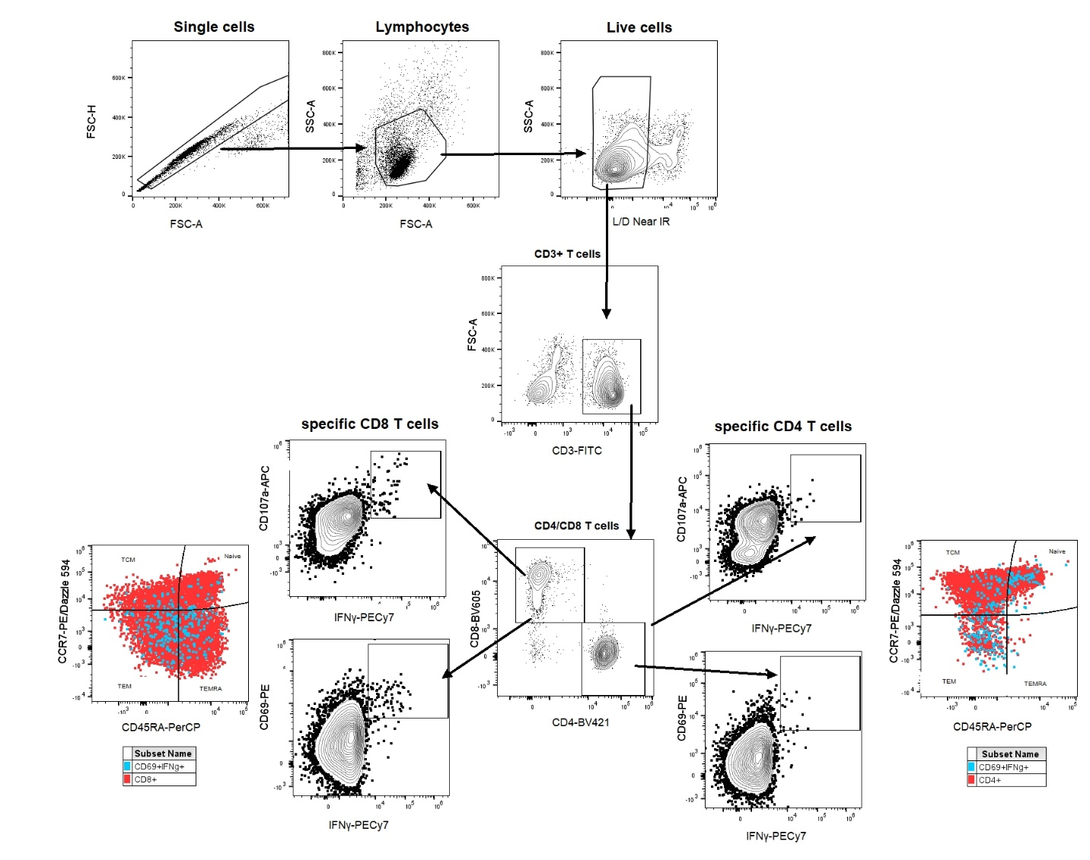

**Figure S3. Related to Figure 3. MVA-specific T cell response in COH04S1 vaccinees.** Gating strategy. Shown is the gating strategy used to identify MVA-specific T cells. Gating was performed on single cells>lymphocytes>live cells>CD3+ cells> CD8+ or CD4+ cells> CD107a+/IFNγ+ or CD69+/IFNγ+ cells. CD69+/IFNγ+ double positive cells were used to identify CD8+ and CD4+ T cell memory subsets. Naïve cells were identified as CCR7+/CD45RA+; central memory (TCM) cells were identified as CCR7+/CD45RA-; effector memory (TEM) cells were identified as CCR7-/CD45RA-; and terminally differentiated effector memory (TEMRA) cells were identified as CCR7-/CD45RA+.



**Figure S4. Related to Figure 3. MVA-specific T cell response in COH04S1 vaccinees.** Example of T cell analysis.Shown is an example of gating of double positive CD107a+/CD69+ and IFNγ+ CD8+ (A) or CD4+ (B) T cells measured in unstimulated or MVA-stimulated PBMC samples ofa volunteer (DL1) before and after vaccination with COH04S1.



**Figure S5. Related to Figure 3. MVA-specific T cell response in COH04S1 vaccinees.** Shown are activated MVA-specific T cells after vaccination with COH04S1.Percentages of MVA-specific IFNγ+/CD69+ CD8+ (A) and CD4+ (B) T cells, and MVA-specific IFNγ+/CD107+ CD8+ (C) and CD4+ (D) T cells were measured in PBMC samples by cytofluorimetry at baseline, and one and five months post-booster vaccinations with COH04S1 at dose-level (DL) 1 (DL1/DL1 and DL1/placebo/DL1), DL2 (DL2/DL2), and DL3 (DL3/DL3). Subjects who received placebo vaccination were used as negative controls. Only one DL3 volunteer had available PBMC samples for the analysis.



**Figure S6. Related to Figure 3. MVA-specific T cell response in COH04S1 vaccinees.** Shown are activated T cell memory subtypes after vaccination with COH04S1. **A-B.** Phenotypic analysis of antigen-specific T lymphocytes was performed using samples collected one month after the second dose of COH04S1 at dose-level (DL) 1 (DL1/DL1 and DL1/placebo/DL1), DL2 (DL2/DL2), and DL3 (DL3/DL3). Shown are percentages of naïve, central memory (TCM), effector memory (TEM), and terminally differentiated effector memory (TEMRA) T cells measured in IFNγ+/CD69+ CD8+ (A) and CD4+ (B) T cell populations. Median values are indicated with lines. **C-D.** Percentages of activated CD8+ (C) and CD4+ (D) T cell memory subtypes in subjects vaccinated with COH04S1 at baseline, and one and five months post-second dose. Bars represent mean values-SD.