Table S2. Sources of summary statistics of breast cancer risk and breast cancer risk factors for calculating genetic correlation

Trait | Source | URL
Dense area | Chen et al. [1] | https://bcac.ccge.medschl.cam.ac.uk/bcacdata/oncoarray/oncoarray-and-combined-summary-result/gwas-summary-results-mammographic-density-2021/
Nondense area | Chen et al. [1] | https://bcac.ccge.medschl.cam.ac.uk/bcacdata/oncoarray/oncoarray-and-combined-summary-result/gwas-summary-results-mammographic-density-2021/
Percent density | Chen et al. [1] | https://bcac.ccge.medschl.cam.ac.uk/bcacdata/oncoarray/oncoarray-and-combined-summary-result/gwas-summary-results-mammographic-density-2021/
Overall breast cancer | Michailidou et al. [2] | http://bcac.ccge.medschl.cam.ac.uk/bcacdata/oncoarray/oncoarray-and-combined-summary-result/gwas-summary-results-breast-cancer-risk-2017/
ER+ breast cancer | Michailidou et al. [2] | http://bcac.ccge.medschl.cam.ac.uk/bcacdata/oncoarray/oncoarray-and-combined-summary-result/gwas-summary-results-breast-cancer-risk-2017/
ER− breast cancer | Michailidou et al. [2] | http://bcac.ccge.medschl.cam.ac.uk/bcacdata/oncoarray/oncoarray-and-combined-summary-result/gwas-summary-results-breast-cancer-risk-2017/
Adult body mass index | Pulit et al. [3] | https://zenodo.org/record/1251813#.YPCd1xNKiSg
Childhood body fatness | Warner et al. [4] | Not publicly available
Age at menarche | Day et al. [5] | https://www.reprogen.org/data_download.html
Age at natural menopause | Day et al. [6] | https://www.reprogen.org/data_download.html

Table S3. Sources of summary statistics of breast cancer risk and breast cancer risk factors for the SNP-set test

Trait | Source | Number of SNPs included
Dense area | Sieh et al. [7] and Chen et al. [1] | 31
Nondense area | Sieh et al. [7] and Chen et al. [1] | 16
Percent density | Sieh et al. [7] and Chen et al. [1] | 23
Overall breast cancer | Michailidou et al. [2] and Zhang et al. [8] | 178
ER+ breast cancer | Michailidou et al. [2] and Zhang et al. [8] | 101
ER− breast cancer | Michailidou et al. [2] and Zhang et al. [8] | 27
Adult body mass index | Pulit et al. [3] | 279
Childhood body fatness | Warner et al. [4] | 18
Age at menarche | Day et al. [5] | 377
Age at natural menopause | Day et al. [6] | 54

Figure S1. Quantile-quantile plots of the GWAS meta-analysis results

a
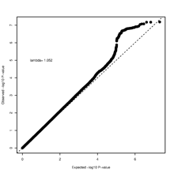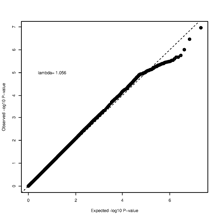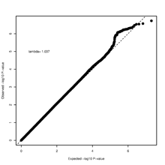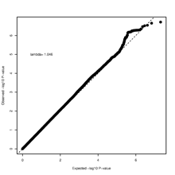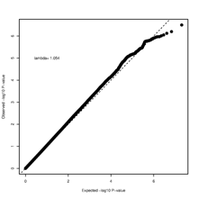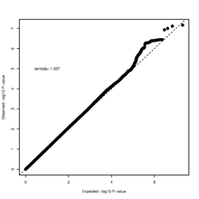

b
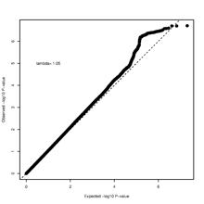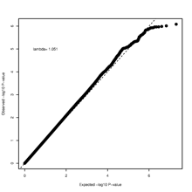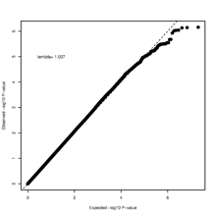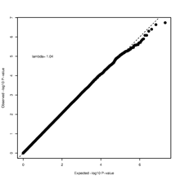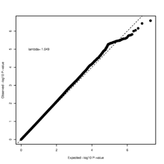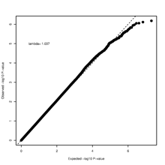

c
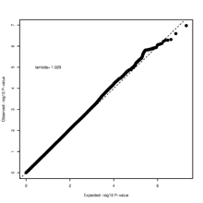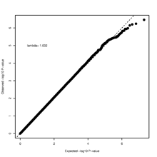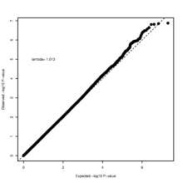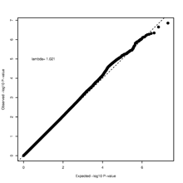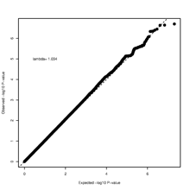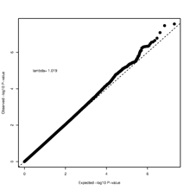

d
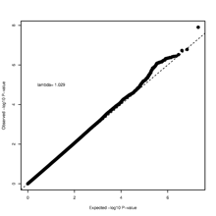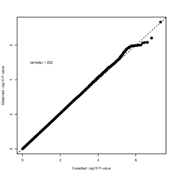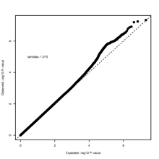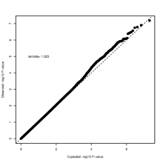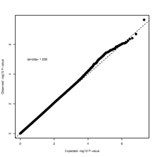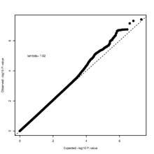

e
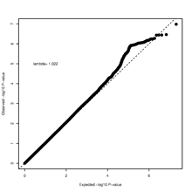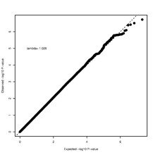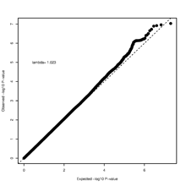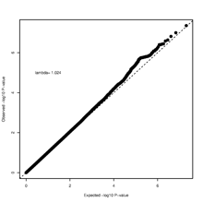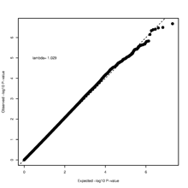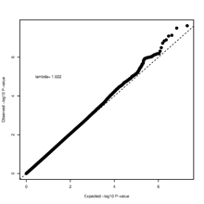

Quantile-quantile plots of the GWAS meta-analysis results. a = V65L; b = V75L; c = V65H; d = V75H; e = VSUM. On each panel, the plots corresponding to Model 0 to Model 5 from left to right.

Figure S2. Manhattan plots of the GWAS meta-analysis results

a
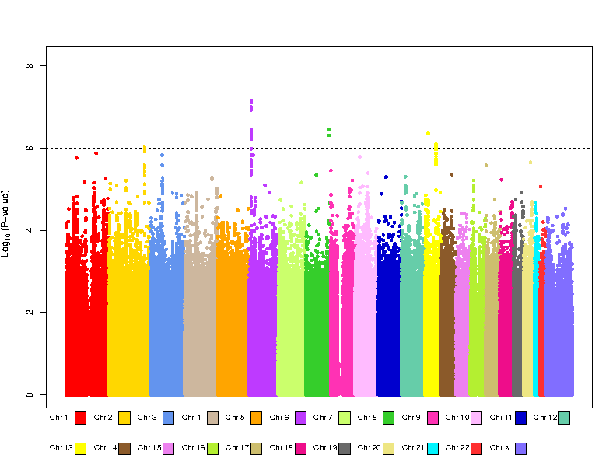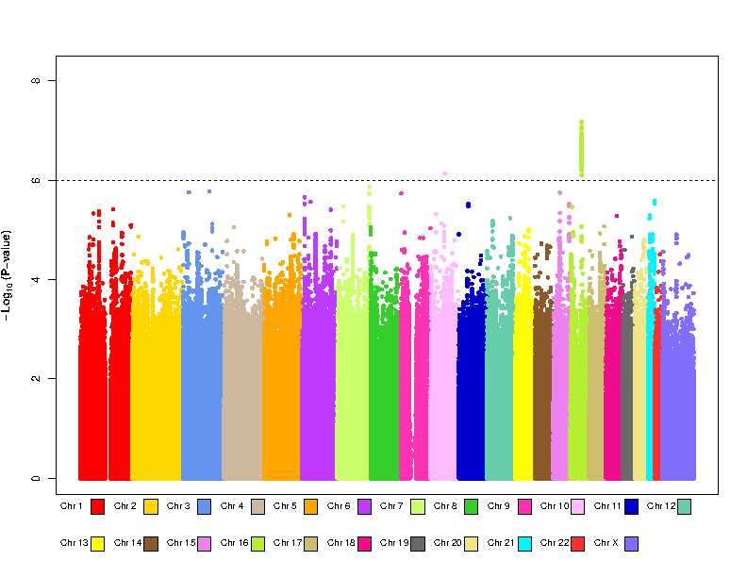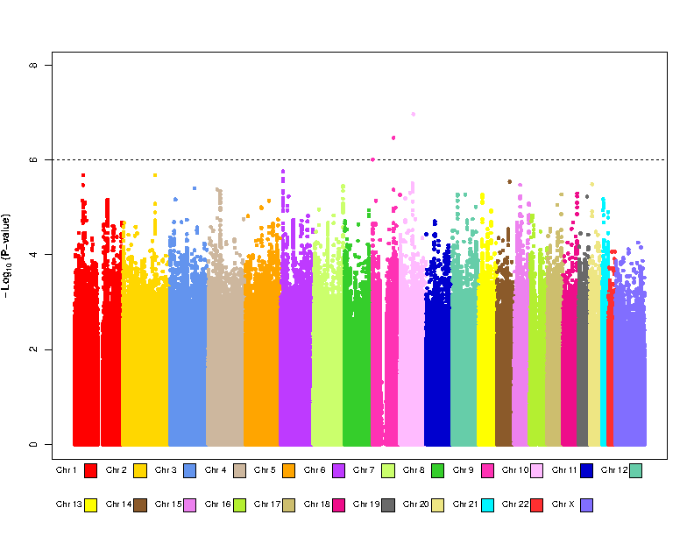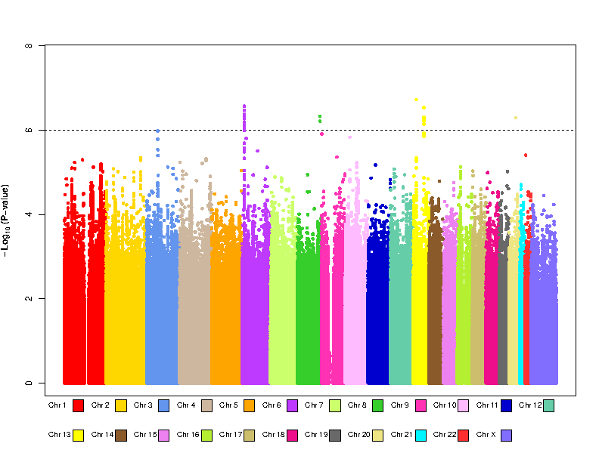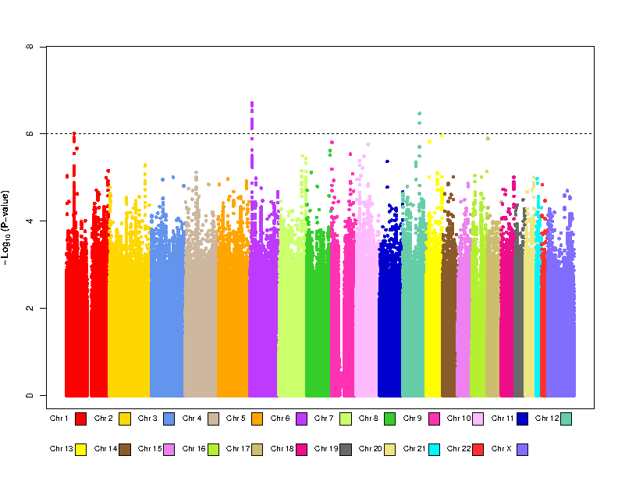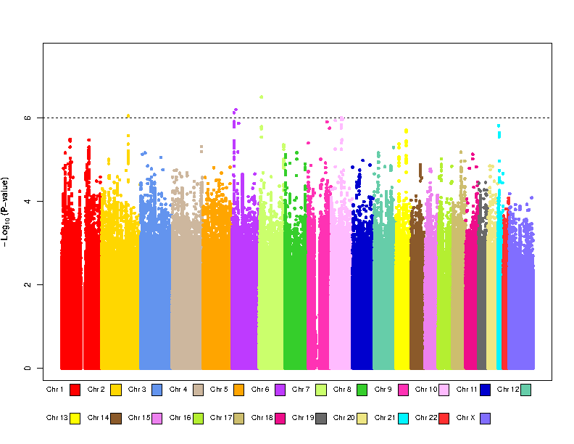

b
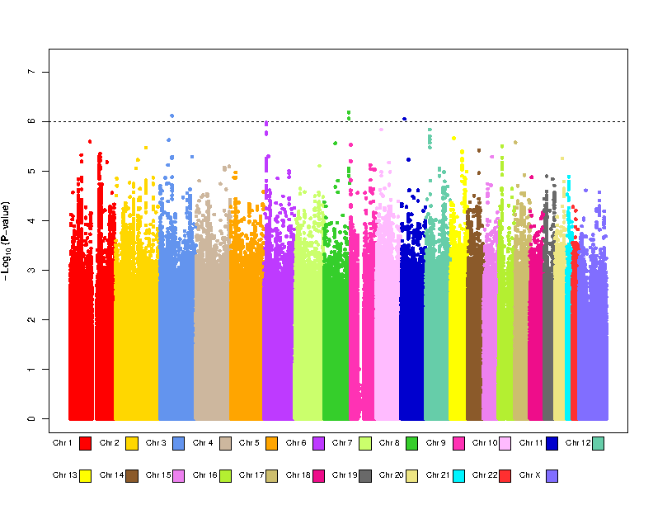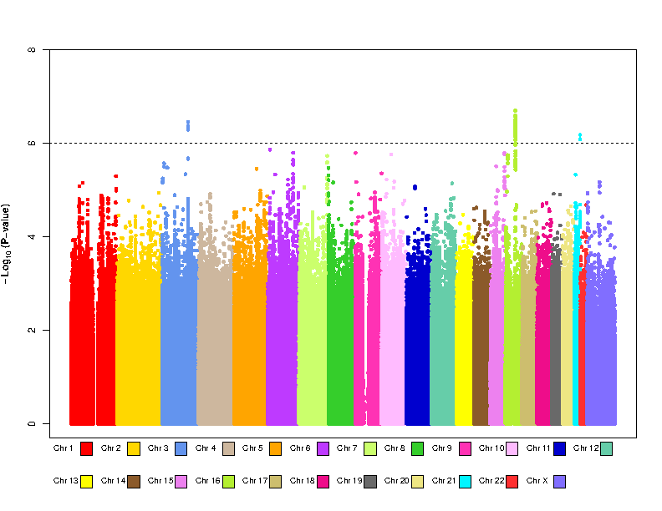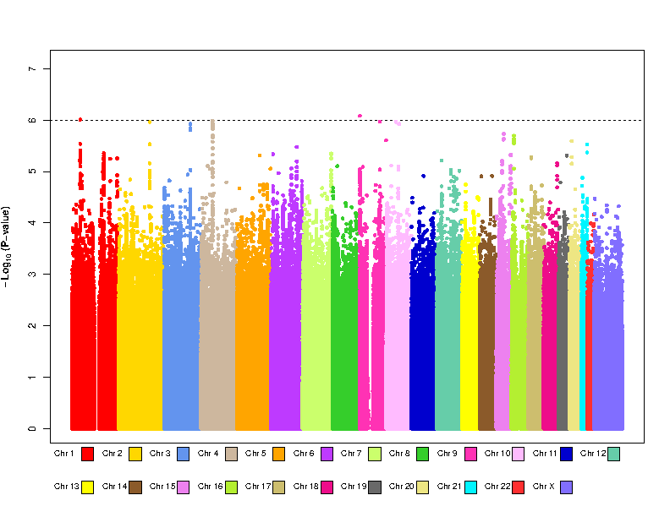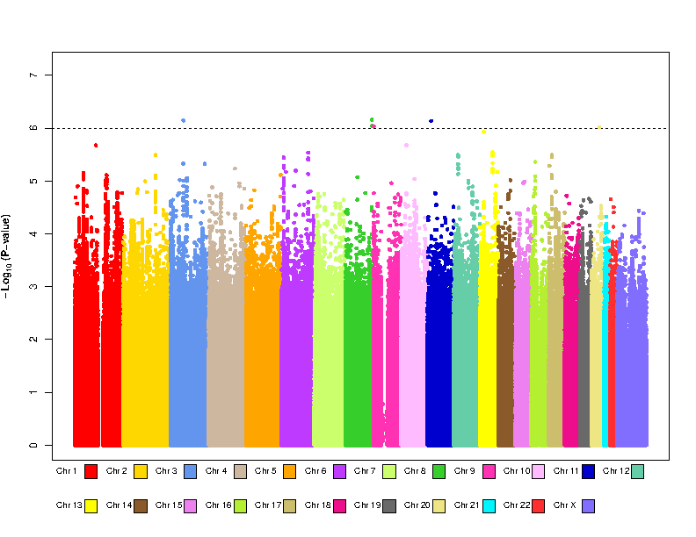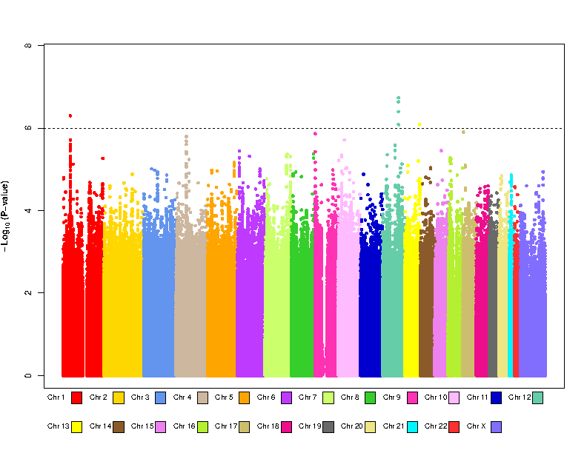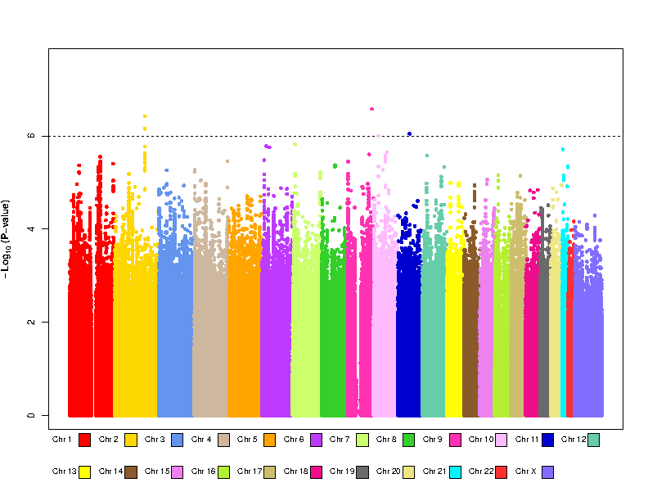

c
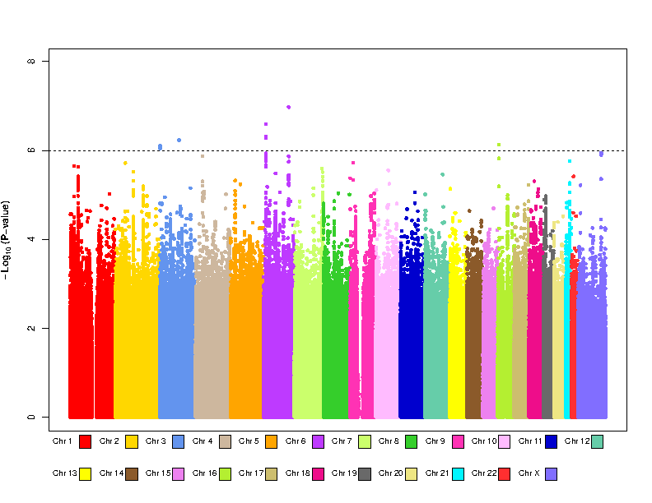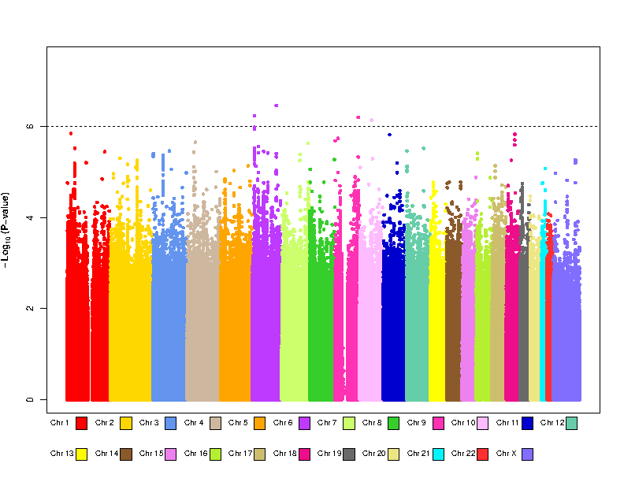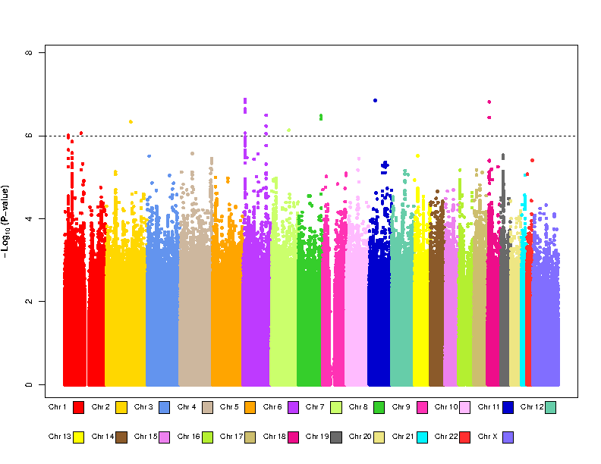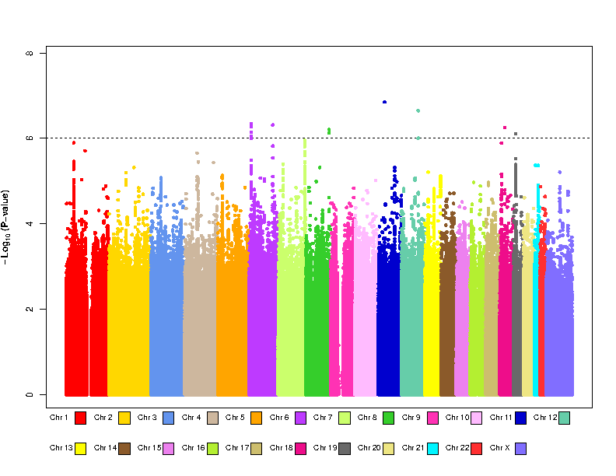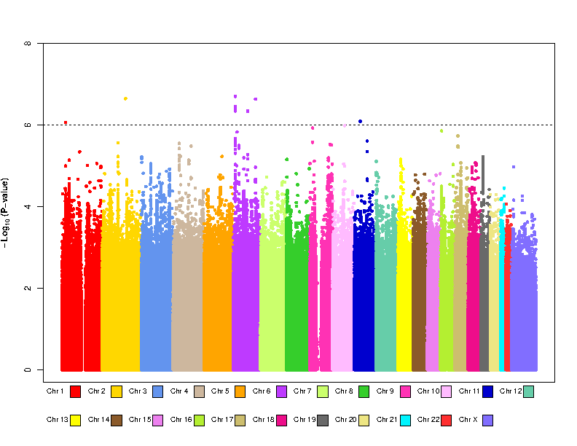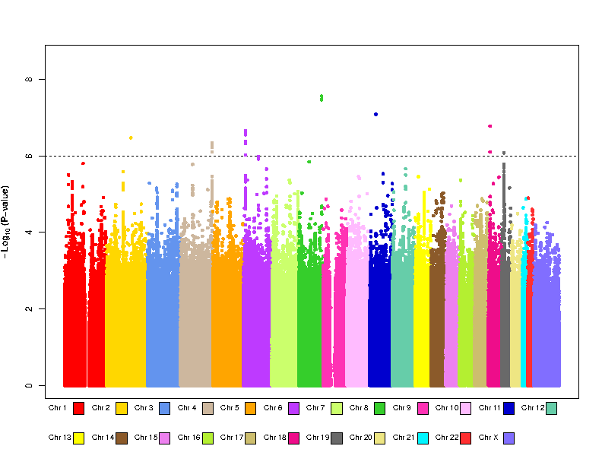

d
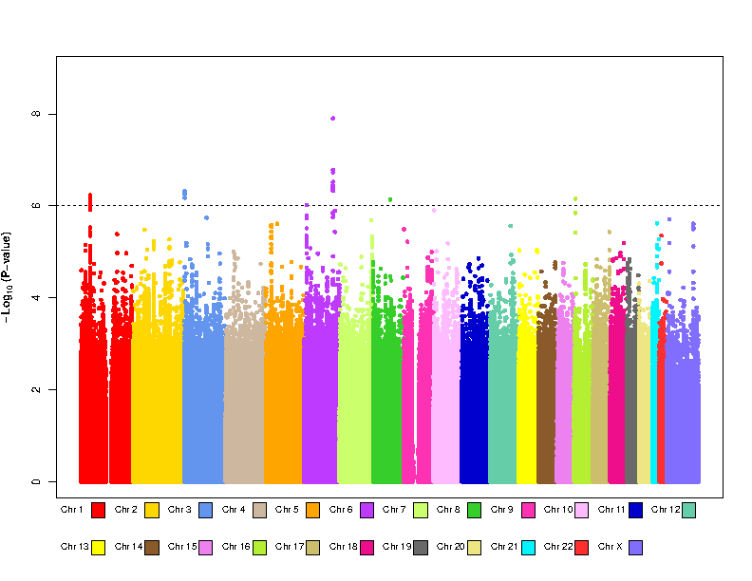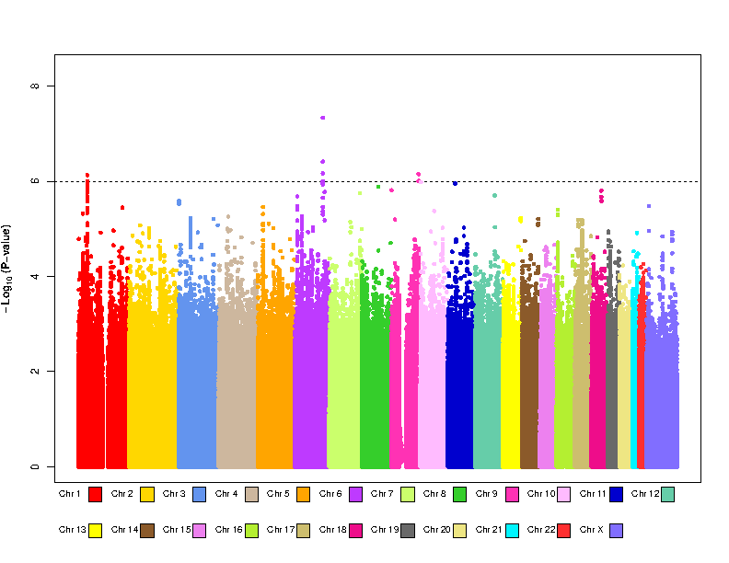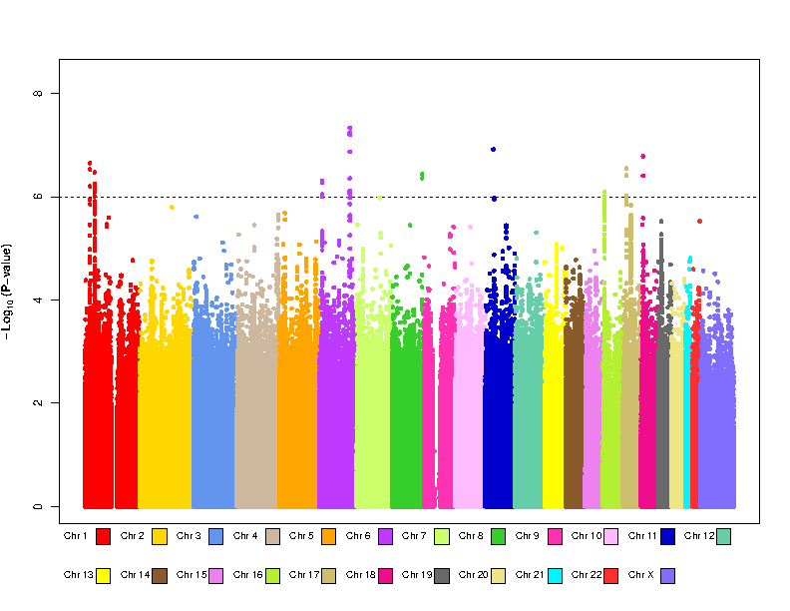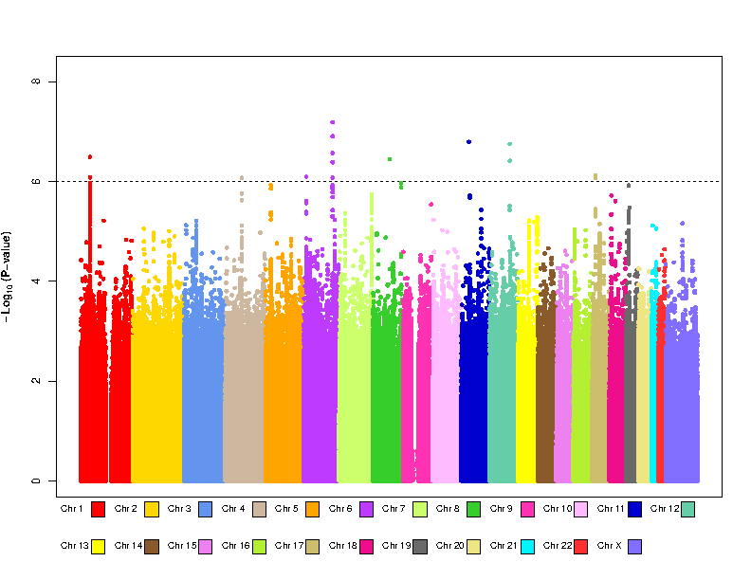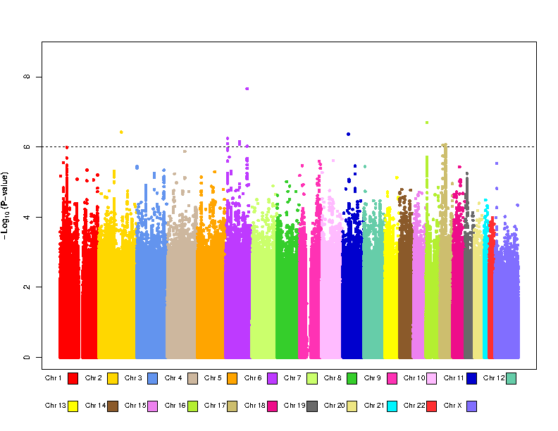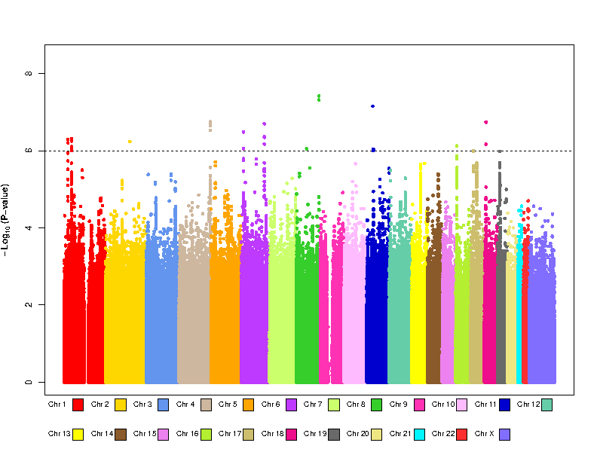

e

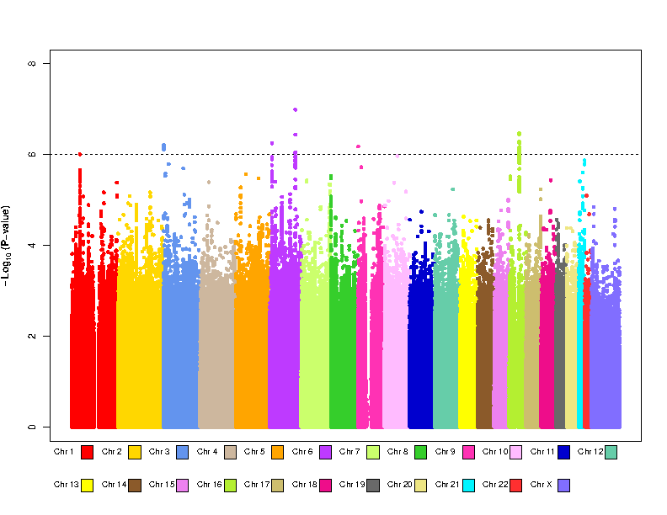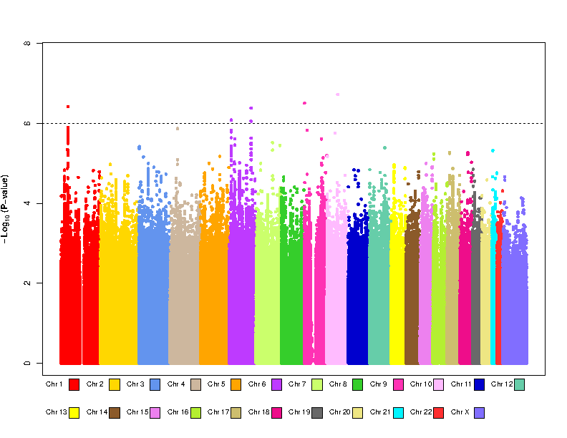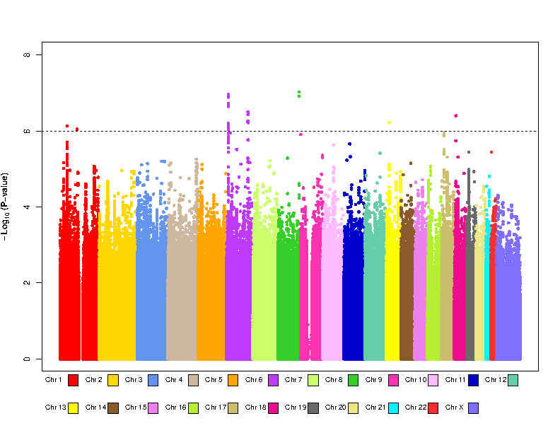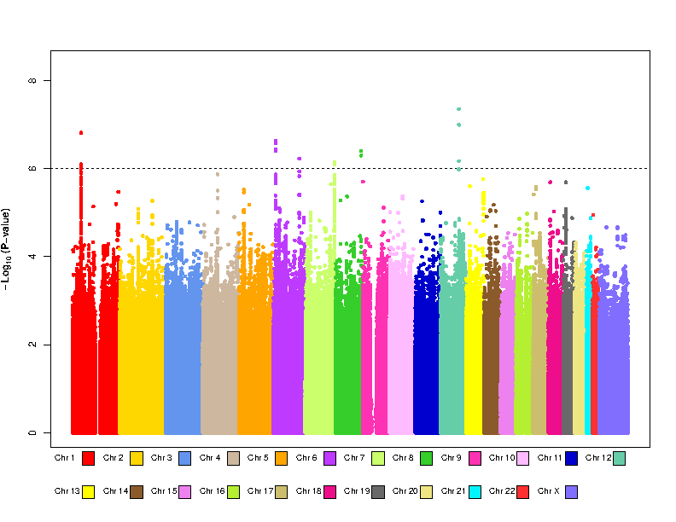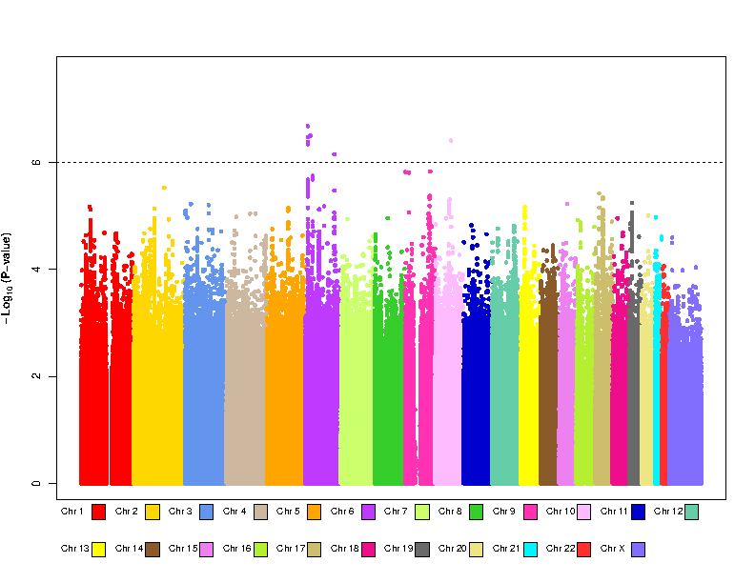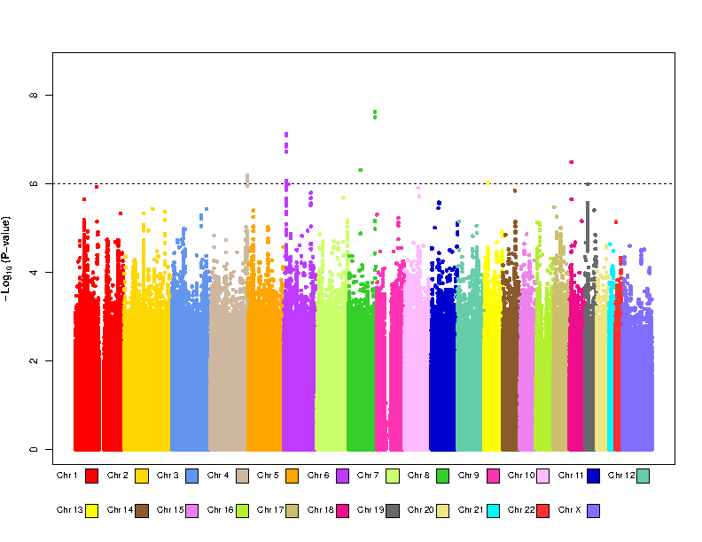

Manhattan plots of the GWAS meta-analysis results. a = V65L; b = V75L; c = V65H; d = V75H; e = VSUM. On each panel, the plots corresponding to Model 0 to Model 5 from left to right.

Figure S3. Quantile-quantile plots of the P value of heterogeneity

a
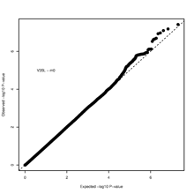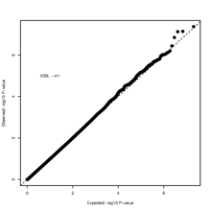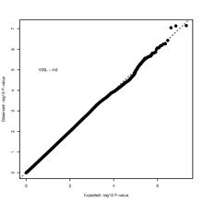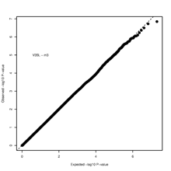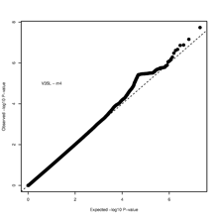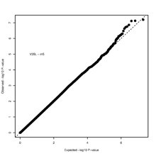

b
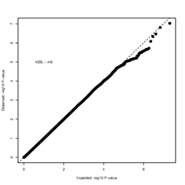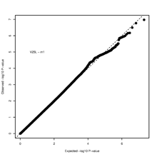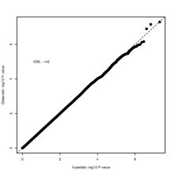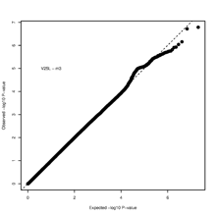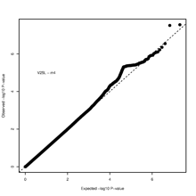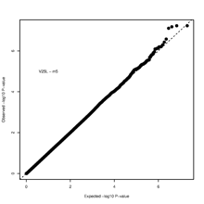

c
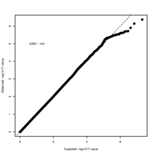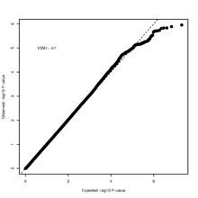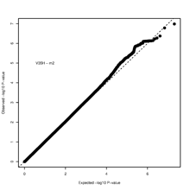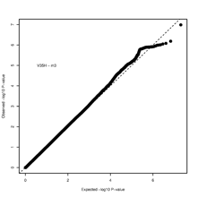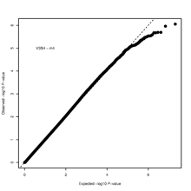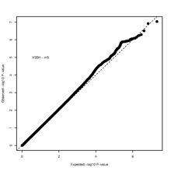

d
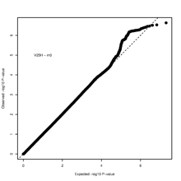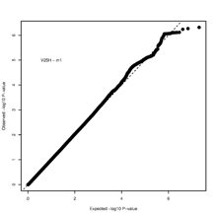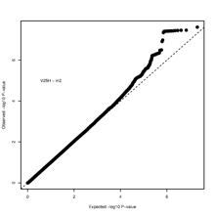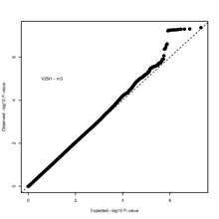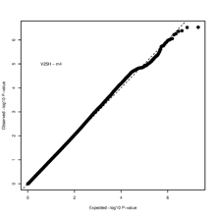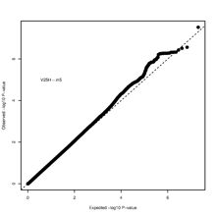

Quantile-quantile plots of the P value of heterogeneity. a = V65L; b = V75L; c = V65H; d = V75H. On each panel, the plots corresponding to Model 0 to Model 5 from left to right.

References

1. Chen H, Fan S, Stone J, Thompson DJ, Douglas J, Li S, Scott C, Bolla MK, Wang Q, Dennis J et al: Genome-wide and transcriptome-wide association studies of mammographic density phenotypes reveal novel loci. Breast Cancer Res 2022, 24(1):27.
2. Michailidou K, Lindstrom S, Dennis J, Beesley J, Hui S, Kar S, Lemacon A, Soucy P, Glubb D, Rostamianfar A et al: Association analysis identifies 65 new breast cancer risk loci. Nature 2017, 551(7678):92-94.
3. Pulit SL, Stoneman C, Morris AP, Wood AR, Glastonbury CA, Tyrrell J, Yengo L, Ferreira T, Marouli E, Ji Y et al: Meta-analysis of genome-wide association studies for body fat distribution in 694 649 individuals of European ancestry. Hum Mol Genet 2019, 28(1):166-174.
4. Warner ET, Rice MS, Zeleznik OA, Fowler EE, Murthy D, Vachon CM, Bertrand KA, Rosner BA, Heine J, Tamimi RM: Automated percent mammographic density, mammographic texture variation, and risk of breast cancer: a nested case-control study. NPJ Breast Cancer 2021, 7(1):68.
5. Day FR, Thompson DJ, Helgason H, Chasman DI, Finucane H, Sulem P, Ruth KS, Whalen S, Sarkar AK, Albrecht E et al: Genomic analyses identify hundreds of variants associated with age at menarche and support a role for puberty timing in cancer risk. Nat Genet 2017, 49(6):834-841.
6. Day FR, Ruth KS, Thompson DJ, Lunetta KL, Pervjakova N, Chasman DI, Stolk L, Finucane HK, Sulem P, Bulik-Sullivan B et al: Large-scale genomic analyses link reproductive aging to hypothalamic signaling, breast cancer susceptibility and BRCA1-mediated DNA repair. Nat Genet 2015, 47(11):1294-1303.
7. Sieh W, Rothstein JH, Klein RJ, Alexeeff SE, Sakoda LC, Jorgenson E, McBride RB, Graff RE, McGuire V, Achacoso N et al: Identification of 31 loci for mammographic density phenotypes and their associations with breast cancer risk. Nat Commun 2020, 11(1):5116.
8. Zhang H, Ahearn TU, Lecarpentier J, Barnes D, Beesley J, Qi G, Jiang X, O'Mara TA, Zhao N, Bolla MK et al: Genome-wide association study identifies 32 novel breast cancer susceptibility loci from overall and subtype-specific analyses. Nat Genet 2020, 52(6):572-581.

