**Online supplementary material 5**

Figure 1. Ranking of topics in terms of prevalence in the corpus for question A, *“What was helpful about the information on the Germ Defence website?”***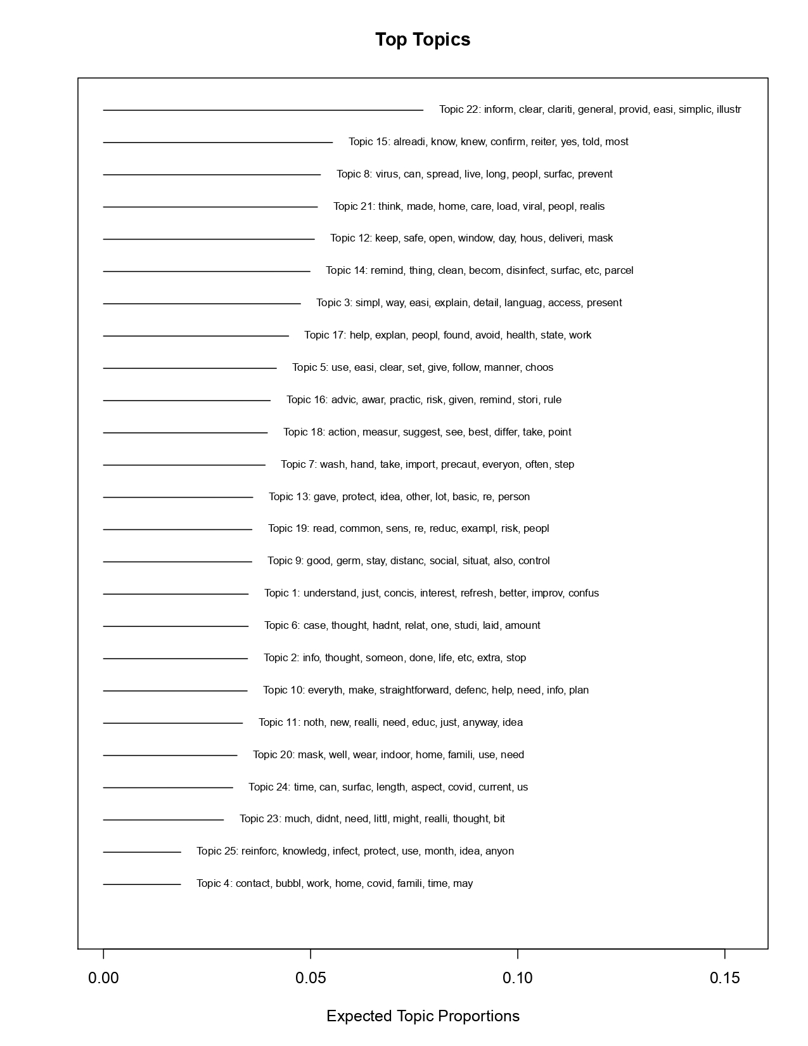**

Figure 2. Ranking of topics in terms of prevalence in the corpus for question B*, “What did you not find helpful about the information on the Germ Defence website?”*

