Supplementary Material

Sex differences in depression and sleep disturbance as inter-related risk factors of diabetes

Supplementary Figures and Tables

Supplementary Figures

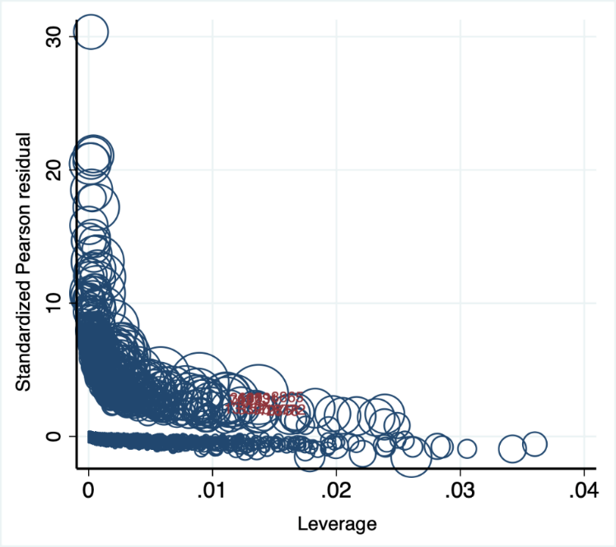
Supplementary Figure S1. Standardized Pearson residuals are plotted against Pregibon leverage, with the size of circle proportional to Pregibon delta beta. The data points with standardized Pearson residual >2 AND leverage >0.01 AND Pregibon delta beta >0.01 are marked (subject number: 1009, 2818, 3685, 7023, 8390, 8865, 13152, 17075, 18772, 19731).

Supplementary Table S1. Multivariate logistic regression in a sample that excluded 10 subjects as potential outliers (subject number: 1009, 2818, 3685, 7023, 8390, 8865, 13152, 17075, 18772, 19731)
Variable | Coefficient (SE) | Odds ratio (SE) | p-value
Sleep
≤5 | 0.44 (0.15) | 1.55 (0.25) | 0.005
6-7 | 0.36 (0.13) | 1.44 (0.19) | 0.006
7-8 | Reference
>8 | 0.44 (0.15) | 1.56 (0.24) | 0.004
Depression
Rarely/never | Reference
Monthly | 0.75 (0.29) | 2.12 (0.67) | 0.011
Often | 0.97 (0.18) | 2.65 (0.51) | <0.001
sex | -0.33 (0.13) | 0.71 (0.08) | 0.008
Depression × sex
D(rarely/never)s(W) | Reference
D(monthly)s(M) | -0.33 (0.13) | 0.71 (0.09) | 0.008
D(monthly)s(W) | 0.75 (0.29) | 2.12 (0.62) | 0.011
D(often)s(M) | -0.03 (0.27) | 0.97 (0.27) | 0.907
D(often)s(W) | 0.97 (0.18) | 2.7 (0.49) | <0.001
D(rarely/never)s(W) | 0.32 (0.18) | 1.37 (0.25) | 0.074
Age | 0.05 (0.004) | 1.05 (0.004) | <0.001
BMI | 0.08 (0.006) | 1.07 (0.007) | <0.001
PA | 0.0007 (0.0001) | 1.00 (0.0001) | <0.001
Caucasian | Reference
Asian | 0.74 (0.24) | 2.10 (0.51) | 0.002
African American | 0.58 (0.13) | 1.79 (0.24) | <0.001
Native American | 0.87 (0.32) | 2.39 (0.76) | 0.006
Income
low | Reference
Medium | -0.54 (0.13) | 0.58 (0.07) | <0.001
High | -0.95 (0.16) | 0.38 (0.06) | <0.001

Supplementary Table S2. Predictive margins of depression at different levels of sleep hours on the probability of diabetes (estimated using Model 1)
Depression × sleep | Margin (SE) | p-value
D(rarely/never)S(≤5 hours) | 0.02 (0.003) | <0.001
D(rarely/never)S(6-7 hours) | 0.02 (0.002) | <0.001
D(rarely/never)S(7-8 hours) | 0.01 (0.001) | <0.001
D(rarely/never)S(>8 hours) | 0.02 (0.002) | <0.001
D(monthly)S(≤5 hours) | 0.03 (0.006) | <0.001
D(monthly)S(6-7 hours) | 0.02 (0.004) | <0.001
D(monthly)S(7-8 hours) | 0.04 (0.007) | <0.001
D(monthly)S(>8 hours) | 0.04 (0.006) | <0.001
D(often)S(≤5 hours) | 0.04 (0.005) | <0.001
D(often)S(6-7 hours) | 0.04 (0.005) | <0.001
D(often)S(7-8 hours) | 0.03 (0.004) | <0.001
D(often)S(>8 hours) | 0.04 (0.005) | <0.001

