Appendix

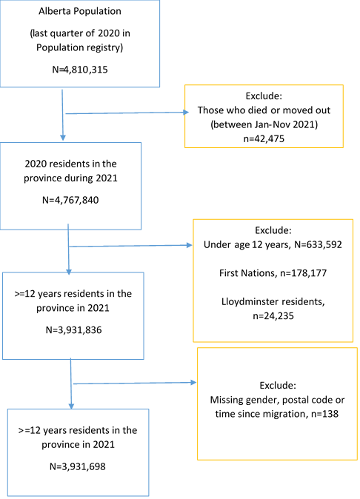

Figure A1. Flow diagram showing selection of participants.

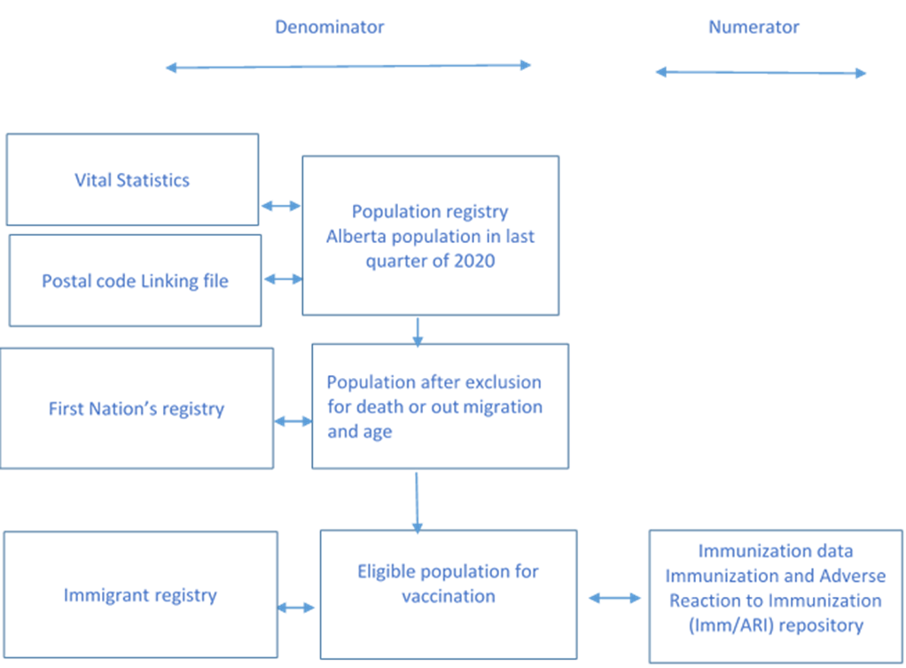

Figure A2. Linkage of different databases.

Table A1: Vaccination coverage of Albertan immigrants categorized by sub-continental region of origin
Continent | % (n)
North America | 63.19% (43,439)
Meso America | 62.42% (34,137)
South America | 75.67% (17,299)
Europe Unspecified | 72.45% (4,191)
East Europe | 60.69% (11,512)
West Europe | 64.05% (9,417)
North Europe | 71.50% (24,356)
South Europe | 70.34% (8,858)
Central Asia | 64.59% (5,370)
Middle East | 75.67% (41,263)
Africa Unspecified | 79.70% (2,308)
North Africa | 75.41% (7,825)
East Africa | 79.51% (20,122)
Central/South Africa | 76.41% (6,775)
West Africa | 82.94% (14,112)
Asia Unspecified | 86.21% (11,857)
East Asia | 85.47% (193,589)
South Asia | 83.71% (101,461)
Oceania | 64.60% (7,700)
Unknown/Missing | 80.16% (35,255)

