## S9. Sensitivity analysis : secondary analyses with staffing as a continuous variable (not tertiles). Extracts from adjusted models presented

TRUST LEVEL

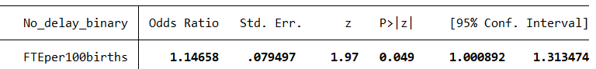

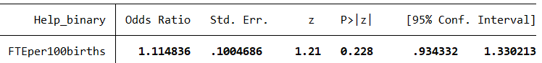

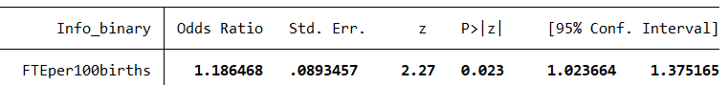

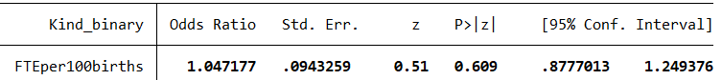

WARD LEVEL

Staff groups  
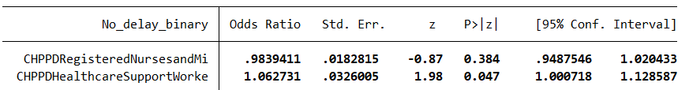

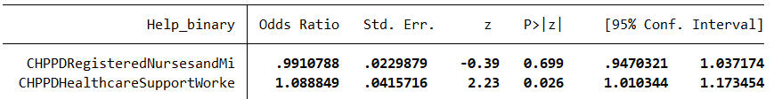

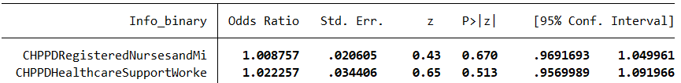

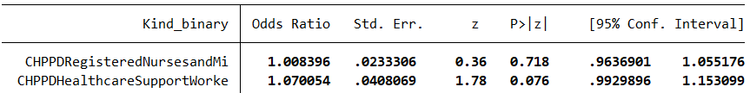

Overall staff and skill mix

