Supplemental Materials for:

Extending non-targeted exposure discovery of environmental chemical exposures during pregnancy and their association with pregnancy complications—a cross-sectional study
Jessica Trowbridge¹, Dimitri Abrahamsson¹, Ting Jiang², Miaomiao Wang², June-Soo Park², Rachel Morello-Frosch³, Marina Sirota⁴, Dana E. Goin¹, Marya Zlatnick¹ and Tracey J. Woodruff¹

¹Department of Obstetrics, Gynecology and Reproductive Sciences, Program on Reproductive Health and the Environment, University of California San Francisco, San Francisco 94143 California
²Department of Toxic Substances Control, Environmental Chemistry Laboratory, California Environmental Protection Agency, Berkeley 94710, California
³Department of Environmental Science and Policy Management and School of Public Health, University of California, Berkeley, Berkeley 94720 California
⁴Bakar Computational Health Sciences Institute and Department of Pediatrics, University of California San Francisco, San Francisco 94158, California

*Corresponding author: Tracey J. Woodruff, tracey.woodruff@ucsf.edu

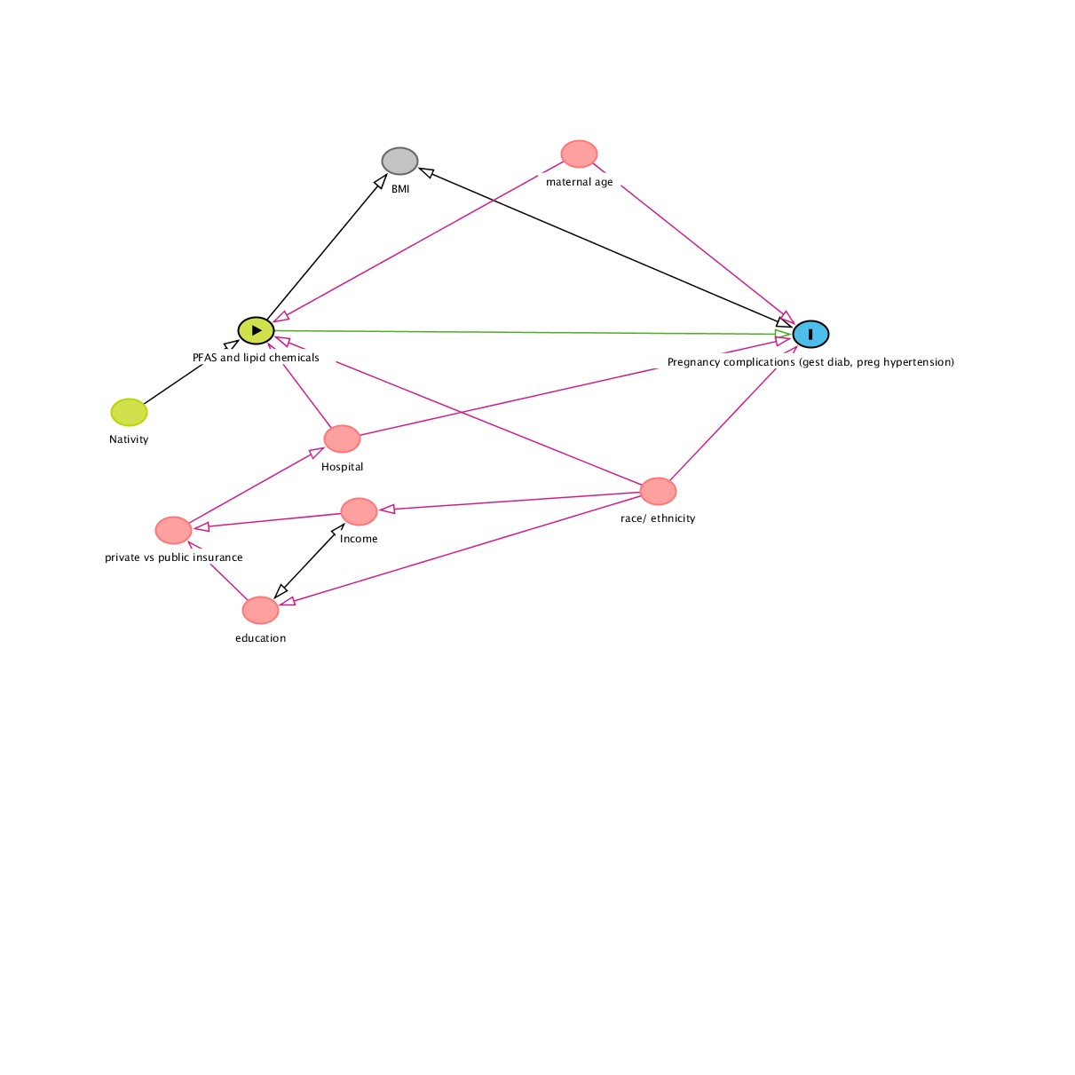
Figure S1. Directed Acyclic Graph (DAG) of the relationship between chemical exposures and pregnancy complications, identifying confounders of interest.

S. Table 2. Odds Ratios from unadjusted and adjusted models for the relationship between chemical exposure during the 2nd trimester and preeclampsia and gestational hypertension

 |  | OR (95% CI)
Chemical |  | Preeclampsia | Gestational Hypertension
 |  | missing n= 14 | missing n= 15
N(%) |  | 20 (7%) | 39 (10%)
Branched PFOS
 | Model0 | 1.18 ( 0.62 , 2.27 ) | 0.95 ( 0.55 , 1.64 )
 | Model1 | 1.54 ( 0.77 , 3.14 ) | 0.82 ( 0.44 , 1.54 )
Linear PFOS
 | Model0 | 1.08 ( 0.59 , 1.92 ) | 0.72 ( 0.42 , 1.21 )
 | Model1 | 1.26 ( 0.66 , 2.34 ) | 0.69 ( 0.35 , 1.27 )
PFHxS
 | Model0 | 1.07 ( 0.65 , 1.63 ) | 0.95 ( 0.62 , 1.38 )
 | Model1 | 1.20 ( 0.70 , 1.93 ) | 0.85 ( 0.50 , 1.34 )
Octadecanedioic acid
 | Model0 | 0.93 ( 0.49 , 1.77 ) | 1.14 ( 0.67 , 1.96 )
 | Model1 | 0.98 ( 0.52 , 1.88 ) | 0.98 ( 0.56 , 1.74 )
Tridecanedioic acid
 | Model0 | 1.09 ( 0.66 , 1.86 ) | 1.34 ( 0.86 , 2.13 )
 | Model1 | 1.11 ( 0.68 , 1.87 ) | 1.37 ( 0.85 , 2.27 )
Deoxycholic acid
 | Model0 | 0.58 ( 0.33 , 1.04 ) | 1.39 ( 0.85 , 2.34 )
 | Model1 | 0.58 ( 0.33 , 1.03 ) | 1.46 ( 0.86 , 2.52 )
ª CI = Confidence Interval; Model0 is the unadjusted model; Model1 is adjusted for maternal age, hospital of delivery, and race/ethnicity; race/ethnicity categories were collapsed due to low numbers of the outcome and to ensure model convergence, categories included: white, Latinx, and other/unknown.

