Table S1 Fitted model parameters and sources for Monte Carol simulation

|  |  |  |  |  |  |
| --- | --- | --- | --- | --- | --- |
| Parameter | Unit | Distribution | Parameters | Number of Observations | Citation |
| transportation distance | kilometer | Pert | mean = 2.5, min =0.3, max = 12.3 | 203 | NA |
| GC SARS-Cov-2/gram stool | log10 GC/g | Pert | mean = 5.4, min = 1.9, max = 10.3 | 166 | (Han et al., 2020  ; Lescure et al., 2020; Wölfel et al., 2020) |
| stool production per day | g/day | Normal | mean = 211, min=0, max=520 | 357 | (Rose et al., 2015) |
| GC SARS-Cov-2/mL urine | log10 GC/mL | Triangle | mean = 3.31, min = 0.59, max = 7.55 | 15 | (Kashi et al., 2020; Roshandel et al., 2020; Yoon et al., 2020) |

Figure S1 Dynamics of bacterial counts in the biofilm of the wastewater pipelines at 12°C and 28°C from day one to day 90.

**Figure S2** The sensitivity analysis based on tornado plot

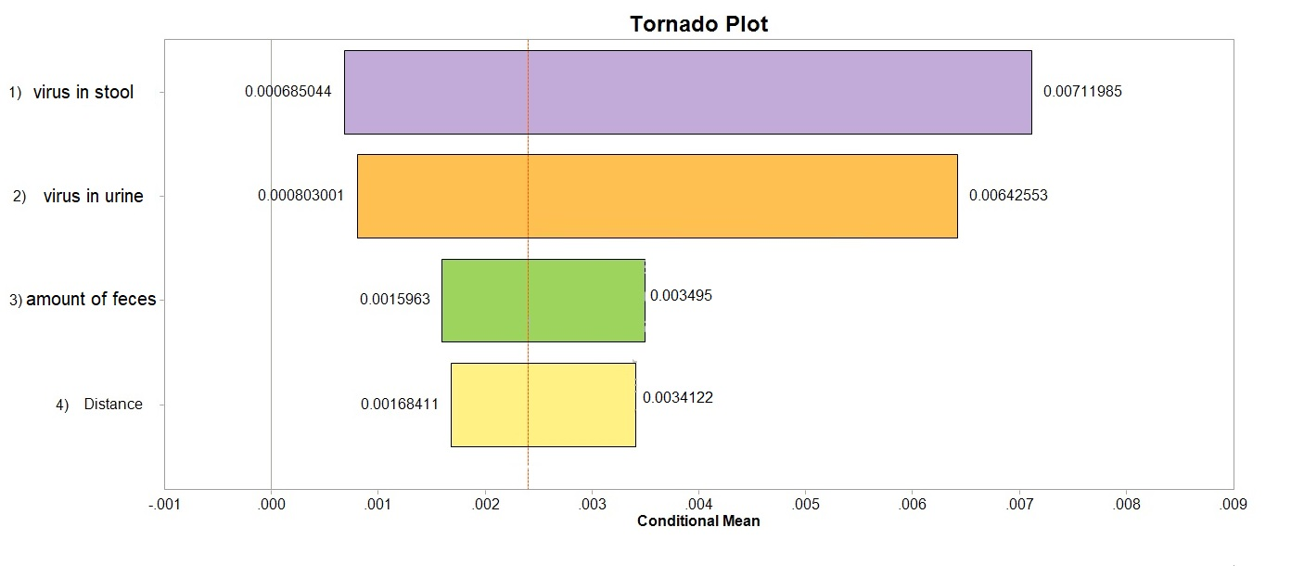

Figure S3 Histogram Plot of Monte Carol simulation results on Dec-14 (A), Dec-18 (B), Dec-22 (C), and Dec-26 (D).

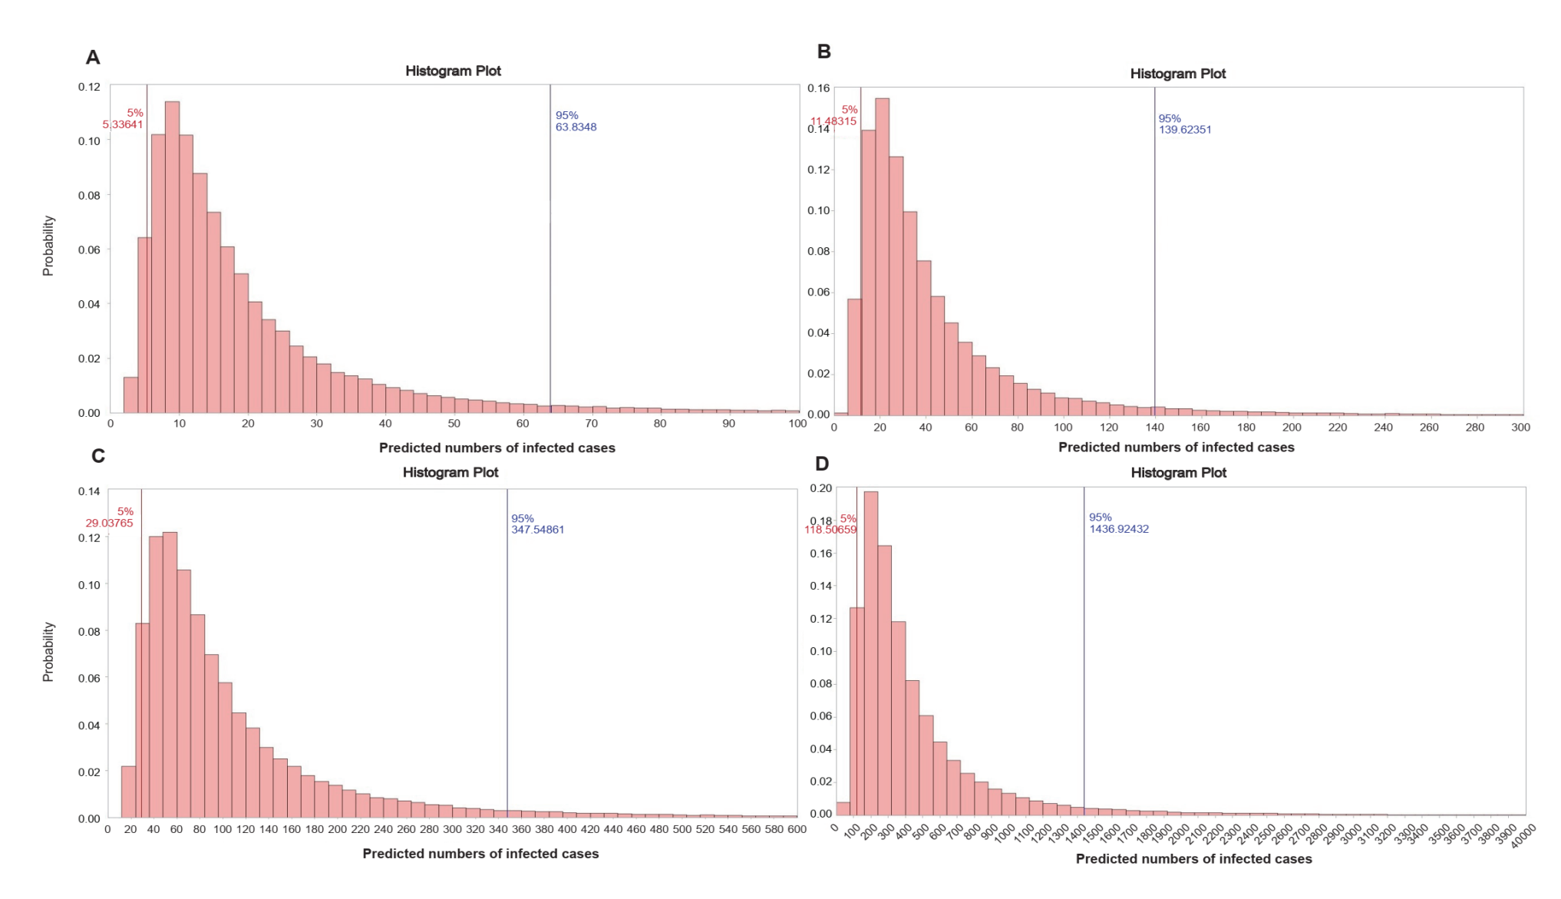

**Reference**

Han D, Li R, Han Y, Zhang R, Li J. COVID-19: Insight into the asymptomatic SARS-COV-2 infection and transmission. Int J Biol Sci. 2020 Aug 27;16(15):2803-2811.

Kashi AH, De la Rosette J, Amini E, Abdi H, Fallah-Karkan M, Vaezjalali M. Urinary Viral Shedding of COVID-19 and its Clinical Associations: A Systematic Review and Meta-analysis of Observational Studies.Urol J. 2020 Sep 5;17(5):433-441.

Lescure FX, Bouadma L, Nguyen D, Parisey M, Wicky PH, Behillil S, Gaymard A, Bouscambert-Duchamp M, Donati F, Le Hingrat Q, Enouf V, Houhou-Fidouh N, Valette M, Mailles A, Lucet JC, Mentre F, Duval X, Descamps D, Malvy D, Timsit JF, Lina B, van-der-Werf S, Yazdanpanah Y.Clinical and virological data of the first cases of COVID-19 in Europe: a case series. Lancet Infect Dis. 2020 Jun;20(6):697-706.

Rose C, Parker A, Jefferson B, Cartmell E: The Characterization of Feces and Urine: A Review of the Literature to Inform Advanced Treatment Technology. *Critical reviews in environmental science and technology* 2015, 45(17):1827-1879.

Roshandel MR, Nateqi M, Lak R, Aavani P, Sari Motlagh R, F Shariat S, Aghaei Badr T, Sfakianos J, Kaplan SA, Tewari AK. Diagnostic and methodological evaluation of studies on the urinary shedding of SARS-CoV-2, compared to stool and serum: A systematic review and meta-analysis. Cell Mol Biol (Noisy-le-grand). 2020 Sep 30;66(6):148-156.

Wurtzer Sb, Maréchal V, Mouchel J, Maday Y, Teyssou R: Evaluation of lockdown impact on SARS-CoV-2 dynamics through viral genome quantification in Paris wastewaters. Eurosurveillance 2020, 25(50): 17

Yoon JG, Yoon J, Song JY, Yoon SY, Lim CS, Seong H, Noh JY, Cheong HJ, Kim WJ. Clinical Significance of a High SARS-CoV-2 Viral Load in the Saliva. J Korean Med Sci. 2020 May 25;35(20):e195.