**SUPPLEMENTAL MATERIAL**

**I. Selection criteria.**

**I.1 Inclusion criteria:**

1. Subjects aged between 3 and 18 years.

2. Voluntariness expressed through informed consent to participate in the study:

- Subjects 3-11 years old: Informed consent of parents or legal guardians

- Subjects aged 12-18 years: Informed Consent of the parents or legal guardians and Informed Assent of the adolescent.

3. Weight-height nutritional assessment between the 10th and 90th percentile (for subjects between 3 and 9 years of age) or the Body Mass Index between the 10th and 90th percentile for subjects between 10 and 18 years of age), according to the standardized nutritional measurement for the Cuban pediatric population.

4. General, regional and apparatus physical examination without alterations.

5. Clinical Laboratory results within range of reference values, or outside ​​but without clinically significant (only for the subjects to be included in phase I).

**I.2. Exclusion criteria:**

1. Acute febrile or infectious disease at the time of the vaccine application or in the 7 days prior to its administration.

2. Any of the following criteria: a) Previous or current history of SARS-CoV 2 infection. b) SARS-CoV 2 PCR positive. c) Be declared in the category of contact or suspect at the time of inclusion.

3. History of hypersensitivity to Thiomersal or any of the components of the formulations.

4. History of having been immunized with a SARS-CoV 2 vaccine.

5. History of having received a vaccine from the Cuban immunization scheme, in a period of less than 30 days prior to the administration of the product under investigation.

6. Use of any investigational product in the 30 days prior to immunization.

7. Application of vaccines containing tetanus toxoid in the last 3 months.

8. History of chronic diseases.

9. History of major congenital malformations (defects that have a significant functional compromise for the individual's life, have medical consequences and require early, sometimes urgent, care).

10. Primary or secondary immune system disease.

11. History of neoplastic disease.

12. History of severe allergic reactions.

13. Treatment with immunomodulators in the last 30 days (eg steroids (except topical and inhaled), Interferon, Immunoferon, Nasalferon, Transfer Factor, monoclonal antibody, Biomodulin T, any ganmaglobulin, Heberferon, Thymosin, Levamisole).

14. Subjects with a history of Convulsive Disease.

15. History of treatment with blood products such as blood cell, plasma, whole blood or platelet concentrate transfusions in the last 4 months.

16. Splenectomy or splenic dysfunction.

17. Child with a minor or mentally disabled mother or father.

18. Pregnancy or lactation (a pregnancy test will be carried out before inclusion and administration of each dose to all girls and adolescents who menstruate).

19. Subjects with tattoos in the deltoid region of both arms.

20. Subjects with a history or positive results for: antibodies against HIV1 + 2, antibodies against hepatitis C, surface antigen of the hepatitis B virus or VDRL serology.

21. History of psychoactive substance use in the last 6 months.

**II. Table S1. Composition of vaccines**

|  |  |  |
| --- | --- | --- |
| **Ingredient** | **Vaccines** | |
|  | **SOBERANA 02** | **SOBERANA Plus** |
| Antigen | SARS-CoV-2 RBD conjugated to  tetanus toxoid, 25 µg RBD  per 20 µg tetanus toxoid | SARS-CoV-2 RBD dimer  (d-RBD), 50 µg |
| Aluminium hydroxide | 0.5 mg | 1.25 mg |
| Sodium chloride | 4.25 mg | 4.25 mg |
| Disodium hydrogen phosphate | 0.03 mg | 0.03 mg |
| Sodium dihydrogen phosphate | 0.02 mg | 0.02 mg |
| Water for injection | 0.5 ml | 0.5 ml |

**III. Outcomes.**

Primary outcome for Phase I: Serious Adverse Events (SAE). Measured as: a) Occurrence of the SAE (Yes, No), b) Duration (Time since the beginning until the end of the event); c) Description of the event; d) Result (Recovered, Recovered with squeals, Persists, Death, Unknown); e) Causality association (Consistent causal relation to immunization, Inconsistent causal relation to immunization, Indeterminate, Unclassifiable) Measurements daily for 28 days after each dose.

Primary Outcome for Phase II: Concentration of specific anti-RBD IgG antibodies and Percentage of subjects with seroconversion 4-fold to pre-vaccination. Measurement time: Day 0, 42 and 70.

Secondary outcomes:

1) Solicited Local and systemic Adverse Events (AE);

2) Unsolicited Adverse Events (AE);

- Measure as: Description of the AE (name of the event), Duration (Time from start date until end date of event), -Intensity of the AE (mild, moderate, severe), - Seriousness (Serious or not serious) -Result (Recovered, Recovered with sequelae, Persists, Death, Unknown), -Causality (causal association consistent with vaccination, Undetermined, causal association inconsistent with vaccination, not classifiable).

- Measurement time: daily for 7 days after each dose for the solicited AE.

- Measurement time: daily for 28 days after each dose for the unsolicited AE.

3) Conventional neutralizing antibody titre: Measurement on days 42 and 70 versus D614G variant, for a subset of subjects with seroconversion.

4) % inhibition of RBD-hACE interaction: Measurement on days 0, 42, 70.

Others:

7) Molecular neutralizing titer (measurement time: Day 0, 42, 70)

8) Conventional neutralizing antibody titre: Measurement on days 70, for a subset of subjects versus alpha, beta, delta and omicron variant

9) RBD-specific T-cells responses producing IFN- γ and TNF- α, (Measurement on days 0, 70)

**IV. Immunological Techniques**

IV.1. *Anti-RBD IgG response:* Anti-RBD IgG in sera was evaluated by a quantitative ultramicro ELISA (UMELISA SARS-CoV-2 anti- RBD, Centre for Immunoassay, Havana, Cuba) using d-RBD as coating antigen (4 µg/mL) and an in-house standard characterized serum, which was arbitrarily assigned 200 AU/mL (based on a half-maximal inhibitory titre of 200 and a conventional virus neutralization titre of 160). The standard curve comprised six two-fold serial dilutions (0, 4, 8, 16, 32 and 64 AU/mL) of the standard. Samples were evaluated in duplicate. After incubation step, two separated steps of biotin-conjugate anti-IgG human (0.1 µg/mL) (Sigma Aldrich, San Luis, EE UU) and later streptavidin/alkaline-phosphatase (Roche, Basel, Swiss) in appropriate buffer were added. The final fluorimetric reaction was induced by adding substrate 4-Methylumbelliferyl Phosphate (Sigma Aldrich, San Luis, EE UU). The reference curve was constructed using a linear interpolation function. The concentration of anti-RBD IgG was expressed as AU/mL. The seroconversion rate was calculated by dividing the concentration at each time point (at Tx) by the pre-vaccination concentration (at T0). A rate ≥ 4 was considered as seroconversion.

*IV.2 Molecular virus neutralization test*: Microtitre plates were coated with 250ng/well of ACE2-hFc in carbonate-bicarbonate buffer, 0.1M (pH9.6) and incubated overnight at 4°C. Plates were blocked with 200µL/well of 2% of skim milk in PBST (PBS with Tween 20 0.05%) during 1 h, at 37°C. Serial dilutions of sera were pre-incubated with RBD-mouse-Fc (RBD-mFc) at a final concentration of 20 ng/mL, for 1 h at 37oC. Mixtures were added to the plates and incubated for 2 h at 37°C. The binding of RBD-mFc was detected by addition of alkaline phosphatase (AP) conjugated anti-mouse IgG antibody (Sigma) for 1 h at 37°C. Finally, p-nitrophenylphosphate (Sigma) at 1 mg/mL in diethanolamine buffer (pH9.8) was added, and plates were incubated at RT for 30 min. The OD at 405nm was measured using a microwell system reader (BioTek). In all steps other than blockade, samples and reagents were added using a final volume of 50 µL/well. Three washing steps with PBST followed all incubations. RBD-mFc, sera and antibody conjugates were diluted in skim milk 0.2%/PBST. Inhibition was calculated and expressed as percentage according to the next formula: Inhibition (%)= [1-(OD405nmsample/OD405nm maximal recognition)] x 100. Herein, maximal recognition corresponds to wells incubated only with RBD-mFc (20 ng/mL). For determination of the mVNT50, dilutions were log transformed and the highest dilution giving 50% of inhibition was calculated.

*IV.3 Conventional Virus Neutralization test*

Neutralizing antibodies against live SARS-CoV-2 was performed in a biosecurity laboratory level 3 (National Civil Defence Research Laboratory, Havana, Cuba) by the conventional virus neutralization test, the gold standard for determining antibody efficacy against SARS-CoV-2 (Manenti et al; 2020). Serial dilutions of heat-inactivated serum samples (starting from 1:5) in Eagle’s Minimal Essential Medium (Gibco, UK) containing 2 % fetal bovine serum (Capricorn, Germany) were incubated for 1 hour at 37°C with an equal volume of viral solution containing 100 TCID50 of SARS-CoV-2 (Strains: CU2010-2025, variant D614G; CU2101-2102, variant B.1.1.7 alpha; CU2104-2179, variant B.1.617.2 delta; CU2104-2180, variant B.1.351 beta; Cuban Collection at National Civil Defence Research Laboratory) in cell plates containing a semiconfluent VeroE6 monolayer (104 cell/well). The highest serum dilution, showing an OD at 540 nm representing the 50% of average OD values from control cell wells (VeroE6 monolayer with mixture of virus-serum) was considered as the neutralization titre and is represented as neutralizing titre 50 (cVNT50).

*IV.4 Specific T-cell response*

Peripheral blood mononuclear cells (PBMCs) were isolated from a subset (n=24) of vaccinated subjects, at on day 0 (before first immunization); day 56 (28 days after the second dose) and 84 (28 days after the third dose), homologous scheme: n=13, heterologous scheme: n=11). RBD-specific T-cell response producing IFN- γ and IL-4 were quantified with enzyme-linked immunospot (ELISpot) assay using human IFN-γ ELISpotPLUS HRP kit (Mabtech, Sweden) and human IL-4 ELISpotplus HRP kit (Mabtech, Sweden) following the manufacturer´s instructions. Briefly, cryopreserved peripheral blood mononuclear cells from vaccinated subjects were thawed and rested for 6 hours in RPMI 1640 medium supplemented with 1000 units/mL penicillin, 1 mg/mL streptomycin, 1 mM pyruvate (Gibco), 50 µM β-mercaptoethanol (Sigma-Aldrich) and 10% *(v/v)* heat-inactivated fetal calf serum (Capricorn). PBMCs (2.5 x 105 cells/well, in duplicate) were stimulated with recombinant RBD (10 µg/mL) at 37°C for 24 h before detection. Specific T-cell response was expressed as the number of spot-forming cells per 106 cells; measurements were subtracted from the unstimulated control values.

**V. Supplementary safety data.**

**Table S2.** Global characterization of adverse events

|  | **Age groups** | |  |
| --- | --- | --- | --- |
| **3-11 years** | **12-18 years** | **Total** |
| **Total adverse events** | 141 | 182 | 323 |
| **Intensity** |  |  |  |
| Mild (Grade 1) | 135 (95.7) | 167 (91.8) | 302 (93.5) |
| Moderate (Grade 2) | 6 (4.3) | 15 (8.2) | 21 (6.5) |
| Severe (Grade 3) | 0 | 0 | 0 |
| **Severity** |  |  |  |
| No Serious | 141 (100.0) | 181 (99.5) | 322 (99.7) |
| Serious | 0 | 1 (0.5) * | 1 (0.3) * |
| **Causal relationship\*\*** |  |  |  |
| Consistent (A1) | 126 (89.4) | 160 (87.9) | 286 (88.5) |
| Consistent (A2) | 0 | 0 | 0 |
| Consistent (A3) | 0 | 0 | 0 |
| Indeterminate (B1) | 0 | 2 (1.1) | 2 (0.6) |
| Indeterminate (B2) | 0 | 1 (0.5) | 1 (0.3) |
| Inconsistent | 15 (10.6) | 19 (10.4) | 34 (10.5) |
| **Result** |  |  |  |
| Recovered | 140 (99.3) | 180 (98.9) | 320 (99.1) |
| Persist | 0 | 1 (0.5)* | 1 (0.3)* |
| **Type** |  |  |  |
| Local | 118 (83.7) | 147 (80.8) | 265 (82.0) |
| Systemic | 23 (16.3) | 35 (19.2) | 58 (18.0) |
| **Solicited** |  |  |  |
| Solicited | 125 (88.7) | 152 (83.5) | 277 (85.8) |
| Unsolicited | 16 (11.3) | 30 (16.5) | 46 (14.2) |
| **Starting at** |  |  |  |
| ≤ 60 min | 25 (13.7) | 25 (17.7) | 50 (15.5) |
| 60 min-24 hours | 127 (69.8) | 85 (60.3) | 212 (65.6) |
| 24-48 hours | 15 (8.2) | 14 (9.9) | 29 (9.0) |
| 48-72 hours | 1 (0.5) | 3 (2.1) | 4 (1.2) |
| > 72 hours | 14 (7.7) | 14 (9.9) | 28 (8.7) |
| **Duration (hours)** |  |  |  |
| ≤ 24 hours | 99 (54.4) | 74 (52.5) | 173 (53.6) |
| 24-48 hours | 37 (20.3) | 35 (24.8) | 72 (22.3) |
| 48-72 hours | 33 (18.1) | 16 (11.3) | 49 (15.2) |
| > 72 hours | 13 (7.1) | 16 (11.3) | 29 (9.0) |
| Footnote: Frequency: number of events, %: values referred to total events.  *\** Dengue.  *\*\* A1:* Vaccine-related event (according to published literature)*; A2:* Event related to a defect in the quality of the vaccine*; A3:* Error-related reaction*; A4:* Event related to the conditions inherent to the vaccinated subject*; B1:* The temporal relationship is consistent, but the evidence is insufficient to consider the vaccination as cause of the event*; B2:* Classification criteria result in contradiction regarding consistencies and inconsistencies with a causal association with immunization | | | |

.

**Table S3**. Frequency of subjects with adverse event by dose

|  |  | **Age groups** | | |
| --- | --- | --- | --- | --- |
|  |  | **3-11 years** | **12-18 years** | **Total** |
| **N** |  | 175 | 175 | 350 |
| **Overall adverse events within 28 days after vaccination** | | | | |
| **Subject with AE** | | 81 (46.3) | 105 (60.0) | 186 (53.1) |
| 1st dose | | 54/175 (30.9) | 98/175 (56.0) | 152/350 (43.4) |
| 2nd dose | | 29/162 (17.9) | 29/159 (18.2) | 58/321 (18.1) |
| 3rd dose | | 30/156 (19.2) | 31/150 (20.7) | 61/306 (19.9) |
| **Subjects with solicited AE within 7 days after vaccination** | | | | |
| **Any** | | 76 (43.4) | 98 (56.0) | 174 (49.7) |
| 1st dose | | 50/175 (28.6) | 90/175 (51.4) | 140/350 (40) |
| 2nd dose | | 27/162 (16.7) | 27/159 (17.0) | 54/321 (16.8) |
| 3rd dose | | 29/156 (18.6) | 28/150 (18.7) | 57/306 (18.6) |
| **Subjects with solicited local adverse events** | | | | |
| **Any** | | 74 (42.3) | 98 (56.0) | 172 (49.1) |
| 1st dose | | 50/175 (28.6) | 90/175 (51.4) | 140/350 (40) |
| 2nd dose | | 27/162 (16.7) | 27/159 (17.0) | 54/321 (16.8) |
| 3rd dose | | 26/156 (16.7) | 27/150 (18.0) | 53/306 (17.3) |
| **Local pain** | | 69 (39.4) | 98 (56.0) | 167 (47.7) |
| 1st dose | | 49/175 (28) | 90/175 (51.4) | 139/350 (39.7) |
| 2nd dose | | 23/162 (14.2) | 27/159 (17.0) | 50/321 (15.6) |
| 3rd dose | | 19/156 (12.2) | 26/150 (17.3) | 45/306 (14.7) |
| **Swelling** | | 9 (5.1) | 2 (1.1) | 11 (3.1) |
| 1st dose | | 2/175 (1.1) | 0/175 (0.0) | 2/350 (0.6) |
| 2nd dose | | 3/162 (1.9) | 0/159 (0.0) | 3/321 (0.9) |
| 3rd dose | | 6/156 (3.8) | 2/150 (1.3) | 8/306 (2.6) |
| **Local warm** | | 4 (2.3) | 0 (0.0) | 4 (1.1) |
| 1st dose | | 0/175 (0.0) | 0/175 (0.0) | 0/350 (0.0) |
| 2nd dose | | 2/162 (1.2) | 0/159 (0.0) | 2/321 (0.6) |
| 3rd dose | | 2/156 (1.3) | 0/150 (0.0) | 2/306 (0.7) |
| **Erythema** | | 5 (2.3) | 1 (0.6) | 6 (1.7) |
| 1st dose | | 0/175 (0.0) | 0/175 (0.0) | 0/350 (0.0) |
| 2nd dose | | 2/162 (1.2) | 0/159 (0.0) | 2/321 (0.6) |
| 3rd dose | | 4/156 (2.6) | 1/150 (0.7) | 5/306 (1.6) |
| **Induration** | | 5 (2.3) | 1 (0.6) | 6 (1.7) |
| 1st dose | | 2/175 (1.1) | 0/175 (0.0) | 2/350 (0.6) |
| 2nd dose | | 1/162 (0.6) | 0/159 (0.0) | 1/321 (0.3) |
| 3rd dose | | 3/156 (1.9) | 1/150 (0.7) | 4/306 (1.3) |
| **Subjects with solicited systemic adverse events** | | | | |
| **Any** | | 5 (2.9) | 4 (2.3) | 9 (2.6) |
| 1st dose | | 1/175 (0.6) | 3/175 (1.7) | 4/350 (1.1) |
| 2nd dose | | 0/162 (0.0) | 0/159 (0.0) | 0/321 (0.0) |
| 3rd dose | | 4/156 (2.6) | 1/150 (0.7) | 5/306 (1.6) |
| **Mild fever** | | 4 (2.3) | 1 (0.6) | 5 (1.4) |
| 1st dose | | 0/175 (0.0) | 1/175 (0.6) | 1/350 (0.3) |
| 2nd dose | | 0/162 (0.0) | 0/159 (0.0) | 0/321 (0.0) |
| 3rd dose | | 4/156 (2.6) | 0/150 (0.0) | 4/306 (1.3) |
| **Fever** | | 2 (1.1) | 1 (0.6) | 3 (0.9) |
| 1st dose | | 1/175 (0.6) | 0/175 (0.0) | 1/350 (0.3) |
| 2nd dose | | 0/162 (0.0) | 0/159 (0.6) | 0/321 (0.3) |
| 3rd dose | | 1/156 (0.1) | 1/150 (0.7) | 2/306 (0.7) |
| **General discomfort** | | 1 (0.6) | 3 (1.7) | 4 (1.1) |
| 1st dose | | 0/175 (0.0) | 3/175 (1.7) | 3/350 (0.9) |
| 2nd dose | | 0/162 (0.0) | 0/159 (0.0) | 0/321 (0.0) |
| 3rd dose | | 1/156 (0.6) | 0/150 (0.0) | 1/306 (0.3) |

**Table S4**.Unsolicited adverse events.

|  | **Age groups** | | |
| --- | --- | --- | --- |
| **3-11 years** | **12-18 years** | **Total** |
| **N (%)** | 175 (100.0%) | 175 (100.0%) | 350 (100.0%) |
| Number of participants reporting unsolicited AEs | 14 (8.0) | 21 (12.0) | 35 (10.0) |
| Vaccine-related | 6 (3.4)* | 10 (5.7)** | 16 (4.6) |
| Headache | 2 (1.1) | 9 (5.1) | 11 (3.1) |
| Non Vaccine-related | 8 (4.6)*** | 13 (7.4)**** | 21 (6.0) |
| Headache | 1 (0.6) | 2 (1.1) | 3 (0.9) |
| * Reported by 1 subject (0.6%, each one): arm cramp, diarrhea, drowsiness, mild fever, heavy arm sensation.  ** Reported by 1 subject (0.6%, each one): arm cramp  *** Reported by 1 subject (0.6%, each one): diarrhea; gastrointestinal disease; epistaxis; boil in ear; foot wound; viral process; nasal secretion; cough  **** Reporting for 1 subject (0.6%, each one): cellulitis on thigh, tonsillitis; miliaria; dengue; diarrhea; fever; hypertension; upper acute respiratory infection; abdominal discomfort; nasal secretion; cough. Reporting for 2 subject (1.1% each one): vomiting; sickness | | | |

**Table S5. Haematology and Blood Chemistry evaluation for children (only phase I)**

|  | | | **3-11 years** | **12-18 years** | **Global** |
| --- | --- | --- | --- | --- | --- |
| N | | | 25 | 24 | 49 |
| **Haemoglobin** | Reference values (g/L) | | 115-135 | F: 120-160; M: 130-160 |  |
| Pre | Media (SD) | 130.5 (8.4) | 138.6 (13.7) | 134.9 (10.3) |
| (Min; Max) | (116;154) | (117;162) | (113;165) |
| Day 7 | Media (SD) | 132.1 (6.8) | 137.9 (12.4) | 134.5 (11.9) |
| (Min; Max) | (117;148) | (113;165) | (116;162) |
| **p vs. 0 (t Student)** | | 0.127 | 0.719 | 0.667 |
| Day 70 | Media (SD) | 127.9 (6.3) | 137.8 (14.2) | 132.6 (11.8) |
| (Min; Max) | (119; 143) | (116; 167) | (116; 167) |
| **p vs. 0 (t Student)** | | 0.130 | 0.807 | 0.435 |
| **Hematocrit** | Reference values | | 2-6 years: 0.34-0.40  7-11years: 0.37-0.49 | F: 0.35-0.45  M: 0.37-0.49 |  |
| Pre | Media (SD) | 0.36 (0.02) | 0.38 (0.03) | 0.37 (0.03) |
| (Min; Max) | (0.32; 0.42) | (0.32; 0.44) | (0.32; 0.44) |
| Day 7 | Media (SD) | 0.36 (0.02) | 0.39 (0.03) | 0.37 (0.03) |
| (Min; Max) | (0.31; 0.40) | (0.32; 0.46) | (0.31; 0.46) |
| **p vs. 0 (t Student)** | | 0.041 | 0.957 | 0.326 |
| Day 70 | Media (SD) | 0.35 (0.02) | 0.38 (0.04) | 0.37 (0.03) |
| (Min; Max) | (0.33; 0.39) | (0.33; 0.46) | (0.33; 0.46) |
| **p vs. 0 (t Student)** | | 0.039 | 0.979 | 0.344 |
| **Platelets** | Reference values (109/L) | | 150-450 | | |
| Pre | Media (SD) | 280 (62) | 231 (51) | 256 (61) |
| (Min; Max) | (175; 410) | (161; 323) | (161; 410) |
| Day 7 | Media (SD) | 288 (54) | 253 (60) | 271 (59) |
| (Min; Max) | (197; 409) | (160; 380) | (160; 409) |
| **p vs. 0 (t Student)** | | 0.355 | 0.178 | 0.099 |
| Day 70 | Media (SD) | 280 (55) | 221 (36) | 252 (55) |
| (Min; Max) | (175; 389) | (169; 285) | (169; 389) |
| **p vs. 0 (t Student)** | | 0.649 | 0.514 | 0.885 |
| **Leukocytes** | Reference values (109/L) | | 2-6 years: 5.0-14.5  7-11 years: 4.5-13.5 | 4.5 – 11.0 |  |
| Pre | Mediana (IRI) | 7.2 (1.8) | 5.5 (1.9) | 6.3 (2.1) |
| (Min; Max) | (4.9; 11.3) | (0.3; 8.6) | (0.3; 11.3) |
| Day 7 | Mediana (IR) | 7.2 (2.4) | 7.2 (1.5) | 7.2 (2.2) |
| (Min; Max) | (4.7; 10.8) | (6.0; 9.0) | (4.7; 10.8) |
| **p vs. 0 (Wilcoxon)** | | 0.162 | 0.000 | 0.000 |
| Day 70 | Mediana (IR) | 7.3 (2.0) | 6.8 (1.6) | 7.0 (1.8) |
| (Min; Max) | (3.7; 12.3) | (3.7; 9.7) | (3.7; 12.3) |
| **p vs. 0 (Wilcoxon)** | | 0.648 | 0.006 | 0.013 |
| **Glucose** | Reference values (mmol/L) | | 3.88 -6.1 | | |
| Pre | Media (SD) | 4.2 (0.3) | 4.7 (0.4) | 4.4 (0.4) |
| (Min; Max) | (3.4; 4.7) | (4.0; 5.7) | (3.4; 5.7) |
| Day 7 | Media (SD) | 4.3 (0.5) | 4.2 (0.3) | 4.3 (0.4) |
| (Min; Max) | (3.3; 5.3) | (3.6; 4.8) | (3.2; 5.3) |
| **p vs. 0 (t Student)** | | 0.103 | 0.000 | 0.025 |
| Day 70 | Media (SD) | 3.4 (0.4) | 4.2 (0.4) | 3.8 (0.5) |
| (Min; Max) | (2.7; 4.1) | (2.9; 5.2) | (2.7; 5.2) |
| **p vs. 0 (t Student)** | | 0.000 | 0.000 | 0.000 |
| **Creatinine** | Pre | Media (SD) | 47.9 (7.8) | 69.2 (14.6) | 58.3 (15.8) |
| (Min; Max) | (30.0; 62.0) | (48.1; 96.3) | (30.0; 96.3) |
| Day 7 | Media (SD) | 43.6 (6.8) | 52.6 (18.8) | 48.0 (14.6) |
| (Min; Max) | (31.0; 53.0) | (18.5; 82.9) | (18.5; 82.9) |
| **p vs. 0 (t Student)** | | 0.000 | 0.000 | 0.000 |
| Day 70 | Media (SD) | 45.2 (7.7) | 68.3 (14.6) | 56.3 (16.3) |
| (Min; Max) | (26.0; 58.0) | (39.0; 92.0) | (26.0; 92.0) |
| **p vs. 0 (t Student)** | | 0.037 | 0.854 | 0.106 |
| **ASAT** | Reference values (U/L) | | Up to 49 U/L | | |
| Pre | Media (SD) | 32.3 (5.9) | 22.0 (3.5) | 27.2 (7.1) |
| (Min; Max) | (22.0; 46.0) | (16.3; 29.4) | (16.3; 46.0) |
| Day 7 | Media (SD) | 21.8 (6.9) | 18.6 (2.0) | 20.2 (5.3) |
| (Min; Max) | (12.0; 36.0) | (15.6; 23.6) | (12.0; 36.0) |
| **p vs. 0 (t Student)** | | 0.000 | 0.000 | 0.000 |
| Day 70 | Media (SD) | 27.8 (4.9) | 17.4 (3.8) | 22.8 (6.8) |
| (Min; Max) | (19.0; 38.0) | (12.0; 27.0) | (12.0; 38.0) |
| **p vs. 0 (t Student)** | | 0.001 | 0.000 | 0.000 |
| **ALAT** | Reference values (U/L) | | Up to 49 U/L | | |
| Pre | Median (IR) | 21.0 (5.4) | 12.2 (4.3) | 18.0 (9.8) |
| (Min; Max) | (15.0; 41.0) | (7.6; 34.4) | (7.6; 41.0) |
| Day 7 | Median (IR) | 17.0 (9.0) | 12.2 (5.3) | 13.4 (7.3) |
| (Min; Max) | (10.0; 53.0) | (7.6; 29.4) | (7.6; 53.0) |
| **p vs. 0 (Wilcoxon)** | | 0.034 | 0.897 | 0.027 |
| Day 70 | Median (IR) | 17.9 (9.5) | 14.3 (8.4) | 16.7 (9.1) |
| (Min; Max) | (9.0; 57.0) | (7.0; 37.0) | (7.0; 57.0) |
| **p vs. 0 (Wilcoxon)** | | 0.010 | 0.948 | 0.027 |

**VI. Supplementary immunogenicity data.**

**Table S6.** Correlations between immunological variables after two doses of SOBERANA 02 and a third doses of SOBERANA Plus.

|  | | | **Anti-RBD IgG (UA/mL)** | **% Inh RBD:hACE2** | **mVNT50** |
| --- | --- | --- | --- | --- | --- |
| **After 2 doses** | **Anti-RBD IgG AU/mL** | r2 Spearman | 1.000 |  |  |
| p | . |  |  |
| N | 318 |  |  |
| **% Inh RBD:hACE2** | r2 Spearman | 0.892** | 1.000 |  |
| p | 0.000 | . |  |
| N | 318 | 318 |  |
| **mVNT50** | r2 Spearman | 0.909** | 0.970** | 1.000 |
| p | .000 | .000 | . |
| N | 318 | 318 | 318 |
| **cVNT50** | r2 Spearman | 0.881** | 0.885** | 0.898** |
| p | 0.000 | 0.000 | 0.000 |
| N | 123 | 123 | 123 |
| **After 3 doses** | **Anti-RBD IgG UA/mL** | r2 Spearman | 1.000 |  |  |
| p | . |  |  |
| N | 306 |  |  |
| **% Inh RBD:hACE2** | r2 Spearman | 0.715** | 1.000 |  |
| p | 0.000 | . |  |
| N | 306 | 306 |  |
| **mVNT50** | r2 Spearman | 0.859** | 0.827** | 1.000 |
| p | 0.000 | 0.000 | . |
| N | 306 | 306 | 306 |
| **cVNT50** | r2 Spearman | 0.804** | 0.729** | 0.874** |
| p | 0.000 | 0.000 | 0.000 |
| N | 131 | 131 | 131 |

After two doses: Two doses of SOBERANA 02 every 28 days; After three doses: Two doses of SOBERANA 02 and a third dose with SOBERANA Plus every 28 days. ** p<0.01

**Table S7.** Predictive value of immunological variable for attaining conventional live-virus neutralization titer >50 (cVNT50 titer>50).

|  |  |  |  |  |  |  |
| --- | --- | --- | --- | --- | --- | --- |
| Test Result Variable(s) | Cutt-off | Area | Std. Errora | Sig. | 95% Confidence Interval | |
| Lower Bound | Upper Bound |
| Anti-RBD IgG (AU/mL) | 192.2 | 0.916 | 0.028 | 0.000 | 0.860 | 0.971 |
| % Inh RBD:hACE2 | 87.1 | 0.960 | 0.016 | 0.000 | 0.928 | 0.992 |
| mVNT50 | 427.5 | 0.952 | 0.018 | 0.000 | 0.917 | 0.987 |

**Figure S1.** ROC Curve for cVNT ≥ 50

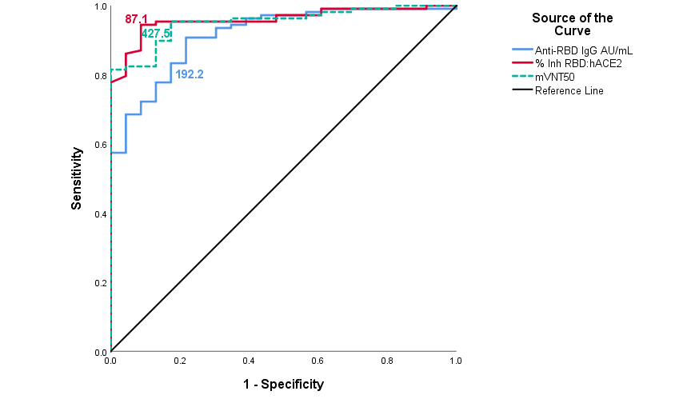

**VII. Supplementary data for immunobridging subset.**

**Table S8**. Demographic characteristics of the subjects including in immunobridging subset

|  |  | **Children** | **Young adults groups as reference** |
| --- | --- | --- | --- |
|  |  | **3-18 years** | **19 -39 years** |
| **N** |  | 131 | 43 |
| **Sex** | |  |  |
| Female | | 60 (45.8) | 27 (62.8) |
| Male | | 71 (54.2) | 16 (37.2) |
| **Skin colour** | |  |  |
| White | | 84 (64.1) | 30 (69.8) |
| Black | | 9 (6.9) | 4 (9.3) |
| Multiracial | | 38 (29.0) | 9 (20.9) |
| **Age** | |  |  |
| Mean (SD) | | 11.2 (4.6) | 28.3 (5.9) |
| Median (IR) | | 11.0 (8.0) | 28.0 (10.0) |
| Range | | 3-18 | 19-39 |

**Table S9**.Subjects 3-18-years-old and 19-39-years-old reporting at least 1 adverse event

|  | **Age groups** | |
| --- | --- | --- |
| **3-18 years** | **19-39 years** |
| **N** | 350 | 261 |
| Subjects with some AE | 186 (53.10%) | 148 (56.7%) |
| Subjects with some VAAE | 177 (50.6%) | 133 (51.0%) |
| Subjects with some Serious AE | 1 (0.3%)* | 3 (1.1%)** |
| Subjects with some Serious VAAE | 0 (0.0%) | 0 (0.0%) |
| Subjects with some Severe AE | 0 (0.0%) | 1 (0.4%)*** |
| Subjects with some Severe VAAE | 0 (0.0%) | 0 (0.0%) |
| * Dengue  ** 1 subject with: Lipothymia- Rectal bleeding-Diarrhea; 1 subject with upper acute respiratory infection; 1 subject with bilateral orchiepididymitis  *** bilateral orchiepididymitis | | |

**Figure S2**. Comparison of solicited adverse events in all participants in the 3–18 y/o group (N=350) and the subset of young adult 19–39 years (N=261)

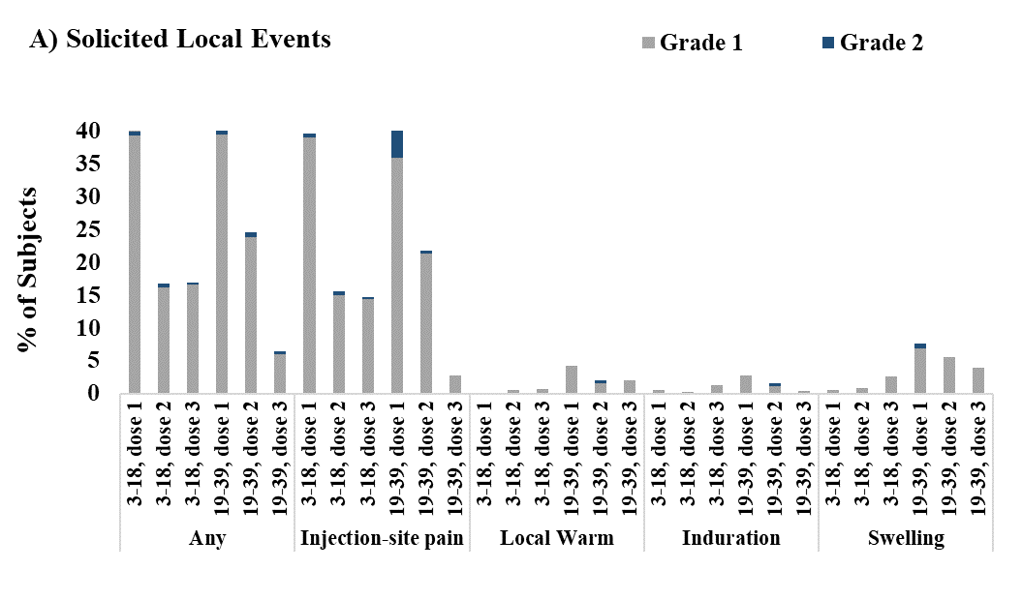

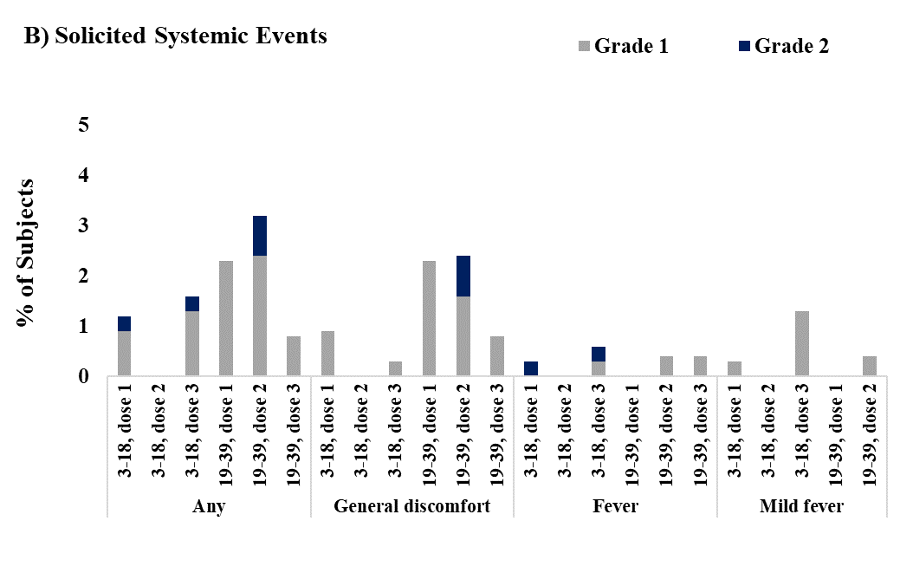

References

Manenti A, Maggetti M, Casa E, Martinuzzi D, [Torelli](https://pubmed.ncbi.nlm.nih.gov/?term=Torelli+A&cauthor_id=32383254) A, Trombetta C. Evaluation of SARS‐CoV‐2 neutralizing antibodies using a CPE‐based colorimetric live virus micro‐neutralization assay in human serum samples. J Med Virol 2020;92:2096-104. <https://doi.org/10.1002/jmv.25986>