SUPPLEMENTARY MATERIAL
Supplementary Table 1 Anti-Parkinson’s disease medication name and corresponding PBS code
Medication | PBS code | Dosage or Strength
Levodopa + carbidopa | 1242J, 1245M, 1255C, 8970D, 9743T, 9744W | Levodopa (100 - 250 mg) + carbidopa (25 - 50 mg)
Levodopa + benserazide | 2225D, 2226E, 2227F, 2228G, 2229H, 2231K, 8218M, 8219N | Levodopa (50 - 200 mg) + benserazide (12.5 - 50 mg)
Levodopa + carbidopa + entacapone | 8797B, 8798C, 8799D, 9292C, 9344T, 9345W | Levodopa (50 - 200 mg) + carbidopa (12.5 - 50 mg) + entacapone (200 mg)
Amantadine hydrochloride | 3016R | 100 mg
Apomorphine hydrochloride hemihydrate | 10950H, 10971K, 11083H, 11093W, 5609F, 5610G, 9607P, 9640J | 10 mg/1 ml injection
Cabergoline | 8393R, 8394T | 500 µg – 2 mg
Pramipexole dihydrochloride monohydrate | 3418X, 3419Y, 3420B, 3421C, 3422D, 5143Q, 5145T, 9151P, 9152Q, 9153R, 9393J, 9394K | 125 µg – 4 mg
Rotigotine | 1140H, 2384L, 2385M, 2410W | 2 – 8 mg/24 hours
Benzatropine mesilate | 11249C, 11255J, 11265X, 2362H | 2 mg tablets, 2 mg/mL injection
Trihexyphenidyl (benzhexol) hydrochloride | 1109J, 1110K | 2 – 5 mg
Rasagiline | 1952R | 1 mg

Supplementary Table 2 APGS Invitations and respondents per state or territory of Australia
State or Territory | Letters sent by state  N (%) | Respondents by state  N (%)
New South Wales | 6280 (31.1) | 6160 (30.2)
Victoria | 5020 (25.1) | 4440 (22.2)
Queensland | 4220 (21.1) | 4860 (24.3)
South Australia | 1880 (9.4) | 1880 (9.4)
Western Australia | 1740 (8.7) | 1860 (9.3)
Tasmania | 640 (3.2) | 460 (2.3)
Australian Capital Territory | 220 (1.1) | 340 (1.7)
Northern Territory | 0.3 | 0.6

Supplementary Figure 1 Male sample age distribution in APGS
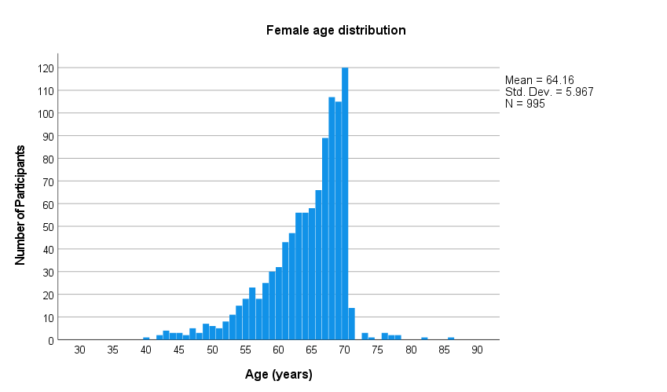

Supplementary Figure 2 Female sample age distribution in APGS
