Aerosol measurement identifies SARS-CoV 2 PCR positive adults compared with healthy controls
Desireé Gutmann, Gerhard Scheuch, Timon Lehmkühler, Laura-Sabine Herrlich, Martin Hutter, Christoph Stephan, Maria Vehreschild, Yascha Khodamoradi, Ann-Kathrin Gossmann, Florian King, Frederik Weis, Maximilian Weiss, Holger F Rabenau, Juergen Graf, Helena Donath, Ralf Schubert, Stefan Zielen.

Methods
eFigure 1: Aerosol Resp-Aer-Meter (A) structure and (B) function, as well as (C) sample measurement.
eFigure 2: Aerosol particle counts in age-matched SARS-CoV-2 PCR-positive and -negative patients.
eFigure 3: Aerosol particle counts in SARS-CoV-2 PCR-positive and -negative patients divided into subgroups.

Methods
SARS-CoV-2 PCR
Repeatedly performed combined nasal and throat PCR swab tests were confirmed before and during admission in all subjects. Semiquantitative real-time PCR (RT-PCR) was assessed predominantly by commercial PCR test. Test results were reported as ‘negative’ or ‘positive’; in the case of a positive result, the cycle threshold (Ct) value was reported. In all participants, a SARS CoV-2 PCR was obtained before enrollment.

eFigure 1: Aerosol Resp-Aer-Meter (A) structure and (B) function, as well as (C) sample measurement.
A. Aerosol Resp-Aer-Meter structure
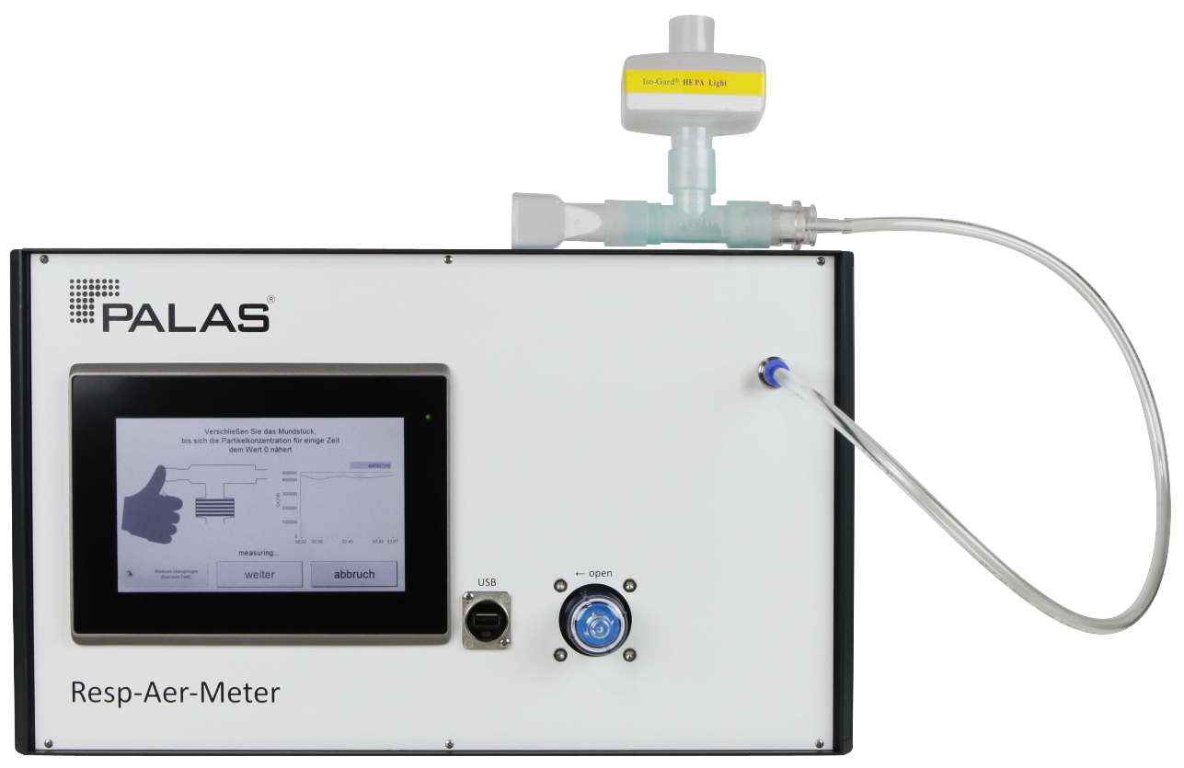

B. Aerosol Resp-Aer-Meter function
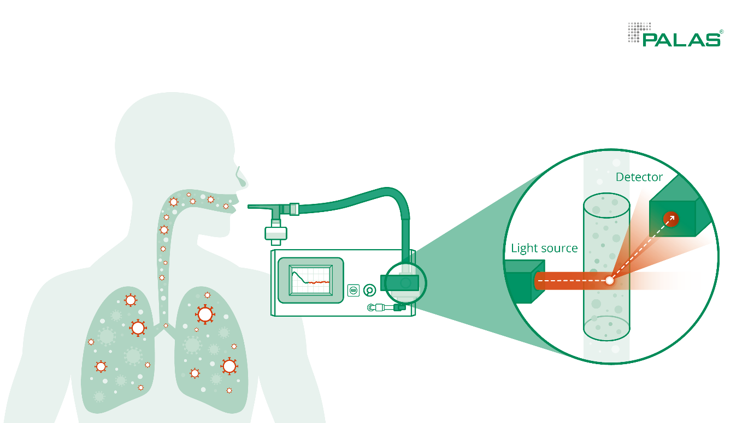

C. Aerosol Resp-Aer-Meter sample measurement
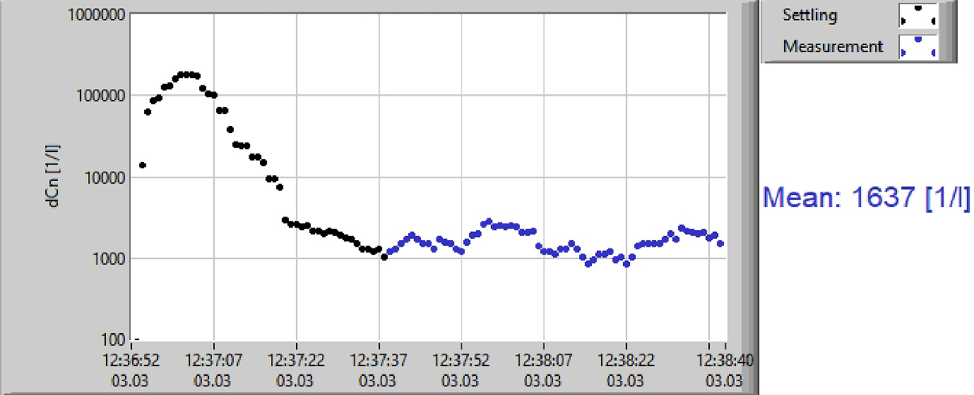

eFigure 2: Aerosol particle counts in age-matched SARS-CoV-2 PCR-positive and -negative patients.
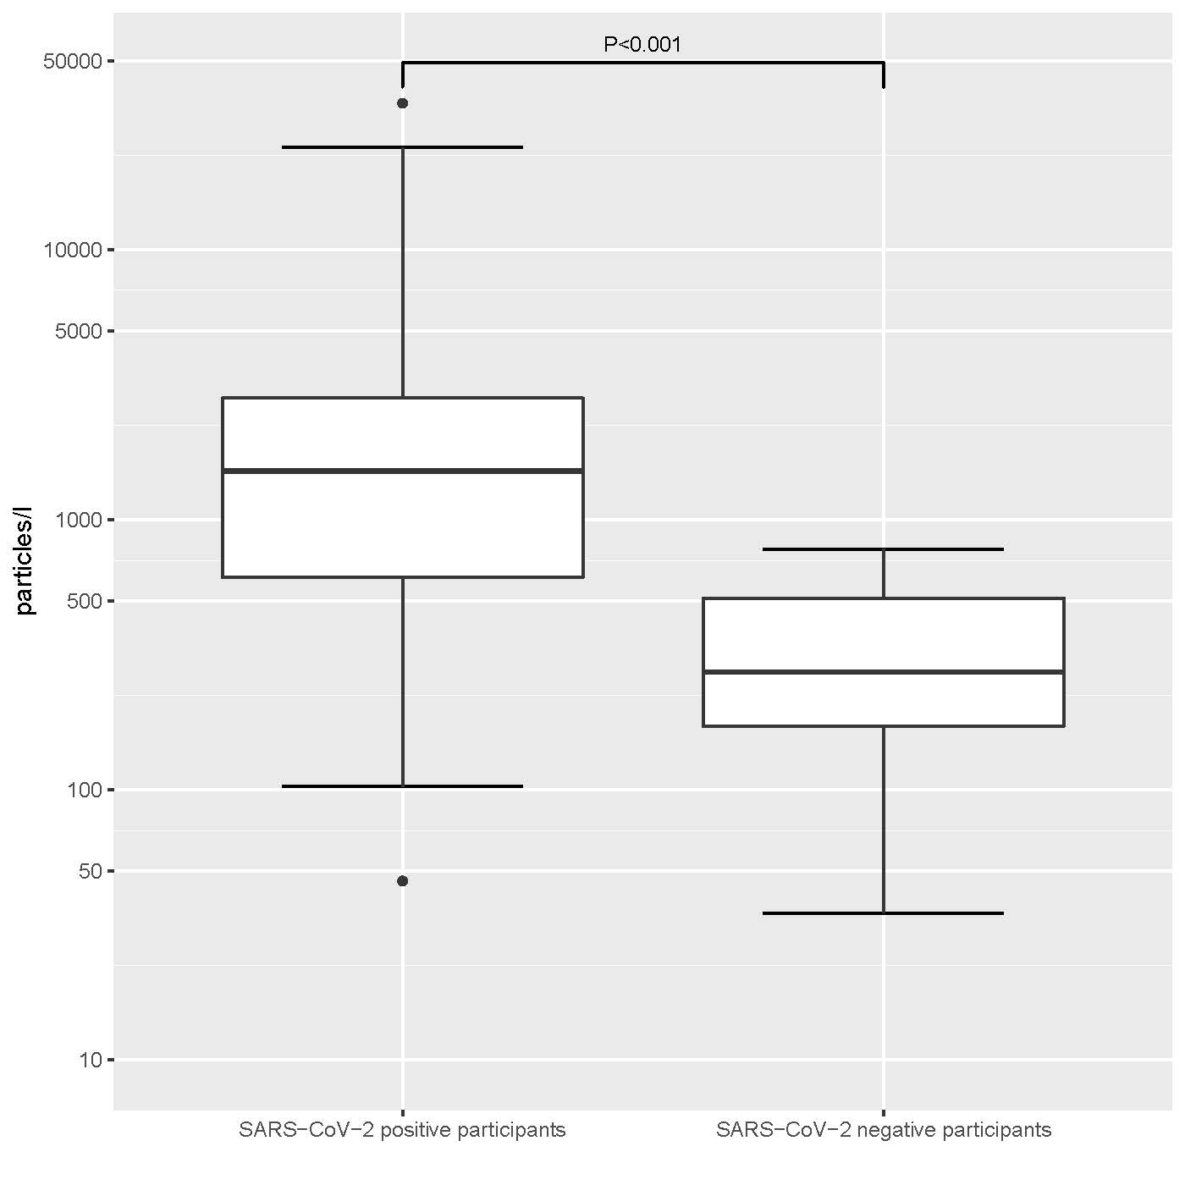
eFigure 3: Aerosol particle counts in SARS-CoV-2 PCR-positive and -negative patients divided into subgroups.
A. Divided into female and male patients
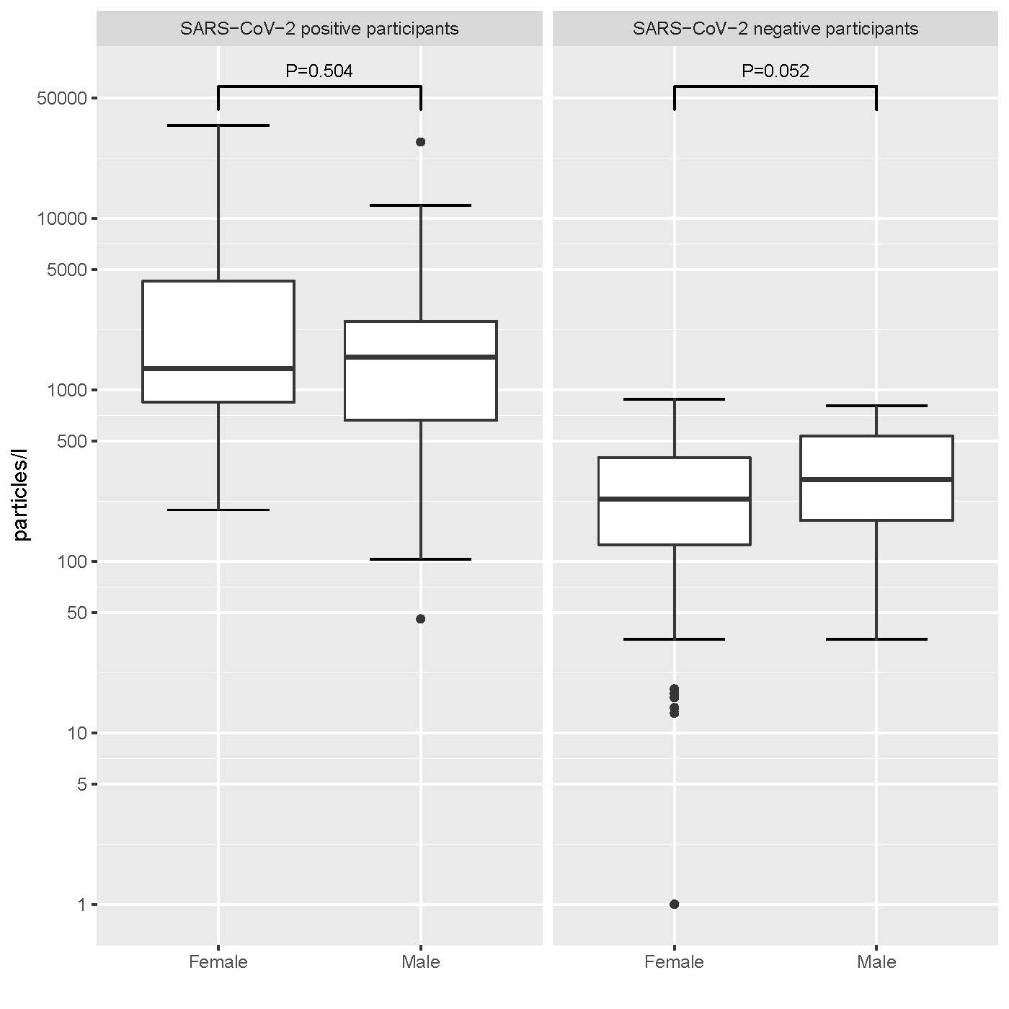

B. Divided in groups of BMI ≤30kg/m² and >30kg/m²
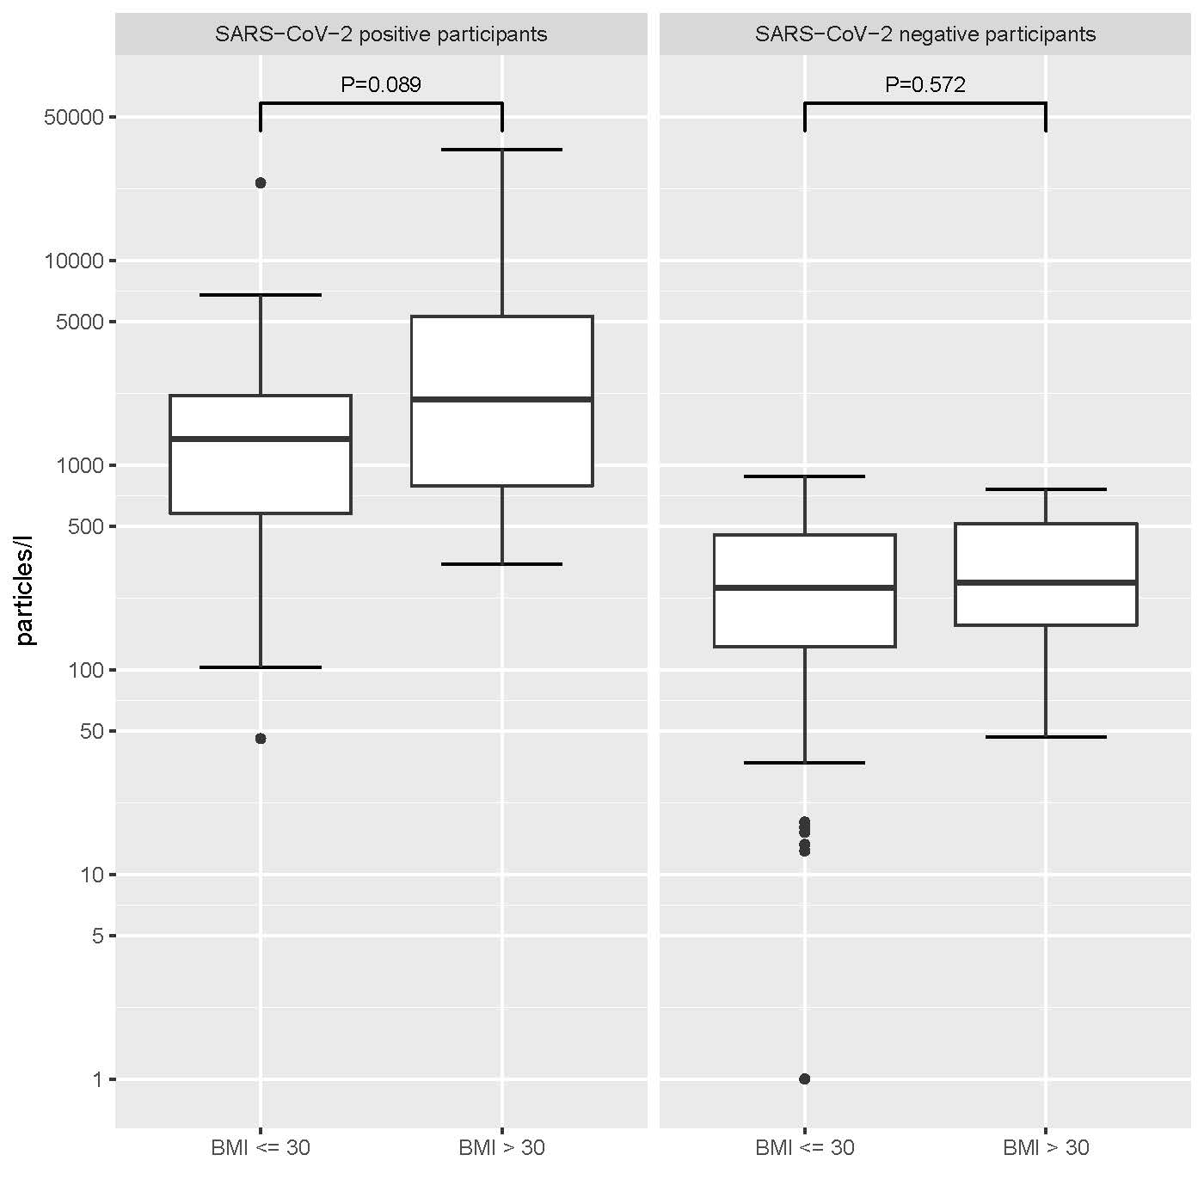

C. Divided into non-smoker and smoker.
