**Effectiveness of mRNA-1273 against SARS-CoV-2 omicron and delta variants**

Supplementary Appendix

**Authors:** Hung Fu Tseng, PhD,1,2,* Bradley K. Ackerson, MD,1 Yi Luo, PhD,1 Lina S. Sy, MPH,1 Carla A. Talarico, PhD,3 Yun Tian, MS,1 Katia J. Bruxvoort, PhD,4 Julia E. Tubert, MPH,1 Ana Florea, PhD,1 Jennifer H. Ku, PhD,1 Gina S. Lee, MPH,1 Soon Kyu Choi, MPH,1 Harpreet S. Takhar, MPH,1 Michael Aragones, MD,1 Lei Qian, PhD1

**Affiliations:** 1Department of Research and Evaluation, Kaiser Permanente Southern California, 100 S. Los Robles Ave., Pasadena, CA, 91101, USA; 2Department of Health Systems Science, Kaiser Permanente Bernard J. Tyson School of Medicine, 98 S. Los Robles Ave., Pasadena, CA, 91101, USA; 3Moderna Inc., 200 Technology Square, Cambridge, MA, 02139, USA; 4Department of Epidemiology, University of Alabama at Birmingham, 1665 University Blvd., Birmingham, AL, 35233, USA

Contents

Supplementary Figure 1. Flow chart for 1-dose, 2-dose, and 3-dose mRNA-1273 vaccine case-control design 3

Supplementary Table 1. List of covariates 4

Supplementary Table 2. Characteristics of SARS-CoV-2 cases and controls, by variant (1-dose analysis) 5

# Supplementary Figure 1. Flow chart for 1-dose, 2-dose, and 3-dose mRNA-1273 vaccine case-control design

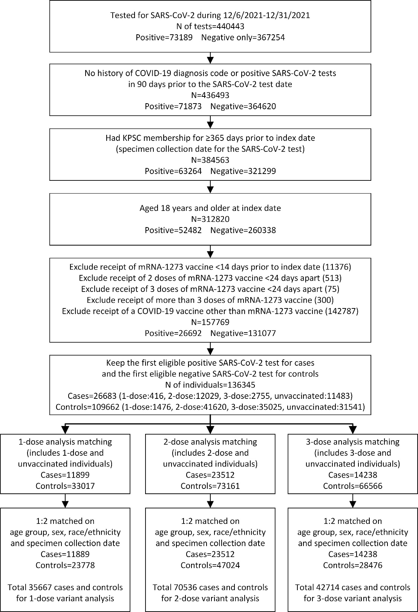

# Supplementary Table 1. List of covariates

|  |
| --- |
| **Covariates** |
| 1. Age |
| 1. Sex |
| 1. Race/ethnicity |
| 1. Body mass index |
| 1. Smoking |
| 1. Charlson comorbidity score |
| 1. Frailty index |
| 1. Kidney disease |
| 1. Heart disease |
| 1. Lung disease |
| 1. Liver disease |
| 1. Diabetes |
| 1. Immunocompromised status |
| 1. Autoimmune condition |
| 1. Pregnancy status |
| 1. History of COVID-19 |
| 1. History of SAR-CoV-2 molecular test |
| 1. Number of outpatient and virtual visits |
| 1. Number of Emergency Department visits |
| 1. Number of inpatient encounters or hospitalizations |
| 1. Preventive care utilization |
| 1. Medicaid status |
| 1. Neighborhood median household income |
| 1. KPSC physician/employee status |
| 1. Specimen type |
| 1. Medical center area |

# Supplementary Table 2. Characteristics of SARS-CoV-2 cases and controls, by variant (1-dose analysis)

|  |  |  |  |  |  |  |
| --- | --- | --- | --- | --- | --- | --- |
|  | **Delta** | | | **Omicron** | | |
|  | **Test Positive Cases** | **Test Negative Controls** | **p-value/ASD** | **Test Positive Cases** | **Test Negative Controls** | **p-value/ASD** |
|  | **N=2942** | **N=5884** |  | **N=8947** | **N=17894** |  |
| Age at specimen collection date, years | |  | 0.91 / 0.01 |  |  | <0.01 / 0.04 |
| mean (sd) | 41.24 (14.29) | 41.33 (14.36) |  | 37.40 (13.06) | 37.92 (13.25) |  |
| median | 39 | 39 |  | 35 | 36 |  |
| Q1, Q3 | 31, 51 | 31, 51 |  | 27, 46 | 28, 46 |  |
| min, max | 18, 90 | 18, 101 |  | 18, 93 | 18, 96 |  |
| Age at specimen collection date, years, n (%) | |  | N/A |  |  | N/A |
| 18-44 | 1844 (62.7%) | 3688 (62.7%) |  | 6477 (72.4%) | 12954 (72.4%) |  |
| 45-64 | 904 (30.7%) | 1808 (30.7%) |  | 2188 (24.5%) | 4376 (24.5%) |  |
| 65-74 | 153 (5.2%) | 306 (5.2%) |  | 238 (2.7%) | 476 (2.7%) |  |
| ≥75 | 41 (1.4%) | 82 (1.4%) |  | 44 (0.5%) | 88 (0.5%) |  |
| Sex, n (%) |  |  | N/A |  |  | N/A |
| Female | 1550 (52.7%) | 3100 (52.7%) |  | 4996 (55.8%) | 9992 (55.8%) |  |
| Male | 1392 (47.3%) | 2784 (47.3%) |  | 3951 (44.2%) | 7902 (44.2%) |  |
| Race/Ethnicity, n (%) |  |  | N/A |  |  | N/A |
| Non-Hispanic White | 1159 (39.4%) | 2318 (39.4%) |  | 2526 (28.2%) | 5052 (28.2%) |  |
| Non-Hispanic Black | 181 (6.2%) | 362 (6.2%) |  | 961 (10.7%) | 1922 (10.7%) |  |
| Hispanic | 1265 (43.0%) | 2530 (43.0%) |  | 4319 (48.3%) | 8638 (48.3%) |  |
| Non-Hispanic Asian | 97 (3.3%) | 194 (3.3%) |  | 387 (4.3%) | 774 (4.3%) |  |
| Other/Unknown | 240 (8.2%) | 480 (8.2%) |  | 754 (8.4%) | 1508 (8.4%) |  |
| Body mass indexb, n (%) |  |  | <0.01 / 0.15 |  |  | <0.01 / 0.08 |
| <18.5 | 20 (0.7%) | 71 (1.2%) |  | 105 (1.2%) | 224 (1.3%) |  |
| 18.5 - <25 | 545 (18.5%) | 1273 (21.6%) |  | 1730 (19.3%) | 3645 (20.4%) |  |
| 25 - <30 | 740 (25.2%) | 1591 (27.0%) |  | 2377 (26.6%) | 4609 (25.8%) |  |
| 30 - <35 | 590 (20.1%) | 1084 (18.4%) |  | 1655 (18.5%) | 3503 (19.6%) |  |
| 35 - <40 | 295 (10.0%) | 607 (10.3%) |  | 837 (9.4%) | 1806 (10.1%) |  |
| 40 - <45 | 117 (4.0%) | 247 (4.2%) |  | 393 (4.4%) | 795 (4.4%) |  |
| ≥45 | 66 (2.2%) | 147 (2.5%) |  | 245 (2.7%) | 539 (3.0%) |  |
| Unknown | 569 (19.3%) | 864 (14.7%) |  | 1605 (17.9%) | 2773 (15.5%) |  |
| Smokingb, n (%) |  |  | <0.01 / 0.12 |  |  | <0.01 / 0.07 |
| No | 1981 (67.3%) | 4103 (69.7%) |  | 6375 (71.3%) | 12709 (71.0%) |  |
| Yes | 484 (16.5%) | 1068 (18.2%) |  | 1268 (14.2%) | 2883 (16.1%) |  |
| Unknown | 477 (16.2%) | 713 (12.1%) |  | 1304 (14.6%) | 2302 (12.9%) |  |
| Charlson comorbidity scorea, n (%) |  |  | 0.01 / 0.07 |  |  | <0.01 / 0.13 |
| 0 | 2443 (83.0%) | 4760 (80.9%) |  | 7721 (86.3%) | 14725 (82.3%) |  |
| 1 | 316 (10.7%) | 652 (11.1%) |  | 866 (9.7%) | 2001 (11.2%) |  |
| ≥2 | 183 (6.2%) | 472 (8.0%) |  | 360 (4.0%) | 1168 (6.5%) |  |
| Frailty indexa, n (%) |  |  | <0.01 / 0.17 |  |  | <0.01 / 0.13 |
| Quartile 1 | 731 (24.8%) | 1474 (25.1%) |  | 2163 (24.2%) | 4258 (23.8%) |  |
| Quartile 2 | 856 (29.1%) | 1350 (22.9%) |  | 2571 (28.7%) | 4424 (24.7%) |  |
| Quartile 3 | 728 (24.7%) | 1481 (25.2%) |  | 2272 (25.4%) | 4442 (24.8%) |  |
| Quartile 4 (most frail) | 627 (21.3%) | 1579 (26.8%) |  | 1941 (21.7%) | 4770 (26.7%) |  |
| Chronic diseasesa, n (%) |  |  |  |  |  |  |
| Kidney disease | 41 (1.4%) | 117 (2.0%) | 0.05 / 0.05 | 62 (0.7%) | 289 (1.6%) | <0.01 / 0.09 |
| Heart disease | 34 (1.2%) | 108 (1.8%) | 0.02 / 0.06 | 59 (0.7%) | 232 (1.3%) | <0.01 / 0.06 |
| Lung disease | 193 (6.6%) | 461 (7.8%) | 0.03 / 0.05 | 531 (5.9%) | 1393 (7.8%) | <0.01 / 0.07 |
| Liver disease | 68 (2.3%) | 162 (2.8%) | 0.22 / 0.03 | 175 (2.0%) | 483 (2.7%) | <0.01 / 0.05 |
| Diabetes | 170 (5.8%) | 386 (6.6%) | 0.15 / 0.03 | 398 (4.4%) | 1064 (5.9%) | <0.01 / 0.07 |
| Immunocompromised, n (%) | 32 (1.1%) | 173 (2.9%) | <0.01 / 0.13 | 131 (1.5%) | 488 (2.7%) | <0.01 / 0.09 |
| HIV/AIDS | 2 | 4 |  | 12 | 30 |  |
| Leukemia/lymphoma, congenital and other immunodeficiencies, asplenia/hyposplenia | 12 | 62 |  | 44 | 150 |  |
| Organ transplant | 2 | 6 |  | 7 | 29 |  |
| Immunosuppressant medications | 18 | 120 |  | 83 | 342 |  |
| Autoimmune conditionsa, n (%) | 55 (1.9%) | 160 (2.7%) | 0.01 / 0.06 | 146 (1.6%) | 373 (2.1%) | 0.01 / 0.03 |
| Rheumatoid arthritis | 13 | 54 |  | 49 | 165 |  |
| Inflammatory bowel disease | 15 | 50 |  | 42 | 92 |  |
| Psoriasis and psoriatic arthritis | 23 | 53 |  | 44 | 94 |  |
| Multiple sclerosis | 4 | 8 |  | 12 | 24 |  |
| Systemic lupus erythematosus | 3 | 12 |  | 19 | 55 |  |
| Pregnant at specimen collection date, n (%) | 57 (1.9%) | 203 (3.5%) | <0.01 / 0.09 | 195 (2.2%) | 774 (4.3%) | <0.01 / 0.12 |
| 1st trimester | 16 | 28 |  | 33 | 80 |  |
| 2nd trimester | 19 | 48 |  | 69 | 174 |  |
| 3rd trimester | 22 | 127 |  | 93 | 520 |  |
| History of COVID-19c, n (%) | 79 (2.7%) | 1354 (23.0%) | <0.01 / 0.64 | 1622 (18.1%) | 4473 (25.0%) | <0.01 / 0.17 |
| History of SARS-CoV-2 molecular testc, n (%) | 1886 (64.1%) | 4684 (79.6%) | <0.01 / 0.35 | 6563 (73.4%) | 13347 (74.6%) | 0.03 / 0.03 |
| Number of outpatient and virtual visitsa, n (%) | |  | <0.01 / 0.29 |  |  | <0.01 / 0.19 |
| 0 | 460 (15.6%) | 586 (10.0%) |  | 1196 (13.4%) | 1920 (10.7%) |  |
| 1-4 | 1123 (38.2%) | 1823 (31.0%) |  | 3460 (38.7%) | 5990 (33.5%) |  |
| 5-10 | 711 (24.2%) | 1593 (27.1%) |  | 2275 (25.4%) | 4596 (25.7%) |  |
| ≥11 | 648 (22.0%) | 1882 (32.0%) |  | 2016 (22.5%) | 5388 (30.1%) |  |
| Number of Emergency Department visitsa, n (%) |  |  | <0.01 / 0.18 |  |  | <0.01 / 0.14 |
| 0 | 2513 (85.4%) | 4642 (78.9%) |  | 7449 (83.3%) | 14106 (78.8%) |  |
| 1 | 308 (10.5%) | 830 (14.1%) |  | 1111 (12.4%) | 2506 (14.0%) |  |
| ≥2 | 121 (4.1%) | 412 (7.0%) |  | 387 (4.3%) | 1282 (7.2%) |  |
| Number of hospitalizationsa, n (%) |  |  | 0.02 / 0.07 |  |  | <0.01 / 0.11 |
| 0 | 2797 (95.1%) | 5512 (93.7%) |  | 8561 (95.7%) | 16710 (93.4%) |  |
| 1 | 118 (4.0%) | 285 (4.8%) |  | 340 (3.8%) | 948 (5.3%) |  |
| ≥2 | 27 (0.9%) | 87 (1.5%) |  | 46 (0.5%) | 236 (1.3%) |  |
| Preventive carea, n(%) | 1355 (46.1%) | 2965 (50.4%) | <0.01 / 0.09 | 3971 (44.4%) | 8578 (47.9%) | <0.01 / 0.07 |
| Medicaid, n (%) | 303 (10.3%) | 684 (11.6%) | 0.06 / 0.04 | 1077 (12.0%) | 2495 (13.9%) | <0.01 / 0.06 |
| Neighborhood median household income, n(%) | |  | 0.04 / 0.07 |  |  | <0.01 / 0.06 |
| < $40,000 | 127 (4.3%) | 273 (4.6%) |  | 387 (4.3%) | 948 (5.3%) |  |
| $40,000-$59,999 | 490 (16.7%) | 1132 (19.2%) |  | 1789 (20.0%) | 3820 (21.3%) |  |
| $60,000-$79,999 | 799 (27.2%) | 1515 (25.7%) |  | 2447 (27.3%) | 4724 (26.4%) |  |
| $80,000+ | 1524 (51.8%) | 2959 (50.3%) |  | 4307 (48.1%) | 8373 (46.8%) |  |
| Unknown | 2 (0.1%) | 5 (0.1%) |  | 17 (0.2%) | 29 (0.2%) |  |
| KPSC physician/employee, n (%) | 75 (2.5%) | 533 (9.1%) | <0.01 / 0.28 | 275 (3.1%) | 466 (2.6%) | 0.03 / 0.03 |
| Specimen type, n (%) |  |  | <0.01 / 0.55 |  |  | <0.01 / 0.21 |
| Nasopharyngeal/oropharyngeal swab | 2541 (86.4%) | 3724 (63.3%) |  | 7599 (84.9%) | 13730 (76.7%) |  |
| Saliva | 401 (13.6%) | 2160 (36.7%) |  | 1348 (15.1%) | 4164 (23.3%) |  |

a Defined in the one year prior to specimen collection date

b Defined in the two years prior to specimen collection date

c Defined based on all available medical records from March 1, 2020 to specimen collection date

Medical center area not shown. There were differences in the distribution of the vaccinated and unvaccinated individuals across the 19 medical center areas.

N/A = not applicable